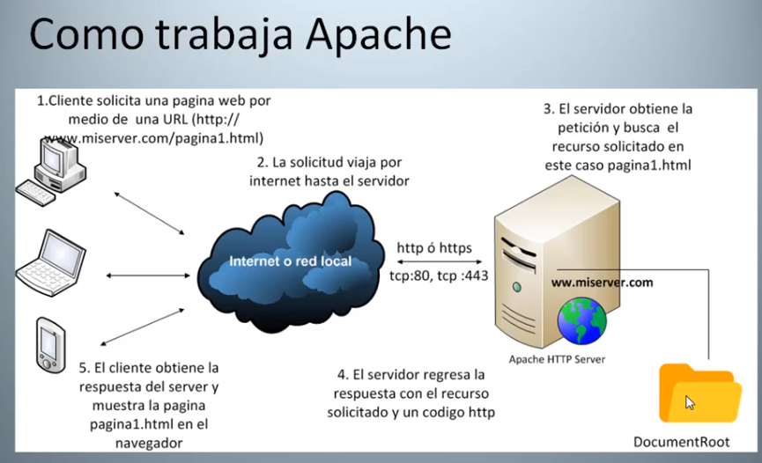

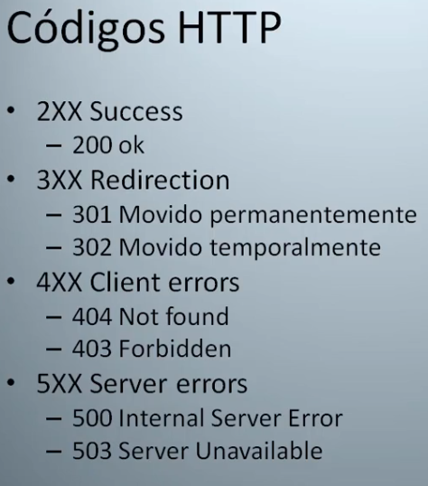

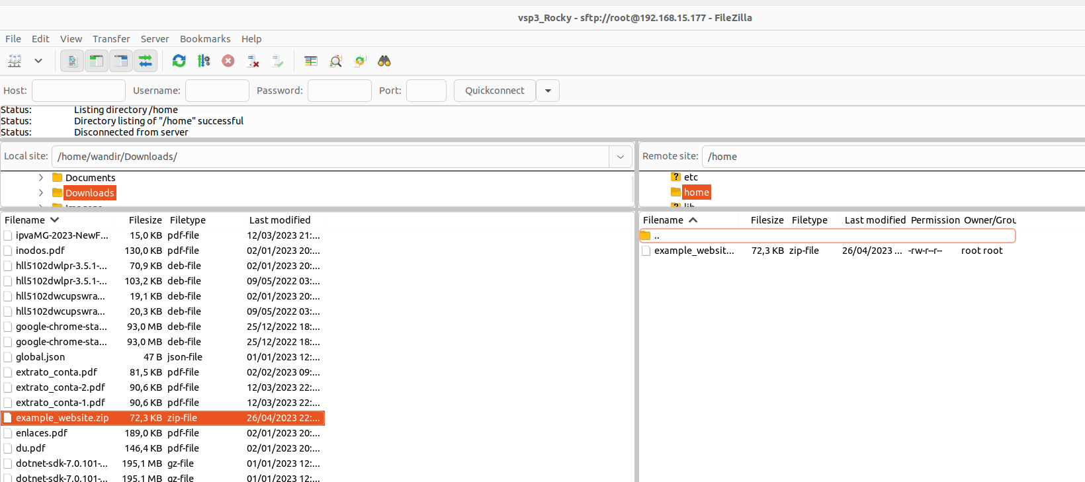
[root@orion /]# pwd
/
[root@orion /]# cd home
[root@orion home]# ls
example_website.zip
[root@orion home]# cd ~
[root@orion ~]# pwd
/root
[root@orion ~]# cd /home
[root@orion home]# ls
example_website.zip
[root@orion home]# unzip example_website.zip
Archive: example_website.zip
creating: example_website/
creating: example_website/css/
inflating: example_website/css/bootstrap.css
inflating: example_website/css/bootstrap.min.css
inflating: example_website/index.html
creating: example_website/js/
inflating: example_website/js/bootstrap.js
inflating: example_website/js/bootstrap.min.js
[root@orion home]# ls -la
total 72
drwxr-xr-x. 3 root root 56 Apr 26 23:40 .
dr-xr-xr-x. 18 root root 235 Apr 26 12:05 ..
drwxr-xr-x. 4 root root 45 Nov 9 2017 example_website
-rw-r--r--. 1 root root 72243 Apr 26 23:37 example_website.zip

[root@orion home]# cd example_website/
[root@orion example_website]# ls -la
total 8
drwxr-xr-x. 4 root root 45 Nov 9 2017 .
drwxr-xr-x. 3 root root 56 Apr 26 23:40 ..
drwxr-xr-x. 2 root root 52 Nov 9 2017 css
-rw-r--r--. 1 root root 4112 Nov 9 2017 index.html
drwxr-xr-x. 2 root root 50 Nov 9 2017 js
[root@orion example_website]# ls css
bootstrap.css bootstrap.min.css
[root@orion example_website]# cp -r * /var/www/html
[root@orion example_website]# ls
css index.html js
[root@orion example_website]# cd /var/www/html
[root@orion html]# ls -la
total 8
drwxr-xr-x. 4 root root 45 Apr 26 23:41 .
drwxr-xr-x. 4 root root 33 Apr 26 12:17 ..
drwxr-xr-x. 2 root root 52 Apr 26 23:41 css
-rw-r--r--. 1 root root 4112 Apr 26 23:41 index.html
drwxr-xr-x. 2 root root 50 Apr 26 23:41 js
[root@orion html]# ls -lZ
total 8
drwxr-xr-x. 2 root root unconfined_u:object_r:httpd_sys_content_t:s0 52 Apr 26 23:41 css
-rw-r--r--. 1 root root unconfined_u:object_r:httpd_sys_content_t:s0 4112 Apr 26 23:41 index.html
drwxr-xr-x. 2 root root unconfined_u:object_r:httpd_sys_content_t:s0 50 Apr 26 23:41 js
?????


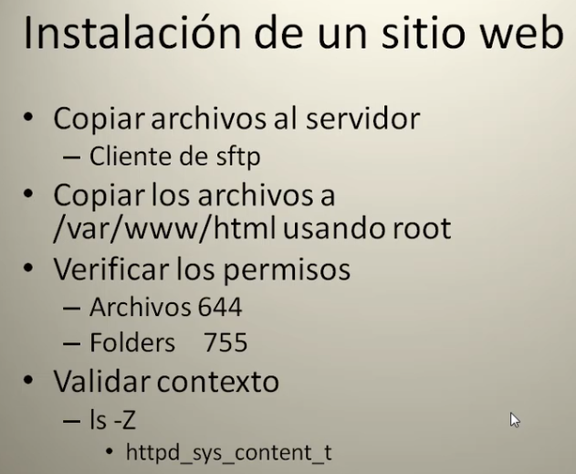

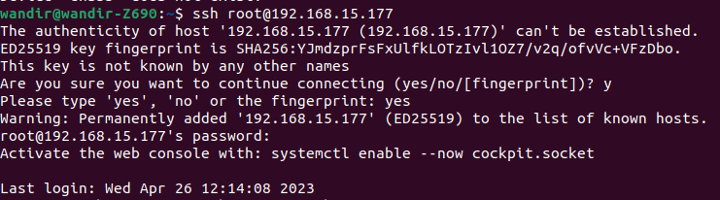

Configurando o Firewall

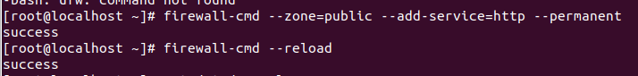
Versão do SO
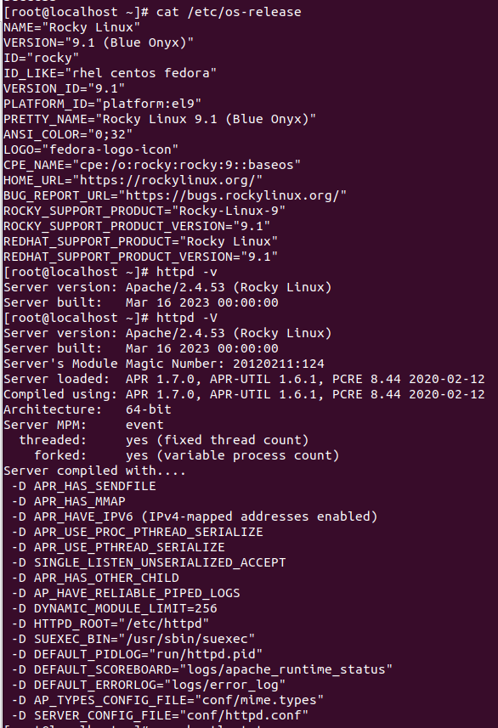

status do apache (httpd)
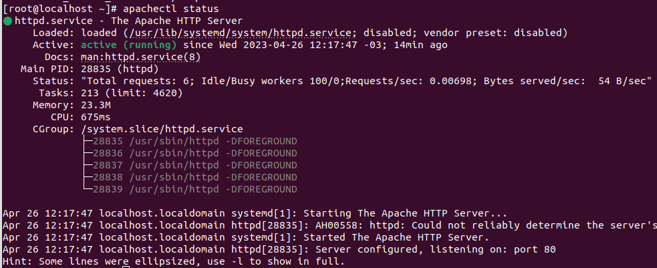

AH00558: httpd: Could not reliably determine the server's fully qualified domain name, using localhost.localdomain. Set the 'ServerName' direc…ess this message

Loaded: loaded (/usr/lib/systemd/system/httpd.service; disabled; vendor preset: disabled) NÃO FOI CONFIGURADO PARA INICIAR NO BOOT

apachectl stop

apachesctl start
Loaded: loaded (/usr/lib/systemd/system/httpd.service; enabled; vendor preset: disabled)

Instalando a documentação do apache;
[root@localhost ~]# yum install httpd-manual
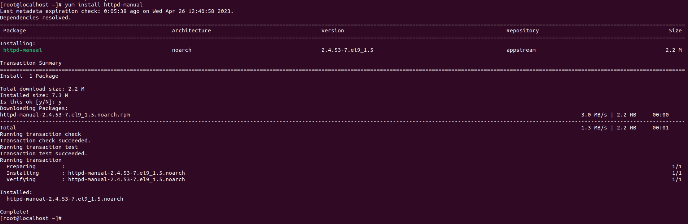
apachectl graceful → reinciar o serviço, porém aguarda a finalização dos processos em andamento.

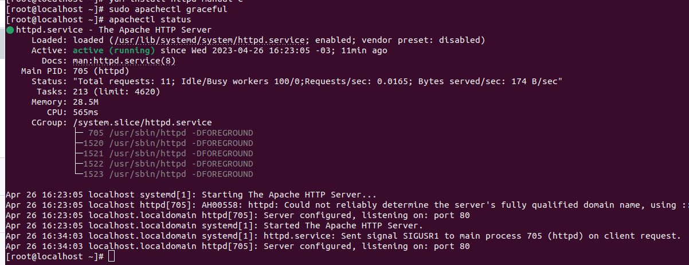

apachectl configtest verifica se a sintaxe do arquivo de configuração httpd.conf está correta:

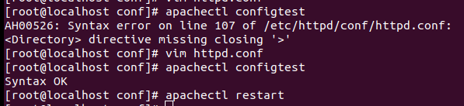
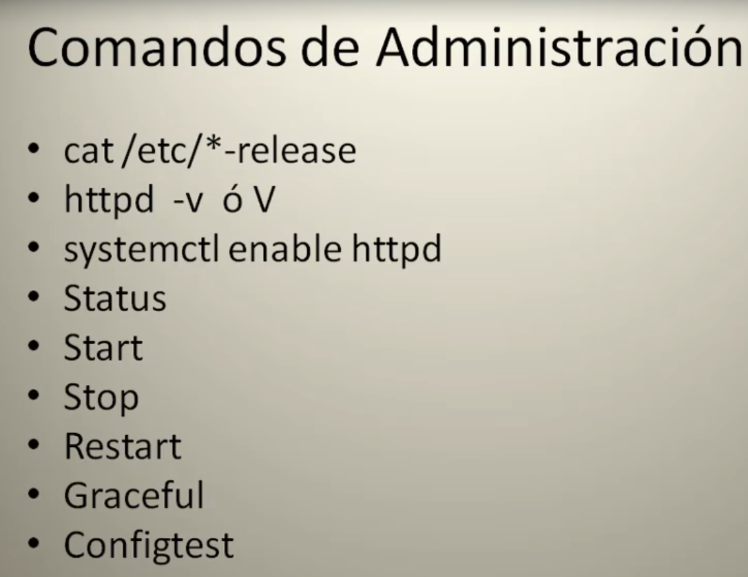
[root@localhost httpd]# ll
total 4
drwxr-xr-x. 2 root root 37 Apr 26 16:51 conf → arquivo de configuração principal
drwxr-xr-x. 2 root root 101 Apr 26 12:46 conf.d
drwxr-xr-x. 2 root root 4096 Apr 26 12:17 conf.modules.d
lrwxrwxrwx. 1 root root 19 Apr 6 13:31 logs -> ../../var/log/httpd → logs
lrwxrwxrwx. 1 root root 29 Apr 6 13:31 modules -> ../../usr/lib64/httpd/modules → binários dos módulos
lrwxrwxrwx. 1 root root 10 Apr 6 13:31 run -> /run/httpd → variáveis de ambiente
lrwxrwxrwx. 1 root root 19 Apr 6 13:31 state -> ../../var/lib/httpd

[root@localhost conf]# pwd
/etc/httpd/conf
[root@localhost conf]# ls -la
total 28
drwxr-xr-x. 2 root root 37 Apr 26 16:51 .
drwxr-xr-x. 5 root root 105 Apr 26 12:17 ..
-rw-r--r--. 1 root root 11995 Apr 26 16:51 httpd.conf
-rw-r--r--. 1 root root 13430 Apr 6 13:30 magic
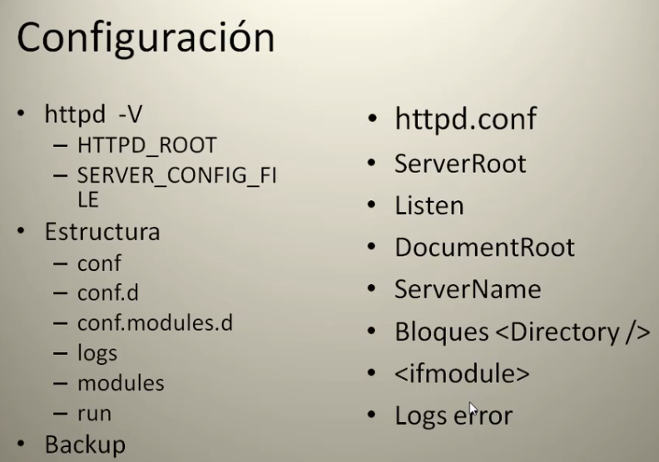
Automação do deploy de uma aplicação webapp net core:
https://raw.githubusercontent.com/Vagelis-Prokopiou/dotfiles/master/bin/apache-vhost-create-dot.net.core.sh
https://www.youtube.com/watch?v=mBhT_MRwGYE

#!/usr/bin/env bash

# Author: Vagelis Prokopiou <vagelis.prokopiou@gmail.com>

# Check for a provided hostname argument.
if [[ ! "$1" ]]; then
echo "Usage: $0 <hostName>";
exit 1;
fi

# Make sure the following modules are enabled.
sudo a2enmod headers;
sudo a2enmod proxy;
sudo a2enmod proxy_http;

user="va";
base_path="/home/${user}/www";
domain="$1";
docroot="${base_path}/${domain}/public_html/web";
logsdir="${base_path}/${domain}/logs";

if [[ -d "${base_path}/${domain}" ]]; then
echo "${domain} already exists. Skipping...";
exit 0;
fi

sudo mkdir -p "${docroot}";
sudo mkdir -p "${logsdir}";
# Create an index file.
echo "<h1>${domain}.local has been created successfully.</h1>" | sudo tee "${docroot}/index.html";

domainSuffix="local.com";

# Create the Apache config files.
echo "
<VirtualHost *:*>
RequestHeader set \"X-Forwarded-Proto\" expr=%{REQUEST_SCHEME}
</VirtualHost>

<VirtualHost *:80>
ProxyPreserveHost On
ProxyPass / http://127.0.0.1:5000/
ProxyPassReverse / http://127.0.0.1:5000/
ServerName ${domain}.local
ServerAlias www.${domain}.local

ErrorLog ${logsdir}/error.log
CustomLog ${logsdir}/access.log combined
</VirtualHost>" | sudo tee "/etc/apache2/sites-available/${domain}.local.conf";

# Enable the site.
sudo a2ensite "${domain}.${domainSuffix}";

# Add the vhost to the vhosts file.
echo "127.0.0.1 ${domain}.${domainSuffix}" | sudo tee --append /etc/hosts;

sudo chown -R va:www-data "${base_path}/${domain}";

# Restart Apache.
sudo systemctl restart apache2;
echo "You can access the site at https://${domain}.${domainSuffix}";

