Project Documentation

# Introduction

Say something to introduce the project

## Objectives and goals

Outline our objectives

# Project Design

Explain the importance of design and how designing the project before beginning the development process was advantageous.

## Project Diagrams

The following are some of the diagrams used to design the project. These diagrams explain how the data flows in the system, the system’s process flow, the system’s entities and the relationships between these entities.

### System Context Diagram

The following is the context diagram for the Laptop Management System. It shows the flow of data from the User and Item external entities into the system. From the user we have the user’s registration details, the user’s item details (laptop or camera details) and requests for reports (from an elevated user e.g. system admin or security guard). We also expect the laptops or cameras to send to the system periodic information about their location around the campus.

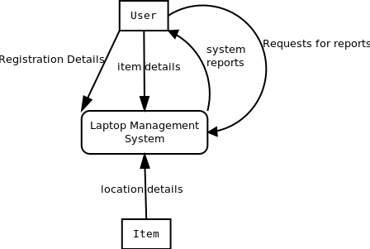

### System Data Flow Diagram

The DFD for the Laptop Management System is presented below. This shows the data flow through the system along with various processes and how they interact with any external entities and data stores.

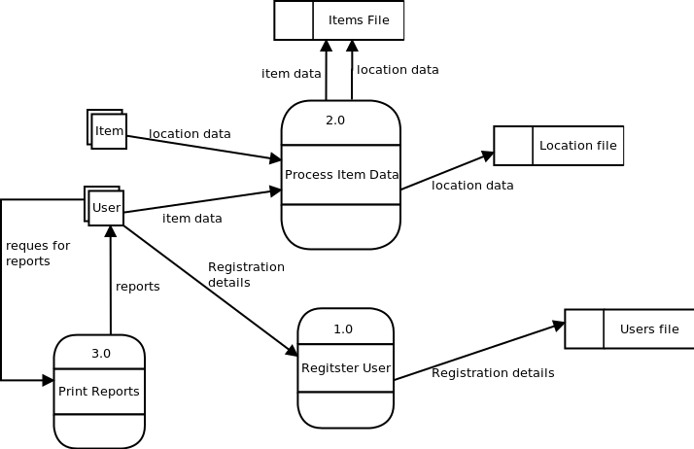

### System Entity Relationship Diagram

Below is the ERD for the Laptop Management System. It displays all the system’s entities along with the relationships between them. We have 3 entities with the attributes shown below. The ‘owned by’ relationship between items and users is a one to many since one user can own many items but an item can only be owned a single user as per the system. Similarly, the ‘registered by’ relationship is one to many since one user can register multiple items but an item can only be registered by a single user (of user type ‘security guard’). The ‘located at’ relationship generates two weak entities i.e. Date and time for the exact time and date the an item’s location is determined by the system.

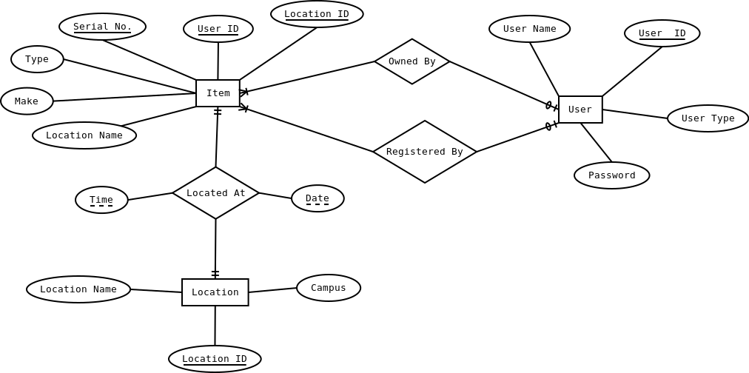

### Database Schema

The following is the database schema for the Laptop Management System. The Sign In table uses the UserID and Serial No fields as its two-field primary key. It also stores the time the student sign in and sign out their items. The Type field in the Items table represents the type of item i.e. Laptop or camera while the Make field represents the item manufacturer i.e. Hp or Dell. User roles in the Users table include Security Guard, Student, Staff, Admin etc.

