**CSC 1500 – Homework 3 – gq5426**

1. If A is an even integer, and B is an even integer, prove (using a Direct Proof) that A*B will result in an even integer as the answer. (*20 pts.*)

2 of any integer is even.

A = 2n (2n meaning some even integer)

B = 2k (2k meaning some even integer)

2n*2k = 2(n*k)

2(n*k) is two of an integer, which is therefore even by above definition.

1. Prove the following statement by contradiction: There exist no INTEGER VALUES for A and B such that 15*A + 5*B = 1. (*20 pts.*)

Proposition: There exist no INTEGER VALUES for A and B such that 15*A + 5*B = 1.

Opposite Proposition: There EXIST INTEGER VALUES for A and B such that 15*A + 5*B = 1.

Prove opposite proposition false.

Integers are whole numbers (i.e. not a fraction).

An integer multiplied by an integer must be an integer.

Two integers added together must be an integer.

3 is an integer.

Therefore 3*integer is also an integer.

15*A + 5*B = 1.

5*(3A + B) = 1

3A + B = (1/5)

Since two integers added together cannot be a fraction, the opposite of the proposition is false.

Because the opposite of the proposition is false, the proposition must be true.

**(3)** For the following predicate statements, present a case that proves the statement is wrong. (*10 pts. each)*

**(3.1) f(x) = (5x)/(10-x) has a real answer for all values of x.**

F(10) = (5*10) / (10-10) = 50/0

Divide by zero is not a real number. The statement is wrong.

**(3.2) If A is an integer, and B is an integer, and A != B, then (A*B) > A AND (A*B) > B.**

0 is an integer. A = 0.

1 is an integer. B = 1.

(1*0) > 0 -> false

(0*1) > 1 -> false

**(4)** Prove the following by induction (*20 pts.*)

$$\frac{1}{1*\left(1+1\right)}+\frac{1}{2*\left(2+1\right)}+\frac{1}{3*\left(3+1\right)}+…+\frac{1}{n*\left(n+1\right)}=\frac{n}{n+1}$$

base case: (1/(1(1+1)) = ½ = (1*1) / (1+1 ) = 1/2

The base case is true.

Assume the case is true for some positive integer n.

½ + … + 1/(n*(n+1)) = n/(n+1

( I assume it is true, so let’s test the next case (n+1), substituting in the result of the generic case for the sum of the series up to the next case. :

n/(n+1) + 1/((n+1)*(n+1 +1)) = n+1 / (n+1 +1)

I am too lazy to type this out, enjoy my handwritten scribbles that involve simplification:

= (n+1)/(n+2)

Both sides are equal, proof by induction. Go team. By proving the base case, and the inductive step, it’s true for all positive integers. Yay.

**(5)** Flashback to Logic Week: Convert the following statements into logic gate diagrams. (*10 pts each.)*

(5.1) ((A xor B) or (C and A)) nor (B nand C)

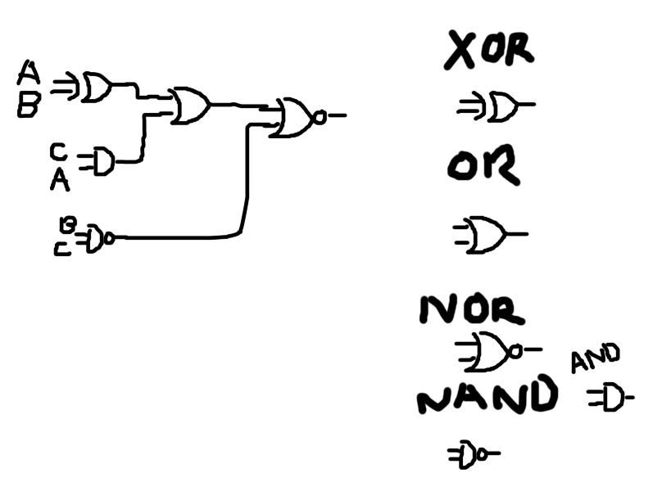

(5.2) (!(!A and B)) xnor (C or (B and !C))

