**CSC 1500 – Homework 2**

**(1) Turn the following phrases into logical statements. Use the capitalized words as your variables. (10 pts.**

**each)**

**(1.1) Either you can go to the MOVIES, or you can obey QUARANTINE (but you can’t do both!)**

MOVIES XOR QUARANTINE

**(1.2) If I go out to a RESTAURANT, then I’m expecting to have a nice MEAL or good SERVICE.**

RESTAURANT IMPLIES (MEAL OR SERVICE)

(RESTAURANT IMPLIES MEAL) OR (RESTAURANT IMPLIES SERVICE)

**(2) State the logical equivalences needed to turn statement 1 into statement 2. (20 pts.)**

Statement 1: (!A or (!B and !C)) and (B or !B)

(!A or (!B and !C)) -> De morgan’s Law -> !(A and !(!B and !C)

!(!B and !C) -> De morgan’s law -> !!(B or C)

!!(B or C) -> Double negation law -> (B or C)

!(A and (B or C)) -> not and is nand -> A nand (B or C)

(B or !B) -> Negation Law -> Always true

And Always True -> Domination law -> True

**Statement 2: (A nand (B or C))**

**(3) Determine if the following logical statement is valid via truth table: (20 pts.)**

**A. Steve can exclusively either Study or Sleep.**

Study XOR Sleep

**B. If Steve studies, then he’ll Pass his Exam.**

Studies -> Exam Pass

Condition Summary: (Study XOR Sleep) AND (Study <= Exam Pass)

**Conclusion: If Steve Sleeps, then he’ll NOT Pass his Exam.**

Sleeps -> !Exam Pass

TEST EQUIVALENCE, ALL FALSES AND TRUES FROM CONDITIONS AND CONCLUSION MUST BE EQUAL -> XNOR

FINAL STATEMENT: ((Study XOR Sleep) AND (Study <= Exam Pass)) XNOR (Study <= Exam Pass)

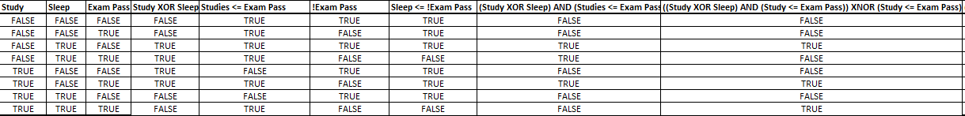

**(4) Convert the following numbers from the base shown, to the base requested. (5 pts. each)**

**(4.1) 38 base 10 = ?? base 2**

38 % 2 - > 0

19 % 2 -> 1

9 % 2 -> 1

4 % 2 -> 0

2 % 2 -> 0

1 % 2 -> 1

100110

**(4.2) 10100011 base 2 = ?? base 10**

1 + 2 + 0 +0 + 0+ 32 + 0 + 128 =163

**(4.3) 15B base 16 = ?? base 10**

**11* 16^0+ 5*16^1 + 1*16^2 = 347**

**(4.4) 423 base 5 = ?? base 3**

**3*5^0 + 2*5^1 + 4*5^2 = 113**

**113%3 -> 2**

**37%3 -> 1**

**12%3 -> 0**

**4%3 -> 1**

**1%3 -> 1**

**1102**

**(5) Please perform the following Binary arithmetic. SHOW ALL WORK (10 pts. each)**

**(5.1) 00111 + 11101 = ?**

4+2+1 + 16 + 8 + 4 +1 = 36 -> 100100

**(5.2) 11011 * 10101 = ?**

**Binary multiplication is not like regular multiplication. This is upsetting.**

**11011**

**\*10101**

**11011+(1101100) + (110110000)**

**27 + 108 + 432 = 567 = 1000110111**