Architecture | DevOps | Dev | Coding
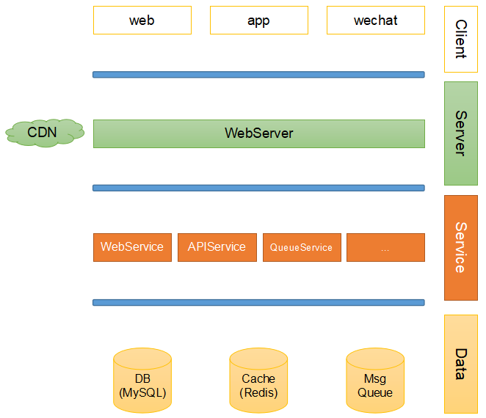 | - Jenkins, SaltStack, Sonar, Maven, Git  - Linux/Ubuntu, Nginx/conf, Tomcat  - Aliyun, AWS: LBS, auto-scaling, RDS, CloudWatch, cli  - Security: SSL, https, csrf  - Distributed: register, monitor, dubbo, ZooKeeper, Eureka, Thrift, Hessian, Broker  - Docker Swarm, Kubernets(k8s), etcd  - Microservice, ServerLess, ServerMesh  - MySQL5.3/5.7: InnoDB, MyISAM, commit, insert/update  - Index: unique, primary, fulltext, clustered  - Redis3.8/4.0: info, salveof, masterauth, slave-read-only, cluster, sentinel, sharding  - LazyFree: huge key, unlink, flushdb async, flushall async  - lua: non-deterministic command, date  - memory: stats, doctor, perge, malloc_stats, usage <key>  - hot keys  - MongoDB  - RabbitMQ, kafka, RocketMQ, MetaQ  - Search Engine: Lucene, ElasticSearch, Solr  - Log: ELK, Data: Hadoop, Spark  - Hands on  - hackerrank.com  - coderpad.io  - Story telling, Executable  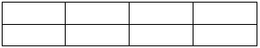  - Crazy 8 sections: | - IDE: Sublime, IDEA, PyCharm, VS Code, Wechat Dev Tool  - Wechat mini program  - Ant Design Pro, React, VUE, Angular  - Django/Python  - Spring Boot/Cloud/Java, application.yml, bean type: prototype, singleton  - NodeJS  - 2-way data-binding  - API: SOA, restful  - http, smtp, telnet: TCP, UDP, netty, io, nio  - syn+ack 3-handshakes  - sliding window  - MyBatis: 2-level cache, Hibernate, Struts  - Consistent Hashing  - Concurrent HashMap, TreeMap, Queue  - Encode: MD5, SHA, DES, RSA, Base64  - Java: DES, DES3, AES  - Redis: master-slave  - Single instance: be used as lock  - string(get/set, 512MB), int  - hash(hmset/hget, 2³²-1, 4G)  - list(lpush/lrange, 2³²-1, 4G)  - set(sadd/smembers)  - sorted set(zset, zddd/zrangebyscore)  - pub/sub  - Scrum: agile  - Jira, Trello, TeamBition, LeanGoo | - Readable  - Testable  - Unit-testing: junit4, mockito2  - log4j  - Multi thread communication:  - wait/notify, producer/consumer  - Lock: synchronized, ReentrantLock  - Singleton, volatile, ThreadLocal  - double, long: 2 slot for variables  - MySQL:  - tiny text: 2⁸-1, 255B  - text: 2¹⁶-1, 64KB  - medium text: 2²⁴-1, 16MB  - long text: 2³²-1, 4GB  - Data:  - xml: SAX, DOM, JDOM, DOM4J  - json: fastjson  - csv, yaml  - Code review, SQL, explain select, show  - DP, AOP  - Regex: (2(([0-4][0-9])|(5[0-5])))|([0-1]?[0-9]?[0-9])  - Ranking algorithm: stability, quick, bubble  - JVM memory: heap, deep/shallow copy  - GC: Young Generation(Eden, Survivor1/2), Tenured/Old Generation, Permanent Area, finalize(), stop-and-copy, GC Roots  - Java8: lambda, stream, functional program  - Python: __init__.py, __all__ = [“m1”]
2017.9.2
Csrf: https://blog.csdn.net/stpeace/article/details/53512283
Design Pattern: https://www.cnblogs.com/tongkey/p/7170826.html
Linux cmd: https://www.cnblogs.com/yjd_hycf_space/p/7730690.html

Micro-service: https://www.cnblogs.com/imyalost/p/6792724.html
LBS: https://blog.csdn.net/west_609/article/details/75808464

Redis: https://www.cnblogs.com/qwangxiao/p/8535202.html
Redis-sentinel: http://blog.51cto.com/dengaosky/2091877
ElasticSearch: https://blog.csdn.net/weixin_41383527/article/details/78914599
ElasticSearch: https://www.cnblogs.com/chowmin/articles/4629220.html
MQ: https://blog.csdn.net/ntotl/article/details/72765713
MQ cluster: https://blog.csdn.net/songfeihu0810232/article/details/73924529
MQ availability: https://www.cnblogs.com/Leo_wl/p/6581989.html
ElasticSearch: https://blog.csdn.net/wangnan9279/article/details/79287846
Log4j: https://blog.csdn.net/u011781521/article/details/55002553
Log4j: https://blog.csdn.net/menghuanzhiming/article/details/77531977

JVM: https://www.cnblogs.com/dingyingsi/p/3760447.html
JVM: https://www.cnblogs.com/zhguang/p/3257367.html
JVM GC: https://www.cnblogs.com/xiaoxi/p/6486852.html

Java String: https://www.cnblogs.com/su-feng/p/6659064.html
Java Map, HashMap, HashTable, TreeMap, LinkedHashMap: https://www.cnblogs.com/lzq198754/p/5780165.html
Java ConcurrentHashMap: https://www.cnblogs.com/ITtangtang/p/3948786.html
Java Set, HashSet, TreeSet, LinkedHashSet: https://blog.csdn.net/qq_33642117/article/details/52040345
Java DateFormat(ThreadLocal): https://www.cnblogs.com/zhuimengdeyuanyuan/archive/2017/10/25/7728009.html

Java Thread: https://blog.csdn.net/u012294820/article/details/78721543?locationNum=2&fps=1
Java Thread: https://www.cnblogs.com/vanl/p/4970284.html
Java Thread: https://www.cnblogs.com/renhui/p/6066852.html
Java ReentrantLock: https://www.cnblogs.com/-new/p/7256297.html
Java IO, bio: https://www.cnblogs.com/fysola/p/6123947.html
Java nio, aio: https://blog.csdn.net/huangwenyi1010/article/details/75577091?ref=myread
Netty nio: https://www.cnblogs.com/Irving/p/5709130.html

