QA TECHNICAL MEMO
TEST: PIT STATION BATTERY CELLS CHARGING QA MEMO
AUTHOR: SIYUAN WANG
TESTERS: _________________________________
WITNESS: PROF. NADOVICH
DATE: 03/11/13

TEST DESCRIPTION
This test is intended to prove that the pit station is capable of charging one pack properly. The pack can consist of 1-8 cells. During the charging process, individual cells needs to be bypassed strictly according to the cell balancing algorithm. When the pack is done charging, the isolation relays in the charging circuits needs to be switched open by the Pit Station Software in order to produce an open circuit so that the battery can be protected from overcharging.

TEST SETUP
- Change the power supply to constant current mode. Turn the power supply output to be off.
- The charging circuit needs to set up according to the physical layout displayed below.
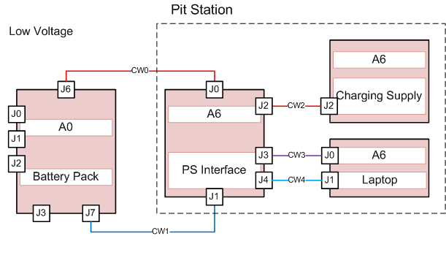
The Ports used by the charging circuit are:

Component Name | Port Label | Port Name
Battery Pack | J6 | Battery’s Power and Ground
Battery Pack | J7 | I2C Databus
PS Interface Board | J0 | Battery’s Power and Ground.
PS Interface Board | J1 | I2C Databus
PS Interface Board | J2 | Power Supply’s Power and Ground
PS Interface Board | J3 | Serial Data (USB) from BMS
PS Interface Board | J4 | Serial Data (USB) from Arduino
Charging Supply | J2 | Power Supply’s Power and Ground
Laptop | J0 | The USB port closest to the power supply port
Laptop | J1 | The USB port furthest from the power supply port
*Red mark indicates that the corresponding port is for a bus.

Wiring Instructions:
CW0: Charging Cable. 10 AWG.
CW1: I2C cable. 24 AWG.
CW2: Charging Cable. 10 AWG
CW3: USB cable provided by the I2C_To_PC adaptor
CW4: USB cable provided by Arduino Leonardo

- Start the Cell Charging Software. Please refer to the Software User Manual here.

Test
Attention: The test sequence does matter here. Previous Test need to be run before the next test starts.
Test Procedure | Passes if | Passed?
Launch the Charger Program | No pop-up window should be displayed | ✓
Launch the Charger Program | The number of cells displayed should be updated with the number of BMS boards | ✓
Click on the “Tools” in the menu bar, and hover over “BMS Port” and “Arduino Port” sub-menu | Under “BMS Port” submenu, the menu item has a port name displayed(i.e. anything other than “Unknown Port”) | ✓
 | Under “Arduino Port” submenu, the menu item has a valid port name displayed(i.e. anything other than “Unknown Port”) | ✓
Unplug the wire from Computer to I2C Adaptor  *Make sure to restart the program after this test is done since the port name may have changed | Warning Message displayed, indicating the communication to The BMS board is down | ✓
Unplug the wire from Computer to Arduino board.  *Make sure to restart the program after this test is done since the port name may have changed | Warning Message displayed, indicating the communication to The Arduino board is down | ✓
Check the displayed screen. | The number of cells displayed on the screens equals the actual amount of cells/BMS boards | ✓
After launching the cell charging software, don’t press the “Start Charging” button yet. Now observe the Relay LED in the Pit Station Interface Board, the System state on the screen, and the current reading on the screen | LED turns off | ✓
 | System State is “IDLE” | ✓
 | Current Reading should be 0A | ✓
Press the “Start Charging” button. Now the user should be prompted with the parameter confirmation page. Now Click on “Change Parameters”. In the “Parameter Setup” page, Repeated enter invalid values(i.e. 6V for Voltage Upper Threshold) for one or several fields and hit “Set Parameter” button | Warning Messages are always displayed | ✓
In the “Parameter Setup” page, enter a new set of parameter values. Now press the “Save Parameter to File” and enter the desired name to save | A “.txt” file was saved in the desired directory. | ✓
In the same “Parameter Setup” page, load an existing parameter file that has different parameter values than those that are already in the fields. To load a parameter file, click on the “Choose File” button. | If all the new values specified in the .txt file are loaded in the corresponding field | ✓
Adjust the power supply to output 20A (constant current). Press the “Set Parameter” button in the “Parameter Setup” page. | System State should now change to CHARGING. | ✓
 | Current Reading should no longer be 0A | ✓
 | “Start Charging” Button should now fade | ✓
Now click on “Stop” button | “Start Charging” button becomes available | ✓
Now click on “Stop” button | “Stop” button no longer available | ✓
Now click on “Stop” button | System state changed to “IDLE” | ✓
Now click on the “Start Charging” button. Wait until one cell’s status becomes “bypassed” | Check if the elapsed bypass time is counting up from 0 | ✓
Manually adjust the current to be larger than the upper threshold using the “Manual Setup” Window under the File menu. | System State should become “IDLE”
Manually adjust the voltage to be larger than the upper threshold using the “Manual Setup” Window under the File menu. | System State should become “IDLE”
Manually adjust the temperature to be larger than the upper threshold using the “Manual Setup” Window under the File menu. | System State should become “IDLE”
Manually adjust the temperature to be within upper threshold using the “Manual Setup” Window under the File menu. | System State should become “IDLE”
Click on “Generate Graph from last data set” button under “Graph” menu | A Charging Characteristic curve is displayed in a new window

