Starting with the problem defined by the author, we will explain how our loss function is designed. Following this, we will discuss how we use a sample, a small batch, to estimate this loss function, and finally, we will cover some of the results reported by the author.
We quickly go over the author's definition.
Intuition
Firstly, we have a random variable x, which is typically a high-dimensional random variable, such as an image. Associated with x, we have an unobserved or latent continuous random variable z, which usually has a much lower dimension than x. This z tends to provide a more essential description, containing the information to describe xxx. We assume that z follows a distribution parameterized by θ. The variable x is a conditional probability, meaning that given zzz, we can sample and generate xxx. By using a latent variable along with our parameter θ, we can generate a sample, and given a sample, combined with the parameter ϕ in our encoder, we can attempt to infer z.
If we have x and want to obtain z through some method, and likewise, if we have z and want to get the corresponding x through this method, achieving this bidirectional transformation is our goal. However, directly estimating this method is infeasible. We know that to obtain z given x using Bayes' theorem, we need the distribution of x given z, the distribution of z, and the distribution of x. But, we do not know z, and the distribution of x is also unknown. Specifically, the distribution of x is the integral of the product of the distribution of z and the distribution of x given z over all z. In reality, both x and z are high-dimensional, and expressing this strictly requires many integrals. Therefore, the distribution of x is intractable, making it impossible to find the latent representation z from x. To estimate the process of obtaining z given x, we use a neural network to approximate this probability distribution. Originally, the process from x to z is related to the parameter θ, but now we use another model parameterized by ϕ. With the help of parameter ϕ, we have a distribution q that we hope closely approximates p. This allows us to estimate z from x. To measure the similarity between these two distributions, we naturally think of the KL divergence.
Loss function
Since we can only compute the distribution q, we start from the perspective of q and calculate the KL divergence from q to p. By definition, we expand the KL divergence, summing or integrating over z. Upon simplification, we find a term log⁡(pθ(x)) that is independent of z. Thus, when multiplying this log term by q and summing, since the log term is a constant, we can place it outside the summation symbol. The result of summing qϕ(z∣x) over z is 1, combining these terms into log⁡(pθ(x)) on the right side of the equation. Thus, we derive the following formula.
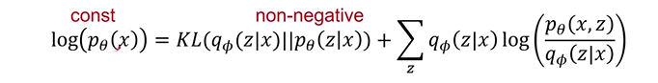
Since the KL divergence is a non-negative value, we only need to maximize the right-hand term, which will consequently minimize the KL divergence on the left-hand side. This right-hand term is referred to as the variational lower bound.
Now, we just need to find a way to maximize this lower bound. This lower bound can then serve as our loss function.
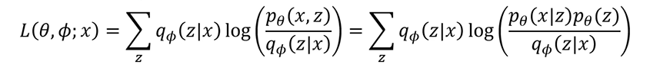
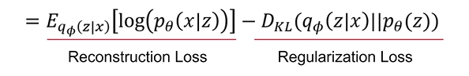
By simplifying, we can express the right-hand side in terms of an expectation, which is actually a KL divergence. To optimize our lower bound, we need to maximize these two terms or estimate their gradients. How should we interpret these two terms?
The left-hand term represents the probability that, given z, the latent representation yields an x that equals our input x. In other words, we want the x derived from z to be as close as possible to the input x, thereby increasing this probability. From the perspective of an autoencoder, this is known as the reconstruction loss.
The right-hand term is a KL divergence, which aims to push qϕ(z∣x) towards pθ(z). This means we want the distribution of our latent representation z to be close to our assumed prior distribution of z. This acts as a regularization loss.
Next, we need to find the derivatives of these two losses to optimize and improve our lower bound. To do this, we will use the Monte Carlo method.
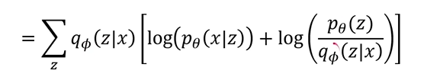
Assuming f(z) inside the brackets, even though there is a ϕ present, we assume that f(z) is independent of ϕ. The expectation of f(z) with respect to q ϕ, when differentiated with respect to ϕ, has the following form:
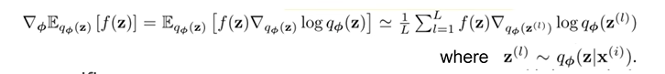
The derivative of log⁡qϕ multiplied by f(z), with the expectation taken over the entire term. When estimating this expectation, we sample a few values, calculate these values, and then take the average as an approximation of the expectation.

Gradient Estimation
However, using such an estimator has a very high variance, which can intuitively lead to unstable training. On this basis, the author proposed the generic stochastic gradient variational Bayes and used the reparameterization trick.
Returning to our Monte Carlo method, we made a strong assumption that f(z) is entirely independent of ϕ. In reality, since qϕappears in the expression, this term is evidently related to ϕ. Therefore, we need to differentiate the entire expression with respect to ϕ
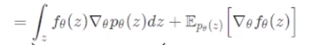
We can see that the latter term is familiar and can be written as an expectation, but the former term cannot be handled this way. This reveals why we cannot directly differentiate f(z) during actual training.
Here, the author uses the reparameterization trick. The core idea is to introduce an auxiliary random variable that is independent of θ, ϕ, x, and z. This auxiliary random variable captures all the randomness in the process of generating zzz, the latent representation. Thus, we can express z as gθ(ϵ,x), transferring the probability distribution from pθ(z) to p(ϵ). The key property of ϵ is that it is independent of ϕ. This trick is known as the reparameterization trick. With the new expression, we can differentiate again, allowing us to estimate the gradient of the loss function.
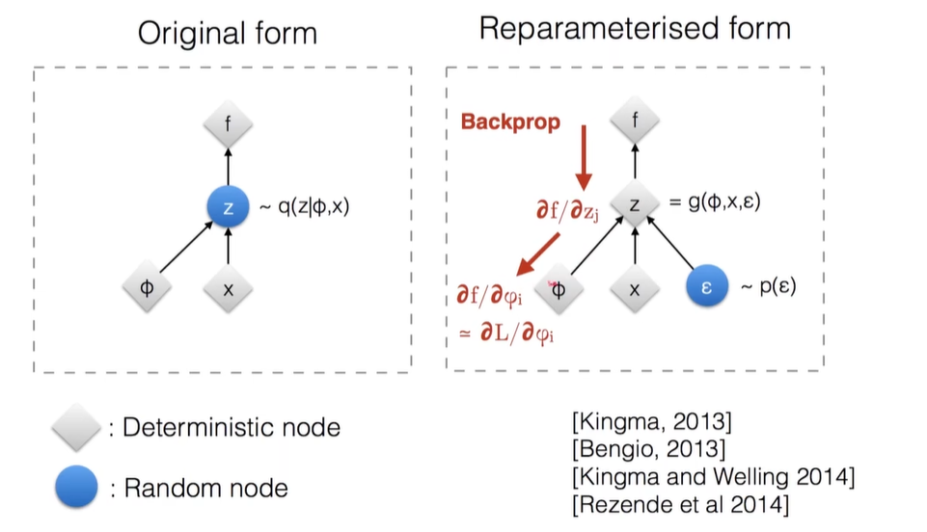
The author provides a more intuitive explanation. In the original form, we use ϕ and x to generate a distribution q and then sample z from this distribution, eventually obtaining f. However, during backpropagation, we cannot pass the gradient through the sampling process. With the reparameterization trick, the randomness is shifted to ϵ. All the randomness in the sampling process is now encapsulated in ϵ. This allows the gradient to be smoothly propagated back through zzz to the parameters ϕ. This is a very clever method.
Returning to our SGVB (Stochastic Gradient Variational Bayes) framework, using the reparameterization trick, ϵ\epsilonϵ is sampled from the distribution, an independent random variable unrelated to θand ϕ. Consequently, our loss function transforms into this new form.
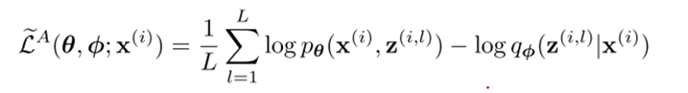
We can directly differentiate the right-hand part with respect to ϕ. This is the first method proposed by the author for estimating the gradient. Building on this, the author also discovered that we can leverage some advantageous properties. Our loss can be written in the form of KL divergence and expectation. The KL divergence has some very useful properties.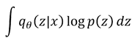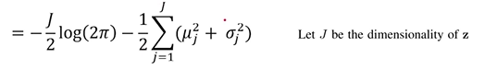
By simplifying, we can derive this equation.
So, the above is the final SGVB method we use. The author, by leveraging the properties of KL divergence and an approximation of the reconstruction loss, provides a relatively stable way to estimate this loss and its gradient.
In summary, our autoencoder model works as follows: we input an x into the encoder, which is determined by the parameter ϕ. The encoder produces a μand a σ. The μand σare used to calculate the KL divergence, and also to sample a z, with the help of ϵ to introduce randomness. This z is then fed into the decoder, which is determined by the parameter θ. After passing through the decoder, we reconstruct an x. We compare the reconstructed x with the original input x, and their mean squared error (MSE) forms another part of our loss. The total loss is the sum of these two losses. This is our classic vanilla variational autoencoder.

