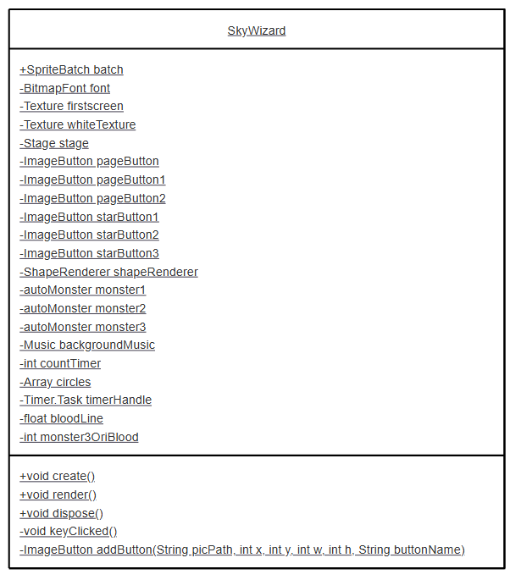

https://www.mermaidchart.com/app/projects/a9b7a3db-cd85-453e-a1b5-41f51a3ee510/diagrams/b1c56632-feb8-4471-bbde-5d4ac060fba7/version/v0.1/edit

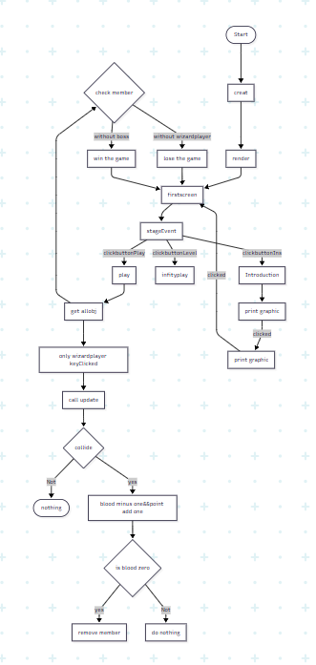

https://www.mermaidchart.com/app/projects/a9b7a3db-cd85-453e-a1b5-41f51a3ee510/diagrams/5be57123-35c6-4f08-8d47-7e950e4266dd/version/v0.1/edit

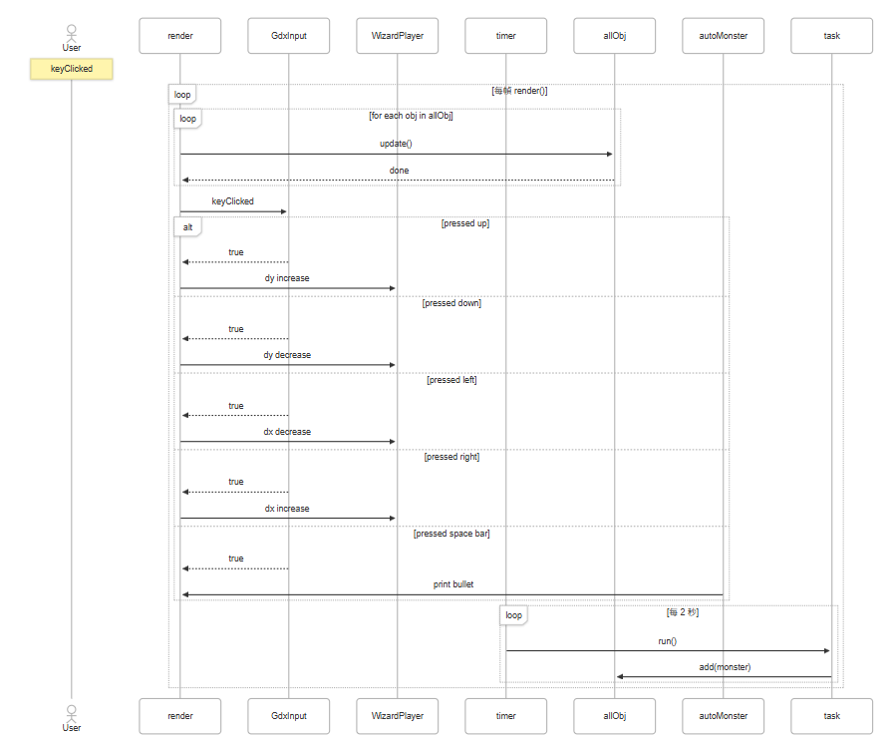

流程圖

---

config:

      theme: redux

---

**flowchart** TD

        A(["Start"])

        A **-->** B["creat"]

        B **-->** C["render"]

        C**-->**10["firstscreen"]

        10 **-->** D["stageEvent"]

        D **--** clickbuttonPlay **-->** E["play"]

        D **--** clickbuttonIns **-->** F["Introduction"]

        D **--** clickbuttonLevel **-->**G["infityplay"]

        E **-->** H["get allobj"]

        H **-->**i["only wizardplayer keyClicked"]

        i  **-->**1["call update"]

        1 **-->**2{"collide"}

        2**--**yes**-->**22["blood minus one&&point add one"]

        22**-->**23{"is blood zero"}

        23**--**yes**-->**24["remove member"]

        23**--**Not**-->**25["do nothing"]

        2**--**Not**-->**4(["nothing"])

        H **-->**6{"check member"}

        6**--**without wizardplayer**-->**7["lose the game"]

        6**--**without boss**-->**8["win the game"]

        7**-->**10

        8**-->**10

        F**-->**f1["print graphic"]

        f1**--** clicked**-->**f2["print graphic"]

        f2**--** clicked**-->**10

**sequenceDiagram**

**actor User**

**participant render**

**participant GdxInput**

**participant WizardPlayer**

**participant timer**

**participant allObj**

**participant autoMonster**

**Note over User: keyClicked**

**loop 每幀 render()**

**loop for each obj in allObj**

**render->>allObj: update()**

**allObj-->>render: done**

**end**

**render->>GdxInput: keyClicked**

**alt pressed up**

**GdxInput-->>render: true**

**render->>WizardPlayer: dy increase**

**else pressed down**

**GdxInput-->>render: true**

**render->>WizardPlayer: dy decrease**

**else pressed left**

**GdxInput-->>render: true**

**render->>WizardPlayer: dx decrease**

**else pressed right**

**GdxInput-->>render: true**

**render->>WizardPlayer: dx increase**

**else pressed space bar**

**GdxInput-->>render: true**

**autoMonster->>render: print bullet**

**end**

**loop 每 2 秒**

**timer->>task: run()**

**task->>allObj: add(monster)**

**end**

**end**