a) printPrimes()的控制流图

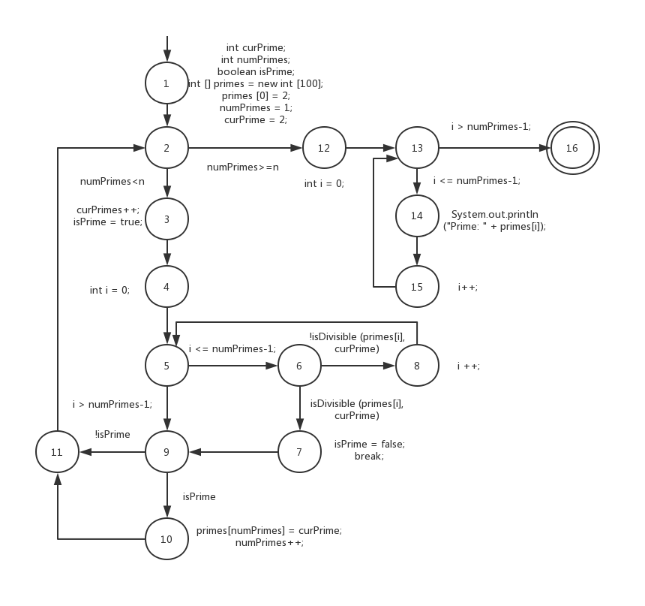

b) 将节点1的 int [] primes = new int [100]; 修改为 int [] primes = new int [4];此时，t2会发现故障，而t1不会。

c) 当 n=1或2时，不满足numPrimes < n，故不经过while循环

d) 节点覆盖：1,2,3,4,5,6,7,8,9,10,11,12,13,14,15,16

边覆盖：

(1,2),(2,3),(2,12),(3,4),(4,5),(5,6),(5,9),(6,7),(6,8),(7,9),(8,5),(9,11),(9,10),(10,11),(11,2),(12,13),(13,14),(13,16),(14,15),(15,13)

主路径覆盖：

(1,2,3,4,5,6,8),(1,2,3,4,5,6,7,9,10,11),(1,2,3,4,5,6,7,9,11),(1,2,3,4,5,9,10,11),(1,2,3,4,5,9,11),(1,2,12,13,14,15),(1,2,12,13,16)

(2,3,4,5,6,8),(2,3,4,5,6,7,9,10,11,2),(2,3,4,5,6,7,9,11,2),(2,3,4,5,9,10,11,2),(2,3,4,5,9,11,2),(2,12,13,14,15),(2,12,13,16)

(3,4,5,6,8),(3,4,5,6,7,9,10,11,2,3),(3,4,5,6,7,9,11,2,3),(3,4,5,9,10,11,2,3),(3,4,5,9,11,2,3)

(4,5,6,8),(4,5,6,7,9,10,11,2,3,4),(4,5,6,7,9,11,2,3,4),(4,5,9,10,11,2,3,4),(4,5,9,11,2,3,4)

(5,6,8,5),(5,6,7,9,10,11,2,3,4,5),(5,6,7,9,11,2,3,4,5),(5,9,10,11,2,3,4,5),(5,9,11,2,3,4,5)

(6,8,5,6),(6,7,9,10,11,2,3,4,5,6),(6,7,9,11,2,3,4,5,6)

(7,9,10,11,2,3,4,5,6,7),(7,9,11,2,3,4,5,6,7)

(8,5,6,8)

(9,10,11,2,3,4,5,6,7,9),(9,11,2,3,4,5,6,7,9),(9,10,11,2,3,4,5,9),(9,11,2,3,4,5,9)

(10,11,2,3,4,5,6,7,9,10),(10,11,2,3,4,5,6,7,9,10)

(11,2,3,4,5,6,7,9,10,11),(11,2,3,4,5,6,7,9,11),(11,2,3,4,5,9,10,11),(11,2,3,4,5,9,11)

(12,13,14,15),(12,13,16)

(13,14,15,13),(13,16)

(14,15,13,14),(14,15,13,16)

(15,13,14,15),(15,13,16)

e) (1,2,3,4,5,6,8,5,6,7,9,10,11,2,12,13,14,15,13,16)

f) (1,2,3,4,5,6,8,5,6,7,9,10,11,2,3,4,5,9,11,2,12,13,14,15,13,16)

设计测试用例：

