
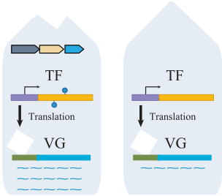
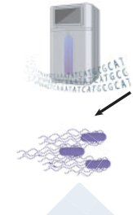
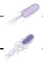
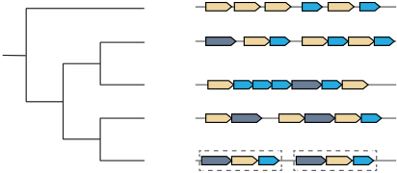
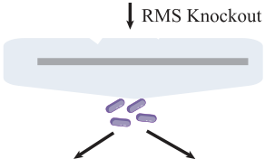
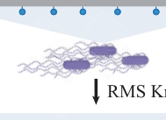
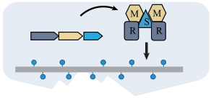
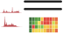


gkaf659
Genomics



HorizontalacquisitionoftheTypeIrestriction–modification
systemenhancesbacterialpathogenicitybymediating
methylationoftranscriptionfactor-encodinggenes
JiayueMa1,†,XiaoliJiang2,†,HaixinBi1,†,JuanjuanLi1,XiangMa1,XueChi1,YanqiongTang1,
ZhuLiu2,*,HongLi | 1,*
1SchoolofLifeandHealthSciences,HainanProvinceKeyLaboratoryofOneHealth,CollaborativeInnovationCenterofLifeandHealth, HainanUniversity,Haikou,Hainan570228,China
2FacultyofAnimalScienceandTechnology,KeyLaboratoryofAnimalNutritionandFeedScienceofYunnanProvince,YunnanAgricultural University,Kunming,Yunnan650201,China
*Towhomcorrespondenceshouldbeaddressed.Email:lihongbio@hainanu.edu.cn CorrespondencemayalsobeaddressedtoZhuLiu.Email:zhuliu@ynau.edu.cn†ThefirstthreeauthorsshouldberegardedasJointFirstAuthors.
Abstract
TheTypeIrestriction–modification(RM)system,encodedbythehsdR,hsdM,andhsdSgenes,playsacrucialroleinshapingtheprokaryoticDNA methylationlandscape.AlthoughknownfordefendingagainstforeignDNA,keyaspectsofitsevolutionarytrajectoryandfunctionalimplications afterstableinheritanceremainpoorlyunderstood.Inthisstudy,weidentifiedfourprimarytypesofTypeIRMsystemsacross4273prokaryotic genomesbasedongenearrangement.Amongthese,the5′-hsdR,hsdM,hsdS-3′(RMS)configurationemergedasthemostevolutionarily advancedform.PhylogeneticreconstructionrevealedthatRMSwasformedthroughgeneduplication,horizontalgenetransfer,andgeneloss, anditnowstablyexistsinbacteria.FunctionalcharacterizationdemonstratedthatRMSdeletioninbacterialedtotheabsenceofflagellaanda significantreductionintheirabilitytocolonizeandinfectmice.Integratedmulti-omicsanalysisuncoveredapotentialregulatorycascadewhere RMSmodulatestheexpressionoftranscriptionfactorsviaDNAmethylation,whichinturnregulatedownstreamflagellarandchemotaxisgenes, therebyinfluencingbacterialpathogenicity.Thesefindingsestablishacompleteevolutionary–functionalparadigm,elucidatinghow(evolutionary trajectory)andwhy(functionalconstraints)RMShasbeenstablyinheritedinbacterialgenomes,andrevealingthemolecularmechanismthrough whichRMSorchestratesbacterialpathogenicity.
Graphicalabstract
 |  |  |  | 
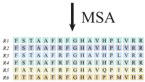


  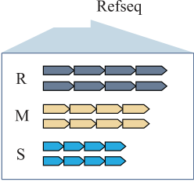 | 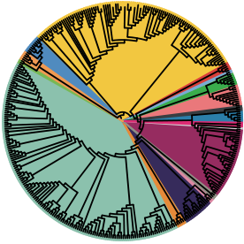 |  |  | 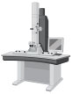 | 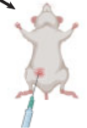
Introduction |  |  |  | (A)toformN4-methylcytosine(4mC),C5-methylcytosine

DNAmethylationisacommonepigenomemodificationin prokaryotes.Inasurveyofthegenomesof230prokaryotes, over90%werefoundtocontainmethylatedsites[1].DNA methylationoccursonthebasesofcytosine(C)andadenine

(5mC),andN6-methyladenine(6mA)inprokaryotes[2]. ThesemodificationsnotonlyprotecttheDNAfrom cleavagebyendonuclease,butalsoplaykeyrolesinnucleoid organization,cellcyclecontrol,DNArepair,andregulationof

Received:February25,2025.Revised:June20,2025.EditorialDecision:June20,2025.Accepted:June24,2025© TheAuthor(s)2025.PublishedbyOxfordUniversityPressonbehalfofNucleicAcidsResearch.
ThisisanOpenAccessarticledistributedunderthetermsoftheCreativeCommonsAttribution-NonCommercialLicense
(https://creativecommons.org/licenses/by-nc/4.0/),whichpermitsnon-commercialre-use,distribution,andreproductioninanymedium,providedthe originalworkisproperlycited.Forcommercialre-use,pleasecontactreprints@oup.comforreprintsandtranslationrightsforreprints.Allother permissionscanbeobtainedthroughourRightsLinkserviceviathePermissionslinkonthearticlepageonoursite—forfurtherinformationpleasecontact journals.permissions@oup.com.

2 Maetal.

transcription[3].Formanyyears,DNAmethylationwas thoughttopredominantlyoccurinpromoterregions,where itactedasarepressiveepigeneticmarktodownregulategene expression.However,morerecentstudieshaverevealedthat DNAmethylationismoreprevalentwithingenebodiesthan inpromoters.Inparticular,intragenicmethylationmayplay anactiveroleinmodulatinggeneexpression[4–6].
Therestriction–modification(RM)system,referredtoas theinnateimmunesysteminprokaryotes,protectsthehost’s DNAbymethylatingitsownsequences,whilerestrictingthe invasionofunmethylatedforeignDNAsuchasphages[7]. RMsystemsareclassifiedintofourtypes(I–IV)basedontheir subunitcomposition,cofactorrequirement,sequencerecogni-tion,andcleavagepattern,withtheTypeIRMsystembe-ingthefirsttobediscovered[8,9].TheTypeIRMsys-temisencodedbythreehsdgenes:hsdR,hsdM,andhsdS. HsdSspecificallyrecognizestheDNAsequence,HsdMbinds S-adenosylmethionine(AdoMet)tocatalyzemethylationof bases,andHsdRtranslocatesDNAinanATP-dependentpro-cessandcleavesunmethylatedDNA[10].IncanonicalType IRMsystem,hsdMandhsdSshareacommonpromoter, whilehsdRisdrivenbyaseparatepromoter.Thesegenes aretypicallyarrangedinthegenomeintheorderof5′-hsdR, hsdM,hsdS-3′(RMS)[8].However,recentstudieshaveidenti-fiedalternativearrangementofTypeIRMsystemsincertain species.Forinstance,inPseudomonasaeruginosa,thegenes areorganizedintheorderof5′-hsdR,hsdS,hsdM-3′(RSM) [11].Additionally,5′-hsdM,hsdS-3′(MS)canfunctionincon-junctionwithhsdR,evenwhenlocatedatdistantregionsof thegenome[12].Despitetheseinsights,thedistributionand diversityofTypeIRMsystemsacrossprokaryotesremain unexplored.
Horizontalgenetransfer(HGT)isakeyprocessinmi-crobialevolutionandecology.Itenablestherapidspreadof geneticmaterialacrossdifferentspecies,contributingtoge-neticdiversity,theacquisitionofnewtraits,andadaptation toenvironmentalchanges[13].Currentevolutionarymodels proposethatTypeIRMsystemsfirstemergedinprokary-otesasprimitivedefensemechanismsduringearlyhost-phage coevolution[14].Subsequently,underconditionsoflowse-lectionpressure,hostsmaybenefitfromeliminatingthese energy-costlyTypeIRMsystemsviaHGT-mediatedgenetic exchange,therebyreducingtheirmetabolicburden.Thisphe-nomenonalsohighlightstheirroleasapan-immunesystem [15,16].ThroughHGT,neighboringstrainscantransiently acquireTypeIRMsystems,enablingrapidadaptationtodi-versephagechallenges.However,acomprehensivestudyon theoriginandevolutionaryhistoryofTypeIRMsystemsis stilllacking.InadditiontodefendingagainstforeignDNA invasion,recentstudieshaveshownthattheTypeIRMsys-temcanalsoinfluencebacterialvirulence.WhentheTypeI RMsystem(RSM)ofP.aeruginosaisknockedout,92genes aredifferentiallyexpressed,andtheRSMstrainexhibitsa marginallybutsignificantlyreductioninvirulencecompared tothewild-type(WT)strain[11].Similarly,inStreptococ-cuspyogenes,20genesaresignificantlydownregulatedinthe RSMstrainrelativetotheWTstrain.Miceinfectedwith theRSMstrainexhibitanenhancedhostimmuneresponse, characterizedbylargerskinlesions,andelevatedlevelsofpro-inflammatorycytokines[17].However,theregulatorymech-anismremainsunclear,particularlyregardingthebiological processesandmechanismscontrolledbythecanonicalTypeI RMsystem(RMS).

Inthisstudy,wesystematicallyinvestigated(i)thephylo-geneticdistributionpatternsoffourdistinctTypeIRMsys-temsacrossprokaryotes,identifyingkeyecologicalandge-ographicalfactorsinfluencingtheirprevalence;(ii)theevo-lutionarytrajectoryofRMS,whichmayemergeasthege-nomicallystabilizedendproductofsuccessivegeneduplica-tion,HGT,andgenelossevents;and(iii)thefunctionalcon-sequencesofRMSmaintenance,particularlyitsmethylation-dependentregulationofbacterialpathogenicityfollowingge-nomicfixation.Throughtheseanalyses,webridgeevolution-arydynamicswithphenotypicoutcomes,andprovidenovel insightsintothemolecularmechanismbywhichRMSregu-latesbacterialpathogenicity.
Materialsandmethods
IdentificationofTypeIRMsystemsandprophages
TheproteinsequencesofhsdR,hsdM,andhsdSwereex-tractedfromtheprotein_gold_seqsfilestoredintheRE-BASEdatabase[18].Redundantsequenceswereremovedus-ingMMseq2[19]witha30%sequenceidentitythreshold. Multiplesequencealignments(MSAs)wereperformedusing MAFFT[20],andhiddenMarkovmodels(HMMs)werecon-structedusinghmmbuildfromHMMER[21].Completelyas-sembledreferencegenomesequences,proteinsequences,and geneannotationsfor4019bacteriaand254archaeawere downloadedfromtheNCBIReferenceSequence(RefSeq) databaseusingNCBIDatasets[22,23].ThehsdR,hsdM,and hsdSwereidentifiedinthesespeciesbysequencealignments againsttheHMMsusinghmmsearchfromHMMERwitha thresholdofe<1×10–10.TheTypeIRMsystem,arranged intheorderofhsdR,hsdM,andhsdSonthegenomewith-outanyinterveninggenes,wasreferredtoasRMS.TheType IRMsysteminwhichhsdRandhsdMwereseparatedby nomorethanfivegenes,whilehsdMandhsdSwereclosely connected,wasdesignedasR-MS.Similarly,RSMandR-SM werealsodefined.Completelyassembledgenomesequences, proteinsequences,andgeneannotationsfor41Aeromonas veroniistrainsweredownloadedfromtheRefSeqdatabase usingNCBIDatasets[22,23].ThehsdR,hsdM,hsdSgenes, alongwithvariousconfigurationsofTypeIRMsystems, wereidentifiedinthesestrains.Prophagesweredetectedfrom genomesequencesusingVIBRANT[24].Wesystematically enumeratedallfourconfigurations(RMS,R-MS,RSM,R-SM)ofTypeIRMsystemswithineachbacterialandarchaeal phylum.Thefrequencyofeachconfigurationwasthencal-culatedasthemeannumberofsystemsperspecieswithin eachphylum,usingthefollowingformula:frequency=(total countofconfigurationXinphylumY)/(numberofspeciesin phylumY).
Constructionofphylogenetictrees
Atotalof120bacterialand53archaealmarkergeneswere identifiedfrom4019bacterialand254archaealgenomes,re-spectively,andsubsequentlyalignedandconcatenatedusing GTDB-Tk[25].Thephylogenetictreeatthephylumlevel wasconstructedusingtheWAGmodelofaminoacidevolu-tioninFastTree[26].Single-copygeneswereextractedfrom A.veroniistrainsusingOrthoFinder[27],andMSAswere performedusingMUSCLE[28].Thealignmentresultswere processedwithTRIMAL[29]forautomatictrimmingusing theautomated1parameter,andsubsequentlyusedtocon-

HGT-acquiredTypeIR-MsystempromotesvirulenceviaTFmethylation 3

structthephylogenetictreeofA.veroniistrainsusingIQ-TREE[30].SpeciescontainingRMS,aswellasthehsdR, hsdM,andhsdSgenesthatmadeupRMS,wereextracted usingaPerlscript.Similarly,120bacterialand53archaeal markergeneswereextractedfromthesespecies,andsubse-quentlyalignedandconcatenatedusingGTDB-Tk[25].Ho-mologoussequencesofHsdR,HsdM,andHsdSwerealigned usingMAFFT[20].Thebest-fitmodelsweredetermined,and phylogenetictreeswereconstructedforthespeciescontain-ingRMSaswellasthehsdR,hsdM,andhsdSgenesusing IQ-TREE[30].Allphylogenetictreeswerevisualizedusing iTOL[31],andtheirreliabilitieswereevaluatedusing1000 bootstraps.
EvolutionaryinferenceofhsdR,hsdM,andhsdS
ThecoreprogramOptRootinRANGER-DTL2.0[32]was usedtooptimallyrootthephylogenetictreesofhsdR,hsdM,

mentedstrainRMS/pRMSwasgeneratedbyconjugating A.veroniiRMSwithE.coliWM3064carryingthepRMS plasmid.Selectionwascarriedoutonsolidmediumcontaining bothampicillinandkanamycin,andtheRMS/pRMSstrain wasconfirmedbycolonyPCR.
Bacterialmorphologyobservation
SinglecoloniesofA.veroniiC4WTandRMSstrainswere pickedandculturedinLBliquidmedium.Aftershakingin-cubationat30◦Cfor12h,theculturesweresubculturedinto freshLBmediumata1%inoculationrate.Followinganaddi-tional6hofincubation,107cellswerecollected,centrifuged at6000rpmfor3min,andwashedtwicewithphosphate bufferedsaline.Thebacterialpelletswerethenresuspended in1mlPBS,and10μlwasplacedonacoppergridand allowedtoairdry.Flagellarmorphologywassubsequently observedunderatransmissionelectronmicroscope(TEM,

andhsdS.Eachrootedgenetreewascomparedagainstthe HT7700).
speciestreetocomputereconciliationsusingthecoreprogram

Ranger-DTL.Foreachgene,1000reconciliationsweregen-eratedwithdifferentrandomseeds,andsubsequentlyinput intothecoreprogramAggregateRangertocomputesupport values.AgeneduplicationorHGTeventwasconsideredsup-portedonlyifthesupportvaluewas>50%.
ConstructionofRMSstrain
TheRMSknockout(RMS)straininA.veroniiC4was Bhomologousrecombinationmethod ()[33].Theupstreamanddownstream fragmentsofhsdR,hsdM,andhsdSwereamplifiedbypoly-cideplasmidpRE112[34]usingtheClonExpressIIOne StepCloningKit(Vazyme,China).Therecombinantplasmids withthecorrectsequences,namedpRE112-hsdR(contain-ingtheupstreamanddownstreamhomologyarmsofhsdR), pRE112-hsdM(containingtheupstreamanddownstream homologyarmsofhsdM),andpRE112-hsdS(containing theupstreamanddownstreamhomologyarmsofhsdS),were transferredintoEscherichiacoliWM3064competentcells viaelectroporation.E.coliWM3064isadiaminopimelic acid(DAP)-auxotrophicstrain(genotype:dapA::erm)de-rivedfromE.coliβ2155,whichservesasanefficientcon-jugationdonorforGram-negativebacteria.pRE112-hsdR wasthenconjugatedintoA.veroniiC4byconjugativetrans-ferandselectedonLBsolidplatescontaining22%sucrose andampicilliconfirmedusingspe-cificprimers().pRE112-hsdMwas conjugatedintothehsdRstrain,andpRE112-hsdSwas conjugatedintothehsdRMstrain,resultingintheRMS strain.
ConstructionofRMS/pRMSstrain
ThehsdRMSgeneclusterwasamplifiedbyPCRusingthe A.veroniiC4genomeasthetemplate.Thefull-lengthhs-dRMSDNAfragmentwastheninsertedintothelinearized pBBRvector(digestedwithKpnIandEcoRI)usingtheOne StepCloneExpresskit(Vazyme,China).TheresultingpBBR-hsdRMS(pRMS)plasmidwassubsequentlytransformedinto E.coliWM3064competentcellsviaheatshock.Thecomple-

Invivocolonizationandpathologicalassessment
Fifteenfour-week-oldmaleKunmingmicewerepurchased fromHainanPharmacologyResearchCenteranddividedinto threegroups.Onegroupservedasacontrol,whiletheother twogroupswereintraperitoneallyinjectedwithA.veroniiC4 WTandRMSstrainsatadoseof105CFU/gofbodyweight, respectively.After8hofinfection,themicewereeuthanized bycervicaldislocation.Hearts,livers,spleens,lungs,andkid-neysweredissectedanddividedintotwoparts.Onepart wasfixedwith4%paraformaldehydefor24h,thensentto WuhanServicebioTechnologyCo.,Ltdforformalinfixation andparaffinembedding,followedbyhematoxylinandeosin (H&E)staining.Thesampleswereimagedusingamicroscope (Servicebio,China).Theotherpartwashomogenizedwith1 mlof1×PBSusingatissuegrinderat2000rpmfor3min. Thesupernatantwasthenplatedontoagarplatescontaining ampicillinandincubatedat30◦Cfor24h.Colonycountswere determined,anddifferenceswereassessedusingANOVA.All theanimalexperimentswereapprovedandconductedincom-pliancewiththeethicalguidelinesandrecommendationses-tablishedbytheethicalcommitteeoftheHainanUniversity (approvalnumberHNUAUCC-2024-00082).
Transcriptomesequencingandanalysis
SinglecoloniesofA.veroniiC4WTandRMSstrainswere pickedandculturedinLBliquidmediumat30◦Cfor16h. Thecellswerethencollectedandstoredat−80◦Cfortran-scriptomeandDNAmethylationsequencing.TotalRNAwas extractedusingtheTRIzolreagent(Invitrogen,USA),andwas subsequentlyanalyzedandquantifiedusinganAgilent2100 Bioanalyzer(Agilent,USA).DNAprobewasdesignedtobe complementarytoaspecificregionofribosomalRNA.RNase HwasusedtodigesttheRNAstrandofDNA/RNAhybrid, whiletheremainingDNAprobewasdigestedbyDNaseI. ThepurifiedRNAwasthenfragmented.First-strandcomple-mentaryDNA(cDNA)wasgeneratedusingrandomhexamer-primedreversetranscription,followedbyasecond-strand cDNAsynthesis.Thesynthesizeddouble-strandedcDNAwas subjecttoendrepair,A-tailing,andadaptorligation.There-sultinglibrarywasamplifiedbyPCRandsubsequentlyse-quencedontheBeijingGenomicsInstituteDNBSEQplatform. ThesequencingdatawerefilteredusingSOAPnuke[35],with thefollowingsteps:(i)removalofreadscontainingadapter;

4 Maetal.

(ii)removalofreadswith>20%low-qualitybases(basequal-ity≤15);and(iii)removalofreadswith>5%unknown base("N"base).Afterward,cleanreadswereobtainedand mappedtothereferencegenomeusingHISAT2[36].Gene

Relativegeneexpressionlevelswerecalculatedusingthe 2−Ctmethod,withgyrBasthereferencegene.Theexpres-
siondifferenceswereassessedusingANOVA.

expressionlevelswerequantifiedusingRSEM[37].Differen-tiallyexpressedgenes(DEGs)wereidentifiedusingDESeq2 | Results

[38]withacorrectedP-value≤0.05.Allgeneswereanno-tatedbysequencealignmentagainsttheKyotoEncyclopedia ofGenesandGenomes(KEGG)[39]database.KEGGenrich-mentanalysisofDEGswasperformedusingthephyperfunc-tioninR,withacorrectedP-value≤0.05.
DNAmethylationsequencingandanalysis
GenomicDNAwasextractedfromA.veroniiC4WTand RMSstrainsusingtheFastPureBacteriaDNAIsolation MiniKit(Vazyme,China).AfterfragmentationwiththeCo-varisg-TUBE,theSMRTbellPrepKit3.0(PacificBiosciences) wasusedforlibraryconstructionaccordingtothemanu-facturer’sinstructions.Theprocedureinvolvesthefollow-ingsteps:(i)repairandA-tailing:repairingsitesofDNA damageandpreparingtheshearedDNAforligationto theSMRTbelladapter;(ii)adapterligationandcleanup: ligatingtheSMRTbelladaptertotheendsofeachDNA fragment;(iii)nucleasetreatment:removingunligatedDNA fragmentsandleftoverSMRTbelladapterfromthesam-ple;and(iv)sizeselection:selectingfragmentswithinthe optimal10–20kbrange.Thefinallibrarywasquality-checkedusinganAgilent2100Bioanalyzer(Agilent,USA) beforebeingsequencedonthePacBioRSIIplatformat WuhanIGENEBOOKBiotechnologyCo.,Ltd.Thesequenc-bax2bam,andanindexofthereferencegenomewasbuiltus-ingSamtools;(ii)bamformatdatawerefilteredandaligned tothereferencegenomeusingPbalign;(iii)6mAsiteswith >25-foldcoveragewereidentifiedusingipdSummary,and

DistributionofTypeIRMsystemsinprokaryotesis diverse
ThehsdR,hsdM,andhsdSgeneswereidentifiedinprokary-otes,including4019bacterialand254archaealspecies (Fig.1A).ThenumberanddistributionofhsdR,hsdM, considerablyamongthesespecies ().Specifically,64.6%,75.5%,and 60.2%ofthespeciescontainedthehsdR,hsdM,andhsdS genes,respectively(Fig.1A).Onaverage,eachspecieshar-bored1.8hsdRgenes,2.3hsdMgenes,and2hsdSgenes(Fig. 1A),suggestingthatthesegeneshaveundergonereplicationor HGT.FourmaintypesofTypeIRMsystemswereidentified inthesespecies:RMS,RSM,R-MS(where"-"indicatesthe presenceofnomorethanfiveinsertedgenesbetweenhsdR andhsdMS),andR-SM(Fig.1B).
ComparedtoR-MS,whichcontainedgeneinsertions,RMS wasmoreprevalentinbacteria(Fig.1C).Similarly,RSMwas morecommonthanR-SMinbacteria(Fig.1C),whilear-chaeashowedoppositetrendswithR-MS/R-SMpredomi-nance(Fig.1C).Foramoredetailedanalysis,thefrequen-ciesofthefourconfigurationsofTypeIRMsystemswere calculatedacrossdifferentphyla(Fig.1D).Amongbacteria, RMSwaspredominantlyfoundinspeciesofFusobacteri-otaandDesulfobacteriota,withanaverageofover0.2RMS perspecies.R-MSwasrarelydetectedinspeciesfromany phylum.RSMwasmostprevalentinspeciesofFirmicutes, Actinobacteriota,Planctomycetota,andMyxococcota(>0.2 systems/species).R-SMwasmorecommonlyfoundinspecies ofCampylobacterota,Planctomycetota,andDesulfobacterota (>0.2systems/species)(Fig.1D).Incontrast,archaealphyla uniformlyexhibitedlowfrequenciesofallfourconfigura-tions,withnonesurpassing0.2systemsperspeciesinanylin-

20basesfromtheirupstreamanddownstreamsequences eage(Fig.1D).

wereextrdMo-tifMaker().The motifthatdifferedbetweentheWTandRMSstrainswas theonerecognizedandmethylatedbyRMS.TF-encoding genescontainingtheRMStargetsiteswereextracted,and theirregulatorysiteswereobtainedfromtheRegPrecise database[40].ForeachTF,sites2memefromMEMEwas usedtoconvertitsregulatorysitefilesintoaMEME motif[41].Genome-widemotifscanningwasperformed againsttheA.veroniiC4genomeusingMAST[11].Puta-tiveTF–targetinteractionsweredefinedwhenmotifmatches werefoundwithin150bpupstreamoftranscriptionstart

Notably,despitetherelativelyhighnumberofindi-sdM,andhsdSinCyanobacteria (),noneofthefourconfigurationsof TypeIRMsystemswerecommonlyobservedwithinthisphy-lum(Fig.1D).Thissuggestedthat,inCyanobacteria,these genestendedtobescatteree,rather thanformingagenecluster().Incon-RSM().Furthermore,weexamined

sites. thefrequencyofprophagesinspeciescontainingTypeIRM
systemsandfoundapositivecorrelationbetweenRMSand

RT-qPCR
TotalRNAwasextractedfromA.veroniiC4WTandRMS strainsusingtheTRIzolreagent(Invitrogen,USA).Reverse transcriptionwasperformedinduplicateusingthePrime ScriptRTKit(Vazyme,China),followedbyqPCRusingthe SYBRPremixExTaqIIkit(Vazyme,China)onaLightCy-clerSystem(Roche,USA).PrimersforReverseTranscription QuantitativePCR(RT-qPCR)werBiotechCo.,Ltdandarelistedin.

prophages(Fig.1E).Thissuggeststhatprophagesmayact ascarriersforRMS,facilitatingitsHGTamongdifferent species.
DistributionofTypeIRMsystemscorrelateswith theecologicalnicheofstrains
TofurtherinvestigatethedistributionpatternsofTypeIRM systemswithinspecies,A.veroniiwaschosenasthemodel organism,and42strainswereanalyzed(Fig.2A).A.veronii

HGT-acquiredTypeIR-MsystempromotesvirulenceviaTFmethylation 5
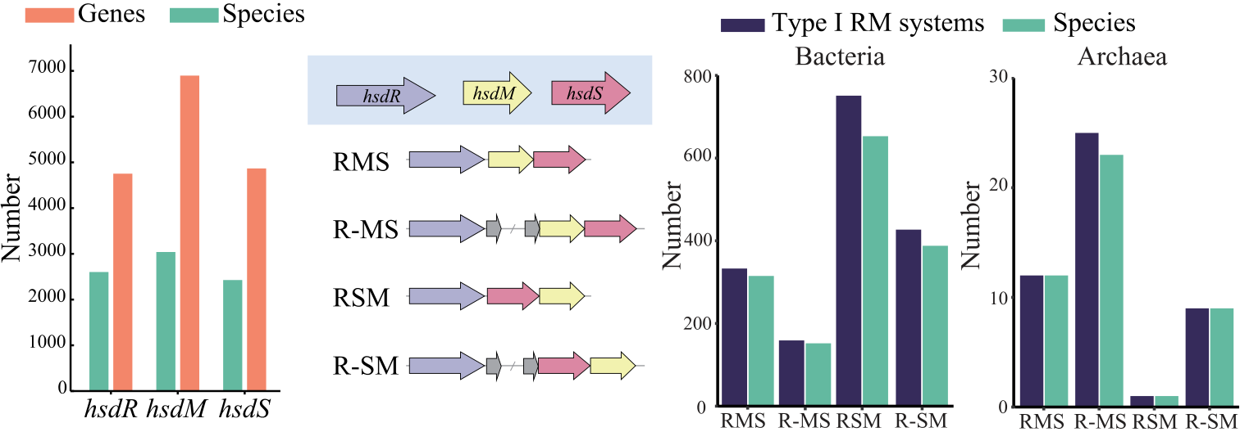
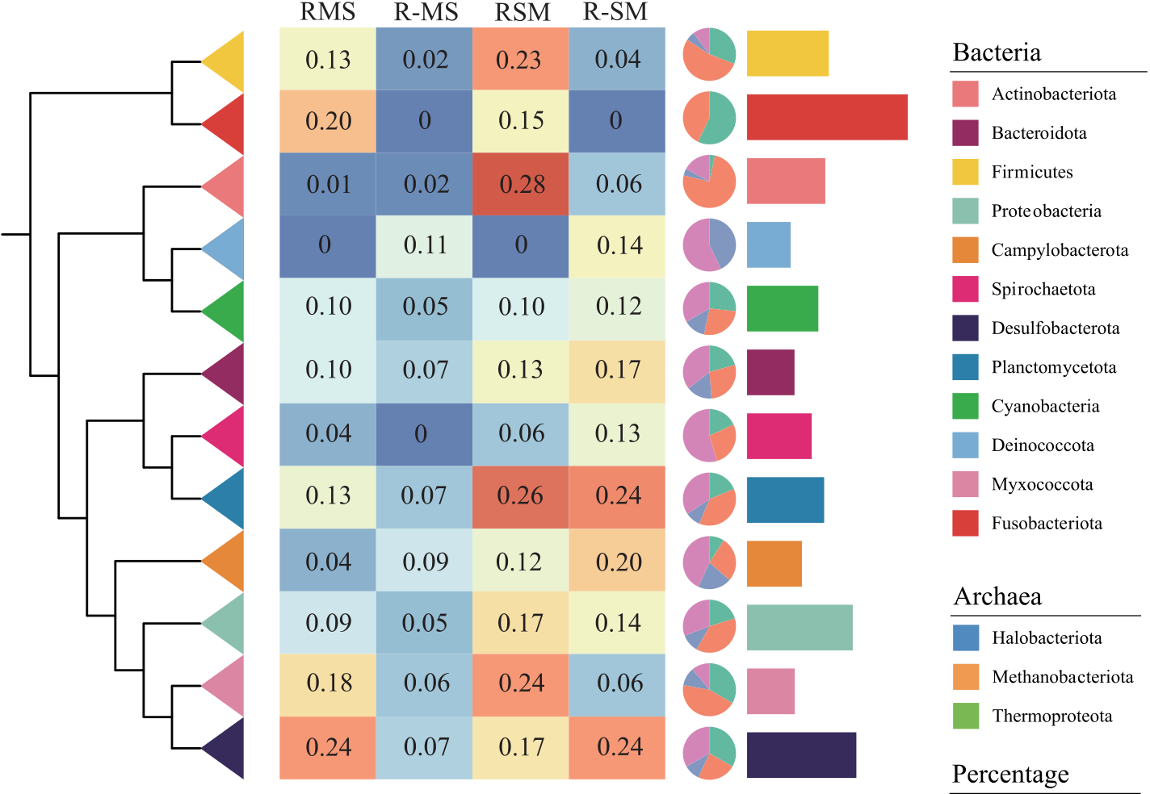
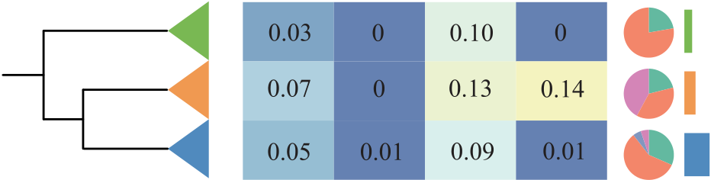
 | 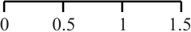
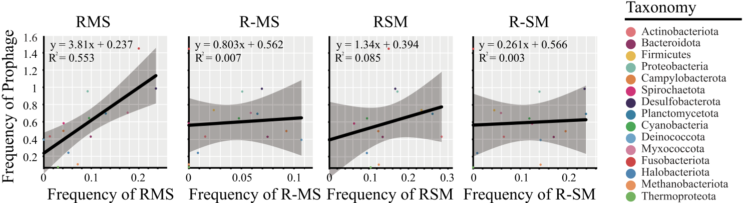
Figure1.DistributionofTypeIRMsystemsandprophagesinprokaryotes.(A)Numberofhsdgenesandthenumberofspeciesharboringthe correspondinghsdgenes.(B)GenearrangementsofthefourconfigurationsofTypeIRMsystems.(C)NumberofTypeIRMsystemsandthenumber ofspeciesharboringthecorrespondingTypeIRMsystems.(D)FrequenciesofTypeIRMsystemsacrossvariousphyla.Thephylogenetictreeillustrates theevolutionaryrelationshipsamongphyla.Theheatmap(withablue-to-redgradient)displaysthefrequencyofTypeIRMsystems.Thepiechart representstheproportionofeachtypeofTypeIRMsystems.Thebarchartshowsthefrequencyofprophages.(E)Correlationbetweenthefrequencies ofTypeIRMsystemsandprophagesatthephylumlevel.

6 | Maetal. |  |  |  |  | Number of prophage
  R
   | SM | MS | R | R | R | MS
  R | MS | R | R | M | R | S | M | SMother
  R
   | S | M | SM | R | M | R | SM | R | SMS | R
  MS | R | R | R | S | M
  other | MS | R | R | MMotherR | R | MS
  MS | R | other | R | R | MS
  other | R | MS | R
  R  MMR | R
     | MS | R | MS
6 | A
 |  |  |  |  |  | 3
 |  |  | WP2-S18-CRE-03
  Tree scale: 0.01
  Geographic location
  Japan
  China
  South Korea
  America
  Turkey
  Thailand
  India
  Australia
  Portugal
  Isolation source
  Water
  Homo sapiens Aquatic life
  Environment
 |  |  | WP8-S18-ESBL-11 |  |  | 0 | 1  1  1 |  | 2 |  |  |  | 6
 |  |  | WP9-W18-ESBL-04
 |  |  | WP3-W19-ESBL-03
 |  |  | 71506
 |  |  | 1708-29120 |  |  | 0 |  |  | 2
 |  |  | ZfB1 |  |  | 0 | 1
 |  |  | 183026
 |  |  | Colony512
 |  |  | C4 | other  M
  R
   | S | M | MS |  | R | MS
  R |  | M | S R |  |  |  | S | M |  |  | S M |  | S | R |  |  |  | R

HGT-acquiredTypeIR-MsystempromotesvirulenceviaTFmethylation 7

isaGram-negativebacteriumknownforitsstrongmotility, virulence,andenvironmentaladaptability[42].Itiswidely distributedinaquaticenvironments,andcaninfectaquatic organismsandhumans,posingasignificantthreattoaqua-cultureandhumanhealth[43,44].Asexpected,notallA. veroniistrainscontainedTypeIRMsystems,andthetypesof thesesystemsvariedsignificantlyacrossstrains,evenwithin thesameclade.Forinstance,noneofthestrains,isolated fromThailandandnamedstartingwith"colony",possessed TypeIRMsystems.Incontrast,theC4strain,whichclus-teredwiththecolony512strain,containedtwotypesofType IRMsystems:RMSandR-SM(Fig.2A).Asimilarpat-ternwasobservedintheMS-18-37andFDAARGOS_632 strains.Notably,evenstrainsfromthesameisolationsource

genesunderwentrelativelyfewduplications,withsuchevents occurringonlyinthreespecieswithinFirmicutes(Fig.3C and–).
Thephylogenetictreetopologiesofthethreegeneswere highlysimilar,eachcomprisingfivedistinctclades(CladesI–V)(Fig.3B).Cladeswithinthesamegroup,suchasClade Iacrossthethreegenetrees,largelyconsistedofthesame species(Fig.3B),indicatingthatthehsdR,hsdM,andhsdS genesfollowsimilarevolutionarytrajectories.Amongthe fivecladegroups,CladeIIIcontainedthefewestphyla (seven),whileCladeIencompassedthemostphyla(nine) (Fig.3B).Foreachclade,thegenetreesdisplayedtopolo-giessomewhatsimilartothespeciestree,suggestingthat RMSisverticallytransmittedwithinthesespeciesduring

orgeographiclocationexhibitedconsiderabledifferencesin evolution.

thenumberandtypesofTypeIRMsystems.Forinstance, theWP3-W19-ESBL-03straincontainedsevenhsdgenesand onlyR-SM,whiletheWP9-W18-ESBL-04strain,withmore thantwicethenumberofhsdgenes,harboredbothR-SMand

Desulfobacterotaoccupiedaprominentpositioninthegene trees,oftenservingastheancestralnodeforotherphyla,such asCampylobacterota,Proteobacteria,andBacteroidota(Fig. 3B).ThissuggeststhatRMSmayhaveinitiallytransferred

RSM(Fig.2A). fromDesulfobacterotatootherphyla,followedbyvertical

Whencomparingstrainsfromdifferentisolationsources, thoseisolatedfromwatergenerallyexhibitedahighernum-berofTypeIRMsystems(Fig.2A),withanaverageofmore thantwoperstrain.Incontrast,strainsisolatedfromhumans containedfewer,withanaverageofonly0.8perstrain.Ad-ditionally,strainsfromwateralsoharboredmoreprophages, withanaverageof3.1perstrain(Fig.2A).Whencompar-ingstrainsfromdifferentgeographiclocations,thoseisolated fromChinaandJapanhadmoreTypeIRMsystems,whereas strainsfromThailandlackedthementirely(Fig.2A).These findingssuggestthatthedistributionofTypeIRMsystemsis shapedbyacombinationoffactors,includingisolationsource

transmissionwithinthosephyla.Cyanobacteriaalsoexhib-itedasimilarpattern(Fig.3B),indicatingthatCyanobacteria couldhavebeenasignificantdonorofRMSincertainphyla. WehypothesizethattheevolutionofRMSinvolvesalong andcomplexprocess(Fig.3D).Initially,ancestralgenesun-dergoduplication,followedbyHGTtootherspecies.Asthese speciescontinuetoevolve,thegenesareeitherverticallyinher-itedorlost.Sinceloosegenomiclocicannotguaranteestable inheritance,thelinkagebetweenthehsdR,hsdM,andhsdS genesgraduallybecomestighterovertime,ultimatelygiving risetothecurrentRMS(Fig.3D).Whilethismodelfitscurrent evidence,futureresearchshouldemployexperimentalevolu-

andgeographiclocation. tiontotestthehypothesis.
ComparedtotheothertwotypesofTypeIRMsystems,
RMSandR-SMweremorefrequentlyfoundinA.veronii

(Fig.2A).ThehsdR,hsdM,andhsdSgenes,whichconstituted RMS,clusteredwithinthesamegroupofcladesacrossall threegenetrees(Fig.2B).ThissuggeststhatRMSisgenetically stableinA.veronii.Notably,thebranchlengthsofhsdRand hsdMwereveryshort,indicatingthattheevolutionarydis-tancesofthesegenesamongdifferentstrainsareminimal.In contrast,thehsdgenesassociatedwithR-SMweredispersed acrossvariousclades,someofwhichcontainedgenesthatdid notbelongtoanyTypeIRMsystem(Fig.2B).Thesegenes arelikelyremnantsofTypeIRMsystemsthatweredisrupted

RMSstrainlacksflagellumandexhibitsareduced virulencephenotype
ToexplorethefunctionalrolesofRMSafteritsstableinheri-tance,weconstructedtheRMSandRMS/pRMSstrainsof A.veroniiC4.Thesestrains,alongwiththeWTstrain,were examinedusingTEM(Fig.4A).Thethreestrainsexhibited similarcellsizeswithroundedends.IntheWTstrain,asingle polarflagellumwasclearlyvisibleatoneend,surroundedby shortanddensepili.Detachedflagellawerealsoobservedin thesurroundingenvironment.Incontrast,theRMSstrain

duringHGT. lackedapolarflagellumandonlycontainedpili,suggesting
thatRMSplaysakeyroleinregulatingflagellarassembly.

RMShasundergonealongandcomplex evolutionaryprocess
WeextractedthespeciesharboringRMSfrom4019bacte-riaand254archaea.Phylogenetictreesforthesespecies(Fig. 3A)aswellasforthehsdR,hsdM,andhsdSgenes(Fig. 3B)formingRMSwereconstructed.Notably,thereweredis-tincttopologiesbetweenthespeciestreeandthegenetrees (Fig.3AandB),suggestingthatthesegenesprimarilyevolve throughHGTacrossprokaryotes.Thisconclusionwasfurther supportedbynucleotidecompositionanalysis,whichdemon-stratedsignificantdeviationsintheGCcontentbetweenthe horizontallytransferredhsdgenesandtheirrecipientgenomes (P-value=0.01forhsdR,P-value=3.62× 10−10forhsdM, andP-val=×−8;Wilcoxonsigned-ranktest;–).Incontrast,these

Notably,theRMS/pRMSstrainstilllackedapolarflagel-lum,indicatingthatRMSmaynotdirectlyregulateflagellar assembly.
Flagellumiscrucialforbacterialmotility,anditsabsence mayreducebacterialpathogenicity.Totestthishypothesis, healthymicewereinfectedwitheithertheWT,RMS,or RMS/pRMSstrain(Fig.4B).ComparedtotheWTstrain, theRMSstrain,whichlackedthepolarflagellum,showed areducedabilitytocolonizevariousorgansofmice,partic-ularlythekidney(Fig.4C).TheRMS/pRMSstrain’scol-onizationabilitypartiallyrecovered,althoughitremained lowerthanthatoftheWTstrain.Histopathologicalanalysis revealedsevererenaltoxicityinmiceinfectedwiththeWT strain,includingenlargedrenaltubules,swollenglomeruli, cellularnecrosis,nuclearpyknosis,andinterstitialconges-tion(Fig.4D).Similarlesionswereobservedinthespleen

8 Maetal.

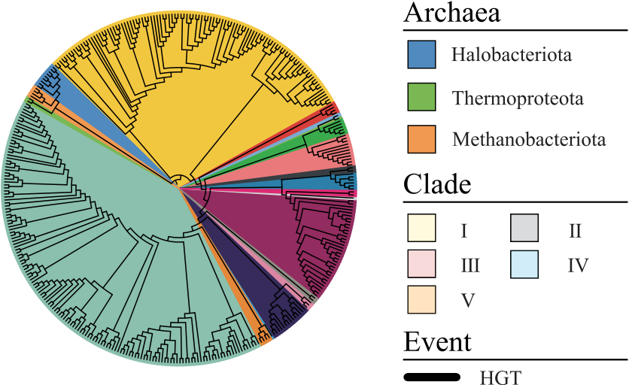




 |  | 
 | 

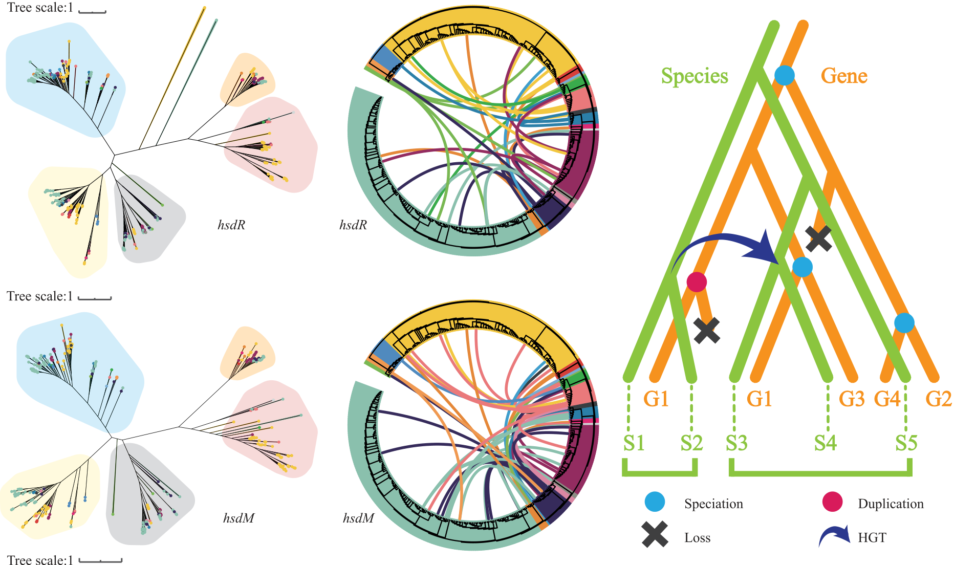
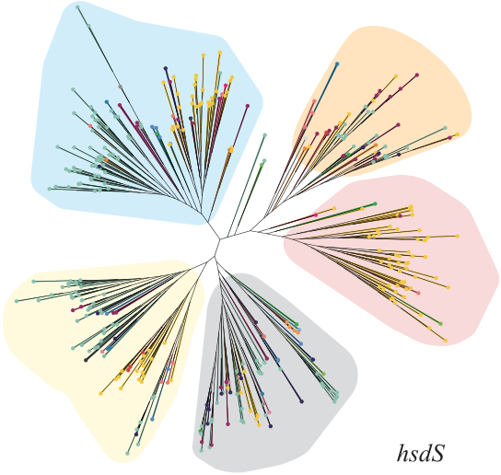 | 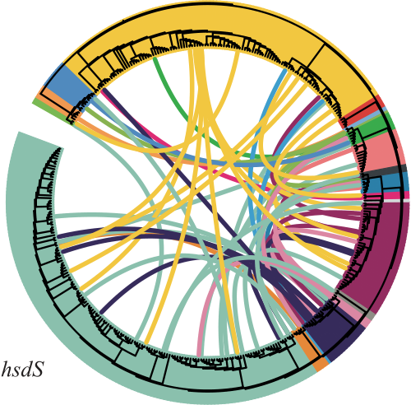 | 
 |  | 
Figure3.PhylogeneticanalysisofRMS.(A)PhylogenetictreeofspeciescontainingthecanonicalTypeIRMsystem(RMS),withdifferentcolors representingdistinctphyla.(B)PhylogenetictreesofhsdR,hsdM,andhsdSgenes,withdifferentcladeshighlightedbyvaryingbackgroundcolors. Coloreddotsontreebranchesindicatephylumaffiliation,followingthesamecolorschemeasshowninpanel(A).(C)HGTpathwaysofhsdR,hsdM,and hsdSgenes.Theoutercirclerepresentsthespeciestreefrompanel(A),whiletheinnercurveindicatestheHGTpath.Thecolorofcurvecorrespondsto thedonorspeciesinvolvedineachHGTevent.(D)EvolutionarymodelofRMSdevelopment.Keystages:(i)duplicationofancestralRMScomponents; (ii)horizontaltransfertodivergentspecies;(iii)lossofinterveninggenes;and(iv)stabilizationintotightlylinkedRMS.

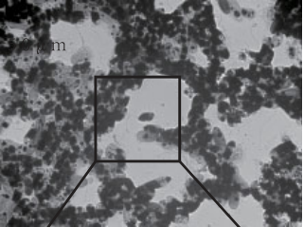
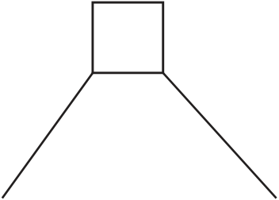
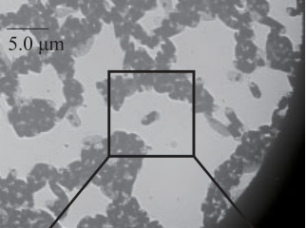
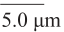
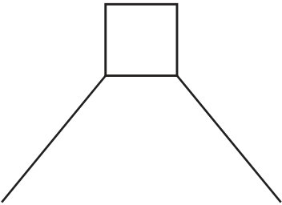
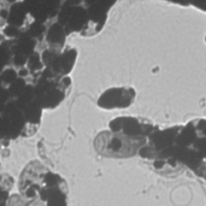
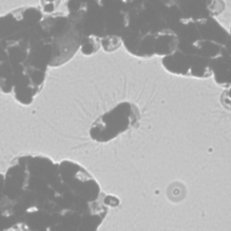
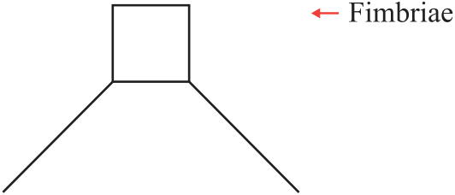
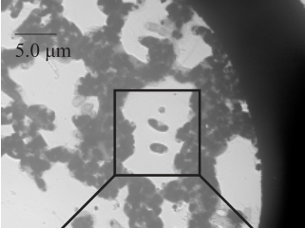
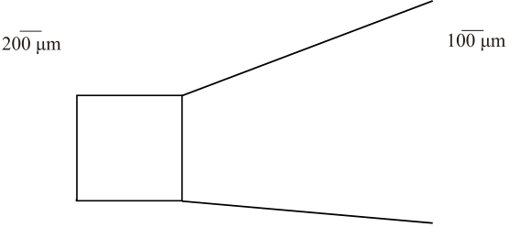
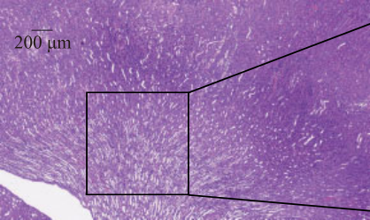
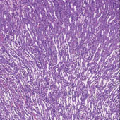
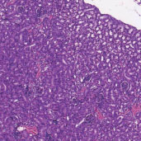
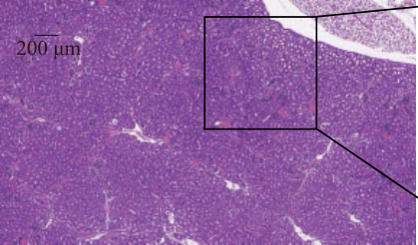
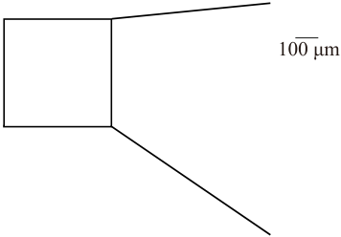
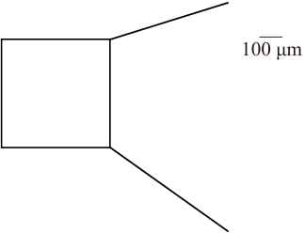
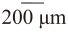
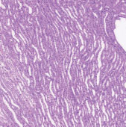
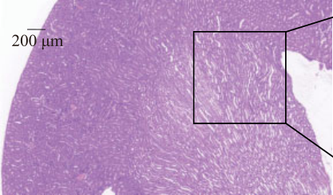
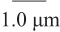
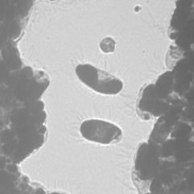
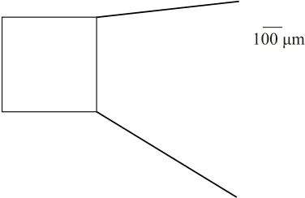
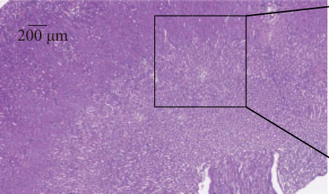
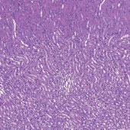
 | HGT-acquiredTypeIR-MsystempromotesvirulenceviaTFmethylation |  | 9
 |  |  | 9


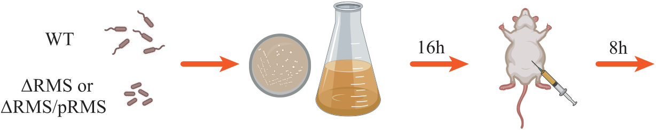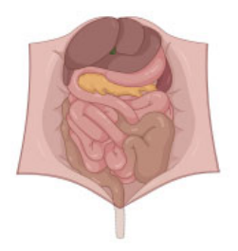
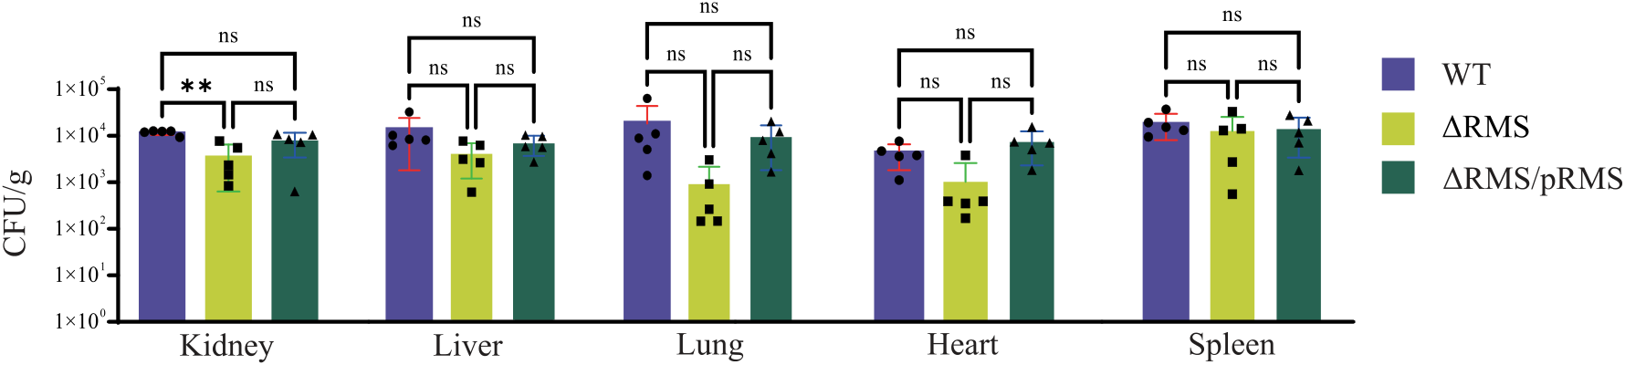


Figure4.ImpactofRMSonbacterialpathogenicity.(A)TEMimagesofA.veroniiWT,RMSknockout(RMS),andcomplemented(RMS/pRMS)
strains.ComparedtotheWTstrain,theRMSandRMS/pRMSstrainslackthepolarflagellum.(B)Schematicillustrationofmouseinfection
experiment.MicewereintraperitoneallyinjectedwiththeWT,RMS,orRMS/pRMSstrainatadoseof105CFU/gofbodyweight.(C)Colonization
abilityindifferenttissuesofmiceafterchallengedbytheWT,RMS,orRMS/pRMSstrain.Dataareshownasmean± SD,withtheerrorbarindicates
thestandarddeviationoffiveindependentexperiments.Thesignificanceofdifferencesincolonycountsamongdifferentstrainsisdeterminedby
one-wayANOVAtest.nsindicatesnosignificantdifferenceand**denotesP<0.01.(D)MicroscopicimagesofkidneytissuesstainedwithH&E
pathologyslices.Thecontrolgroupshowsthenormaltissuemorphology.

10 Maetal.

andliver,withinflammatoryresponsesinthespleenandfo-calruptureoflivercellsaccompaniedbynuclearaggregation ().Incontrast,infectionwiththeRMS straindidnotinduceobviouspathologicalchanges.Notably,

ever,the89downstream-regulatedDEGscompletelylacked RMStargetsites,indicatingthatRMSindirectlyregulates downstreamgenes,includingthoseinvolvedinflagellar assemblyandchemotaxis,ultimatelyinfluencingbacterial

theRMS/pRMSstrainalsocausedrenaltubuleswelling, pathogenicity.
splenicinflammatory,andhepatocytedamage,althoughits
virulencewasstilllowerthanthatoftheWTstrain.Theresults indicatedthattheknockoutofRMSsubstantiallyre-ducesthecolonizationabilityandvirulenceofA.veronii C4. | Discussion  RMsystemsserveaskeyDNAdefensemechanismsin prokaryotes,playingacrucialroleinprotectinghostsagainst
foreigngeneticelements,suchasphages.Thesesystemsare

RMSmodulatestheexpressionofdownstream genesbymethylatingtranscriptionfactor-encoding genes
ToinvestigatethemolecularmechanismsbywhichRMSregu-latesbacterialpathogenicity,wesequencedthetranscriptomes andmethylomesofbothWTandRMSstrains.Comparedto theWTstrain,167genesweredifferentiallyexpressedinthe RMSstrain,whichweresignificantlyenrichedinpathways

traditionallyclassifiedintofourtypes(I–IV)basedontheir structuralandfunctionalcharacteristics[8].AlthoughTypes IIandIIIRMsystemshavebeenextensivelystudied,signifi-cantknowledgegapspersistregardingTypeIRMsystemde-spiteitswidespreadoccurrenceinprokaryotes.Specifically, threekeyaspectsremainpoorlyunderstood:(i)itsdistribution patternsacrossprokaryotes,(ii)itsevolutionaryoriginand long-termevolutionarytrajectory,and(iii)itsfunctionalrole followingstableinheritanceaswellasunderlyingmolecular

associatedwithflagellarassembly,bacterialchemotaxis,and mechanism.

more(Fig.5A).Notably,theseDEGstendedtoclusterwithin thegenome,forminggeneclustersthatencodesuchasthepro-teinsinvolvedinflagellarassemblyandchemotaxis(Fig.5B). ThisfindingsuggeststhatDEGsmaybeco-regulatedbycer-

Throughasystematicanalysisof4273prokaryotic genomes,wefoundthatonly64.6%(hsdR),75.5%(hsdM), and60.2%(hsdS)ofspeciescarrygenesencodingTypeIRM systems,suggestingthatatleastaquarterofspeciesmayrely

tainTFs. onalternativedefensemechanisms,suchasTypeII/IIIRM

IntheWTstrain,sevenmethylatedmotifswereidentified (underlined=methylatedbases),includingthreereverse-complementarypairs5′-GTANNNNNNNNCTTC-3′↔5′-GAAGNNNNNNNNTAC-3′, 5′-CCAYNNNNNCTG-3′↔5′-CAGNNNNNRTGG-5′,5′-TCAHNNNNNRTGGC-3′↔5′-GCCAYNNNNNDTGA-3′, and
5′-GATC-3′. In contrast, the RMS strain only ex-hibited five 5′-CCAYNNNNNCTG-3′↔5′-CAGNNNNNRTGG-5′, 5′-TCAHNNNNNRTGGC-3′↔5′-GCCAYNNNNNDTGA-3′, and
5′-GATC-3′. The motif pair 5′-GTANNNNNNNNCTTC-3′↔5′-GAAGNNNNNNNNTAC-3′,whichwasabsentinthe RMSstrain,wastheRMStargetsites(Fig.5C).Atotalof 386sequencesmatchingtheRMStargetsitesweredispersed throughoutthegenome,with330ofthesesequenceslocated withinthebodiesof316protein-codinggenes.Functional enrichmentanalysisrevealedthesegenesweresignificantly associatedwithamidtransmembrane transportprocesses().
dgenes,16encodedTFs,9ofwhich ()exhibitedmeasurableregulatory activity.Theseninledtheexpres-sionof89genes()thatweresig-nificantlydownregulatedintheRMSstrain.TheDEGsin-cludedthoseencodingflagellarcomponents(suchasflgO, flgP,fliC,andfliD)andchemotaxisproteins(likecheV,cheR, andmcp).ThroughRT-qPCRvalidation(Fig.6A),wecon-firmedreducedexpressionofboththeTF-encodinggenes (rpoN,rpoS,andflrA)andtheirrespectivetargets:RpoN-regulated(flgOandflgP),RpoS-regulated(fliCandfliD),and Flra-regulated(cheVandcheR)genes.Allexaminedgenes exceptrpoNshowedsignificantdownregulation,withpar-ticularlystrongeffectsobservedforrpoS,flgP,fliC,and fliD(Fig.6A).Notably,thenineTF-encodinggenescon-tainedbothRMStargetsitesandahighlyconservedmo-tif5′-TBVBCSABCTRHKCG-3′(E-value=5.30×10−10;).How-

systemsorCRISPR–Cassystems,toprotecttheirgenomicin-tegrity[45].Furtheranalysisrevealedthatfourmaingene arrangementsofTypeIRMsystemsexistinprokaryotes. Amongthem,RMSandRSM,consistingoftightlylinked hsdR,hsdM,andhsdSgenes,weremorefrequentlyobserved inbacteriacomparedtoR-MSandR-SM,whichhavegene insertions.WhilearchaeashowedoppositetrendswithR-MS/R-SMpredominance.Thisfindingisinstrongalign-mentwithevolutionarytheories.Underevolutionarypres-sures,earlyTypeIRMsystems,constructedfrompre-existing components,evolveinto"simpler"systemsthroughdomain fusionordeletion[46].ThissuggeststhatR-MSmayrepre-sentanearlierformofRMS,whileR-SMmaybeanearly versionofRSM.Overtime,genesinsertedbetweenhsdRand hsdMS/hsdSMareprogressivelylost,eventuallyleadingtothe formationofthemorestreamlinedRMSandRSM.Further-more,thecloseproximityofhsdRandhsdM/hsdSonthe genomereducesthelikelihoodofrandomimbalancesbetween thesegenes,minimizingtheriskofself-restriction,whichcould triggerthehost’sSOSresponse[47].Thismayexplainwhythe hosttendstofavorRMSorRSMasthefinalformofTypeI RMsystems.
Thecomparativeanalysisatthephylumlevelrevealedevo-lutionarydynamics.WhilethephylumCyanobacteriaexhib-itedabundantcopiesofindividualhsdR,hsdM,andhsdS genes,thecompleteTypeIRMsystemsshowedremarkably lowoccurrencefrequencies.GiventhattheemergenceofType IRMsystemsisthoughttobebasedonpre-existingcompo-nents[48],theobservedpatterninCyanobacterialikelyre-flectsanearlystageintheevolutionaryprocessofTypeIRM systems.Incontrast,thephylumDesulfobacterotaexhibited distinctlydifferentevolutionarycharacteristics:itnotonly harboredasignificantlyhigherabundanceofcompleteTypeI RMsystems,butalsomaintainedelevatedcopiesofindividual hsdgenes.Particularlynoteworthywastheobservationthat thetransitionalconfigurationR-SMoccurredatsubstantially higherfrequenciesthanthefullydevelopedarchitectureRSM

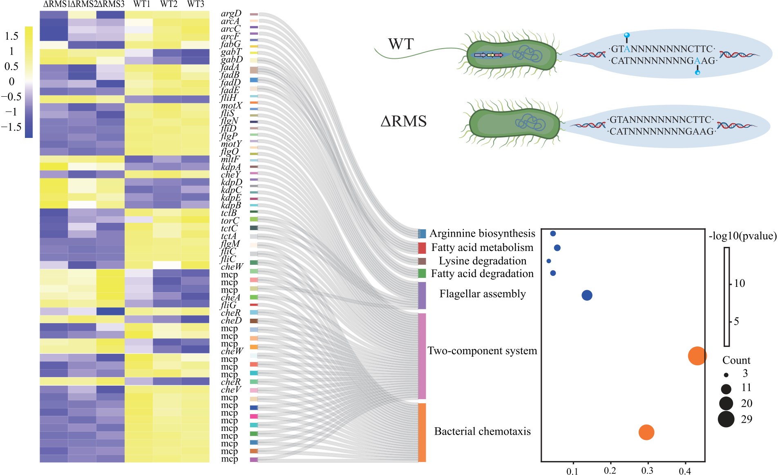
HGT-acquiredTypeIR-MsystempromotesvirulenceviaTFmethylation 11



Figure5.PathwaysregulatedbyRMS.(A)KEGGfunctionalenrichmentanalysisofDEGs.TheheatmapdisplaystheirexpressionlevelsinA.veronii WTandRMSknockout(RMS)strains,withcolorsrangingfrompurple(lowexpression)toyellow(highexpression).Sankeyandbubbleplotsillustrate thepathwaysenrichedbyDEGs.(B)GeneclusterscomprisingpartialDEGs.(C)MotifidentifiedandmethylatedbyRMS.FollowingRMSknockout,the correspondingsequencesintheRMSstrainlosemethylationmodifications.

withinthisphylum.Thisuniquedistributionpatternstrongly suggeststhatTypeIRMsystemsinDesulfobacterotaarecur-rentlyundergoingrapidevolution.Weproposethefollowing evolutionarytrajectory:First,individualhsdgenesprogres-sivelyassembleintonovelTypeIRMsystems.Concurrently, themoreprimitiveR-SMundergostreamliningprocesses(e.g. geneloss)toevolveintothemorestableRSM.Thisdifferen-tialevolutionarypatternlikelyreflectsstrongenvironmental adaptationpressures.
Toelucidatethekeyfactorsshapingthedistributionpat-ternsofTypeIRMsystems,weconductedacomparative genomicanalysisusingA.veroniiasamodelorganism,ex-aminingstrainsisolatedfromdiverseecologicalniches.Our findingsrevealedthataquaticisolatesexhibitedasignifi-

cantlyhighernumberofTypeIRMsystemsandprophages comparedtostrainsfromotherenvironments.Thiscould beduetothefavorableconditionsforphagesurvivalin aquaticenvironments,whichenablestrainstointegratemore phagesequencesintoitsgenome,resultinginahighernum-berofprophages.Moreover,strainsmayneedtoevolvea greaternumberofTypeIRMsystemsasadefensemech-anismagainstphages[49].Notably,ourstudyalsore-vealeddistinctgeographicaldistributionpatterns:Chinese andJapaneseisolateswereenrichedwithTypeIRMsys-tems,whileThailandisolatescompletelylackedthem.This geographicalcorrelationisfurthersupportedbystudieson Helicobacterpylori,whereRMsystemdiversitycorrelates withstrainoriginsacrosscontinents[50].SomeRMsystems

12 Maetal.

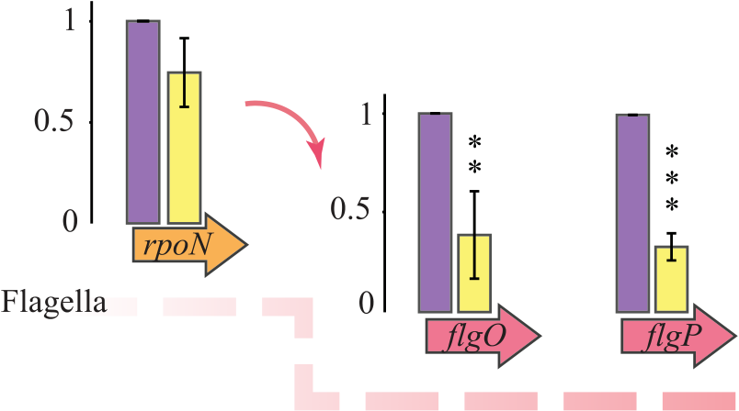
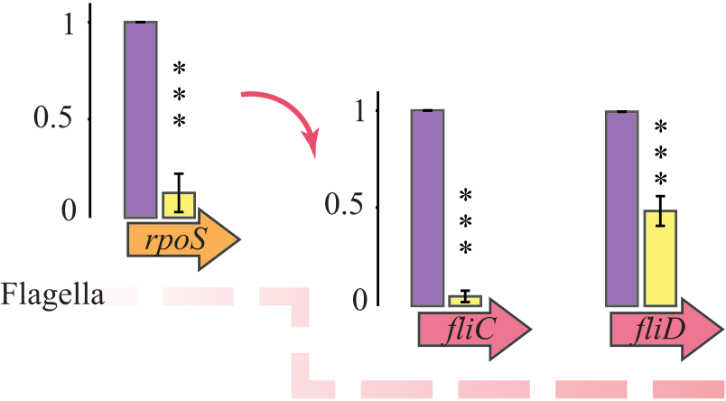

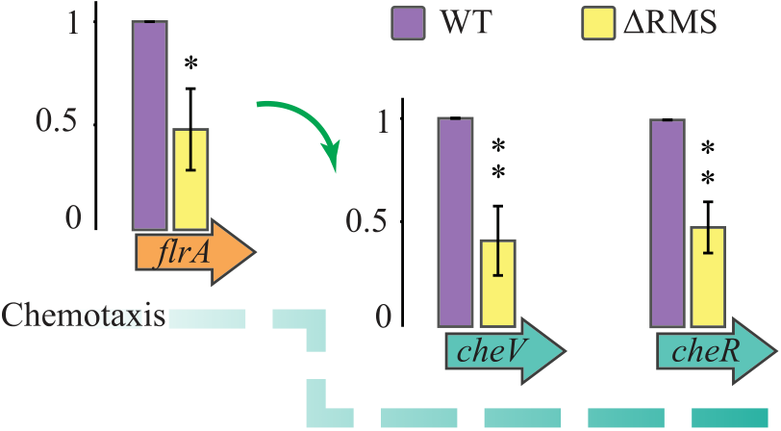

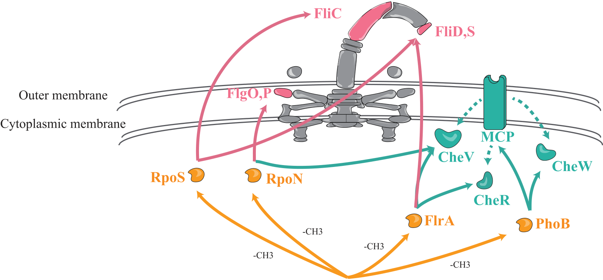

Figure6.RegulationmechanismsofflagellarassemblyandchemotaxisbyRMS.(A)RT-qPCRvalidationofDEGs.Theorangearrowindicatesthe transcriptionfactor(TF),whilethegreenandredarrowsrepresenttheirtargetgenes,encodingchemotaxisproteinsandflagellarproteins,respectively. Dataareshownasmean± SD,withtheerrorbarindicatesthestandarddeviationofthreeindependentexperiments.Thesignificanceofdifferencesin geneexpressionlevelsbetweenA.veroniiWTandRMSstrainsisassessedusingone-wayANOVAtest.*P<0.05,**P<0.01,and***P<0.001.(B) SchematicdiagramillustratingthehypotheticalregulatorymodelbywhichRMSregulatesflagellarassemblyandchemotaxis.RMSinitiallyregulatesTFs (indicatedinorange)throughDNAmethylation,whichinturncontroltheexpressionofflagellarproteins(indicatedinred)andchemotaxisproteins.

mayhavebeenacquiredduringearlyhumanmigrationsout ofAfrica,whileothersareindependentlyobtainedbyge-ographicallyisolatedpopulationslater[51].Thesefindings suggestthatdefensesystems,includingTypeIRMsystems, playcrucialrolesinlong-termbacterialevolutionandhost

wehaveobtainedrobustevidenceforwidespreadHGTin thecanonicalTypeIRMsystem(RMS).HGTservesasa primaryevolutionaryforcedrivingtheremarkablediversity ofhsdgenearrangements,whichinturngeneratesthevari-ousconfigurationsofTypeIRMsystems.Particularlynote-

adaptation. worthyisourdemonstrationofextensiveHGToccurringat

TheevolutionarydynamicsofRMsystemshavelongbeen recognizedtoinvolveHGT[52,53].However,significant gapsremaininourunderstandingofHGTinTypeIRM systems.Byperformingphylogeneticreconciliationbetween speciestreesandindividualgenetrees(hsdR,hsdM,andhsdS),

multipletaxonomiclevels—bothwithinandbetweenphyla. Thisbroad-scalemobilitystronglysupportsthehypothesis thatRMSlikelyservesasacommunalresource,contribut-ingtoprokaryoticpan-immunity[15].Phylogeneticclassifica-tionofhsdgenesidentifiedfivedistinctcladeswithcontrasting

HGT-acquiredTypeIR-MsystempromotesvirulenceviaTFmethylation 13

evolutionarypatterns.CladeIII,containingthefewestphyla, appearstorepresentamorerecentlyevolvedgroupwithlim-itedHGT.Incontrast,CladeIexhibitedthebroadestphylum-leveldistribution,suggestingbothanancientevolutionary originandsustainedcross-phylumdisseminationthrough extensiveHGT.Thesefindingsalignwellwithcurrentunder-standingofimmunesystemevolutioninprokaryotes.Immune systemsareenergeticallycostlyandareretainedandverti-callytransmittedonlyunderselectivepressure[54,55].When selectivepressureislow,however,immunesystemsareoften transferredviamobilegeneticelements(MGEs),whichkeep theminastateofconstantflux[15,56].Althoughthecur-rentstudyoffersasystematiccharacterizationofhsdgene evolutionarydynamicsattheprokaryoticscale,subsequent

theotherbindstothesequence5′-CTTC-3′↔5′-GAAG-3′. ThemodulararchitectureofHsdSenablesremarkablephase variationthroughTRDrecombination,generatingdiversese-quencespecificitiesacrossstrainsandspecies.Acompelling exampleisseeninH.pylori.P12strain(HsdS1withTRDs c+a)recognizes5′-GAAN8TAG-3′↔5′-CTAN8TTC-3′.F16strain(HsdS2withTRDsh+d)recognizes5′-CAA N7RTAB-3′↔5′-VTAYN7TTG-3′.Recombinantvariant (HsdS3withTRDsa+h)recognizes5′-CAAN8TAG-3′↔5′-CTAN8TTG-3′[5].ThisTRDshufflingmechanismrepre-sentsapowerfulevolutionarydriverthatgeneratesmethylome diversityandfacilitatesbacterialadaptation.Inthefuture,we willsystematicallycharacterizeHsdSdomainrearrangements, withthegoalofreconstructingtheevolutionaryhistoryof

researchshouldprioritizeselectedmodelorganismstodis- TypeIRMsystems.

sectstrain-specifichsdgenomicrearrangements.Byemploying integratedapproaches,theseinvestigationswillelucidatethe synergisticeffectsofMGEs,recombinationevents,andniche-specificselectionpressuresinorchestratingtheadaptiveevo-

Genome-widelocalizationanalysisfurtherrevealedthat theRMStargetsiteswerepreferentiallyenrichedwithin genebodiesratherthanpromoterregions,suggestinga non-canonicalregulatorymodethatdiffersfromtraditional

lutionofRMS. TF-mediatedpromoterregulation.Thisobservationaligns

TheevolutionarypersistenceofRMSsuggeststhatitmay conferdualselectiveadvantages:maintaininggenomein-tegritythroughRMwhileepigeneticallyregulatingcriticalbi-ologicalprocesses.TodissectthefunctionofRMSaftersta-bleinheritance,weconstructedtheRMSandRMS/pRMS strainsforcomprehensivephenotypiccharacterization.TEM anlysisrevealedthattheWTstrainexhibitedanintactflag-ellum,whereastheRMSstraincompletelylostitsflagellum (retainingonlypili),indicatingthatRMSplaysacrucialregu-latoryroleinflagellarassembly.Notably,theRMS/pRMS strainfailedtorestoreflagellarformation,suggestingthat RMSexertsitsfunctionthroughindirectregulatorymecha-nismsratherthandirectlycontrollingflagellargeneexpres-sion.Thesefindingsarestronglysupportedbyinvivoinfec-tionassays:ComparedtotheWTstrain,theRMSstraindis-playedreducedcolonizationinmurinekidneys,spleens,and livers,andcausednoevidenthistopathologicaldamage.Al-thoughcomplementationrestoredcolonizationandvirulence, itstilldidnotreachthelevelsobservedintheWTstrain.This phenotypicpatternalsocloselyparallelsfindingsinS.pyo-genes,wheredeletionofRSMsimilarlyattenuatesvirulence withonlypartialrestorationinthecomplementedstrain[17]. Suchcross-speciesconsistencyimpliesthatTypeIRMsys-

withemergingparadigmsofintragenicDNAmethylation ineukaryotes,wheregenebodymethylationeffectsareex-plainedbytwoprevailinghypotheses.Oneisderivedfrom theanticorrelationbetweenH2A.Zhistonevariantdistri-butionandDNAmethylation.Thishypothesisproposes thatgenebodymethylationmaintainstranscriptionalcon-tinuitybyinhibitingH2A.Zdeposition[58].Theother positsthatgenebodymethylationenhancestranscriptional efficiencybysuppressingaberrantinitiationfromalternative promotersand/orantisensetranscription[58–60].Wespec-ulatethatinprokaryotes,RMS-mediatedgenebodymethy-lationmayexertanalogouseffectsongeneexpression.For instance,throughmodulationofnucleoid-associatedpro-tein(NAP)–DNAinteractions,whereinmethylationsterically hindersNAPbindingandconsequentlyalterslocalDNA topologyandRNApolymeraseprocessivity.Alternatively,via regulationoffunctionalgenomicelements,wherebymethy-lationsuppressesspurioustranscriptioninitiation.Thispro-cessmayinvolveauxiliaryfactorsthatpotentiallyrecog-nizeandbindtoconservedmotifswithinTFs,e.g.the motif5′-TBVBCSABCTRHKCMABCTGCTGGAKCHG-3′, therebycooperatingwithRMStojointlymodulateTFs.These putativemechanisms,however,requiresystematicexperimen-

temslikelygovernbacterialpathogenicityviaindirectmech- talvalidation.

anisms.Furthermore,theresultsalsoprovidenewinsights intothegeneticorganizationrequirementsofTypeIRMsys-tems.AlthoughthegenomicarrangementofhsdR,hsdM,and hsdSvariesamongdifferentsystems(e.g.RSMandRMS), thesedifferencesdonotappeartoaffectcorefunctionality.In contrast,thetranscriptionalorientationofhsdgenesiscrit-icalforthefunctionalityofTypeIRMsystems.WhenhsdS andhsdMareencodedonoppositestrands,oneofthegenes mayfailtobeexpressedduetotheabsenceofapromoter

Genomicanalysisidentified16TF-encodinggenescontain-ingRMStargetsites,amongwhichnineTFswerefoundto regulate89DEGsinvolvedincriticalpathogenicity-associated processes,includingflagellarassemblyandbacterialchemo-taxis.SupportedbyRT-qPCRvalidation,wepostulateapo-tentialcascaderegulationmodel(Fig.6B):RMSmayfine-tunetheexpressionoftheseTF-encodinggenesthroughDNA methylation,whiletheseTFsinturnactasregulatoryhubs modulatingdownstreamgenes,ultimatelygoverningbacte-

[57]. rialpathogenicity.Thishierarchicalregulationexhibitsre-

Integrativemulti-omicsanalysesfurthersubstantiateour g3′↔5′-GAAGNNNNNNNNTAC-3′.Theywerespecifically recognizedbyHsdS,whichcontainstwostructurallyinde-pendenttargetrecognitiondomains(TRDs)connectedbyα-helicallinkers.EachTRDexhibitsdistinctsequencespeci-

markablesignalamplification;evensubtlechangesinTFex-pressioncancausesubstantialfluctuationsindownstream targets[61,62].However,weemphasizethisrepresents onepossiblemechanismamongtheorganism’sdiversereg-ulatoryrepertoire.Inconclusion,ourstudyoffersnewin-sightsintohowRMSachievesstablegenomicinheritance—throughhorizontaltransferfollowedbyfunctionalintegra-tionintopathogenicitynetworks,whereitcouldserveas high-levelepigeneticmodulatorratherthandirecttranscrip-

ficity:onerecognizesthesequence5′-GTA-3′↔5′-TAC-3′and tionalcontroller.

14 Maetal.

Acknowledgements
Authorcontributions:J.M.wasinvolvedinconceptualization, methodology,investigation,formalanalysis,visualization, andwriting—originaldraft.X.J.wasinvolvedinmethodol-ogy,investigation,andwriting—originaldraft.H.B.wasin-volvedinformalanalysis,visualization,anddatacuration. J.L.wasinvolvedininvestigation.X.M.wasinvolvedinin-vestigation.X.C.wasinvolvedinformalanalysis.Y.T.was involvedinformalanalysis.Z.L.wasinvolvedinconceptu-alization,writing—reviewandediting,andsupervision.H.L. wasinvolvedinconceptualization,writing—originaldraft, writing—reviewandediting,andsupervision.
Supplementarydata
isavailableatNARonline.
Conflictofinterest
Nonedeclared.

8. MurrayNE.TypeIrestrictionsystems:sophisticatedmolecular machines(alegacyofBertaniandWeigle).MicrobiolMolBiolRev 2000;64:412–34.
9. RobertsRJ,BelfortM,BestorTetal.Anomenclaturefor
restrictionenzymes,DNAmethyltransferases,homing
endonucleasesandtheirgenes.NucleicAcidsRes
2003;31:1805–12.
10. SistlaS,RaoDN.S-Adenosyl-L-methionine-dependentrestriction enzymes.CritRevBiochemMol2024;31:1–19.
11. DoberenzS,EckweilerD,ReichertOetal.Identificationofa PseudomonasaeruginosaPAO1DNAmethyltransferase,its targets,andphysiologicalroles.mBio2017;8:e02312-16.
12. DeSteCroixM,VaccaI,KwunMJetal.Phase-variable
methylationandepigeneticregulationbytypeI
restriction–modificationsystems.FEMSMicrobiolRev
2017;41:S3–15.
13. NiehusR,MitriS,FletcherAGetal.Migrationandhorizontal genetransferdividemicrobialgenomesintomultipleniches.Nat Commun2015;6:8924.14. BowerEKM,CooperLP,RobertsGAetal.Amodelforthe evolutionofprokaryoticDNArestriction–modificationsystems baseduponthestructuralmalleabilityoftypeI

Funding | restriction–modificationenzymes.NucleicAcidsRes 2018;46:9067–80.https://doi.org/10.1093/nar/gky760

ThisresearchwassupportedbytheNationalNaturalSci-enceFoundationofChina(32460244),theHainanProvin-cialNaturalScienceFoundationofChina(225MS009and 322RC589),theHainanProvinceScienceandTechnology SpecialFund(ZDYF2024XDNY164),andtheNationalNat-uralScienceFoundationofChina(22206152).Fundingtopay theOpenAccesspublicationchargesforthisarticlewaspro-videdbyNationalNaturalScienceFoundationofChina.
Dataavailability
RNAandDNAmethylationsequencingdataareavailable atSequenceReadArchiveinNationalCenterforBiotech-nologyunderaccessionnumbersPRJNA1200627andPR-

15. BernheimA,SorekR.Thepan-immunesystemofbacteria:
antiviraldefenceasacommunityresource.NatRevMicrobiol 2020;18:113–9.16. OmerS,HarlowTJ,GogartenJP.Doessequenceconservation provideevidenceforbiologicalfunction?TrendsMicrobiol
2017;25:11–8.
17. NyeTM,JacobKM,HolleyEKetal.DNAmethylationfroma typeIrestrictionmodificationsysteminfluencesgeneexpression andvirulenceinStreptococcuspyogenes.PLoSPathog
2019;15:e1007841.18. RobertsRJ,VinczeT,PosfaiJetal.REBASE:adatabaseforDNA restrictionandmodification:enzymes,genesandgenomes.
MicrobiolMolBiolRev2023;51:D629–30.
19. SteineggerM,SödingJ.MMseqs2enablessensitiveprotein sequencesearchingfortheanalysisofmassivedatasets.Nat Biotechnol2017;35:1026–8.

JNA1010177. 20. RozewickiJ,LiS,AmadaKMetal.MAFFT-DASH:integrated proteinsequenceandstructuralalignment.NucleicAcidsRes 2019;47:W5–10.

References
1. BlowMJ,ClarkTA,DaumCGetal.Theepigenomiclandscapeof prokaryotes.PLoSGenet2016;12:e1005854.
2. CasadesúsJ.BacterialDNAmethylationandmethylomes.Adv ExpMedBiol2016;945:35–61.
3. Sánchez-RomeroMA,CasadesúsJ.Thebacterialepigenome.Nat RevMicrobiol2020;18:7–20.
4. KahramanoglouC,PrietoAI,KhedkarSetal.GenomicsofDNA cytosinemethylationinEscherichiacolirevealsitsrolein
stationaryphasetranscription.NatCommun2012;3:886.
5. FurutaY,Namba-FukuyoH,ShibataTFetal.Methylome diversificationthroughchangesinDNAmethyltransferase sequencespecificity.PLoSGenet2014;10:e1004272.
6. ZhaoH,MaJ,TangYetal.Genome-wideDNA
N6-methyladenosineinAeromonasveroniiandHelicobacter pylori.BMCGenomics2024;25:161.
7. PleškaM,QianL,OkuraRetal.Bacterialautoimmunityduetoa restriction–modificationsystem.CurrBiol2016;26:404–9.

21. EddySR.AcceleratedprofileHMMsearches.PLoSComputBiol 2011;7:e1002195.22. O’LearyNA,WrightMW,BristerJRetal.Referencesequence (RefSeq)databaseatNCBI:currentstatus,taxonomicexpansion, andfunctionalannotation.NucleicAcidsRes2016;44:D733–45.
23. O’LearyNA,CoxE,HolmesJBetal.Exploringandretrieving sequenceandmetadataforspeciesacrossthetreeoflifewith NCBIdatasets.SciData2024;11:732.
24. KieftK,ZhouZ,AnantharamanK.VIBRANT:automated recovery,annotationandcurationofmicrobialviruses,and evaluationofviralcommunityfunctionfromgenomicsequences. Microbiome2020;8:90.
25. ChaumeilPA,MussigAJ,HugenholtzPetal.GTDB-Tkv2: memoryfriendlyclassificationwiththegenometaxonomy database.Bioinformatics2022;38:5315–6.
26. PriceMN,DehalPS,ArkinAP.FastTree2—approximately maximum-likelihoodtreesforlargealignments.PLoSOne 2010;5:e9490.

HGT-acquiredTypeIR-MsystempromotesvirulenceviaTFmethylation 15

27. EmmsDM,KellyS.OrthoFinder:phylogeneticorthology
inferenceforcomparativegenomics.GenomeBiol2019;20:238.
28. EdgarRC.Muscle5:high-accuracyalignmentensemblesenable unbiasedassessmentsofsequencehomologyandphylogeny.Nat Commun2022;13:6968.
29. Capella-GutiérrezS,Silla-MartínezJM,GabaldónT.TrimAl:a toolforautomatedalignmenttrimminginlarge-scalephylogenetic analyses.Bioinformatics2009;25:1972–3.
30. MinhBQ,SchmidtHA,ChernomorOetal.IQ-TREE2:new modelsandefficientmethodsforphylogeneticinferenceinthe genomicera.MolBiolEvol2020;37:1530–4.
31. LetunicI,BorkP.InteractiveTreeofLife(iTOL)v6:recentupdates tothephylogenetictreedisplayandannotationtool.NucleicAcids Res2024;52:W78–82.
32. BansalMS,KellisM,KordiMetal.RANGER-DTL2.0:rigorous reconstructionofgene-familyevolutionbyduplication,transfer andloss.Bioinformatics2018;34:3214–6.
33. Serapio-PalaciosA,WoodwardSE,VogtSLetal.TypeVIsecretion systemsofpathogenicandcommensalbacteriamediateniche occupancyinthegut.CellRep2022;39:110731.
34. ChenX,YinJ,YeJetal.EngineeringHalomonasbluephagenesis

isolaterecoveredfromapatientwithcholangitis.JMedMicrobiol 2009;58:451–5.
45. BeavoguiA,LacroixA,WiartNetal.Thedefensomeofcomplex bacterialcommunities.NatCommun2024;15:2146.
46. BowerEKM,CooperLP,RobertsGAetal.Amodelforthe evolutionofprokaryoticDNArestriction–modificationsystems baseduponthestructuralmalleabilityoftypeI
restriction–modificationenzymes.NucleicAcidsRes
2018;46:9067–80.
47. PleškaM,QianL,OkuraRetal.Bacterialautoimmunityduetoa restriction–modificationsystem.CurrBiol2016;26:404–9.
48. EriksenRS,MalhotraN,SeshasayeeASetal.Emergenceof networksofsharedrestriction–modificationsystemsin phage–bacteriaecosystems.JBiosci2022;47:38.
49. OliveiraPH,TouchonM,RochaEP.Regulationofgeneticflux betweenbacteriabyrestriction–modificationsystems.ProcNatl AcadSciUSA2016;113:5658–63.
50. AilloudF,GottschallW,SuerbaumS.Methylomeevolution suggestslineage-dependentselectioninthegastricpathogen Helicobacterpylori.CommunBiol2023;6:839.
51. GorrellR,KwokT.TheHelicobacterpylorimethylome:rolesin generegulationandvirulence.CurrTopMicrobiolImmunol

TD01fornon-sterileproductionof 2017;400:105–27.

poly(3-hydroxybutyrate-co-4-hydroxybutyrate).Bioresour Technol2017;244:534–41.
35. ChenY,ChenY,ShiCetal.SOAPnuke:aMapReduce
acceleration-supportedsoftwareforintegratedqualitycontroland preprocessingofhigh-throughputsequencingdata.GigaScience 2018;7:1–6.
36. ZhangY,ParkC,BennettCetal.Rapidandaccuratealignmentof nucleotideconversionsequencingreadswithHISAT-3N.Genome Res2021;31:1290–5.37. LiB,DeweyCN.RSEM:accuratetranscriptquantificationfrom RNA-seqdatawithorwithoutareferencegenome.BMC
Bioinformatics2011;12:323.
38. LoveMI,HuberW,AndersS.Moderatedestimationoffold changeanddispersionforRNA-seqdatawithDESeq2.Genome Biol2014;15:550.39. KanehisaM,ArakiM,GotoSetal.KEGGforlinkinggenomesto lifeandtheenvironment.NucleicAcidsRes2008;36:D480–4.
40. NovichkovPS,KazakovAE,RavcheevDAetal.RegPrecise3.0—a resourceforgenome-scaleexplorationoftranscriptional
regulationinbacteria.BMCGenomics2013;14:745.
41. BaileyTL,JohnsonJ,GrantCEetal.TheMEMEsuite.Nucleic AcidsRes2015;43:W39–49.42. MaiaJCDS,SilvaGAA,CunhaLSBetal.Genomic
characterizationofAeromonasveroniiprovidesinsightsinto taxonomicassignmentandrevealswidespreadvirulenceand resistancegenesthroughouttheworld.Antibiotics2023;12:1039.
43. FFernández-BravoA,FiguerasMJ.Anupdateonthegenus Aeromonas:taxonomy,epidemiology,andpathogenicity.
Microorganisms2020;8:129.
44. Sánchez-CéspedesJ,FiguerasMJ,AspirozCetal.Developmentof imipenemresistanceinanAeromonasveroniibiovarsobriaclinical

52. YanoH,AlamMZ,RimbaraEetal.Networkingand
specificity—changingDNAmethyltransferasesinHelicobacter pylori.FrontMicrobiol2020;11:596598.
53. TeachmanAM,FrenchCT,YuHetal.Genetransferin Mycoplasmapulmonis.JBacteriol2002;184:947–51.
54. RollieC,ChevallereauA,WatsonBNJetal.Targetingoftemperate phagesdriveslossoftypeICRISPR–Cassystems.Nature
2020;579:E10.
55. VanHouteS,BucklingA,WestraER.Evolutionaryecologyof prokaryoticimmunemechanisms.MicrobiolMolBiolRev
2016;80:745–63.56. BeamudB,BenzF,BikardD.Goingviral:theroleofmobile geneticelementsinbacterialimmunity.CellHostMicrobe
2024;32:804–19.57. AtackJM,GuoC,LitfinTetal.SystematicanalysisofREBASE identifiesnumeroustypeIrestriction–modificationsystemswith duplicated,distincthsdSspecificitygenesthatcanswitchsystem specificitybyrecombination.mSystems2020;5:e00497-20.
58. MuyleAM,SeymourDK,LvYetal.Genebodymethylationin plants:mechanisms,functions,andimportantimplicationsfor understandingevolutionaryprocesses.GenomeBiolEvol 2022;14:evac038.
59. YangX,HanH,DeCarvalhoDDetal.Genebodymethylation canaltergeneexpressionandisatherapeutictargetincancer.
CancerCell2014;26:577–90.
60. WangQ,XiongF,WuGetal.Genebodymethylationincancer: molecularmechanismsandclinicalapplications.ClinEpigenetics 2022;14:154.61. WeeKB,YioWK,SuranaUetal.Transcriptionfactoroscillations inducedifferentialgeneexpressions.BiophysJ2012;102:2413–23.
62. SpitzF,FurlongEE.Transcriptionfactors:fromenhancerbinding todevelopmentalcontrol.NatRevGenet2012;13:613–26.

Received:February25,2025.Revised:June20,2025.EditorialDecision:June20,2025.Accepted:June24,2025© TheAuthor(s)2025.PublishedbyOxfordUniversityPressonbehalfofNucleicAcidsResearch.
ThisisanOpenAccessarticledistributedunderthetermsoftheCreativeCommonsAttribution-NonCommercialLicense(https://creativecommons.org/licenses/by-nc/4.0/),whichpermits non-commercialre-use,distribution,andreproductioninanymedium,providedtheoriginalworkisproperlycited.Forcommercialre-use,pleasecontactreprints@oup.comforreprintsand translationrightsforreprints.AllotherpermissionscanbeobtainedthroughourRightsLinkserviceviathePermissionslinkonthearticlepageonoursite—forfurtherinformationpleasecontact journals.permissions@oup.com.

补充：第 6 页（菌株信息表格，pdf2docx 跳过页）
6
Ma et al.
AVNIH1
WP8-W19-CRE-03
Colony108
HX3
X11
B565
SW3814
FDAARGOS 632
MS-18-37
32286
Hm21
JC529
X12
FC951
HD6454
17ISAe
A29V
A8-AHP
CB51
GD21SC2322TT
TH0426
HD6448
Colony27
Colony54
Colony121
Colony111
Colony604
Colony125
Colony58
Colony112
AV040
jsyz553301
C4
Colony512
183026
ZfB1
1708-29120
71506
WP3-W19-ESBL-03
Location
Source
1
Homo sapiens
Aquatic life
Geographic location
Gene
Isolation source
Environment
Number of prophage
183026 cds-locus tag J6598 RS21045
71506 cds-locus tag LEO77 RS21110
1708-29120 cds-locus tag HUI97 RS20540
17ISAe cds-locus tag C7U63 RS15555
GD21SC2322TT cds-locus tag NQU90 RS21695
Hm21 cds-locus tag M001 RS20665
WP2-S18-CRE-03 cds-locus tag H7R57 RS22770
A29V cds-locus tag K3G24 RS20745
C4 cds-locus tag ONR73 RS23260
32286 cds-locus tag JC622 RS23435
jsyz553301 cds-locus tag NBH81 RS00775
WP8-S18-ESBL-11 cds-locus tag H7R84 RS00835
HD6448 cds-locus tag KXU59 RS23820
MS-18-37 cds-locus tag EFI48 RS21550
AV040 cds-locus tag MYF86 RS04315
CB51 cds-locus tag A6033 RS00980
WP9-W18-ESBL-04 cds-locus tag H7R81 RS03540
183026 cds-locus tag J6598 RS20075
TH0426 cds-locus tag AMS64 RS21255
MS-18-37 cds-locus tag EFI48 RS20620
X11 cds-locus tag CVS41 RS06745
FC951 cds-locus tag C0073 RS19265
GD21SC2322TT cds-locus tag NQU90 RS16525
GD21SC2322TT cds-locus tag NQU90 RS14130
32286 cds-locus tag JC622 RS04595
HX3 cds-locus tag FGM04 RS20330
WP3-W19-ESBL-03 cds-locus tag H7R62 RS03475
HD6454 cds-locus tag KW556 RS21080
HD6454 cds-locus tag KW556 RS14965
HD6448 cds-locus tag KXU59 RS06860
32286 cds-locus tag JC622 RS17025
71506 cds-locus tag LEO77 RS08640
C4 cds-locus tag ONR73 RS20720
X11 cds-locus tag CVS41 RS18825
Colony112 cds-locus tag JRZ96 RS11340
WP9-W18-ESBL-04 cds-locus tag H7R81 RS13320
AVNIH1 cds-locus tag WM43 RS03820
AVNIH1 cds-locus tag WM43 RS20630
TH0426 cds-locus tag AMS64 RS14945
WP8-W19-CRE-03 cds-locus tag H7R74 RS08050
Colony112 cds-locus tag JRZ96 RS11335
jsyz553301 cds-locus tag NBH81 RS08970
FC951 cds-locus tag C0073 RS21535
WP8-S18-ESBL-11 cds-locus tag H7R84 RS22480
Colony121 cds-locus tag JR036 RS11415
GD21SC2322TT cds-locus tag NQU90 RS14390
ZfB1 cds-locus tag EO082 RS15560
WP2-S18-CRE-03 cds-locus tag H7R57 RS04790
1708-29120 cds-locus tag HUI97 RS06675
HX3 cds-locus tag FGM04 RS09940
HX3 cds-locus tag FGM04 RS09955
71506 cds-locus tag LEO77 RS14530
jsyz553301 cds-locus tag NBH81 RS07145
Colony512 cds-locus tag JR017 RS03765
HD6448 cds-locus tag KXU59 RS12610
HX3 cds-locus tag FGM04 RS04430
Hm21 cds-locus tag M001 RS11460
GD21SC2322TT cds-locus tag NQU90 RS02295
HD6454 cds-locus tag KW556 RS15770
WP9-W18-ESBL-04 cds-locus tag H7R81 RS12075
WP8-W19-CRE-03 cds-locus tag H7R74 RS21665
WP9-W18-ESBL-04 cds-locus tag H7R81 RS22345
WP3-W19-ESBL-03 cds-locus tag H7R62 RS08695
32286 cds-locus tag JC622 RS13960
HD6448 cds-locus tag KXU59 RS10605
HD6454 cds-locus tag KW556 RS16465
HD6454 cds-locus tag KW556 RS12480
WP8-S18-ESBL-11 cds-locus tag H7R84 RS22260
17ISAe cds-locus tag C7U63 RS21695
HD6454 cds-locus tag KW556 RS03130
32286 cds-locus tag JC622 RS05780
WP2-S18-CRE-03 cds-locus tag H7R57 RS23105
X12 cds-locus tag CVS42 RS15310
32286 cds-locus tag JC622 RS13055
Tree scale: 1
32286 cds-locus tag JC622 RS17050
FC951 cds-locus tag C0073 RS19295
GD21SC2322TT cds-locus tag NQU90 RS16560
32286 cds-locus tag JC622 RS04545
HD6454 cds-locus tag KW556 RS21100
WP3-W19-ESBL-03 cds-locus tag H7R62 RS03455
GD21SC2322TT cds-locus tag NQU90 RS14150
HD6454 cds-locus tag KW556 RS14990
HX3 cds-locus tag FGM04 RS20350
HD6448 cds-locus tag KXU59 RS06840
C4 cds-locus tag ONR73 RS20695
X11 cds-locus tag CVS41 RS18795
71506 cds-locus tag LEO77 RS08615
AVNIH1 cds-locus tag WM43 RS03795
jsyz553301 cds-locus tag NBH81 RS08955
AVNIH1 cds-locus tag WM43 RS20605
TH0426 cds-locus tag AMS64 RS14970
WP9-W18-ESBL-04 cds-locus tag H7R81 RS13345
WP8-W19-CRE-03 cds-locus tag H7R74 RS08025
Colony112 cds-locus tag JRZ96 RS11330
FC951 cds-locus tag C0073 RS21555
WP8-S18-ESBL-11 cds-locus tag H7R84 RS22500
Colony121 cds-locus tag JR036 RS11390
32286 cds-locus tag JC622 RS05795
WP2-S18-CRE-03 cds-locus tag H7R57 RS23120
HD6454 cds-locus tag KW556 RS03115
17ISAe cds-locus tag C7U63 RS21710
X12 cds-locus tag CVS42 RS15300
71506 cds-locus tag LEO77 RS14515
jsyz553301 cds-locus tag NBH81 RS07170
71506 cds-locus tag LEO77 RS14520
jsyz553301 cds-locus tag NBH81 RS07155
GD21SC2322TT cds-locus tag NQU90 RS14370
ZfB1 cds-locus tag EO082 RS15540
1708-29120 cds-locus tag HUI97 RS06655
WP2-S18-CRE-03 cds-locus tag H7R57 RS04770
HX3 cds-locus tag FGM04 RS09970
WP9-W18-ESBL-04 cds-locus tag H7R81 RS09975
HD6454 cds-locus tag KW556 RS17955
Colony512 cds-locus tag JR017 RS19565
HD6448 cds-locus tag KXU59 RS12630
Colony512 cds-locus tag JR017 RS19560
Hm21 cds-locus tag M001 RS11475
HX3 cds-locus tag FGM04 RS04450
WP9-W18-ESBL-04 cds-locus tag H7R81 RS12095
HD6454 cds-locus tag KW556 RS15740
WP8-W19-CRE-03 cds-locus tag H7R74 RS21635
WP8-W19-CRE-03 cds-locus tag H7R74 RS21650
WP3-W19-ESBL-03 cds-locus tag H7R62 RS08715
WP9-W18-ESBL-04 cds-locus tag H7R81 RS22360
32286 cds-locus tag JC622 RS13980
HD6454 cds-locus tag KW556 RS12460
WP8-S18-ESBL-11 cds-locus tag H7R84 RS22275
HD6454 cds-locus tag KW556 RS12450
HD6448 cds-locus tag KXU59 RS10620
HD6454 cds-locus tag KW556 RS16455
32286 cds-locus tag JC622 RS13060
HD6448 cds-locus tag KXU59 RS10640
17ISAe cds-locus tag C7U63 RS15550
GD21SC2322TT cds-locus tag NQU90 RS21700
WP8-S18-ESBL-11 cds-locus tag H7R84 RS00840
183026 cds-locus tag J6598 RS21050
A29V cds-locus tag K3G24 RS20750
C4 cds-locus tag ONR73 RS23265
jsyz553301 cds-locus tag NBH81 RS00780
MS-18-37 cds-locus tag EFI48 RS21545
32286 cds-locus tag JC622 RS23440
1708-29120 cds-locus tag HUI97 RS20545
HD6448 cds-locus tag KXU59 RS23825
WP2-S18-CRE-03 cds-locus tag H7R57 RS22775
71506 cds-locus tag LEO77 RS21115
Hm21 cds-locus tag M001 RS20660
AV040 cds-locus tag MYF86 RS04320
CB51 cds-locus tag A6033 RS00970
WP9-W18-ESBL-04 cds-locus tag H7R81 RS03550
X11 cds-locus tag CVS41 RS06725
183026 cds-locus tag J6598 RS20080
TH0426 cds-locus tag AMS64 RS21260
MS-18-37 cds-locus tag EFI48 RS20625
MS-18-37 cds-locus tag EFI48 RS22045
TH0426 cds-locus tag AMS64 RS11975
32286 cds-locus tag JC622 RS13860
C4 cds-locus tag ONR73 RS20345
A29V cds-locus tag K3G24 RS01470
WP8-S18-ESBL-11 cds-locus tag H7R84 RS20330
HD6454 cds-locus tag KW556 RS02510
Tree scale: 1
C4 cds-locus tag ONR73 RS20700
HD6448 cds-locus tag KXU59 RS06845
HD6454 cds-locus tag KW556 RS21095
FC951 cds-locus tag C0073 RS19290
HX3 cds-locus tag FGM04 RS20345
WP3-W19-ESBL-03 cds-locus tag H7R62 RS03460
71506 cds-locus tag LEO77 RS08620
GD21SC2322TT cds-locus tag NQU90 RS16555
32286 cds-locus tag JC622 RS04550
32286 cds-locus tag JC622 RS17040
GD21SC2322TT cds-locus tag NQU90 RS14145
X11 cds-locus tag CVS41 RS19670
AVNIH1 cds-locus tag WM43 RS20610
AVNIH1 cds-locus tag WM43 RS03800
WP8-W19-CRE-03 cds-locus tag H7R74 RS08030
FC951 cds-locus tag C0073 RS21550
WP8-S18-ESBL-11 cds-locus tag H7R84 RS22495
TH0426 cds-locus tag AMS64 RS14965
Colony121 cds-locus tag JR036 RS11395
WP9-W18-ESBL-04 cds-locus tag H7R81 RS13340
jsyz553301 cds-locus tag NBH81 RS08960
HD6448 cds-locus tag KXU59 RS10645
WP8-W19-CRE-03 cds-locus tag H7R74 RS08020
AVNIH1 cds-locus tag WM43 RS20600
WP9-W18-ESBL-04 cds-locus tag H7R81 RS13350
AVNIH1 cds-locus tag WM43 RS03790
jsyz553301 cds-locus tag NBH81 RS08950
FC951 cds-locus tag C0073 RS21565
WP8-S18-ESBL-11 cds-locus tag H7R84 RS22505
GD21SC2322TT cds-locus tag NQU90 RS02305
HD6454 cds-locus tag KW556 RS15745
HD6448 cds-locus tag KXU59 RS12625
HX3 cds-locus tag FGM04 RS04445
Hm21 cds-locus tag M001 RS11470
WP9-W18-ESBL-04 cds-locus tag H7R81 RS12090
WP8-W19-CRE-03 cds-locus tag H7R74 RS21660
WP9-W18-ESBL-04 cds-locus tag H7R81 RS22350
WP3-W19-ESBL-03 cds-locus tag H7R62 RS08700
HD6454 cds-locus tag KW556 RS12465
WP8-S18-ESBL-11 cds-locus tag H7R84 RS22270
32286 cds-locus tag JC622 RS13975
HD6448 cds-locus tag KXU59 RS10615
HD6454 cds-locus tag KW556 RS16460
X12 cds-locus tag CVS42 RS22355
GD21SC2322TT cds-locus tag NQU90 RS14375
ZfB1 cds-locus tag EO082 RS15545
WP2-S18-CRE-03 cds-locus tag H7R57 RS04775
1708-29120 cds-locus tag HUI97 RS06660
32286 cds-locus tag JC622 RS13065
HX3 cds-locus tag FGM04 RS09965
HD6454 cds-locus tag KW556 RS17950
183026 cds-locus tag J6598 RS20085
MS-18-37 cds-locus tag EFI48 RS20630
TH0426 cds-locus tag AMS64 RS21265
71506 cds-locus tag LEO77 RS14525
WP9-W18-ESBL-04 cds-locus tag H7R81 RS03545
1708-29120 cds-locus tag HUI97 RS20550
32286 cds-locus tag JC622 RS23445
jsyz553301 cds-locus tag NBH81 RS00785
WP2-S18-CRE-03 cds-locus tag H7R57 RS22780
C4 cds-locus tag ONR73 RS23270
71506 cds-locus tag LEO77 RS21120
AV040 cds-locus tag MYF86 RS04325
183026 cds-locus tag J6598 RS21055
A29V cds-locus tag K3G24 RS20755
17ISAe cds-locus tag C7U63 RS15545
GD21SC2322TT cds-locus tag NQU90 RS21705
HD6448 cds-locus tag KXU59 RS23830
Hm21 cds-locus tag M001 RS20655
WP8-S18-ESBL-11 cds-locus tag H7R84 RS00845
C4 cds-locus tag ONR73 RS20340
CB51 cds-locus tag A6033 RS00965
X11 cds-locus tag CVS41 RS19745
17ISAe cds-locus tag C7U63 RS21705
HD6454 cds-locus tag KW556 RS03120
32286 cds-locus tag JC622 RS05790
WP2-S18-CRE-03 cds-locus tag H7R57 RS23115
jsyz553301 cds-locus tag NBH81 RS07150
Tree scale: 1
Arrangement
hsdR
hsdM
hsdS
A
B
Tree scale: 0.01
RMS
Water
hsdR
hsdM
hsdS
Other
R-MS
RSM
R-SM
WP2-S18-CRE-03
WP8-S18-ESBL-11
WP9-W18-ESBL-04
M S
R
other
R
R
M S
R
R
S M
R
R
S M
R
R
M S
R
M S
M S
R
R
S M
R
M S
M
R
S M
R
R
S
M
R
M S
other
M S
R
R
M Mother R
R
M S
M
R
R
R
M S
R
other
R
M S
R
other
R
S M S
R
R
S M S
R
R
other
R
S
M
M S
R
R
M S
S M
R
other
R
R
R
Rother
R
MS R
R
R
MM R
R
R
R
R
R
S
M
R
S M S
R
R
S
R
other
R
S
M
M S
R
R
S
M
R
M S
M S
R
R
S
M
MS
R
S M
other
R
R
M S
M
M S
R
R
M
M S other
R
M
M S
R
M S
R
S M
R
S
M
R
R
S M
S M
R
R
R
S M
R
R
R
S M
R
S
M
R
R
M S
R
S M
M
S M S
R
R
R
other
R
M S
M
R
R
M
R
S M
R
R
M S
R
S M
M S
R
R
R
M S
M S
R
R
R
S
M
R
M S
R
R
M
R
S
M
R
S Mother
M
M
S
R
S M S
R
R
R
R
S
M
R
S M
R
M
R
S M
R
S MS
R
M
S
R
R
M S
R
R
M S
R
other
R
M S
R
1
2
1
4
1
2
3
0
3
2
6
0
1
0
0
0
1
0
0
1
1
0
2
3
2
3
3
2
3
3
3
1
5
4
3
1
6
1
2
1
2
2
Number of prophage
Japan
China
South Korea
America
Thailand
India
Australia
Portugal
Turkey
Figure 2. Distribution of Type I RM systems and prophages in A. veronii strains. ( A ) Distribution of hsd genes in A. veronii strains. The phylogenetic tree
illustrates the e v olutionary relationships among strains, with geographic location and isolation source indicated by different colors. The gene cluster
shows the relative positions of hsd genes within the genome. The bar chart represents the number of prophages in each strain. ( B ) Phylogenetic trees
of hsdR , hsdM , and hsdS genes in A. veronii . Genes encoding the same type of Type I RM systems (RMS, R-MS, RSM, or R-SM) are highlighted with
the same background color. Genes without background color do not encode any Type I RM system.
Downloaded from https://academic.oup.com/nar/article/53/13/gkaf659/8198039 by guest on 10 August 2026

