Article |   https://doi.org/10.1038/s41467-024-54995-4
Multicopy subtelomeric genes underlie animal infectivity of divergent
Cryptosporidium hominis subtypes
Received: 22 November 2023 | Wanyi Huang1,2, Wei He1,2, Yue Huang1,2, Yongping Tang1, Ming Chen1,

Accepted: 27 November 2024

Lianbei Sun1, Zuwei Yang1, Tianyi Hou1, Huimin Liu1, Haoyu Chen1,
Tianpeng Wang1, Na Li1, Yaqiong Guo1
, Lihua Xiao1
& Yaoyu Feng1

):,; | ):,; | The anthroponotic Cryptosporidium hominis differs from the zoonotic C.
1234567890():,; | 1234567890():,; | parvum in its lack of infectivity to animals, but several divergent subtypes have
1234567890():,; | 1234567890():,; | recently been found in nonhuman primates and equines. Here, we sequence 17
1234567890():,; | 1234567890():,; | animal C. hominis isolates and generate a new IbA12G3 genome at the chro-
mosome level. Comparative analysis with 222 human isolates shows significant genetic divergence of the animal isolates, with genetic recombination among them. They have additional subtelomeric insulinase and MEDLE genes. In interferon-γ knockout mice, three monkey isolates show differences in infec-tivity and induce higher and longer oocyst shedding than a reference C. par-vum isolate. Deletion of the MEDLE genes significantly reduces the growth and pathogenicity of a virulent strain in mice. Co-infection of two fluorescence-tagged C. hominis subtypes produces bicolored oocysts, supporting the con-clusion that mixed subtype infections can lead to genetic recombination. These data provide insight into potential determinants of host infectivity in Cryptosporidium, and a convenient animal model for biological studies of C. hominis.

Cryptosporidium spp. are the leading cause of diarrhea-related deaths in humans and various animals1. Of the 47 established Cryptosporidium species, Cryptosporidium hominis and Cryptosporidium parvum are the two most important species infecting humans2. The two species differ ingeneticcharacteristics(suchasthecopynumberofsomesub-telomeric genes) and in their ability to experimentally infect mice, rats, andcalves3.C.hominiswasonce thoughttoinfect onlyhumans,but

Common human subtype families include Ia, Ib, Id, Ie, If, and Ig. They havebeenfoundinNHPs,butonlyoccasionallyinotheranimals4. Among others, Ik is a subtype family adapted to equine animals, while Ii, Im, and In are adapted to NHPs12. As NHPs are genetically related to humans, they have been considered as potential reservoirs for human-pathogenicCryptosporidiumspecies13.Inrecentyears,bothNHP-adapted subtype families (including IiA17, ImA18, ImA13, InA14, InA17,

has been increasingly reportedin animals4. Recentdata indicate that | and | InA26 | subtypes) |  | and | human-pathogenic |  | subtype |  | families
nonhuman primates (NHPs), horses, and donkeys are natural hosts for | (including |  | IaA13R7, | IaA13R8, |  | IaA14R7, | IbA12G3, |  | IdA20, | IdA14,

C.hominis,withinfectionratesashighas5.9%infarmedmacaque monkeys and 13.6% in farmed donkeys5–10.
Todate,morethan10C.hominissubtypefamilieshavebeen recognizedbasedonsequenceanalysisofthe60-kDaglycoprotein (gp60)gene.Mostofthemshowapreferenceforspecifichosts11.

IeA11G3T3,IfA16G2subtypes)havebeendetectedinNHPs.Impor-tantly, the equine-adapted Ik and NHP-adapted Ii subtypes have been foundinhumansin Europe,andtheImA13subtypecausedahuman cryptosporidiosisoutbreakinKenyain2022,suggestingapotential expansion of the host range of the equine- and NHP-adapted C. hominis

1State Key Laboratory for Animal Disease Control and Prevention, Center for Emerging and Zoonotic Diseases, College of Veterinary Medicine, South China
Agricultural University, Guangzhou, China.2These authors contributed equally: Wanyi Huang, Wei He, Yue Huang. |  | e-mail: ;
;
Nature Communications| (2024) 15:10774 | 1

Article | https://doi.org/10.1038/s41467-024-54995-4

tohumans14–16.Theseanimal-adaptedsubtypefamiliesofC.hominis haveminorsequencedifferencesfromthehuman-pathogenicsub-typesatthe18SrRNAlocus12.However,sequenceheterogeneity betweendifferentcopiesofthe18SrRNAgeneispresentinhuman C. hominis isolates and other Cryptosporidium species17. Therefore, the geneticandbiologicalcharacteristicsoftheseanimal-adaptedsub-types are poorly understood.
In this work, we obtain whole-genome sequences (WGS) from 17

collinearitybetweentheC.parvumandC.hominisgenomes,this findingsuggeststhatthecollapsedregionsintheC.hominis IbA12G3_46287genomemaycontainsequencesofthemissingtelo-mericends.Notably,thenewlygeneratedreferencegenomewas comparableincompletenesstotheC.parvumreferencegenomes IOWA-CDC and IOWA-BGF (Supplementary Fig. 1b).
Genetic divergence of animal-adapted subtypes from human

NHPandequine-adaptedisolatesofC.hominis.Wegeneratea C. hominis subtypes

chromosome-levelgenomeofamonkeyC.hominisIbA12G3strain usinglong-read(PacBio)andshort-read(Illumina)sequencingtech-nologies and perform comparative genomic analyses of the WGS data alongwiththoseof222humanisolatestounderstandthegenetic characteristics of animal-adapted C. hominis subtypes. Because these isolateshaveadditionalsubtelomericMEDLEandinsulinase(INS) genes that are normally found in C. parvum, we evaluate the suscept-ibilityofinterferon-γknockout(GKO)micetotheNHP-adaptediso-lates. Weknock outthe two extracopiesoftheMEDLEgenestotest their biological significance in C. hominis infectivity and pathogenicity. Todemonstratethattheseisolatesaregeneticallytractableandto provideexperimentalsupportfortheoccurrenceofgeneticrecom-bination in C. hominis, we also fluorescently tag two isolates with dif-ferent infectivity and virulence and generate a genetic cross of them. Ourresultsrevealthegenomiccharacteristicsofanimal-adaptedC. hominis isolates and the role of genetic recombination in their evolu-tion. They provide insight into potential genetic determinants of host infectivityandvirulenceinCryptosporidiumspp.andalaboratory

Using the new C. hominis reference genome, more than 371,000 core wgSNPsweredetectedbetweenC.hominis,C.parvum,C.tyzzeri,C. meleagridis, and C. cuniculus. (the gnomonic regions for core wgSNPs aredescribedinSupplementaryTable4).Incontrast,approximately 15,500corewgSNPswerepresentbetweentheNHP-adaptedand human-adaptedC.hominisisolates,whichwasslightlylessthanthe 16,900corewgSNPsbetweenthelatterandequine-adaptedisolates (Supplementary Data 2). This was higher than the maximum of 4260 core wgSNPs between human isolates of different geographical origin, butlowerthantheapproximately20,000corewgSNPsbetween typical anthroponoticIIc and zoonoticIIa and IId subtypesofC.par-vum. The clades of the maximum likelihood (ML) tree were segregated by Cryptosporidium species, with all C. hominis isolates clustering in a cladeseparatefromC.cuniculus,C.parvum,C.tyzzeri,andC.melea-gridis isolates (Supplementary Fig. 2a). These data suggest that animal-adaptedandhuman-adaptedC.hominisaregeneticallyrelated,but thereishost-source-associatedgeneticdiversityinC.hominisgen-omes, and host-related differences are much greater than geographic

animal model for biological studies of C. hominis. differences in C. hominis.
WeinvestigatedthepopulationstructureofC.hominisusinga

Results
A new chromosome-level reference genome of C. hominis TogaininsightintothegeneticcharacteristicsofC.hominis,wefirst generatedanewC.hominisgenomeusingtheIbA12G3_46287strain isolatedfromNHPs.Thenewreferencegenomehadnogapsor ambiguous bases and contained 8 chromosomes with 13 telomeric ends withtheAAACCTorAGGTTTrepeats,exceptforthe5′endofchro-mosome1andthe3′endofchromosomes7and8(Supplementary Table 2). The chromosome-level IbA12G3_46287 genome has a genomic structure similar to the C. parvum reference genomes (IOWA-CDC and IOWA-ATCC)18,19.Theunassembledchromosomeendswerelocated upstream or downstream of the rRNA unit, which is more than 7000 bp in length. In long-read mapping, we observed an increase in read depth at the fully resolved 5′ end of chromosome 7, which contains one rRNA unit,withsomereadsshownaswhiteblocks(i.e.,canbealignedelse-where),indicatingthehighsequenceidentitynatureofthemulticopy rRNAunits(SupplementaryFig.1a).WeidentifiedfiverRNAunitson chromosomes 1, 2, 7, and 8 in the new IbA12G3 genome. Between them, the18S,5.8S,and28SrRNAgeneswereconservedinlengthand sequence between copies, except for the unit on chromosome 2, which had the B-type RNA sequence previously described in C. parvum IOWA-CDC strain12. This rRNA unit had very different ITS1 and ITS2 sequences (Supplementary Table 3).
Interestingly, a similar increase in read depth was observed in an upstreamregionofapproximately15 kbinlengthatthe5′endof chromosome7,whichcontainsCHM_7g5511,CHM_7g5501,and

totalof35,248corewgSNPsinC.hominisisolates.Theyformedsix major clusters in pairwise ANI comparisons. Among them, monkey and equineisolatesformedtheirownclusters,withlownucleotideiden-tities between the two groups and with human isolates (Fig. 1a). Con-sistentwiththesefindings,theMLtreeshowedtheformationofsix cladesthatwerelargelysegregatedbythehost.Inparticular,the monkey and equine C. hominis isolates had long branches, suggesting that they are divergent from the remaining isolates (Fig. 1b). Further-more, the monkey and equine isolates were divergent from the human isolatesinthePCAanalysis,andtherewasnoapparentgeneflow betweenthesegroupsinthephylogeneticnetworkanalysis(Supple-mentary Fig. 2b, c). In contrast, human C. hominis isolates showed high nucleotide identity (>99.9%) and frequent gene flow between them21.
Population division in animal-adapted C. hominis isolates InthePCAanalysis,thegenomesoftheanimalisolatesformedfour majorclusters,withIk,Ii,andmostImisolatesformingtheirown clusters.However,isolatesofseveralsubtypes,includingan IbA12G3 isolate,formedthefourthcluster(Fig.1c).Pairwisedxyanalysis showed that all IkA16G1 isolates from donkeys had high genetic simi-larity, while most of the IiA17 and ImA18 isolates from monkeys most showedhighsequenceidentitywithineachsubtypeexceptfor IiA17_45372andImA18_37833(Fig.1d).Incontrast,InA14_45028, InA17_46269, ImA18_37833, ImA20_46260, and IbA12G3_46287 showed moresequenceidentitytoeachotherthantoothersubtypeswithin the same subtype family. These data suggest thatthe animal isolates

CHM_7g4601 | (orthologs | of | CPCDC_5g5511, | CPCDC_5g5500, | and | had different ancestral origins.
CPCDC_7g4601 in C. parvum). Several types of reads were mapped to

thisregion,likelyindicatingthecollapseofsomesimilarsequences (SupplementaryFig.1a).Sincethecompressedregionscontainboth the rRNA unit and the subtelomeric INS gene (Supplementary Fig. 1a), these five sequence types could be associated with the five rRNA units. A T2T C. parvum genome (IOWA-BGF)20has recently been published, showing four 35 kb region duplications (sequence identity > 97%) that have been tentatively located at the 5′ ends of chromosomes 1 and 7 andthe3′endsofchromosomes7and8.Giventhestructural

Gene flow between animal isolates
Weperformedidentity-by-descent(IBD)analysistofurtherinvestigate the ancestral relationships among the animal isolates. Shared IBDs (with mean sharing fractions greater than 80%) were present in the following groups:(1)allthreeIkA16G1isolates;(2)allfiveIiA17isolates;(3)most ImA18isolates;(4)ImA18_37833andInA14_45028;(5)InA17_46269, ImA20_46260,andIbA12G3_46287(Fig.2a).Thissuggeststhatisolates within each group are genetically related and that there might be some

Nature Communications| (2024) 15:10774 | 2

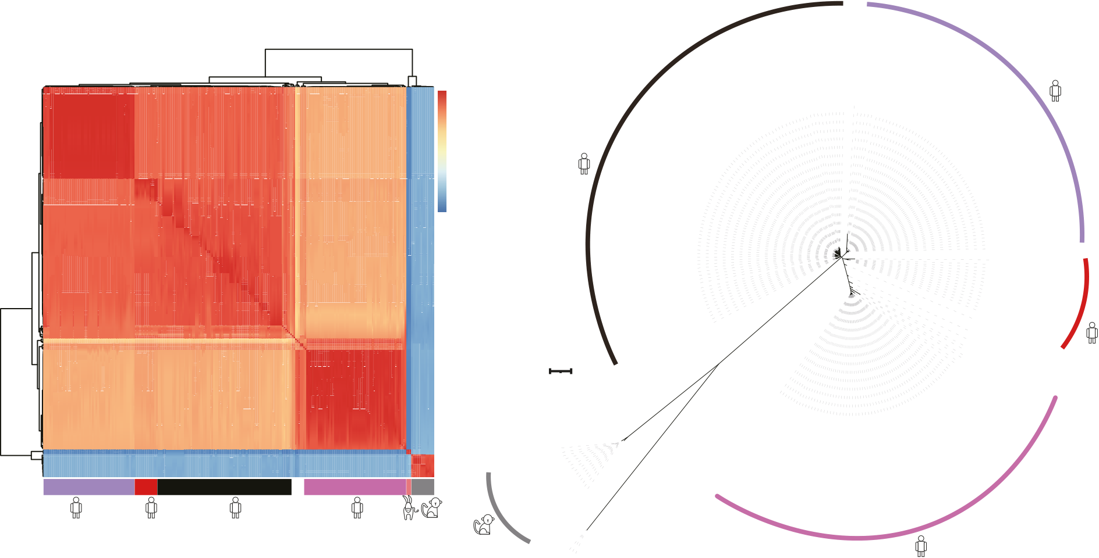
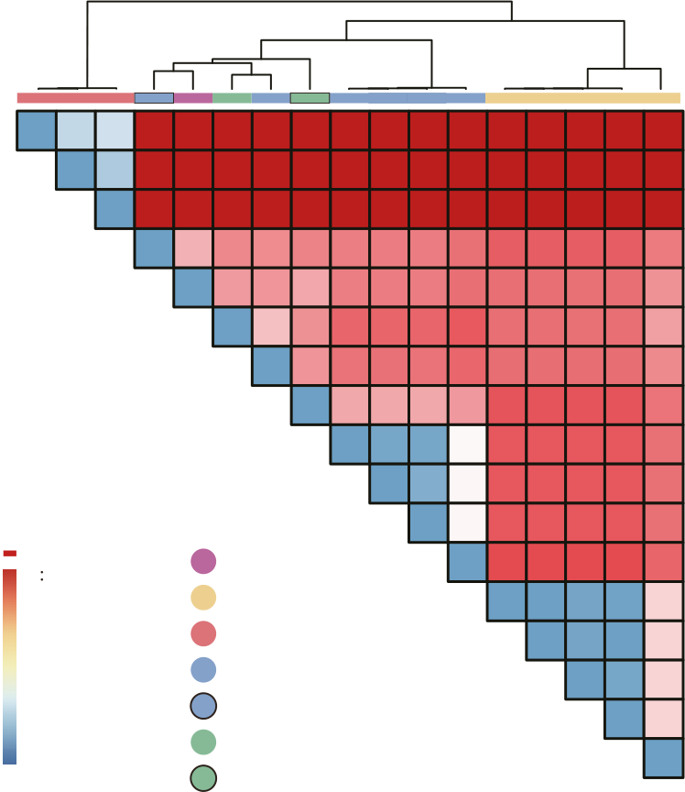
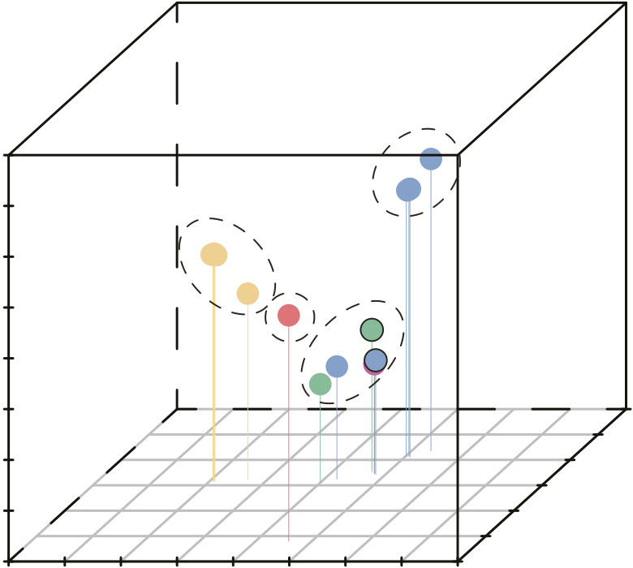
Article | https://doi.org/10.1038/s41467-024-54995-4

geneflowbetweenisolates inthegroupwithmultiplesubtypes. Inthe phylogenetic network analysis, these animal isolates formed four major clusterswithparalleledgesbetweenclustersofmonkeyisolates,sug-gesting the occurrence of gene flow (Fig. 2b). Results of the STRUCTURE analysisrevealedthepresenceofgenomeadmixtureinIiA17_45372,

monkey IbA12G3 isolate had 15,364 core SNPs compared to a human IbA12G3isolate,whichwasmuchhigherthanthe2006–3905SNPs between the latter and other human isolates (Fig. 3a and Supplemen-taryData2).Incontrast,InA17_46269,ImA20_46260,andmonkey IbA12G3 had high IBD values and low dxy values in most regions of the

InA14_45028, | InA17_46269, | ImA18_37833, | ImA20_46260, | and | eightchromosomes,indicatingthatthesegenomeswerehighly rela-

IbA12G3_46287,confirmingthepresenceofgeneticrecombination among the isolates (Fig. 2c and Supplementary Fig. 2d).
Origin of IbA12G3 subtype in NHPs
Thegp60subtypeIbA12G3isamemberofthehuman-pathogenicIb subtypefamilybuthasonlyrecentlybeendetectedinNHPs.The

ted(Fig. 2a and SupplementaryFig. 3). Inaddition, the results of the phylogenetic network analysis showed the presence of gene flow from InA17_46269 and ImA20_46260 to monkey IbA12G3 (Fig. 2b).
Phylogenetic topology weighting was performed on the genomes of InA17_46269, ImA20_46260, monkey IbA12G3, and human IbA12G3. ThisconfirmedthegeneticrelatednessofInA17_46269andmonkey

a | b | SRR11843801 IeA11G3T3 Ghana
a | Average | SRR11843801 IeA11G3T3 Ghana
a | nucleotide identity | SRR11843801 IeA11G3T3 Ghana
a | 1 | SRR11843801 IeA11G3T3 Ghana
0.9995
0.999
0.9985
0.998
Tree scale: 1
If | Ia | Ib
Subtype
c |  |  |  |  | IbA12G3 |  |  |  | ImA18 |  | InA14 |  |  | d |  | 0.00 |  |  | 0.91 | 0.92 | 0.92
 |  |  |  |  | IiA17 |  |  |  | ImA20 |  | InA1
PC3 | 0.8 | 0.8 | 0.6 | 0.4 |  |  |  |  |  |  | InA1 |  |  |  | 0.000.00 | 0.00 | 0.91 | 0.91 | 0.91 | 0.92 | 0.92 | 0.92 | 0.92 | 0.92 | 0.92 | 0.91 | 0.91 | 0.91 | 0.91 | 0.91 | 6430
 |  |  |  |  | IkA16G1
 |  |  |  |  | 45031 |  |  |  |  |  |  |  |  |  | 0.00 | 0.00 | 0.92 | 0.91 | 0.91 | 0.92 | 0.92 | 0.92 | 0.92 | 0.92 | 0.92 | 0.91 | 0.91 | 0.91 | 0.91 | 0.91 | 6427
 |  |  |  |  |  |  |  |  |  |  |  |  |  |  | 0.00 |  | 0.91 | 0.91 | 0.91 | 0.92 | 0.92 | 0.92 | 0.92 | 0.92 | 0.92 | 0.91 | 0.91 | 0.91 | 0.91 | 0.91 | 6410
 |  |  |  |  |  |  |  |  |  |  |  |  |  |  |  |  | 0.00 | 0.04 | 0.06 | 0.05 | 0.06 | 0.06 | 0.06 | 0.06 | 0.07 | 0.08 | 0.08 | 0.08 | 0.08 | 0.06 | 46260
 |  |  |  |  |  |  |  |  |  |  |  |  |  |  |  |  |  | 0.00 | 0.05 | 0.05 | 0.04 | 0.06 | 0.06 | 0.06 | 0.07 | 0.07 | 0.07 | 0.07 | 0.07 | 0.05 | 46287
 |  |  |  |  |  |  |  |  |  |  |  |  |  |  | Average dxy |  | 0.00 | 0.00 |  | 0.03 | 0.05 | 0.07 | 0.07 | 0.07 | 0.08 | 0.07 | 0.07 | 0.07 | 0.07 | 0.05 | 45028
45025
45034
45030
PC3 | 0.6
 |  |  |  |  |  |  |  |  |  |  |  |  |  |  |  |  |  | 0.00 |  |  | 0.05 | 0.07 | 0.07 | 0.07 | 0.07 | 0.07 | 0.07 | 0.07 | 0.07 | 0.06 | 37833
26772 27013
26783 26769
 |  |  |  |  |  |  |  |  |  |  |  |  |  |  |  |  |  | 0.00 |  |  |  | 0.04 | 0.04 | 0.04 | 0.05 | 0.08 | 0.08 | 0.08 | 0.08 | 0.07 | 46269
PC3 | 0.4
 |  |  |  |  | 45372 |  |  |  |  |  |  |  |  |  |  |  |  |  |  |  |  | 0.00 | 0.00 | 0.00 | 0.01 | 0.08 | 0.08 | 0.08 | 0.08 | 0.07 | 45030
PC3 | 0.2 | 0.8 | 0.6 | 0.4 | 6410  6430  6427 |  |  |  | 46269
 |  |  |  |  |  |  |  |  |  |  |  |  |  |  |  |  |  |  |  |  |  |  | 0.00 | 0.00 | 0.01 | 0.08 | 0.08 | 0.08 | 0.08 | 0.07 | 45025
PC3 | 0.0 |  |  |  |  |  |  |  |  |  |  |  |  |  |  |  |  | Subtype |  |  |  | 0.00 | 0.00 | 0.00 | 0.01 | 0.08 | 0.08 | 0.08 | 0.08 | 0.07 | 45034
 |  |  |  |  | 37833  45028 |  |  |  |  | 46260  46287
 |  |  |  |  |  |  |  |  |  |  |  |  |  |  | 0.92 |  | 0.00 | IbA12G3 |  |  |  | 0.00 | 0.00 | 0.00 | 0.00 | 0.09 | 0.09 | 0.09 | 0.09 | 0.07 | 45031
PC3 | −0.8−0.6−0.4−0.2 | 0.8 | 0.6 | 0.4 | 0.6 |  |  |  |  |  |  |  |  |  | 0.08 |  | 0.00 | IiA17 |  |  |  |  |  |  |  | 0.00 | 0.00 | 0.00 | 0.00 | 0.02 | 26783
 |  |  |  |  | 0.4 |  |  |  |  |  |  |  |  |  | 0.06 |  | 0.00 | IkA16G1 |  |  |  |  |  |  |  |  | 0.00 | 0.00 | 0.00 | 0.02 | 26783
 |  |  |  |  |  |  |  |  |  |  |  |  |  |  |  |  |  |  |  |  |  |  |  |  |  |  |  |  |  |  | 26769
 |  |  |  |  | 0.2
 |  |  |  |  |  |  |  |  |  |  |  |  |  |  | 0.04 |  | 0.00 | ImA18 |  |  |  |  |  |  |  |  |  | 0.00 | 0.00 | 0.02 | 26772
 |  |  |  |  | 0.0
 |  |  |  |  |  |  |  |  |  |  |  |  |  |  | 0.02 |  | 0.00 | ImA20 |  |  |  |  |  |  |  |  |  |  | 0.00 | 0.02 | 27013
 |  |  |  |  | −0.2
 |  |  |  |  | −0.4 |  |  |  |  |  |  |  |  |  | 0 |  | 0.00 | InA14 |  |  |  |  |  |  |  |  |  |  |  | 0.00 | 45372
 |  |  |  |  | −0.6 |  |  |  |  |  |  |  |  |  |  |  | 0.00 | InA17
 |  |  |  |  | 0.2 | 0.0 | −0.2 | −0.4 |  | −0.6 |  | −0.8
PC2

Fig. 1 | Genetic divergence of Cryptosporidium hominis isolates from monkeys and donkeys. a Pairwise comparisons of average nucleotide identity (ANI) of C. hominis genomes. b Phylogenetic relationships of C. hominis isolates inferred by maximum likelihood analysis of 35,248 core wgSNPs. These C. hominis isolates (colored by subtype family) formed 6 major clades. Among them, two divergent

marked with different colors (see figure key). c Principal component analysis (PCA) of animal isolates based on pruned SNPs, in which PC1, PC2, and PC3 account for variability among isolates. d Mean absolute divergence (dxy) between pairs of C. hominis genomes. Low dxy values indicate that the genomes are closely related. c,d Subtypes are marked with different colors (see figure key). Source data are pro-

clades contain the monkey and equine isolates. a, b Hosts and subtype families are | vided as a Source Data file.
Nature Communications| (2024) 15:10774 |  | 3

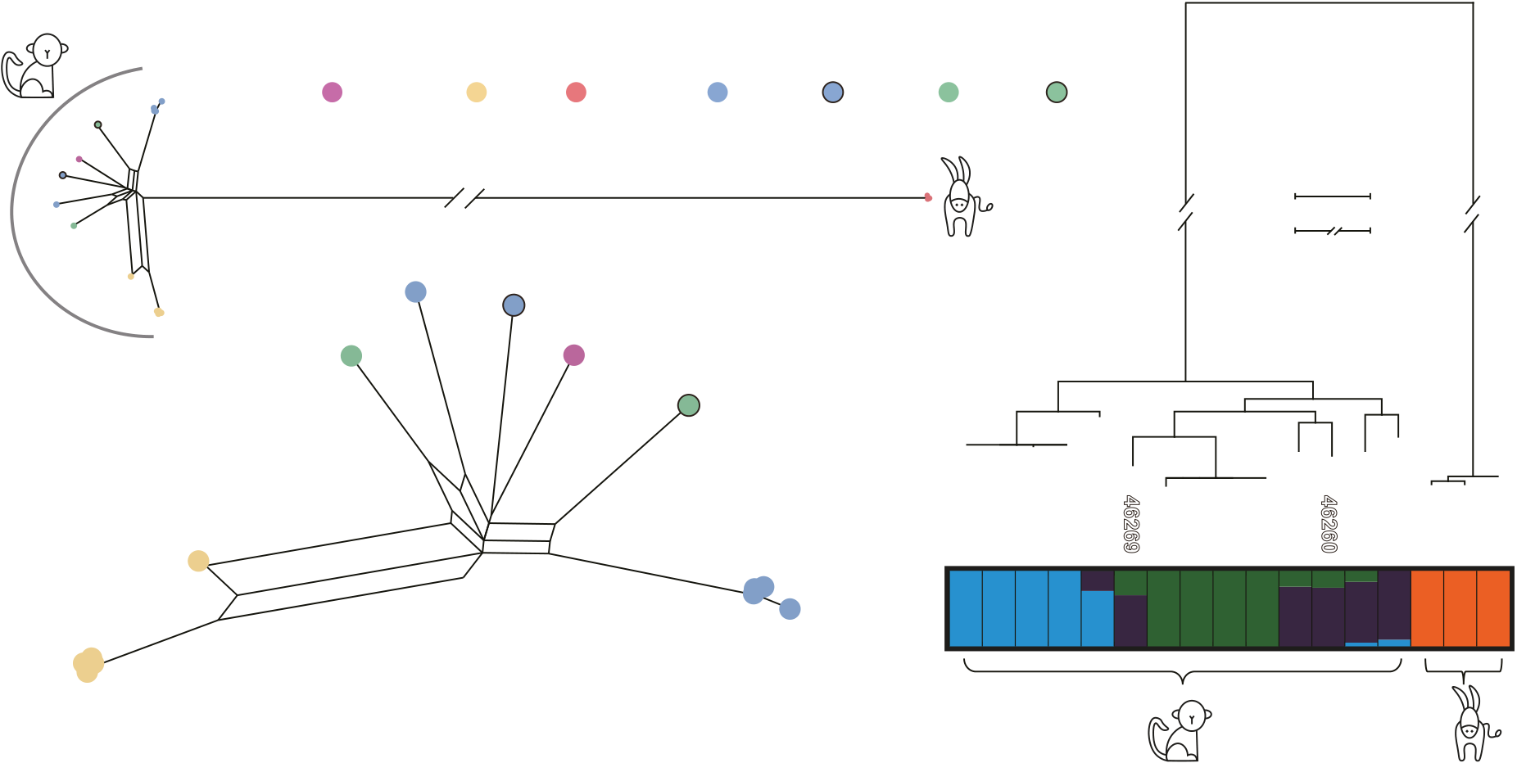
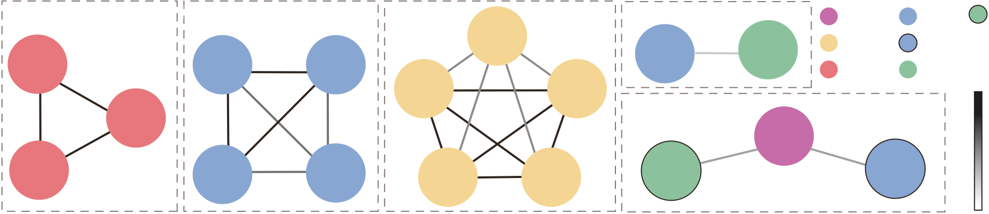
Article |  |  |  |  |  |  |  | https://doi.org/10.1038/s41467-024-54995-4
a | 6410 | Group 2 | 45034 | Group 3 | 45372 | 27013 | Group 4 | Subtype
Group 1 |  |  |  |  |  |  |  | IbA12G3 |  | ImA18 |  | InA17
6427 | 6410 | 45030 | 45034 | 26772 | 45372 | 27013 | 37833 | 45028 | IiA17 | ImA20
 |  |  |  |  |  |  |  | IkA16G1 |  | InA14 | IBD
 |  |  |  |  |  |  |  | 1.0
 |  |  |  |  |  |  | Group 5
46287
6430 | 45025 | 45031 | 26769 | 26783 | 46269 | 46260
0.8
b c
Subtype
IbA12G3 | IiA17 | IkA16G1 | ImA18 | ImA20 | InA14 | InA17
0.05
0.1
45372 | 45028 | 37833 | 46260 | 46287 | 46269 | 45025 | 100 | 93 | 100 | 99 | 94 | 97 | 91 | 100
 |  |  |  |  |  |  |  |  |  |  | 100 | 97 | 91 | 100
 |  |  |  |  |  |  |  |  |  | 100
45030
45034
K = 4
27013 45031
26772
26769
26783

Fig. 2 | Gene flow among animal-adapted Cryptosporidium hominis isolates. a Relatedness network for pairs of isolates inferred using identity-by-descent (IBD) analysis. Nodes represent isolates (colored by subtype family), while edges between nodes indicate IBD sharing. All edges with IBD higher than the threshold (IBD = 0.8) are shown. b A phylogenetic network of animal isolates based on 15,886 core wgSNPs. The parallel edges in the network indicate gene flow between isolates.

K = 4. The rooted ML tree was constructed using the TVM + G model implemented using 15,886 core wgSNPs. The major hosts of the clades are marked at the bottom panel and the isolates are colored by subtypes as in panel A. Each isolate is repre-sented by a single bar in 4 colored ancestral components depending on the K values used. Other results with K values of 2 to 7 are shown in Figure S2d. a–c Subtypes are marked with different colors (see figure key). Source data are provided as a Source

c Phylogeny and population structure of the divergent C. hominis isolates with | Data file.

IbA12G3, with the averageweightingofthetwo assister populations (topo4) accounting for 60% of the genome (Fig. 3b). The presence of other topologies indicated the occurrence of sequence introgression from other sources (Fig. 3b, c). Consistent with these findings, low dxy valueswereobservedbetweenmonkeyIbA12G3andInA17_46269in large regions of chromosomes 1 and 5, between monkey IbA12G3 and ImA20_46260onchromosomes4and8,andbetweenmonkeyand human IbA12G3 at the gp60 locus (Fig. 3d, colored boxes). In addition, themonkeyIbA12G3showedsubstantial dxyvaluesinsome areasof the genome (such as the 650–750 kb region on chromosome 1), sug-gestingthepresenceofadditionalintrogressionofotherexogenous sequences into this isolate.
The two IbA12G3_human isolates were collected in North America, while the monkeyIbA12G3isolate was found in China. Therefore,we also tested whether the Asian human isolates played a role in shaping the monkey IbA12G3 genome. The ML tree showed a very long branch

performed on the monkey IbA12G3, human IbA12G3, and the Chinese IaA18R4 genomes, as well as on the monkey IbA12G3, human IbA12G3, andtheDhakaIbgenomes.Thedatashowedthatthegeneticrelat-edness of human and monkey IbA12G3 was higher than that of monkey IbA12G3 and Asian isolates (Supplementary Fig. 4). The fewer SNPs and lowerdxyvaluesbetweenthehumanandmonkeyIbA12G3than between the latter and the Asian isolates further supported this finding (Supplementary Data 2 and Supplementary Fig. 3). These data suggest that the current Asian human isolates are divergent from the monkey isolates, despite being from the same geographic region.
Genetic recombination in other monkey C. hominis isolates TheIBDdatasuggestedthatInA17_46269andImA20_46260were under the influence of IbA12G3_46287 (Fig. 2a). Average weighting, fd, and dxy analyses confirmed the occurrence of ImA18 sequence intro-gressionintheInA17_46269genome,andImA18_37833sequence

fortheisolatefromaChinesehumanandtheformationofacluster | introgression |  |  | in | the | ImA20_46260 |  |  | genome |  | (Supplementary
with the If subtype family, while the Dhaka isolates formed its subclade | Figs. | 3 | and | 5). | Specifically, |  | the | former |  | involved |  | nucleotides

located in a mixed population with other human isolates from around the world (Fig. 1b). The data indicated that the Chinese isolate shared sequenceswiththeUSisolates,whiletheDhakaisolatesweresegre-gatedbygeographicorigin21.Phylogenetictopologyweightingwas

550 k–1000 k on chromosome 8, while the latter involved nucleotides 500 k–750 k on chromosome 2 (Supplementary Fig. 5).
Isolate37833wasanImA18subtypeatthegp60locus,butwas genetically related to InA14_45028 based on the IBD analysis (Fig. 2a).

Nature Communications| (2024) 15:10774 | 4

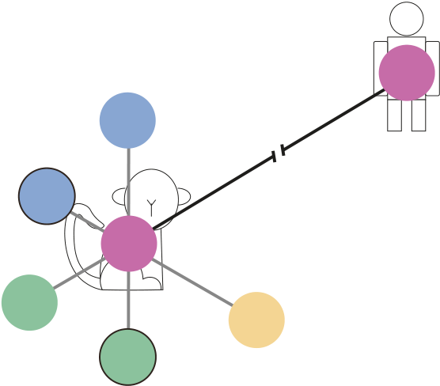

Article |  | https://doi.org/10.1038/s41467-024-54995-4
a | b
Ib_human
No. of SNPs between subtypes |  |  |  |  |  |  |  |  | ImA20  InA17 |  |  |  |  | Ib_human |  |  | InA17 |  | ImA20 |  |  | Ib_human |  | ImA20 |  | InA17  Ib_human | Ib_human | 0.1
IbA12G3
IbA12G3 |  |  |  |  |  |  |  |  | 0.6 | Outgroup
ImA18 |  |  |  |  |  | 15364 |  |  | 0.5
ImA20 |  |  | 1021 |  | 1126 |  | IiA17 |  | Average weighting  0.4  0.3  0.2 |  | Ib_human |  |  |  |  |  | ImA20  Ib_human |  | Ib_human |  |  | ImA20 |  | InA17  Ib_human |  | InA17  Ib_human | InA17 | 0.1
 |  |  |  |  |  |  |  |  |  |  |  |  |  |  |  |  |  |  | InA17 |  |  | InA17 |  |  |  | ImA20 | IbA12G3 | 0.1
 |  |  |  |  |  |  |  |  |  |  |  |  |  |  |  |  | IbA12G3  Outgroup |  | IbA12G3  Outgroup |  |  | IbA12G3  Outgroup |  | IbA12G3  Outgroup |  | IbA12G3  Outgroup | ImA20  Outgroup | 0.0
665
IbA12G3
 |  |  |  |  |  |  |  |  |  |  | ImA20
 |  |  |  |  |  |  |  |  |  |  | InA17 |  |  | InA17 |  | topo10 |  |  | topo5 |  |  | topo6 |  | topo8 |  | topo14 | topo15 | 0.0
820 |  |  |  |  |  |  |  |  |  |  |  |  |  | ImA20 |  |  |  |  |  |  |  |  |  |  |  |  |  | 0.0
 |  |  |  |  |  |  |  |  |  |  | IbA12G3 |  |  |  |  |  |  |  |  |  |  |  |  |  |  |  |  | 0.0
 |  |  |  |  |  |  |  |  |  |  | Outgroup |  |  | IbA12G3 |  |  |  |  |  |  |  |  |  |  |  |  |  | 0.0
InA14 |  | 832 |  |  |  |  |  |  |  |  |  |  |  | Outgroup |  |  |  |  |  |  |  |  |  |  |  |  |  | 0.0
 |  |  |  |  |  |  |  |  |  |  |  |  |  | InA17  Ib_human |  |  |  |  | Ib_human |  |  | InA17 |  | InA17 |  | Ib_human | Ib_human | 0.0
InA17 |  |  |  |  |  |  |  |  | 0.1 |  |  |  |  |  |  |  |  |  | InA17 |  |  | ImA20  Ib_human |  | ImA20  Ib_human |  | InA17 | ImA20 | 0.0
 |  |  |  |  |  |  |  |  |  |  |  |  |  | ImA20 |  |  |  |  | ImA20 |  |  |  |  |  |  | ImA20 | InA17 | 0.0
0.0 |  |  |  |  |  |  |  |  |  |  | topo4 | topo13 |  | IbA12G3 |  |  |  |  | IbA12G3 |  |  | IbA12G3 |  | IbA12G3  Outgroup |  | IbA12G3 | IbA12G3  Outgroup | 0.0
 |  |  |  |  |  |  |  |  |  |  | topo4 |  |  | Outgroup |  |  |  |  | Outgroup |  |  | Outgroup |  |  |  | Outgroup | IbA12G3  Outgroup | 0.0
 |  |  |  |  |  |  |  |  |  |  | topo4 |  |  | topo1 |  | topo2 |  |  | topo3 |  |  | topo7 |  | topo9 |  | topo12 | topo11 | 0.0
c |  |  |  |  |  |  |  |  |  |  |  |  |  | d |  | Subtype family |  |  |  |  |  |  |  |  |  |  |  | 0.0
 |  |  |  |  |  |  |  |  |  |  |  |  |  | Ib_human |  |  |  |  | ImA20 |  | InA17 |  |  |  |  |  |  | 0.0
1.0
0.5
1.0
 |  |  |  |  |  |  |  |  |  |  |  |  |  | dxy | 1.0 | 0 Mb 0.2 Mb 0.4 Mb 0.6 Mb 0.8 Mb
 |  |  |  |  |  |  |  |  |  |  |  |  |  | dxy | 0.5
 |  |  |  |  |  |  |  |  |  |  |  |  |  | dxy | 0.0
1.0  0.5  1.0 |  |  |  |  |  |  |  |  |  |  |  |  |  | dxy | 1.0
 |  |  |  |  |  |  |  |  |  |  |  |  |  | dxy | 0.5
 |  |  |  |  |  |  |  |  |  |  |  |  |  | dxy | 0.0
 |  |  |  |  |  |  |  |  |  |  |  |  |  | dxy | 1.0 | 0 Mb 0.2 Mb 0.4 Mb 0.6 Mb 0.8 Mb
1.0
0.5
1.0
 |  |  |  |  |  |  |  |  |  |  |  |  |  | dxy | 0.5
 |  |  |  |  |  |  |  |  |  |  |  |  |  | dxy | 0.0
 |  |  |  |  |  |  |  |  |  |  |  |  |  | dxy | 1.0 | 0 Mb |  | 0.2 Mb |  |  |  | 0.4 Mb |  | 0.6 Mb |  | 0.8 Mb | 1.0 Mb
Weighting | 1.0
0 Mb 0.2 Mb 0.4 Mb 0.6 Mb 0.8 Mb 1.0 Mb
0 Mb 0.2 Mb 0.4 Mb 0.6 Mb 0.8 Mb 1.0 Mb
Weighting | 0.5 |  |  |  |  |  |  |  |  |  |  |  |  | dxy | 0.5
Weighting | 1.0 |  |  |  |  |  |  |  |  |  |  |  |  | dxy | 0.0
Weighting | 1.0 |  |  |  |  |  |  |  |  |  |  |  |  | dxy | 1.0
Weighting | 1.0
Weighting | 0.5 |  |  |  |  |  |  |  |  |  |  |  |  | dxy | 0.5
Weighting | 1.0 |  |  |  |  |  |  |  |  |  |  |  |  | dxy | 0.0
1.0  0.5  1.0 |  |  |  |  |  |  |  |  |  |  |  |  |  | dxy | 1.0
 |  |  |  |  |  |  |  |  |  |  |  |  |  |  |  | gp60
 |  |  |  |  |  |  |  |  |  |  |  |  |  | dxy | 0.5
 |  |  |  |  |  |  |  |  |  |  |  |  |  | 0.0  1.0  0.5  0.0  1.0  0.5  0.0 |  | 0 Mb |  | 0.2 Mb |  | 0.4 Mb |  |  | 0.6 Mb |  | 0.8 Mb | 1.0 Mb | 1.2 Mb
1.0
0.5
1.0
0 Mb 0.2 Mb 0.4 Mb 0.6 Mb 0.8 Mb 1.0 Mb 1.2 Mb
0 Mb 0.2 Mb 0.4 Mb 0.6 Mb 0.8 Mb 1.0 Mb 1.2 Mb
1.0
0.5
1.0
0 Mb |  |  |  | 0.2 Mb |  |  | 0.4 Mb | 0.6 Mb | 0.8 Mb |  | 1.0 Mb |  | 1.2 Mb

Fig. 3 | Origin of Cryptosporidium hominis IbA12G3 subtype from monkeys. a Overall genetic differences between monkey and human IbA12G3 isolates based on the number of core wgSNPs shared between isolates. b Genome-wide dis-tribution of phylogenetic relationships among the monkey IbA12G3, ImA20_46260, InA17_46269, and human IbA12G3 using a 50-SNP sliding window with IkA16G1 as the outgroup. The top panel shows all possible topologies, while the bottom panel shows the genome-wide average weighting of each topology. c Distribution of

topology weightings (colors as in B) across eight chromosomes. d Distribution of dxy values between the monkey IbA12G3 genome and the ImA20_46260,
InA17_46269, and human IbA12G3 genomes across the eight chromosomes. The green and blue boxes show regions with high sequence identity between monkey IbA12G3 and InA17_46269 and ImA20_46260, respectively, while the purple box shows the introgression of the human IbA12G3 sequence into monkey IbA12G3. Source data are provided as a Source Data file.

Thegeneratedphylogeneticnetworkandthemeandxyshowedthat |  |  |  |  |  |  |  | equine, and monkey C. hominis isolates were largely collinear with only a few minor structural differences (Fig. 4a and Supplementary Fig. 7).
ImA18_37833 | was | under | the | influence | of | InA14_45028 | and

IbA12G3_46287(Fig.1dandSupplementaryFig.3).Phylogenetic topology weighting of these isolates and the ImA18 population showed no dominance of any specific topology across the eight chromosomes, indicating the occurrence of multiple sequence introgression events in

AmongtheC.hominisgenomes,allmonkeyisolateshadan approximately 16 kb insertion in the 5′ region of chromosome 5. This region contained the orthologs of the CPCDC_5g5511, CPCDC_5g5500, CPCDC_5g5490, and CPCDC_5g5480 genes, which encode an INS-like

ImA18_37833. | The | results | of | the | dxy | analysis | suggested | that | protease,an NFDQsecretory protein,andtwoMEDLEsecretory pro-

IbA12G3_46287contributedalargeregionofchromosome1,ImA18 contributedregionsofchromosomes1,6,and7,whileInA14_45028 contributedregionsofchromosomes4and6(Supplementary Fig.6a–c).Similarly,theIiA17isolatesanalyzedinthisstudyshowed high identity to each other, except for IiA17_45372, which appeared to havegeneflow from InA14_45028. A large region oftheInA14_45028 with an fd value of 1 and low dxy values was present on chromosome 7, confirmingtheoccurrenceofInA14_45028sequenceintrogression into IiA17_45372 (Supplementary Fig. 6d–g).
Differences in gene content among genomes of NHP, equine and human C. hominis subtypes
We obtained short-read assemblies of other animal C. hominis isolates, with genome sizes ranging from 8.97 to 9.12 Mb in 62 to 825 contigs. The majority of them were comparable in completeness to the new C. hominisIbA12G3_46287genome(SupplementaryFig.1).Thedataof wholegenomealignmentshowedthatthegenomesfromhuman,

teins (Supplementary Fig. 7a). The CPCDC_5g5480 gene was also pre-sentintheequineisolates.Inread-mapping,readsfrommonkeyor equine isolates were mapped to these loci, but no reads were mapped fromhumanisolates(Fig.4b).ThesedataandthePCRresultssup-ported gene insertions and deletions (Supplementary Fig. 8).
Althoughwecannotdeterminetheexactcopynumbersofthe subtelomeric INS and MEDLE genes in the genomes of C. hominis iso-lates from NHP due to the collapse of highly identical sequences at the 5′ end of chromosome 1 and the 3′ ends of chromosomes 7 and 8, the absenceofsuchgenesintheC.hominisgenomesofhumanisolates was determinednotonlybyaligningallassembliestothenewrefer-ence genome but also by blast analyses, read mapping, and PCR. For example, no reads from human C. hominis isolates were mapped to the orthologsofgenesCPCDC_5g5511(anINSgene),CPCDC_5g5490(a MEDLE gene), and CPCDC_5g5480 (another MEDLE gene) at the 5′ end ofchromosome5oftheC.hominisIbA12G3_46287(Fig.4b).The resultsofthePCRanalysissupportedthepresenceofseveralC.

Nature Communications| (2024) 15:10774 | 5

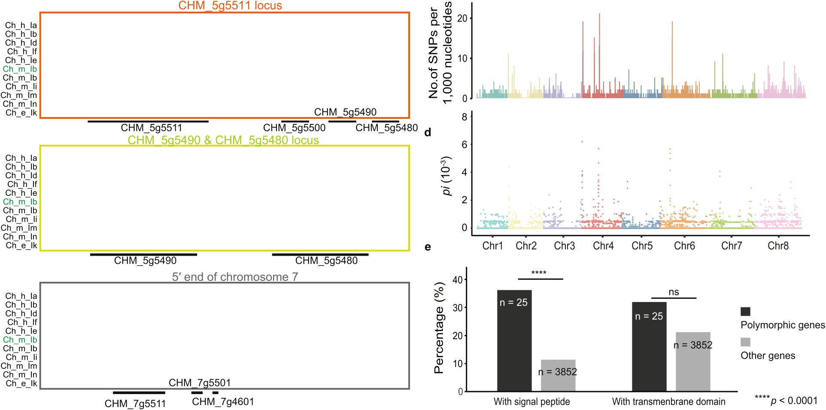
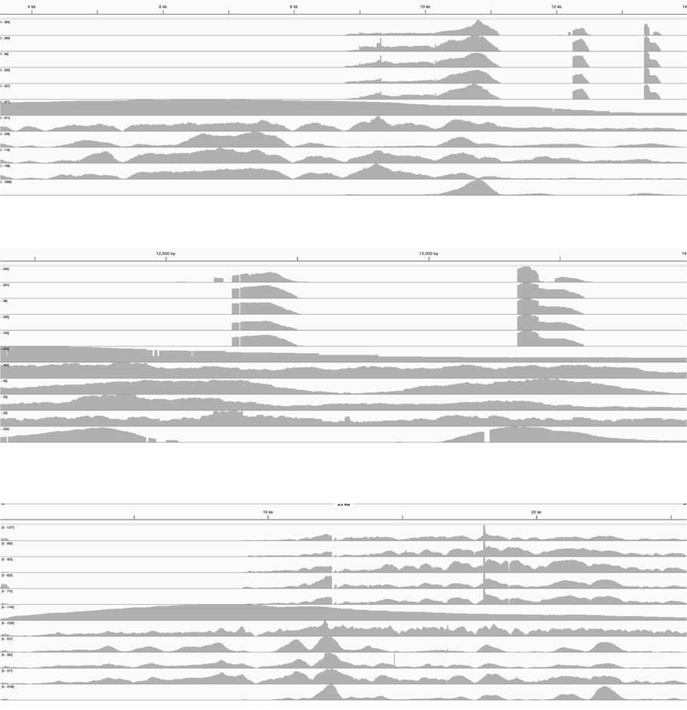
Article |  | https://doi.org/10.1038/s41467-024-54995-4
 |  | 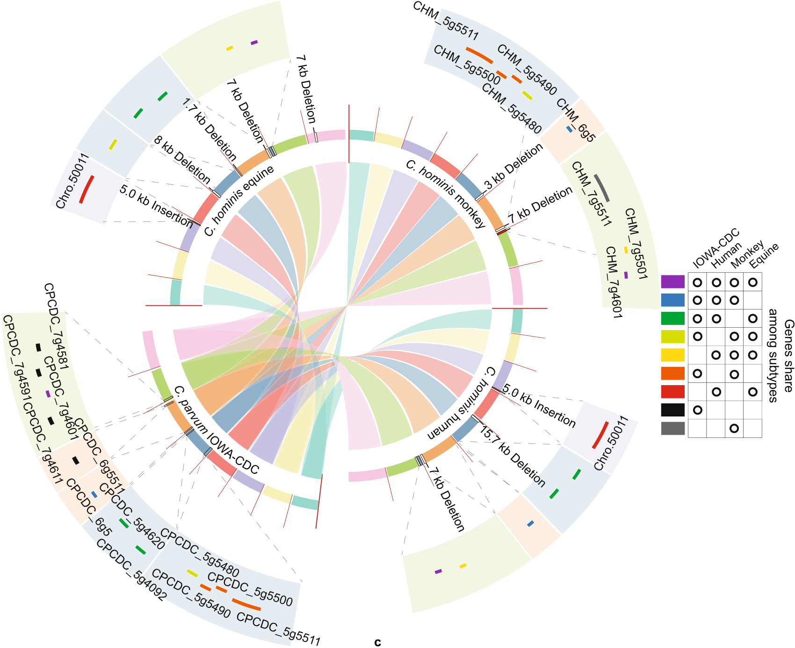

parvum-associatedgenesintheNHPisolatesbutnotinthehuman isolates (Supplementary Fig. 8). Blastn analysis of genome assemblies from C. hominis human isolates did not find any sequences of the INS gene,whileonlyonesequenceoftheMEDLEgenewasfoundand identifiedasanorthologofCPCDC_7g4601.Intblastnanalysisof databases constructed with short reads from Illumina sequencing, the protein sequence of the INS gene (CHM_5g5511) pulled out some reads from C. hominis monkey and C. parvum isolates with average identities

of 100% and > 90%, respectively, but with the average identity of <50% fromC.hominishumanisolates.Thelatterwereassembledtoan orthologofCPCDC_3g4270(anINS-likegenewithnoCNVbetween isolates).TheproteinsequencesoftheMEDLEgenes(CHM_5g5490 andCHM_5g5480)pulledoutreadsinC.hominisNHPandhuman isolates with maximum identities of 100% and 80%. These reads from theNHPandhumanisolateswereassembledtothreesequences (representingtheorthologsofCPCDC_5g5490,CPCDC_5g5480,and

Nature Communications| (2024) 15:10774 | 6

Article | https://doi.org/10.1038/s41467-024-54995-4

Fig. 4 | Genomic differences among Cryptosporidium hominis genomes. a Syntenic relationship in gene organization among genomes of human, monkey, and equine C. hominis isolates using the C. parvum IOWA-CDC and the C. hominis IbA12G3 genomes as the references. The genomes are largely colinear. Copy number variations (CNVs) of genes between C. hominis genomes were detected by genome alignment and verified by read-mapping, blast analyses, and nested PCR.
The CNVs are shown in blocks of different colors (see figure key). Among the genomes analyzed, the orthologs of CPCDC_5g5511 and CPCDC_5g5490 (the orange block) are absent in human and equine C. hominis isolates, while the ortholog of CPCDC_5g5480 (the light green block) is absent in human C. hominis; orthologs of CPCDC_5g4092 and CPCDC_5g4620 (the green block) are absent in monkey C. hominis; the ortholog of CPCDC_6g5 (the blue block) is absent in equine C. hominis; the ortholog of Chro.50011 (the red block) is absent in C. parvum and monkey C.
hominis isolates. Monkey C. hominis genomes have an additional copy of the

ortholog of CPCDC_5g5511 (the gray block) on chromosome 7, compared with other genomes analyzed. All C. hominis genomes do not have orthologs of CPCDC_6g5511, CPCDC_7g4611, CPCDC_7g4591, and CPCDC_7g4581 (the black block). b Confirmation of the subteleomeric genes in animal-adapted C. hominis subtypes using read-mapping. All reads were mapped to the chromosome-level reference genome of C. hominis. Data from PacBio are highlighted in green. c Distribution of core SNPs in monkey C. hominis genomes by chromosome (with a 1000 bp sliding window and 500 bp steps). d Nucleotide diversity (Pi) among monkey C. hominis genomes using a 1000 bp sliding window. e Differences in the distribution of genes encoding proteins with signal peptides and transmembrane domains between highly polymorphic genes and other genes. Highly polymorphic genes are more likely to encode proteins with signal peptides (p = 7.5 × 10−15). Sta-tistical analysis was performed using the one-tailed chi-squared test. Source data are provided as a Source Data file.

CPCDC_7g4601)andonesequence(representingtheorthologof CPCDC_7g4601),respectively.Theseresultssupporttheconclusion that C. hominis human isolates lacked the one INS and the two MELDEL genesdetectedinC.hominisNHPisolates(SupplementaryTable5).

evaluatetheinfectivityofmonkeyC.hominisisolatestomice.GKO micewereinoculatedwith104oocystsofImA20,InA17,andthe monkeyIbA12G3.ResultsofqPCRanalysisshowedthatmost mice were positive 4 days post infection (DPI) (Fig. 5a). DNA sequence

Since increased read coverage and multiple read types were observed | analysis | of | the | gp60 | gene | confirmed | that | the | subtypes | of

in a 10 kb region at the 5′ end of chromosome 7 in the monkey isolate IbA12G3_46287,whichcontainedtheothercopyoftheorthologof CPCDC_5g5511,C.hominisNHPisolatesmayhaveseveraladditional

oocystsproducedinthemice atthepeak of infection(DPI9)andat other times matched those of the inoculated oocysts (Supplementary Fig. 9a, b), confirming thatthe mice were infected with these C. hominis

copies of the CPCDC_5g5511 gene (Fig. 4b, Supplementary Fig. 1a, and subtypes.

Supplementary Table 5).
Itisalsodifficulttodeterminethecopynumberofthe CPCDC_5g5500geneinC.hominisisolates.Thegeneencodesa secretory NFDQ protein and is located atthe 5′ end of chromosome 5 in C. parvum. A paralog of it is located at the 3′ end of chromosome 6 in C. parvum.Bothcopiesarenextofthetwocopiesofthesubtelomeric INSgene(CPCDC_5g5511andCPCDC_6g5511).IntheC.hominis IbA12G3_46287 genome, these two copies of the NFDQ gene are loca-ted at the 5′ ends of chromosome 5 and chromosome 7. The increase in

OocystsheddinginmiceinfectedwiththeIOWA-Waterborne isolateofC.parvumpeakedatDPI9(oocystspergramof feces,OPG = 4logs)andbegantodecline,eventuallybecoming negativeafterDPI60(Fig.5a).Incontrast,themiceinfectedwith monkey C. hominis isolates showed a rapid increase in oocyst shedding intensity,withOPGreaching6logsonDPI9.Thereafter,OPGlevels decreased slowly but remained positive for over 80 days. Peak OPGs and mean OPGs over 80 days were significantly higher in mice infected monkeyisolatesthaninmiceinfectedwiththeIOWA-Waterborne

read depth in a telematic region at the 5′ end of chromosome 7 con- isolate.

taining the CHM_7g5501 (ortholog of CPCDC_5g5500 inC. parvum) and the appearance of several read types suggest that the monkey isolate mayhaveadditionalcopiesofthisgene(Fig.4bandSupplementary Fig.1a).Thisislikelypartofthesequencecompressionatthechro-mosome ends. In addition, this increase in read coverage of the NFDQ gene occurred in other C. hominis isolates (Fig. 4b).
Allmonkeyisolateshada3 kbdeletioninthe3′region ofchro-mosome 5. This resulted in the loss of two orthologs of CPCDC_5g4620 and CPCDC_5g4092 (Supplementary Fig. 7c). The equine isolates had a 1.7 kb deletion in the 5′ region of chromosome 6, resulting in the loss of

Histological examination at DPI 12 revealed that the parasite load in the ileum was significantly higher in mice infected with monkey C. hominisisolatesthaninthoseinfectedwiththeIOWA-Waterborne isolate (Supplementary Fig. 9c). In addition, the intestinal villus length/ cryptdepth(v/c)ratiowassignificantlylowerinmiceinfectedwith monkeyisolates,butnotinthoseinfectedwithIOWA-Waterborne (Fig.5c,d).Scanningelectronmicroscopy(SEM)analysisoftheileal tissue confirmed the presence of abundant parasites on the intestinal epithelium of mice infected with monkey isolates, particularly IbA12G3 (Fig.5e).Noparasiteswereobservedintheintestinaltissuesof

theortholog ofCPCDC_6g5,whiletheyhada5 kbfragmentinthe3′ uninfected mice.
regionofchromosome3containingaC.hominisspecificgene,
Chro.50011, which was absent in the monkey isolates (Supplementary Differences in virulence and infectivity between monkey C.
Fig. 7d). Read mapping and blast results supported the validity of these hominis isolates

gene insertions and deletions.
Sequence differences among monkey C. hominis isolates
There were 2314 SNPs in the core genome (without telemetric regions) among the monkey C. hominis isolates. Altogether, 25 genes displayed substitution rates above the threshold (average + 3 SD) and contained morethantwoSNPs(Fig.4candSupplementaryTable6).These findingsweresupportedbythePivaluesamongthesegenomes (Fig.4d).Mostofthepolymorphicgeneswerelocatedinthesub-telomeric regions of the chromosomes and encoded mostly proteins withthesignalpeptides(Fig.4e).Theyincludedfourgenesencode mucinproteins(theorthologsofCPCDC_2g420,CPCDC_2g450, CPCDC_4g1300, and CPCDC_6g1080) (Supplementary Table 6).
Mouse infectivity of monkey C. hominis isolates
ThepresenceofseveralsubtelomericINSandMEDLEgenesthatare associatedwithbroadhostrangeofC.parvumpromptedusto

OPGlevelsofmiceinfectedwithInA17andImA20subtypesreached almost 7 logs but decreased to 4 logs within 1 month. In contrast, OPG levels of mice infected with IbA12G3 reached over 7 logs and remained athighlevels (6 logs) fortwomonths(Fig.5a). In addition,themice infected with IbA12G3 and InA17 had slightly reduced body weight gain (Fig.5b).Thehighervirulence ofIbA12G3was also supportedby the measurementofparasiteburdenandv/cratiointheilealtissue (Fig. 5c,d and Supplementary Fig. 9c).
In experimental infections of GKO mice with varying numbers of oocysts, a single IbA12G3 oocyst resulted in infection in three of eight mice, with a calculated ID50 of seven oocysts. On the other hand, five InA17 oocysts were able to induce infection in five of eight mice, with ID50 values of eight oocysts. In contrast, even the use of 1000 ImA20 oocysts induced infections in only two of four mice, with a calculated ID50 of >1000 oocysts (Supplementary Table 7). The prepatent period andthetimetopeakoocystsheddingwerelongerinmiceinfected with lower oocyst doses (Fig. 5f–h).

Nature Communications| (2024) 15:10774 | 7

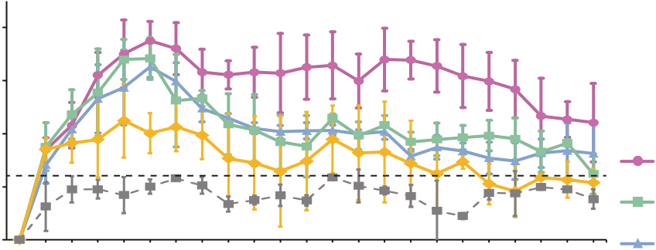
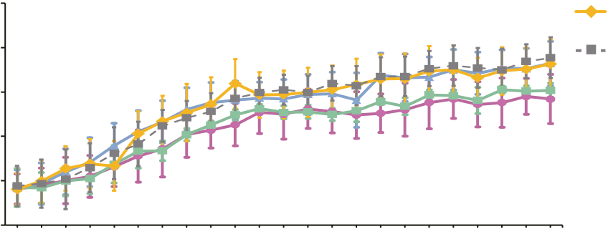
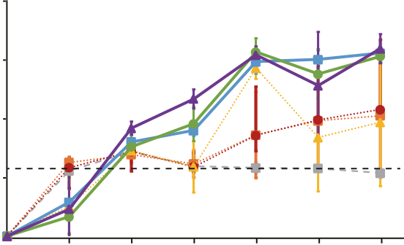
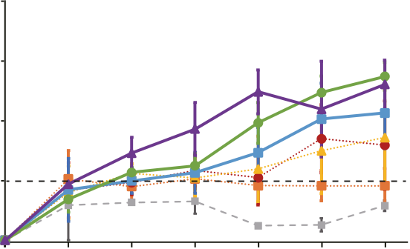
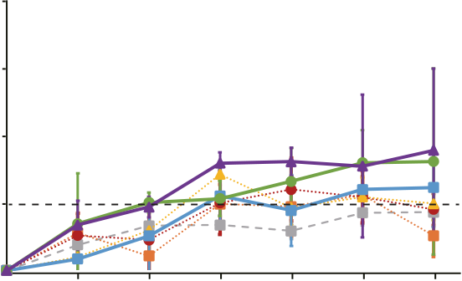
Article |  |  |  |  |  |  |  |  |  |  |  |  |  |  |  |  |  |  |  |  |  |  |  |  |  |  |  |  |  |  |  |  |  |  |  |  |  |  |  |  |  |  |  |  |  | https://doi.org/10.1038/s41467-024-54995-4
a |  |  |  |  |  |  |  |  |  |  |  |  |  |  |  |  |  |  |  |  |  |  | e |  |  |  |  |  |  |  |  |  |  |  |  |  |  |  |  |  |  |  |  |  |  | IbA12G3 InA17 ImA20 |  | 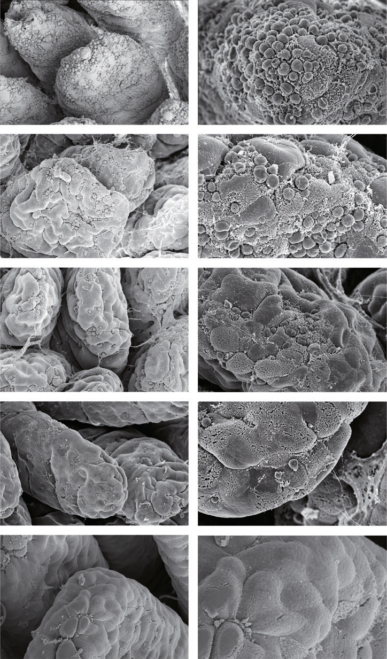
Oocysts per gram | of feces (log) |  | 8 |  |  |  |  |  |  |  |  |  |  |  |  |  |  |  |  |  |  |  | IbA12G3
Oocysts per gram |  |  | 6
Oocysts per gram |  |  | 4
Oocysts per gram |  |  | 2
0 |  |  |  |  |  |  |  |  |  |  |  |  |  |  |  |  |  |  |  |  |  |  | InA17
b | 30 |  |  |  | 0 |  | 2 | 4 | 6 |  | 9 | 12 |  | 15 | 18 |  | 21 |  | 24 | 27 |  | 30 |  | 33 |  | 36 |  | 41 |  | 46 | 51 | 56 |  | 61 |  | 66 |  | 71 | 76 |  | 80 | ImA20
IOWA-Waterborne
Bodyweight (g) |  | 25 |  |  |  |  |  |  |  |  |  |  |  |  |  |  |  |  |  |  |  |  | Negative control
 |  | 20
 |  | 15
 |  | 10
5
0 |  |  |  |  |  |  | 2 | 4 | 6 |  | 9 | 12 |  | 15 | 18 |  | 21 |  | 24 | 27 |  | 30 |  | 33 |  | 36 |  | 41 |  | 46 | 51 | 56 |  | 61 |  | 66 |  | 71 | 76 |  | 80
Days post infection
c |  |  |  |  |  |  |  |  |  |  | d |  |  |  |  |  |  |  |  |  |  |  | 0.0043
0.0022 |  |  |  |  |  |  |  |  |  |  |  |  |  |  |  |  |  |  |  |  |  |  | 0.0051 |  |  |  |  |  |  |  |  |  |  |  |  |  |  |  |  |  |  |  |  |  |  | Waterborne Negative control
120  No. of parasites on a villus  90  60  30  0 |  |  |  |  |  | 0.0007 |  |  |  |  |  |  |  |  |  |  |  |  |  |  |  |  | Villus length / Crypt depth (V/C) |  |  |  |  |  | 8 | 0.0186 |  |  |  |  |  |  |  |  |  |  |  |  |  |  | IOWA-
 |  |  |  |  |  | 0.0126  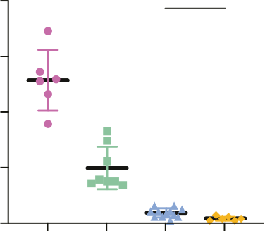 |  |  |  |  |  |  |  |  |  |  |  |  |  |  |  |  |  |  |  |  |  |  | 8 | 0.3434  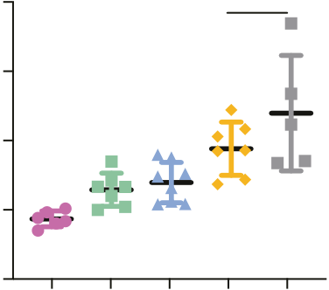 |  |  |  |  |  |  |  |  |  |  |  |  |  |  | IOWA-
 |  |  |  |  |  |  |  |  |  |  |  |  |  |  |  |  |  |  |  |  |  |  |  |  |  |  |  |  | 6
 |  |  |  |  |  |  |  |  |  |  |  |  |  |  |  |  |  |  |  |  |  |  |  |  |  |  |  |  | 4
 |  |  |  |  |  |  |  |  |  |  |  |  |  |  |  |  |  |  |  |  |  |  |  |  |  |  |  |  | 2
 |  |  |  |  |  |  |  |  |  |  |  |  |  |  |  |  |  |  |  |  |  |  |  |  |  |  |  |  | 0
 |  |  |  |  |  | Ib |  |  |  | In |  |  |  | Im |  |  |  | IOWA |  |  |  |  |  |  |  |  |  |  | 0 | Ib |  |  |  | In |  |  | Im |  |  | IOWA |  |  | Control |  | IOWA-
f |  |  |  |  |  |  |  |  |  |  |  |  |  |  |  |  |  |  |  |  |  |  | g
 |  |  |  |  |  |  |  |  |  |  |  |  |  |  |  |  |  |  |  |  |  |  |  |  |  |  |  |  |  |  |  |  |  |  |  |  |  |  |  |  |  |  |  |  |  | h
Oocysts per gram of feces (log) | 8 | 0 |  | IbA12G3 |  |  |  |  | 4 |  |  |  | 6 |  |  | 9 |  |  |  |  | 12 |  |  |  | 15 |  |  |  |  | Oocysts per gram of feces (log) |  | 8 | 0 |  | InA17 |  |  |  |  | 4 |  |  | 6 | 9 |  | 12 | 15 |  | Oocysts per gram of feces (log) | 8 | 0 | ImA20 | 4 |  | 6 | 9 | 12 | 15
Oocysts per gram of feces (log) | 6 |  |  | 2 |  |  |  |  |  |  |  |  |  |  |  |  |  |  |  |  |  |  |  |  |  |  |  |  |  |  |  | 6 |  |  | 2 |  |  |  |  |  |  |  |  |  |  |  |  |  |  | 6 | 0 | 2
Oocysts per gram of feces (log) | 4 |  |  |  |  |  |  |  |  |  |  |  |  |  |  |  |  |  |  |  |  |  |  |  |  |  |  |  |  |  |  | 4 |  |  |  |  |  |  |  |  |  |  |  |  |  |  |  |  |  | 4
Oocysts per gram of feces (log) | 2 |  |  |  |  |  |  |  |  |  |  |  |  |  |  |  |  |  |  |  |  |  |  |  |  |  |  |  |  |  |  | 2 |  |  |  |  |  |  |  |  |  |  |  |  |  |  |  |  |  | 2
Oocysts per gram of feces (log) | 0 |  |  |  |  |  |  |  |  |  |  |  |  |  |  |  |  |  |  |  |  |  |  |  |  |  |  |  |  |  |  | 0 |  |  |  |  |  |  |  |  |  |  |  |  |  |  |  |  |  | 0
 |  |  |  |  |  |  |  |  | Days post infection |  |  |  |  |  |  |  |  |  |  |  |  |  |  |  |  |  |  |  |  |  |  |  |  |  |  |  |  |  |  | Days post infection |  |  |  |  |  | Days post infection
Negative control |  |  |  |  |  |  |  |  |  |  |  |  |  |  |  |  |  |  |  |  |  |  |  |  |  |  | 1 oocyst |  |  |  |  |  |  |  | 5 oocyst |  |  |  |  |  |  |  | 10 oocyst |  |  | 50 oocyst |  |  |  | 100 oocyst |  |  |  | 1000 oocyst

Fig. 5 | Differences in infection patterns and virulence among three Cryptos-poridium hominis isolates from monkeys. a Oocyst shedding patterns in interferon-γ knockout mice (n = 6 per group, C. hominis IbA12G3, InA17, and ImA20, C. parvum IIaA17G2R1, and uninfected). The detection threshold is indicated by the dotted line. The peak values of oocysts per gram of feces (OPG) of IbA12G3, ImA20, and InA17 are significantly higher than those of IIaA17G2R1 (p = 0.0022, 0.0022, and 0.0095), and the mean OPGs of IbA12G3, ImA20, and InA17 over 80 days are sig-nificantly higher than those of IIaA17G2R1 (p < 0.0001, p < 0.0001, and p < 0.0001). The mean OPG of IbA12G3 over 80 days is significantly higher than that of ImA20 and InA17 (p < 0.0001 and p < 0.0001). Statistical analysis was performed using the two-tailed Wilcoxon signed-rank test. b Differences in body weight among the five groups of mice. c Mean number of parasites per villus in the small intestine of infected mice (n = 3 per group). The number of parasites after C. hominis infection

was significantly higher than that of C. parvum IIaA17G2R1 subtype (p = 0.0022, 0.0007, and 0.0126 for IbA12G3,InA17, and ImA20). d Differences in the villus/crypt height ratio (v/c) of the ileum of infected mice. The v/c values of mice infected with monkey C. hominis were significantly lower than those of healthy mice (p = 0.0043, 0.0051, and 0.0186 for IbA12G3, InA17, and ImA20), while there was no significant difference between C. parvum IIaA17G2R1-infected and uninfected control mice (p = 0.3434). c, d Statistical analyses were performed using the two-tailed
Mann–Whitney U test. e Scanning electron microscopy images of the ileum and colon of GKO mice of the five groups (n = 3). Scale bars = 30 µm (left) and = 10 µm (right). f–h Oocyst shedding patterns of GKO mice infected with different doses (1000 (n = 4), 100 (n = 4), 50 (n = 6), 10 (n = 6), 5 (n = 8), 1 (n = 8), and 0 (n = 4)) of IbA12G3, InA17, and ImA20 isolates. a,b,c,d,f,g,h Data are presented asmean values +/−SD. Source data are provided as a Source Data file.

Contribution of subtelomeric MEDLE and INS genes to C. hominis infectivity in mice | abletogenerateamutantexpressingtdTomatobutlackingthe CHM_5g5480 and CHM_5g5490 (Fig. 6c). The complete deletion of the

To assess the biological significance of the MEDLE and INSgenes,we firstattemptedtoreplacetheadditionalCHM_5g5480,CHM_5g5490 andCHM_5g5511genesintheIbA12G3genome (theorthologsofthe CPCDC_5g5480,CPCDC_5g5490,andCPCDC_5g5511genesinC.par-vum)withthetdTomatosequence(Fig.6a,b).Amongthem, CHM_5g5480andCHM_5g5490weredispensablebecausewewere

genes was confirmed by the read mapping results, which showed that thelocuscouldnotbefullycoveredbythereadsfromtheIbA12G3-ΔCHM_5g5480/5490 line (Fig. 6d). The PCR analysis also confirmed the complete deletion of the genes (Supplementary Fig. 10a).
Afterseveralfailedattemptstoknockoutthefulllengthofthe CHM_5g5511 (INS) gene, an alternative approach was taken to remove

Nature Communications| (2024) 15:10774 | 8

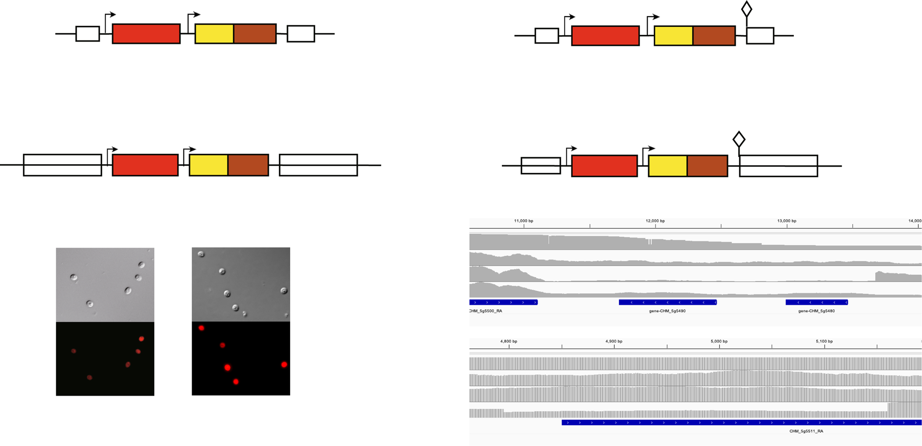
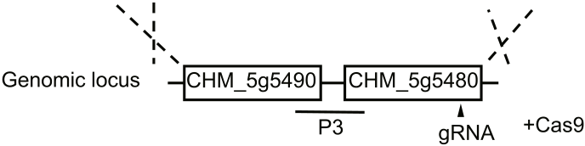
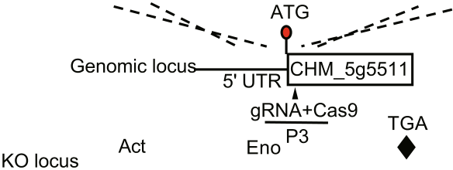
Article |  |  | https://doi.org/10.1038/s41467-024-54995-4
 |  |  | 
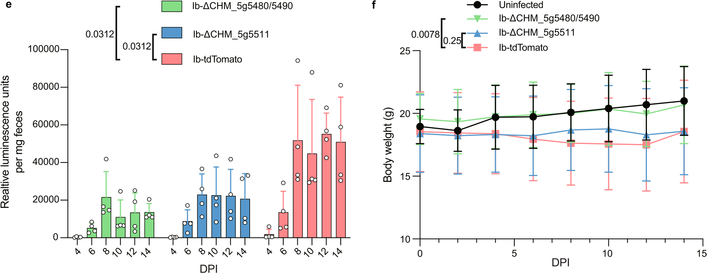

Fig. 6 | Subtelomeric MEDLE and INS genes play important roles in C. hominis infectivity in mice. a, b Strategy used to replace the target region with sequences encoding tdTomato, NanoLuciferase (Nluc), and neomycin-resistance gene (Neo). a The region containing CHM_5g5490 and CHM_5g5480 was deleted. b The 310 bp from the 5′ end of the Ib-CHM_5g5511 gene was deleted, and a stop codon was inserted downstream of the deletion site. c Microscopy of oocysts from mice infected with the transgenic parasites, with all oocysts being red. Scale bars in the figures are 10 µm. d Confirmation of the knockout genes in C. hominis
IbA12G3 strain using read mapping. All reads were mapped to the chromosome-level reference genome of C. hominis. e Oocyst shedding patterns in uninfected

partial deletion of CHM_5g5511 (Ib_ΔCHM_5g5511), and tdTomato tagged strains (Ib-tdTomato). GKO mice (n = 4 per group) were infected with 104oocysts. The mean OPGs of Ib_ΔCHM_5g5480/5490 and Ib_ΔCHM_5g5511 over 14 days are significantly higher than those of Ib-tdTomato (p = 0.0312 and 0.0312, respectively).
f Differences in body weight among the four groups of mice (n = 4 per group). Infection with the IbA12G3-ΔCHM_5g5480/5490 improved the weight gain of mice compared to the Ib-tdTomato group (p = 0.0078), while no difference in weight gain was observed between the mice infected with IbA12G3-ΔCHM_5g5511 and Ib-tdTomato (p = 0.25). e, f Error bars represent SD values. Statistical analyses were performed using the two-tailed Wilcoxon signed-rank test. Source data are pro-

interferon-γ knockout (GKO) mice and mice experimentally infected with C. vided as a Source Data file.
hominis IbA12G3 CHM_5g5490/CHM_5g5480 deletion (Ib_ΔCHM_5g5480/5490),

310 bpfromthe5′endoftheIb-INSgeneandinsertastopcodon downstream of the deletion site to disrupt its expression (Fig. 6b). The sgRNAandthehomologyrepairfragmentsweredesignedbasedon theidenticalregionsofthedifferentcopiesofCHM_5g5511.TheIFA

asthemutantshadboththeinsertionandtheKOregion(Supple-mentaryFig.10b).Wealsotriedthreetimestoknockoutthewhole genome region on chromosome 5 with two MEDLE and one INS genes, butwereunabletoobtaintransgenicparasitesafterparomomycin

results showed that all the mutants expressed tdTomato, and the PCR selection.

results showed that the mutants carried the selective tags (Fig. 6c and SupplementaryFig.10b).Thesedataindicatedthatalltheparasites were transgenic. However, in the WGS analysis of the mutant line, the 5′endoftheINSgenehadmappedreadswithapproximately50% reducedcoverage,suggestingthatonlypartsofthemulticopyINS gene were knocked out. This finding was supported by the PCR results,

InGKOmice,deletionofCHM_5g5480/CHM_5g5490orpartial deletionofCHM_5g5511resultedinsignificantlylowerinfection intensity than the tagged wild-type (Ib-tdTomato), as indicated by the measurementoffecalluciferaseactivity(Fig.6e).Infectionwiththe IbA12G3-ΔCHM_5g5480/5490resultedinsignificantlyhigherweight gainofmicethaninfectionwithIb-tdTomato,withtheformer

Nature Communications| (2024) 15:10774 | 9


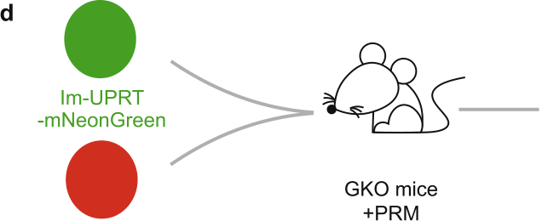



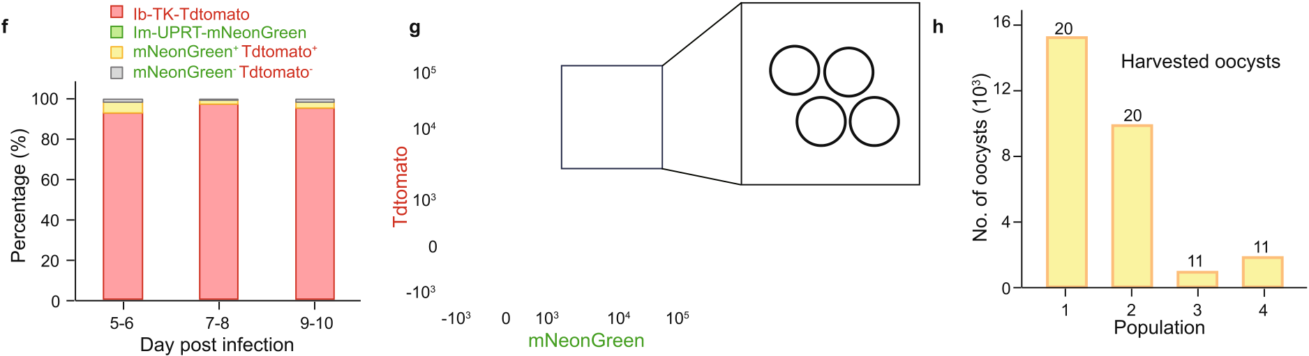
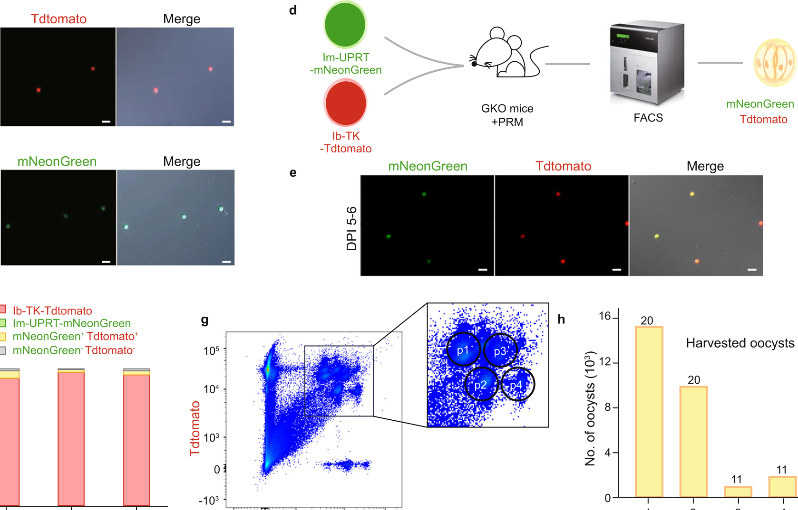
Article |  | https://doi.org/10.1038/s41467-024-54995-4

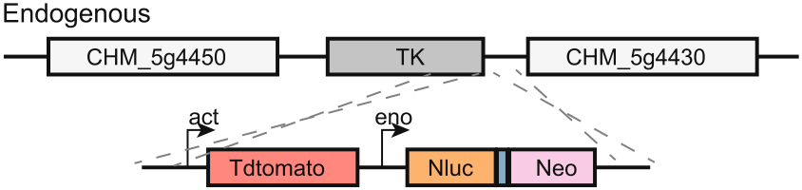

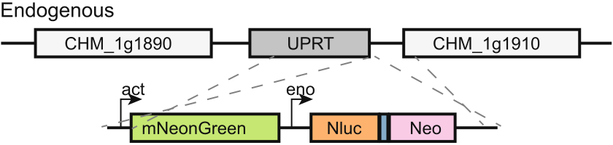

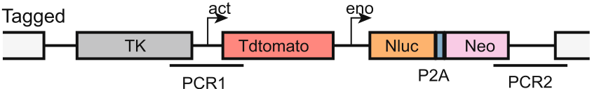


Fig. 7 | Genetic tagging and crosses of two monkey isolates of Cryptosporidium hominis with different virulence. a Illustration of the strategy used in endogenous tagging of the IbA12G3 isolate downstream of the TK (CHM_5g4440, ortholog of CPCDC_5g4440 in C. parvum) locus with a cassette of tdTomato, NanoLuciferase (Nluc), and neomycin-resistance gene (Neo). b Illustration of the strategy used in endogenous tagging of the ImA20 isolate downstream of the s UPRT (CHM_1g1900, ortholog of CPCDC_1g1900 in C. parvum) locus with a mNeonGreen-Nluc-P2A-Neo cassette. c Image of oocysts purified from fecal samples of mice infected with endogenously tagged C. hominis IbA12G3. and ImA20 isolates. d Diagram of the genetic cross of endogenously tagged IbA12G3. and ImA20 isolates. 104oocysts of each Ib-TK-Tdtomato oocysts (red) and Im-UPRT-mNeonGreen oocysts (green)

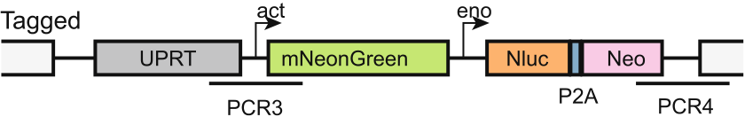
fluorescent reporters (yellow) were identified by fluorescence microscopy and collected by flow cytometric analysis of purified oocysts. e Fluorescence micro-scopy images of purified oocysts at DPI 5. Recombinant progeny expressed both with Tdtomato and mNeonGreen oocysts and were yellow in the merged images. c, e Scale bars in the figures are 10 µm. f Distribution of oocysts of different colors in the progeny of the genetic cross at different time points after infection. g Results of flow cytometry of oocysts purified at DPI 5 showing the oocyst population with double positive fluorescence. h Number of yellow oocysts harvested from the four regions in I by flow cytometric sorting. Numbers on the bars are numbers of oocysts confirmed as yellow by fluorescence microscopy. All harvested oocysts examined by fluorescence microscopy were yellow. Source data are provided as a Source

were used to infect the same GKO mouse (n = 3). Oocysts expressing both | Data file.
behaving like the uninfected group (Fig. 6f). However, no difference in weightgainwasobservedbetweenmiceinfectedwithIbA12G3-ΔCHM_5g5511 and Ib-tdTomato. | ofthetwolines(Fig.7c). PCRandsequence analysesconfirmedthat bothtransgeniclines had thecorrectinsertioninto thegenomicloci (Supplementary Fig. 11a).
Weco-infectedGKOmicewithequalnumbersofIbA12G3-TK-

Tractability and utility of monkey C. hominis isolates
TofacilitatebiologicalstudiesofC.hominisinfection,wegenerated transgeniclinesbyintroducingtheTdtomatosequenceintothe IbA12G3 isolate and the mNeonGreen sequence into the ImA20 isolate usingCRISPR/Cas9(Fig.7a,b).Thetransgeniclinesalsocarriedthe nanoluciferasesequenceforeasymeasurementofparasiteload. Immunofluorescence staining showed that oocysts harvested from the fecalsamplesofGKOmiceinoculatedwiththetransgeniclines expressed Tdtomato or mNeonGreen, supporting the correct tagging

TdtomatoandImA20-UPRT-mNeonGreenoocystsandselectedthe transgenic lines by paromomycin treatment (Fig. 7d). Some oocysts of thegeneticcrossharvestedatDPI5hadbothredandgreencolors (yellowinmergedimages)(Fig.7eandSupplementaryFig.11b).Red oocysts had the absolute advantage (>90%), consistent with the higher infectivity of IbA12G3 than ImA20 (Fig. 7f). Adjusting the infection dose (increasing the infection dose of ImA20 tenfold) increased the yield of yellow progeny (Supplementary Fig. 11c). Flow cytometric analysis of theprogenyshowedthattheyellowoocystsclusteredintofour

Nature Communications| (2024) 15:10774 | 10

Article |  |  | https://doi.org/10.1038/s41467-024-54995-4
populations at the late time point of infection (DPI 5 and DPI 6) (Fig. 7g | crab-eating | monkeys | in | China | since | 20148. | Because | the

and Supplementary Fig. 11d, e). Fluorescence microscopy revealed that alloocystsfromthesepopulationswereyellow(Fig.7handSupple-mentary Fig. 11f).Theyprovide experimental support for the conclu-sion that co-infection of two C. hominis subtypes can produce genetic recombinants, which was observed in the evolutionary analysis of the

IbA12G3subtypehasaglobaldistributioninhumansbutisonly occasionallydetectedinNHPsinBangladeshandChina5,38,wecon-sidered the gene flow from humans to NHPs more likely for this unique IbA12G3 genome that we sequenced. However, we have no other more robust evidence for the direction of C. hominis flow between humans

monkey isolates. and NHPs.
TakingadvantageofthepresenceofseveralC.parvum-specific
Discussion genesthathavebeenassociatedwithabroadhostrange,wehave

Theresultsofthisstudyhaveconfirmedthebiologicalclassification and the genetic uniqueness of C. hominis naturally circulating in sev-eralanimalspeciesatthewholegenomelevel.Whileseveralunique gp60 subtype families have been reported in equine animals (Ik) and Old-World monkeys (Ii, Im, and In) in recent years, very few sequence dataareavailablefromtheseisolates.Sequenceanalysisofthecon-served18SrRNAgenesuggeststhatthesesubtypesmaybehost-adapted C. hominis variants with minor sequence differences from the common C. hominis subtype families in humans12. This was supported by partial WGS data from an IkA18G1 isolate from a human patient in Sweden22.InthepresentstudybasedonWGSdata,C.hominisfrom humans, equine animals, and macaques formed a distinct clade sepa-ratefromC.hominisrelatedspecies.However,theirgenomesare divergent from each other and there is limited gene flow between the three groups. These results support the animal isolates as C. hominis and the existence of host adaptation within this species4,12.
Comparativegenomicdatafromthestudysuggestthatcopy number variation in subtelomeric genes may contribute to the differ-ence in host range between C. hominis animal and human isolates. C. hominis isolates from humans, equine animals, and macaques differ in the copy numbers ofthe MEDLE and INSgenes. Proteins encoded by these twogenefamilies havebeenassociated withhost specificityin Cryptosporidiumspp23,24.Therefore,thesedifferencesmayleadto differences in host infectivity among the human, monkey, and equine subtypesofC.hominis.Surprisingly,themonkeyC.hominissubtype ImA13 recently caused an outbreak of diarrhea in humans, suggesting an underestimated host range of the NHP-adapted C. hominis14.
Multiplerecombinationunderliesthegeneticdiversityand population genetic structures of C. hominis NHP-adapted subtypes. We foundstrongevidenceforsequenceintrogressionamongIbA12G3, IiA17,ImA18,ImA20,InA14,andInA17.ImA18hasbeenreportedin China as a the dominant subtype for C. hominis infection in crab-eating

established a mouse infection model of C. hominis using these monkey isolates.Previous studies have shownthatcommon subtypes of human C. hominis are not infectious to rodents3. Because the NHP-adapted C. hominis subtypes have several subtelomeric INS and MEDLE genes that have been associated with animal infectivity in C. parvum, we evaluated their infectivity to GKO mice. The three C. hominis isolates from NHPs not only infected these mice but also induced significantly higher and more prolonged oocyst shedding than the IIa-Waterborne reference of C. parvum. Thus, the host range of monkey C. hominis isolates is indeed broader than that of human isolates.
Inthepresentstudy,weprovideexperimentalevidenceforthe potential involvement of the subtelomeric INS and MEDLE genes in C. hominisinfectivityandpathogenicity.Thesegeneshavebeenimpli-catedintheinvasionanddevelopmentofCryptosporidiumspp39–41. DeletionofthesubtelomericMEDLEgenes(orthologsofthe CPCDC_5g5490andCPCDC_5g5480genes)significantlyreducedC. hominisgrowthinGKOmiceandpreventedbodyweightlossin infectedanimals. The data suggest that MEDLEgenesare involved in hostinfectivity,butothergenesmayalsocontributetoC.hominis infectivity in mice. In contrast, the INS gene was partially knocked out. This may be due to the presence of multiple copies of the subtelomeric INSgenewithhighsequenceidentityinthisisolate,andthecurrent CRISPRprocedurecannotsimultaneouslymanipulatemultipleiden-tical loci on different chromosomes. Interestingly, the partial deletion of the INS genes also significantly reduced C. hominis growth but not as much as the MEDLE genes. In addition, we attempted to knock out the entire INS and MEDLE region with double sgRNAs covering the entire region. Thefailure toobtaintransgenic parasitesafterparomomycin selection may support the importance of these genes, but we could not excludethattheregionwastoolargetobeknockedout.Studiesof multiplegenesinCryptosporidiumremainchallenging,althoughthe combinedfunctionofINSandMEDLEcouldbefurtherexploredin

macaquesonabreedingfarminHainan5.TheIiA17subtypewas first | futurestudies | using | the | recentlydeveloped | secondselection

reportedinarhesusmonkeyintheUnitedStatesandhasbeen detected several times in macaque monkeys and humans in China and Thailandsince20145,6,8,15,25,26.ThissubtypeislikelytobeanativeC.

markers42,43.Overall,thedatasupporttheprevioussuggestionthat copynumbervariationinsubtelomericgenesencodingtheINSand MEDLEsecretoryproteinsmaycontributetothedifferencesinhost

hominis subtype in NHPs in China and Southeast Asia. In addition, the | infectivity | between | different | Cryptosporidium | species | and
InA14 subtype is also common in macaque monkeys on the same farm5. | subtypes24,27,44.

We have further provided experimental support for the occurrence of genetic recombination during co-infection of two C. hominis subtypes in mice, demonstrating a high frequency of genetic recombination in C. hominis and the formation of progenies with recombined genomes. Therefore,theco-occurrenceofthesesubtypesalongwithseveral othersubtypesonthefarmallowsforgeneticrecombinationand underlies the genetic diversity. Genetic recombination also plays a key role in shaping the population structure of C. hominis in humans and C. parvum in both humans and animals21,27–29.

The three monkey isolates examined in this study, each with dif-ferentgp60subtypes,exhibitdifferentinfectivityandvirulence.In particular,IbA12G3inducedasignificantlyhigherintensityofoocyst shedding in mice than ImA20 and InA17. In addition, both IbA12G3 and InA17infectionsresultedinsignificantlyhigherparasiteloadsinthe mouseintestinethanImA20,withtheformertwoalsocausing reductions in body weight gain, consistent with their much lower ID50 values.Previously,differencesininfectivityandvirulencehavebeen observedbetweendifferentsubtypefamiliesofC.parvumandC.

GeneticrecombinationbetweentheNHP-adaptedsubtypesand | tyzzeri45–47, | and | between | different | isolates | of | the | same | gp60

the human IbA12G3 subtype is likely responsible for the emergence of the divergent subtype in monkeys.The monkey IbA12G3 isolate has the common Ib-type gp60 sequence seen in human IbA12G3 isolates, but has sequences similar to the ImA20 and InA17 subtypes in NHP in most genomicregions.TheIbA12G3subtypeisacommonhuman-pathogenicsubtypethathasbeenreportedinmanycountriessince 2009andhasbeenidentifiedasthecauseofcryptosporidiosisout-breaks in the United Kingdom and Australia30–37. It has been found in

subtype48–50. Results from comparative genomic analysis indicate that sequencedifferencesingenesencodingmucinglycoproteinsand other secretory proteins areassociated with different phenotypic traits of isolates in mice45,46. This is consistent with the data obtained in the present study. Among the highly polymorphic genes between monkey C.hominisisolates,therearefourgenesencodingmucinproteins includingtheGP60.Mucinglycoproteinsplayacriticalroleinspor-ozoiteinvasion51,especiallyGP60,whichalsohasmultiplefunctions

Nature Communications| (2024) 15:10774 | 11

Article | https://doi.org/10.1038/s41467-024-54995-4
duringC.parvuminfectionandisanimportantfactorinhost infectivity52. | between2017and2022,wereusedinthestudy(Supplementary Table 1). They were obtained from previous molecular epidemiological

ThenewlydevelopedmousemodelofC.hominisinfectionpro-videsanaccessiblemechanismforadvancedbiologicalcharacteriza-tion of this important human pathogen. In the present study, we were abletoendogenouslytagtwoisolateswithdifferentinfectivityand virulencetomicewithfluorescentreportersandananoluciferase, allowingforeasydetectionandtrackingofthem.Moreimportantly, we were able to genetically cross the two isolates and enrich the pro-genyofthegeneticcrossusingflowcytometry.Previously,genetic crossesbetweenC.parvumisolatesandbetweenC.parvumandC. tyzzeri have been made in vivo and in vitro53–56. However, the genetic crossesreportedhereareintendedtodemonstratethattheseC. hominis isolates are genetically tractable, and together with the newly developedC.hominismousemodeltheyprovideanaccessible mechanism for advanced biological characterization of this important

studiesofCryptosporidiumspp5,9.Fecalsamplescontainingoocysts were stored in 2.5% potassium dichromate solution at 4 °C prior to the oocyst isolation for WSS analysis and infection studies. The C. parvum“IOWA” isolate (IIaA17G2R1 subtype) was purchased from Waterborne, Inc. (New Orleans, LA, United States). The species and subtype identity of the isolates were determined by PCR and sequence analysis of the 18S rRNA and gp60 genes59,60. Information on the sequenced isolates is provided in Supplementary Data 1.
GKOmiceonaC57BL/6backgroundwereobtainedfromthe InstituteofLaboratoryAnimalsScience,ChinseAcademyofMedical Sciences. Mice were housed in clean filter-top cages with a 12:12 light-darkcycle, 50–60% humidity, and room temperature (22 °C) according to standard protocols under the regulations of the Institutional Animal CareandUseCommittee,SouthChinaAgriculturalUniversity(No.

humanpathogen.Weanticipateusingthisapproachforfuturedis- 2022c011).
coveryofgeneticdeterminantsofhostinfectivityandvirulenceand

comparative studies of C. parvum and C. hominis.
Priortothisstudy,ourunderstandingoftheemergenceof thenovelC.hominissubtypeswaslimitedbythelackofWGS data.Inthisstudy,weacquiredWGSdatafromfouranimal-adaptedC.hominissubtypefamiliesanddemonstratedtheir genomicuniqueness.Previousevolutionarygeneticandmulti-locussequenceanalyseshadindicatedthepresenceofgeo-graphicsegregationwithinC.hominis21,57,butwedidnotdetect obvioussequenceintrogressionfromAsianhumanisolatesinto theChinesemonkeyisolates.Therefore,amoresystematicana-lysisofhumanisolatesfromChina,wherethenovelsubtypesare emerging12,andKenya,whereoneofthenovelsubtypescauseda recenthumancryptosporidiosisoutbreak14,isneededtoimprove theunderstandingofthetransmissionofthenovelC.hominis subtypes.WhilethenewlygeneratedreferenceC.hominisgen-omeprovidesinsightsintothecopynumbervariationofsub-telomericgenes,threechromosomeendswithhighsequence identityinC.parvum20aremissingfromtheassemblydueto

Whole-genome sequencing
OocystswerepurifiedfromC.hominis-positivesamplesusingdis-continuoussucroseandcesiumchloridegradientsasdescribed61. Seventeen DNA samples were extracted from the purified oocysts after five freeze-thaw cycles using the QIAamp DNA minikit (Qiagen, United States,Cat.51304).Whole-genomeamplification(WGA)wasper-formedontheextractedDNAusingaREPLI-gMidikit(Qiagen,Cat. 150043)followingthemanufacturer-recommendedprocedures.The WGA products were sequenced on an Illumina HiSeq 2500(Illumina, San Diego, CA,United States) using the 150-bp or 250-bp paired-end approach.DNAwasalsoextractedfromIbA12G3-monkey-46287 oocysts using the traditional phenol-chloroform method. After WGA, the product was sequenced using standard PacBio ccs procedures.
Atotalof240whole-genomesequence(WGS)datasetsofC. hominis,C.parvum,C.cuniculus,C.tyzzeri,C.ubiquitum,andC. meleagridis were downloaded from the Sequence Read Archive data-baseoftheNationalCenterforBiotechnologyInformation(NCBI) ()usingprefetchv2.11.3(

PacBio’sreadlengthlimitation.Theincreasedreaddepthin | github.com/ncbi/sra-tools). | They | were | generated | in | published

anotherchromosomeendduringreadmappingsuggeststhe presenceofcollapsedsequences58.Therefore,chromosomeend replicationinC.hominismayhaveoccurredinthesamechro-mosomesasinC.parvum.Thisreplicationmayhavealsooccur-

studies21–23,27,62–69. Some basic information about the WGS data is pro-vided in Supplementary Data 1.
Genome assembly and gene annotation for the reference C.

redinotherspeciesthatarecloselyrelatedtoC.parvum.More hominis genome

longreaddatafromotherC.hominisisolatesareneededto confirmthisobservation20.
Inconclusion,thegenomesoftheNHP-adaptedandequine-adaptedsubtypesdiffersignificantlyfromthoseofthehuman-pathogenicsubtypefamilies.Thesedifferencesaremainlyinthe CNVsofthesubtelomericMEDLEandINSgenes.Thesedifferences contributetotheirinfectivityinGKOmice.Theresultsofthisstudy alsoindicatethattheco-occurrenceofdifferentsubtypeshasledto frequentrecombinationbetweensubtypes,shapingthepopulation structure of C. hominis in NHPs and the emergence of new subtypes. Theseobservationsimproveourunderstandingoftheevolutionary genetics of C. hominis and provide rich targets for advanced studies of geneticdeterminantsofhostinfectivityandvirulenceofisolates.In particular,the C.hominismouse model andgeneticallytractable iso-lates of varying infectivity and virulence developed in this study will be veryuseful forcomparative studiesofC.hominisandC.parvumand advancedcharacterizationsofgeneticdeterminantsofphenotypic traits of these important pathogens.
Methods
Cryptosporidium isolates and mice
A total of 17 C. hominis-positive samples, collocated from crab-eating macaques(Macacafascicularis)anddonkeys(Equusasinus)inChina

Sequence reads obtained from PacBio were filtered for chimeras using 3rd-ChimeraMiner70.SequencereadsobtainedfromIlluminawere trimmedforadaptersequencesandpoorsequencequality(phred score <30andtrimmedlength<60)usingfastpv0.23.4.Ahybridde novo assemblywasperformedwiththePacBioandIllumina reads of IbA12G3-monkey-46287usingwenganv0.2withMmodel,agenome size of 9.5 Mb, haploid, and a Kmer of 63. The PacBio reads were also assembleddenovousingthehifiasmv0.19.8withaKmerof63.The final assembly was polished using racon v1.5.0 with default settings and manualinspection of the long PacBio reads mapped to the contigs. The assemblies were aligned and sorted against the reference genomes of C.parvumIOWA-CDC(ofthedominantIIaA15G2R1subtype)18and IOWA-BGF (of the IIaA17G2R1 subtype)20using the “move contig” tool of Mauve v2.3.1. To assess the quality of the new assembly, the PacBio longreadsweremappedbacktothenewassemblyusingminimap2 v2.28 with the map-hifi mode () and visualized with igv v2.17.1.
GeneannotationfortheC.hominisIbA12G3genomewasper-formed using AUGUSTUS v3.5.0 () and GeMoMa71. Annotations from the C. parvum reference genomes(IOWA-CDCandIOWA-BGF)were usedtotrainAUGUSTUS for the prediction, while the annotations from the reference genomes weretransferredtotheC.hominisIbA12G3basedonconserved

Nature Communications| (2024) 15:10774 | 12

Article | https://doi.org/10.1038/s41467-024-54995-4
synteny. The uncharacteristic genes were annotated by searching the NCBInon-redundantproteindatabaseusingBlastpv2.10.1withan e-value of 1 × 10−6. | with shared ancestryusinghmmIBD v2.0.4. IsolateswithIBDsharing greaterthanthemean+SDoftheirgenomeswereconsideredas related ones. Relatedness networks for pairs of isolates were generated
using Cytoscape v3.9.1 ().
Genome assembly of other isolates and comparative genomic Gene flow between populations was assessed using phylogenetic
analyses network analysis and topology weighting. The neighbor-net algorithm
All trimmed Illumina reads were assembled de novo using CLC Geno- of SplitsTree676() was used to
mics Workbench with a word size of 63 and bubble size of 400. Gen- generate phylogenetic networks. Twist.py (

omeswerealsoassembledusingSPAdes3.1()withakmerof63andthecarefulmode.The assemblieswerealignedandsortedagainstthechromosome-level reference genome of C. hominis IbA12G3-monkey using Mauve’s “move contig”tooltoobtain thesizeof thefinal genomeassembliesof the isolates.Thegenomeswithtwoormoretypesofgp60or18SrRNA sequences and/or an assembly larger than 9.1 Mb were considered as mixed infections and excluded from further analysis.
The trimmed reads were mapped to the new reference C. hominis 46287genomeandtheotherisolatesusingtheBWA-MEMv0.7.17. Duplicate reads were marked and removed in the bam files using the MarkDuplicatesalgorithmofpicardv3.1.1(

)wasusedtoestimatetopologyweightingwith a50 bp window acrosseightchromosomesto examine phylogenetic relationshipsacrossthegenomeamongthreepopulationsofC. hominisisolates and an outgroup. The genome-wide average weight-ing of each topology and the distribution of topology weightings were visualizedusingtheRpackage‘PlotTwist’().Toidentifytheintrogressedgenomic regionsacrossthewholegenome,absolutedivergence(dxy)was estimatedacrossthegenomeusingasetofSNPs.Thedxyvalues betweenpopulationsorisolateswerecalculatedina10-kbsliding windowusingpopgenWindows.pyinGenomics_general(),andvisualizedinline

github.io/picard/) | with | REMOVE_DUPLICATES=true, | CREATE_- | plotsusingtheRpackage‘ggplot2’.Inaddition,themodifiedfdtest

INDEX=true,andASSUME_SORTED=true.Genomecoverageand sequencedepthwereestimatedusingthempileupalgorithmof SAMtoolsv1.7().Thempileupand call algorithms of BCFtools v1.12 () were used to generate a VCF file of sequence variants, with parameters-c50,-d500,and-ploidy1.LowqualitySNPs(QUAL < 30,FORMAT/ DP < 3 and AVG FORMAT/DP > 25) were filtered out using the BCFtools filter algorithm. The bam file of 46287 isolates from the read mapping was visualized in IGV, to look for pile-ups representing the repetitive sequence regionsinthegenome58.Toavoidtheintroductionofarti-ficialwhole-genomeSNPs(wgSNPs)estimatedbyshortreadsfrom different family members randomly mapped to a locus72, the wgSNPs were divided into core wgSNPs and secondary wgSNPs using the view algorithmofBCFtools.ThecorewgSNPscovermost ofthegenomic regions(SupplementaryTable4),exceptforthesubtelomeric sequencesandrepetitivesequences,suchastheCPCDC_3g4270/ CPCDC_3g4260 locus and the rRNA units18.
Population genetic analyses
Relationships among C. hominis isolates were examined using princi-palcomponentanalysis(PCA),STRUCTURE,phylogenetic,andIBD73 analyses. Core wgSNPs identified across all C. hominis genomes were prunedusingPLINKv2.00()with-mac3and-genoof0.2togenerateadatasetofhigh-qualitycore wgSNPs. The dataset was subjected to PCA analysis using LDAK v5.274. ClusteringamongtheisolateswasvisualizedusingtheRpackage‘ggplot2’().The corewgSNPsamongtheanimalC.hominisisolateswereextracted from the previous high-quality core wgSNPs dataset with --max-miss-ing1usingVcftoolsv0.1.16(). ThesewgSNPswereusedforPCAanalysisusingLDAK.Asetof unlinked sites was generated with 10-kb sliding windows using PLINK with --indep-pairwise of 10 5 0.4. These wgSNPs were also subjected to STRUCTUREanalysisusingStructurev.2.3.4(),withthebestnumberof subpopulations(Kvalue)beingcalculatedusingPophelperv2.3.1

with100-kbslidingwindowsand10-kbstepswasperformedas describedusingABBABABAwindows.pyinGenomics_general.Three populationsandoneoutgroupwereusedwiththerelationship (((P1, P2),P3), O),where P1isclosertoP2than P3.Positivefdvalueswere considered as introgression signals.
Structural differences between C. hominis genomes
Allshort-readgenomeswerealignedagainstthenewC.hominis IbA12G3genomeandC.parvumreferencegenomes(IOWA-CDCand IOWA-BGF)usingthe“movecontig”toolinMauvev2.3.1.Structural variations(SVs)andcopynumbervariations(CNVs)betweenthe genomeswerethenmanuallydetected.TheCNVsbetweenthegen-omesofanimalandhumanisolateswereverifiedbyreadmapping, blast analyses, and PCR. Reads were mapped to the reference genomes containingthegenomicsequencesoftheSNVsusingminimap2for long reads and BWA-MEM for short reads (see above). These genomic sequenceswereusedtoconstructdatabasesusingmakeblastdbin Blast+v2.16.0,andtheassemblieswerecomparedtothedatabases using blastn. In addition, the reads from the sequencing were used to buildnucleotidedatabases,andtheproteinsequencesoftheCNVs werecomparedtothemusingtblastn.PrimersforPCRamplification areshowedinSupplementaryTable8.Nucleotidediversity(Pi)was usedtomeasurethedegreeofvariabilityofgenomicregionsina group. It was calculated among C. hominis isolates using the Vcftools v0.1.16 with a 10-kb sliding window.
Experimental infection of mice with C. hominis
Priortoexperimentalinfection,allGKOmicewereverifiedtobe Cryptosporidium-free by nested PCR analysis of the 18S rRNA gene. All cages,waterbottles,andbeddingwereautoclavedbeforeuse.All infection studies were performed on mice between 4 and 5 weeks of age,withequalnumbersofmaleandfemalemice.Miceininfected groups received Cryptosporidium oocysts by oral gavage, while mice in uninfectedcontrolgroupsreceivedPBS.Allmiceintheseinfection studieswerehousedindividuallyinseparatecages(onemouseper cage).OocystsheddingwasmeasuredbyqPCRanalysisofthe18S

( articles/index.html). The rRNAgeneasdescribed45.Sequenceanalysisofthegp60genewas
results of the STRUCTURE analysis were visualized using the CLUMPAK usedtoverifytheidentityofC.hominisperiodicallythroughoutthe
server().ThewgSNPsamongother course of infection.

isolates were extracted from the wgSNPs using Vcftools. ML trees were generated from the wgSNPs using RAxM-NG with a substitution model and1000replicatesofbootstrapping.Thesubstitutionmodelwas estimatedusingjModelTestv2.1.10basedonvaluesfromAkaike Information Criterion75. The IBD analysis was used to identify isolates

ToisolateC. hominisfrommonkeys,threeGKOmice wereused forinfectionwithoocystsfromeachclinicalsample.Allmicewere inoculatedwithoocyststhatwerefreshlypurifiedfromclinicalsam-ples. Infected mice were housed separately from each other in indivi-dual cages and the oocyst shedding of each mouse was monitored for

Nature Communications| (2024) 15:10774 | 13

Article | https://doi.org/10.1038/s41467-024-54995-4
60days.Allcomparativeinfectionstudiesandotherassaysused oocysts freshly purified from experimentally infected mice. Due to the | based on visual inspection of the PacBio read mapping to the reference C. hominis genome.
high cost of GKO mice and the variable freshness and oocyst load of

clinicalsamples,onlythreemonkeyisolatesweremaintainedinour laboratory,includingImA20,InA17,andIbA12G3.Theseisolates represent three closely related subtype families. We also successfully infectedGKOmicewithanotherImA18isolate,buthadtomakethe decisiontomaintainonlythreeisolatesduetocostandlabor.The

Generation of transgenic parasites
Freshoocystsweretreatedwith10%Clorox(0.5%sodiumhypo-chlorite)onicefor10 min,followedbytreatmentwithsodiumtaur-odeoxycholateat37 °Cfor60 min.Theexcystedsporozoitesof IbA12G3andImA20isolateswereelectroporatedwithTK-Tdtomato-

equineisolateswerenottestedformouseinfectivitybecausethey Nluc-P2A-neo and UPRT-mNeonGreen-Nluc-P2A-neo plasmids,
havefewersubtelomericINSandMEDLEgenesthan themonkeyiso- respectively,whileformerstrainalsowaselectroporatedwith
lates(lesslikelytoinfectmice)andbecauseofthesmallnumberof ΔCHM_5g5511-Tdtomato-Nluc-P2A-neoorΔCHM_5g5480/5490-Tdto-
oocysts purified from clinical samples. mato-Nluc-P2A-neo plasmids, together with the corresponding

ToevaluatethevirulenceandinfectivityofC.hominisisolates from monkeys, 30 GKO mice were divided into five groups (n = 6 for eachgroup),includingtheIbA12G3infectiongroup,theInA17infec-tion group, the ImA20 infection group, the C. parvum IIa-Waterborne infectiongroup,andtheuninfectedcontrolgroup.Allmiceexcept those in the control group were inoculated with 104oocysts that were freshly purified from maintenance mice. The oocyst shedding pattern and body weight of each mouse were monitored for 80 days.
Todeterminethemedianinfectiousdose(ID50)ofC.hominis isolatesfrommonkeys,120GKOmicewererandomlyassignedto sevengroupsforeachofthethreesubtypesdescribedabove,each receiving different doses of oocysts, including 1000 (n = 4), 100 (n = 4), 50 (n = 6), 10 (n = 6), 5 (n = 8), 1 (n = 8), and 0 (n = 4). Oocyst shedding ineachmousewasmonitoredfor15daysusingqPCRasdescribed

sgRNAs.Theelectroporatedparasiteswereorallygavagedtothree GKO mice that were previously treated orally with sodium bicarbonate toneutralizegastricacid.Transgenicparasiteswereselectedby treatingGKOmicewith16 g/Lparomomycininthedrinkingwater starting 18 h after the oocyst inoculation. They were verified by mea-surementofnanoluciferaseactivityusingCytation(BioTek,Synergy H1),fluorescencemicroscopicanalysisof oocystspurifiedfromfecal pelletsofinfectedmiceunderamicroscope(Olympus,BX53),PCR amplification, and WGS of the purified oocysts.
Experimental infection of mice with transgenic C. hominis ToevaluatetheinfectivityoftransgenicC.hominisisolatestoGKO mice, 16 four-week-old GKO mice were divided into four groups (n = 4 foreachgroup),includingthetaggedIbA12G3infectiongroup

above,andtheID50ofeachisolatewascalculatedusinglogistic | (IbA12G3-Tdtomato), |  | the | CHM_5g5511 |  | KO | group | (IbA12G3-
regression. | ΔCHM_5g5511), | the | CHM_5g5480 |  | and | CHM_5g5490 |  | KO | group
(IbA12G3-ΔCHM_5g5480/5490), and the uninfected control group. All

Study of pathological changes induced by the C. hominis isolates Fifteen 4-week-old GKO mice were randomly divided into five groups (n = 3 for each group): the C. hominis IbA12G3 group, the InA17 group,

miceexceptthoseinthecontrolgroupwereinoculatedwith104 oocysts. Mice in the infection study were housed in individual cages, andoocystsheddingpatternsandbodyweightofeachmousewere

the ImA20 group, the C. parvum IIa-Waterborne group, and the unin- monitored for 15 days.
fected control group. Mice in the infected groups were inoculated with

104oocysts freshly purified from maintenance mice. Mice were sacri-ficed at DPI 12 for the assessment of parasite burden and pathological changesintheileumandcolonbyhistologyandscanningelectron microscopy (SEM) as described45.

Genetic cross between C. hominis isolates
Three4-week-oldGKOmiceweresimultaneouslyinfectedwith104 oocystsofeachtdTomato-taggedIbA12G3andmNeonGreen-tagged ImA20lines.FecalsampleswerecollecteddailystartingatDPI5. Oocystswerepurifiedfromfecesbysucroseandcesiumchloride

Construction of CRISPR/Cas9 plasmids for genetic modification gradient centrifugation and examined by immunofluorescence
of C. hominis microscopy.Yellow(bothtdTomatoandmNeonGreenpositive)

TheCRISPR/Cas9technologywasusedtogeneratetransgenicC. hominislineswithfluorescentandnanoluciferasereportersas described77. CRISPR/Cas9 plasmids were generated by adding a single-guideRNA(sgRNA)targetingthegeneofinteresttothelinearCas9 plasmid using the Gibson assembly kit. The sgRNAs were designed to target the TK gene in the IbA12G3 genome and the UPRT gene in the

oocysts were sorted and harvested by flow cytometry using FACSAria III (BD Biosciences, USA), and the data were analyzed using BD FACS-Diva v8.0.3. To increase the yield of yellow progeny, three 4-week-old GKOmicewereinfectedwith105oocystsofmNeonGreen-tagged ImA20 lines and 104oocysts of tdTomato-tagged IbA12G3.

ImA20genome,whilethetaggingplasmidscontainedtheTK-Tdto- Statistical analysis
mato-Nluc-P2A-neoandUPRT-mNeonGreen-Nluc-P2A-neorepaircas- AllstatisticalanalyseswereperformedusingthePrismv10unless settes and DNA sequences homologous to the regions targeted by the otherwise noted. The Mann–Whitney U test was used to compare the sgRNAs. means of two groups, and the Wilcoxon signed-rank test was used to AsgRNAtargetingthe3′endoftheCHM_5g5480wasusedto compare the growth curves of two groups.
knockouttheCHM_5g5480andCHM_5g5490genes.Thehomology
repair fragments were PCR amplified from the IbA12G3 genome, con- Reporting summary
sistingof1202 bpoftheCHM_5g54905′UTRand1358 bpofthe FurtherinformationonresearchdesignisavailableintheNature CHM_5g5480 3′ UTR. The fragments were assembled with a reporter- Portfolio Reporting Summary linked to this article.
drug selection cassette amplified from TK-Tdtomato-Nluc-P2A-neo. In
addition,toknockoutallpassiblecopiesoftheCHM_5g5511,the Data availability

sgRNAandthehomologyrepairfragmentsweredesignedbasedon theidenticalregionsofthedifferentcopiesofCHM_5g5511.AgRNA targetingthe5′endofthegeneswasused.The783 bpsequence upstream and 559 bp sequence downstream of the 310-bp 5′ end of the CHM_5g5511wereamplifiedfromtheIbA12G3genomeandusedto insertthedual reporter-drugselectioncassette(Tdtomato-Nluc-P2A-neo). The sgRNA and repair fragments targeted conserved sequences

All sequence data have been deposited in the NCBI Short Read Archive ()undertheBioProjectaccession numberPRJNA1033585.ThefinalgenomeassemblyofC.hominis IbA12G3_46287hasbeensubmittedtoGenBankunderaccession numbersJBGCUF000000000.Accessioncodesforthegenomic sequence datasets analyzed in this study are provided in Supplemen-tary Data 1. Source data are provided with this paper. The.vcf file used

Nature Communications| (2024) 15:10774 | 14

Article |  | https://doi.org/10.1038/s41467-024-54995-4
inthisstudyisavailableintheFigsharedatabase78.Sourcedataare | 18. | Huang, W. et al. Sequence introgression from exogenous lineages
provided with this paper. | 18. | underlies genomic and biological differences among Cryptospor-
idium parvum IOWA lines. Water Res. 254, 121333 (2024).
Code availability | 19. | Baptista, R. P. et al. Long-read assembly and comparative evidence-

AllanalysesaredescribedandcitedintheMethods.Customcodes used in this work have been deposited on GitHub ().

based reanalysis of Cryptosporidium genome sequences reveals expanded transporter repertoire and duplication of entire chro-mosome ends including subtelomeric regions. Genome Res. 32, 203–213 (2021).

References 20.Baptista, R. P., Xiao, R., Li, Y., Glenn, T. C. & Kissinger, J. C. New T2T
1. Checkley, W. et al. A review of the global burden, novel diagnostics, assembly of Cryptosporidium parvum IOWA annotated with refer-
therapeutics, and vaccine targets for Cryptosporidium. Lancet ence genome gene identifiers. Preprint at bioRxiv (2023).
Infect. Dis. 15, 85–94 (2015). 21. Huang, W. et al. Multiple introductions and recombination
2. Ryan, U. M., Feng, Y., Fayer, R. & Xiao, L. Taxonomy and molecular events underlie the emergence of a hyper-transmissible Cryp-
epidemiology of Cryptosporidium and Giardia - a 50 year per- tosporidium hominis subtype in the USA. Cell Host Microbe 31,
spective (1971-2021). Int. J. Parasitol. 51, 1099–1119 (2021). 112–123 e114 (2023).
3. Morgan-Ryan, U. M. et al. Cryptosporidium hominis n. sp. (Api- 22.Sikora, P. et al. Genomic variation in IbA10G2 and other patient-
complexa: Cryptosporidiidae) from Homo sapiens. J. Eukaryot. derived Cryptosporidium hominis subtypes. J. Clin. Microbiol. 55,
Microbiol. 49, 433–440 (2002). 844–858 (2017).
4. Widmer, G., Koster, P. C. & Carmena, D. Cryptosporidium hominis 23.Guo, Y. et al. Comparative genomic analysis reveals occurrence of
infections in non-human animal species: revisiting the concept of genetic recombination in virulent Cryptosporidium hominis sub-
host specificity. Int. J. Parasitol. 50, 253–262 (2020). types and telomeric gene duplications in Cryptosporidium parvum.
5. Chen, L. et al. Cryptosporidium parvum and Cryptosporidium BMC Genomics 16, 320 (2015).
hominis subtypes in crab-eating macaques. Parasit. Vectors 12, 24.Feng, Y. et al. Comparative genomic analysis of the IId subtype family
350 (2019). of Cryptosporidium parvum. Int. J. Parasitol. 47, 281–290 (2017).
6. Zhao, W. et al. Molecular prevalence and subtyping of Cryptos- 25.Mallon, M.E., MacLeod, A., Wastling, J. M., Smith, H. & Tait, A.
poridium hominis among captive long-tailed macaques (Macaca Multilocus genotyping of Cryptosporidium parvum Type 2:
fascicularis) and rhesus macaques (Macaca mulatta) from Hainan population genetics and sub-structuring. Infect. Genet. Evol. 3,
Island, southern China. Parasit. Vectors 12, 192 (2019). 207–218 (2003).
7. Jian, F. et al. Common occurrence of Cryptosporidium hominis in 26.Feng, Y., Lal, A. A., Li, N. & Xiao, L. Subtypes of Cryptosporidium spp.
horses and donkeys. Infect. Genet. Evol. 43, 261–266 (2016). in mice and other small mammals. Exp. Parasitol. 127, 238–242 (2011).
8. Karim, M. R. et al. Multilocus typing of Cryptosporidium spp. and 27. Wang, T. et al. Sympatric recombination in zoonotic Cryptospor-
Giardia duodenalis from non-human primates in China. Int. J. Para- idium leads to emergence of populations with modified host pre-
sitol. 44, 1039–1047 (2014). ference. Mol. Biol. Evol. 39, msac150 (2022).
9. Li, F. et al. Different distribution of Cryptosporidium species between 28.Corsi, G. I. et al. Recent genetic exchanges and admixture shape the
horses and donkeys. Infect. Genet. Evol. 75, 103954–103954 (2019). genome and population structure of the zoonotic pathogen Cryp-
10. Wang, W. et al. Prevalence and genotypic identification of Cryp- tosporidium parvum. Mol. Ecol. 0, 1–13 (2022).
tosporidium in free-ranging and farm-raised donkeys (Equus asinus 29.Nader, J. L. et al. Evolutionary genomics of anthroponosis in Cryp-
asinus) in Xinjiang, China. Parasite 27, 45 (2020). tosporidium. Nat. Microbiol. 4, 826–836 (2019).
11. Xiao, L. & Feng, Y. Molecular epidemiologic tools for waterborne 30.Chalmers, R. M., Robinson, G., Elwin, K. & Elson, R. Analysis of the
pathogens Cryptosporidium spp. and Giardia duodenalis. Food Cryptosporidium spp. and gp60 subtypes linked to human out-
Waterborne Parasitol. 8-9, 14–32 (2017). breaks of cryptosporidiosis in England and wales, 2009 to 2017.
12. Feng, Y., Ryan, U. M. & Xiao, L. Genetic diversity and population Parasit. Vectors 12, 95 (2019).
structure of Cryptosporidium. Trends Parasitol. 34, 997–1011 (2018). 31. Braima, K. et al. Molecular analysis of cryptosporidiosis cases in
13. Li, J. et al. An investigation of parasitic infections and review of Western Australia in 2019 and 2020 supports the occurrence of two
molecular characterization of the intestinal protozoa in nonhuman swimming pool associated outbreaks and reveals the emergence of
primates in China from 2009 to 2015. Int. J. Parasitol. Parasites Wildl. a rare IbA12G3 subtype. Infect. Genet. Evol. 92, 104859 (2021).
6, 8–15 (2017). 32.Millán, R., Köster, P. C., Fuentes, I. & Carmena, D. IbA12G3: First
14. Toriro, R. et al. Outbreak of diarrhea caused by a novel Cryptos- report of a rare sub-genotype in Spain. Enferm. Infecc. Y Microbiol.
poridium hominis subtype during british military training in Kenya. Clin. 37, 279–281 (2019).
Open Forum Infect. Dis. 11, ofae001 (2024). 33.Urrea-Quezada, A. et al. Clinical Manifestations of Cryptosporidiosis
15. Lebbad, M., Winiecka-Krusnell, J., Insulander, M. & Beser, J. Mole- and Identification of a new Cryptosporidium Subtype in Patients

cular characterization and epidemiological investigation of Cryp-tosporidium hominis IkA18G1 and C. hominis monkey genotype IiA17, two unusual subtypes diagnosed in Swedish patients. Exp.

From Sonora, Mexico. Pediatr. Infect. Dis. J. 37, E136–E138 (2018). 34.Guy, R. A. et al. Molecular characterization of Cryptosporidium isolates from humans in Ontario, Canada. Parasit. Vectors 14,

Parasitol. 188, 50–57 (2018). |  | 69 (2021).  35.Bujila, I. et al. Cryptosporidium species and subtypes identified in human domestic cases through the national microbiological sur-veillance programme in Sweden from 2018 to 2022. BMC Infect. Dis. 24, 146 (2024).  36.Bacchetti, R., Connelly, L., Browning, L. & Alexander, C. L. Changing molecular profiles of human cryptosporidiosis cases in Scotland as a result of the coronavirus disease, COVID-19 pandemic. Br. J.  Biomed. Sci. 80, 11462 (2023).
16. | Lebbad, M., Winiecka-Krusnell, J., Stensvold, C. R. & Beser, J. High
diversity of Cryptosporidium species and subtypes identified in cryptosporidiosis acquired in Sweden and abroad. Pathogens 10, 523 (2021).
17. | Xiao, L. et al. Presence of heterogeneous copies of the small subunit
rRNA gene in Cryptosporidium parvum human and marsupial gen-otypes and Cryptosporidium felis. J. Eukaryot. Microbiol. 46, 44s–45s (1999).
Nature Communications| (2024) 15:10774 |  | 15

Article | https://doi.org/10.1038/s41467-024-54995-4

37.Insulander, M. et al. Molecular epidemiology and clinical manifes-tations of human cryptosporidiosis in Sweden. Epidemiol. Infect. 141, 1009–1020 (2013).
38.Karim, M. R. et al. Occurrence and molecular characterization of Cryptosporidium spp. and Giardia duodenalis among captive

57.Tanriverdi, S. et al. Inferences about the global population struc- tures of Cryptosporidium parvum and Cryptosporidium hominis.
Appl. Environ. Microbiol. 74, 7227–7234 (2008).
58.Baptista, R. P. & Kissinger, J. C. Is reliance on an inaccurate genome sequence sabotaging your experiments? PLoS Pathog. 15, e1007901

mammals in the Bangladesh National Zoo. Parasitol. Int. 84, (2019).
102414 (2021). 59.Xiao, L. et al. Molecular characterization of Cryptosporidium

39.Su, J. et al. Differential expression of three Cryptosporidium species-specific MEDLE proteins. Front. Microbiol. 10, 1177 (2019). 40.Fei, J. et al. Characterization of MEDLE-1, a protein in early devel- opment of Cryptosporidium parvum. Parasit. Vectors 11, 312 (2018).

oocysts in samples of raw surface water and wastewater. Appl. Environ. Microbiol. 67, 1097–1101 (2001).
60.Alves, M. et al. Subgenotype analysis of Cryptosporidium isolates from humans, cattle, and zoo ruminants in Portugal. J. Clin. Micro-

41. | Zhang, S. et al. Characterization of a species-specific insulinase-like | 61. | biol. 41, 2744–2747 (2003).
protease in Cryptosporidium parvum. Front. Microbiol. 10, |  | 61. | Arrowood, M. J. & Donaldson, K. Improved purification methods for
354 (2019). |  | 61. | calf-derived Cryptosporidium parvum oocysts using discontinuous
42.Vinayak, S. et al. Bicyclic azetidines kill the diarrheal pathogen |  | 61. | sucrose and cesium chloride gradients. J. Eukaryot. Microbiol. 43,
Cryptosporidium in mice by inhibiting parasite phenylalanyl-tRNA |  | 61. | 89S (1996).

synthetase. Sci. Transl. Med. 12, eaba8412 (2020).
43.Hanna, J. C. et al. Mode of action studies confirm on-target engagement of lysyl-tRNA synthetase inhibitor and lead to new selection marker for Cryptosporidium. Front. Cell Infect. Microbiol. 13, 1236814 (2023).
44.Liu, S. et al. Evolution of mitosome metabolism and invasion-related proteins in Cryptosporidium. BMC Genomics 17, 1006 (2016).
45.He, X. et al. A productive immunocompetent mouse model of cryptosporidiosis with long oocyst shedding duration for immu-nological studies. J. Infect. 84, 710–721 (2022).
46.Jia, R. et al. High infectivity and unique genomic sequence char-acteristics of Cryptosporidium parvum in China. PLoS Negl. Trop. Dis. 16, e0010714 (2022).

62.Isaza, J. P. et al. Revisiting the reference genomes of human pathogenic Cryptosporidium species: reannotation of C. parvum Iowa and a new C. hominis reference. Sci. Rep. 5, 16324 (2015).
63.Hadfield, S. J. et al. Generation of whole genome sequences of new Cryptosporidium hominis and Cryptosporidium parvum isolates directly from stool samples. BMC Genomics 16, 650 (2015).
64.Gilchrist, C. A. et al. Genetic diversity of Cryptosporidium hominis in a Bangladeshi community as revealed by whole-genome sequen-cing. J. Infect. Dis. 218, 259–264 (2018).
65.Amid, C. et al. The COMPARE data hubs. Database 2019, 1–14 (2019).
66.Arias-Agudelo, L. M., Garcia-Montoya, G., Cabarcas, F., Galvan-Diaz, A. L. & Alzate, J. F. Comparative genomic analysis of the principal Cryptosporidium species that infect humans. PeerJ 8,

47.Sateriale, A. et al. A genetically tractable, natural mouse model of e10478 (2020).
cryptosporidiosis offers insights into host protective immunity. Cell 67.Tichkule, S. et al. Comparative genomics revealed adaptive
Host Microbe 26, 135–146 e135 (2019). admixture in Cryptosporidium hominis in Africa. Microb. Genom. 7,
48.Gaber, M. et al. Evidences of brain and lung invasion of a local water 000493 (2020).

Cryptosporidium parvum isolate in comparison to Iowa strain: ser-ological and immunohistochemical cytokine evaluation. Ann.
Parasitol. 66, 311–318 (2020).
49.Sayed, F. G., Hamza, A. I., Galal, L. A., Sayed, D. M. & Gaber, M. Virulence of geographically different Cryptosporidium parvum iso-lates in experimental animal model. Ann. Parasitol. 62, 221–232

68.Knox, M. A., Garcia, R. J. & Hayman, D. T. S. Draft genome assem-blies of two Cryptosporidium hominis isolates from New Zealand. Microbiol. Resour. Announc. 10, e0036321 (2021).
69.Cabarcas, F. et al. Cryptosporidium hominis phylogenomic analysis reveals separate lineages with continental segregation. Front.
Genet. 12, 740940 (2021).

(2016). 70.Lu, N. et al. Exploration of whole genome amplification generated
50.Sonzogni-Desautels, K., Mead, J. R. & Ndao, M. Mouse models for chimeric sequences in long-read sequencing data. Brief. Bioinform.
use in Cryptosporidium infection studies and quantification of 24, bbad275 (2023).
parasite burden using flow cytometry, qPCR, and histopathology. 71. Keilwagen, J. et al. Using intron position conservation for homology-
Methods Mol. Biol. 2052, 229–251 (2020). based gene prediction. Nucleic Acids Res. 44, e89 (2016).
51. Ludington, J. G. & Ward, H. D. The Cryptosporidium parvum c-type 72. Agyabeng-Dadzie, F., Xiao, R. & Kissinger, J. C. Cryptosporidium
lectin CpClec mediates infection of intestinal epithelial cells via genomics - current understanding, advances, and applications.
interactions with sulfated proteoglycans. Infect. Immun. 84, Curr. Trop. Med. Rep. 11, 92–103 (2024).
1593–1602 (2016). 73.Schaffner, S. F., Taylor, A. R., Wong, W., Wirth, D. F. & Neafsey, D. E.
52.Li, M. et al. Variant surface protein GP60 contributes to host hmmIBD: software to infer pairwise identity by descent between
infectivity of Cryptosporidium parvum. Commun. Biol. 7, 1175 haploid genotypes. Malar. J. 17, 196 (2018).
(2024). 74.Speed, D., Holmes, J. & Balding, D. J. Evaluating and improving
53.Wilke, G. et al. A stem-cell-derived platform enables complete heritability models using summary statistics. Nat. Genet. 52,
Cryptosporidium development in vitro and genetic tractability. Cell 458–462 (2020).

Host Microbe 26, 123–134 e128 (2019).
54.Tanriverdi, S., Blain, J. C., Deng, B., Ferdig, M. T. & Widmer, G.
Genetic crosses in the apicomplexan parasite Cryptosporidium parvum define recombination parameters. Mol. Microbiol. 63,

75.Posada, D. jModelTest: phylogenetic model averaging. Mol. Biol. Evol. 25, 1253–1256 (2008).
76.Huson, D. H. & Bryant, D. Application of phylogenetic networks in evolutionary studies. Mol. Biol. Evol. 23, 254–267 (2006).

1432–1439 (2007). | 77. | Vinayak, S. et al. Genetic modification of the diarrhoeal pathogen

55.Feng, X., Rich, S. M., Tzipori, S. & Widmer, G. Experimental evidence for genetic recombination in the opportunistic pathogen Cryptos- poridium parvum. Mol. Biochem. Parasitol. 119, 55–62 (2002). 56.Shaw, S. et al. Genetic crosses within and between species of

Cryptosporidium parvum. Nature 523, 477–480 (2015).
78.Huang, W., Xiao, L. & Feng, Y. Multicopy subtelomeric genes underlie animal infectivity of divergent Cryptosporidium hominis subtypes Data sets. figshare i

Cryptosporidium. Proc. Natl. Acad. Sci. USA 121, e2313210120 (2024). | (2024).
Nature Communications| (2024) 15:10774 |  | 16

Article | https://doi.org/10.1038/s41467-024-54995-4

Acknowledgements
This work was supported in part by the National Key Research and Development Program of China (2022YFD1800200 to L.X.), Guangdong Major Project of Basic and Applied Basic Research (2020B0301030007 to L.X.), National Natural Science Foundation of China (32030109 to L.X.), 111 Project (D20008 to L.X.), and Double First-Class Discipline Promotion Project (2023B10564003 to L.X.). We thank the Instrumental Analysis & Research Center, South China Agricultural University for electron microscopy sample processing and image acquisition.
Author contributions
Conceptualization: Y.F. and L.X. Methodology and investigation: Wanyi, W.H., Y.H., Y.T., L.S., Z.Y., H.L., H.C., Y.G., and N.L. Comparative genomic and evolutionary genetic analyses: Wanyi, M.C., T.H., and T.W. Genetic Engineering: W.H. and Y.H. Supervision: Y.G., Y.F., and L.X. Writing—original draft: Wanyi, Y.G., L.X., and Y.F. Writing— review and editing: All

Peer review information Nature Communications thanks the anon-ymous, reviewer(s) for their contribution to the peer review of this work. A peer review file is available.
Reprints and permissions information is available at
Publisher’s note Springer Nature remains neutral with regard to jur-isdictional claims in published maps and institutional affiliations.
Open Access This article is licensed under a Creative Commons Attribution-NonCommercial-NoDerivatives 4.0 International License, which permits any non-commercial use, sharing, distribution and reproduction in any medium or format, as long as you give appropriate credit to the original author(s) and the source, provide a link to the Creative Commons licence, and indicate if you modified the licensed

authors. material. You do not have permission under this licence toshare adapted
material derived from this article or parts of it. The images or other third

Competing interests
The authors declare no competing interests.
Additional information
Supplementary information The online version contains supplementary material available at
.

party material in this article are included in the article’s Creative Commons licence, unless indicated otherwise in a credit line to the material. If material is not included in the article’s Creative Commons licence and your intended use is not permitted by statutory regulation or exceeds the permitted use, you will need to obtain permission directly from the copyright holder. To view a copy of this licence, visit .

Correspondence and requests for materials should be addressed to © The Author(s) 2024
Yaqiong Guo, Lihua Xiao or Yaoyu Feng.
Nature Communications| (2024) 15:10774 | 17

