|  |
| --- |
| University of Florida |
| PENMSHXP Manual |
| Version 2.6b |
|  |
| Ce Yi and A. Haghighat |
| pwr_z1if2.pngove_z1cm.pngmox1.png |

|  |
| --- |
| ©2008 Transport Theory Group |

Contents

[Version 2.6b 1](#_Toc240796995)

[1. Introduction 1](#_Toc240796996)

[2. PENMSHXP Input Files 1](#_Toc240796997)

[3. A Sample Input deck 5](#_Toc240796998)

[4. *PENMSHXP* Output Files 11](#_Toc240796999)

[5. *PENMSHXP* Plotting Options 13](#_Toc240797000)

[6. Phantom Binary File Handling 16](#_Toc240797001)

[Appendix A: sample prbname\_out.mba file (material balance output file of PENMSHXP) 19](#_Toc240797002)

[Appendix B: sample prbname.src file (fixed source file) 21](#_Toc240797003)

[Appendix C: PENMSH XP Command Line Options 23](#_Toc240797004)

**Tables**

[Table 1 List of input files of PENMSH and *PENMSHXP* 2](#_Toc214363974)

[Table 2 Overlay shapes in *PENMSH* and *PENMSHXP* 10](#_Toc214363975)

[Table 3 *PENMSHXP* output flies 11](#_Toc214363976)

[Table 4 *PENMSHXP* plotting options with DISLIN library 13](#_Toc214363977)

**Figures**

[Figure 1. Meshing plot for the sample input files generated by PENMSHXP 9](#_Toc214364017)

[Figure 2 2-D material distribution plot for a reactor model 14](#_Toc214364018)

[Figure 3 2-D and 3-D contour plots with PENMSHXP 15](#_Toc214364019)

**Examples**

[Example 1: Sphere overlay card in *PENMSHXP* 2](#_Toc214694415)

[Example 2: *prbname.spc* file in *PENMSHXP* and *PENINP* 3](#_Toc214694416)

[Example 3: *prbname.mba* file in *PENMSHXP* 3](#_Toc214694417)

[Example 3a: Command option to load one set of flux files in specified directory 4](#_Toc214694418)

[Example 3b: Command option to load one set of flux files in default directory 4](#_Toc214694419)

[Example 3c: Command option to load one set of flux files with normalization. 4](#_Toc214694420)

[Example 4: Command option to load two set of flux files for comparison. 4](#_Toc214694421)

[Example 5a: A sample *penmsh.inp* file. 5](#_Toc214694422)

[Example 5b: A sample *prbname#.inp* file. 6](#_Toc214694423)

[Example 6 Command option to specify log file name 12](#_Toc214694424)

[Example 7: Command option to load binary medical phantom file. 15](#_Toc214694425)

[Example 8: A sample of phantom input file 16](#_Toc214694426)

[Example 9a. *-dot* command option usage 22](#_Toc214694427)

[Example 9b. *-dot* command option usage 23](#_Toc214694428)

[Example 10. *-nd* command option usage 23](#_Toc214694429)

**PENMSHXP**

**A Mesh Generator to Build PENTRAN Input Deck**

# Introduction

*PENMSHXP*, or *PENMSH* Express, is another utility tool, which combines most of the functions of *PENMSH* and *PENINP* with some new features. *PENTRAN* users can choose either *PENMSH*&*PENINP*, or *PENMSHXP* to build their problem models. From version 2.0, *PENMSHXP* can also be used to generate *TITAN* [3] input deck with the command line option ‘*–titan’*. *PENMSHXP* was originally developed for handling some problems where *PENMSH/PENINP* has memory issues. Users familiar with *PENMSH* will find it is straightforward to switch to *PENMSHXP*, since *PENMSHXP* uses almost the same input deck syntax as *PENMSH*, and a *PENMSH* input deck can be used by *PENMSHXP* directly to generate the same geometry model. However, the generated *PENTRAN* input deck is not necessary exactly the same as the one generated by *PENMSH/PENINP*. For example, the FIDO sequences in Block 2 and 5 of the *PENTRAN* input deck could be different, since the same array can be represented by different sets of FIDO sequence. In most cases, the FIDO sequence generated by *PENMSHXP* tends to be more concise. Also the default values of some *PENTRAN* input deck variables have been updated in *PENMSHXP*. It is important to note that for both utilities, it is still users’ responsibility to check on some *PENTRAN* variables in order to complete a meaningful *PENTRAN* calculation.

*PENMSHXP* is written from scratch with a number of new features. And some functions of *PENMSH* might be implemented in different ways in *PENMSHXP*. For example, *PENMSHXP* utilizes dynamic memory management, and includes a new set of FIDO sequence generation routines, and a new projection procedure from the source grid to coarse/fine meshing scheme. These new features are used to improve the performance of *PENMSHXP*. Our focus in this manual is mainly on the usage of *PENMSHXP*, and some new functions we have introduced in *PENMSHXP*. Here we assume readers are already familiar with *PENMSH&PENINP*. Details of PENMSH and PENTRAN input deck syntax can be found in the PENMSH and PENTRAN manuals respectively. We also assume users are familiar with the TECPLOT software. Finally, it is worth to note that DORT/TORT input deck generation is not available in *PENMSHXP*.

# PENMSHXP Input Files

Table 1 compares the input files used by PENMSH and *PENMSHXP*.

Table 1 List of input files of PENMSH and *PENMSHXP*

|  |  |  |  |
| --- | --- | --- | --- |
| File names | Description | PENMSH | PENMSHXP |
| *penmsh.inp* | Meshing parameters | Required | Required |
| *Prbname#.inp or*  *Prbname.inp* | Meshing per z level  All-zlev-in-one input | Required | Required |
| *Prbname.hdr* | Problem header file | Required | Required |
| *mshprm* | Memory parameters | Optional | Not used |
| *Prbname.src* | Source spectrum | Optional | Optional |
| *Prbname.spc* | Source spectrum | Optional | Optional |
| *Prbname.chi* | Fission spectrum | Not available | Optional |
| *Prbname.mba* | Material balance | Optional | Optional |
| *prbname#.flx* or *prb#.flx* or *.fjn* | Group fluxes (.*flx*) or current (.*fjn*), generated by *PENDATA* from PENTRAN calculation | Not available | Optional |

Note that only *penmsh.inp* and *prbname#.inp* (# is z-level number) are required by *PENMSHXP*. *penmsh.inp* specifies some general parameters of the transport model, such as total number of z-levels, SN order, and so on. The cards in *prbname#.inp*, where # is the *z* level number, will define the geometry for the corresponding *z* level. More details about these cards are discussed in next section with a sample model. All the syntax and overlay types in PENMSH are supported in *PENMSHXP*, with one exception: The sphere overlay card is defined by the coordinates of the sphere center and the radius, not by the six boundary positions as in *PENMSH*. See the following example:

Example 1: Sphere overlay card in *PENMSHXP*

/overlay cm 1

1 /num of overlay

4 /shape id: 4 for sphere

12 /mat number

5 5 5 3 /overlay type 4 : center\_x, y, z and radius

Some new overlay shapes and features will also be discussed in the next section. Two *PENMSH* files, *prbname.hdr* (header file) and *mshprm* (pre-defined variables for memory allocation) are not used in *PENMSHXP*. *prbname.src* (source grid magnitude) and *prbname.spc* (source spectrum) are of the same format as *PENMSH*. A sample of *prbname.src* can be found in Appendix B. Example 2 is a sample of *prbname.spc*.

Example 2: *prbname.spc* file in *PENMSHXP* and *PENINP*

1.0

0.0

0.0

The above prbname.spc defines the source spectrum for a three-group model, with source particles only in the first group. By default, all sources have the same spectrum.

*prbname.chi* is an optional file for *PENMSHXP*, which provides the fission spectrum of Material 1. By default, all the other materials are assigned the same fission spectrum as Material 1. *prbname.chi* has the same format as *prbname.spc*. The total number of entries in both files equals to the number of groups.

*prbname.mba* has the same format as used by PENINP. Example 3 is a sample prbname.mba file:

Example 3: *prbname.mba* file in *PENMSHXP*

-PENINP USER INPUT MATERIAL INVENTORY FOR BALANCE-

(The first 6 lines of this deck are comments)

Material Material Target (cm3) Density g/cc

Name Number Volume (see xsec)

---------- -------- ----------------- ------------

Material1 1 5.475328 6.5060E+00

Material2 2 342.4973 5.9643E+00

Material3 3 19.67009 8.032

Material4 4 179.5754 1.0

Material5 5 159.6034 1.6

Material6 6 9.022014 8.032

Material7 7 82.36524 1.0

Material8 8 0.0 0.0

Material9 9 3858.04 1.0

With prbname.mba, users can provide the volume information of each material in the model. *PENMSHXP* will compare these values with the model volumes for the same materials after meshing. The comparison results will be written in the output file of prbname\_out.mba. A sample of prbname\_out.mba file corresponding to the above *prbname.mba* file can be found in Appendix A.

*PENMSHXP* can process the calculated fluxes in *prbname#.flx* files, where # is the energy group number. The fluxes, as well as the material and source distributions of the model, will be written into a TECPLOT binary file, called *prbname\_mix.plt*. Then, users can use TECPLOT to make various flux/source/material distribution plots. The flux processing function is triggered by the command line parameter of ‘-*f1*’.

Example 3a: Command option to load one set of flux files in specified directory

[home/user/]# penmshxp –*i* venus –*f1* venus/s10

The ‘*-i*’ option specifies the input file directory. For the above command, *PENMSHXP* will read the input files (*penmsh.inp*, *prbname#.inp* etc.) from the directory of /home/user/venus, and the flux files (*prbname#.flx* or *prb#.flx*) from the directory of /home/user/venus/s10. If no flux file directory is specified, the default directory is the current directory. For example:

Example 3b: Command option to load one set of flux files in default directory

[home/user/]# penmshxp *–i* venus –*f1*

*PENMSHXP* will read the fluxes from the current directory (*/home/user/).* The flux files are generated by PENDATA from the results of a valid PENTRAN run on the same model, with only the scalar flux column necessary in the files. If there are more than one column in the files, the last column will be used. *PENMSHXP* will first try to read the flux files by the name of *prbname#.flx*. If they don’t exist, it will try to read *prb#.flx*. All available flux files are processed at the same time. If a flux file for a certain group is not present in the flux directory, *PENMSHXP* will automatically skip processing that group. *PENMSHXP* can also normalize the group fluxes by the command option ‘*-n*’.

Example 3c: Command option to load one set of flux files with normalization.

[home/user/]# penmshxp *–i* venus –*f* -*n*

With the above command, fluxes from all available groups will be normalized to the maxim value. Note that ‘*-f*’ option is the same as ‘-*f1*’ option. The normalized fluxes, instead of values from *prbname#.flx* or *prb#.flx*, will be written into the TECPLOT binary file. Note that *PENMSHXP* can process two sets of fluxes at the same time for comparison by adding another command line parameter -*f2* with –*f1*:

Example 4: Command option to load two set of flux files for comparison.

[home/user/]# penmshxp *–i* venus –*f* *1* venus/s10 –*f* *2* venus/s12

Assuming users make two PENTRAN runs on the same model with two quadrature sets: S10 and S12. And the flux files from the two runs are located in the directories of /home/user/venus/s10 and /home/user/venus/s12, respectively. With the above command, *PENMSHXP* will read both fluxes sets and compare the difference. The relative difference of the two fluxes set will be written into the TECPLOT binary file ( $\frac{ϕ_{s_{10}}-ϕ_{s_{12}}}{ϕ_{s_{12}}}$). Note that the second flux set, the S12 run in this case, is used as the reference. Another similar command option ‘–*f3*’ or ‘-fjn’ can be used to read the flux current output files (*.fjn*, using njdump=1 in PENTRAN input deck BLOCK VII) generated by PENDATA (Option 9). Five columns (scalar flux moments, current, current projections along x, y and z) are necessary in the *prbname#.fjn* files. These five variables will be written in the TECPLOT file for all available groups. Flux current x, y, z projection data can be used to make a vector plot in TECPLOT.

# A Sample Input deck

Here we use one z-level model with 3x3 coarse meshes to demonstrate the overlay scheme and other input card syntax. As listed in Table 1, only the *penmsh.inp* and *prbname#.inp* files are required by *PENMSHXP*, other files are optional. The *penmsh.inp* file for this model is given in Example 5:

Example 5a: A sample *penmsh.inp* file.

/Sample penmsh.inp file

/Problem name

over

/# coarse z-levels, # materials, mathematica flag

1,12,0

/z-level coarse mesh boundaries

0.0, 10.0

/max. number of fine z-mesh per coarse z-level

10

/fine-to-med grid ratio along x.., y.., z.. in each coarse z-level

1

1

1

/source format, # x-src mesh, # y-src mesh, # z-src mesh, ngrp, sn, pn

-1,10,10,2,47,8,3

/xsec type, xsec #comment cards, xsec Legendre order, ihm=total # of columns

1, 1, 3, 50

/Bdy conds: ibback(-x),ibfrnt(+x),jbeast(-y),jbwest(+y),kbsout(-z),kbnort(+z)

1,0,1,0,1,0

/source material id (if soure format <0)

1

/source intensity (if <0, source magnitude)

1.0

The format and syntax of the penmsh.inp file are the same as PENMSH, except for several minor differences. A comment line starts with ‘/’, ‘!’, or ‘#’ in *PENMSHXP*. The first card specifies the problem name. Various output file names begin with the problem name. It is recommended that the name is less than 10 characters. The last entry in the second card is not used. Originally it is the flag for Mathematica data output in PENMSH. The third card defines the z-level boundaries. The number of entries should be *# zlevel + 1*. And they are entered in an increasing order. The next card specifies the maxim *z* fine meshes for each *z* level (number of entries = number of z level), although the actual *z* fine mesh numbers are given in the z-level input file (*prbname#.inp*). And it can be larger than the number specified here. *PENMSHXP* keeps this card here only for compatibility with *PENMSH*. Fine-to-medium grid ratio is a parameter used in PENTRAN for multi-grid acceleration. The card has three lines for the three axes *x*, *y* and *z*. Users specify the ratios for every z level (number of entries = number of *z* level) on each line. In this case, the model only has one z level, and the ratio is one.

A negative source format entry (*s\_format*) means that a uniform source is distributed in one material. Users can define a number of source materials. For example, by assigning *s\_format=-3*, sources will be uniformly located in 3 materials. And the material ids and source intensities are given in the last two cards. The number of entries in these last two cards should be equal to the absolute values of *s\_format*. Note that the source intensity has a unit of #of particles/sec.cm3. A negative value can be used to define source magnitude (#of particles/sec) deposited in the material. *s\_format=2* is used to specify *k-effective* calculation for PENTRAN. Other positive values of *s\_format* are undefined. Besides the sources defined in penmsh.inp, *PENMSHXP* always looks for *prbname.src* file in the input directory unless *s\_format=2*. If *prbname.src* is present and processed, *PENMSHXP* will add up both sources (uniform material source in *penmsh.inp*, and source grid defined in *prbname.src*). The source grid numbers along *x*, *y* and *z* are defined by the next three entries after *s\_format* in the same card. And a sample prbname.src file is provided in Appendix B.

Example 5b: A sample *prbname#.inp* file.

/Sample prbname#1.inp file

/ncx, ncy, maxfinz (maxfinz < 0, add z-fine per cm below y-fine)

3, 3, 1

/ x-fine mesh per CM (# of FM along x axis for each CM)

25 25 25

50 40 40

50 50 50

/ y-fine mesh per CM (# of FM along x axis for each CM)

25 25 25

50 40 40

50 50 50

/ cm boundaries along x-axis

0.0, 5.0, 10.0 15.0

/cm boundaries along y-axis

0.0, 5.0, 10.0 15.0

/ CM type (negative : overlays in that CM)

/double digit number e.g. -31: cm type 1, but with 3 overlay blocks

1 2 3

-1 -1 -1

-1 -1 -31 / (*to be continued in next page)*

/Sample prbname#1.inp file (continued)

/ number of material regions per coarse mesh

4 3 4

4 1 1

1 1 1

/ coarse mesh 1 (cm type 1 with 4 rectangular regions)

0 2 0 2 /left boundaries for the 4 regions,

2 5 2 5 /right boundaries for the 4 regions

0 0 3 3 /bottom boundaries for the 4 regions

3 3 5 5 /top boundaries for the 4 regions

2 4 7 10 /mat number

/ coarse mesh 2 (cm type 2 with 3 circular regions)

0 7 10 /inside radius for region 1, 2 and 3

7 10 15 /outside radius for region 1, 2 and 3

0 0 0 /CM bot not used (legacy penmsh)

5 5 5 /CM top not used (legacy penmsh)

7 5 6 /mat numbers for the 3 regions

/ coarse mesh 3 (cm type 3: circle and line)

0 0 13 13 /inside radius for the 4 regions

13 13 20 20 /outside radius for the 4 regions

0 6 0 6 /bottom line in degree, 0=CM bottom)

6 0 6 0 /top line in degree, 0=CM top)

7 8 9 10 /mat number

/ coarse mesh 4 cm type 1, 4 rectangular regions with overlay

0 2.5 0 2.5 /left boundaries for the 4 regions

2.5 5 2.5 5 /right …

5 5 7.5 7.5 /bottom …

7.5 7.5 10 10 /top …

1 4 7 10 /mat number …

/ coarse mesh 5 (only one region)

2 /mat #

/ coarse mesh 6

1

/ coarse mesh 7

12

/ coarse mesh 8

11

/ coarse mesh 9

12

/overlay cm 4 : 4 quarter circles

4 /num of overlays

21 22 23 24 /shape id: quarter circles with different orientation See Fig. 1

12 12 12 12 /mat number

3 4 8 9 /overlay #1: left right, bot , top

1 2 8 9 /overlay #2: left right, bot , top

1 2 6 7 /overlay #3: left right, bot , top

3 4 6 7 /overlay #4: left right, bot , top

/overlay cm 5: triangle

1 /1 overlay shape

3 /shape id=3, triangle

7 /mat

6 6 9 6 8 9 /A(x,y) B(x,y), C(x,y) / (to be continued)

/Sample prbname#1.inp file (continued)

/overlay cm 6: Sector

1 /1 overlay shape

51 /shape id=51, sector overly

7 /mat

11 7.5 12.732 5.5 12.732 9.5 /O(x,y) B(x,y), C(x,y)

/overlay cm 7: lattice repeated circle

2 /1 overlay, negative sign means lattice structure overlay block

-2 -2 /shape id =-2 repeated circle

1 4 /mat

/circle left, right, bot, top (first overlay)

0.1 0.9 10.1 10.9

/rep\_i, rep\_j, rep\_k, pitch\_x, pitch\_y, pitch\_z (lattice number and element dist.)

5 5 1 1 1 0

/circle left, right, bot, top (second overlay)

0.1 0.9 10.1 10.9

/rep\_i, rep\_j, rep\_k, pitch\_x, pitch\_y, pitch\_z (lattice number and pitch size)

3 3 1 2 2 0

/overlay cm 8: lattice rectangular within circle

3 /3 overlays,

2 -2 -1 / id: 2 circle (regular) id -2: circle (lattice); id: -1 rect (lattice);

3 -1 4 /mat numbers. minus mat number-> element mat num card

/circle left, right, bot, top (first overly)

6.0 9.0 11.0 14.0

/circle left, right, bot, top (second overlay)

5.1 5.9 10.1 10.9

/lattice card, triggered by overlay type id=-2 (second overlay)

5 5 1 1 1 0 /num of lattice elements and pitch size, see overlay cm7

/lattice element mat #, triggered by mat#=-1,FIDO support(second overlay)

10R1 5R7 10R1 /mat # for 25 elements (5x5x1)

/rectangular left, right, bot, top (third overlay)

5.3 5.7 10.3 10.7

/rep\_i, rep\_j, rep\_k, pitch\_x, pitch\_y, pitch\_z (third overlay)

5 5 1 1 1 0

/overlay cm 9: 3 overlay input blocks

/first overlay block is a regular block

3 /num of overlays

1 -2 1 /shape id 1, rectangular

9 1 3 /mat number

/left rgt bot top (first overlay)

11.0 14.0 11.0 14.0

/circle left, right, bot, top (second overlay)

10.1 10.9 10.1 10.9

/rep\_i, rep\_j, rep\_k, pitch\_x, pitch\_y, pitch\_z (lattice number and pitch size)

5 5 1 1 1 0

/left rgt bot top (third overlay)

12.1 12.9 12.1 12.9

Figure 1 shows the model for the above input files (Examples 5a and 5b).

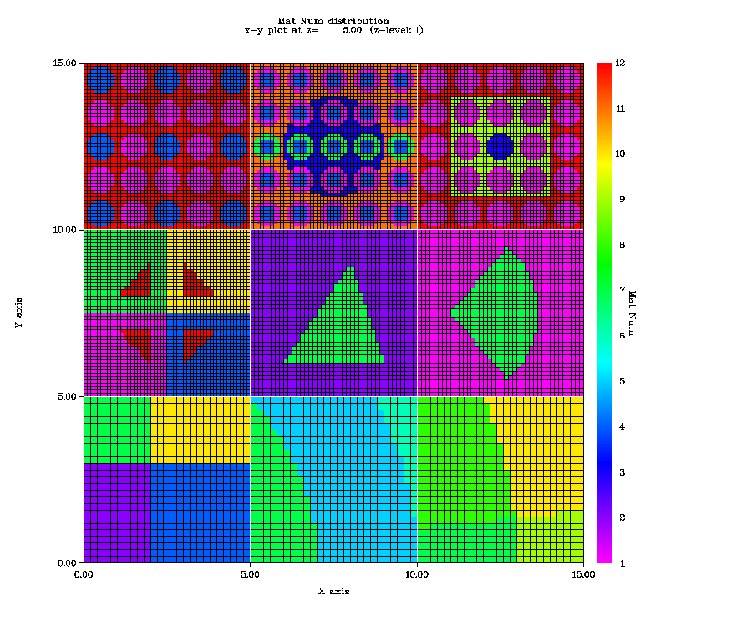

Figure 1. Meshing plot for the sample input files generated by PENMSHXP

There are nine coarse meshes in this z level. The first three coarse meshes (the bottom row with CM 1 on the left) are CM type 1, 2 and 3 without overlay structures. CM 4 is a coarse mesh with four quarter circle overlays. They follow the same syntax as PENMSH. CM 5 and 6 demonstrate two new overlay shapes in *PENMSHXP*: triangle and sector, with the overlay ID 3 and 51 respectively. Both overlay shapes are specified by the coordinates of three vertexes. Note that for a sector overlay, the first vertex should be the center of circle (See the overlay for CM 5 and 6 cards in the sample file). Table 2 lists all the supported overlay shapes in *PENMSHXP*.

Table 2 Overlay shapes in *PENMSH* and *PENMSHXP*

|  |  |  |  |
| --- | --- | --- | --- |
| Shape | Shape ID | PENMSH Spec. | PENMSH XP Spec. |
| Rectangular | 1 | -x, +x, -y, +y | -x, +x, -y, +y , (-z, +z)\* |
| Cylinder (along z) | 2 | -x, +x, -y, +y | -x, +x, -y, +y, (-z, +z) |
| Quarter Cylinder | 21,22,23,24 | -x, +x, -y, +y | -x, +x, -y, +y, (-z, +z) |
| Cylinder (along y) | 25 | Not available | -x, +x, -z, +z |
| Cylinder (along x) | 26 | Not available | -y, +y, –z, +z |
| Arbitrary Triangle | 3 | Not available | Ax, Ay, Bx, By, Cx,Cy, (-z, +z) |
| Prismatic Right triangle | 31,32,33,34 | -x, +x, -y, +y | -x, +x, -y, +y, (-z, +z) |
| Sphere | 4 | -x, +x, -y, +y ,-z, +z | Ox, Oy, Oz, r, (-z, +z) |
| Sector | 51 | Not available | Ox, Oy, Ax, Ay, Bx, By, (-z, +z) |
| Hexagon | 6 | Not available | Ox, Oy, Ax, Ay |

\*( ) means the inside specification numbers are optional. (Brackets are not included)

As discussed in Example 1 in Section 2, the sphere overlay shape is specified differently in *PENMSHXP*. All the other overlay shapes follow the same syntax as *PENMSH*. For any overlay shape card in *PENMSHXP*, two additional z axis boundary values (-z, +z) can be added at the end of the specification sequence. If these two values present, the overlay shape will only appear in between –z and +z.

In Example 5, CM 7, 8, and 9 are used to demonstrate the lattice structure of overlay shapes. Lattice overlays can be specified by a negative value in the ‘overlay type’ card, as demonstrated in the overlay block for CM7. For example, ‘-2’, as an overlay type, specifies a lattice circle structure. For a lattice overlay, additional specification card(s), after the ‘overlay boundary’ card, are required to describe the lattice structure. As shown in the CM 7 overlay block, the first additional card, called ‘number of lattice element and pitch size’ card, is composed of six numbers: the first three are the numbers of lattice elements along x, y, and z, and the next three numbers are the pitch sizes (distance between elements) along x, y, and z. Note only lattice in Cartesian Geometry is supported. The second additional card, called ‘lattice element material’ card, is required only if lattice elements use different materials. This card is triggered by a negative overlay material number (See CM8 Overalay 2). The card is to specify the material number for each lattice element. This ‘lattice element material’ card is placed after the ‘number of lattice element and pitch size’ card. The total number of entries should be equal to the number of lattice elements. The numbering of lattice elements follows the same ordering as coarse/fine mesh numbering. (i.e. increasing along x first, then y, then z). FIDO input (R and Q) is supported in this card. More details about FIDO can be found in *PENTRAN* manual. NOTE: FIDO (R and Q) input format is supported only in the following cards: overlay type, overlay material, and overlay lattice element material.

Several overlays can be cast onto the same individual fine mesh. And a fine mesh takes the last overlay on it as its final material number. And by default, all the x, y,and z coordinates used in the CM material and overlay specification cards are the global coordinates. If a negative number is given in ‘number of subregion’ card, the coordinates are taken as relative to the coordinate coarse mesh left bottom corner.

Since version 2.65b, PENMSHXP also reads an ‘all-zlev-in-one’ input file (*prbname.inp*), instead of a number of z-level input file (*prbname#.inp*). The ‘all-in-one’ input file contains information for all z-levels. Note that penmsh.inp file remain the same.

The following figure shows a sample all-zlev-in-one input file:

/All-zlev-in-one input file : prbname.inp

/ncx, ncy

3, 2

/ cm bounds along x-axis (in seq ...x)

0.0 15.0 20.0 25.0

/cm bounds along y-axis (in seq ...x)

0.0000E+00 15.0000E+00 2.0000E+01

/CM cards

cm=1 1 1

2 /cm(1,1,1) mat num

5 5 5 /cm(1,1,1) fine mesh number along x y z

cm=2 1 1

2

15 5 12

cm=3 1 1

2

5 5 12

cm=1 2 1

2

15 5 12

cm= 2 2 1

2

5 5 12

cm=3 2 1

2

5 15 12

cm=1 1 2

-1 /minus mat number -> overlay exist

40 40 40

/overlay

2

-2 -4

5 -1

/first overlay (circle)

0.0 1.0 0.0 1.0

3 3 1 2.5 2.5 0

/second overlay (sphere)

10.0 10.0 1.0 1.0

3 3 3 2.5 2.5 2.5

5 7 9 2Q3 2Q9

cm=2 1 2

2

5 15 12

cm=3 1 2

1

15 15 12

cm=1 2 2

2

5 15 12

cm=2 2 2

2

5 5 12

cm=3 2 2

2

15 5 12

The first card in the ‘all-zlev-in-one’ input file specifies the number of coarse meshes along x and y. Note number of coarse meshes along z axis is specified in the penmsh.inp file. The next two cards specify the coarse mesh boundaries along x and y axis, respectively. The rest of the cards are coarse mesh cards, used to define each coarse mesh individually. A coarse mesh card starts with a marker ‘cm=’, followed the coarse mesh’s x, y, and z index. For example, ‘cm=1 1 1’ marks the definition of the coarse mesh (1 1 1). Each coarse mesh requires a marker, ‘cm=i j k’, but they can appear in any order. Following the coarse mesh marker, two cards are required: the first card defines the coarse mesh material; the second card specifies the number of fine meshes along x, y, and z axis in the coarse mesh. A negative coarse mesh material number indicates that there are overlay structures in the coarse mesh. Overlay cards follows the ‘number of fine meshes along x, y, and z’ card. And they have the same syntax as in the ‘prbname#.inp’. (see Example 5b)

# *PENMSHXP* Output Files

Table 3 lists the output files by *PENMSHXP*.

Table 3 *PENMSHXP* output flies

|  |  |
| --- | --- |
| File names | Description |
| prbname\_out.pen | PETRAN input deck |
| prbname\_out.mba | Material balance tables |
| read.log | Processing log file |
| prbname\_mix.plt. | TECPLOT binary file, contains all the meshing data |
| prbname.mcr | TECPLOT macro file |
| prbname#.png | z-level plots, where # is the z level number |

Prbname\_out.pen is the generated *PENTRAN* input file. For very large models, it could take a while to generate the FIDO characters in the PENTRAN input deck. Users can use “*-offf90*” option to turn off the .f90 output file, if *PENMSHXP* is used only for testing the model geometry. Another command option in version 1.6 or later is –*nofido*, which turns off the FIDO sequence generation in the source section of *prbname\_out.pen*.

*prbname\_out.mba* contains meshing and material balance information of the model. A sample of *prbname\_out.mba* can be found in Appendix A, which contains two sections: The first section of the file lists the material information for each coarse mesh in the model. The second section provides the volume information for each material in the model. If the prbname.mba input file exists in the input file directory, the second section also provides the comparison results between the target volume (provided in prbname.mba) and the model volume (calculated by *PENMSHXP*) for each material. More details can be found in the PENTRAN manual.

*read.log* is the processing log file. All the data processed in the input files will be listed in the log file. This file can be useful in case of PENMSHXP running into unexpected errors. PENMSHXP can trap some errors in the input files. Error messages and warnings will be streamed out both on screen and in the log file. The default log file name is read.log. Users can use ‘-*l*’ option to specify the log file name. For example:

Example 6 Command option to specify log file name

[home/user/]# penmshxp *–l mylog.txt*

In the above command, *PENMSHXP* reads the input files from current directory, and all the processing log will be written into a file named mylog.txt.

*prbname\_mix.plt* is a TECPLOT binary file with a point-wise structure. A fine mesh corresponds to one point. Each fine mesh has at least 5 variables: x, y, z, mat\_num, and source intensity. If the flux files are properly processed as discussed in Section 2, the group flux variables will be added in the list: grp1, grp2, etc. A coarse mesh forms a zone in TECPLOT, and all the coarse meshes in one z level form a zone group.

*prbname.mcr* is a TECPLOT macro file. It can be loaded within TECPLOT: menu -> file -> macro -> play, then select the file. The macro will make a scatter plot in TECPLOT, with the *mat\_num* as the contour variable. Therefore, after the macro file is loaded, a material distribution plot of the model should appear in the plot window. The TECPLOT output files can be disabled by using a command option *“-offplt”.*

*prbname#.png* is an image file to show the x-y plot in the middle of each z-level, which is similar to the z-level postscript files generated by PENMSH. In *PENMSHXP*, the default format of the plots is PNG, which is compatible with most image viewer software. Details of plotting options are given in the next section.

# *PENMSHXP* Plotting Options

*PENMSHXP* generates z-level plots using the DISLIN graphic library, which is written by Helmut Michels, and can be found at http://www.dislin.de. The library is free for non-commercial use. A separate version of *PENMSHXP* is available without the support of this DISLIN plotting function. Users can still use TECPLOT to generate various plotting. Table 4 lists the command options for DISLIN plotting options.

Table 4 *PENMSHXP* plotting options with DISLIN library

|  |  |  |  |
| --- | --- | --- | --- |
| Options | Arguments | Description | |
| -plot *n* | *n* is an integer to specify x, y, and/or z plot | | Mid-level plots  *n*=1, 2, or 4: plotting on each z, y or x level mid-plane. Users can add the numbers up to plot along multi axes. e.g. n=5 will plot along z and x axes; n=7 will plot along all there axes. |
| -plotx ,-ploty, -plotz  *pos1, pos2*… | *pos1*, *pos2* … are position values | | Specified position plots  To plot on a number of positions along an axis.  e.g. *–plotx 1.2 3.0* will plot on the planes of x=1.2 and x=3.0 |
| -msf *m* | *m* is an integer to specify to plot *mat*, *src*, and/or *flux* | | To specify material, fixed source, or flux plots  *m*=1, 2, or 4: plotting material, fixed source, or flux. Users can add the numbers up to plot multi variable distributions. e.g. n=5 will plot mat and flux; n=7 will plot *mat*, *src*, and *flux*.  If a negative number is used, an ASCII data file (.cat) is also generated. |
| -3d | N/A | | Turn on 3-d contour plotting. Without using this option, 2-d contour plots are generated. |
| -size *f* | *f*  is a real number to specify a size multiplication factor | | To control the *.png* file size  e.g. –size 2.0 will increase the plot size by a factor of 2. *f* ranges from 0.1 to 9. By default *f=1*. The plot size is 900 pix wide. The height depends on the model x-y size ratio. |
| -nofm |  | | Turn off fine mesh line drawing for all CM.  Note FM lines automatically turned off if FM size is less than 8 pixel in a CM |
| -offpng | N/A | | Turn off plotting |
| -z | z lever number | | Plot a single z level. |
| -color | <0-8> | | Define a color map, default is 3, a rainbow color map. |
| -cm |  | | Color map help info |

By default, PENMSHXP will generate a material distribution plot per *z* level at the z-level mid-plane. The default size of the image is 900 pixels along x axis, and y-size is automatically calculated based on the model geometry (x-y ratio).

Figure 2 shows a sample z-level plot from a reactor model.

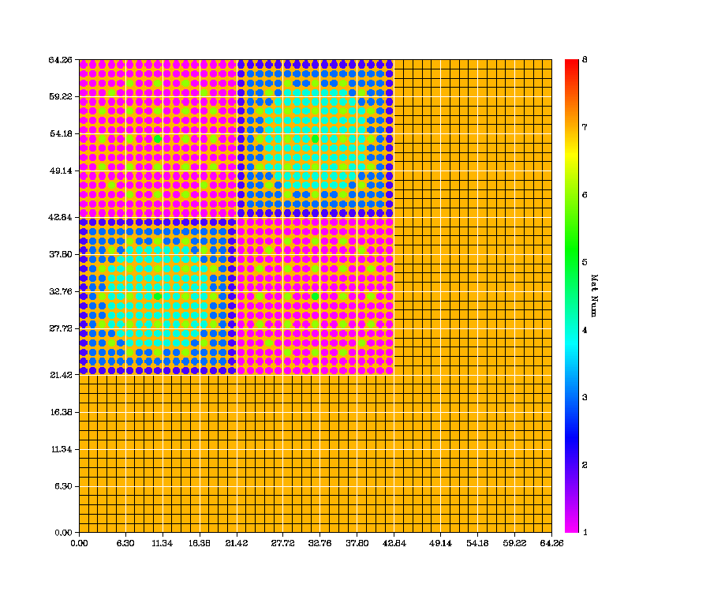

Figure 2 2-D material distribution plot for a reactor model

In Figure 2, coarse meshes boundaries are drawn with white lines. And fine meshes are represented with black lines. Note if the size of a fine mesh is less than 8 pixels, fine mesh lines will be automatically disabled in the coarse mesh for a clearer view of the material distribution. As shown in Fig. 2, the fine mesh boundary lines (black lines) are not visible in the fuel region because of the small size of the fine mesh, but can be seen in the reflector region. The coordinates of the coarse mesh boundaries are labeled along the axis. Each fine mesh is filled with color based on the material number. And the legend is shown on the right side of the figure.

Users can use ‘-plot’ option to specify the axis along which the mid-plane will be plot on (See Table 4). *PENMSHXP* can also plot on user-specified positions along an axis with the *-plotx*, *-ploty* and *–plotz* options. The *‘-msf*’ option is used to specify different plotting variables: materials, fixed source and/or flux. If *-msf 4* or higher is used, *PENMSHXP* will try to load the flux files. Users can use *‘-f*’ option to specify the flux file directory. (See section 2). If ‘*-f2’* option is used, the difference between two flux sets will be plot. If *–msf* *-4* is used, beside the plot graphic files, *PENMSHXP* will also output an ASCII data file (*.cat*) for each plot. The ‘-3d’ option will turn on the 3-D contour plot. Figure 3 shows 2-D and 3-D flux distribution plots on the same plane.

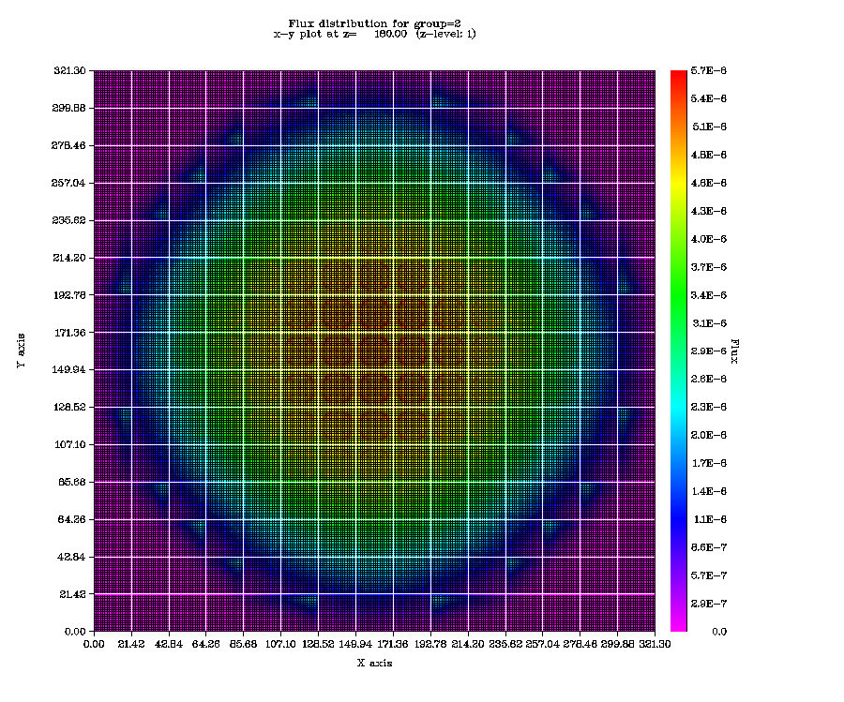 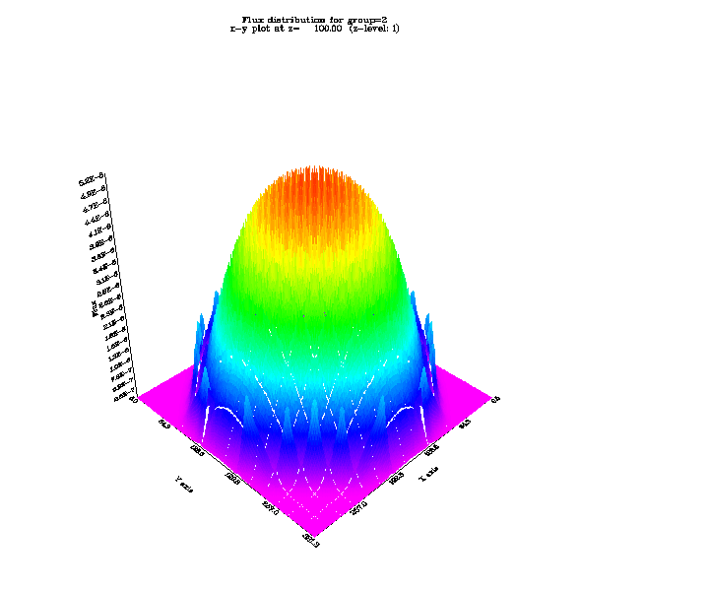

(a) 2-D plot (b) 3-D contour plot

Figure 3 2-D and 3-D contour plots with PENMSHXP

Note that for version 2.5 and above, PENMSHXP will overwrite the existing PNG files with the same name, instead of generating new files. The naming convention is :

*<prbname’s first 3 letters>\_<xyz> <plot number><ic><msf>.png*

For example, if the problem name is ‘test’, ‘*tes\_z1cm.png*’ will be the first level material distribution plot (at mid-level). Here ‘*c*’ means a mid-zlevel plot, and ‘*m*’ indicates a material distribution. While ‘*i*’ indicate is a specific location plot (when –plotx, -ploty or –plotz is used), instead of a mid-level plot, ‘s’ and ‘f’ mean source distribution plot and flux distribution plot, respectively.

For a 2-group model, a command option:

*‘-ploty 1.3 4.5 –msf 7 –f* ’

will generate 8 plots assuming flux files (*.flx*) are successfully loaded from current director. They are material, source, and flux distribution at y=1.3cm and 4.5cm. The file names are:

*tes\_y1im.png* : material plot at y=1.3

*tes\_y1is.png* : source plot at y=1.3

*tes\_y1if1.png* : group 1 flux plot at y=1.3

*tes\_y1if2.png* : group 2 flux plot at y=1.3

*tes\_y2im.png* : material plot at y=4.5

*tes\_y2is.png* : source plot at y=4.5

*tes\_y2if1.png* : group 1 flux plot at y=4.5

*tes\_y2if2.png* : group 2 flux plot at y=4.5

A large set of graphic files could be generated, especially if the number of group is large. User can refer the screen output, the log file, or the title line within a graphic file for information on each plot. Users can turn off plotting entirely by using a command option *–offpng*. ‘-z’ option is used to plot a single z level material distribution. This is designed to help user to adjust meshing parameters while building the problem model level by level. When *‘-z n’* option is used (where *n* is the z-level number), only *penmsh.inp* and *prbname#n.inp* are required to build z-lever *n*.

# Phantom Binary File Handling

*PENMSHXP* can build a model based on a phantom binary file by using the command line option *‘-hrt’*, followed by the name of the phantom input file (user-defined).

Example 7: Command option to load binary medical phantom file.

[home/user/]# penmshxp –hrt phantom.inp

With the above command, *PENMSHXP* attempts to open phantom.inp in the current directory. *penmsh.inp* and *prbname#.inp* files in Table 1 are not required for a phantom model. Instead, *PENMSHXP* builds the model material and source distributions based on the phantom binary files: a voxel-wise material attenuation file and an optional voxel-wise source activity file. Some parameters of the phantom are defined in phantom.inp, such as the binary file name(s), number of voxels in the phantom, etc. *PENMSHXP* renders each voxel as a fine mesh. Users can define the coarse mesh boundaries in the unit of # voxel in the phantom.inp. All the other input files in Table 1 remain the same syntax. If the phantom input file name is not specified, the default name is *heart.inp*.

Example 8: A sample of phantom input file

/phantom input file: hrt2.inp

/ prbname

hrt2

/# of voxels along x, y,and z

65 ,61 ,58

/voxel size along x, y, and z

0.3125, 0.3125, 0.3125

/mat binary file name, src binary file name (optional)

hrt\_atn.bin hrt\_act.bin

/data type for each binary file

/binary datatype=0 : 4 byte integer (default)

/binary datatype=1 : 4 byte real

/binary datatype=-1 : 4 byte integer as mat #

1 1

/number of coarse meshes along x, y and z

3 3 3

/number of voxels per coarse mesh along x, y, and z

10 45 10

10 41 10

10 38 10

/source format,# source fine meshes (x,y,z),#group,sn,pn

0,30,30,30,5,18,3

/cross-section file: format, # comment lines,Leg. order, table length

1,1,3,8

/BCs

0,0,0,0,0,0

In the above example, the first three cards specify problem name, number of voxels and voxel size along x, y and z, respectively. Two binary files are specified by the following binary file name card. The first file is the attenuation/material number binary file, named *hrt\_atn.bin* in this model. The file contains the material attenuation coefficients or the material numbers for each voxel/fine mesh depending on the following data type card, in which users can specify the data format in each binary file. *PENMSHXP* reads the binary data as 4 byte integer (Type 0) or as 4 byte real number (Type 1). If Type 0 or 1 is specified for the attenuation/material number binary file (hrt\_atn.bin), *PENMSHXP* reads data as attenuation coefficients (with the unit of cm-1), and assigns a unique material number for every different value of attenuation coefficient automatically (first come, first serve). The total number of materials is determined by the total number of different attenuation values in the binary file. *PENMSHXP* can also read the data as material number (4 byte integer) if *datatype=-1* is specified for the attenuation/material number binary file. And the total number of material is the maxim integer in the binary file. In either case, the material numbers and their associated attenuation values (if *datatype=0* or *1*) will be written in an output file called *prbname\_data.out*. The second file, *hrt\_act.bin*, is an optional file. *hrt\_act.bin* contains the radiation activity value for each voxel/fine mesh, which can be used to specify the fixed source distribution in the model. Generally, datatype=1 (4 byte real number) should be used for the activity file. Both the attenuation/material number binary file and the activity binary file should have the same size of the total number of voxels multiplying by 4 bytes. Besides the radiation activity binary file, users can also define sources uniformly deposited in one or more materials, and/or with a source grid magnitude file (prbname.src), as the same way in the penmsh.inp file. If multi-sources are defined in different ways, *PENMSHXP* combines all the sources together, and projects them on the fine meshes.

All command options are listed Appendix C.

## Appendix A: sample prbname\_out.mba file (material balance output file of PENMSHXP)

Material Balance Summary for Model: core

Section 1 : Coarse Mesh information

CM # x\_size y\_size z\_size fm num tot\_fm fm\_vol num\_mat # of fm per mat

x y z mat 1 2 3 4 5 6 7 8 9

1 11.530 11.284 5.000 60 60 2 7200 9.035E-02 5 14 1000 48 540 0 0 0 0 5598

2 11.530 11.284 5.000 60 60 2 7200 9.035E-02 5 14 1000 48 540 0 0 0 0 5598

3 11.530 11.284 5.000 60 60 2 7200 9.035E-02 5 14 1000 48 540 0 0 0 0 5598

4 11.530 11.284 4.050 60 60 2 7200 7.319E-02 5 14 1000 48 540 0 0 0 0 5598

5 11.530 11.284 4.000 60 60 2 7200 7.228E-02 4 0 0 0 0 1014 48 540 0 5598

6 11.530 11.284 4.738 60 60 2 7200 8.561E-02 4 0 0 0 0 1014 48 540 0 5598

7 11.530 11.284 4.000 60 60 2 7200 7.228E-02 1 0 0 0 0 0 0 0 0 7200

8 11.530 11.284 4.000 60 60 2 7200 7.228E-02 1 0 0 0 0 0 0 0 0 7200

Section 2 : Model mat. information

Contents of file: ./ntest/test4/core.mba

-PENINP USER INPUT MATERIAL INVENTORY FOR BALANCE-

(The first 6 lines of this deck are comments)

Material Material Target (cm3) Density g/cc

Name Number Volume (see xsec)

---------- -------- ----------------- ------------

Material1 1 5.475328 6.5060E+00

Material2 2 342.4973 5.9643E+00

Material3 3 19.67009 8.032

Material4 4 179.5754 1.0

Material5 5 159.6034 1.6

Material6 6 9.022014 8.032

Material7 7 82.36524 1.0

Material8 8 0.0 0.0

Material9 9 3858.04 1.0

Model Material Inventory/Volume Table

Targeted Mean Density: 1.435529E+00 g/cm3 from .mba file

Targeted Volume: 4.656249E+03 cm3 Mass: 6.684180E+03 g

Model Volume: 4.656249E+03 cm3 Mass: 6.657266E+03 g

Material Mat Fine Model (cm3) % of Mdl/Trg Model Mass Model

name No. Meshes volume Total V-Ratio Excess (g) Mass (g)

---------- ------ -------- ------------- ------- --------- ------------ ----------

Material1 1 56 4.819413E+00 0.104 8.802E-01 -4.267E+00 3.136E+01

Material2 2 4000 3.442438E+02 7.393 1.005E+00 1.042E+01 2.053E+03

Material3 3 192 1.652370E+01 0.355 8.400E-01 -2.527E+01 1.327E+02

Material4 4 2160 1.858916E+02 3.992 1.035E+00 6.316E+00 1.859E+02

Material5 5 2028 1.601037E+02 3.438 1.003E+00 8.004E-01 2.562E+02

Material6 6 96 7.578871E+00 0.163 8.400E-01 -1.159E+01 6.087E+01

Material7 7 1080 8.526230E+01 1.831 1.035E+00 2.897E+00 8.526E+01

Material8 8 0 0.000000E+00 0.000 NaN 0.000E+00 0.000E+00

Material9 9 47988 3.851826E+03 82.724 9.984E-01 -6.214E+00 3.852E+03

TOTAL 57600 4.656249E+03

Material Vol in Cm^3

Total Vol : 4.656249E+03

Total Mat Vol: 4.656249E+03

## Appendix B: sample prbname.src file (fixed source file)

Prbname.src has two sections. The first section specifies the source grid boundaries along x, y and z (in unit of cm). The second

section defines the source intensities for each grid node (in unit of #of particles/sec.cm3). The number of source meshes is given in the

source specification card in penmsh.inp. For the input file of example 3 in Section 3, the numbers of source meshes are 10, 10, and 2

for x, y and z axis. Note that source grid are independent of the model meshing. Therefore, the boundaries of source meshes are not

required to agree with the model meshing.

Sample prbname.src file corresponding penmsh.inp in example 3 as follows:

0.0 1.26 2.52 3.78 5.04 6.3 7.56 8.82 10.08 11.34 12.6 /x src. mesh boundary. # meshes=10

0.0 1.26 2.52 3.78 5.04 6.3 7.56 8.82 10.08 11.34 12.6 /y src mesh boundary # meshes=10

0.0 5.0 10.0 /z src mesh boundary # meshes=2

Z level 1 (in this example, 10x10 values to specify the source intensities for each src mesh

------------------------------------------------------------- / two comment lines. (do not start with / ! or #)

0.034 0.040 0.043 0.041 0.000 0.043 0.045 0.041 0.000 0.038

0.033 0.041 0.043 0.044 0.043 0.045 0.045 0.044 0.040 0.040

0.035 0.041 0.045 0.045 0.042 0.044 0.045 0.044 0.040 0.040

0.037 0.042 0.044 0.043 0.000 0.043 0.044 0.042 0.000 0.038

0.045 0.047 0.048 0.049 0.048 0.047 0.045 0.042 0.041 0.041

0.046 0.048 0.049 0.049 0.049 0.048 0.045 0.000 0.041 0.041

0.047 0.049 0.049 0.049 0.049 0.048 0.046 0.043 0.042 0.041

0.044 0.048 0.049 0.049 0.049 0.049 0.047 0.045 0.043 0.041

0.045 0.047 0.048 0.048 0.049 0.048 0.047 0.046 0.044 0.040

0.045 0.045 0.045 0.046 0.047 0.047 0.047 0.045 0.044 0.039

Z level 2 (in this example, 10x10 values to specify the source intensities for each src mesh

------------------------------------------------------------- / two comment lines. (do not start with / ! or #)

0.043 0.042 0.000 0.043 0.045 0.046 0.045 0.044 0.041 0.037

0.043 0.042 0.000 0.043 0.045 0.046 0.045 0.044 0.041 0.037

0.040 0.041 0.041 0.041 0.041 0.040 0.039 0.037 0.034 0.030

0.049 0.049 0.049 0.048 0.048 0.047 0.045 0.043 0.039 0.039

0.046 0.046 0.046 0.045 0.044 0.043 0.041 0.039 0.034 0.041

0.044 0.043 0.043 0.041 0.040 0.039 0.037 0.035 0.031 0.036

0.042 0.041 0.041 0.040 0.039 0.038 0.036 0.034 0.032 0.028

0.040 0.039 0.038 0.037 0.036 0.035 0.033 0.031 0.029 0.026

0.036 0.034 0.035 0.034 0.033 0.032 0.031 0.028 0.026 0.023

0.033 0.032 0.031 0.030 0.029 0.028 0.027 0.025 0.023 0.021

## Appendix C: PENMSH XP Command Line Options

SYNOPSIS

penmshxp [flag1] [flag1 argument] [flag2] [flag2 argument] ...

DESCRIPTION

Flag Flag\_argument

-i, or --input *input\_dir*

To specify *input\_dir* as the input file directory. If *input\_dir* is not provided or *‘-i*’ option is not used, the current directory will be the input file directory

-f1, -f or --flux *flux\_dir*

To specify *flux\_dir* as the flux directory, where flux files (*proname#.flx* or *prb#.flx*) are located. Default directory is the current directory. See the examples in section 2.

-f2 *ref\_flux\_dir*

To specify *ref\_flux\_dir* as the reference flux directory, where reference flux files (*proname#.flx* or *prb#.flx*) are located. Default directory is the current directory. See the examples in Section 2.

-f3 or -fjn flux\_current\_dir

To Specify *flux\_current*\_dir as the flux current directory, where flux current files (*proname#.fjn* or *prb#.fjn*) are located. If this option is used, -f1 and –f2 options are ignored.

-l, or --log logfile name

To specifies the log file name

-h, or --help

To display help screen

-dot *DotBit*

*DotBit* is an integer, which controls the *spacpf* value format in the PENTRAN input file (Block V). The absolute value of DotBit specifies the number of digits after the point for a *spacpf* FIDO entry. A negative number means the *spacpf* value is in the scientific format. For example:

Example 9a. *-dot* command option usage

[home/user/]# penmshxp –dot 3

The above command will generate a FIDO sequence for *spacpf* like:

*spacpf=*2R1.345 3R241.123 20R0.012 …

Example 9b. *-dot* command option usage

[home/user/]# penmshxp –dot 5

The above command will generate a FIDO sequence for *spacpf* like:

*spacpf=*2R1.34512E+00 3R2.41123R+02 20R1.21157E-02 …

-nd, or –ndmesh *ndmesh*

To specify the differencing scheme id*: ndmeth* in *PENTRAN* input file (BLOCK 4)

Example 10. *-nd* command option usage

[home/user/]# penmshxp –nd -2

The above command will set ndmeth=-2 in the generated PENTRAN input deck. If this option is not used, the default one is 2.

-w *max\_warning*

To control maxim number of the same warning messages displayed. The default value of *max\_warning* is 5

-offf90

Turns off the PENTRAN input deck .pen file generating.

-offplt

Turns off the TECPLOT binary file generating

-offpng

To Turn off the *.png* file plotting. More plotting options is listed in Table 4

-nofido

To Turns off FIDO in source block (Block 5, Variable *spacpf*) in PENTRAN input file.

-hrt *filename*

*PENMSHXP* will run on the phantom binary file handling mode. See Section 5.

-titan

*PENMSHXP* will generate TITAN input file

-fgm

generate file flux.fgm : avg. flux per material zone for each group

Note: require load the flux using -f option

-agm

generate file flux.agm: avg. adjoint flux per material zone for each group

Note: groups are flipped

-ff

generate file prbname.flx.out : flux distribution file

Note: require load the all group flux using -f option

-fa

generate file prbname.adj.out: avg. adjoint flux distribution file

Note: groups are flipped