桌面游戏设计文档

# 游戏基本信息

|  |  |
| --- | --- |
| 游戏名称  Game Title | The Cavalry Field |
| 游戏风格/类别  Game Style/ Genre | abstract strategy |
| 背景故事  Background Story | World War I was the last glory of the cavalry, |
| 游戏时长/人数范围  Time / People | 30min/ 4 players |
| 核心机制  Mechanism | tactic & luck |
| 美术风格  Art Style | realism |
| 灵感来源  Insprition | the movie *war horse* |
|  |  |

# GAME STATEMENT:

To capture other player’s pawns( cavalryman) and became the people who has most pawns( captives).

# GAME PIECES:

Chess board/ Dice/ 24Pawns(6 each for 4 colors)

# GAME SETUP (START GAME):

4 players will set 6 pawns in their camp.

# HOW TO PLAY (PLAYERS’ TURN):

When it's the player's turn, they need to roll two dice to get two step numbers. Then they need to choose two pa too move( all direction are allowed).

# END GAME (WIN CONDITIONS):

The game will end in ten rounds. After ten rounds, players can compare the captive number to complete ranking.

# RULES/ MECHANICS:

Each piece’s must move outward at the first time.

When the piece move to the edge of the chessboard, the piece need to move backward with the rest of steps.

When a cavalryman stand on or cross enemy, the enemy piece will be captured and be came captive.

The player who capture the piece can keep the piece they capture. until settlement.

# Game Pieces Details

**XXX Card**

|  |  |  |  |
| --- | --- | --- | --- |
| Name | Visual | Description | Quantity |
| white\_pawns\*6 |  |  |  |
| red\_pawns\*6 |  |  |  |
| pink\_pawns\*6 |  |  |  |
| blue\_pawns\*6 |  |  |  |
| dice\*2 |  |  |  |
| chessboard | 221689948424_.pic | Four color is the camp for each player. The grid area is allowed for player to move. |  |

# Porotype Record

Ver.7/20

Photo:

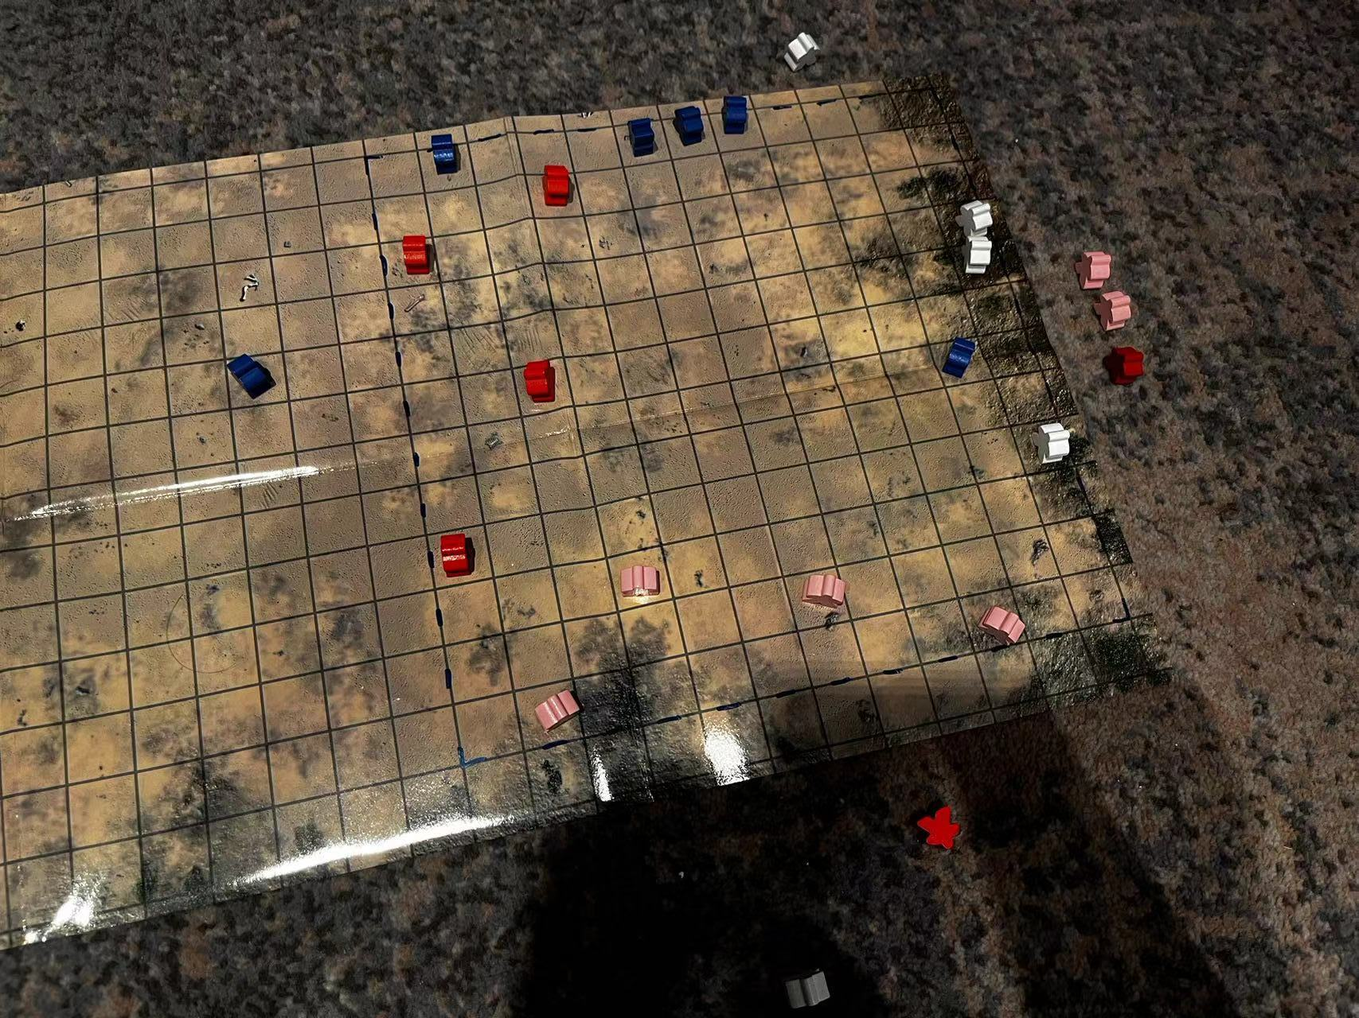

Advantage:

There are a lot of options available to players, and mid to early players have a great gaming experience.

Issue:

The progress of the game is very slow. If the player adopts a conservative defensive strategy, it will be difficult for other players to attack it effectively.

Improvement:

this is the initial version.

Ver.7/21

Photo:

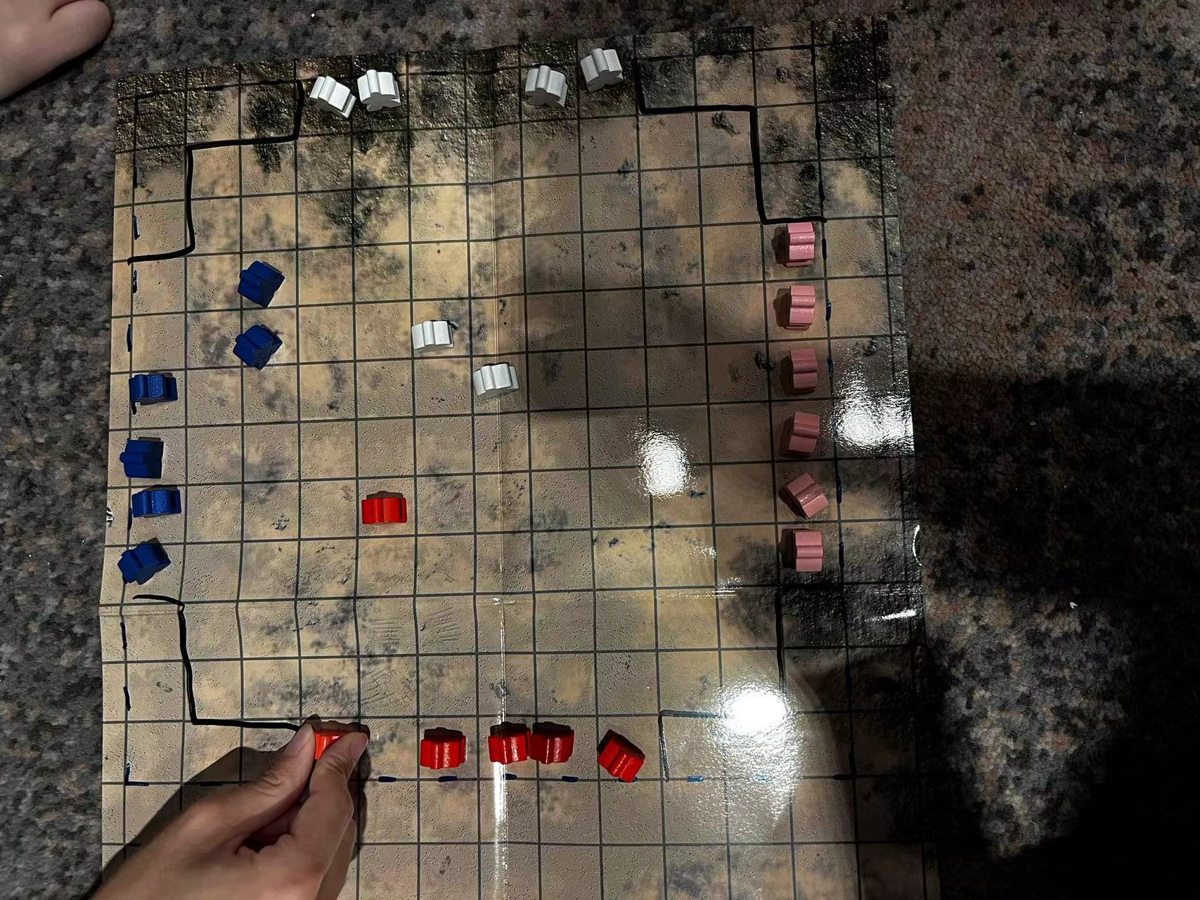

Advantage:

The progress of the game exceeds the original version. Players can obtain higher returns by adopting active and aggressive strategies.

Issue:

It is too easy for players to run away when only one or two pieces are left.game is hard to end

Improvement:

Added restricted areas in the four corners and mandatory for the player to move forward on the first turn, effectively preventing players from staying in camp.

Ver.7/21

Photo:

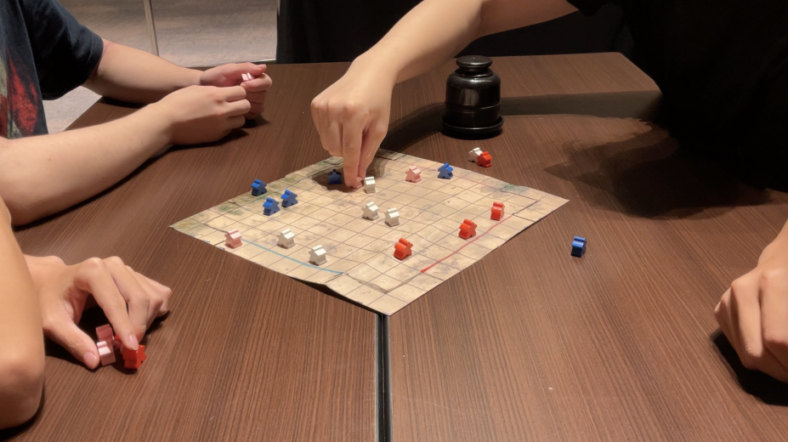

Advantage:

The duration of the game is further shortened, and the player's strategy and layout mechanism are more perfect. Players are more willing to take the initiative.

Issue:

The first-mover disadvantage is more obvious.

Improvement:

Added a mechanism for the immediate end of ten rounds. Improve the victory mechanism to win by counting the number of prisoners.