Re-NIA: a neighbor-information-aware graph neural network with unstable-prediction-guided subgraph relearning for miRNA-disease association prediction

Abstract
MicroRNAs (miRNAs) are closely associated with various human diseases. Accurately predicting miRNA-disease associations (MDA) is essential for elucidating disease mechanisms and advancing medical research. In recent years, graph neural networks (GNNs) have achieved remarkable success in MDA prediction tasks. However, challenges remain, particularly in effectively modeling heterogeneous neighbor information and ensuring prediction stability. To address these issues, we propose a novel deep learning framework named Re-NIA. We first construct a heterogeneous graph comprising miRNAs and diseases. Then, we design the NIA model, which decouples the input features into discriminative features for downstream prediction and aggregative features for neighborhood message propagation. A decorrelation propagation mechanism is introduced during message passing to suppress feature redundancy. These two types of features are then dynamically fused using a bidirectional cross-attention mechanism. Building upon NIA, we further pretrain the model to capture training information, from which a pulse signal matrix is constructed to detect unstable predictions. Based on these unstable associations, an unstable subgraph is then constructed and optimized through a relearning mechanism, thereby improving the model's prediction stability. Five-fold cross-validation experiments on the HMDD v2.0 dataset show that Re-NIA achieves an AUC of 94.29%, outperforming various existing models. In case studies on Lymphoma, Esophageal Neoplasms, and Prostate Neoplasms, Re-NIA also demonstrates excellent performance, with 28, 29, and 27 out of the top 30 predicted miRNAs respectively validated by the dbDEMC and miR2Disease databases, further verifying the practical applicability of Re-NIA.

Keywords: graph neural networks; miRNA-disease associations; attention mechanism; relearning mechanism.

Introduction

MicroRNAs (miRNAs) are endogenous, single-stranded non-coding RNAs typically 19–25 nucleotides in length, widely present in eukaryotic organisms [1]. By base-pairing with target messenger RNAs (mRNAs), they regulate gene expression via mRNA degradation or translational repression [2]. Numerous studies have demonstrated that miRNAs play essential roles in biological processes such as cell growth, proliferation, and differentiation [3]. Moreover, their dysregulation is closely linked to various diseases, including cancers, metabolic disorders, and neurological conditions [4]. Accurately identifying potential miRNA-disease associations (MDAs) is critical for understanding disease mechanisms and facilitating diagnosis, targeted therapy, and personalized medicine [5]. As a result, researchers from fields such as immunology, genetics, and bioinformatics have devoted substantial effort to exploring miRNA-disease relationships [6].
In the early stages, MDA discovery primarily relied on experimental techniques like RT-PCR, microarrays, and primer extension assays [7]. Though accurate, these methods are time-consuming, costly, and environmentally sensitive. The emergence of curated datasets such as HMDD v2.0 enabled a shift toward computational approaches, which offer faster and more economical alternatives [8]. Early studies focused on similarity-based methods, assuming functionally similar miRNAs associate with phenotypically similar diseases. For instance, Jiang et al. used functional networks [9], while Xuan et al. proposed HDMP, a k-nearest-neighbor-based model [10]. However, these methods are limited to known associations. Machine learning techniques addressed this by learning biological features to uncover novel MDAs. Chen et al. introduced RLSMDA [11], using regularized least squares in a semi-supervised framework. Still, challenges remain in processing high-dimensional data and integrating complex features. With the rise of deep learning, more advanced models emerged. Xuan et al. proposed a dual CNN framework [12], while Zeng et al. combined singular value decomposition with deep matrix factorization to capture both linear and nonlinear patterns [13].
Graph neural networks (GNNs), known for their powerful capabilities in modeling graph-structured data, have shown great promise in MDA prediction. GNNs can integrate node attributes with graph topology to capture both local and global semantic relationships [14]. For instance, Li et al. proposed NIMCGCN to learn latent representations of miRNAs and diseases through GCNs and generate association matrices [15]. Tang et al. used GCN encoders to extract features from various similarity views and combined them with multi-channel attention [16]. Ding et al. constructed separate miRNA and disease subnetworks and trained them using variational autoencoders [17]. Furthermore, Yu et al. proposed a meta-path-based approach by defining seven symmetric semantic paths in a heterogeneous miRNA-disease-gene network to compute final association scores through iterative feature updates [18].
Despite the remarkable progress of GNN-based approaches, several critical challenges remain unaddressed. Two prominent issues include the heterogeneity of the MDA graph and the instability of GNN performance. Specifically, the MDA graph is inherently heterogeneous, containing multiple types of nodes (miRNAs and diseases) and multi-source heterogeneous information [19]. Most GNN models are designed for homogeneous graphs and employ static or coarse-grained neighbor aggregation strategies, overlooking the diverse importance of neighbor information across different prediction tasks [20]. As a result, noisy neighbors may interfere with prediction accuracy [21]. Furthermore, studies have revealed that GNNs often exhibit more severe performance fluctuations compared to traditional models, even under identical hyperparameter settings—a disadvantage for tasks requiring prediction stability, such as MDA inference [22]. In addition, redundancy and over-smoothing of node features also hinder GNN performance [23].
To address the above challenges, we propose a novel deep learning framework named Re-NIA. This model is designed to accommodate the heterogeneous nature of the MDA graph while enhancing the robustness of GNN-based predictions. First, we construct a heterogeneous graph using verified MDAs and similarity relationships, and project miRNA and disease nodes into a unified latent space via type-specific transformation matrices. To capture neighborhood-aware features, we design a specialized GNN model named NIA that decouples the input features into discriminative and aggregative components, which are used for downstream prediction and neighbor information aggregation, respectively. During aggregation, we introduce a redundancy-suppressing module based on decorrelated propagation to enhance feature independence and expressiveness. Moreover, a bidirectional cross-attention mechanism is incorporated to dynamically weight neighbor contributions, effectively capturing their task-specific importance and improving information fusion. To further mitigate the instability of GNNs, Re-NIA first pre-trains the NIA model for several epochs. A pulse signal matrix is then constructed to represent fluctuations in prediction results across training rounds. Using Otsu's thresholding method, we identify unstable MDA pairs and construct an unstable subgraph. This subgraph is fed into a fresh (untrained) copy of the NIA model, while the original graph is input to the pretrained main model. Their losses are then combined to jointly update the parameters of the main model. Finally, a fully connected layer is used to generate association scores between miRNAs and diseases. To evaluate the effectiveness of Re-NIA, we conducted five-fold cross-validation experiments on the HMDD v2.0 dataset. Our model achieved an AUC of 94.29%, demonstrating superior predictive accuracy and compared to existing MDA prediction methods.

Materials and dataset
Datasets
In this study, we conduct experiments on publicly available datasets, HMDDv2.0, which is widely used for exploring associations between miRNAs and diseases [8]. This dataset includes 383 distinct diseases ($N_{d}=$383), 495 miRNAs ($N_{m}=$495), and 5,430 experimentally validated miRNA-disease associations. Among a total of 189,585 possible miRNA-disease pairs, only 5,430 are confirmed associations ($S$ positive edges), resulting in a highly sparse dataset with severe class imbalance between positive and negative samples. To address this issue, we randomly sample 5,430 pairs from the remaining 184,155 unconfirmed pairs to serve as negative samples ($S$ negative edges). Additionally, both forward and reverse edges are added to enhance the structural information of the heterogeneous graph, alleviating the imbalance problem. Consequently, the resulting heterogeneous graph contains a total of $4S$= 21,720 edges: $2S$ labeled as 1 for positive (associated) miRNA-disease pairs, and $2S$ labeled as 0 for negative (unknown) pairs.
To better evaluate the model's predictive performance, we adopt a five-fold cross-validation strategy [24]. All known miRNA-disease associations are divided into five equally sized subsets. In each iteration, one subset is used as the test set and the remaining four subsets as the training set. This process is repeated five times, ensuring that each subset serves as the test set once. The final results are averaged across all five runs. Accordingly, the heterogeneous training subgraph used in each iteration contains $E =$21,720$×$4$⁄$5$=$17,376 edges. Based on this, we construct an adjacency matrix $A∈R^{N×N}$ (where $N={N_{m}+N}_{d}$). If there exists a positive or negative edge between miRNA $i$ and disease $j$, then $A_{i,j} =$ 1; otherwise, $A_{i,j} =$0. Thus, $A$ contains 17,376 entries with value 1, indicating the edges in the training subgraph. Since the graph is bidirectional, A is symmetric. The test subgraph is constructed in the same way.
Feature Matrix Construction
In this study, the feature matrix of the graph is constructed based primarily on the similarity information between miRNAs and between diseases.
For miRNAs, similarity is computed through a two-step process. First, based on the assumption that “miRNAs with similar functions are more likely to be associated with phenotypically similar diseases,” we compute the functional similarity scores between miRNAs [25]. These scores are used to construct a functional similarity adjacency matrix $MFSM∈R^{N_{m}×N_{m}}$, which encodes pairwise functional similarities among miRNAs. However, the $MFSM$ matrix is highly sparse due to the presence of numerous zero elements. To mitigate this, we introduce the Gaussian Interaction Profile (GIP) kernel similarity, calculated based on the interaction profiles of each miRNA and a kernel bandwidth parameter [26]. This results in a GIP kernel similarity matrix $MGSM∈R^{N_{m}×N_{m}}$. Finally, we integrate the $MFSM$ and $MGSM$ matrices to obtain the final miRNA similarity matrix $IM∈R^{N_{m}×N_{m}}$.
For disease similarity, a similar two-step approach is adopted. First, using the hierarchical structure of the Medical Subject Headings (MeSH) database, each disease is represented by a Directed Acyclic Graph (DAG). The semantic contribution of each ancestor node in the DAG is calculated by considering its frequency and relevance across different DAGs [10], [27]. This yields a disease semantic similarity matrix $DSSM∈R^{N_{d}×N_{d}}$. Next, the GIP kernel similarity matrix for diseases $DGSM∈R^{N_{d}×N_{d}}$ is computed in the same manner as for miRNAs. These two matrices are then integrated to obtain the final disease similarity matrix $ID∈R^{N_{d}×N_{d}}$.
Given the heterogeneity of miRNA and disease nodes, which exist in distinct feature spaces, we introduce a node-type transformation mechanism to project them into a unified feature space with dimension $d$, making them suitable for joint processing within the model. The transformation is defined as:
$F_{m}=IM*W_{m}$ (1)
$F_{d}=ID*W_{d}$ (2)
where $W_{m}$ and $W_{d}$ are learnable transformation matrices for miRNAs and diseases, respectively.
After transformation, $F_{m}$ and $F_{d}$ are concatenated row-wise to form the final heterogeneous feature matrix $X∈R^{N×d}$, which serves as the input to the model.
Through the above steps, we obtain the two most critical components of the miRNA-disease heterogeneous graph: the adjacency matrix $A$ and the feature matrix $X$. An overview of the construction process is illustrated in Fig. 1.
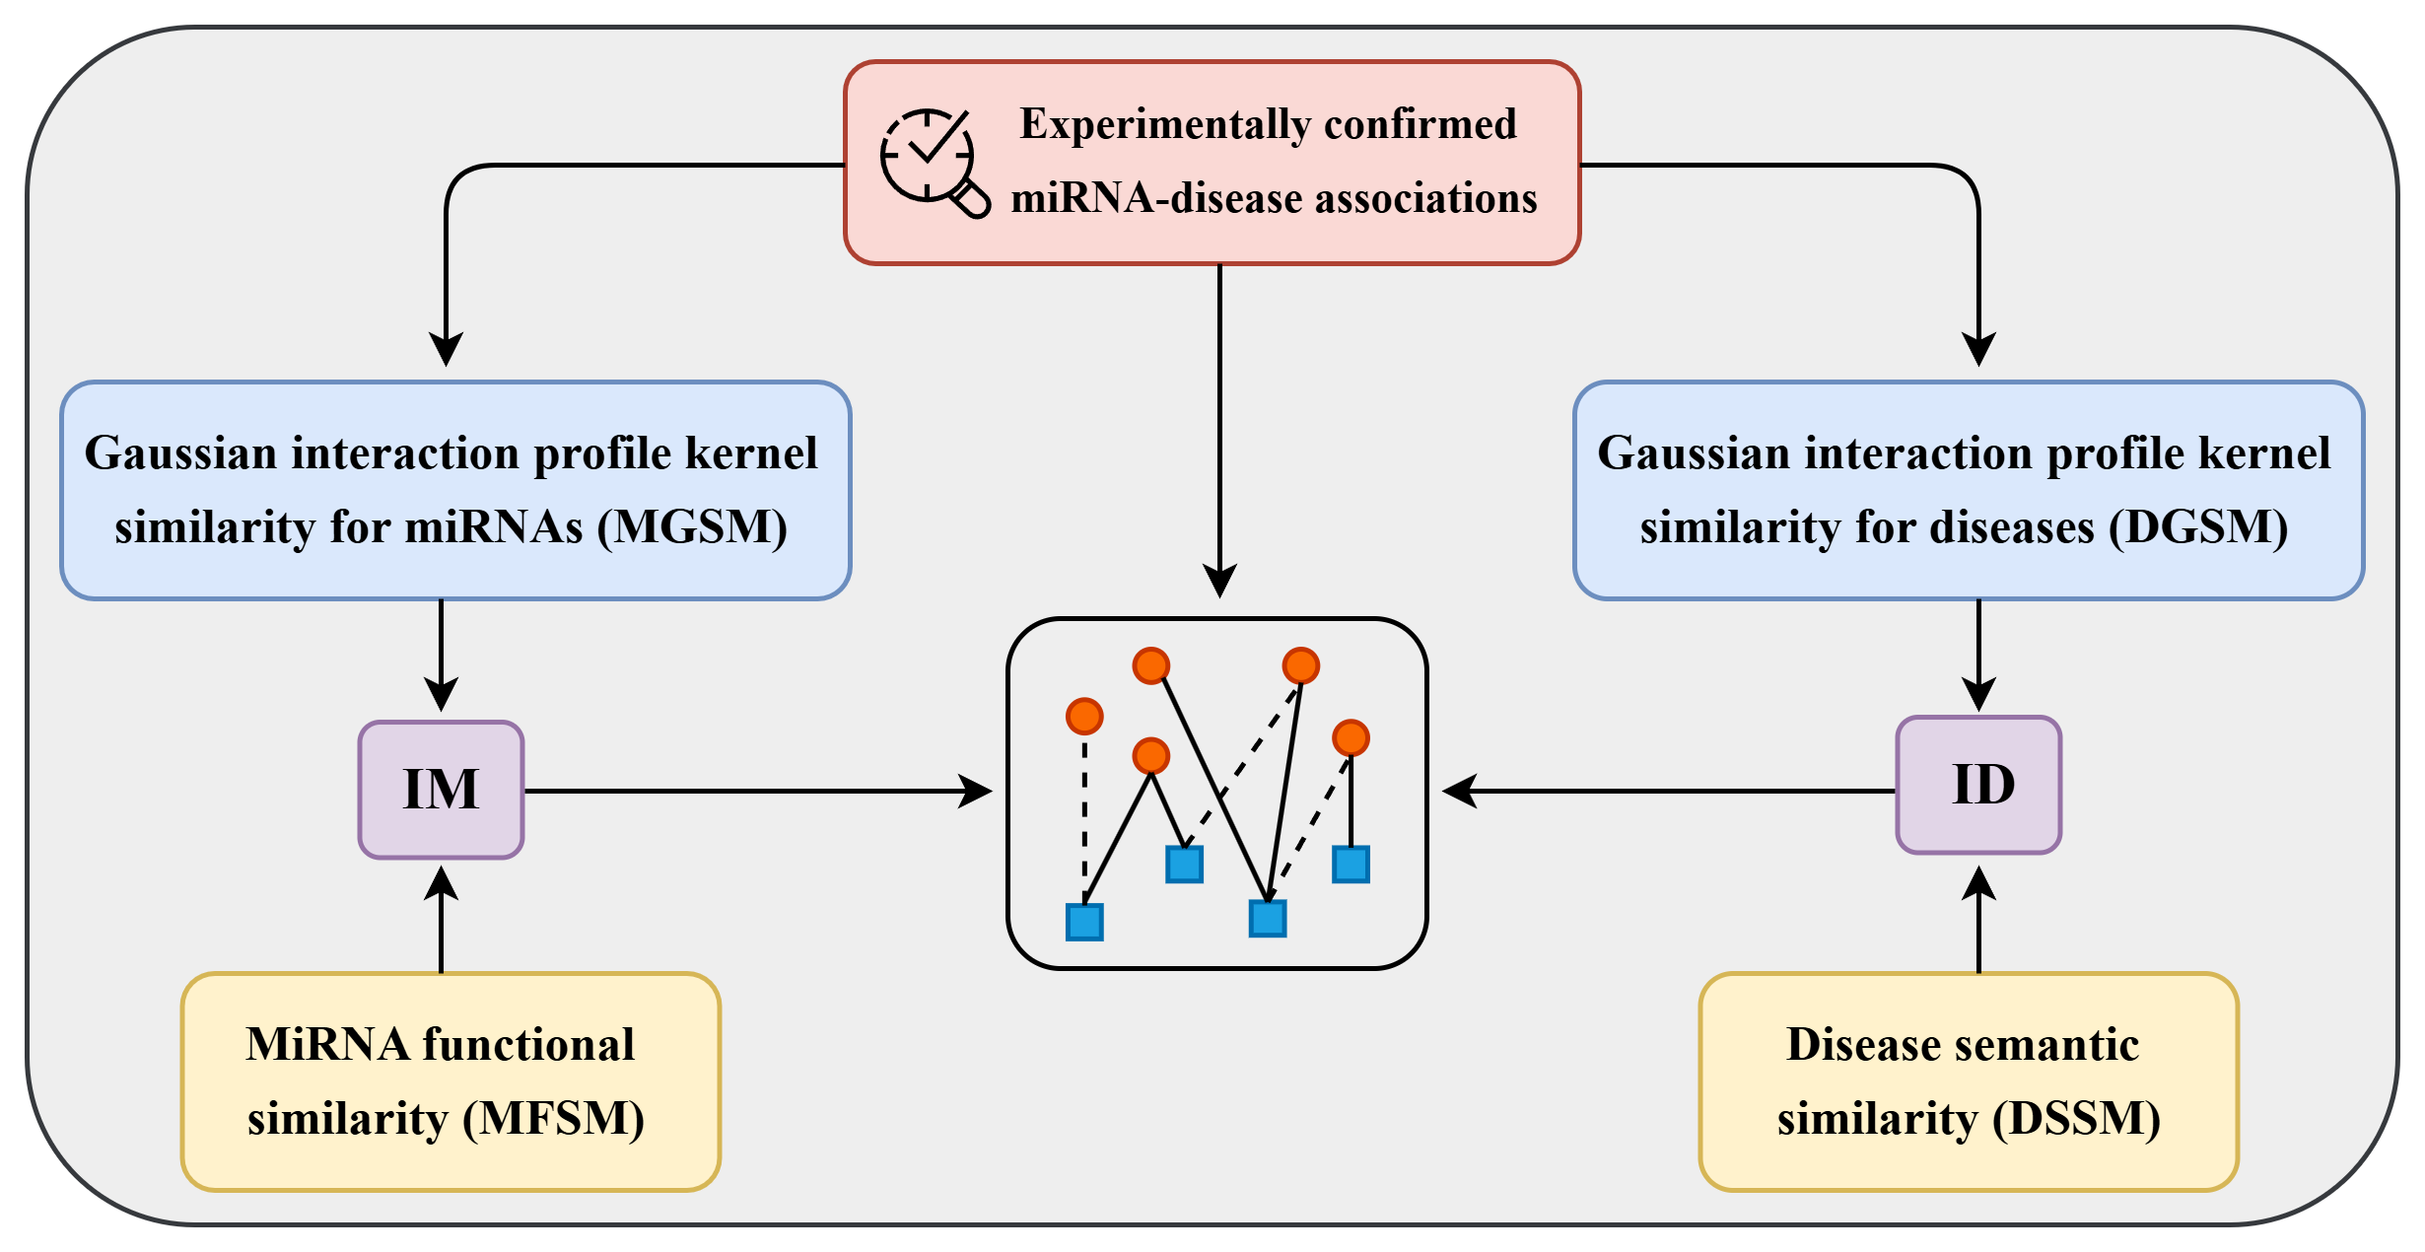
Fig. 1. The construction process of the miRNA-disease
heterogeneous graph

Re-NIA
In this section, we provide a detailed overview of the proposed Re-NIA model. The overall Re-NIA framework consists of two main components: 1. the construction of the NIA model. 2. the relearning process based on the unstable subgraph.
The construction of the NIA model can be further divided into the following four steps:
Step Ⅰ: Feature Decoupling: The input features are split into discriminative and aggregative parts, serving prediction and neighborhood aggregation tasks, respectively.
Step Ⅱ: Redundancy-Suppressing Aggregation:
Aggregative features are processed via a redundancy-suppressing module that removes correlated noise during aggregation.
Step Ⅲ: Neighbor-Information Awareness: A cross-attention module fuses discriminative and updated the

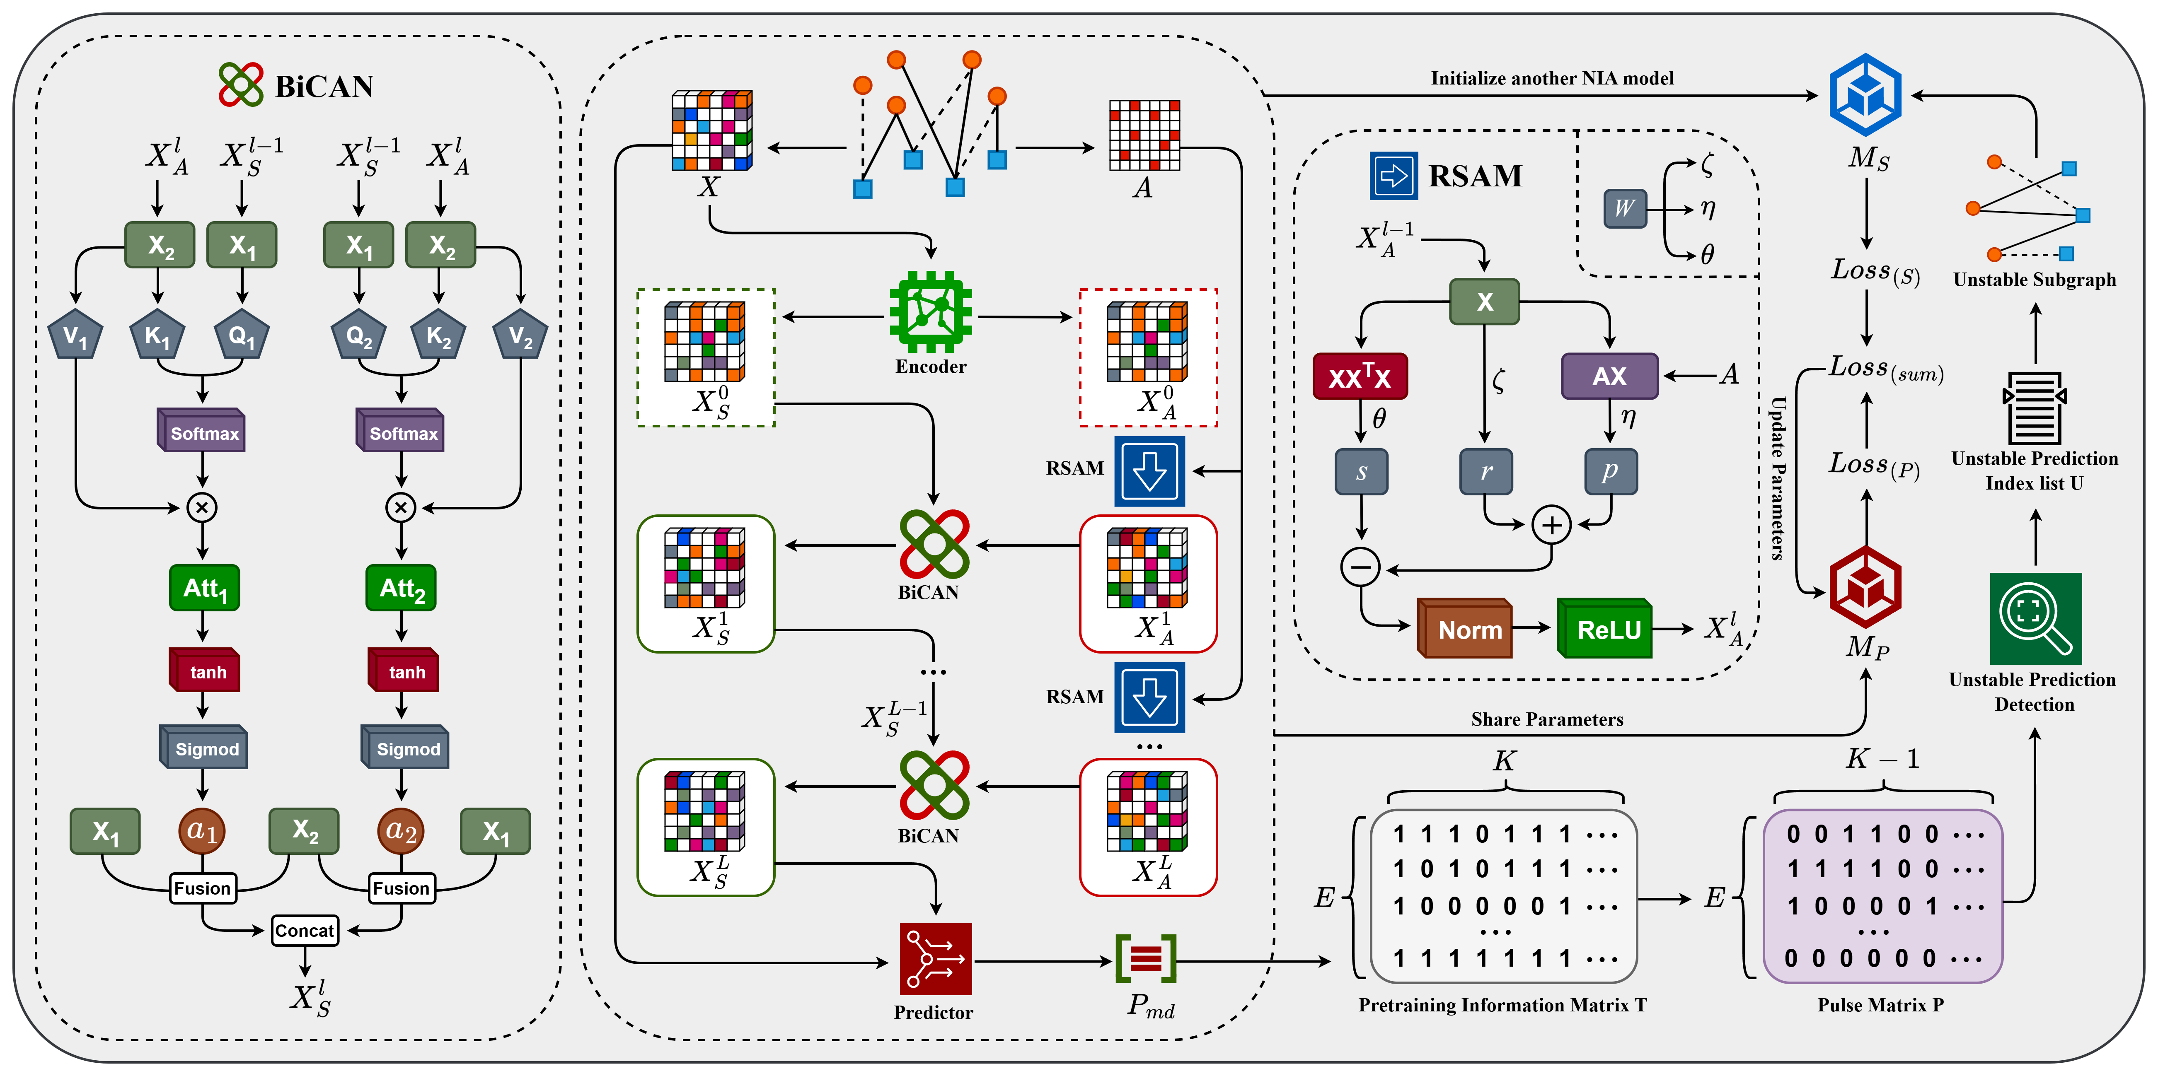
Fig. 2. The overall framework of the Re-NIA model

aggregative features by weighting neighbor contributions.
Step Ⅳ: Prediction Output: Final discriminative features are fed into a fully connected layer for prediction;
The relearning process based on the unstable subgraph consists of the following three steps:
Step Ⅰ: Pretraining: The constructed NIA model is pretrained for a fixed number of epochs, and the predictions from each epoch are recorded for further analysis.
Step Ⅱ: Unstable Prediction Detection: A pulse matrix captures prediction fluctuations, and unstable associations are identified via Otsu thresholding to form an unstable subgraph.
Step Ⅲ: Relearning: Both the unstable and original graphs are input into two NIA models (fresh and pretrained), trained jointly to refine the main model's parameters.
A illustration of the Re-NIA framework on each step in
detail is shown in Fig. 2.
Feature Decoupling
In the initial stage of the NIA model construction, a linear layer is employed as an encoder to process the input feature matrix $X$. The encoded features are then decoupled into two parallel paths:
$X_{S}^{0}=X_{A}^{0}=f_{Encoder}\left(X\right)$ (3)
$f_{Encoder}\left(X\right)=ReLU\left(Norm\left(X*W_{E}\right)\right)$ (4)
Here, $X_{S}∈R^{N×d}$ represents the discriminative features used for downstream prediction tasks, and $X_{A}∈R^{N×d}$ denotes the aggregative features used for neighbor information aggregation. $W_{E}∈R^{d×d}$ is a learnable weight matrix used for linear transformation. $Norm\left(⋅\right)$ denotes a normalization operation, and $ReLU\left(⋅\right)$ is the rectified linear unit activation function, which enhances the model’s non-linear representation capability. This decoupling strategy enables each node to independently assess the impact of its neighbors on the prediction task in the subsequent neighbor-aware fusion stage.
Redundancy-Suppressing Aggregation
In GNN-based node representation learning, deeper convolutional layers often cause feature homogenization and information redundancy. This leads to over-smoothing, where node representations across classes become indistinguishable, and to redundancy accumulation, where correlated or duplicate features degrade model discriminability. Inspired by decorrelated representation learning, which uses feature correlation matrices to quantify redundancy, we propose an aggregation mechanism that integrates residual retention, message passing, and redundancy suppression. Based on this, the Redundancy-Suppressing Aggregation Module named “RSAM” is created, which takes the aggregative features $X_{A}$ and the heterogeneous adjacency matrix $A$ as input. The core idea is to decompose the feature aggregation process into three components. For convenience, we denote the layer index by $l$ in the following terms:
• Residual Term ($r∈R^{N×d}$):
This term retains the feature representations from the previous layer to prevent feature degradation or vanishing. It is formulated as:
$r=ζ⋅X_{A}^{l-1}$ (5)
The coefficient $ζ$ controls the update magnitude. It adjusts the strength of propagation and redundancy suppression, respectively. Incorporating residuals helps preserve self-information and improves training stability.
• Graph Propagation Term ($p∈R^{N×d}$):
This term aggregates neighborhood information via the normalized adjacency matrix $\tilde{A}∈R^{N×N}$, defined as:
$p=η⋅\tilde{A}X_{A}^{l-1}$ (6)
$\tilde{A}={\hat{D}}^{-\frac{1}{2}}\hat{A}{\hat{D}}^{-\frac{1}{2}}$ (7)
where $\hat{D}=D+I$ and $D$ is the corresponding degree matrix with diagonal entries $D_{i,i}=\sum_{j=1}^{N}{A_{i,j}}$. $I$ is the identity matrix. The coefficient $η$ adjusts the strength of graph-based message passing.
• Redundancy Suppression Term ($s∈R^{N×d}$):
We propose a penalty mechanism based on feature autocorrelation to explicitly suppress redundant dimensions. A self-correlation matrix is constructed to evaluate inter-dimensional redundancy. This is used to reweight and suppress the original representation:
$s=θ⋅X_{A}^{l-1}\left(X_{A}^{l-1^{⊤}}X_{A}^{l-1}\right)*W_{s}$ (8)
Here, $θ$ controls the strength of suppression, and $W∈R^{d×d}$ is a learnable parameter matrix that adjusts sensitivity to different redundant dimensions. The objective is to penalize highly correlated dimensions, thereby enhancing feature expressiveness.
To set the coefficients $ζ$, $η$, and $θ$, we adopt an adaptive mechanism that combines learnability with normalization. Specifically, we introduce a learnable 3-dimensional vector $W∈R^{3}$, which is normalized using a softmax function to produce three non-negative weights that sum to 1: $\left[ζ, η, θ\right]=softmax\left(W\right)$. These weights dynamically balance the contributions of the residual, propagation, and redundancy-suppression paths in the aggregation process.
Finally, the output of the current layer's aggregation is computed by normalizing and applying non-linear transformation to the combined results $X_{A}^{l}∈R^{N×d}$:
$X_{A}^{l}=ReLU\left(Norm\left(r+p-s\right)\right)$ (9)
Through this module, NIA enhances the independence and informativeness of feature representations during neighborhood aggregation, laying a solid foundation for the downstream neighbor-aware fusion module to integrate high-quality feature signals.
Neighbor-Information Awareness
In GNNs, node feature updates rely heavily on the aggregation of neighboring information. However, we observe that most aggregation schemes suffer from two major limitations: 1. Nodes passively receive information from neighbors without actively discerning which neighbors are relevant or should be ignored [28]. 2. Most GNNs model information flow solely from neighbors to the central node, while overlooking how neighbors perceive or respond to the central node-lacking symmetric interaction modeling [29].
To address these limitations, we draw inspiration from the bidirectional cross-attention mechanism in natural language processing(NLP), which captures mutual attention between two sequences (e.g., “A attends to B” vs. “B attends to A”) [30]. We extend this concept to graphs and propose the Bidirectional Cross-Attention-based Neighbor-awareness module named “BiCAN”, enabling each node to consider: 1. How the current node attends to its neighbors ($Att₁∈R^{N×d}$). 2. How its neighbors attend to the current node ($Att₂∈R^{N×d}$). These two attention outputs are then adaptively fused, yielding more context-aware and semantically bidirectional aggregation outcomes. Specifically, in this step, the NIA model updates the discriminative features by integrating the previous discriminative features with the aggregated features obtained from the RSAM. Based on the bidirectional attention principle, the update process is as follows:
1. Attention from $X_{S}^{l-1}$ to $X_{A}^{l}$:
We treat the previous-layer discriminative features $X_{S}^{l-1}$ as Query, and the current aggregated features $X_{A}^{l}$ as Key and Value, then calculate attention information ${Att}_{1}$:
$\left\{\begin{aligned}Q_{1}=X_{S}^{l-1}*W_{q}^{\left(1\right)} \\ K_{1}=X_{A}^{l}*W_{k}^{\left(1\right)} \\ V_{1}=X_{A}^{l}*W_{v}^{\left(1\right)}\end{aligned}\right.$ (10)
${Att}_{1}=softmax\left(\frac{Q_{1}K_{1}^{T}}{\sqrt{d}}\right)*V_{1}$ (11)
2. Attention from $X_{A}^{l}$ to $X_{S}^{l-1}$:
We reverse the perspective, using the aggregated features as Query, and the discriminative features as Key and Value: then calculate attention information ${Att}_{2}$:
$\left\{\begin{aligned}Q_{2}=X_{A}^{l}*W_{q}^{\left(2\right)} \\ K_{2}=X_{S}^{l-1}*W_{k}^{\left(2\right)} \\ V_{2}=X_{S}^{l-1}*W_{v}^{\left(2\right)}\end{aligned}\right.$ (12)
${Att}_{2}=softmax\left(\frac{Q_{2}K_{2}^{T}}{\sqrt{d}}\right)*V_{2}$ (13)
The attention outputs ${Att}_{1}$ and ${Att}_{2}$ are then used to compute adaptive fusion weights for the two types of features:
$\left\{\begin{aligned}a_{1}=σ\left(tanh⁡(A_{1})\right) \\ a_{2}=σ\left(tanh⁡(A_{2})\right)\end{aligned}\right.$ (14)
$\left\{\begin{aligned}Info_{1}=a_{1}*X_{A}^{l}+\left(1-a_{1}\right)*X_{S}^{l-1} \\ Info_{2}=a_{2}*X_{S}^{l-1}+\left(1-a_{2}\right)*X_{A}^{l})\end{aligned}\right.$ (15)
$X_{S}^{l}=\left[Info_{1} || Info_{2}\right]*W_{f}$ (16)
In the above, $W_{q}∈R^{d×d}$, $W_{k}∈R^{d×d}$, $W_{v}∈R^{d×d}$ and $W_{f}∈R^{d×2d}$ are all learnable weight matrices for linear transformation, and$tanh(·)$ denotes the hyperbolic tangent activation function. Through this mechanism, the NIA model achieves bidirectional neighbor-awareness and selective feature fusion. It allows each node to not only assess the relevance of neighboring nodes but also capture their reciprocal responses.
Output Prediction
After $l$ layers of processing in the NIA, we obtain the final feature representation $X_{S}^{L}$. To alleviate the vanishing gradient problem, we introduce a residual structure in the prediction phase by fusing the final node feature $X_{S}^{L}$ with the original node feature $X$. As described earlier in the feature matrix construction, $X$ is a matrix composed of both miRNA and disease features, concatenated row-wise. Therefore, we first extract the top $N_{m}$ rows from $X_{S}^{L}$ and $X$ to obtain the miRNA feature matrices $X_{S\left(m\right)}^{L}∈R^{N_{m}×d}$, $X_{R\left(m\right)}∈R^{N_{m}×d}$; then extract the bottom $N_{d}$ rows to obtain the disease feature matrices $X_{S\left(d\right)}^{L}∈R^{N_{d}×d}$, $X_{R\left(d\right)}∈R^{N_{d}×d}$. We then perform residual fusion and apply a linear layer followed by an activation function to obtain the final miRNA and disease feature matrices $X_{m}∈R^{N_{m}×d}$ and $X_{d}∈R^{N_{d}×d}$:
$X_{m}=ELU\left(\left[X_{S\left(m\right)}^{L} || X_{R\left(m\right)}\right]*W_{m}\right)$ (17)
$X_{d}=ELU\left(\left[X_{S\left(d\right)}^{L} || X_{R\left(d\right)}\right]{*W}_{d}\right)$ (18)
Here, $ELU(·)$is the activation function; $W_{m}∈R^{d×2d}、W_{d}∈R^{d×2d}$ are the learnable weight matrices used for linear transformation in the residual fusion process; and "||" denotes column-wise concatenation.
Next, we extract the miRNA index $I_{m}∈R^{E}$ and the disease index $I_{d}∈R^{E}$ from the training subgraph of the heterogeneous graph. These indices correspond to node positions in the graph, meaning that the $i$-th element in $I_{m}$ and $I_{d}$ indicates an edge between the corresponding nodes. Since the training subgraph contains $E$ edges, both $I_{m}$ and $I_{d}$ are of length $E$. Based on this, we extract the final miRNA and disease features for prediction from $X_{m}$ and $X_{d}$, denoted as $X_{m}^{P}∈R^{E×d}$ and $X_{d}^{P}∈R^{E×d}$, and compute the prediction scores:
$P_{md}=σ\left(\left[X_{m}^{P} || X_{d}^{P}\right]*W_{P}\right)$ (19)
Here, $W_{P}∈R^{1×2d}$ is the weight matrix of the fully connected layer; $P_{md}∈R^{E×1}$ is the final output of the model, where each row indicates the predicted probability of an association between a given miRNA and disease pair.
After obtaining the prediction scores, we use a binary cross-entropy loss function combined with L2 regularization to train the NIA model. The specific training loss is defined as follows:
$L_{BCE}=-\left[ylogP_{md}+\left(1-y\right)log\left(1-P_{md}\right)\right]$ (20)
$L2\left(W_{all}\right)=\sum_{i=1}^{J}{||W_{all}^{i}}||_{2}^{2}$ (21)
$L=L_{BCE}+λ*L2\left(W_{all}\right)$ (22)
Here, y is the ground truth label indicating whether a miRNA-disease association exists (1 for positive edge, 0 for negative edge); $J$ is the total number of model parameters; $W_{all}$ is the set of all trainable parameters, with $W_{all}^{i}$ representing the $i$-th parameter; and $λ$ is a coefficient controlling the weight of the L2 regularization term. $L$ is the final training loss.
Pretraining
To address this issue and enhance the stability of our model, we employ a relearning strategy guided by unstable predicted associations. First, after constructing a complete NIA network as described in previous steps, we initialize a primary NIA model denoted as $M_{P}$ and perform pretraining for $K$ epochs. After training, we construct a pretraining information matrix $T∈R^{E×K}$, which records the prediction results of $M_{P}$ over $K$ pretraining epochs. The matrix $T$ is defined as follows:
$T\left(i,j\right)=\left\{\begin{aligned} 1 &if P_{md}^{\left(i\right)} ≥ 0.5 \\ 0 &otherwise \end{aligned}\right.$ (23)
Where $P_{md}^{\left(i\right)}$ refers to the i-th row vector of the prediction score matrix $P_{md}$ output by the model, indicating the prediction score for the $i$-th miRNA-disease association. Thus, $T_{i, j}$ represents the binary prediction result (1 for associated, 0 for not associated) for the $i$-th pair at the $j$-th epoch. As previously noted, $i$ ranges from 1 to $E$, representing the total number of association pairs predicted by $M_{P}$. In the next step, we will identify unstable associations based on matrix $T$.
Unstable Prediction Detection
To identify unstable miRNA-disease associations, we use the pretraining information matrix $T$ to construct a pulse matrix $P∈R^{E×(K-1)}$ that captures the variation in predictions across the $K$ pretraining epochs. It is defined as:
$P\left(i,j\right)=\left\{\begin{aligned} 1 &if { T}_{i,j} ≠ T_{i,j+1} \\ 0 &otherwise \end{aligned}\right.$ (24)
This binary-encoded matrix converts prediction history into a sequence of pulses, where a value of 1 indicates a prediction flip at that epoch. We then calculate the number of flips $c_{i}$ for each association:
$c_{i}=\sum_{j=1}^{K-1}{P_{i,j}}$ (25)
To distinguish "stable" and "unstable" association pairs from a global perspective, we adopt the idea of Otsu adaptive thresholding algorithm, which is widely used in image processing tasks [31]. This method aims to find an optimal global threshold $τ^{*}$ to divide all associations into two categories: "relatively stable association pairs" with jump counts $c_{i}$ less than or equal to $τ^{*}$, and "unstable association pairs" with jump counts greater than $τ^{*}$. To determine the threshold $τ^{*}$, we first calculate the probability distribution of the jump counts for all association pairs: $\{ p_{0},p_{1},…,p_{K-1} \}$, where $p_{n}$ represents the proportion of association pairs with a jump count of $n$ among all associations, satisfying: $\sum_{n=0}^{K-1}{p_{n}}=1$. Then, we compute $τ^{*}$ by using the following method:
$σ_{B}^{2}\left(τ\right)=\frac{{\left(μ_{τ}⋅ω_{τ}-μ_{τ}^{'}\right)}^{2}}{ω_{τ}⋅\left(1-ω_{τ}\right)+ϵ}$ (26)
$μ_{τ}=\sum_{i=0}^{τ}{i}⋅p_{i}$ (27)
$ω_{τ}=\sum_{i=0}^{τ}{p_{i}}$ (28)
$μ_{τ}^{'}=\sum_{i=0}^{E-1}{i}⋅p_{i}$ (29)
Where $ω_{τ}$ denotes the proportion of association pairs with jump counts not exceeding $τ$ among all pairs, $μ_{τ}$ represents the average jump count of these pairs, and $μ_{τ}^{'}$ is the average jump count over all association pairs. $ϵ$ is a small constant introduced to prevent division by zero. Since $τ∈[0, K-1]$, we traverse all possible values of tau and select the one that maximizes the inter-class variance $σ_{B}^{2}\left(τ\right)$ as the optimal threshold $τ^{*}$. Based on this threshold, the index list $U$ of unstable association pairs is determined as follows:
$U=\{i | c_{i}>τ^{*}\}$ (30)
Using this index list $U$, we identify the corresponding miRNAs and diseases, and the edges connecting them to construct the unstable subgraph $G_{u}$, which is then used in the relearning phase.
Relearning
In this phase, we focus on the unstable subgraph $G_{u}$ obtained from the previous step. This subgraph consists of miRNA-disease associations that showed significant prediction fluctuations during pretraining. These edges represent associations that the current model struggles to predict reliably. To address this, we introduce a relearning mechanism targeted at the unstable subgraph to further optimize the parameters of the NIA, enhancing its stability and reliability. We begin by initializing a new NIA model, denoted $M_{S}$, as the relearning sub-model. We train $M_{S}$ on the unstable subgraph $G_{u}$ using the same procedure as before and obtain the corresponding loss $L_{S}$. During this process, $M_{S}$ updates its parameters using $L_{S}$. Meanwhile, we input the original graph $G$ into the pretrained primary model $M_{P}$ and compute its loss $L_{P}.$ The overall loss is then computed as:
$α_{P}=\frac{L_{P}}{L_{P}+L_{S}}$ (31)
$L_{sum}=α_{P}⋅L_{P}+\left(1-α_{P}\right)⋅L_{S}$ (32)
Where $α_{P}$ controls the relative weights of the losses from $M_{P}$ and $M_{P}$. This adaptive fusion strategy adjusts the contribution of each model based on their current loss values. Finally, the primary NIA model $M_{P}$ updates its parameters based on the total loss $L_{sum}$. The overall workflow of the Re-NIA algorithm is shown in Table 1.
Table 1. The overall workflow of the Re-NIA algorithm
The algorithm of Re-NIA
Data: MiRNA-diseases heterogeneous graph $G=(A, X)$.
Result: Final prediction score $P_{md}$.
1 Initialize the NIA model $M_{P}$ and its parameters;
2 while fold in folds do
3 while epoch in pretraining do
4 Calculate the prediction score $P_{md}$ and loss $L_{P}$using
$M_{P}$ and $G$; (Eq. (17-19, 20-22))
5 Update the parameters of $M_{P}$ by $L_{P}$;
6 end
7 Obtain the pretraining information matrix $T$; (Eq. (23))
8 Identify the unstable prediction pairs index list $U$;
(Eq. (24-30))
9 Construct the unstable subgraph $G_{u}$ by $U$;
10 Initialize another NIA model $M_{S}$ and its parameters;
11 while epoch in relearning do
12 Recalculate the prediction score $P_{md}$ and loss $L_{P}$using
$M_{P}$ and $G$; (Eq. (17-19, 20-22))
13 Calculate the prediction score $P_{md}^{'}$ and loss $L_{S}$ using
$M_{S}$ and $G_{u}$; (Eq. (17-19, 20-22))
14 Update the parameters of $M_{P}$ by $L_{P}$ and $L_{S}$;
Eq. (31-32))
15 end
16 end
17 Return the final prediction score $P_{md}$ from $M_{P}$;

Results
Experimental setup and evaluation metrics
The Re-NIA model is implemented using Pytorch Geometric (PyG), a framework specifically designed for the efficient construction and training of graph neural networks. Additionally, Deep Graph Library (DGL) is also utilized for certain graph structure construction and processing tasks. Re-NIA adopts five-fold cross-validation, where each fold undergoes independent training and testing. In each fold, Re-NIA is first pretrained for $K$ epochs, followed by the re-learning phase. During the relearning phase, an early stopping strategy is applied. After training, the primary NIA model $M_{P}$ is evaluated on the test set.
In terms of model configuration, the number of layers$L$ in the NIA model is set to 2. For Re-NIA, the number of training epochs $K$ during the pretraining phase is set to 200, while the maximum number of training epochs in the relearning phase is set to 1000. The model parameters are optimized using the Adam optimizer, with a learning rate of 0.001 and a weight decay of 0.005.
As for evaluation metrics, we use several standard indicators for binary classification: AUC, AUPR, Accuracy, Precision, Recall, and F1 score. AUC reflects the area under the ROC curve and indicates the trade-off between true and false positive rates. AUPR measures the balance between precision and recall across thresholds. Accuracy is the ratio of correctly predicted samples, Precision is the proportion of true positives among predicted positives, and Recall is the proportion of correctly identified actual positives. The F1 score is the harmonic mean of precision and recall. All metrics are averaged across folds to ensure a valid evaluation.
Performance
Through multiple rounds of training and verification, the Re-NIA model demonstrates outstanding performance in the task of miRNA-disease association prediction, as shown in Fig. 3, Fig. 4 and Table 2.
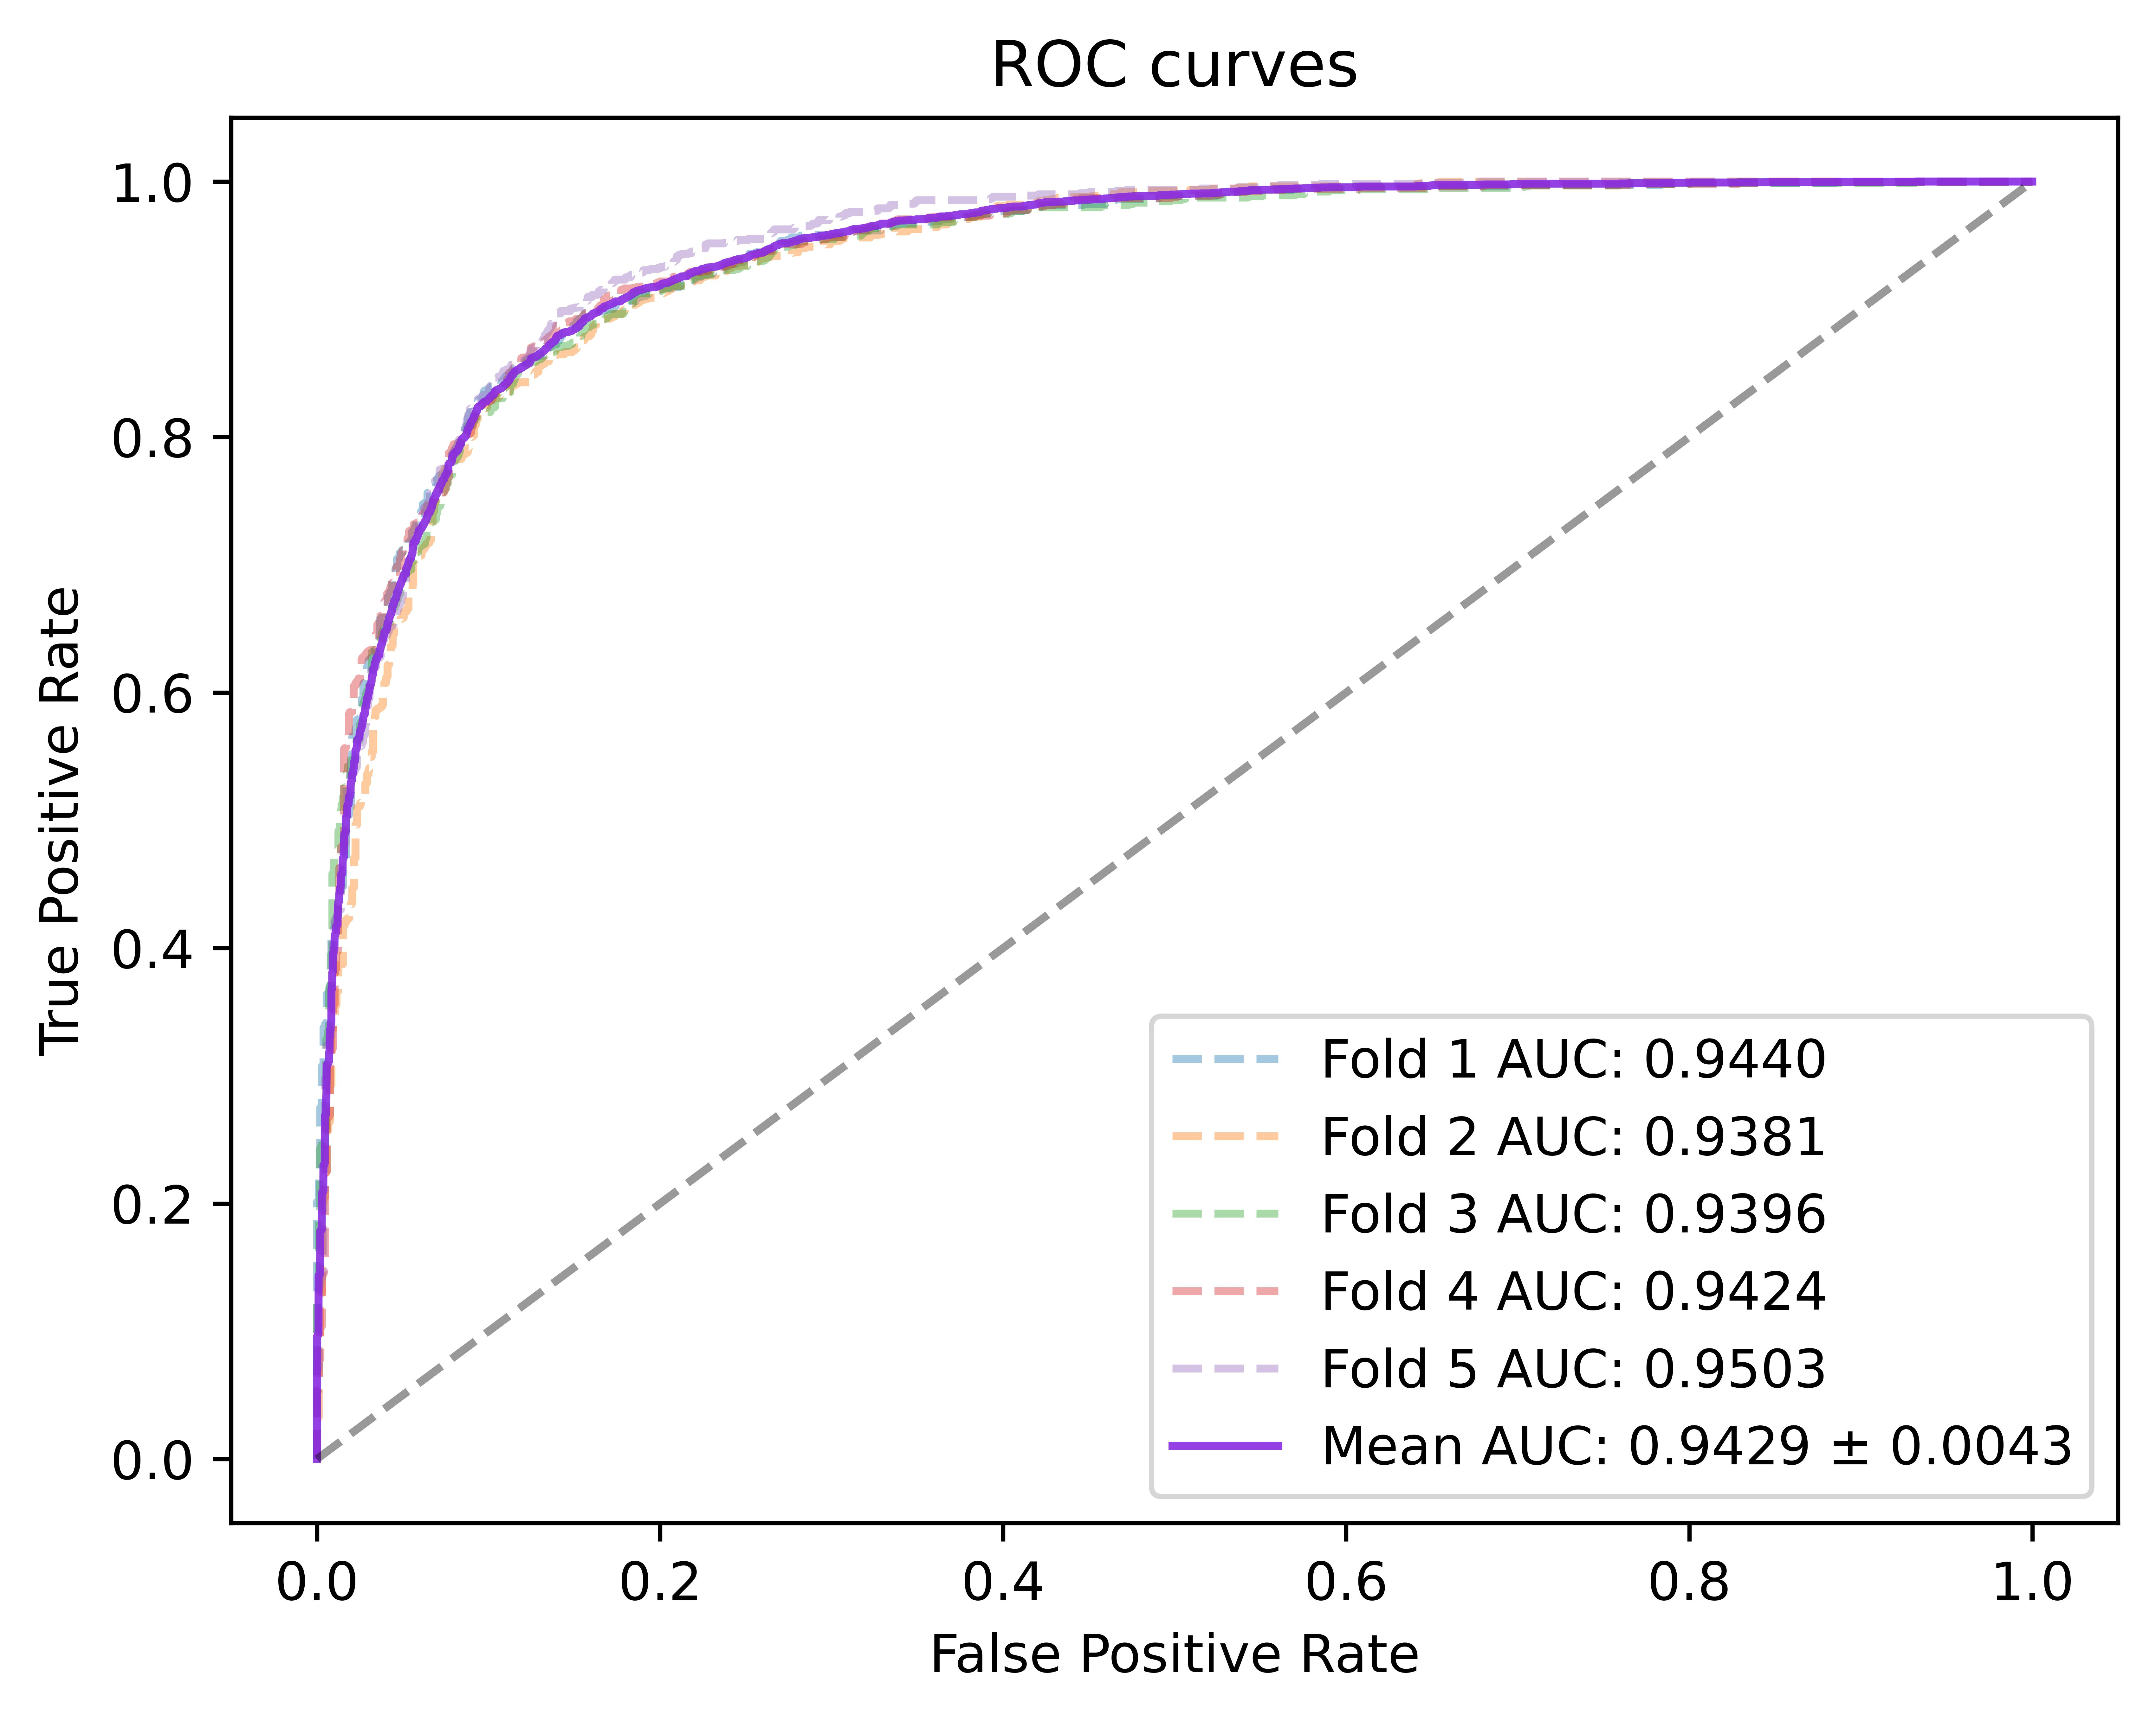
Fig. 3. ROC curves performed by Re-NIA model based on HMDD v2.0
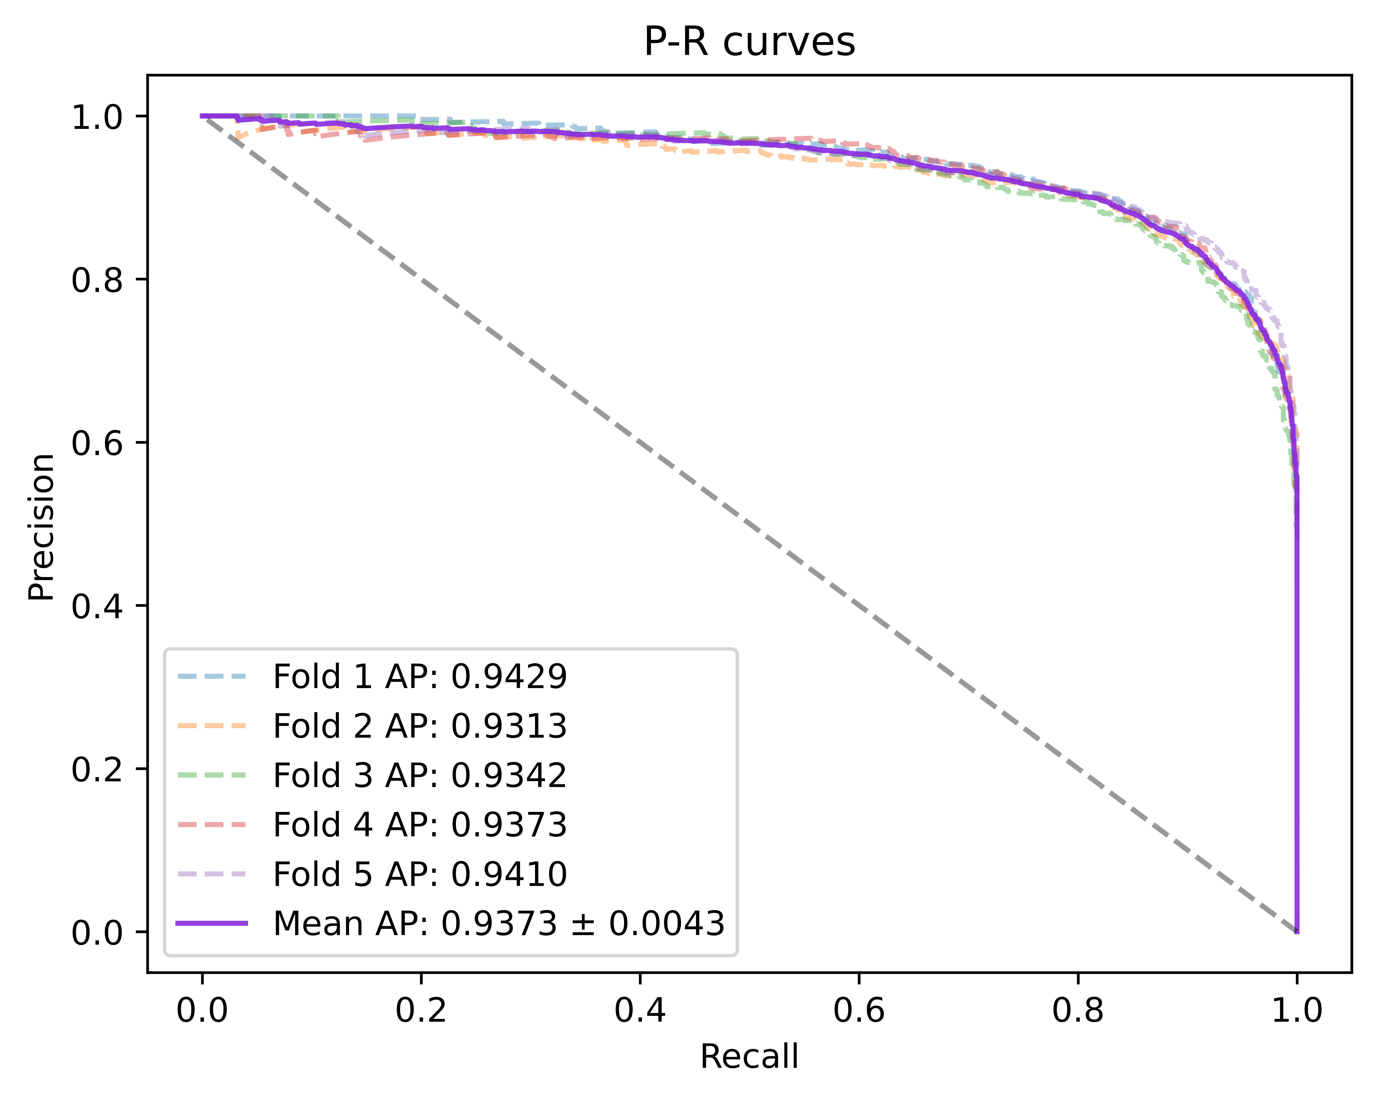
Fig. 4. P-R curves performed by Re-NIA model based on HMDD v2.0
Table 2. Results of 5-fold cross-validation performed by Re-NIA model
Fold | Acc.(%) | Pre.(%) | Rec.(%) | F1(%)
1 | 86.69 | 86.58 | 87.28 | 86.93
2 | 86.00 | 87.50 | 84.48 | 85.96
3 | 86.10 | 82.82 | 89.65 | 86.10
4 | 86.90 | 87.97 | 85.58 | 86.76
5 | 85.73 | 80.17 | 95.25 | 87.06
mean | 86.28  ±0.0044 | 85.01  ±0.0302 | 88.45  ±0.0382 | 86.56  ±0.0045
The experimental results show that under five-fold cross-validation on the HMDD v2.0 dataset, Re-NIA achieves an average AUC of 94.29% and an average AUPR of 93.73%, demonstrating its excellent discriminative capability and well-balanced trade-off between precision and recall. In addition, the model achieves an average Accuracy of 86.28%, Precision of 85.01%, Recall of 88.45%, and F1 score of 86.56%, showcasing the strong predictive performance of Re-NIA.
Comparison with other models
To further verify the performance of Re-NIA, we systematically compare it with several existing miRNA-disease association prediction models. The selected baselines are all representative or high-performing models in recent years, covering various typical approaches. Brief descriptions of the selected models are as follows:
DARSFormer [32]: Combines dynamic attention mechanisms with spectral graph Transformers to predict miRNA–disease associations via feature enhancement and graph attention-based aggregation.
GRPAMDA [33]: Integrates Drop-Feature-based stochastic propagation with attention mechanisms, utilizing feature perturbation and neighbor-enhanced aggregation to

Table 3. Comparative results of the Re-NIA model and other models on the HMDDv2.0 dataset

Model | AUC(%) | AUPR(%) | Acc(%) | Pre (%) | Rec (%) | F1(%)
DARSFormer | 94.18 | 93.67 | 87.09 | 86.56 | 87.81 | 87.17
GRPAMDA | 93.46 | 93.31 | 86.00 | 85.79 | 86.37 | 86.06
HGATMDA | 93.52 | 93.15 | 86.14 | 86.10 | 86.25 | 86.15
HHOMR | 93.28 | 92.97 | 86.25 | 85.54 | 84.98 | 85.65
JKNMDA | 93.30 | 93.14 | 85.18 | 88.90 | 80.44 | 84.43
PMDAGS | 92.22 | 92.18 | 84.64 | 82.83 | 87.53 | 85.06
SMALF | 90.57 | 90.93 | 83.45 | 82.00 | 85.76 | 83.81
Re-NIA | 94.29 | 93.73 | 86.28 | 85.01 | 88.45 | 86.56

perform miRNA-disease association prediction.
HGATMDA [34]: Proposes an heterogeneous graph attention network that employs multi-head mechanisms to fuse neighbor structures and node attributes for embedding generation and association prediction.
HHOMR [35]: Uses a hybrid high-order moment representation combined with element-level attention to enhance miRNA and disease node features and predict their associations using a residual network.
JKNMDA [36]: Constructs a heterogeneous graph using miRNA-disease associations and similarities, aggregates local neighbor information with GAT, and extracts global features through a jump knowledge network for final prediction.
PMDAGS [37]: Builds node features using similarity vectors and known association vectors, applies nonlinear diffusion-based graph convolution to extract embeddings, and uses a multi-layer perceptron to predict miRNA–disease associations.
SMALF [38]: Stacks autoencoders to extract latent features of miRNAs and diseases, fuses similarity information to construct feature vectors, and uses XGBoost for final prediction.
The results are shown in Table 3. By comparison, Re-NIA outperforms other models in terms of AUC, AUPR, and F1 score. Although Accuracy and Precision are not the highest
among all models, they still remain at a competitive level, indicating that the model has achieved a good balance between identifying positive and negative samples. Overall, Re-NIA balances multiple performance metrics well, demonstrating its comprehensive advantage in the miRNA-disease association prediction task.
Ablation Study
To evaluate the contribution of each key module in the Re-NIA model to its overall performance, we conducted a series of ablation experiments. Under the same datasets and experimental settings, some modules were removed or replaced, and the models were retrained for comparative analysis. The ablation experiments primarily targeted the RSAM, BiCAN, and the Relearning module. Accordingly, we constructed the following variant models:
• w/o-RSAM: The redundancy-suppression Aggregation module RSAM is removed and replaced by a standard GCN to perform the feature aggregation task.
• w/o-BiCAN: The bidirectional cross-attention module in BiCAN is removed; instead, the discriminative and aggregation features are concatenated directly and passed through a linear layer for fusion.
• w/o-Relearning: The pretraining stage, unstable association detection, and the subsequent re-learning process are removed. Only the NIA model is used to complete the prediction task.
Fig. 5 shows the experimental results of the above variant models. The results indicate that:
1. Replacing RSAM with a standard GCN led to a decrease in multiple performance metrics, indicating that RSAM effectively suppresses redundant information during neighbor feature aggregation and enhances the effectiveness of feature representation. In contrast, a conventional GCN lacks the ability to distinguish between relevant and irrelevant features, thereby degrading the model's performance.
2. Replacing BiCAN with a simple concatenation and linear fusion module also resulted in performance drops across several metrics. This demonstrates the importance of the bidirectional cross-attention mechanism in BiCAN for improving the quality of neighbor information integration and global discriminability. It further confirms that the mechanism enables dynamic modeling of fine-grained interactions between discriminative and aggregative features, significantly enhancing the expressive power of the final node representations.
3. Removing the Relearning module caused the model to lose its capacity to identify and retrain on unstable predictions, which impaired its ability to handle prediction uncertainty, leading to reduced prediction accuracy. Moreover, the

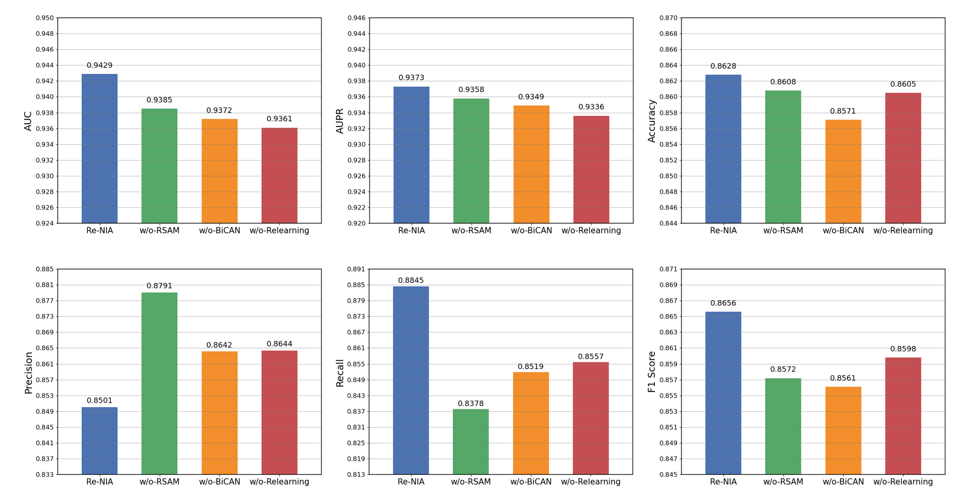
Fig. 5. Ablation study results of the Re-NIA model based on HMDD v2.0
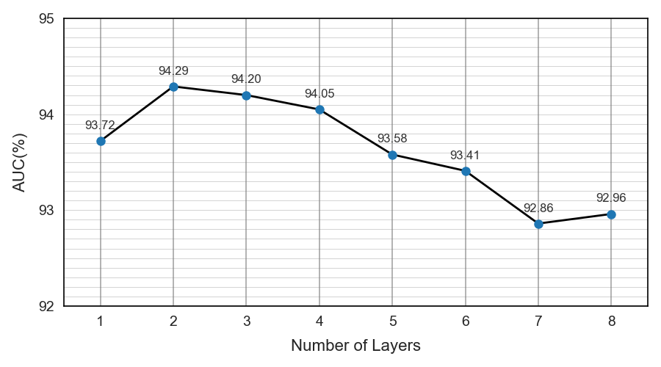
Fig. 6. The AUC of Re-NIA model under different numbers of layers.
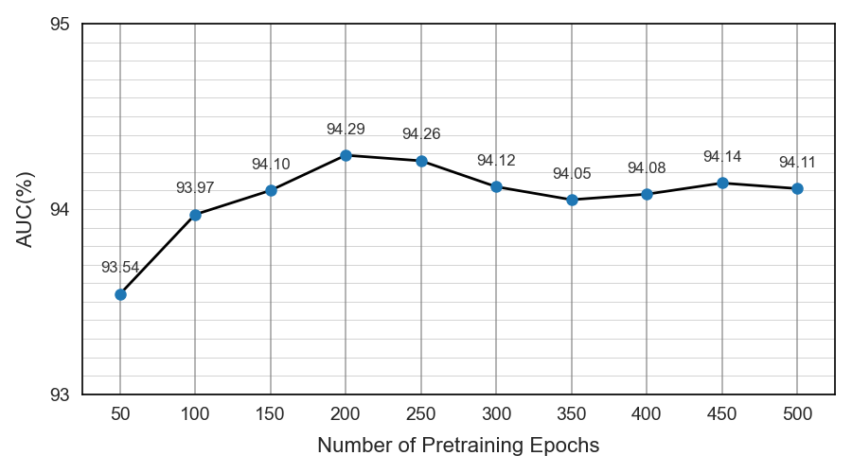
Fig. 7. The AUC of Re-NIA model under different numbers of epochs.
absence of this module also negatively impacted the model’s prediction stability, which will be further discussed in the next section.
4. It is worth noting that all ablated models achieved better Precision than the original model. This may be because, without certain feature enhancement or neighbor-aware mechanisms, the ablated models tended to make more conservative predictions, favoring high-confidence positive samples. This reduced the number of false positives and improved Precision. However, such conservativeness also limited the model’s ability to recognize borderline or potential positive samples, leading to declines in other metrics. In contrast, the full Re-NIA model is structurally designed to comprehensively explore potential associations, demonstrating stronger generalization and biological discovery capabilities. Although its Precision is slightly lower, it achieves a more balanced overall performance.
Hyperparameter Analysis
To explore the impact of certain key hyperparameters on the performance of Re-NIA, we designed a set of sensitivity analysis experiments. We selected two hyperparameters that significantly affect the model’s performance: the number of layers $L$ in the NIA model and the number of pretraining epochs $K$. Keeping all other parameters constant, we evaluated the prediction performance under different grid values of these two parameters. The results are shown in Fig. 6 and Fig. 7. According to the experimental results, we observed that:
1. As the number of layers $L$ increases, the model performance shows a trend of first increasing and then decreasing. The model achieves best performance when $L$ $=$ 2, indicating that the information propagation and feature representation ability are well-balanced at this depth. A small $L$ limits the receptive field for neighbor information, resulting in insufficient feature aggregation. On the other hand, an excessively large $L$ may introduce too much noise or redundancy, leading to over-smoothing and a drop in discriminative capability.
2. Regarding the number of pretraining epochs $K$, we found that performance tends to improve with increasing $K$. This may be because when $K$ is small, the detection of unstable predictions is not sufficient, and thus the guidance effect of the relearning phase is limited. When $K$ increases to a moderate value, the model achieves its best performance. However, further increasing $K$ causes performance even slightly degrade, possibly because excessive pretraining leads
the model to overfit the unstable patterns, compromising its global generalization ability.
Stability Evaluation of Re-NIA
To evaluate the prediction stability of Re-NIA and the contribution of the relearning mechanism, we designed a special comparative experiment. First, we collected the training history from the last $K$ epochs of Re-NIA during the relearning phase, and constructed the corresponding pulse matrix $P^{\left(R\right)}$ according to the previously introduced unstable association detection method. Similarly, we built the pulse matrix $P^{\left(N\right)}$ for the original NIA model (i.e., w/o-Relearning) following the same procedure. Based on these matrices, we evaluated the contribution of the relearning mechanism to model stability. To this end, we propose a novel metric called Weighted Flip Run Length ($WFRL$). For each miRNA-disease association pair, the $i$-th row vector $P_{i}^{\left(⋅\right)}∈R^{1×(K-1)}$ in the pulse matrix represents the flip sequence over the training epochs, where a value of 1 indicates a prediction flip. We identify all consecutive segments of value 1 in $P_{i}^{\left(⋅\right)}$, with each segment denoting a continuous unstable interval during training. A longer segment suggests more severe prediction volatility for that sample. Assuming there are $M_{i}$ such segments in $P_{i}^{\left(⋅\right)}$, and the length of the $m$-th segment is $L_{i,m}$, the WFRL score of the $i$-th sample is defined as:
$WFRL=\frac{1}{E}\sum_{i=1}^{E}{\frac{\sum_{m=1}^{M_{i}}{L_{i,m}^{2}}}{\sum_{m=1}^{M_{i}}{L_{i,m}}}}$ (33)
In this formula, we apply a square-weighted mechanism to emphasize the contribution of long flip sequences. MiRNA-disease association pairs that exhibit prolonged instability during training contribute more to the instability score. For samples with no prediction flips, the $WFRL$ value is set to 0. Finally, by averaging over all $E$ samples, we obtain a global stability score $WFRL$ for the entire model. When only short and occasional disturbances occur, the $WFRL$ value remains relatively low; however, the presence of long, continuous instability intervals significantly increase this value, effectively reflecting the degree of temporal prediction inconsistency. To further validate this metric, we also computed $WFRL$ for three additional models and compared them with that of Re-NIA [32], [33], [35]. The results are shown in Fig.8. Re-NIA achieves the lowest $WFRL$ among all models, indicating significantly reduced prediction fluctuation and enhanced stability. This validates the effectiveness of our relearning strategy guided by unstable associations, which mitigates the inherent instability issues in GNN-based MDA prediction tasks.
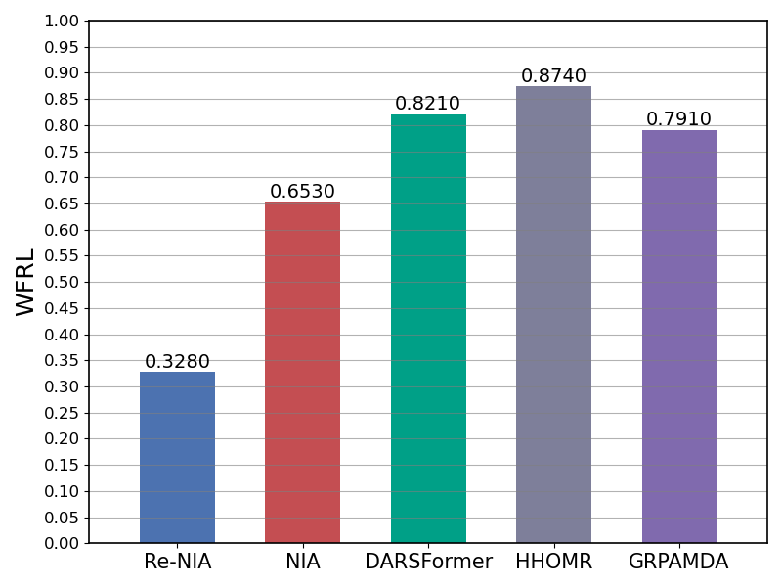
Fig. 8. The WFRL value of five models
Case Study
To further verify the practical applicability of Re-NIA, we conducted a series of case studies on several common diseases. In this study, Lymphoma, Esophageal Neoplasms, and Prostate Neoplasms were selected as the target diseases. First, we adjusted the training and testing datasets: all edges connecting the target disease to miRNAs were assigned to the testing set, while the remaining edges were used for training. Based on this setup, the Re-NIA model was trained. After training, Re-NIA was used to generate prediction scores for the specific disease–miRNA associations, which were then ranked in descending order. The predicted results were subsequently validated using the dbDEMC and miR2Disease databases [6], [39].
• Lymphoma: This disease originates from the human immune system and is a highly heterogeneous malignant neoplasm, mainly including Hodgkin lymphoma and non-Hodgkin lymphoma. In recent years, its incidence has been steadily increasing. Numerous studies have shown that miRNAs play a vital regulatory role in the onset, progression, and metastasis of lymphoma. For example, the miR-106a and miR-17-92 clusters have been reported to be upregulated in T-cell lymphomas [40], [41]. Therefore, studying miRNA-lymphoma associations is of great practical significance. As shown in Table x, among the top 30 miRNAs predicted by Re-NIA to be associated with lymphoma, 28 were validated by the dbDEMC and miR2Disease databases.
• Esophageal Neoplasms: This is a common malignant neoplasm of the digestive system, primarily including esophageal squamous cell carcinoma and adenocarcinoma. It ranks among the top in both incidence and mortality worldwide. Recently, miRNAs have been widely recognized for their regulatory roles in the development of this cancer. For instance, miR-373 has been found to participate in the progression of esophageal squamous cell carcinoma by inhibiting its downstream neoplasm suppressor gene LATS2 [42], [43], [44]. According to the prediction results of this study, among the top 30 miRNAs predicted to be associated with esophageal neoplasm, 29 were validated by the dbDEMC databases.
• Prostate Neoplasms: This is a male-specific malignancy that includes various types originating from epithelial or mesenchymal tissues, with prostatic adenocarcinoma being the most common. Epidemiological data show that it ranks high in terms of incidence among male cancers, with a notable mortality rate. Many studies have revealed that the occurrence of prostate cancer is often accompanied by abnormal miRNA expression. For example, miR-143 and miR-145 have been found to be significantly downregulated, which is closely associated with the development of prostate cancer [45], [46]. In our model’s prediction results, 27 of the top 30 miRNAs predicted to be associated with prostate cancer were validated by the dbDEMC and miR2Disease databases.
Tables 4–6 present the results of the case study experiments. These results shows that the Re-NIA model exhibits excellent generalization ability and biological consistency across various typical neoplasms in the task of miRNA-disease association prediction. It can effectively identify potential key miRNAs, showing the strong practical value of the Re-NIA model.
Table 4. Top 30 miRNAs related to Lymphoma predicted by Re-NIA
miRNA  (1-15) | Evidence | miRNA  (16-30) | Evidence
hsa-mir-206 | dbDEMC | hsa-mir-29b | dbDEMC
hsa-mir-15b | dbDEMC | hsa-mir-199a | dbDEMC
hsa-mir-221 | dbDEMC and miR2Disease | hsa-mir-223 | dbDEMC
hsa-mir-125b | Unconfirmed | hsa-mir-183 | dbDEMC
hsa-mir-34a | dbDEMC | hsa-mir-214 | dbDEMC
hsa-mir-145 | dbDEMC and miR2Disease | hsa-mir-23b | dbDEMC
hsa-mir-23a | dbDEMC | hsa-mir-30a | dbDEMC
hsa-mir-29a | dbDEMC | hsa-mir-192 | dbDEMC
hsa-mir-1 | dbDEMC | hsa-mir-93 | dbDEMC
hsa-mir-30b | dbDEMC | hsa-let-7a | dbDEMC
hsa-mir-222 | dbDEMC | hsa-mir-143 | dbDEMC and miR2Disease
hsa-mir-196a | dbDEMC | hsa-mir-141 | dbDEMC
hsa-mir-133a | dbDEMC | hsa-mir-31 | dbDEMC
hsa-mir-132 | dbDEMC | hsa-mir-146b | Unconfirmed
hsa-mir-106b | dbDEMC | hsa-let-7b | dbDEMC
Table 5. Top 30 miRNAs related to Esophageal Neoplasms
predicted by Re-NIA
miRNA  (1-15) | Evidence | miRNA  (16-30) | Evidence
hsa-mir-125b | dbDEMC | hsa-mir-146b | dbDEMC
hsa-mir-17 | dbDEMC | hsa-mir-106b | dbDEMC
hsa-mir-221 | dbDEMC | hsa-mir-200b | dbDEMC
hsa-mir-16 | dbDEMC | hsa-mir-142 | dbDEMC
hsa-mir-122 | Unconfirmed | hsa-mir-30a | dbDEMC
hsa-mir-1 | dbDEMC | hsa-mir-195 | dbDEMC
hsa-mir-29a | dbDEMC | hsa-mir-9 | dbDEMC
hsa-mir-19b | dbDEMC | hsa-mir-133b | dbDEMC
hsa-mir-23a | dbDEMC | hsa-mir-182 | dbDEMC
hsa-mir-29b | dbDEMC | hsa-mir-7 | dbDEMC
hsa-mir-18a | dbDEMC | hsa-mir-24 | dbDEMC
hsa-mir-222 | dbDEMC | hsa-mir-181b | dbDEMC
hsa-mir-15b | dbDEMC | hsa-let-7i | dbDEMC
hsa-mir-206 | dbDEMC | hsa-let-7e | dbDEMC
hsa-mir-181a | dbDEMC | hsa-let-7d | dbDEMC
Table 6. Top 30 miRNAs related to Prostate Neoplasms
predicted by Re-NIA
miRNA  (1-25) | Evidence | miRNA  (26-50) | Evidence
hsa-mir-21 | dbDEMC and miR2Disease | hsa-mir-19a | dbDEMC
hsa-mir-155 | dbDEMC | hsa-mir-199a | dbDEMC and miR2Disease
hsa-mir-146a | miR2Disease | hsa-mir-223 | dbDEMC and miR2Disease
hsa-mir-17 | miR2Disease | hsa-mir-29b | dbDEMC and miR2Disease
hsa-mir-20a | miR2Disease | hsa-mir-122 | Unconfirmed
hsa-mir-34a | dbDEMC and miR2Disease | hsa-mir-92a | Unconfirmed
hsa-mir-16 | dbDEMC and miR2Disease | hsa-mir-133a | dbDEMC
hsa-mir-29a | dbDEMC and miR2Disease | hsa-mir-150 | dbDEMC
hsa-mir-18a | Unconfirmed | hsa-let-7a | dbDEMC and miR2Disease
hsa-mir-126 | dbDEMC and miR2Disease | hsa-mir-31 | dbDEMC and miR2Disease
hsa-mir-1 | dbDEMC | hsa-mir-143 | dbDEMC and miR2Disease
hsa-mir-15a | dbDEMC and miR2Disease | hsa-mir-181a | dbDEMC and miR2Disease
hsa-mir-221 | dbDEMC and miR2Disease | hsa-mir-210 | miR2Disease
hsa-mir-19b | dbDEMC and miR2Disease | hsa-mir-182 | dbDEMC and miR2Disease
hsa-mir-222 | dbDEMC and miR2Disease | hsa-mir-106b | dbDEMC
Conclusion
MiRNA-mediated gene regulatory abnormalities are closely associated with the occurrence and progression of various human malignant neoplasms. Therefore, accurately predicting potential associations between miRNAs and diseases is of great significance for advancing biomedical research and clinical applications. In this study, we propose a graph neural network-based framework for miRNA-disease association prediction, named Re-NIA. This model incorporates a redundancy suppression aggregation mechanism, a bidirectional neighbor information modeling strategy, and a relearning mechanism to enhance prediction stability, effectively extracting reliable features and mitigating prediction fluctuations. On the publicly available HMDD v2.0 dataset, Re-NIA achieves excellent performance across multiple evaluation metrics, demonstrating stronger competitiveness compared to mainstream existing methods. Through the design of stability evaluation experiments, we successfully demonstrate the superior stability of Re-NIA. In case studies involving lymphoma, esophageal cancer, and prostate cancer, 28, 29 and 27 of the top 30 predicted miRNAs, respectively, were validated by authoritative databases, highlighting the model’s strong practical applicability. Future research will further explore integrating multi-source biological data such as sequence information, functional annotations, and cross-species knowledge into the heterogeneous graph modeling framework, while also optimizing model stability to improve prediction accuracy and interpretability. Overall, Re-NIA provides a reliable and efficient solution for the task of miRNA-disease association prediction.

References
- Bartel, D. P. (2004). MicroRNAs: genomics, biogenesis, mechanism, and function. Cell, 116(2), 281–297.
- He, L., & Hannon, G. J. (2004). MicroRNAs: small RNAs with a big role in gene regulation. Nature Reviews Genetics, 5(7), 522–531.
- Bushati, N., & Cohen, S. M. (2007). microRNA functions. Annual Review of Cell and Developmental Biology, 23, 175–205.
- Calin, G. A., & Croce, C. M. (2006). MicroRNA signatures in human cancers. Nature Reviews Cancer, 6(11), 857–866.
- Chen, X., & Yan, G. Y. (2013). Novel Human miRNA–Disease Association Inference Based on miRNA Expression Similarity. Scientific Reports, 3, 2193.
- Jiang, Q., Wang, Y., Hao, Y., Juan, L., Teng, M., Zhang, X., ... & Liu, Y. (2009). miR2Disease: A manually curated database for microRNA deregulation in human disease. Nucleic Acids Research, 37(Database issue), D98–D104.
- Liu, C. G., Calin, G. A., Volinia, S., & Croce, C. M. (2008). MicroRNA expression profiling using microarrays. Nature Protocols, 3(4), 563–578.
- Li, Y., Qiu, C., Tu, J., Geng, B., Yang, J., Jiang, T., & Cui, Q. (2014). HMDD v2.0: a database for experimentally supported human microRNA and disease associations. Nucleic Acids Research, 42(D1), D1070–D1074.
- Jiang, Q., Wang, Y., Hao, Y., Juan, L., Teng, M., Zhang, X., ... & Liu, Y. (2009). miR2Disease: A manually curated database for microRNA deregulation in human disease. Nucleic Acids Research, 37(Database issue), D98–D104.
- Xuan, P., Han, K., Guo, M., Guo, Y., Li, J., Ding, J., & Zhang, T. (2013). Prediction of microRNAs associated with human diseases based on weighted k most similar neighbors. PLOS ONE, 8(8), e70204.
- Chen, X., Liu, M. X., & Yan, G. Y. (2012). RLSMDA: Predicting multiple types of human microRNA–disease associations. Bioinformatics, 28(16), 2252–2258.
- Xuan, P., Zhang, T., Wang, X., Wang, H., Liu, Y., & Liu, J. (2019). Dual convolutional neural network for predicting microRNA–disease associations. Frontiers in Genetics, 10, 1127.
- Zeng, X., Zhang, X., Zou, Q. (2019). Integrative approaches for predicting microRNA–disease associations using deep matrix factorization. BMC Bioinformatics, 20(1), 1–12.
- Kipf, T. N., & Welling, M. (2017). Semi-supervised classification with graph convolutional networks. International Conference on Learning Representations (ICLR).
- Li, C., Huang, Y., Yang, H., & Jiang, Y. (2021). NIMCGCN: A node-level iterative refinement model for predicting miRNA–disease associations via graph convolutional networks. Briefings in Bioinformatics, 22(5), bbab093.
- Tang, C., Zhang, K., Luo, C., & Liu, X. (2022). MSMGCN: Predicting miRNA–disease associations using multi-channel sparse attention and multi-view graph convolutional network. Briefings in Bioinformatics, 23(5), bbac303.
- Ding, Y., Tang, J., Guo, F. (2020). Identification of miRNA–disease associations based on variational autoencoder. IEEE Access, 8, 48952–48962.
- Yu, L., Huang, Y., Jiang, Y., & Ni, J. (2021). MPMDA: meta-path based framework for miRNA–disease association prediction. Briefings in Bioinformatics, 22(6), bbab297.
- Zhang, Z., Yu, L., & Jiang, Y. (2021). A survey on graph neural networks for knowledge graph completion. Artificial Intelligence Review, 54(5), 3279–3317.
- Wang, X., Ji, H., Shi, C., Wang, B., Ye, Y., Cui, P., & Yu, P. S. (2019). Heterogeneous graph attention network. The World Wide Web Conference (WWW), 2022–2032.
- Zhou, J., Cui, G., Zhang, Z., Yang, C., Liu, Z., Wang, L., ... & Sun, M. (2020). Graph neural networks: A review of methods and applications. AI Open, 1, 57–81.
- Liu, S., Gao, T., Chen, S., Zhang, J., & Li, X. (2022). Towards stable graph neural networks. International Conference on Learning Representations (ICLR).
- Oono, K., & Suzuki, T. (2020). Graph neural networks exponentially lose expressive power for node classification. International Conference on Learning Representations (ICLR).
- Chen, X., Yan, C. C., Zhang, X., Li, Z., Deng, L., & Zhang, Y. (2018). HGIMDA: Heterogeneous graph inference for miRNA-disease association prediction. Oncotarget, 8(47), 80185–80194.
- Wang, D., Wang, J., Lu, M., Song, F., & Cui, Q. (2010). Inferring the human microRNA functional similarity and functional network based on microRNA-associated diseases. Bioinformatics, 26(13), 1644–1650.
- Van Laarhoven, T., Nabuurs, S. B., & Marchiori, E. (2011). Gaussian interaction profile kernels for predicting drug–target interactions. Bioinformatics, 27(21), 3036–3043.
- M. Chen et al., “A novel information diffusion method based on network consistency for identifying disease related microRNAs,” RSC Adv.,vol.8, no. 64, pp. 36675–36690, 2018.
- Mounir Ghogho. (2024). Revisiting Neighborhood Aggregation in Graph Neural Networks for Node Classification. arXiv preprint.
- Jinbo Song, Chao Chang, Fei Sun, Xinbo Song, & Peng Jiang. (2021). NGAT4Rec: Neighbor-Aware Graph Attention Network For Recommendation. ACM Conference.
- Jimale, E. L., Chen, W., Al‑antari, M. A., Gu, Y. H., Agbesi, V. K., Feroze, W., Akmel, F., Assefa, J. M., & Shahzad, A. (2025). Graph-to-Text Generation with Bidirectional Dual Cross-Attention and Concatenation. Mathematics, 13(6), 935.
- Otsu, N. (1979). A threshold selection method from gray-level histograms. IEEE Transactions on Systems, Man, and Cybernetics, 9(1), 62–66.
- Li, Z., Bai, X., Nie, R., Liu, Y., Zhang, L., & You, Z. (2024). Predicting miRNA–Disease Associations Based on Spectral Graph Transformer With Dynamic Attention and Regularization. IEEE Journal of Biomedical and Health Informatics, 28(12), 7611–7622.
- Zhong, T., Li, Z., You, Z.-H., Nie, R., & Zhao, H. (2022). Predicting miRNA–disease associations based on graph random propagation network and attention network. Briefings in Bioinformatics, 23(2), bbab589.
- Ji, C., Wang, Y., Ni, J., Zheng, C., & Su, Y. (2021). Predicting miRNA–Disease Associations Based on Heterogeneous Graph Attention Networks. Frontiers in Genetics, 12, 727744.
- Li, Z., Wan, L., Wang, L., Wang, W., & Nie, R. (2024). HHOMR: A Hybrid High‑Order Moment Residual Model for miRNA–Disease Association Prediction. Briefings in Bioinformatics, 25(5), bbae412.
- Li, Z.-W., Wang, Q.-K., Yuan, C.-A., Han, P.-Y., You, Z.-H., & Wang, L. (2023). Predicting miRNA–Disease Associations by Graph Representation Learning Based on Jumping Knowledge Networks. IEEE/ACM Transactions on Computational Biology and Bioinformatics, 20(5), 2629–2638.
- Yan, C., & Duan, G. (2024). PMDAGS: Predicting miRNA–Disease Associations With Graph Nonlinear Diffusion Convolution Network and Similarities. IEEE/ACM Transactions on Computational Biology and Bioinformatics, 21(3), 394–404.
- Liu, D., Huang, Y., Nie, W., Zhang, J., & Deng, L. (2021). SMALF: miRNA–Disease Associations Prediction Based on Stacked Autoencoder and XGBoost. BMC Bioinformatics, 22(1), 219.
- Z.Yangetal.,“dbDEMC2.0:Updated database of differentially expressed miRNAs in human cancers,” Nucleic Acids Res., vol. 45, pp. D812–D818, 2017.
- Olive, V., Bennett, M. J., et al. (2009). miR‑19 is a key oncogenic component of miR‑17‑92. Genes & Development, 23(24), 2839–2849.
- He, L., Thomson, J. M., et al. (2005). A microRNA polycistron as a potential oncogene. Nature, 435(7043), 828–833.
- Wang, L., Wang, L., Chang, W., et al. (2019). miR‑373 promotes ESCC by targeting LATS2 and OXR1. International Journal of Biological Markers, 34(3), 221–229.
- Spandidos Publications. (2012). MicroRNAs in esophageal cancer. Molecular Medicine Reports, 5(2), 256–262.
- Li, W. et al. (2018). Upregulation of miR‑371–373 cluster in ESCC. Cancer Journal, 24(1), 22–29.
- Adammek, M., et al. (2013). miR‑143 and miR‑145 suppress prostate cancer cell migration and invasion. Fertility and Sterility, 99(7), 2006–2014.
- Porkka, K. P., et al. (2007). MicroRNA expression profiling in prostate cancer. Cancer Research, 67(13), 6130–6135.

