Re-NIA: a neighbor-information-aware graph neural network with unstable-prediction-guided subgraph relearning for miRNA-disease association prediction

Abstract
microRNAs (miRNAs) play critical roles in the development of various human diseases. Recently, graph neural networks (GNNs) have been widely applied to predict miRNA-disease associations, achieving promising results. However, many existing methods overlook the heterogeneity of miRNA-disease graphs and face challenges in neighbor aggregation and model stability. To address these issues, we propose Re-NIA, a novel GNN framework designed to enhance heterogeneous graph modeling and prediction robustness. Re-NIA constructs a heterogeneous miRNA-disease graph and applies a type-conversion mechanism to project nodes into a unified space. A Neighbor Information Awareness (NIA) module with redundancy suppression and dynamic attention is introduced to perform fine-grained modeling and weighted aggregation of neighbors, effectively distinguishing relevant from noisy information. To mitigate instability during training, Re-NIA incorporates a relearning mechanism guided by unstable predictions, which detects fluctuation patterns via a pulse matrix, identifies unstable associations using the Otsu algorithm, and builds an unstable subgraph to refine learning on hard cases. Experiments on the HMDD v2.0 dataset using five-fold cross-validation show that Re-NIA achieves an AUC of 94.29%, outperforming multiple existing methods in both accuracy and stability.

Keywords: graph neural networks; miRNA-disease associations; neighbor-aware learning; attention mechanism; relearning mechanism.

Introduction

MicroRNAs (miRNAs) are endogenous, single-stranded non-coding RNAs typically 19–25 nucleotides in length, widely present in eukaryotic organisms. By base-pairing with target messenger RNAs (mRNAs), they regulate gene expression via mRNA degradation or translational repression. Numerous studies have demonstrated that miRNAs play essential roles in biological processes such as cell growth, proliferation, and differentiation. Moreover, their dysregulation is closely linked to various diseases, including cancers, metabolic disorders, and neurological conditions. Accurately identifying potential miRNA–disease associations (MDAs) is critical for understanding disease mechanisms and facilitating diagnosis, targeted therapy, and personalized medicine. As a result, researchers from fields such as immunology, genetics, and bioinformatics have devoted substantial effort to exploring miRNA–disease relationships.
In the early stages, MDA discovery primarily relied on experimental techniques like RT-PCR, microarrays, and primer extension assays. Though accurate, these methods are time-consuming, costly, and environmentally sensitive. The emergence of curated datasets such as HMDD v2.0 enabled a shift toward computational approaches, which offer faster and more economical alternatives. Early studies focused on similarity-based methods, assuming functionally similar miRNAs associate with phenotypically similar diseases. For instance, Jiang et al. used functional networks, while Xuan et al. proposed HDMP, a k-nearest-neighbor-based model. However, these methods are limited to known associations. Machine learning techniques addressed this by learning biological features to uncover novel MDAs. Chen et al. introduced RLSMDA, using regularized least squares in a semi-supervised framework. Still, challenges remain in processing high-dimensional data and integrating complex features. With the rise of deep learning, more advanced models emerged. Xuan et al. proposed a dual CNN framework, while Zeng et al. combined singular value decomposition with deep matrix factorization to capture both linear and nonlinear patterns.
Graph neural networks (GNNs), known for their powerful capabilities in modeling graph-structured data, have shown great promise in MDA prediction. GNNs can integrate node attributes with graph topology to capture both local and global semantic relationships. For instance, Li et al. proposed NIMCGCN to learn latent representations of miRNAs and diseases through GCNs and generate association matrices. Tang et al. used GCN encoders to extract features from various similarity views and combined them with multi-channel attention. Ding et al. constructed separate miRNA and disease subnetworks and trained them using variational autoencoders. Furthermore, Yu et al. proposed a meta-path-based approach by defining seven symmetric semantic paths in a heterogeneous miRNA-disease-gene network to compute final association scores through iterative feature updates.
Despite the remarkable progress of GNN-based approaches, several critical challenges remain unaddressed. Two prominent issues include the heterogeneity of the MDA graph and the instability of GNN performance. Specifically, the MDA graph is inherently heterogeneous, containing multiple types of nodes (miRNAs and diseases) and multi-source heterogeneous information. Most GNN models are designed for homogeneous graphs and employ static or coarse-grained neighbor aggregation strategies, overlooking the diverse importance of neighbor information across different prediction tasks. As a result, noisy neighbors may interfere with prediction accuracy. Furthermore, studies have revealed that GNNs often exhibit more severe performance fluctuations compared to traditional models, even under identical hyperparameter settings—a disadvantage for tasks requiring prediction stability, such as MDA inference. In addition, redundancy and over-smoothing of node features also hinder GNN performance.
To address the above challenges, we propose a novel deep learning framework named Re-NIA. This model is designed to accommodate the heterogeneous nature of the MDA graph while enhancing the robustness of GNN-based predictions. First, we construct a heterogeneous graph using verified MDAs and similarity relationships, and project miRNA and disease nodes into a unified latent space via type-specific transformation matrices. To capture neighborhood-aware features, we design a specialized GNN model named NIA that decouples the input features into discriminative and aggregative components, which are used for downstream prediction and neighbor information aggregation, respectively. During aggregation, we introduce a redundancy-suppressing module based on decorrelated propagation to enhance feature independence and expressiveness. Moreover, a bidirectional cross-attention mechanism is incorporated to dynamically weight neighbor contributions, effectively capturing their task-specific importance and improving information fusion. To further mitigate the instability of GNNs, Re-NIA first pre-trains the NIA model for several epochs. A pulse signal matrix is then constructed to represent fluctuations in prediction results across training rounds. Using Otsu's thresholding method, we identify unstable MDA pairs and construct an unstable subgraph. This subgraph is fed into a fresh (untrained) copy of the NIA model, while the original graph is input to the pretrained main model. Their losses are then combined to jointly update the parameters of the main model. Finally, a fully connected layer is used to generate association scores between miRNAs and diseases. To evaluate the effectiveness of Re-NIA, we conducted five-fold cross-validation experiments on the HMDD v2.0 dataset. Our model achieved an AUC of 94.29%, demonstrating superior predictive accuracy and robustness compared to existing state-of-the-art methods.

Materials and dataset
Datasets
In this study, we conduct experiments on two publicly available datasets, HMDDv2.0 and HMDD v3.0, which are widely used for exploring associations between miRNAs and diseases. We take HMDD v2.0 as an example for detailed explanation. This dataset includes 383 distinct diseases ($N_{d}$), 495 miRNAs ($N_{m}$), and 5,430 experimentally validated miRNA-disease associations. Among a total of 189,585 possible miRNA–disease pairs, only 5,430 are confirmed associations ($S$ positive edges), resulting in a highly sparse dataset with severe class imbalance between positive and negative samples. To address this issue, we randomly sample 5,430 pairs from the remaining 184,155 unconfirmed pairs to serve as negative samples ($S$ negative edges). Additionally, both forward and reverse edges are added to enhance the structural information of the heterogeneous graph, alleviating the imbalance problem. Consequently, the resulting heterogeneous graph contains a total of $4S$= 21,720 edges: $2S$ labeled as 1 for positive (associated) miRNA-disease pairs, and $2S$ labeled as 0 for negative (unknown) pairs.
To better evaluate the model's predictive performance, we adopt a five-fold cross-validation strategy. All known miRNA-disease associations are divided into five equally sized subsets. In each iteration, one subset is used as the test set and the remaining four subsets as the training set. This process is repeated five times, ensuring that each subset serves as the test set once. The final results are averaged across all five runs. Accordingly, the heterogeneous training subgraph used in each iteration contains $E =$21,720$×$4$⁄$5$=$17,376 edges. Based on this, we construct an adjacency matrix $A∈R^{N×N}$ (where $N={N_{m}+N}_{d}$). If there exists a positive or negative edge between miRNA $i$ and disease $j$, then $A_{i,j} =$ 1; otherwise, $A_{i,j} =$0. Thus, $A$ contains 17,376 entries with value 1, indicating the edges in the training subgraph. Since the graph is bidirectional, A is symmetric. The test subgraph is constructed in the same way. HMDD v3.0 differs from HMDD v2.0 only in the numbers of miRNAs, diseases, and validated miRNA–disease associations. All other processing steps and calculations remain consistent.
Feature Matrix Construction
In this study, the feature matrix of the graph is constructed based primarily on the similarity information between miRNAs and between diseases.
For miRNAs, similarity is computed through a two-step process. First, based on the assumption that “miRNAs with similar functions are more likely to be associated with phenotypically similar diseases,” we compute the functional similarity scores between miRNAs. These scores are used to construct a functional similarity adjacency matrix $MFSM∈R^{N_{m}×N_{m}}$, which encodes pairwise functional similarities among miRNAs. However, the $MFSM$ matrix is highly sparse due to the presence of numerous zero elements. To mitigate this, we introduce the Gaussian Interaction Profile (GIP) kernel similarity, calculated based on the interaction profiles of each miRNA and a kernel bandwidth parameter. This results in a GIP kernel similarity matrix $MGSM∈R^{N_{m}×N_{m}}$. Finally, we integrate the $MFSM$ and $MGSM$ matrices to obtain the final miRNA similarity matrix $IM∈R^{N_{m}×N_{m}}$.
For disease similarity, a similar two-step approach is adopted. First, using the hierarchical structure of the Medical Subject Headings (MeSH) database, each disease is represented by a Directed Acyclic Graph (DAG). The semantic contribution of each ancestor node in the DAG is calculated by considering its frequency and relevance across different DAGs. This yields a disease semantic similarity matrix $DSSM∈R^{N_{d}×N_{d}}$. Next, the GIP kernel similarity matrix for diseases $DGSM∈R^{N_{d}×N_{d}}$ is computed in the same manner as for miRNAs. These two matrices are then integrated to obtain the final disease similarity matrix $ID∈R^{N_{d}×N_{d}}$.
Given the heterogeneity of miRNA and disease nodes, which exist in distinct feature spaces, we introduce a node-type transformation mechanism to project them into a unified feature space with dimension $d$, making them suitable for joint processing within the model. The transformation is defined as:
$F_{m}=IM*W_{m}$ (1)
$F_{d}=ID*W_{d}$ (2)
where $W_{m}$ and $W_{d}$ are learnable transformation matrices for miRNAs and diseases, respectively.
After transformation, $F_{m}$ and $F_{d}$ are concatenated row-wise to form the final heterogeneous feature matrix $X∈R^{N×d}$, which serves as the input to the model.
Through the above steps, we obtain the two most critical components of the miRNA-disease heterogeneous graph: the adjacency matrix A and the feature matrix $X$. An overview of the construction process is illustrated in Figure 1.

Re-NIA
In this section, we provide a detailed overview of the proposed Re-NIA model. The overall Re-NIA framework consists of two main components: 1. the construction of the NIA model. 2. the relearning process based on the unstable subgraph.
The construction of the NIA model can be further divided into the following four steps:
Step Ⅰ: Feature Decoupling: The input features are split into discriminative and aggregative parts, serving prediction and neighborhood aggregation tasks, respectively.
Step Ⅱ: Redundancy-Suppressing Aggregation:
Aggregative features are processed via a redundancy-suppressing module that removes correlated noise during aggregation.
Step Ⅲ: Neighbor-Information Awareness: A cross-attention module fuses discriminative and updated aggregative features by weighting neighbor contributions.
Step Ⅳ: Prediction Output: Final discriminative features are fed into a fully connected layer for prediction; training is end-to-end.
The relearning process based on the unstable subgraph consists of the following three steps:
Step Ⅰ: Pretraining: The constructed NIA model is pretrained for a fixed number of epochs, and the predictions from each epoch are recorded for further analysis.
Step Ⅱ: Unstable Prediction Detection: A pulse matrix captures prediction fluctuations, and unstable associations are identified via Otsu thresholding to form an unstable subgraph.
Step Ⅲ: Relearning: Both the unstable and original graphs are input into two NIA models (fresh and pretrained), trained jointly to refine the main model's parameters.
A illustration of the Re-NIA framework on each step in

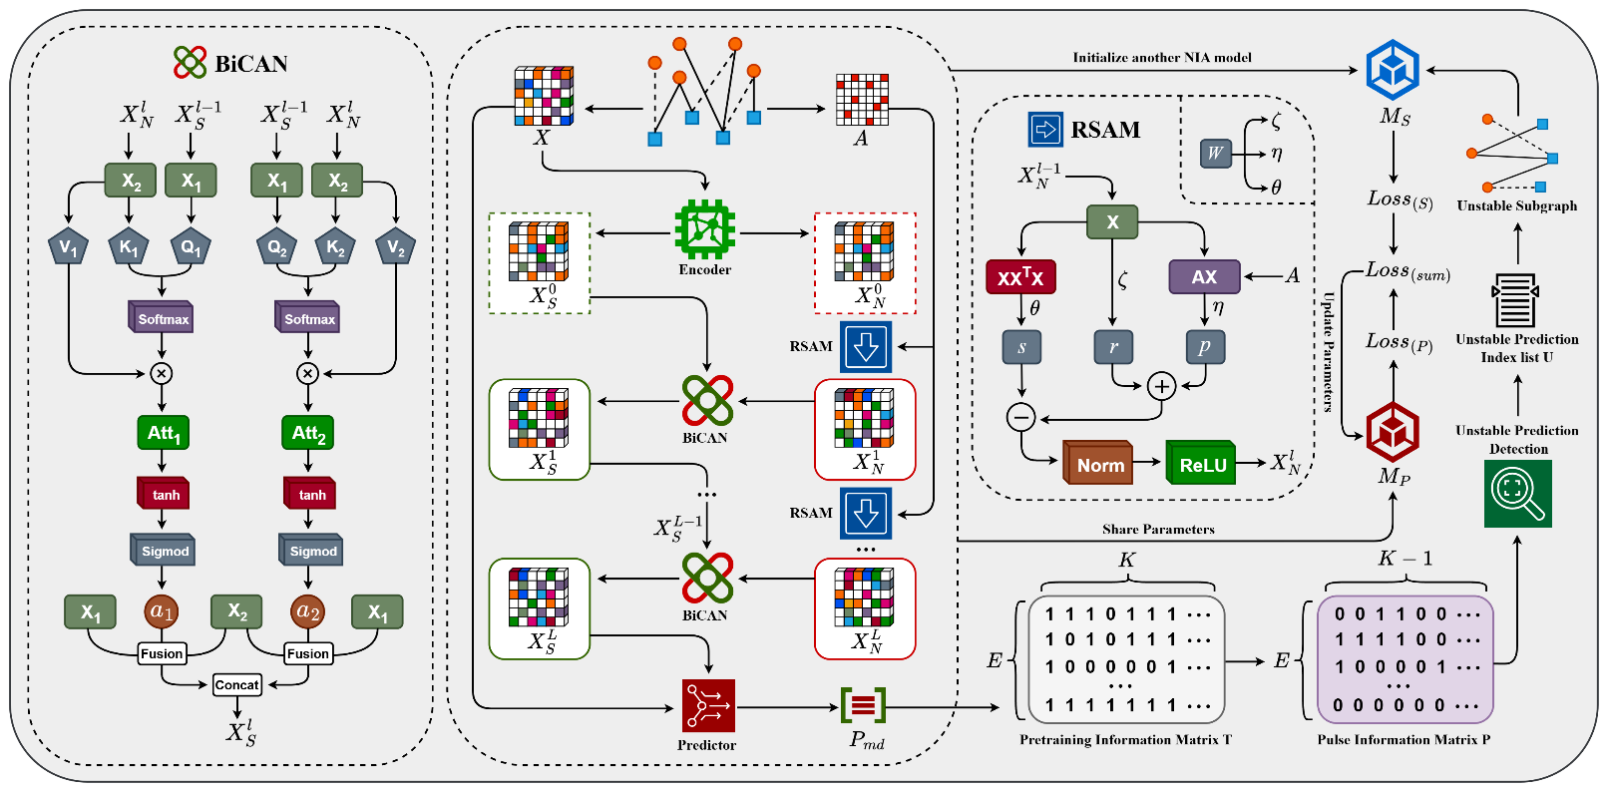
Figure 2. The Overall framework of the Re-NIA model

detail is shown in Figure 2.

Feature Decoupling
In the initial stage of the NIA model construction, a linear layer is employed as an encoder to process the input feature matrix $X$. The encoded features are then decoupled into two parallel paths:
$X_{S}^{0}=X_{A}^{0}=f_{Encoder}\left(X\right)$ (3)
$f_{Encoder}\left(X\right)=ReLU\left(Norm\left(X*W_{E}\right)\right)$ (4)
Here, $X_{S}∈R^{N×d}$ represents the discriminative features used for downstream prediction tasks, and $X_{A}∈R^{N×d}$ denotes the aggregative features used for neighbor information aggregation. $W_{E}∈R^{d×d}$ is a learnable weight matrix used for linear transformation. $Norm\left(⋅\right)$ denotes a normalization operation, and $ReLU\left(⋅\right)$ is the rectified linear unit activation function, which enhances the model’s non-linear representation capability. This decoupling strategy enables each node to independently assess the impact of its neighbors on the prediction task in the subsequent neighbor-aware fusion stage.
Redundancy-Suppressing Aggregation
In GNN-based node representation learning, a long-standing issue is the progressive feature homogenization and information redundancy that arises with deeper convolutional layers. On one hand, this leads to over-smoothing, where node representations across different classes become indistinguishable. On the other hand, it results in feature redundancy accumulation, where numerous highly correlated or duplicate feature dimensions emerge in high-dimensional space, reducing model discriminability and efficiency. Inspired by the idea in decorrelated representation learning that “feature correlation matrices can quantify redundancy, ” we design a novel aggregation mechanism that integrates residual retention, message passing, and redundancy suppression. Based on this, we propose the Redundancy-Suppressing Aggregation Module named “RSAM”, which takes the aggregative features $X_{A}$ and the heterogeneous adjacency matrix $A$ as input. The core idea is to decompose the feature aggregation process into three components. For convenience, we denote the layer index by $l$ in the following formulas:
• Residual Term ($r∈R^{N×d}$):
This term retains the feature representations from the previous layer to prevent feature degradation or vanishing. It is formulated as:
$r=ζ⋅X_{A}^{l-1}$ (5)
The coefficient $ζ$ controls the update magnitude. It adjusts the strength of propagation and redundancy suppression, respectively. Incorporating residuals helps preserve self-information and improves training stability.
• Graph Propagation Term ($p∈R^{N×d}$):
This term aggregates neighborhood information via the normalized adjacency matrix $\tilde{A}∈R^{N×N}$, defined as:
$p=η⋅\tilde{A}X_{A}^{l-1}$ (6)
$\tilde{A}={\hat{D}}^{-\frac{1}{2}}\hat{A}{\hat{D}}^{-\frac{1}{2}}$ (7)
where $\hat{D}=D+I$ and $D$ is the corresponding degree matrix with diagonal entries $D_{i,i}=\sum_{j=1}^{N}{A_{i,j}}$. $I$ is the identity matrix. The coefficient $η$ adjusts the strength of graph-based message passing.
• Redundancy Suppression Term ($s∈R^{N×d}$):
We propose a penalty mechanism based on feature autocorrelation to explicitly suppress redundant dimensions. A self-correlation matrix is constructed to evaluate inter-dimensional redundancy. This is used to reweight and suppress the original representation:
$s=θ⋅X_{A}^{l-1}\left(X_{A}^{l-1^{⊤}}X_{A}^{l-1}\right)*W_{s}$ (8)
Here, $θ$ controls the strength of suppression, and $W∈R^{d×d}$ is a learnable parameter matrix that adjusts sensitivity to different redundant dimensions. The objective is to penalize highly correlated dimensions, thereby enhancing feature expressiveness.
To set the coefficients $ζ$, $η$, and $θ$, we adopt an adaptive mechanism that combines learnability with normalization. Specifically, we introduce a learnable 3-dimensional vector $W∈R^{3}$, which is normalized using a softmax function to produce three non-negative weights that sum to 1: $\left[ζ, η, θ\right]=softmax\left(W\right)$. These weights dynamically balance the contributions of the residual, propagation, and redundancy-suppression paths in the aggregation process.
Finally, the output of the current layer's aggregation is computed by normalizing and applying non-linear transformation to the combined results $X_{A}^{l}∈R^{N×d}$:
$X_{A}^{l}=ReLU\left(Norm\left(r+p-s\right)\right)$ (9)
Through this module, NIA enhances the independence and informativeness of feature representations during neighborhood aggregation, laying a solid foundation for the downstream neighbor-aware fusion module to integrate high-quality feature signals.
Neighbor-Information Awareness
In GNNs, node feature updates rely heavily on the aggregation of neighboring information. However, we observe that most aggregation schemes suffer from two major limitations: 1. Nodes passively receive information from neighbors without actively discerning which neighbors are relevant or should be ignored. 2. Most GNNs model information flow solely from neighbors to the central node, while overlooking how neighbors perceive or respond to the central node-lacking symmetric interaction modeling.
To address these limitations, we draw inspiration from the bidirectional cross-attention mechanism in natural language processing, which captures mutual attention between two sequences (e.g., “A attends to B” vs. “B attends to A”). We extend this concept to graphs and propose the Bidirectional Cross-Attention-based Neighbor-awareness module named “BiCAN”, enabling each node to consider: 1. How the current node attends to its neighbors ($Att₁∈R^{N×d}$). 2. How its neighbors attend to the current node ($Att₂∈R^{N×d}$). These two attention outputs are then adaptively fused, yielding more context-aware and semantically bidirectional aggregation outcomes. Specifically, in this step, the NIA model updates the discriminative features by integrating the previous discriminative features with the aggregated features obtained from the RSAM. Based on the bidirectional attention principle, the update process is as follows:
1. Attention from $X_{S}^{l-1}$ to $X_{A}^{l}$:
We treat the previous-layer discriminative features $X_{S}^{l-1}$ as Query, and the current aggregated features $X_{A}^{l}$ as Key and Value:
$\left\{\begin{aligned}Q_{1}=X_{S}^{l-1}*W_{q}^{\left(1\right)} \\ K_{1}=X_{A}^{l}*W_{k}^{\left(1\right)} \\ V_{1}=X_{A}^{l}*W_{v}^{\left(1\right)}\end{aligned}\right.$ (10)
${Att}_{1}=softmax\left(\frac{Q_{1}K_{1}^{T}}{\sqrt{d}}\right)*V_{1}$ (11)
2. Attention from $X_{A}^{l}$ to $X_{S}^{l-1}$:
We reverse the perspective, using the aggregated features as Query, and the discriminative features as Key and Value:
$\left\{\begin{aligned}Q_{2}=X_{A}^{l}*W_{q}^{\left(2\right)} \\ K_{2}=X_{S}^{l-1}*W_{k}^{\left(2\right)} \\ V_{2}=X_{S}^{l-1}*W_{v}^{\left(2\right)}\end{aligned}\right.$ (12)
${Att}_{2}=softmax\left(\frac{Q_{2}K_{2}^{T}}{\sqrt{d}}\right)*V_{2}$ (13)
The attention outputs ${Att}_{1}$ and ${Att}_{2}$ are then used to compute adaptive fusion weights for the two types of features:
$\left\{\begin{aligned}a_{1}=σ\left(tanh⁡(A_{1})\right) \\ a_{2}=σ\left(tanh⁡(A_{2})\right)\end{aligned}\right.$ (14)
$\left\{\begin{aligned}Info_{1}=a_{1}*X_{A}^{l}+\left(1-a_{1}\right)*X_{S}^{l-1} \\ Info_{2}=a_{2}*X_{S}^{l-1}+\left(1-a_{2}\right)*X_{A}^{l})\end{aligned}\right.$ (15)
$X_{S}^{l}=\left[Info_{1} || Info_{2}\right]*W_{f}$ (16)
In the above, $W_{q}∈R^{d×d}$, $W_{k}∈R^{d×d}$, $W_{v}∈R^{d×d}$ and $W_{f}∈R^{d×2d}$ are all learnable weight matrices for linear transformation, and$tanh(·)$ denotes the hyperbolic tangent activation function. Through this mechanism, the NIA model achieves bidirectional neighbor-awareness and selective feature fusion. It allows each node to not only assess the relevance of neighboring nodes but also capture their reciprocal responses.
Output Prediction
After $l$ layers of processing in the NIA, we obtain the final feature representation $X_{S}^{L}$. To alleviate the vanishing gradient problem, we introduce a residual structure in the prediction phase by fusing the final node feature $X_{S}^{L}$ with the original node feature $X$. As described earlier in the feature matrix construction, $X$ is a matrix composed of both miRNA and disease features, concatenated row-wise. Therefore, we first extract the top $N_{m}$ rows from $X_{S}^{L}$ and $X$ to obtain the miRNA feature matrices $X_{S\left(m\right)}^{L}∈R^{N_{m}×d}$, $X_{R\left(m\right)}∈R^{N_{m}×d}$; then extract the bottom $N_{d}$ rows to obtain the disease feature matrices $X_{S\left(d\right)}^{L}∈R^{N_{d}×d}$, $X_{R\left(d\right)}∈R^{N_{d}×d}$. We then perform residual fusion and apply a linear layer followed by an activation function to obtain the final miRNA and disease feature matrices $X_{m}∈R^{N_{m}×d}$ and $X_{d}∈R^{N_{d}×d}$:
$X_{m}=ELU\left(\left[X_{S\left(m\right)}^{L} || X_{R\left(m\right)}\right]*W_{m}\right)$ (17)
$X_{d}=ELU\left(\left[X_{S\left(d\right)}^{L} || X_{R\left(d\right)}\right]{*W}_{d}\right)$ (18)
Here, $ELU(·)$is the activation function; $W_{m}∈R^{d×2d}、W_{d}∈R^{d×2d}$ are the learnable weight matrices used for linear transformation in the residual fusion process; and "||" denotes column-wise concatenation.
Next, we extract the miRNA index $I_{m}∈R^{E}$ and the disease index $I_{d}∈R^{E}$ from the training subgraph of the heterogeneous graph. These indices correspond to node positions in the graph, meaning that the $i$-th element in $I_{m}$ and $I_{d}$ indicates an edge between the corresponding nodes. Since the training subgraph contains $E$ edges, both $I_{m}$ and $I_{d}$ are of length $E$. Based on this, we extract the final miRNA and disease features for prediction from $X_{m}$ and $X_{d}$, denoted as $X_{m}^{P}∈R^{E×d}$ and $X_{d}^{P}∈R^{E×d}$, and compute the prediction scores:
$P_{md}=σ\left(\left[X_{m}^{P} || X_{d}^{P}\right]*W_{P}\right)$ (19)
Here, $W_{P}∈R^{1×2d}$ is the weight matrix of the fully connected layer; $P_{md}∈R^{E×1}$ is the final output of the model, where each row indicates the predicted probability of an association between a given miRNA and disease pair.
After obtaining the prediction scores, we use a binary cross-entropy loss function combined with L2 regularization to train the NIA model. The specific training loss is defined as follows:
$L_{BCE}=-\left[ylogP_{md}+\left(1-y\right)log\left(1-P_{md}\right)\right]$ (20)
$L2\left(W_{all}\right)=\sum_{i=1}^{J}{||W_{all}^{i}}||_{2}^{2}$ (21)
$L=L_{BCE}+λ*L2\left(W_{all}\right)$ (22)
Here, y is the ground truth label indicating whether a miRNA-disease association exists (1 for positive edge, 0 for negative edge); $J$ is the total number of model parameters; $W_{all}$ is the set of all trainable parameters, with $W_{all}^{i}$ representing the $i$-th parameter; and $λ$ is a coefficient controlling the weight of the L2 regularization term. $L$ is the final training loss.
Pretraining
To address this issue and enhance the stability of our model, we employ a relearning strategy guided by unstable predicted associations. First, after constructing a complete NIA network as described in previous steps, we initialize a primary NIA model denoted as $M_{P}$ and perform pretraining for $K$ epochs. After training, we construct a pretraining information matrix $T∈R^{E×K}$, which records the prediction results of $M_{P}$ over $K$ pretraining epochs. The matrix $T$ is defined as follows:
$T\left(i,j\right)=\left\{\begin{aligned} 1 &if P_{md}^{\left(i\right)} ≥ 0.5 \\ 0 &otherwise \end{aligned}\right.$ (23)
Where $P_{md}^{\left(i\right)}$ refers to the i-th row vector of the prediction score matrix $P_{md}$ output by the model, indicating the prediction score for the $i$-th miRNA-disease association. Thus, $T_{i, j}$ represents the binary prediction result (1 for associated, 0 for not associated) for the $i$-th pair at the $j$-th epoch. As previously noted, $i$ ranges from 1 to $E$, representing the total number of association pairs predicted by $M_{P}$. In the next step, we will identify unstable associations based on matrix $T$.
Unstable Prediction Detection
To identify unstable miRNA-disease associations, we use the pretraining information matrix T to construct a pulse matrix $P∈R^{E×(K-1)}$ that captures the variation in predictions across the K pretraining epochs. It is defined as:
$P\left(i,j\right)=\left\{\begin{aligned} 1 &if { T}_{i,j} ≠ T_{i,j+1} \\ 0 &otherwise \end{aligned}\right.$ (24)
This binary-encoded matrix converts prediction history into a sequence of pulses, where a value of 1 indicates a prediction flip at that epoch. We then calculate the number of flips $c_{i}$ for each association:
$c_{i}=\sum_{j=1}^{K-1}{P_{i,j}}$ (25)
To distinguish “stable” from “unstable” associations globally, we draw inspiration from the Otsu thresholding algorithm in image processing to determine an optimal threshold $τ^{*}$ based on the pulse matrix $P$. Associations with a flip count above $τ^{*}$ are defined as unstable miRNA-disease associations. To compute $τ^{*}$, we first estimate the probability distribution $\{ p_{0},p_{1},…,p_{K-1} \}$, where $p_{i}$ denotes the proportion of associations with i flips, satisfying $\sum_{i=0}^{K-1}{p_{i}}=1$. Then, we compute $τ^{*}$ by maximizing the between-class variance:
$σ_{B}^{2}\left(τ\right)=\frac{{\left(μ_{τ}⋅ω_{τ}-μ_{τ}^{'}\right)}^{2}}{ω_{τ}⋅\left(1-ω_{τ}\right)+ϵ}$ (26)
$μ_{τ}=\sum_{i=0}^{τ}{i}⋅p_{i}$ (27)
$ω_{τ}=\sum_{i=0}^{τ}{p_{i}}$ (28)
$μ_{τ}^{'}=\sum_{i=0}^{E-1}{i}⋅p_{i}$ (29)
Here, $μ_{τ}$ is the mean of the “foreground” class, $ω_{τ}$ is its probability mass, and $μ_{τ}^{'}$ is the global mean. $ϵ$ is a small constant to avoid division by zero. Since $τ∈[0, K-1]$, we traverse all possible values and select the $τ$ that maximizes $σ_{B}^{2}\left(τ\right)$, defining it as the optimal threshold $τ^{*}$. Based on this, we define the index list of unstable associations:
$U=\{i | c_{i}>τ^{*}\}$ (30)
Using this index list $U$, we identify the corresponding miRNAs and diseases, and the edges connecting them to construct the unstable subgraph $G_{u}$, which is then used in the relearning phase.
Relearning
In this phase, we focus on the unstable subgraph $G_{u}$ obtained from the previous step. This subgraph consists of miRNA-disease associations that showed significant prediction fluctuations during pretraining. These edges represent associations that the current model struggles to predict reliably. To address this, we introduce a relearning mechanism targeted at the unstable subgraph to further optimize the parameters of the NIA, enhancing its stability and reliability. We begin by initializing a new NIA model, denoted $M_{S}$, as the relearning sub-model. We train $M_{S}$S on the unstable subgraph $G_{u}$ using the same procedure as before and obtain the corresponding loss $L_{S}$. During this process, $M_{S}$ updates its parameters using $L_{S}$. Meanwhile, we input the original graph $G$ into the pretrained primary model $M_{P}$ and compute its loss $L_{P}.$ The overall loss is then computed as:
$α_{P}=\frac{L_{P}}{L_{P}+L_{S}}$ (31)
$L_{sum}=α_{P}⋅L_{P}+\left(1-α_{P}\right)⋅L_{S}$ (32)
Where $α_{P}$ controls the relative weights of the losses from $M_{P}$ and $M_{P}$. This adaptive fusion strategy adjusts the contribution of each model based on their current loss values. Finally, the primary NIA model $M_{P}$ updates its parameters based on the total loss $L_{sum}$.

Results
Experimental setup and evaluation metrics
The Re-NIA model is implemented using Pytorch Geometric (PyG), a framework specifically designed for the efficient construction and training of graph neural networks. Additionally, Deep Graph Library (DGL) is also utilized for certain graph structure construction and processing tasks. Re-NIA adopts five-fold cross-validation, where each fold undergoes independent training and testing. In each fold, Re-NIA is first pretrained for $K$ epochs, followed by the re-learning phase. During the relearning phase, an early stopping strategy is applied. After training, the primary NIA model $M_{P}$ is evaluated on the test set.
In terms of training settings, the number of pretraining epochs $K$ is set to 300, and the maximum number of training epochs for the relearning phase is set to 1000. The model is optimized using the Adam optimizer with a learning rate of 0.001 and a weight decay of 0.005. More detailed parameter configurations are listed in Table 1.
As for evaluation metrics, we adopt several commonly used indicators for binary classification tasks, including AUC, AUPR, Accuracy, Precision, Recall, and F1 score. Among them, AUC is the area under the ROC curve, ranging from 0 to 1. Since the ROC curve reflects the trade-off between the true positive rate and false positive rate, AUC serves as a comprehensive indicator of overall model performance. AUPR is another important metric for binary classification, representing the trade-off between precision and recall at various threshold levels. Accuracy indicates the proportion of correctly predicted samples among all samples. Precision refers to the proportion of true positives among all predicted positives. Recall measures the proportion of actual positives that are correctly identified. The F1 score is the harmonic mean of precision and recall. During the experiments, we compute all six metrics in each fold and report their average across folds to ensure comprehensive and stable evaluation.
Performance
Through multiple rounds of training and verification, the Re-NIA model demonstrates outstanding performance in the task of miRNA-disease association prediction, as shown in Fig. 3, Fig. 4 and Table 2.
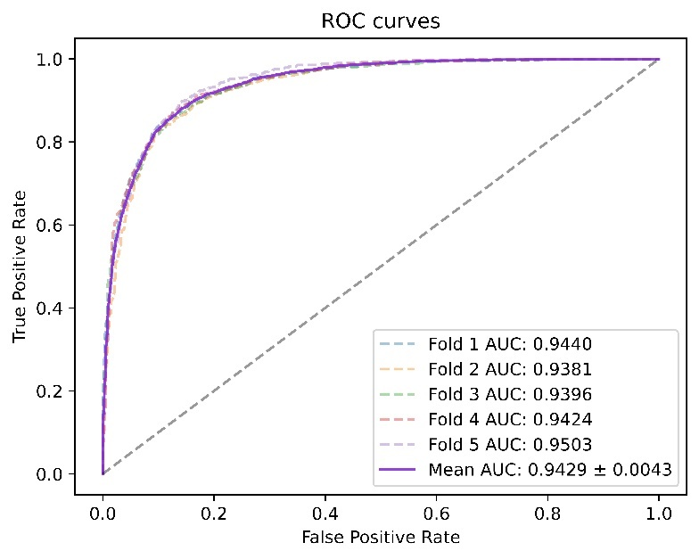
Fig. 3. ROC curves performed by Re-NIA model based on HMDD v2.0.
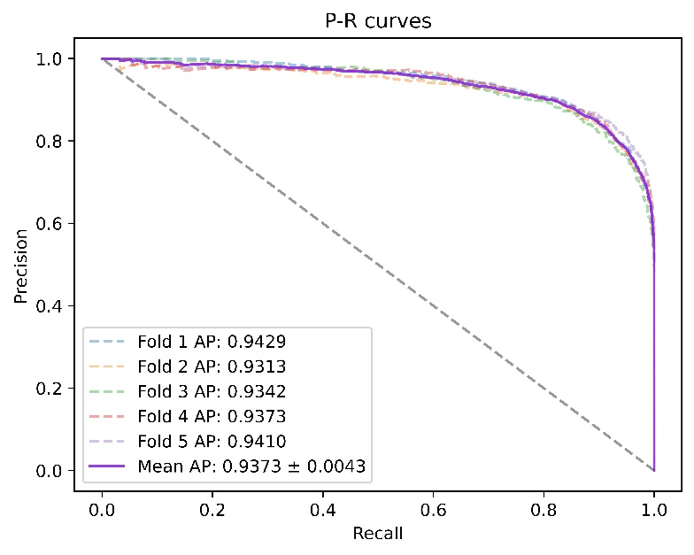
Fig. 4. P-R curves performed by Re-NIA model based on HMDD v2.0.
Table 2. results of 5-fold cross-validation performed by Re-NIA model
Fold | Acc.(%) | Pre.(%) | Rec.(%) | F1(%)
1 | 86.69 | 86.58 | 87.28 | 86.93
2 | 86.00 | 87.50 | 84.48 | 85.96
3 | 86.10 | 82.82 | 89.65 | 86.10
4 | 86.90 | 87.97 | 85.58 | 86.76
5 | 85.73 | 80.17 | 95.25 | 87.06
mean | 86.28  ±0.0044 | 85.01  ±0.0302 | 88.45  ±0.0382 | 86.56  ±0.0045
The experimental results show that under five-fold cross-validation on the HMDD v2.0 dataset, Re-NIA achieves an average AUC of 94.29% and an average AUPR of 93.73%, demonstrating its excellent discriminative capability and well-balanced trade-off between precision and recall. In addition, the model achieves an average Accuracy of 86.28%, Precision of 85.01%, Recall of 88.45%, and F1 score of 86.56%, showcasing the strong predictive performance of Re-NIA.
Comparison with other models
To further verify the performance of Re-NIA, we systematically compare it with several existing miRNA-disease association prediction models. The selected baselines are all representative or high-performing models in recent years, covering various typical approaches. Brief descriptions of the selected models are as follows:
DARSFormer[ ]: Combines dynamic attention mechanisms with spectral graph Transformers to predict miRNA–disease associations via feature enhancement and graph attention-based aggregation.
GRPAMDA[ ]: Integrates Drop-Feature-based stochastic propagation with attention mechanisms, utilizing feature perturbation and neighbor-enhanced aggregation to perform miRNA–disease association prediction.
HGATMDA[ ]: Proposes an end-to-end heterogeneous graph attention network that employs multi-head mechanisms to fuse neighbor structures and node attributes for embedding generation and association prediction.
HHOMR[ ]: Uses a hybrid high-order moment representation combined with element-level attention to enhance miRNA and disease node features and predict their associations using a residual network.
JKNMDA[ ]: Constructs a heterogeneous graph using miRNA–disease associations and similarities, aggregates local neighbor information with GAT, and extracts global features through a jump knowledge network for final prediction.
PMDAGS[ ]: Builds node features using similarity vectors and known association vectors, applies nonlinear diffusion-based graph convolution to extract embeddings, and uses a multi-layer perceptron to predict miRNA–disease associations.
SMALF[ ]: Stacks autoencoders to extract latent features of miRNAs and diseases, fuses similarity information to construct feature vectors, and uses XGBoost for final prediction.
The results are shown in Table 3. By comparison, Re-NIA outperforms other models in terms of AUC, AUPR, and F1 score. Although Accuracy and Precision are not the highest among all models, they still remain at a competitive level, indicating that the model has achieved a good balance between identifying positive and negative samples. Overall, Re-NIA balances multiple performance metrics well, demonstrating its comprehensive advantage in the miRNA–disease association prediction task.

Table 3. comparative results of the Re-NIA model and other models on the HMDDv2.0 dataset

Model | AUC(%) | AUPR(%) | Acc(%) | Pre (%) | Rec (%) | F1(%)
DARSFormer | 94.18 | 93.67 | 87.09 | 86.56 | 87.81 | 87.17
GRPAMDA | 93.46 | 93.31 | 86.00 | 85.79 | 86.37 | 86.06
HGATMDA | 93.52 | 93.15 | 86.14 | 86.10 | 86.25 | 86.15
HHOMR | 93.28 | 92.97 | 86.25 | 85.54 | / | 85.65
JKNMDA | 93.30 | 93.14 | 85.18 | 88.90 | 80.44 | 84.43
PMDAGS | 92.22 | 92.18 | 84.64 | 82.83 | 87.53 | 85.06
SMALF | 90.57 | 90.93 | 83.45 | 82.00 | 85.76 | 83.81
Re-NIA | 94.29 | 93.73 | 86.28 | 85.01 | 88.45 | 86.56

Ablation Study
To evaluate the contribution of each key module in the Re-NIA model to its overall performance, we conducted a series of ablation experiments. Under the same datasets and experimental settings, some modules were removed or replaced, and the models were retrained for comparative analysis. The ablation experiments primarily targeted the RSAM, BiCAN, and the Relearning module. Accordingly, we constructed the following variant models:
• w/o-RSAM: The redundancy-suppression Aggregation module RSAM is removed and replaced by a standard GCN to perform the feature aggregation task.
• w/o-BiCAN: The bidirectional cross-attention module in BiCAN is removed; instead, the discriminative and aggregation features are concatenated directly and passed through a linear layer for fusion.
• w/o-Relearning: The pretraining stage, unstable association detection, and the subsequent re-learning process are removed. Only the NIA model is used to complete the prediction task.
Table 4 shows the experimental results of the above variant models. The results indicate that:
Replacing RSAM with a standard GCN leads to a decrease in the model's performance (e.g., xxx), which shows that RSAM effectively suppresses redundant information during the aggregation of neighbor node features, thereby improving the quality of information representation. In contrast, a standard GCN cannot distinguish between redundant or irrelevant features, resulting in degraded performance.
Replacing BiCAN with a simple concatenation and linear fusion module also causes a decline in performance (e.g., xxx), indicating that the bidirectional cross-attention mechanism in BiCAN plays an important role in enhancing the quality of neighbor information fusion and the global discriminative ability. This further confirms that the mechanism can dynamically model fine-grained interactions between discriminative and aggregation features, thereby significantly improving the expressiveness of the final node representations.
Removing the Relearning module means the model no longer identifies and re-trains on unstable prediction results, thus losing its ability to model and optimize prediction uncertainty, which causes a drop in prediction accuracy. In addition, removing this module also reduces the stability of the model's predictions, which will be further discussed in the following sections.
Hyperparameter Analysis
To explore the impact of certain key hyperparameters on the performance of Re-NIA, we designed a set of sensitivity analysis experiments. We selected two hyperparameters that significantly affect the model’s performance: the number of layers $L$ in the NIA model and the number of pretraining epochs $K$. Keeping all other parameters constant, we evaluated the prediction performance under different grid values of these two parameters. The results are shown in Table 5. According to the experimental results, we observed that:
1. As the number of layers $L$ increases, the model performance shows a trend of first increasing and then decreasing. The model achieves optimal performance when $L =$2, indicating that the information propagation and

feature representation ability are well-balanced at this depth. A small $L$ limits the receptive field for neighbor information, resulting in insufficient feature aggregation. On the other hand, an excessively large $L$ may introduce too much noise or redundancy, leading to over-smoothing and a drop in discriminative capability.
2. Regarding the number of pretraining epochs $K$, we found that performance tends to improve with increasing $K$. This may be because when $K$ is small, the detection of unstable predictions is not sufficient, and thus the guidance effect of the relearning phase is limited. When $K$ increases

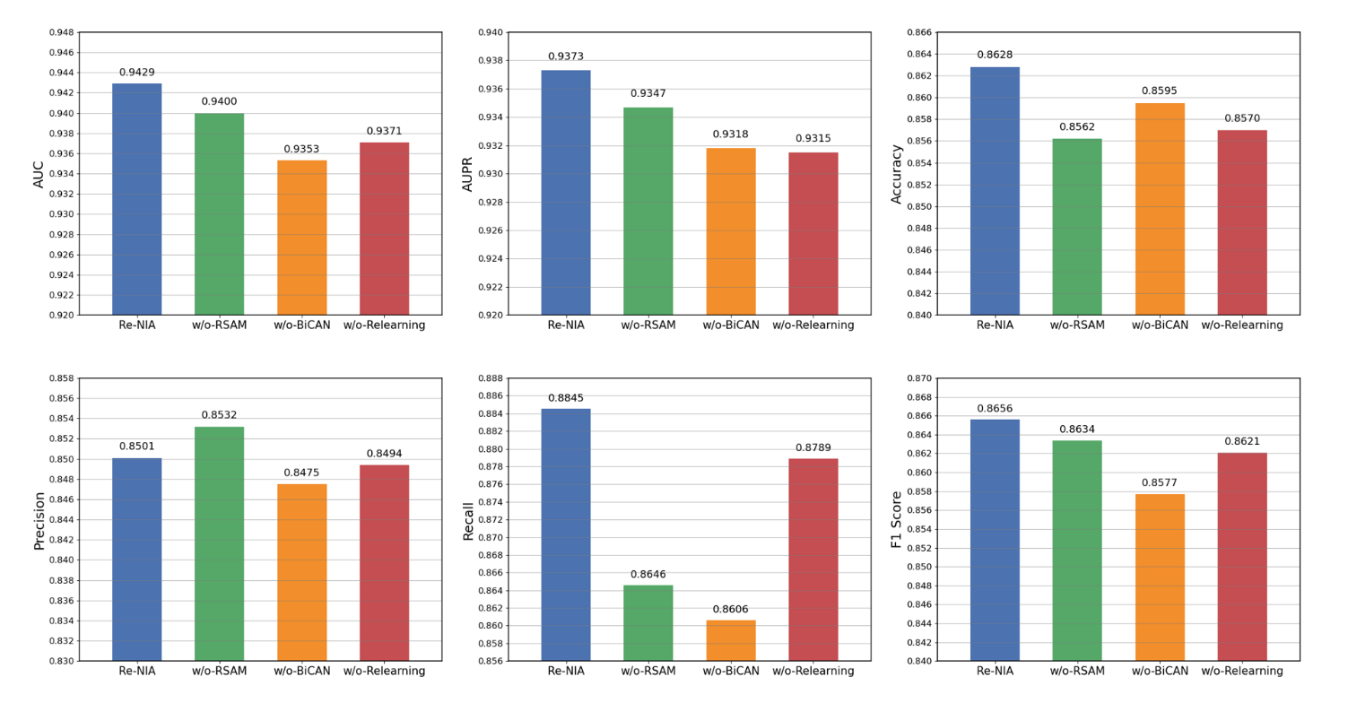
Fig. 5. Ablation study results of the Re-NIA model based on HMDD v2.0.

to a moderate value, the model achieves its best performance. However, further increasing $K$ causes performance even slightly degrade, possibly because excessive pretraining leads
the model to overfit the unstable patterns, compromising its global generalization ability.
Stability Evaluation of Re-NIA
To evaluate the prediction stability of Re-NIA and the contribution of the Relearning strategy, we designed a set of comparative experiments. First, we collected the last $K^{(R)}$ training results of the complete Re-NIA model during the relearning phase and constructed a pulse matrix $P^{\left(R\right)}$ following the unstable node detection method described earlier. In addition, we applied the same method using only the NIA to construct a pulse matrix $P^{\left(N\right)}$, and compared both matrices to evaluate the stability gain provided by the Relearning module. For this purpose, we introduced two new metrics:
$MFC=\frac{1}{E}\sum_{i=1}^{E}{c_{i}^{\left(⋅\right)}}=\frac{1}{E}\sum_{i=1}^{E}{\sum_{j=1}^{K^{(R)}}{P_{i,j}^{\left(⋅\right)}}}$ (31)
$UR=\frac{\left|\{i{ | c}_{i}^{\left(⋅\right)}>τ_{\left(⋅\right)}^{*}\}\right|}{E}$ (32)
where $c_{i}^{\left(⋅\right)}$ and $τ_{\left(⋅\right)}^{*}$ represent the jump count and the optimal threshold (obtained using Otsu algorithm) computed from the corresponding pulse matrix $P^{\left(⋅\right)}$. These two metrics were used to evaluate the stability of Re-NIA. To further verify the results, we also calculated the same two metrics for two comparative models mentioned earlier and compared them with Re-NIA. The experimental results are shown in Table 4.
Table 4. Results of stability evaluation on four methods
Fold | Acc.(%) | Pre.(%) | Rec.(%) | F1(%)
1 | 86.69 | 86.58 | 87.28 | 86.93
2 | 86.00 | 87.50 | 84.48 | 85.96
3 | 86.10 | 82.82 | 89.65 | 86.10
4 | 86.90 | 87.97 | 85.58 | 86.76
5 | 85.73 | 80.17 | 95.25 | 87.06
mean | 86.28  ±0.0044 | 85.01  ±0.0302 | 88.45  ±0.0382 | 86.56  ±0.0045
The results indicate that the Re-NIA model outperforms the baseline models in both metrics: the average number of jumps is significantly lower, suggesting reduced prediction fluctuation; and the proportion of high-frequency jump samples (i.e., samples with frequently changing predictions) is also considerably reduced. These findings validate that the proposed Relearning strategy guided by unstable associations effectively mitigates the instability problem of GNN-based prediction models.
Case Study
The results indicate that the Re-NIA model outperforms the baseline m

