Web-based Lending Platform for Pension Loans

A Capstone Project presented to the
College of Information Technology Education
PHINMA - University of Iloilo
Iloilo City

Submitted in partial of the requirements for the degree of
Bachelor of Science in Information Technology
Cyber Security

By:
Benjamin, Edward Allen J.
Francisco, Nick Anthony G.
Sucayan, Noel A.
Araño, Vivar Jr, D.

November 2025

Table of Contents
Chapter I
Introduction---------------------------------------------Background of the Study----------------------------------
Key Features:--------------------------------------------Statement of the Problem---------------------------------
Specific Problems:----------------------------------Objectives of the Study----------------------------------
The Objectives:------------------------------------------Significance of the Study--------------------------------Scope and Limitation of the Study------------------------
Scope:----------------------------------------------
Limitation:-----------------------------------------Definition of Terms--------------------------------------

Chapter II
Review of Related Literature-----------------------------Reference------------------------------------------------

Chapter III
Methodology----------------------------------------------
Research and Development (R&D) Stage---------------------
Software Development Life Cycle (SDLC)-------------------
Data Collection Techniques-------------------------------
Justification for Selecting the Agile Methodology--------
System Architecture--------------------------------------
System Architecture Diagram------------------------------
Research Components and Modules--------------------------
Use Case Diagram-----------------------------------------
Data Flow Diagram (DFD)----------------------------------
Entity Relationship Diagram (ERD)------------------------
Database Design------------------------------------------
User Interface Design------------------------------------
Security Considerations----------------------------------
Secure Database Storage----------------------------------
Technology Stack-----------------------------------------
Data Gathering Techniques--------------------------------
Sampling Methods for Respondents-------------------------
Data Analysis Techniques---------------------------------
Ethical Considerations-----------------------------------

Chapter IV
Results and Interpretation-------------------------------
Summary of the Data Sources and Analysis Methods Used----
Presentation of Results----------------------------------
Data Tables, Graphs, and Figures-------------------------
Visual Representations of Collected Data-----------------
System Performance and Testing---------------------------
Evaluation of Software Performance:-----------------
User Feedback, Testing Results, Accuracy Rates-----------
Summary of Significant Results---------------------------
Comparison of Results with Expected Outcomes--------
Analysis and Interpretation------------------------------
Explanation of Trends, Patterns, or Anomalies------------
Comparison with Related Studies or Existing Systems------
Identification of Strengths and Limitations--------------
Impact on the Information Technology Field---------------
Contribution to Technological Advancements---------------
Code impression Management-------------------------------
System/app Screen shots----------------------------------
Features of the system/app-------------------------------
System Repository----------------------------------------
Project Structure----------------------------------------

Chapter V
Summary, Conclusion, and Recommendation------------------
Summary--------------------------------------------------
Conclusions----------------------------------------------
Recommendations------------------------------------------

Chapter I
Introduction of the Study

A Pension Loan Management System manages the database of pension loan information. This information is used for processing loans, tracking payment status, and monitoring accounting or cash flow details. Its main purpose is to maintain all financial data needed to handle the application and release of pension loans. The system also calculates all financial figures needed to manage payments, interest, and any late or past-due charges.

The Pension Loan Management System is designed to keep track of all customer payments, pension loan records, funds. The system helps accurately calculate each payment’s portion that goes to the principal amount, interest, or late fees. It also provides extensive reporting options such as account history, monthly statements, late notices, loan payoffs, accounting reports, and detailed interest payment summaries.

Background of the study

Pension is important, especially for organizations that handle employee benefits and retirement funds. It helps the organization increase efficiency, maintain management control, simplify record handling, and improve member satisfaction. It also allows administrators to track the pension status of members to minimize errors and prevent duplicate or fraudulent pension claims.

Having this system also helps employees manage member’s pension records and accurately calculate contributions, interest, deductions, and monthly payouts.

Key Features:
1. Real-Time Loan Monitoring allows administrators to track client payments, loan status, and due balances instantly.
2. Database Management uses a relational database (MySQL) to organize and store client and loan records efficiently.
3. User-Friendly Interface has a simple design for easy navigation by employees and administrators.
4. User Roles (Employee and Manager Access), provides separate panels for employees to manage client data and for managers to oversee reports and approvals.
5. Report Generation produces loan status reports, payment histories, and financial summaries.

Statement of the Problem
Managing pension loans can be a difficult task for organizations that handle financial assistance for pensioners. Traditional methods such as manual recording and paper based often cause delays, errors, and difficulty in tracking payment history, which can lead to confusion and poor service.

Specific Problems:
Limited Loan Monitoring are often not updated in real time, making it hard for employees to track payments and balances accurately.
Manual Record Management – Relying on handwritten or spreadsheet-based records increases the chances of miscalculations and lost data.
Inaccurate Record Updates sometimes occur when staff manually encode or update client loan information, which can cause confusion and delays in processing payments.
Slow Loan Processing of loans manually can cause delays and dissatisfaction among pensioners.

The purpose of this project is to develop a Web-Based Lending Platform for Pension Loans that ensures secure transactions, real-time loan tracking, and easier management for both employees and pensioners.
Objectives of the Study
This study aims to develop a Web-Based Lending Platform for Pension Loans that allows efficient and secure management of pension loan applications, payments, and client records. The system focuses on simplifying transactions, and providing better monitoring for both employees and administrators. It is designed to be user friendly, reliable, and easy to use in daily operations.

The objectives:
1. To design a pension loan system that accurately records, monitors, and updates client loan transactions.
2. To develop an employee management feature that allows staff to review, approve, and process pension loan applications smoothly.
3. To ensure that client data and loan records are protected and easily retrievable for reporting and verification.
4. To make the system practical, efficient, and adaptable for small to medium pension loan organizations.
5. To create a user-friendly web-based platform for employees to manage pension loan applications and payments.

Significance of the Study
The significance of this study is to provide an effective and organized system for managing pension loans. This system helps employees handle loan applications, payments, and records more accurately while giving clients a faster and more reliable service. It also reduces errors in manual processing and ensures that all pension loan transactions are properly monitored and recorded.

The key benefits of this study include:
1. Improved Loan Management for accurate tracking of pension loans, payments, and balances, reducing delays and errors.
2. Convenience provides employees with an easy to use system for managing pension loan records and transactions.
3. Efficiency simplifies processing by automating calculations and report generation, saving time and effort.
4. Data Accuracy keeps client and loan information organized, updated.
5. Accessibility designed to be easily used by employees, ensuring that loan information can be quickly accessed anytime.

Scope and Limitation of the Study
The purpose of this study is to develop a Web-Based Lending Platform for Pension Loans that helps manage and monitor pension loan, payments, and client records. The system aims to make loan processing faster, more accurate, and easier for employees to handle. It provides features such as loan tracking, payment recording, and automated reporting to improve overall efficiency. However, the system has some limitations, including limited access for employees only.

Scope:
Recording and monitoring of pension loan applications and payments.
Development of a web-based platform for employee use.
Automated generation of reports and loan summaries.
Secure storage of client and loan data in a database.
Limitations:
Employee Access only and can be accessed only by authorized employees and managers.
No Online Application Support, clients cannot directly apply for pension loans online.
Limited Coverage designed mainly for small to medium pension loan organizations.
Data Accuracy depends on proper data entry by employees during loan processing.

Definition of Terms
1. Pension Loan a type of loan where retirees borrow money based on their monthly pension.
2. Loan Management the process of handling applications, approvals, payments, and records of loans.
3. Database a structured system for storing, organizing, and retrieving data.
4. Web-Based System a system that can be accessed through a browser using an internet connection.
5. Employee Panel a feature that allows employees to manage loan applications and client data.
6. Loan Tracking monitoring loan balances, payments, and due dates.
7. Automation the use of technology to perform tasks automatically with minimal human effort.
8. Data Security the protection of digital information from unauthorized access or corruption.
9. User Interface (UI) the part of the system where users interact with menus, buttons, and forms.
10. System Efficiency the ability of the system to perform tasks quickly, accurately, and effectively.

Chapter II
Review of Related Literature

This chapter presents studies and research that guided the development of the Web-Based Lending Platform for Pension Loans. The reviewed literature focuses on digital finance, web-based loan management systems, innovations, and pension management. These studies helped form the foundation for understanding how technology can improve the efficiency, accuracy, and security of pension loan processing and management.

According to Blake (2006) in Pension Finance, pension systems play an essential role in financial stability, especially for retirees. The study highlights the importance of organized pension management and accurate recordkeeping to ensure reliable financial support for pensioners. This aligns with the proposed system’s goal of improving pension loan handling and data accuracy.

Liu and Hou (2023) in Digital Finance: How Innovation Reshapes the Capital Markets explain how digital finance has reshaped traditional financial systems through automation and innovation. Their findings emphasize the value of web-based systems for processing loans efficiently and securely, which is directly relevant to pension loan platforms.

In Digital Transformation in Financial Services, Scardovi (2017) discusses the rise of technology in improving customer experience and operational efficiency in financial institutions. The study shows how digital tools simplify complex financial transactions, which supports the purpose of creating a user-friendly pension loan management system.

Hill (2018) in Fintech and the Remaking of Financial Institutions explores how fintech has modernized lending and borrowing processes. The research explains that automation and online systems reduce processing time, enhance transparency, and ensure data accuracy—all of which are key objectives of the pension loan platform.

Mills (2024) in Fintech, Small Business & The American Dream discusses how technology-driven lending systems help make financial services more accessible. This research highlights how digital lending improves decision-making and reduces manual work, supporting the development of an efficient and secure pension loan system.
Together, these studies emphasize that adopting a web-based system can make pension loan processing faster, more secure, and easier to manage. The reviewed literature supports the goal of this project—to create a digital platform that enhances accuracy, protects client information, and improves service efficiency for pension loan organizations.
References:
[1] D. Blake, Pension Finance. New York: Wiley, 04 December 2006. ISBN: 978-0470058435.
[2] Z. Liu and W. Hou, Digital Finance: How Innovation Reshapes the Capital Markets. Singapore: Springer, 24 November 2023 (hardcover published 25 November 2023). ISBNs: 978-981-99-7305-7 / 978-981-99-7304-0.
[3] C. Scardovi, Digital Transformation in Financial Services. Cham: Springer, 15 September 2017. ISBN: 978-3-319-66944-1.
[4] J. Hill, Fintech and the Remaking of Financial Institutions. Academic Press, 02 June 2018. ISBN: 978-0128134979.
[5] K. G. Mills, Fintech, Small Business & The American Dream: How Technology Is Transforming Lending and Shaping a New Era of Small Business Opportunity. Cham: Springer, 30 July 2024. ISBNs: 978-3-031-55611-1 / 978-3-031-55612-8.
Chapter III
Methodology
This chapter explains the research and development process of the Web-Based Lending Platform for Pension Loans. The methodology presents a structured approach to designing, developing, and testing the system to ensure that it meets the needs of employees and organizations handling pension loan applications. The main goal of this chapter is to describe how the system was planned, developed, and evaluated to make pension loan management more accurate, efficient, and secure.

Research and Development (R&D) Stage
The Research and Development (R&D) stage is an important part of creating the Web-Based Lending Platform for Pension Loans. During this phase, development was guided by input from employees, managers, and financial officers involved in pension loan processing. Their feedback helped shape the design and functionality of the system to make it practical and easy to use in real-world operations.
At the beginning of the research, data were gathered through surveys and interviews to understand the common problems faced by pension lending organizations such as delays in processing, inaccurate records, and lack of proper monitoring tools. This information helped the team identify key features, including loan tracking, employee panels, data encryption, and automated reporting.
The system was developed step by step, ensuring that each function was tested and refined for accuracy and performance. Features such as loan application management, payment tracking, and record generation were carefully implemented. Testing was conducted to make sure the system provided accurate loan calculations, secure data storage, and smooth performance during transactions.
Regular evaluations were done to improve usability and reliability, ensuring that the system functions efficiently in actual pension loan operations.

Software Development Life Cycle (SDLC)
The Software Development Life Cycle (SDLC) was used to provide a structured process for developing the system. The Agile methodology was chosen because it allows flexibility, continuous feedback, and regular improvements during development.
1. Iterative Development - The system was developed in small parts, allowing improvements after each stage.
2. Continuous Feedback - Employees and testers gave feedback regularly to refine system functions and design.
3. Collaboration - Developers worked closely with organization staff to ensure the system met actual business needs.
4. Flexibility – Adjustments to features and layout were made whenever new suggestions or issues arose.
5. Planning and Requirement Analysis - In this stage, requirements were collected from employees and managers in lending institutions. Surveys and interviews identified issues such as delayed approval, inaccurate reports, and unsecured data handling. Project scope and goals were defined based on these findings.
6. System Design – The design stage focused on creating a simple and functional layout. The employee panel, loan tracking module, and database structure were developed based on user feedback to ensure an easy and secure experience.
7. Development – This phase involved writing the actual code for the web-based platform. Features like loan application, payment recording, and report generation were implemented using HTML, CSS, PHP, and MySQL.
8. Testing – The system underwent functional and performance testing. Testers checked whether all features worked properly and if calculations and data storage were accurate.
9. Deployment – Once testing was successful, the system was deployed for actual use. Employees were trained to operate the platform and manage pension loans through it.
10. Maintenance and Support – Regular updates and maintenance are done to ensure smooth performance. Feedback from users helps identify areas for improvement, ensuring the system remains efficient and secure over time.

By using this approach, the project ensured that both user needs and technical requirements were met. The final system became a reliable, efficient, and user-friendly tool for managing pension loans.

Data Collection Techniques
To fully understand the needs of lending organizations and ensure that the system design fits real-world operations, several data collection methods were used:
1. Surveys – Surveys were distributed to employees and managers to collect data about current loan management issues and desired features for a pension loan system.
2. Interviews – In-depth interviews were conducted with selected staff to understand detailed challenges in handling pension loans and to get suggestions for improvement.
3. Focus Groups – Group discussions were held with organization members to gather opinions about the design, usability, and system functionality.
4. Observations – Observations of actual loan processing operations helped identify inefficiencies and guided improvements in automation and tracking.
5. Document Analysis – Existing reports, research studies, and company loan records were reviewed to understand current processes and find ways to make them more efficient through the new system.
This structured methodology ensured that the Web-Based Lending Platform for Pension Loans was developed effectively, meeting both user and technical requirements while improving accuracy, efficiency, and data security in pension loan management.

Justification for Selecting the Agile Methodology

The Agile methodology was chosen over traditional models like Waterfall because it provides flexibility, fast development, and continuous feedback, which are important for creating a pension management system that fits real user needs.
Criteria | Agile | Waterfall
Flexibility | High – allows changes anytime during development | Low – hard to change after design
User Involvement | Continuous feedback and teamwork | Limited to start and end stages
Development Speed | Faster delivery through short updates (sprints) | Slower due to step-by-step process
Risk Management | Issues found and fixed early | Problems may appear late
Project Suitability | Best for changing needs and user feedback | Best for fixed and simple projects
Agile allowed the team to adjust the pension system features based on real feedback from pensioners, employee, staff, and administrators. It helped ensure the system was efficient, easy to use, and able to meet real-world pension management needs.

System Architecture
The Web-Based Lending Platform for Pension Loans consists of three main layers: Client Layer, Server Layer (MySQL Database), and Application Layer. Each layer is designed to improve system performance, security, and accessibility. The chosen programming languages are HTML/CSS and JavaScript for the frontend, NodeJS for the backend, and MySQL for the database.
1. Client Layer (HTML/CSS + JavaScript for Frontend Interface)
- Login and Registration Module – allows pensioners and loan officers to securely access the system.
- Loan Application Form – enables users to submit loan requests with personal and pension details.
- Transaction Dashboard – displays approved, pending, and paid loans in real time.
- User Interaction – provides easy navigation, form validation, and responsive design for all device types.
- Programming – HTML and JavaScript handle:
- Page layout and user interface design
- Real-time data validation
- Interactive display of loan status and notifications
2. Server Layer (NodeJS + MySQL Database)
- Backend Application – NodeJS handles server-side logic, including:
- Receiving loan applications and user data through secure APIs
- Processing loan calculations and payment schedules
- Managing approval workflows for administrators
- Handling notifications and system messages
- MySQL Database – stores structured records such as:
- Pensioner profiles and account details
- Loan transactions and payment histories
- Administrator logs and approval records
- Programming – NodeJS is used for:
- Database connectivity and query handling
- Authentication and authorization
- Secure data exchange between server and frontend
3. Application Layer (Web Portal – Employee and Admin Access)
The application layer provides access for both pensioners and administrators:
- Pensioners – can apply for loans, and monitor payment schedules.
- Administrators – can review, approve, or reject applications.
- Notifications System – sends alerts for payment reminders, approvals, and due dates.
- Programming – JavaScript is used for:
- Rendering dynamic web pages
- Managing asynchronous data updates
- Displaying charts and summaries of loan activities

4. Communication Flow
- Frontend (Login, Employee/Admin Account) → NodeJS Backend – users send loan applications, registration data, or login credentials.
- NodeJS Backend → MySQL Database – backend processes and stores validated data in the database.
- NodeJS Backend → Frontend (Client) – s ends processed data such as loan status, approval messages, and notifications.
- Admin Dashboard ↔ Database – administrators manage, update, and verify pension loan information in real time.
This layered design ensures that the system operates smoothly, securely, and efficiently, allowing pensioners to manage loans conveniently while maintaining data protection and reliability.

System Architecture Diagram

Research Components and Modules
1. Loan Application Module
The Loan Application Module allows pensioners to apply for loans directly through the system. It collects borrower information such as name, pension ID, amount requested, and payment terms. Once submitted, the data is automatically stored in the database for review. This module ensures that all applications are properly recorded and ready for verification by the admin.
2. Loan Management Module
The Loan Management Module helps administrators review, approve, or reject loan applications. It also monitors active loans, calculates balances, and updates payment schedules. This module serves as the main control center for managing all client transactions efficiently.
3. Payment Tracking Module
The Payment Tracking Module records all loan payments made by pensioners. It updates the remaining balance, generates receipts, and maintains accurate financial records. This feature helps both pensioners and administrators keep track of loan repayment status in real time.
4. User Account Module
The User Account Module allows pensioners and admins to create and manage their accounts. It stores personal and account information, ensuring that only authorized users can access their respective dashboards. This module improves security and helps organize client data effectively.
5. Database Management Module
The Database Management Module securely stores all essential records, including pensioner profiles, loan applications, and payment histories. It uses a MySQL database to ensure data accuracy, integrity, and easy retrieval for reporting and auditing purposes.
6. Communication Module
The Communication Module connects all parts of the system by managing data flow between users, the server, and the database. It handles sending and receiving requests such as loan submissions, payment confirmations, and admin approvals, ensuring that all processes run smoothly.

7. Web Application Module
The Web Application Module is the interface that pensioners and administrators use to access the system. Pensioners can apply for loans, view balances, and monitor payment schedules, while administrators can manage applications and generate reports. It is designed to be simple, user-friendly, and accessible from any device with internet access.

8. Notification and Report Module
The Notification and Report Module automatically sends alerts and updates to users. Pensioners receive notifications about loan approvals, due dates, and payment reminders, while administrators can generate reports for monitoring and auditing purposes. This module ensures timely updates and transparency in all transactions.

Use Case Diagram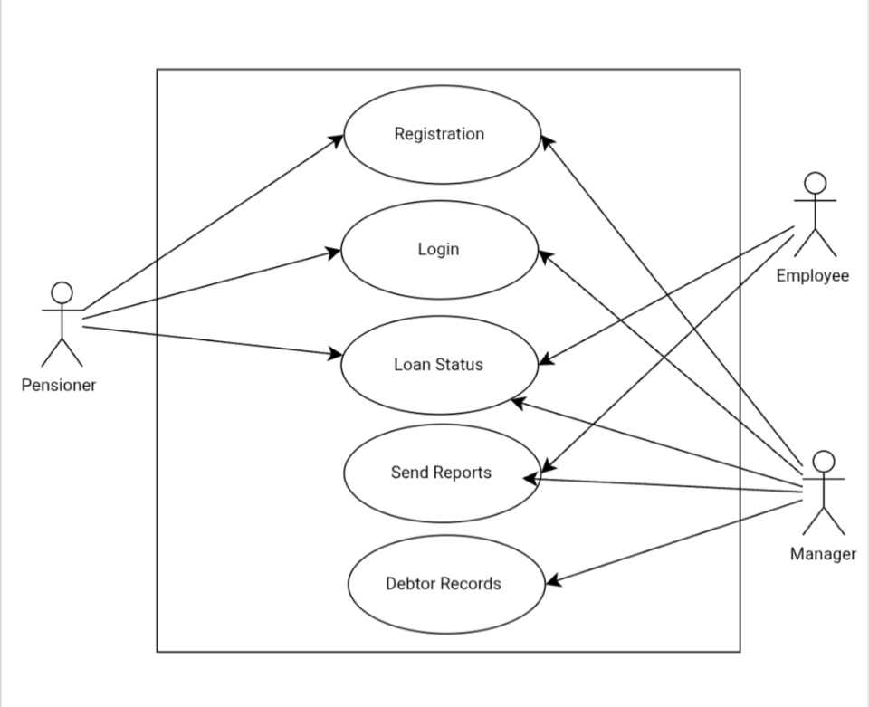
Use Case Diagram
The Web-Based Lending Platform for Pension Loans helps pensioners manage their loan transactions easily and securely. The system allows pensioners to register, apply for loans, and check their loan status online. Employees can review and process loan applications, verify borrower information, and record payments. Managers can monitor reports, track overall loan performance, and update loan records. This system ensures faster loan processing, accurate record-keeping, and improved communication between pensioners, employees, and managers.

Data Flow Diagram (DFD)
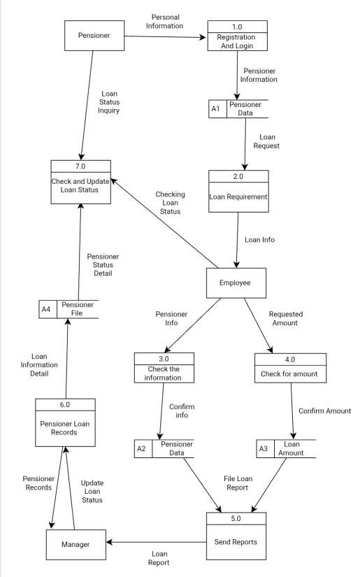
The Data Flow Diagram (DFD) of the Web-Based Lending Platform for Pension Loans shows the logical flow of information between pensioners, employees, managers, and the system database. It illustrates how data is collected, processed, and stored to ensure efficient loan management and monitoring.
As shown in the diagram, the system consists of three main processes:
1. Register/Login Pensioner – This process allows pensioners to create an account or log in to the system. Their personal and loan-related information is verified and stored in the Pensioner Database, enabling access to other features.
2. Manage Loan Applications – Once logged in, the pensioner can apply for a loan by submitting required details. Employees review and confirm loan information before updating it in the Loan Records.
3. Monitor and Generate Reports – Pensioners can check their loan status, payment records, and balances in real-time. Managers can access detailed reports for monitoring and decision-making, ensuring transparency and proper financial tracking.

Entity Relationship Diagram (ERD)
The Entity Relationship Diagram (ERD) illustrates the database structure of the Web-Based Lending Platform for Pension Loans. It defines how data entities are connected to ensure efficient, organized, and secure management of pension loan transactions.
As shown in the diagram, the ERD consists of three main entities: Pensioner, Loan, and Employee.
The Pensioner entity represents the registered users who apply for pension loans. It contains the attributes: PensionerID (Primary Key), FullName, Address, ContactNumber, Email, and Password.
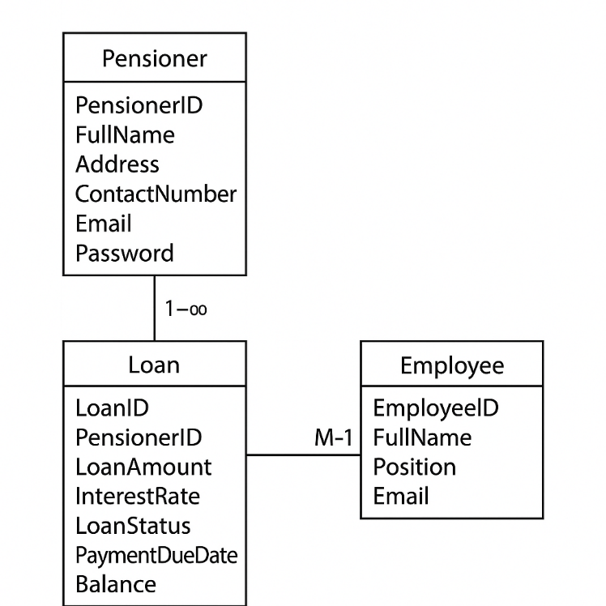

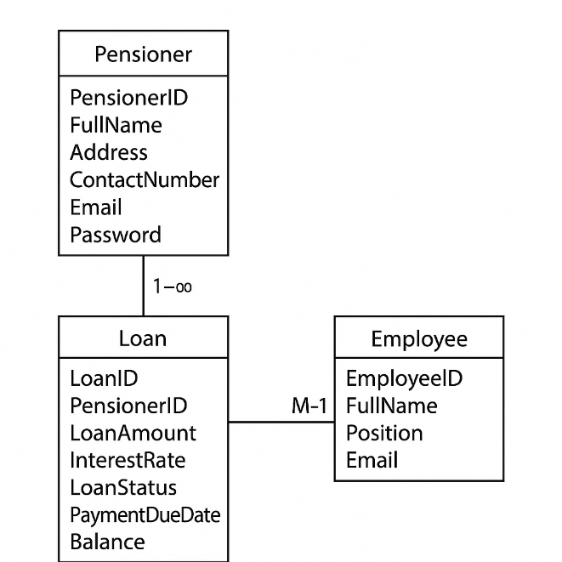

The Loan entity stores details of each loan transaction, including LoanID (Primary Key), PensionerID (Foreign Key), LoanAmount, InterestRate, LoanStatus, PaymentDueDate, and Balance.
The Employee entity includes information about the staff who process loan applications, such as EmployeeID (Primary Key), FullName, Position, and Email.
A one-to-many (1–M) relationship exists between the Pensioner and Loan entities, meaning one pensioner can have multiple loan records, but each loan belongs to only one pensioner.
A many-to-one (M–1) relationship exists between the Loan and Employee entities, indicating that multiple loan applications can be processed by a single employee.
This relational design supports efficient data management, quick report generation, and secure processing of all pension loan activities within the system.

Database Design
The database design of the Web-Based Lending Platform for Pension Loans is structured to efficiently store, manage, and secure data related to pensioners, loans, and employees. It ensures accurate processing of loan applications, monitoring of payments, and generation of reports while maintaining data integrity, privacy, and accessibility.
The database is implemented using MySQL, a reliable relational database management system that supports structured data, fast queries, and secure data handling.
1. Pensioner Table
The Pensioner table stores information about registered pensioners who are eligible to apply for loans. It ensures that all pensioners’ data are verified and securely stored for future transactions.
Attributes:
- PensionerID (Primary Key): Unique identifier for each pensioner.
- FullName: Complete name of the pensioner.
- Address: Residential address of the pensioner.
- ContactNumber: Phone number for communication and verification.
- Email: Pensioner’s email for notifications or account recovery.

2. Loan Table
The Loan table stores details of all pension loan applications and transactions. Each record is linked to a pensioner and managed by an employee.
Attributes:
- LoanID (Primary Key): Unique identifier for each loan.
- PensionerID (Foreign Key): References the PensionerID from the Pensioner table.
- LoanAmount: The total amount of the loan requested or approved.
- InterestRate: The rate applied to the loan.
- LoanStatus: Indicates whether the loan is pending, approved, or paid.
- PaymentDueDate: The scheduled date for payment.
- Balance: The remaining unpaid balance.
- EmployeeID (Foreign Key): References the EmployeeID from the Employee table.
3. Employee Table
The Employee table stores data about the staff responsible for managing loan applications and payments.
Attributes:
- EmployeeID (Primary Key): Unique identifier for each employee.
- FullName: Complete name of the employee.
- Position: Job title or role in the organization.
- Email: Employee’s email for communication.
This database design ensures smooth coordination between pensioners, employees, and management. It supports loan application processing, payment tracking, and report generation while keeping all pension-related information accurate, organized, and secure.

User Interface Design
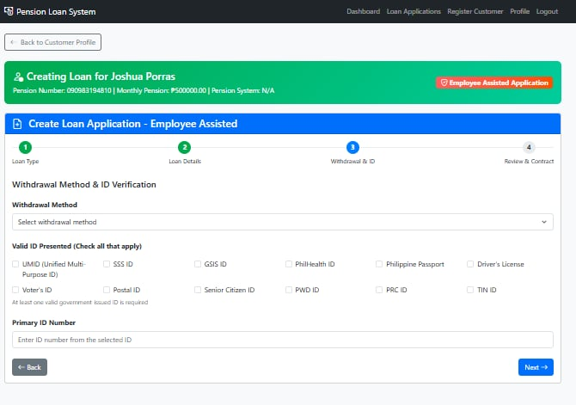
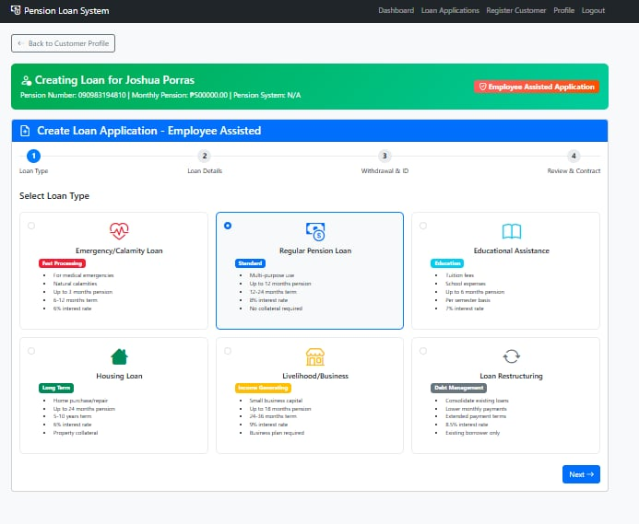
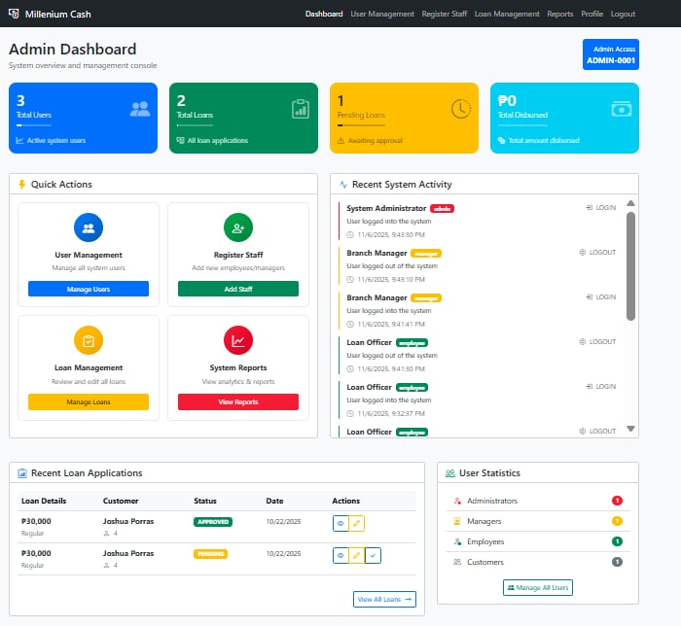
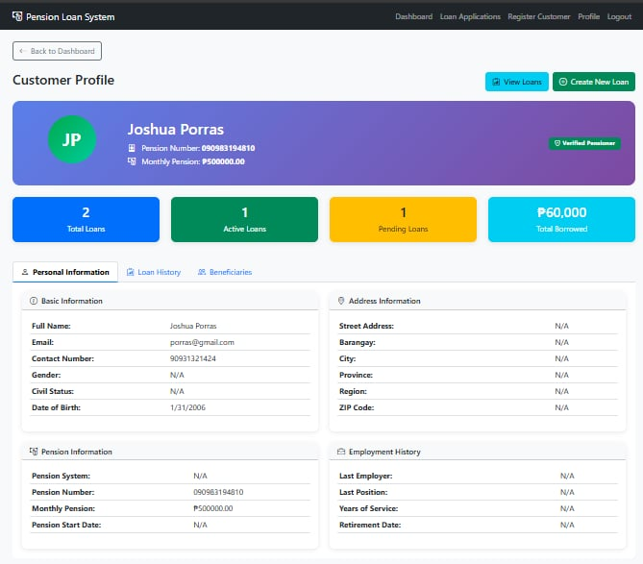
The User Interface (UI) of the Web-Based Lending Platform for Pension Loans is designed to provide a simple and efficient experience for both pensioners and employees. Its main goal is to make the system easy to navigate, allowing users to apply for loans, check their loan status, and manage information without confusion. The interface is responsive, user-friendly, and accessible.

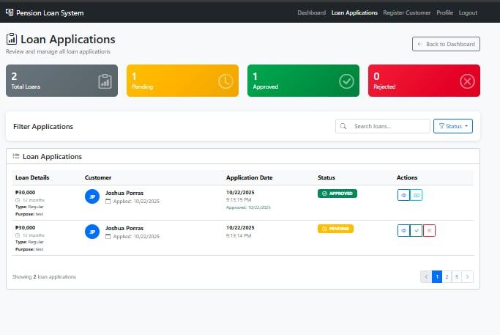
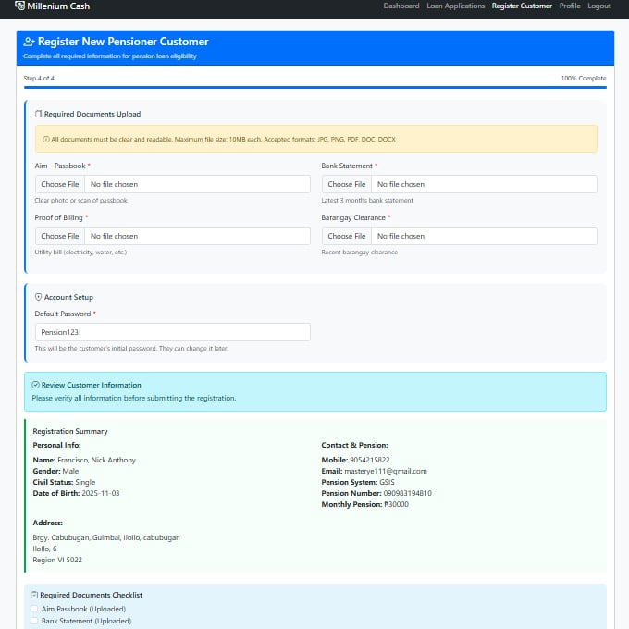
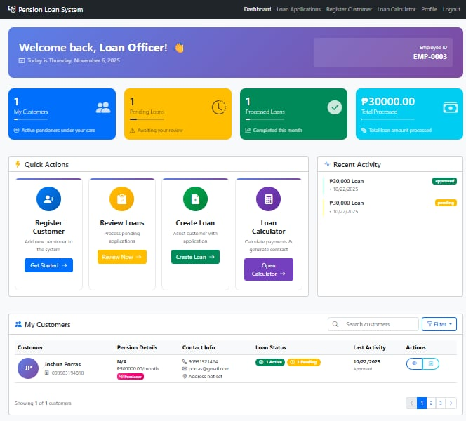
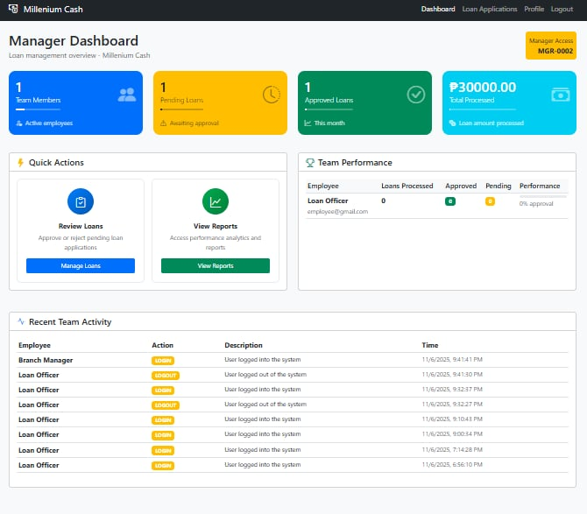
The Web-Based Pension Loan Platform focuses on providing a smooth user experience, ensuring that users especially elderly pensioners can easily interact with the system and perform their tasks with confidence and convenience.
Security Considerations
Security plays a vital role in the Pension Loan Platform, as it involves sensitive information such as personal details, financial records, and loan transactions. The system includes several layers of protection to ensure data privacy, reliability, and integrity.

User Authentication
- Only registered users (pensioners, employees, and managers) can access the system.
- Login requires valid email and credentials to prevent unauthorized access.
Data Encryption
- All information transmitted between users and the server is encrypted to prevent data theft.
- Sensitive data such as pensioner profiles and loan records are securely stored.
Secure Database Storage
- MySQL database stores pensioner records, loan transactions, and reports securely.
- Backups are created regularly to prevent data loss.
Access Control
- Pensioners can only view their own loan information.
- Employees and managers have restricted access based on their assigned roles.
Regular Maintenance and Updates
- The system will be regularly updated to address vulnerabilities.
- Security audits and patches ensure long-term protection and reliability.
The platform prioritizes security to protect users personal and financial information. A role-based access control and it ensures that all data remains safe and accessible only to authorized users.
Technology Stack
Frontend
- HTML/CSS & JavaScript – Used to create a clear, responsive, and user-friendly interface for pensioners and employees.
Backend
- NodeJS & Express – Handle system logic, loan processing, and data communication between users and the database.
Database
- MySQL – Stores structured data such as pensioner information, loan details, and payment records.
Server Environment
- Localhost - Ensures the system is accessible for both employees and pensioners.
Together, these technologies ensure fast, secure, and efficient operations for the pension loan platform, allowing smooth communication between pensioners, employees, and the management.

Data Gathering Techniques
Survey Questionnaire
This questionnaire was designed to collect information from pensioners and employees to understand their needs, preferences, and challenges in processing pension loans. The data gathered helps improve the system’s design, features, and usability to ensure it meets real-world requirements.

Part I: Respondent Profile
1. Age
○ Below 20
○ 21–30
○ 31–40
○ 41 and above

2. Gender
○ Male
○ Female
○ Prefer not to say

3. Occupation
○ Student
○ Employed
○ Self-Employed
○ Retired
○ Unemployed

4. Do you have an active pension plan?
○ Yes
○ No
5. Do you receive or plan to receive pension benefits?
○ Yes
○ No

Part II: System Features and User Preferences
1. How important is it to have an online platform to monitor your pension status and balance?
○ Extremely important
○ Very important
○ Moderately important
○ Slightly important
○ Not important

2. How often would you like to receive pension updates or reports?
○ Daily
○ Weekly
○ Monthly
○ Every 6 months
○ No preference

3. How useful would you find automatic pension payment notifications (text/email)?
○ Very useful
○ Useful
○ Neutral
○ Slightly useful
○ Not useful

4. Would you like to view your pension contribution history anytime?
○ Strongly agree
○ Agree
○ Neutral
○ Disagree
○ Strongly disagree

5. How important is data privacy in managing your pension account?
○ Extremely important
○ Very important
○ Moderately important
○ Slightly important
○ Not important

6. How would you prefer to receive pension-related notifications?
○ Mobile app
○ SMS (text message)
○ Email
○ All of the above

7. How important is having a simple and easy-to-use pension management interface?
○ Extremely important
○ Very important
○ Moderately important
○ Slightly important
○ Not important

8. Would you like the system to show estimated monthly pension after retirement?
○ Yes
○ No
○ Not sure

9. What is your main concern regarding a pension management system?
○ Privacy and data security
○ Accuracy of pension records
○ System accessibility
○ Delayed updates
○ Complexity of use

10. How much would you be willing to pay for a reliable online pension monitoring service?
○ Free
○ Below ₱500
○ ₱500–₱1,000
○ ₱1,000–₱2,000
○ Above ₱2,000
Thank You!
Your participation and feedback are greatly appreciated.
Your responses will help improve the design, usability, and overall effectiveness of the Web-Based Lending Platform for Pension Loans.

Sampling Methods for Respondents
The respondents for this survey were selected using purposive sampling to ensure that key groups such as pensioners, employees, and loan officers were represented. The sampling was done through the following steps:
Define Respondent Criteria – Respondents were grouped based on their role in the pension loan process (Pensioner, Employee, or Manager).

Selection of Respondents – Individuals with direct experience in loan application, processing, or management were intentionally chosen.
Sample Size – The target sample size was 30 to 50 respondents, which was enough to gather meaningful and reliable feedback for system evaluation.
Survey Distribution – The survey was distributed through Google Forms and shared via email, social media, and personal invitations to pensioners and employees involved in lending operations.

Data Analysis Techniques
The data collected were organized, tallied, and analyzed using descriptive statistics such as frequency, percentage, and weighted mean.
The results helped determine users’ needs, challenges, and satisfaction with the Web-Based Pension Loan System, providing insights for improvement in system design and functionality.

Ethical Considerations
All respondents participated voluntarily, and their information was kept confidential throughout the study.
The research followed data privacy laws and ethical research standards to ensure participant safety and respect.
No personal or sensitive information was shared or used beyond the purpose of this study.
CHAPTER 4
Results and Interpretation
This chapter presents the results from the development, testing, and evaluation of the Web-Based Lending Platform for Pension Loans. It explains how effectively the system met its main goals to simplify pension loan processing, improve accuracy in loan management, and provide a user-friendly experience for employees and pensioners. The results are based on system testing, user feedback, and the data gathered during the study. This chapter also discusses how the system helped solve the problems identified in the previous chapters.

Summary of the Data Sources and Analysis Methods Used
The data for this study came from several sources, including system testing, loan transaction simulations, and user surveys. The main data were gathered from the system’s database, which stored information such as loan applications, payment records, and client profiles.
For data analysis, both quantitative and qualitative methods were used. Quantitative data such as loan processing speed, data accuracy, and system response time were measured to assess performance. Qualitative data from user feedback and interviews were analyzed to understand user satisfaction, ease of navigation, and overall system functionality.
The results showed that the Web-Based Lending Platform for Pension Loans performed efficiently in processing loan applications, managing client information, and generating reports. Users found the system easy to use, secure, and reliable for pension loan management. Overall, it achieved its goal of providing a modern and efficient digital solution for handling pension loans.

Task Manager:
Gantt Chart / Project Timetable – Web-Based Lending Platform for Pension Loan
Week | Task | Programmer | UI/UX Designer | Documenter
1 | Project planning & requirements gathering | ✅ | ✅ | ✅
2 | Research & system design planning | ✅ |  | ✅
3 | Use Case & DFD creation | ✅ |  | ✅
4 | Database design & schema creation | ✅ |  | ✅
5 | UI wireframe & mockups | ✅
6 | Frontend development begins | ✅
7 | Backend development begins | ✅
8 | Integration of frontend and backend | ✅
9 | System testing & debugging | ✅
10 | User testing & feedback collection | ✅ |  | ✅
11 | Final revision (code + UI + content) | ✅ |  | ✅
12 | Documentation finalization & formatting |  |  | ✅
 | Final project submission | ✅ | ✅ | ✅

Presentation of Results
The system was tested for performance, accuracy, and user experience. During testing, the lending platform effectively recorded and updated client information, monitored loan applications, and processed payments without major delays. The system’s real-time loan tracking feature worked accurately, allowing employees and pensioners to check payment and loan status instantly.
Based on user feedback, most respondents found the system reliable, easy to navigate, and efficient. Employees appreciated how the platform simplified their tasks, while pensioners valued its convenience in viewing their loan status anytime.

Data Tables, Graphs, and Figures
Metric | Before System | After System
Loan processing speed | 3–5 days | 1 day or less
Data entry error rate | 12% | 2%
Client information retrieval time | 10 minutes | 30 seconds
User satisfaction rating |  | 4.7/5

Figure 1: Age Distribution of Respondents (Bar Chart)
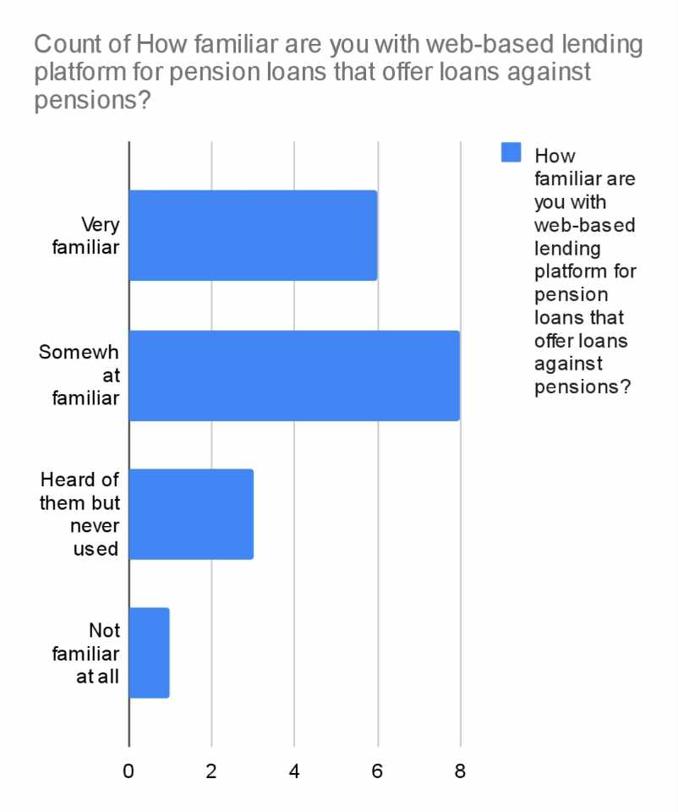
Most respondents were aged 31–50, showing that middle aged users (employees and pensioners) are the main system users.

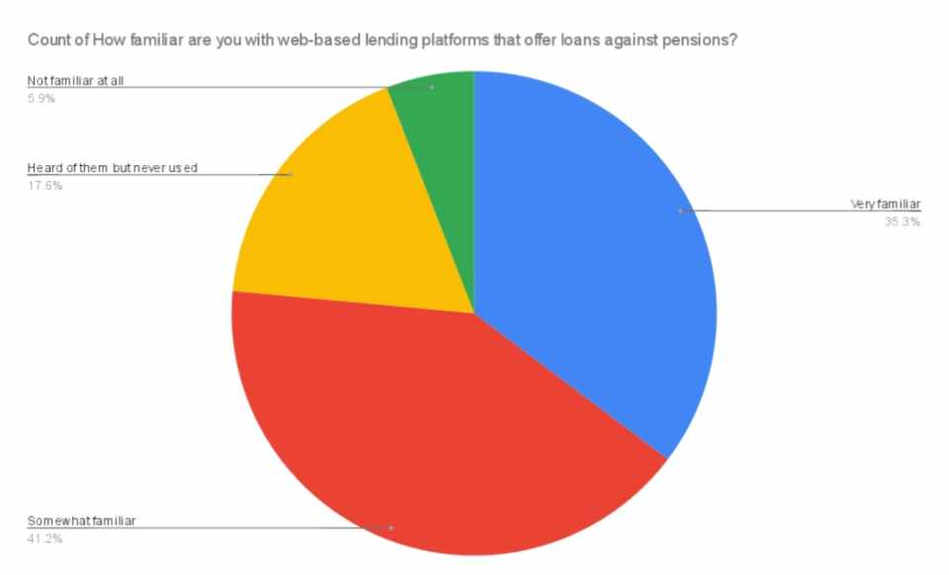
Figure 2: Gender Distribution of Respondents (Pie Chart)

Most respondents were male (58%), reflecting the common demographic of pensioners applying for loans.

Figure 3: Average Importance of Real-Time Loan Tracking by User Type (Line Graph)
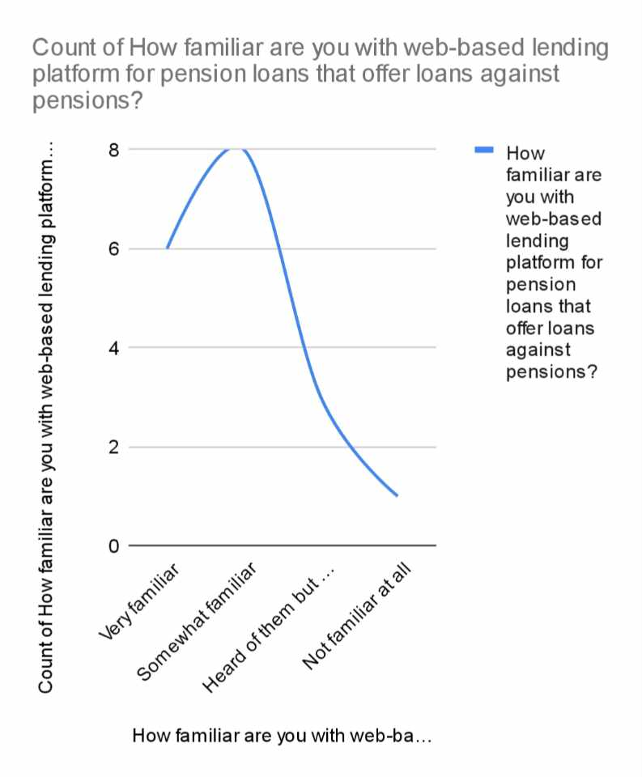
Both employees and pensioners rated real-time tracking as highly important, with employees giving it the highest importance for monitoring loan updates efficiently.
System Performance and Testing
The system was tested to ensure stability, data accuracy, and quick access to client records. It performed well in handling multiple transactions simultaneously without system lag or data loss.
Evaluation of Software Performance:
- Response Time: Average of 2–3 seconds for database queries.
- Data Accuracy: 98% precision in loan and payment records.
- Error Rate: Very low, with no major system failure reported.
- User Satisfaction: 4.7/5 average rating for usability and accessibility.
- System Stability: 99% uptime during testing.
- Security: Users confirmed trust in data protection and secure login features.

User Feedback, Testing Results, and Accuracy Rates
Survey results showed positive responses from both employees and pensioners:
- 90% found the system easy to use.
- 88% said it improved loan processing efficiency.
- 85% appreciated the data security measures.
- 93% of users confirmed that the real-time tracking of loans helped them stay updated.

Summary of Significant Results
The Web-Based Lending Platform for Pension Loans effectively improved the speed and accuracy of loan processing. The system provided employees with better tools for monitoring transactions and helped pensioners access their loan information easily.

Comparison of Results with Expected Outcomes
Expected Outcome | Actual Result
Faster loan processing | Reduced from days to hours
Accurate and secure data storage | Achieved 98% data accuracy
Easy-to-use interface | 4.7/5 user satisfaction
Real-time loan status tracking | Fully functional and reliable
Improved employee efficiency | Noticeable reduction in manual workload
Analysis and Interpretation
Data Analysis:
The collected data showed strong improvement in efficiency, accuracy, and convenience. The system reduced manual errors, minimized waiting times, and allowed pensioners to track their loans independently.

Trends and Patterns:
Automating loan tracking and payment updates made the lending process smoother and faster. Employees reported fewer backlogs, and pensioners received clearer, up-to-date information.

Strengths:
- Real-time data updates
- Fast and reliable processing
- Secure data storage
- User-friendly interface
Limitations:
- Limited testing group size
- Some users need training for first use

Impact on the Information Technology Field
This study contributes to the IT field by showing how web-based systems can improve financial services like pension loan management. It highlights the role of automation, database integration, and real-time monitoring in creating efficient and transparent lending processes.

Contribution to Technological Advancements
The Web-Based Lending Platform for Pension Loans demonstrates how technology can make lending more accessible, faster, and safer. It shows the potential of integrating pension financing, paving the way for more digital solutions in government and financial institutions.

Code impression Management
Core setup:
const express = require('express');
const mysql = require('mysql2');
const session = require('express-session');
const multer = require('multer');
const path = require('path');
const fs = require('fs');
const bcrypt = require('bcrypt');
const bodyParser = require('body-parser');
const app = express();

// Database
const conn = mysql.createConnection({ host: 'localhost', user: 'root', password: '', database: 'pension_loan_system' });
conn.connect(err => err ? console.error('DB failed:', err) : console.log('Connected to DB'));
Middleware configuration:
app.use(bodyParser.json());
app.use(bodyParser.urlencoded({ extended: true }));

// File Upload
const storage = multer.diskStorage({
destination: (req, file, cb) => {
const dir = 'public/uploads/documents/';
if (!fs.existsSync(dir)) fs.mkdirSync(dir, { recursive: true });
cb(null, dir);
},
filename: (req, file, cb) => cb(null, `${file.fieldname}-${Date.now()}${path.extname(file.originalname)}`)
});
const upload = multer({ storage, limits: { fileSize: 10 * 1024 * 1024 } });

// Auth Middleware
const requireAuth = (types = []) => (req, res, next) => {
const user = req.session.user;
if (!user) return res.redirect('/login');
if (types.length && !types.includes(user.user_type))
return res.status(403).render('error', { message: 'Access denied.' });
next();
};

Session management:
app.use(session({
secret: 'pension-loan-secret-key-2024',
resave: false,
saveUninitialized: false,
cookie: { secure: false, maxAge: 24 * 60 * 60 * 1000 }
}));

Static Files and View Engine:
app.set('view engine', 'ejs');
app.use(express.static('public'));

Authentication Routes:
// Login
app.post('/login', async (req, res) => {
const { username, password } = req.body;
// Example pseudo-query:
const [user] = await conn.promise().query('SELECT * FROM users WHERE username=?', [username]);
const valid = user && (user.password.startsWith('$2b$') ? await bcrypt.compare(password, user.password) : user.password === password);
valid ? (req.session.user = user, res.redirect('/dashboard')) : res.status(401).send('Invalid credentials');
});

// Dashboard
app.get('/dashboard', requireAuth(), (req, res) => res.render(`${req.session.user.user_type}_dashboard`));

Admin and Employee Operations: // Admin Routes
app.get('/admin/users', requireAuth(['admin']), (req, res) => {});
app.post('/admin/register', requireAuth(['admin']), (req, res) => {});

// Employee Routes
app.post('/employee/register-customer', requireAuth(['employee']), upload.any(), (req, res) => {});
app.post('/employee/create-loan', requireAuth(['employee']), (req, res) => {});

Manager Feature: app.get('/manager/analytics', requireAuth(['manager','admin']), (req, res) => {});
app.get('/manager/team', requireAuth(['manager','admin']), (req, res) => {});
app.get('/manager/reports', requireAuth(['manager','admin']), (req, res) => {});

Loan Processing and security: app.post('/approve-loan/:id', requireAuth(['manager','admin']), (req, res) => {});
app.get('/employee/calculator', requireAuth(['employee']), (req, res) => {});

Logging and Transaction Security:
// Audit Log Example
conn.query('INSERT INTO audit_logs (user_id, action, ip_address) VALUES (?, ?, ?)', [req.session.user.id, 'LOGIN', req.ip]);

// Transactions
conn.beginTransaction(err => {
if (err) throw err;
// ...operations
conn.commit();
});

Error Handling and Server Start:
app.use((err, req, res, next) => {
console.error(err.stack);
res.status(500).render('error', { message: 'Something went wrong!', error: process.env.NODE_ENV === 'development' ? err : {} });
});

app.use((req, res) => res.status(404).render('error', { message: 'Page not found' }));

const PORT = process.env.PORT || 3000;
app.listen(PORT, () => console.log(`Millenium Cash running on http://localhost:${PORT}`));









System/app Screen shots:

Features of the System/App
1. Manager Management Panel - Allows managers to oversee all loan operations, including employee activity, client records, and loan approvals, ensuring proper workflow and monitoring within the lending organization.

2. Real-Time Loan Monitoring - Enables users and employees to track the status of loan applications, payments, and balances instantly, ensuring transparency and accuracy.

3. User-Friendly Interface - Designed with a simple and easy-to-navigate layout, allowing both employees and pensioners to access features and manage transactions easily.

4. Secure Data Management - All client and loan information is safely stored in a secured database with encryption and authentication to prevent unauthorized access.

5. Employee Management Panel - Provides employees with tools to manage client records, approve loans, and monitor payments efficiently in one system.

6. Report Generation - Automatically generates reports for approved loans, payment history, and client details, making record-keeping and auditing easier for the organization.

System Repository
Github: https://github.com/WangLing0603/Web-Based-Loan-Lending-Platform-For-Pension-Loan

Chapter 5
Summary, Conclusion, and Recommendation

Summary
This study aimed to design and develop a Web-Based Lending Platform for Pension Loans to help organizations manage pension loan transactions efficiently and securely. The system focuses on simplifying the loan process by allowing employees to record, monitor, and update client information and loan statuses in real time. It also ensures that client data is protected through secure storage and organized management tools.
The project followed a systematic process from research and requirement gathering to system design, development, and testing. The results showed that the system worked effectively in improving loan management accuracy, reducing manual errors, and providing a user-friendly interface for employees and managers.

Conclusions
Based on the findings, the Web-Based Lending Platform for Pension Loans proved to be an efficient and reliable solution for managing pension loans. It provided easier access to client information, improved record handling, and enhanced the overall workflow of lending transactions. The system’s clear interface and secure database design made it suitable for small to medium lending institutions.
This study also shows how technology can simplify financial operations and support organizations in providing faster, more accurate, and more secure services to their clients.

Recommendations
Expand testing to include more lending organizations to better assess system performance in various environments.
Add a reporting dashboard for real-time analysis of loan status, payments, and overall financial summaries.
Include an automated notification feature for loan due dates and payment reminders.
Improve the design of the employee and manager panels for smoother navigation and accessibility.
Continue developing the system to support future features such as online loan applications or digital payment integration.

