h092540 Machine Learning HW5

1.Guassian Process

Part1.
use rational quadratic kernel:
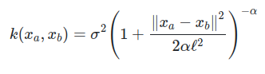

hyper-parameter:
σ : 0.2 (because noisy of data is β = 0.2)
α : 0.2
l : 0.5

code:
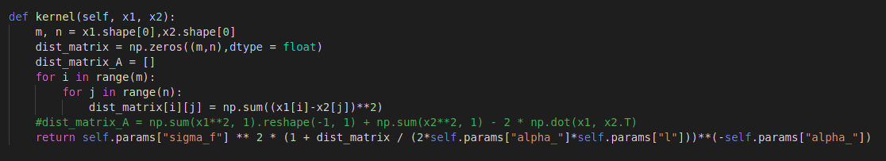
kernel:

predict(get mean and covariance matrix):

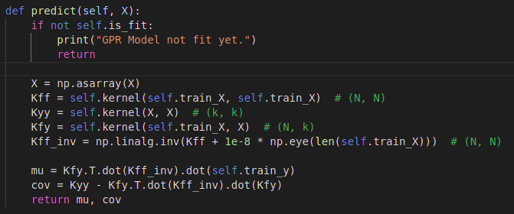

draw plot:
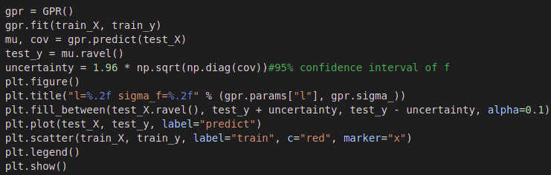
plot:

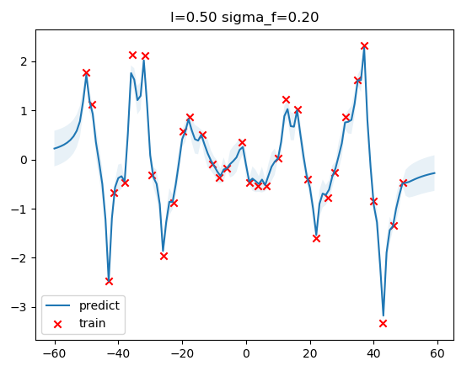

Part2.
Optimize:

Discussion.
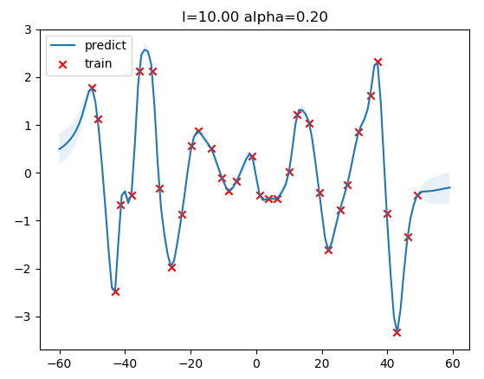
for l:
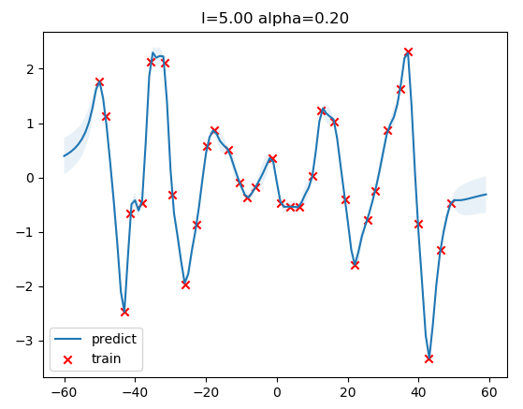

By increasing value of l, the overall spread of the covariance increases . The curve is more smooth.

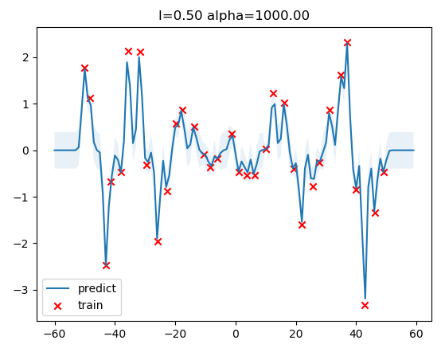
for alpha:
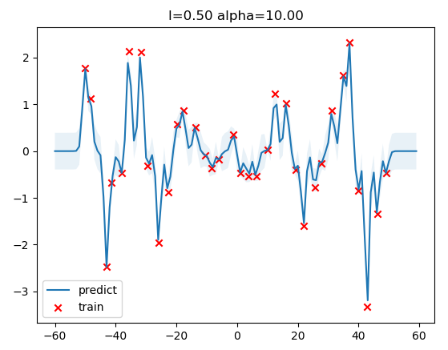

Decreasing the scale-mixture α will allow for more minor local variations while still keeping the longer scale trends defined by l.

2.SVM on MNIST dataset

