Predicting ocean pressure field with a physics-informed neural network
Seunghyun Yoon, $​^{1,2}$ Yongsung Park, $​^{2,a}$ Depeter Gerstoft, $​^{2}$ D and Woojae Seong $​^{1,3}$ D
$​^{1}$ Department of Naval Architecture and Ocean Engineering, Seoul National University, Seoul 08826, Republic of Korea
$​^{2}$ Scripps Institution of Oceanography, University of California San Diego, La Jolla, California 92093-0238, USA
$​^{3}$ Research Institute of Marine Systems Engineering, Seoul National University, Seoul 08826, Republic of Korea

ABSTRACT:
Ocean sound pressure field prediction, based on partially measured pressure magnitudes at different range-depths, is presented. Our proposed machine learning strategy employs a trained neural network with range-depth as input and outputs complex acoustic pressure at the location. We utilize a physics-informed neural network (PINN), fitting sampled data while considering the additional information provided by the partial differential equation (PDE) governing the ocean sound pressure field. In vast ocean environments with kilometer-scale ranges, pressure fields exhibit rapidly fluctuating phases, even at frequencies below $100 Hz$ , posing a challenge for neural networks to converge to accurate solutions. To address this, we utilize the envelope function from the parabolic-equation technique, fundamental in ocean sound propagation modeling. The envelope function shows slower variations across ranges, enabling PINNs to predict sound pressure in an ocean waveguide more effectively. Additional PDE information allows PINNs to capture PDE solutions even with a limited amount of training data, distinguishing them from purely data-driven machine learning approaches that require extensive datasets. Our approach is validated through simulations and using data from the SWellEx-96 experiment. © 2024 Acoustical Society of America.
https://doi.org/10.1121/10.0025235
(Received 24 June 2023; revised 19 February 2024; accepted 21 February 2024; published online 13 March 2024) [Editor: Zoi-Heleni Michalopoulou] Pages: 2037-2049

I. INTRODUCTION
Sound propagation in the ocean has representations governed by physical laws in ocean acoustic environments. A physics-informed neural network (PINN) $​^{1}$ trains the neural network using sampled data and encodes the underlying physical laws governing the dataset, represented with partial differential equations (PDEs). We present a PINN-based strategy that offers a realistic prediction of ocean acoustic propagation.
In this study, we present OceanPINN, a machine learning framework for predicting ocean acoustic pressure fields. A PINN is fitted to the partially observed experimental data while integrating prior scientific knowledge. OceanPINN utilizes pressure magnitude data from various range-depths for data fitting. Beyond fitting data at known points, OceanPINN enforces the underlying physics of the ocean waveguide, including governing partial differential equation (PDE) and the pressure-release surface boundary condition, which enables extended predictions to unknown points. A sound speed profile (SSP) is required as prior information to compute the governing PDE. Once trained, the OceanPINN can predict the sound pressure field at any given range-depth. The predicted pressure field has a wide range of applications, such as source localization, $​^{2−4}$ sonar performance assessment, $​^{5,6}$ and noise prediction for marine mammals. $​^{7,8}$
Many papers have adopted machine learning methods for ocean acoustics problems through purely data-driven approaches. $​^{9−19}$ A few studies have explored integrating physical knowledge into neural networks by applying PINN to estimate modal wavenumbers $​^{20}$ or by modifying the machine learning framework to satisfy a ray or modal solution. $​^{21,22}$ Recently, PINN has been applied for underwater pressure prediction. $​^{23}$ However, the research has focused on an ideal environment with small domain sizes and simple environmental conditions. Our objective is to enable a PINN framework that works in more realistic ocean acoustic environments with kilometer-scale ranges.
Purely data-driven machine learning approaches require extensive training datasets to learn the PDE solutions. In contrast, the PINN-based method encourages the network to learn the structural information expressed by the PDEs, facilitating the network to capture the PDE solutions well, even with a low amount of training data.
PINN has been applied to various fields, including seismology, $​^{24}$ fluid dynamics, $​^{25}$ and biophysics. $​^{26}$ In various acoustic field predictions, PINNs have been employed to solve the Helmholtz $​^{27−29}$ or wave equation. $​^{30,31}$ However, these applications involve smaller domain sizes $​^{23,31}$ or lower frequencies, $​^{27−30}$ resulting in less complex fields compared to our focus on kilometer-scale real ocean acoustic fields.
Despite the success of PINNs, recent studies $​^{32,33}$ have shown their limitations in complex PDE problems. Specifically, fully connected neural networks, commonly used in the architecture of PINNs, suffer from a fundamental issue, known as spectral bias. $​^{34}$ Spectral bias refers to the difficulty in learning high-frequency functions. The spectral bias problem in PINNs $​^{32}$ was analyzed through neural tangent kernel theory, $​^{35}$ revealing challenges in learning high-frequency functions. $​^{36}$ Consequently, applying PINNs to a realistic ocean acoustics environment presents greater challenges due to spectral bias. In our approach, to address this spectral bias, we transform the pressure field into a low-fluctuating representation, called an envelope. OceanPINN is trained to approximate this envelope, with the loss function incorporating the modified Helmholtz equation and pressure-release surface boundary conditions.

a)Email: yongsungpark@ucsd.edu

Ocean waveguides are typically modeled with two boundary conditions: a pressure-release ocean surface and a bottom with sediment layers. The propagation of acoustic waves within these waveguides is governed by the acoustic wave equation or the Helmholtz equation in the frequency domain. Conventionally, the governing equation is solved using ray theory, normal mode theory, and a parabolic equation model in the ocean environment. $​^{37}$ The accuracy of acoustic wave field simulations is highly dependent on environmental parameters, including the SSP, bathymetry, and sediment properties. However, the vastness of the ocean can lead to situations with unknown environmental parameters. Direct measurement of sediment properties is challenging and is typically inferred through geoacoustic inversion methods $​^{38−40}$ from measured acoustic signals. These inversion methods approximate the actual bottom using geoa-coustic models, requiring a certain degree of prior knowledge about the bottom in the area of interest. $​^{41,42}$ The absence of this knowledge can substantially increase the range and number of model parameters needed for analysis. Furthermore, incorrect assumptions about the bottom model can lead to errors in the predicted fields. In contrast, OceanPINN does not require any prior knowledge of the bottom, distinguishing it from conventional model-based geoacoustic inversion methods.
Working with ocean acoustic experimental data presents several challenges. First, array sizes are insufficient to cover the whole ocean waveguide. Additionally, due to the ocean’s temporal variability, remeasuring in previously unmeasured areas is complicated, as environmental changes can alter data characteristics. Moreover, accurately measuring the phase in experiments is challenging because of its sensitivity; the phase of ocean acoustic pressure is affected by the Doppler effect $​^{43,44}$ and varies rapidly across the range. This sensitivity makes range-coherent processing difficult. OceanPINN can address these challenges by predicting unmeasured pressure fields with magnitude data and reconstructing phase information.
In summary, we mitigate the spectral bias in PINNs using the low-fluctuating nature of the envelope that constructs acoustic pressure fields and this enables ocean acoustic pressure field prediction. OceanPINN does not require complex bottom modeling. Additionally, training OceanPINN with magnitude data enables the reconstruction of phase information, allowing for potential range-coherent processing and improving performance. OceanPINN is evaluated in simulation and experiment conducted in the shallow water evaluation cell experiment 1996 (SWellEx-96). $​^{45,46}$

II. PINN-BASED PRESSURE FIELD PREDICTION
In this section, we provide the required background and description of the proposed method. Section II A introduces the governing PDE and discusses the challenges of applying PINN in the ocean waveguide. Section II B explains the data preprocessing method to overcome these challenges. Section II C introduces the general PINN framework, and the proposed PINN-based ocean acoustic pressure field prediction method is described in Sec. II D.

A. Pressure field in the ocean waveguide
The acoustic pressure field satisfies the Helmholtz equation. In an ocean waveguide with a constant-density medium and an azimuth-independent environment, the Helmholtz equation in range-depth coordinates $\left(r,z\right)$ is expressed as $​^{37}$
$$\frac{1}{r}\frac{∂}{∂r}\left(r\frac{∂p}{∂r}\right)+\frac{∂^{2}p}{∂z^{2}}+\frac{ω^{2}}{c^{2}}p=0, \text{(1)}$$
where $ω$ is an angular frequency, $p$ is a pressure field, and $c$ is a sound speed of medium. The notation $\left(r,z\right)$ is abbreviated for variables $p$ and $c$ . The pressure field is obtained by solving the Helmholtz equation with boundary conditions.
Here, we detail the characteristics of the pressure field within an ocean waveguide. For simplicity, a range-independent environment is assumed. Consider a scenario in which a point source is at position $\left(r,z_{s}\right)$ and a single receiver is at position $\left(0,z\right)$ . The Helmholtz equation is solved with normal mode theory, $​^{37}$ and the pressure field is a sum of normal modes as
$$p\left(r,z\right)=\frac{i}{4ρ\left(z_{s}\right)}\sum_{m=1}^{M}{Ψ_{m}}\left(z_{s}\right)Ψ_{m}\left(z\right)H_{0}^{\left(2\right)}\left(k_{m}r\right), \text{(2)}$$
where $k_{m}$ is the $m$ th mode wavenumber, $M$ is the number of propagating modes, and $Ψ_{m}\left(z\right)$ denotes the $m$ th modal depth function. We adopt the second kind Hankel function $H_{0}^{\left(2\right)}\left(k_{m}r\right)$ , as we use the Fourier transform pair in the time-frequency $\left(t,f\right)$ domain as
(3)
$$p\left(f\right)=\int_{−∞}^{∞}{p}\left(t\right)e^{−i2πft}dt$$
$$p\left(t\right)=\int_{−∞}^{∞}{p}\left(f\right)e^{i2πft}df$$
where the sign of the phase in the exponent term is opposite to Ref. 37. Mode wavenumbers are determined by environmental parameters (e.g., SSP and geoacoustic parameters).
We can compute the mode wavenumber in the perfectly known environment and generate the pressure field.
Hankel function $H_{0}^{\left(2\right)}\left(k_{m}r\right)$ determines the pressure variation in range direction as Eq. (2). In the far field $\left(kr≫1\right)$ , the Hankel function form is asymptotic,
$$H_{0}^{\left(2\right)}\left(kr\right)≈\sqrt{\frac{2}{πkr}}e^{−i\left(kr−π/4\right)}. \text{(4)}$$
The phase of the Hankel function changes rapidly with slight range variations, causing the pressure field to exhibit rapid variations with respect to range. In contrast, the magnitude of the Hankel function, i.e., $\sqrt{2/πkr}$ changes slowly with respect to range. In Fig. 1, we present an example of a simulated pressure field using the Kraken normal mode model $​^{47}$ in an isovelocity environment (see Sec. IV A for detail). As seen in Figs. 1(c) and 1(e), the real and imaginary component of the pressure field exhibits rapid variation with respect to range, while the magnitude changes gradually, as shown in Fig. 1(a). This characteristic of complex pressures presents two challenges: (1) The highly fluctuating patterns make training neural networks challenging. (2) Even a small error in range, denoted as $Δr$ , results in a significant difference between the measured pressures $p\left(r,z\right)$ and $p\left(r+Δr,z\right)$ . We can mitigate the second challenge by using the magnitude of measured pressure $\left|p\right|$ with lower sensitivity. The approach to address the first challenge is detailed in the subsequent section.

B. Smoothing the pressure field
To address the first challenge, we adopt an envelope $ψ\left(r,z\right)$ used in the derivation of the parabolic equation, $​^{37}$
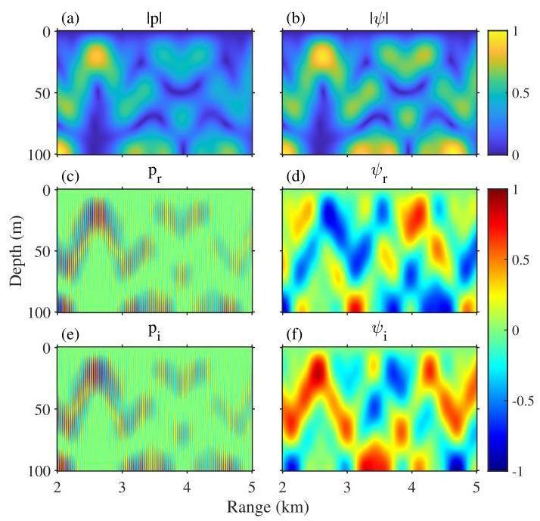

FIG. 1. (Color online) Normalized (a) and (b) magnitude, (c) and (d) real, and (e) and (f) imaginary of pressure field (left) and envelope field (right). The data are simulated in an isovelocity environment with a $100 Hz$ source at $25 m$ depth.
J. Acoust. Soc. Am. 155 (3), March 2024 and smooth the pressure field. The envelope $ψ\left(r,z\right)$ is defined by Eq. (6.3) of Ref. 37,
$$ψ\left(r,z\right)=p\left(r,z\right)/H_{0}^{\left(2\right)}\left(k_{0}r\right), \text{(5)}$$
where $k_{0}=ω/c_{0}$ is the reference wavenumber, $c_{0}$ is the reference sound speed, which is $1500 m/s$ . We name Eq. (5) as the envelope transform. In an ocean waveguide, the acoustic pressure field is dominated by modes with close mode wave-numbers. Mode wavenumber can be expressed as $k_{m}=ω/c_{m}$ , where $c_{m}$ represents the phase velocity of $m$ th mode. Since $c_{0}$ is close to $c_{m},k_{0}$ is close to $k_{m}$ , and an envelope transform can smooth the acoustic pressure field by decreasing a wavenumber to $k_{m}−k_{0}$ . Figures 1(d) and 1(f) show a real and imaginary component of envelope $ψ$ , exhibiting much smoother variation compared to the pressure field in Figs. 1(c) and 1(e). If $c_{0}$ is adjusted to reduce further $\left|k_{m}−k_{0}\right|$ , a smoother envelope field is achieved. However, since $c_{0}=1500 m/s$ significantly reduces the wavenumber, further adjustment yields marginal effects. Since the range of $c_{m}$ is unknown, we set $c_{0}$ as $1500 m/s$ .
To overcome the second challenge, we use the magnitude of the envelope, which is easily converted from the magnitude of the pressure field. In far-field condition $\left(kr≫1\right)$ , the magnitude of the envelope is expressed as
$$\left|ψ\left(r,z\right)\right|=\sqrt{\frac{πk_{0}r}{2}}\left|p\left(r,z\right)\right|. \text{(6)}$$
Figure 1(b) shows the envelope magnitude. Unlike the pressure magnitude in Fig. 1(a), the envelope magnitude does not decrease with range, as it is compensated by a factor of $\sqrt{r}$ .
The governing equation for envelope $ψ$ is derived:
Rewriting the Helmholtz equation in Eq. (1) as
$$\frac{∂^{2}p}{∂r^{2}}+\frac{1}{r}\frac{∂p}{∂r}+\frac{∂^{2}p}{∂z^{2}}+k_{0}^{2}n^{2}p=0, \text{(7)}$$
where $n\left(r,z\right)=c_{0}/c\left(r,z\right)$ is the index of refraction. Substituting the pressure $p$ into Eq. (7) by envelope $ψ$ , and using that the Hankel function, satisfies the Bessel differential equation, $​^{37}$
$$\frac{∂^{2}H_{0}^{\left(2\right)}\left(k_{0}r\right)}{∂r^{2}}+\frac{1}{r}\frac{∂H_{0}^{\left(2\right)}\left(k_{0}r\right)}{∂r}+k_{0}^{2}H_{0}^{\left(2\right)}\left(k_{0}r\right)=0, \text{(8)}$$
gives
$$\frac{∂^{2}ψ}{∂r^{2}}+\left(\frac{2}{H_{0}^{\left(2\right)}\left(k_{0}r\right)}\frac{∂H_{0}^{\left(2\right)}\left(k_{0}r\right)}{∂r}+\frac{1}{r}\right)\frac{∂ψ}{∂r}+\frac{∂^{2}ψ}{∂z^{2}}$$
$$+k_{0}^{2}\left(n^{2}−1\right)ψ=0. \text{(9)}$$
Using Eq. (4), the governing equation for envelope function $ψ$ is derived as $​^{37}$
$$N_{ψ}\left[ψ\right]\overset{\text{ def }}{=}\frac{∂^{2}ψ}{∂r^{2}}−2ik_{0}\frac{∂ψ}{∂r}+\frac{∂^{2}ψ}{∂z^{2}}+k_{0}^{2}\left(n^{2}−1\right)ψ=0,$$
(10)
where $N_{ψ}$ represents differential operator.

C. Physics-informed neural networks
PINN is a deep-learning framework for solving forward and inverse problems involving nonlinear PDEs. $​^{1}$ PINN deals with general physics systems, characterized by a governing equation, Eq. (11), and a boundary condition, Eq. (12), that are satisfied within a domain $Ω$ along its boundary $∂Ω$ ,
$$N\left[u\left(x\right)\right]=f\left(x\right) x∈Ω, \text{(11)}$$
$$B\left[u\left(x\right)\right]=g\left(x\right) x∈∂Ω, \text{(12)}$$
where $x$ represents input coordinates, such as spatial and temporal dimensions, while $u$ represents physical quantities, as pressure or velocity. $N\left[⋅\right]$ and $B\left[⋅\right]$ denote differential operator. Neural networks are universal function approxima-tors, $​^{48}$ capable of representing any continuous function with the proper configuration and a sufficient number of neurons. For PINN, neural networks are used to approximate the solutions of PDEs, $u\left(x\right)$ (see Fig. 2).
A limited set of input-output pairs ${\left\{x_{m}^{i},u\left(x_{m}^{i}\right)\right\}}_{i=1}^{N_{m}}$ is known, obtained from initial conditions or measurements. There are three sources of information to solve the problem: (1) a limited number of known input-output pairs, (2) the governing equation, and (3) the boundary condition. It is important to note that even with limited data, leveraging the system’s underlying physics allows us to compensate for sparse datasets. Contrasting with purely data-driven machine learning methods that depend solely on a limited dataset of input-output pairs, PINNs integrate physical principles into their loss function. This integration enables the PINN to effectively solve problems, even with a small amount of dataset.
PINNs are trained with a composite loss function,
$$L\left(θ\right)=λ_{M}L_{M}\left(θ\right)+λ_{B}L_{B}\left(θ\right)+λ_{N}L_{N}\left(θ\right), \text{(13)}$$
where $λ_{M},λ_{B}$ , and $λ_{N}$ are weighting coefficients and $θ$ is trainable parameters of neural network. Neural network parameters are updated using gradient-descent methods based on the backpropagation of the loss function. Each loss term is expressed as
$$L_{M}\left(θ\right)=\frac{1}{N_{m}}\sum_{i=1}^{N_{m}}{{\left|\hat{u}\left(x_{m}^{i};θ\right)−u\left(x_{m}^{i}\right)\right|}^{2}}, \text{(14)}$$
$$L_{B}\left(θ\right)=\frac{1}{N_{b}}\sum_{i=1}^{N_{b}}{{\left|B\left[\hat{u}\left(x_{b}^{i};θ\right)\right]−g\left(x_{b}^{i}\right)\right|}^{2}}, \text{(15)}$$
$$L_{N}\left(θ\right)=\frac{1}{N_{n}}\sum_{i=1}^{N_{n}}{{\left|N\left[\hat{u}\left(x_{n}^{i};θ\right)\right]−f\left(x_{n}^{i}\right)\right|}^{2}}. \text{(16)}$$
$L_{M},L_{B}$ , and $L_{N}$ have a distinct role: fitting the neural network to the known data, enforcing the boundary condition, and the governing equation. Traditional neural networks rely solely on a data-based loss function, $L_{M}$ . In contrast, PINNs incorporate physics-based losses, $L_{B}$ and $L_{N}$ . These losses are evaluated at different sets of data points, including known points ${\left\{x_{m}^{i}\right\}}_{i=1}^{N_{m}}$ , boundary points ${\left\{x_{b}^{i}\right\}}_{i=1}^{N_{b}}$ , and collocation points ${\left\{x_{n}^{i}\right\}}_{i=1}^{N_{n}}$ . Boundary and collocation points are specific sampling locations to enforce the boundary condition and the governing PDE. These points are strategically sampled from the boundary $∂Ω$ and the domain $Ω$ of the physics problem, respectively. The number of these sampling points, $N_{n}$ for collocation and $N_{b}$ for boundary points, can be freely selected. The differential operator $B\left[⋅\right]$ and $N\left[⋅\right]$ can be easily calculated since neural networks can efficiently compute gradients of the outputs with respect to the inputs, $∂\hat{u}/∂x$ , via automatic differentiation. $​^{49}$ This enables computing loss terms $L_{B}$ and $L_{N}$ .
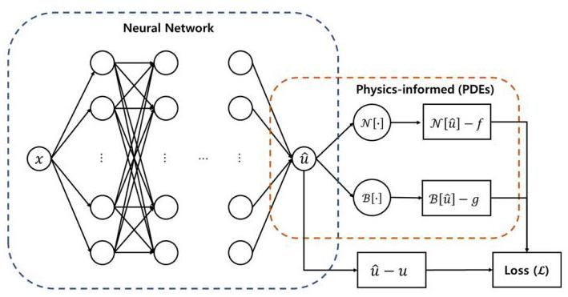

FIG. 2. (Color online) The general PINN framework.

D. OceanPINN
We propose OceanPINN, an approach that harnesses ${PINN}^{1}$ to reconstruct the unmeasured acoustic field in ocean waveguides, using partially measured data. Due to the sensitivity of the phase, we exclusively use the magnitude from the measured data. As depicted in Fig. 3(a), acoustic magnitudes are transformed into envelope magnitudes using Eq. (6) before training.
In the OceanPINN, the fully connected neural network receives a range-depth $\left(r,z\right)$ as input and outputs the real and imaginary envelope ${\hat{ψ}}_{r}\left(r,z\right)$ and ${\hat{ψ}}_{i}\left(r,z\right)$ at the input location $\left(r,z\right)$ , as Fig. 3(c). The complex envelope is formed from these outputs as $\hat{ψ}={\hat{ψ}}_{r}+i{\hat{ψ}}_{i}$ . After training, the neural network generates the envelope $\hat{ψ}\left(r,z\right)$ for specific points $\left(r,z\right)$ . The pressure field $\hat{p}\left(r,z\right)$ is then estimated by multiplying the estimated envelope $\hat{ψ}\left(r,z\right)$ with the Hankel function $H_{0}^{\left(2\right)}\left(k_{0}r\right)$ .
A fully connected neural network with $L$ hidden layers, an input layer (layer 0 ), and an output layer (layer $L+1$ ) is used for the OceanPINN [see Fig. 3(c)]. We apply the sine activation functions because it is effective in representing the complex signals and their derivative. $​^{50}$ In addition, adopting sine activation is effective for solving the Helmholtz Equation. $​^{27,50}$ The network can be expressed as
$$x_{l+1}=\left\{\begin{matrix}sin\left(W_{l}x_{l}+b_{l}\right), & l=0,…,L−1, \\ W_{l}x_{l}, & l=L,\end{matrix}\right. \text{(17)}$$
where $x_{l}$ denotes the $l$ th layer and $W_{l}$ and $b_{l}$ denote the weight and bias connecting the layer $l$ and $l+1$ .
We use three sources of information: (1) measured data, (2) the governing equation [Eq. (10)], and (3) the pressure release surface boundary condition with $ψ\left(r,0\right)=0$ . Each information is incorporated into the loss function as
$$L_{M}=\frac{1}{N_{m}}\sum_{i=1}^{N_{m}}{\left|{\hat{ψ}}_{r}^{2}\left(r_{m}^{i},z_{m}^{i}\right)+{\hat{ψ}}_{i}^{2}\left(r_{m}^{i},z_{m}^{i}\right)−{\left|ψ\left(r_{m}^{i},z_{m}^{i}\right)\right|}^{2}\right|},$$
(18)
$$L_{B}=\frac{1}{N_{b}}\sum_{i=1}^{N_{b}}{{\left|\hat{ψ}\left(r_{b}^{i},0\right)\right|}^{2}}, \text{(19)}$$
$$L_{N}=\frac{1}{N_{n}}\sum_{i=1}^{N_{n}}{{\left|N_{ψ}\left[\hat{ψ}\left(r_{n}^{i},z_{n}^{i}\right)\right]\right|}^{2}}. \text{(20)}$$
Here, neural network parameters $θ$ are omitted for simplicity. Note that in Eq. (18), since only the magnitude of the measured data is available, the neural network outputs are compared with the magnitude square. Losses are combined as in Eq. (13) and used to train OceanPINN.
Training points are depicted in Fig. 3(c). Boundary points are evenly sampled from the water surface, and collocation points are sampled from the water medium differently in each iteration to prevent the PINN from being trapped in local minima. $​^{51}$ Further details on the sampling method for collocation points are shown in Appendix A.
We utilize the following hyperparameters: loss weight coefficients are set as $λ_{M}=1,λ_{N}={10}^{5},λ_{B}=1$ . Further details for loss weight coefficients are provided in Appendix B. The number of training points, $N_{n}$ and $N_{b}$ , are set to 3000 and 100, respectively. The network architecture comprises $L=5$ hidden layers, each with 160 neurons. The loss function is optimized using the Adam optimizer with a learning rate of ${10}^{−4}$ . We multiplied the loss function by ${10}^{4}$ arbitrarily, which improved the convergence speed and model performance of analyzed cases. This adjustment aims to prevent overly small gradients, reducing the likelihood of the model falling into local minima.

III. ISOVELOCITY PROBLEM
This section evaluates and compares the performance of OceanPINN with other representative machine-learning frameworks. We consider a simple problem characterized by an isovelocity profile, constant density, and boundary conditions including a pressure-release surface and a rigid bottom, as outlined in Chapter 5.4 of Ref. 37 (see Fig. 4). The acoustic pressure field is generated using Eq. (5.49) from Ref. 37. The first four of the 13 propagating modes are considered for simulation following the example presented in Refs. 37 and 52. The pressure field is generated across a range of $2−5 km$ . The sound pressure level (SPL) of the simulated pressure field is presented in Fig. 5(a), which is normalized by its maximum value.
To assess the predictive performance in unsampled range-depths, we sample pressure magnitudes while excluding certain depths and ranges. For depth, pressure magnitudes are sampled at $5 m$ intervals, specifically between 5 and $30 m$ and $80−95 m$ . For ranges, pressure magnitudes are sampled at $25 m$ intervals over $600 m$ , and the next $400 m$ is unsampled. This pattern is repeated. Dashed boxes in Figs. 5(b)-5(d) illustrate the sampled regions.
The predictive performance is quantitatively assessed by the mean absolute error (MAE) of SPL, defined as
$$MAE=\frac{1}{n}\sum_{i=1}^{n}{\left|L_{p}^{i}−{\hat{L}}_{p}^{i}\right|}, \text{(21)}$$
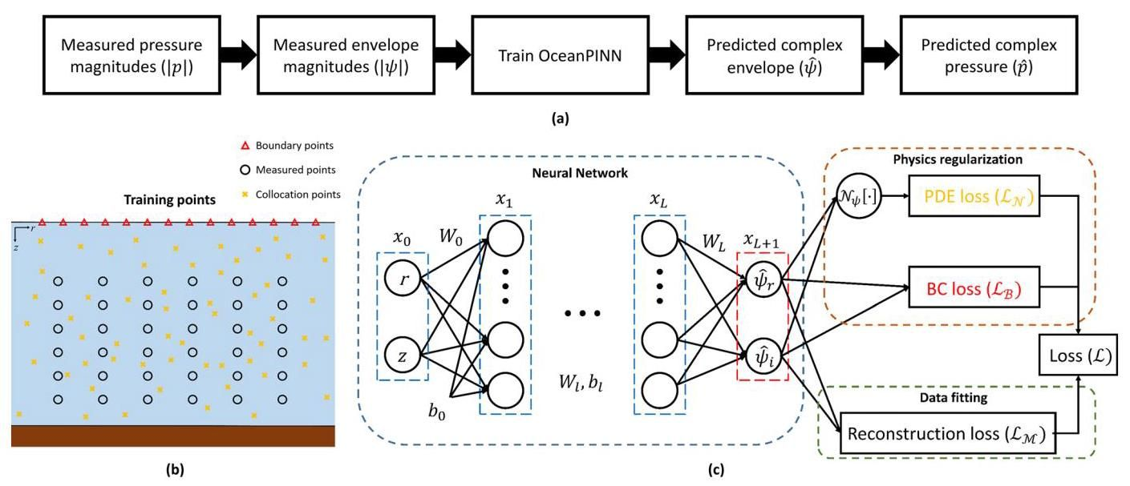

FIG. 3. (Color online) (a) Flowchart, (b) training points, (c) schematic of the OceanPINN.
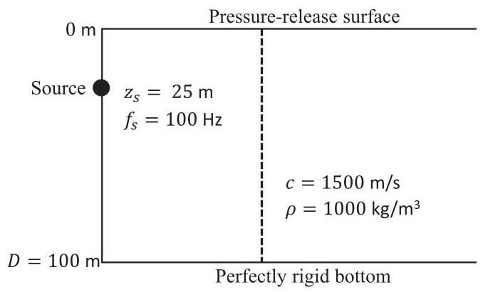

FIG. 4. Schematic of the isovelocity problem.
where ${\hat{L}}_{p}$ and $L_{p}$ are the predicted and true SPL, $n$ is the total number of evaluated points, and $i$ indexes the individual points. For the isovleocity problem, evaluation points are uniformly distributed on the $\left(r,z\right)$ grid at $10 m$ and $1 m$ intervals, respectively. Surface points are excluded due to the SPL being negative infinity, i.e., $p\left(r,0\right)=0$ .

A. Results
Three machine learning methods are evaluated, including the proposed OceanPINN. Two methods are compared with OceanPINN, all employing the same neural network architecture but differing in their outputs and loss functions. Specifically, whereas OceanPINN outputs the envelope $\hat{ψ}$ , two other methods output the pressure $\hat{p}$ . The first method for comparison is a purely data-driven approach, trained solely using reconstruction loss where $ψ$ of Eq. (18) is replaced by $p$ . The second method for comparison is a PINN that outputs the pressure. This method is trained with composite loss similar to OceanPINN, which replaces the $ψ$ to $p$ in Eq. (18) and Eq. (19), and Eq. (20) is revised to enforce the original Helmholtz equation in Eq. (7). To keep the loss functions on equal footing, we empirically choose $λ_{M}=λ_{N}=λ_{B}=1$ , in agreement with Ref. 23.
These methods are trained over 500000 epochs using pressure magnitude samples, and after training, they predict the complex pressure field in the entire domain. The magnitude of the predicted pressure field and the phase difference from the true field are presented in Figs. 5(b)-5(d). The SPL figures are normalized to the maximum value of the true pressure field. The homogeneous Helmholtz equation allows multiple solutions with constant phase shifts $θ$ . For instance, if $p\left(r,z\right)$ is a solution, then $p\left(r,z\right)e^{iθ}$ is a valid solution. Since phase information is not provided, the predicted field can exhibit a constant phase difference from the true field. Note that these predictions with a constant phase difference, still qualify as PDE solutions and are spatially coherent.
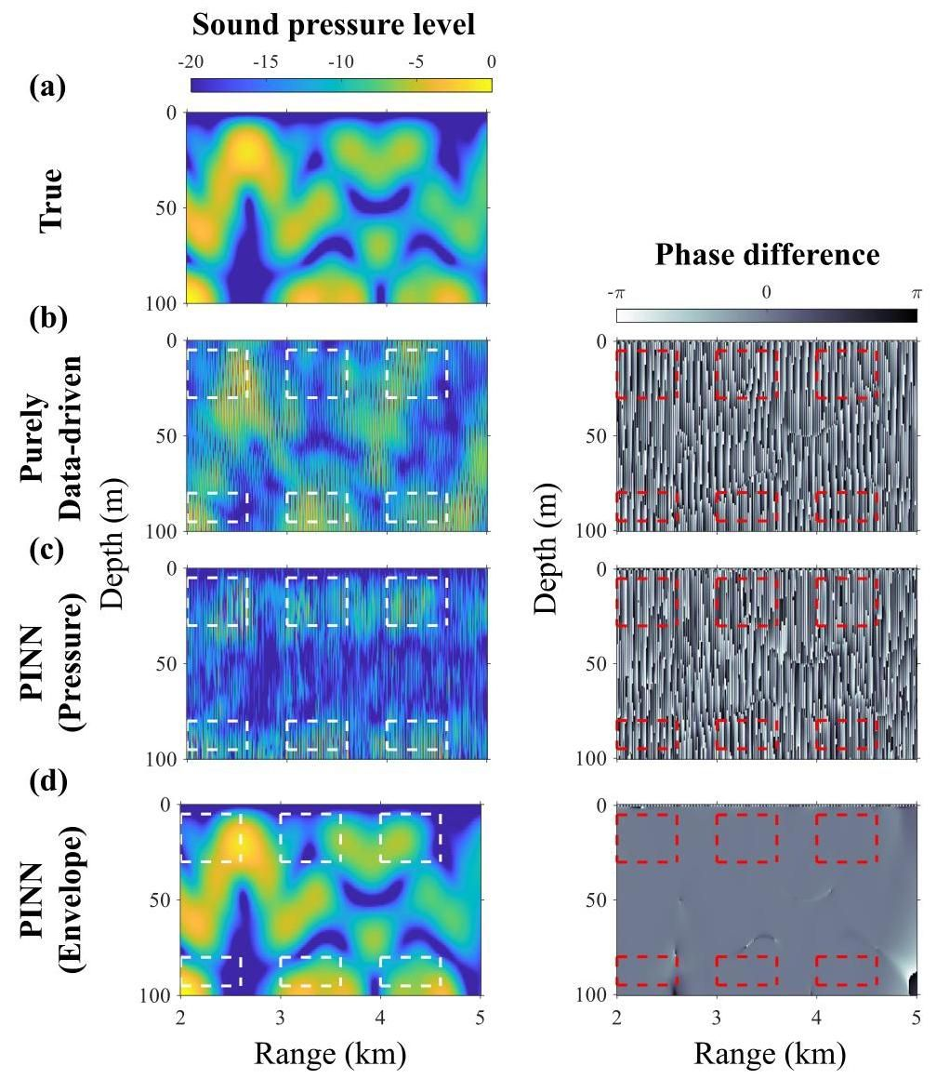

FIG. 5. (Color online) (Left) The normalized sound pressure level (dB), (Right) phase difference between true and predicted pressure field. Each row illustrates (a) true, (b) purely data-driven method, (c) PINN with pressure output, (d) PINN with envelope output (OceanPINN). Dashed boxes represent the sampled region.
2042 J. Acoust. Soc. Am. 155 (3), March 2024
Figures 5(b) and 5(c) present the prediction results of the compared methods, showing significant discrepancies from the true values in both magnitude and phase. The predicted SPLs in Figs. 5(b) and 5(c) are inaccurate even in the sampled region. This inaccuracy is attributed to the relatively sparse sampling intervals, which are insufficient for neural networks to capture the highly fluctuating nature of complex ocean acoustic pressure fields. In contrast, OceanPINN predictions in Fig. 5(d) are accurate in both magnitude and phase. The proposed method achieves significantly lower MAE than other methods, as shown in Table I. The phase differences are consistent across the entire region, except in the small areas where the magnitude is close to zero, where we can neglect the phase. These results demonstrate the effectiveness of the proposed PINN framework using the envelope field. However, OceanPINN also exhibits inaccuracies around $5 km$ , near the bottom, highlighting the inherent challenges PINNs face with extrapolation. $​^{53}$

IV. SWELLEX-96
We evaluate the OceanPINN in a more realistic environment. The analysis utilizes both simulation and experimental data from the SWellEx-96 Event ${S5}^{54−57}$ environment, which was conducted at 23:15-00:30 UTC from May 10-11, 1996. A brief overview of the SWellEx- 96 experiment and the specific source-receiver configuration used for the training data is provided.
During the experiment, the source ship simultaneously towed two sources: the shallow source and the deep source, each transmitting different multi-tonal sets. Here, we focus on the $109 Hz$ shallow source towed at a $9 m$ depth. The data were recorded by a 64-element VLA spanning depths of 94.125-212.25 m. A subset of the VLA comprising 13 evenly spaced elements (from elements 1-61) was selected for constructing the training dataset. The dataset incorporates data from transmissions originating between 1.5 and $3.5 km$ from the VLA, excluding ranges of $2.1−2.3 km$ and 2.7-2.9 km. Source-receiver configuration for training data is illustrated in Fig. 6(a).
We assumed a range-independent environment, consistent with previous studies. $​^{43,44,52,58}$ With $N_{r}$ range samples and 13 hydrophones, we can obtain $N_{r}×13$ different magnitude pressure field measurements, denoted as $\left|p\left(r_{i},z_{j}\right)\right|$ for $1≤i≤N_{r},1≤j≤13$ , where $r_{i}$ represents the distance
TABLE I. MAE of the predicted pressure field in Figs. 5(b)-5(d).
Method | MAE (dB)
Purely data-driven | 5.65
PINN (Pressure) | 7.58
OceanPINN | 0.50
J. Acoust. Soc. Am. 155 (3), March 2024 between the $i$ th transmission source and $j$ th hydrophone at depth $z_{j}$ . These measurement points are illustrated as white points in Fig. 6(a). The number of range samples, $N_{r}$ differs between simulation and experiment. The measured pressure magnitude $\left|p\right|$ is converted to the envelope magnitude $\left|ψ\right|$ according to Eq. (6) and used to train OceanPINN.
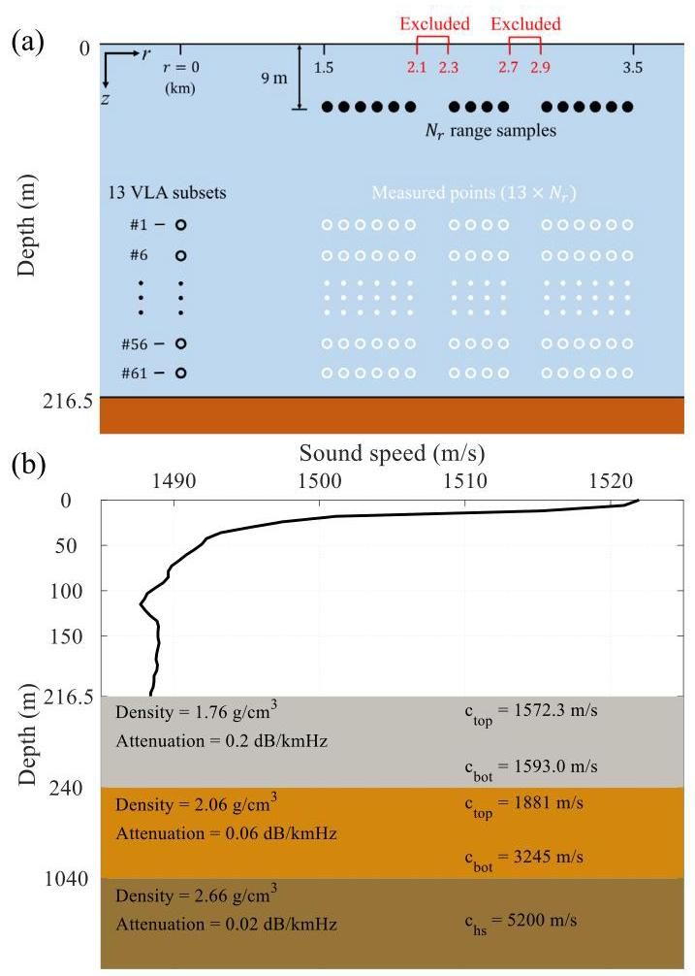

FIG. 6. (Color online) (a) Source-receiver configuration for the training dataset, (b) environmental parameters of the SWellEx-96 experiment.

A. SWellEx-96 simulation data generation
In the simulation, the data are sampled in $20 m$ range intervals and yields a total of $N_{r}×N_{z}=83×13$ samples for training. We used the Kraken normal mode model $​^{47}$ to simulate the acoustic pressure field. Bottom attenuation influences the effective mode cutoff, and using an incorrect number of propagating modes can lead to mismatches between replicas and experimental data. $​^{55,59}$ Accordingly, we conducted SWellEx-96 109 Hz simulations using 14 modes, as in the experimental data. The environmental parameters used for simulation are illustrated in Fig. 6(b).
OceanPINN is assessed across various signal-to-noise ratios (SNRs) of 12 and $6 dB$ , including noiseless conditions. In noisy scenarios, Gaussian noise is added to the generated pressure data. SNR is defined as
$$SNR=20\log_{10}\frac{{∥\begin{matrix}P_{s}\end{matrix}∥}_{F}}{{∥\begin{matrix}P_{n}\end{matrix}∥}_{F}}, \text{(22)}$$
where $∥⋅∥_{F}$ is Frobenius norm, and $P_{s}∈C^{N_{r}×N_{z}}$ and $P_{n} ∈C^{N_{r}×N_{z}}$ represent the noiseless measurement and additive noise at $N_{r}$ range samples and $N_{z}$ depth samples.

B. SWellEx-96 simulation results
OceanPINN is trained over 1200000 epochs. After training, the pressure field is generated on a uniform $\left(r,z\right)$ grid. The grid spans from 1 to $4 km$ for $r$ at $10 m$ intervals and from 0 to $216.5 m$ for $z$ with 300 uniformly spaced points.
Figures 7(b)-7(d) present predicted pressure magnitude fields, beamformings, and phase differences by OceanPINN, trained with data from various SNRs. All pressure magnitude figures are normalized to the maximum value of the true pressure field, and the beamforming figures are scaled to their maximum values. For easier comparison, each phase difference figure has been shifted by a constant phase to make the average phase difference zero.
The predicted SPLs from OceanPINN are consistent with the true field across all SNRs. However, as previously discussed in Sec. IV A, discrepancies are observed in the extrapolated range of $3.5−4 km$ . Table II provides a detailed quantitative analysis. MAEs increase in every SNRs as the predicted range extends from 1.5-3.5 km to 1-4 km.
We validated the physical consistency of the predicted pressure field by the direction of arrival (DOA) in the beamforming figures. $​^{54,56}$ We applied conventional beamforming to the predicted pressure fields. OceanPINN accurately predicts DOA within the interpolated range of $1.5−3.5 km$ , affirming the physical consistency of its pressure field predictions. However, beamforming results of OceanPINN show discrepancies at $3.5−4 km$ , showing limitations in extrapolating over longer ranges.
The phase differences depicted in Figs. 7(b) -7(d) are nearly zero across the entire region within the interpolated range of $1.5−3.5 km$ , indicating precise phase estimation. Discontinuities in these figures correspond with regions where the pressure magnitude is negligible or zero, which leads to phase values becoming indeterminate. In noisy conditions, such discontinuities become more prominent, since noise can mask the low-magnitude areas. In the extended range, the phase error increases, also showing challenges in range extrapolation.
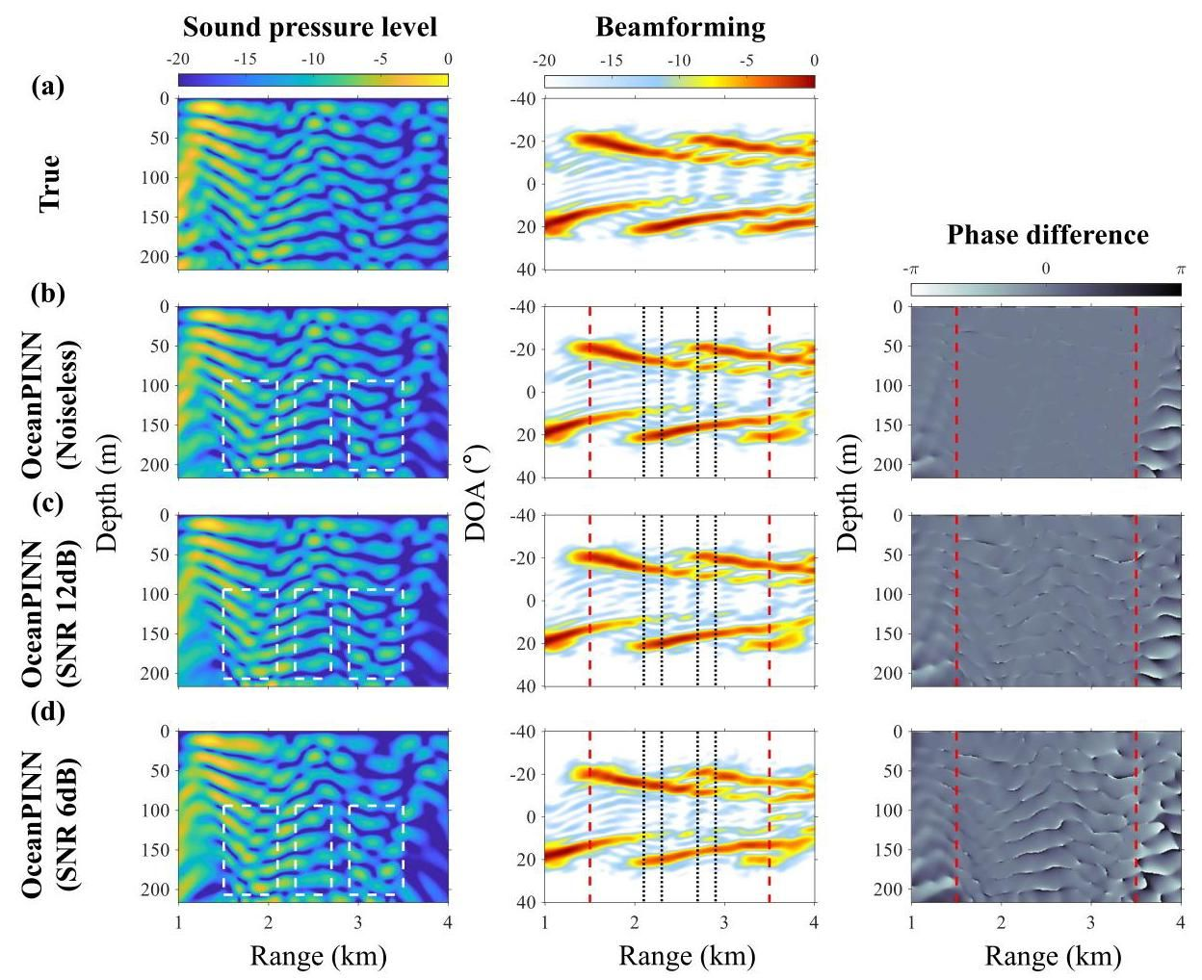

FIG. 7. (Color online) (Left) The normalized sound pressure level (dB), (Middle) beamforming (dB), and (Right) phase difference between true and predicted pressure field. Each row illustrates (a) true and OceanPINN prediction using (b) noiseless, (c) SNR 12 dB, (d) SNR 6 dB simulation data. Dashed and dotted lines represent the boundaries of sampled data.
TABLE II. MAE of the predicted pressure field in Figs. 7(b)-7(d): Evaluated in the interpolated range of $1.5−3.5 km$ and the extended range of $1−4 km$ .
Meausurement SNR | MAE (dB)
Meausurement SNR | 1.5-3.5 km | 1-4 km
Noiseless | 0.18 | 0.68
12 dB | 0.87 | 1.44
6 dB | 1.83 | 2.38

C. SWellEx-96 experimental data
SWellEx-96 data are recorded by the VLA at a sampling rate of $1500 Hz$ . Due to data corruption, the data from the 22nd hydrophone are excluded from the analysis. Global positioning system (GPS) data from the tow ship and the VLA are used to estimate ranges and synchronize the corresponding time. We analyze data recorded at 23:50-00:06 UTC, which corresponds to distances of 3.7-1.3 km from the VLA. Note that the ship was moving closer to the VLA during this period.
The signal is divided into 817 snapshots, each 2.73 s $\left(2^{12}\right.$ samples) long, with a 50% overlap. These snapshots are then analyzed using a fast Fourier transform (FFT). Due to the towed source in the SWellEx-96 experiment, the measurements were affected by the Doppler shift. $​^{43,52}$ To account for Doppler offset, we select the FFT bin with the maximum power within the range of $109±0.5 Hz$ .
From the entire processed data, a specific subset is selected for the training dataset, which follows the source-receiver configuration depicted in Fig. 6(a), consistent with the simulation analysis. The only difference lies in the number of range samples $N_{r}$ . For range samples, the training dataset encompasses snapshots from 3.5 km (61st snapshot) to $1.5 km$ (736th snapshot) relative to the VLA but excludes data from the ranges of $2.1−2.3 km$ and $2.7−2.9 km$ , yielding a total of $N_{r}=537$ samples. For receiver configuration, the training dataset consistently utilizes a uniformly spaced subset of 13 elements (elements 1-61).
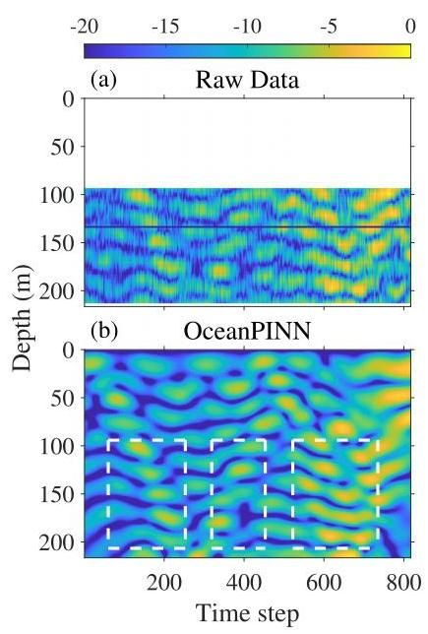

FIG. 8. (Color online) Normalized sound pressure level (dB) of (a) raw data, (b) OceanPINN predicted data with the boundaries of measurements indicated (white boxes).
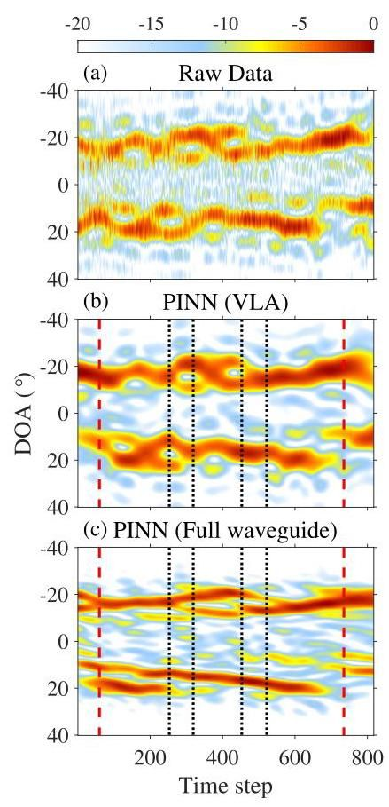

FIG. 9. (Color online) Conventional beamforming (dB) from (a) raw data, (b) OceanPINN predictions within VLA depth, (c) across the full water column. The measurement boundaries are at 1.5 and $3.5 km$ (black dashed), while the excluded sections are at $2.1−2.3$ and $2.7−2.9 km$ (red dotted).

D. SWellEx-96 experimental results
OceanPINN is trained over 1200000 epochs. Once OceanPINN is trained, the pressure field is generated on a uniform $\left(r,z\right)$ grid. Here, $r$ corresponds to the range of each snapshot, and $z$ consists of 300 uniformly distributed points spanning the full water column $0−216.5 m$ .
Figure 8 illustrates the normalized SPLs of the raw data and the OceanPINN prediction, normalized with respect to the maximum of the raw data. The data from the 22nd element [black line in Fig. 8(a)] is excluded from the analysis due to corruption. The SPL increases over time since the source approaches. Comparisons are confined to the VLA region due to no measurements above it. The OceanPINN predictions show a good agreement with the experimental data within the interpolated range $\left(1.5−3.5 km\right)$ , including the excluded parts not used for training. Nevertheless, discrepancies are noted in some parts of the extrapolated range. Additionally, the OceanPINN-predicted pressure field exhibits reduced noise features compared to the raw data.
We validate the physical consistency of OceanPINN predictions by comparing their DOA using conventional beamforming. This comparison allows us to indirectly validate the predictions in unmeasured regions above the VLA. The beamforming is normalized by the maximum value. Figure 9 shows the beamforming from raw data, OceanPINN prediction within VLA depth, and OceanPINN prediction for the whole water column. The DOA from OceanPINN prediction shows good agreement with raw data. Similar to the magnitude, the interpolated range $\left(1.5−3.5 km\right)$ showed consistency, while the extrapolated range showed slight differences. Since the array aperture length is identical in Figs. 9(a) and 9(b), beamforming results show the same resolution. While Fig. 9(c) uses an extended array, it shows improved angular resolution, and can distinguish multipath. The results indicate that the OceanPINN prediction is consistent physically. Moreover, akin to Fig. 8, the noisy feature is decreased in the beam-formings from OceanPINN predictions.

V. CONCLUSION
We introduced an approach named OceanPINN, which uses the PINN for predicting acoustic pressure fields in ocean waveguides from partially measured data. OceanPINN can be considered a method that performs interpolation and extrapolation from a few sampled points based on physics knowledge. Specifically, the neural network is trained with a physics-based loss that enforces the governing equation and the surface-boundary condition.
The rapid phase variations of the complex pressure field in the ocean acoustic environment pose two challenges for applying the PINN framework. The first is spectral bias, which we mitigated by transforming the high-wavenumber pressure field into a low-wavenumber envelope. The second is the inaccuracy of phase measurements; we addressed this by training solely on the magnitude of the measured pressure data.
The simulations indicated that OceanPINN can accurately predict unmeasured pressure fields. Moreover, results show that OceanPINN can infer phase information solely from magnitude data. In real data applications, OceanPINN predictions match well with VLA measurements and show physically consistent predictions, even above the VLA, which is unmeasured in the experiment. However, the performance of OceanPINN degrades in the extrapolated range, both in simulations and experimental data, which is possibly an inherent weakness of PINNs.

ACKNOWLEDGMENTS
This research was supported by the Korea Institute for Advancement of Technology (KIAT) grant funded by the Korea Government (MOTIE) (Grant No. P0017304, Human Resource Development Program for Industrial Innovation), and the National Research Foundation of Korea (NRF) grant funded by the Korea government (MSIT) (Grant No. 2021R1F1A1045480), and the Office of Naval Research, Grant No. N00014-21-1-2267.

AUTHOR DECLARATIONS Conflict of Interest
The authors have no conflicts to disclose.

DATA AVAILABILITY
The data that support the findings of this study are available from the corresponding author upon reasonable request.

APPENDIX A: COLLOCATION POINT SAMPLING
Within the PINN framework, the correct solution is known only at a few points. The values at the remaining unknown points are deduced by minimizing the PDE residual defined as
$$R\left(θ\right)=N\left[\hat{u}\left(x;θ\right)\right]−f\left(x\right) \text{(A1)}$$
in the general PINN framework in Sec. II C. However, it is important to note that a small PDE residual does not necessarily imply a correct solution. For instance, in our problem, a trivial solution of $ψ\left(r,z\right)=0$ also effectively minimizes the PDE residual. According to Ref. 51, for training PINNs to converge correctly, the correct solution needs to propagate from known points to unknown points throughout iterations. Failure in this propagation can lead subsequent points to convergence to the trivial solution. The PDE residual calculated at a specific collocation point is influenced only by nearby values, and if these nearby values are incorrect, that local region can exhibit a low PDE residual even if it is not a correct solution. Such a failure in propagation is also observed in OceanPINN. As seen in Fig. 7(d), in a far extrapolated range near $4 km$ , the predicted pressure field shows a trivial solution of $p\left(r,z\right)=0$ in several areas.
As training progresses, PINN can be converged to solutions that have two distinct regions: one region converges to the correct solutions, while the other converges to trivial solutions. Although both regions show low PDE residuals, the narrow boundary between them is likely to exhibit high PDE residuals. However, since PDE loss is averaged over all collocation points, the loss remains small, if collocation points are uniformly distributed and most areas show low PDE residuals. This can lead to challenges in updating and getting stuck in local minima. We adopt Retain-Resample-Release (R3) sampling, $​^{51}$ which accumulates collocation points in high PDE residual regions to address this problem. Specifically, R3 sampling determines collocation points by retaining half of the points with high PDE residuals from the previous iteration and resampling the other half from a uniform random distribution.
As OceanPINN has a real and imaginary output, during a training process, the real $\left(R_{r}\right)$ and imaginary $\left(R_{i}\right)$ PDE residuals are computed separately for collocation point ${\left\{r_{n}^{i},z_{n}^{i}\right\}}_{i=1}^{N_{n}}$ , and summed for calculating PDE loss $L_{N}$ as
$$L_{N}\left(θ\right)=\frac{1}{N_{n}}\sum_{k=1}^{N_{n}}{{\left|R_{r}^{k}\left(θ\right)+iR_{i}^{k}\left(θ\right)\right|}^{2}}, \text{(A2)}$$
$$R_{r}^{k}\left(θ\right)=\frac{∂^{2}{\hat{ψ}}_{r}^{k}}{∂r^{2}}+2k_{0}\frac{∂{\hat{ψ}}_{i}^{k}}{∂r}+\frac{∂^{2}{\hat{ψ}}_{r}^{k}}{∂z^{2}}+k_{0}^{2}\left(n^{2}−1\right){\hat{ψ}}_{r}^{k}, \text{(A3)}$$
$$R_{i}^{k}\left(θ\right)=\frac{∂^{2}{\hat{ψ}}_{i}^{k}}{∂r^{2}}−2k_{0}\frac{∂{\hat{ψ}}_{r}^{k}}{∂r}+\frac{∂^{2}{\hat{ψ}}_{i}^{k}}{∂z^{2}}+k_{0}^{2}\left(n^{2}−1\right){\hat{ψ}}_{i}^{k}, \text{(A4)}$$
where superscript $k$ denotes corresponding to the $k$ th collocation point.
We aim to accumulate collocation points with either high real or imaginary PDE residuals to achieve a balance between the real and imaginary residuals of the PDE. The pseudo-code of the sampling method for collocation points is described in Algorithm I.

APPENDIX B: LOSS WEIGHT COEFFICIENTS
PINNs utilize a composite loss function comprising physics-based loss and data-fitting terms. The general form of the PINN composite loss function can be represented as
$$L\left(θ\right)=\sum_{i=1}^{M}{λ_{i}}L_{i}\left(θ\right). \text{(B1)}$$
With this loss function, neural network parameters $θ$ are typically updated with the gradient descent as $​^{60}$
$$θ_{n+1}=θ_{n}−η\sum_{i=1}^{M}{λ_{i}}∇_{θ}L_{i}\left(θ_{n}\right), \text{(B2)}$$
where $η$ denotes the learning rate. Disparities in the gradients of these loss terms can lead to discrepancies in the convergence rates of each component. Disparities in the gradients of each loss term $∇_{θ}L_{i}\left(θ_{n}\right)$ can lead to discrepancies in the convergence rates of each component. $​^{36,60}$ Loss weight coefficients address this issue, as they rescale the learning rate of each loss term $L_{i}$ to $ηλ_{i}$ and balance the convergence rate across different loss terms.
OceanPINN utilizes three loss terms: $L_{N}$ ensures adherence to the governing equation, while $L_{M}$ and $L_{B}$ adjust the OceanPINN prediction at sampling points to match measured and surface pressures. The formulation of $L_{N}$ deviates from the other two, potentially leading to discrepancies in gradient magnitudes. Considering these distinctions, we test various loss weight coefficients of $λ_{N}=\left\{{10}^{2}\right.$ , $\left.{10}^{3},{10}^{4},{10}^{5},{10}^{6}\right\}$ , while setting $λ_{M}=λ_{B}=1$ . The best results are obtained from $λ_{N}={10}^{5}$ for every SWellEx-96 simulation in Sec. IV A, as shown in Fig. 10. $λ_{N}={10}^{4}$ also demonstrates predictions close to the true solution and $λ_{N}={10}^{3}$ yields favorable results in the noiseless scenario.
ALGORITHM 1. Retain-Resample-Release (R3) sampling algorithm for OceanPINN.

1: Sample the initial population $P_{0}$ of collocation points ${\left\{x_{n}^{i}\right\}}_{i=1}^{N_{n}}$ from a uni-
form distribution $U\left(Ω\right)$
for $i=0$ to max. iteration -1 do
Compute the real $\left(R_{r}\right)$ and imaginary $\left(R_{i}\right)$ PDE residuals of collocation
points $x_{n}∈P_{i}$
Sort $R_{r}$ and $R_{i}$
Select populations $P_{i,\text{ real }}^{r}$ and $P_{i,\text{ imag }}^{r}$ such that satisfy top one-third $R_{r}$
and $R_{i}$
Merge two populations except overlapping $P_{i}^{r}←P_{i,\text{ real }}^{r}∪P_{i,\text{ imag }}^{r}$
Retain $P_{i}^{r}$ and resample the population $P_{i}^{s}$ from a uniform distribution
$U\left(Ω\right)$
Merge the two population $P_{i+1}←P_{i}^{r}∪P_{i}^{s}$
end for

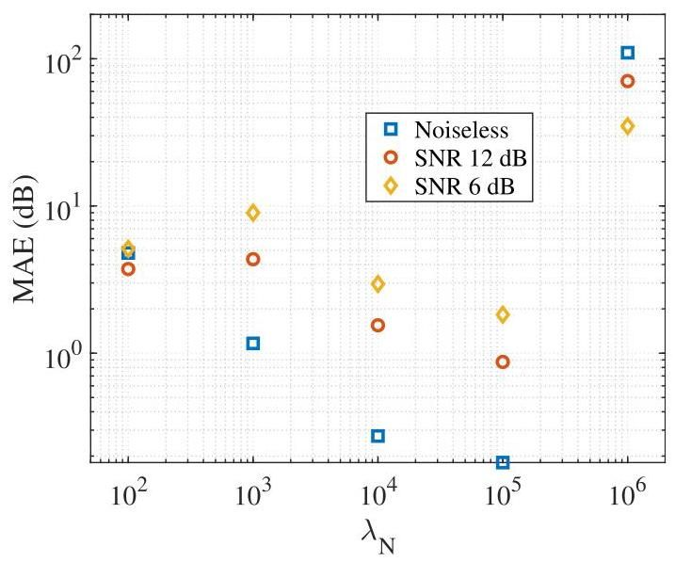

FIG. 10. (Color online) MAE (dB) of the OceanPINN predicted field’s sound pressure level, trained with different $λ_{N}$ and SWellEx-96 simulation data with different SNRs from Sec. IV A.
Figure 11 shows examples of predictive failure in the noiseless SWellEx-96 simulation scenario due to inappropriate $λ_{N}$ values. As shown in Fig. 11(a), relatively low values of $λ_{N}$ can lead OceanPINN to overfit at measured and surface points. In contrast, as depicted in Fig. 11(b), an overly high $λ_{N}$ can lead OceanPINN to converge to trivial solutions, i.e., zero pressure field. This trivial solution satisfies the homogeneous Helmholtz equation, and can easily reduce $L_{N}$ , though not a meaningful solution. MAE in Fig. 10 is high for $λ_{N}={10}^{6}$ due to the pressure being close to zero.
At low SNR, the MAE increases with lower $λ_{N}$ . This is attributed to a lower $λ_{N}$ amplifying the impact of the reconstruction loss, which leads to overfitting to noisy measured data. However, a lower $λ_{N}$ facilitates faster model
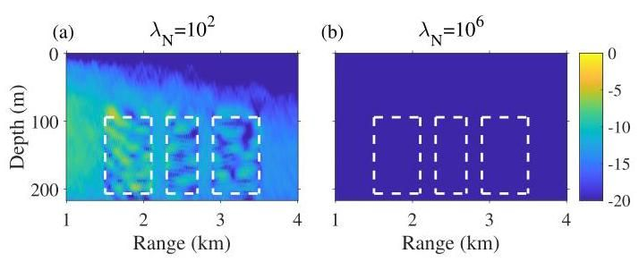

FIG. 11. (Color online) The normalized sound pressure level (dB) of OceanPINN predicted pressure field, which is trained with (a) $λ_{N}={10}^{2}$ ,(b) $λ_{N}={10}^{6}$ .

