ForceBoard: Text Entry, Subtle Interaction

| 1st Author Name  Affiliation  City, Country  e-mail address | 2nd Author Name  Affiliation  City, Country  e-mail address | 3rd Author Name  Affiliation  City, Country  e-mail address |
| --- | --- | --- |

# ABSTRACT

Paste the appropriate copyright/license statement here. ACM now supports three different publication options:

* ACM copyright: ACM holds the copyright on the work. This is the historical approach.
* License: The author(s) retain copyright, but ACM receives an exclusive publication license.
* Open Access: The author(s) wish to pay for the work to be open access. The additional fee must be paid to ACM.

This text field is large enough to hold the appropriate release statement assuming it is single-spaced in Times New Roman 8-point font. Please do not change or modify the size of this text box.

Each submission will be assigned a DOI string to be included here.

We present Forceboard, a pressure-based text input system.

The text entry ratio was surprisingly fast.

## Author Keywords

Pressure input; text entry; one-dimensional input.

## ACM Classification Keywords

H.5.m. Information interfaces and presentation (e.g., HCI): Miscellaneous; See<http://acm.org/about/class/1998> for the full list of ACM classifiers. This section is required.

# Paper design

1. It is important to motivate our research.

2. It is important to demonstrate that Forceboard is easy-to-learn and with satisfying performance

3. It should be interesting if we can contribute some new knowledge about pressure control; It is also interesting if we add some knowledge or new input paradigm for 1-d input.

4. It should be good if we can show our design is rational and clever.

5. Our technique has to be describe very clearly with no confusion, and missing details.

# INTRODUCTION

Visual feedback is very important for this. Latency is a problem. We will explore the eyes-free interaction in the future.

One-dimensional interaction represents constraint interface that attracts increasing attention.

In this paper, we explore a new 1D modality, the pressure input.

The difference of pressure-based interface to other. For example, using a phone, we have a click event. It is like a dial.

We have to highlight the design of the technique.

We should clearly describe the segmentation of the interface for interaction. For example, the start seg, the letter seg, and the high seg.

We will also discuss the uniqueness of our research, and how it can be applied to other 1D interface, e.g. for disabled people to input with foot on a brake.

Wte have a iterative design. We have a pilot study first, leading to the initial design and questions. We conducted User Study 1 to answer the questions. We use the findings to improve the design and implementation. We evaluate the final technique.

We finally discuss it.

Feedback design is also important.

# Related Work

Pressure is one of the most natural way of human interaction with the environment. Gripping, twisting, typing and many other daily actions have strong connection with pressure. Pressure control offer users a natural method of manual input to control analog information [2005 Mozobuchi]. In general, it adds a new dimension which can be manipulated without any hand movement, saving the interaction space [2010 Stewart].

The usage of pressure as a technique of interaction has been more and more pervasive. Since Ramos et al. [Ramos 2004] designed target selection by pressure, menu selection, which is the most relevant to our work, has been investigated as a fundamental application as force input [2007 Cechanowicz, 2010 Stewart, 2012 Wilson, 2013 Wilson]. Moreover, other typical applications include navigation [2013 Wilson, 2013 Spelmezan], zooming in and out [2005 Ramos, 2006 Rekimoto, 2011 Mandalapu], scrolling [2011 Mandalapu, 2014 Rendl], 3D object previewing [2006 Rekimoto, 2009 Shi, 2012 Heo] and expressive typing [2011 Heo,].

*Recently with the development of flexible electronics, the range of pressure’s application got expanded. Ahn et al. [2015 Ahn] proposed BandSense, a new interaction technique which allows pressure-sensitive multi-touch interaction on a wristband. Directional force is applied to control the move of map or cursor. Rendl et al. [2016 Rendl] presented a new concept for smartphones named FlexCase, which combines intentional touches, pressure and flex sensor with an e-paper display to enrich the interaction techniques with the original screen.*

## Model

Many work has been done in order to understand about human’s ability to control pressure, with a pen or a mouse for desktop screen and a pen or fingers for mobile device.

Ramos et al. [Ramos 2004] and Mozobuchi et al. [2005 Mozobuchi] studied man’s ability of using pressure to select items with styli. They applied linear transfer function and found out about 6 levels of pressure space as the maximum number to ensure the accuracy. Ramos et al. also reported user’s difficulty at controlling low levels of pressure. Yin et al. [2010 Yin] quantified the force of pressure using a pen. They stated that the normal tasks such as drawing and writing has a pressure size from 0.82N to 3.16N, while the resting force is usually between 0.78 N and 1.58 N. They found the error rate changed from 4.9% for one layer of pressure to 35% for six layers. Wang et al. Wilson et al. [2010 Wilson] proposed that with adequate feedback, users can accurately distinguish up to 10 levels of pressure. Wang et al. [2016 Wang] investigated the maintenance accuracy when applying force on a sensor with a probe ranging from 0.5N to 5N. The absolute error increases as the force magnitude increases (From 5% to 25% and 1% to 7% without and with visual feedback) while the relative error significantly large only when force was 0.5N. (11% vs. 5% and 3% vs. 1% without and with visual feedback), which was in line with [2004 Ramos].

Visual feedback has been shown to be significant to ensure the high accuracy and low variance [2004 Ramos, 2010 Yin, 2010 Stewart, 2010 Wilson, 2016 Wang].

The comparison between two most popular selection methods, Quick Release and Dwell, has been discussed. No matter using any tools or just fingertips, Quick Release tends to be much faster while Dwell is more accurate [2004 Ramos, 2007 Cechanowicz, 2009 Brewster, 2010 Wilson].

Stewart et al. [2010 Stewart] looked into the different transfer function, including linear [2004 Ramos], quadratic [2007 Cechanowicz], fish-eye [Shi 2008] and several other functions. They pointed out that the different conclusion may be caused by different linear or non-linear pressure sensors. They also presented that with linear sensors, the linear function outperforms among other functions.

*Mandalapu et al. [2011 Mandalapu] proposed that pressure can be controlled in a bi-directional manner, both from zero to positive and positive to zero.*

*Taher et al. [2014 Taher] noticed that the force variation of thumb is much higher than index finger when performing two-finger gestures such as zooming and rotation. They also found that gestures are longer on the phone, while more force will be applied on the tablet. They also found more force will be applied during participants’ walking.*

## Pressure & Text

Pressure has also been used in text entry as an auxiliary channel, especially on mobile devices. Brewster et al. [2009 Brewster] proposed a novel way to control character cases with pressure on soft keyboards, with soft pressure to lower case and hard pressure to upper case. They get the average performance of words-per-minute (WPM) as 11.8. McCallum et al. [2009 McCallum] proposed similar concept but used it as different way. Based on MultiTap keyboard, they developed *PressureText*, which maps three distinguished pressure levels to three different characters. The average WPM of their new devices (9.1) is higher than MultiTap (8.64). Arif et al. [2009 Arif, 2013 Arif] developed a new text entry technique, which requires users to apply more force on keys that are more unlikely. Their evaluation showed that the new technique (WPM 18.03) outperforms the conventional one (WPM 17.48). Weir et al. [2014 Weir] developed two systems called *GPType* and *ForceType* to improve text entry. The *GPType* uses Gaussian Processto model user’s touch offset and variance on the screen to reduce character error rate (by 4.9% for sitting situation). The *ForceType*, with similar concept as [Arif 2009], allows user to control the level of uncertainty in their input character by pressure force to prevent autocorrection and increase typing speed (by 19.23 WPM compared to 15.42 WPM).

## Text Entry on Constraint Interface

The need of input on constraint user interface, such as one-dimensional text entry, has been growing. But only a few number literatures discuss about this topic. Walmsley et al. [2014 Walmsley] developed *Rotext*, which maps device orientation to a character with only audio feedback. Users can get an average performance of 12.6 WPM at first and can enter up to 37 WPM after training. Yu et al. [2016 Chun Yu] developed 1D Handwriting system on smart glasses, which project 2D handwriting strokes into 1D space. User studies showed that participants can outperforms a selection-based technique, with both letter input (4.67 WPM vs. 4.20 WPM) and word input (9.72 WPM vs. 8.10 WPM). Participant can obtain 19.6 WPM after extensive training.

# The Initial Design

## D

## Pilot Study

We first explore the cursor-based design.

We found the appropriate cursor width to be 5 and 7. Size of 3 would impose too much load on users, causing uncomfortableness.

We found as user users still undershoot or overshoot. Users tended to pre-program the motor control, not fully depending on the cursor hit. If speed is up, it is not easy for them to confirm the selection. Instead of cursor, the cursor seems more like a visual feedback that controls the trade-off between speed and accuracy.

Overshoot is more problem.

Therefore, to reduce effort and improve speed, we decide to position our technique as continuous input technique (in the backend algorithm), and take advantage of modern statistical decoding method (Bayesian Method).

As a result, we have a number of questions regarding the design or parameter. For this reason, we run our study 1.

# User Study 1

The purpose of this study is to better understand users’ behavior with varying levels of force, and to investigate whether text entry is possible with force.

Pressure control has been investigated before. But none has researched it as a main control channel to input text. So we are trying to find a continuous and fast pressure-based input method, with a tolerance for some level of inaccurate input.

## Apparatus and participants

We used an iPhone 6s for this experiment. The iPhone has a pressure-sensitive capacitive touchscreen (display size: 4.7”; resolution: 1366×768), with a pressure resolution of approx. 1 gf and a pressure-sensitive range of 400 gf. The iPhone used in this study was running iOS 9.3. We developed a piece of software that recorded all touch events, including pressure and the corresponding time information.

Fourteen participants (seven males and seven females, ages 18‒33) were recruited from the local university campus. The participants had at least two years of experience with smart phones, and considered themselves to be comfortable with these devices. (?) of them had prior experience with force-related technology.

## Design and procedure

We chose to investigate cursors with widths of 5 and 7 letters with the following considerations:

- A 3-letter-wide cursor design was discarded in the pilot study, as participants reported that it was difficult to control, and performances with this cursor width is not as satisfactory as with the widths of 5 and 7.

- A 9-letter-wide cursor design was not included because simulation showed that in (?%) of word-input tasks, the right recommendation would be too far back in the results list

For each width, 78 random letter sequences were generated by the experiment program, resulting in 234 letters for each width per participant. Each sequence contained 3 letters, which is a length easy to memorize while typing in, Each letter in the English alphabet was repeated 9 times.

We asked the participants to memorize each sequence, and then select each letter with the word selection method (i.e. use pressure to move the cursor to desired position; relieve pressure but not let go of the finger; repeat the process to select multiple letters in a word). We told the participants to select each letter naturally, and to not fixate on any letter. In order to better perceive natural behavior of pressure control, we set the display of input text to be a “*” sequence instead of letters, thus avoiding users adjusting their input method according to the result displayed.

## Results

Our pressure-based input method is easy to understand. We asked subjects to self-assess their familiarity with the English alphabet from 1 to 5; the mean of the 14 subjects’ reports is 3.36 with a standard deviation of 1.206. All the subjects were able to begin the experiment right after a few practice words.

In the process of the experiment, users typed at an increasing speed as shown in the chart. Meanwhile, the accuracy is not affected. This illustrates that the users kept learning during the experiment.

- Release behavior

//pic?

In the process of studying releasing behavior of users, we define *max pressure* as the highest position of pressure during a single letter’s input. *Falling time* refers to the time period between reaching *max pressure* and finishing input. *Deviation* is the difference of *max pressure* and the expected input pressure.

We analyzed the relation of *deviation* and *falling time* under the same level of *max pressure.* We discovered that in cases with higher level of *max pressure*, the *falling time* increases significantly as the *deviation* increases. Based on this finding, we conjecture that when *overshooting* the target letter, our subjects tend to hesitate while releasing pressure. This natural hesitation inspired us to improve our design in the subsequent study.

### Overall trend

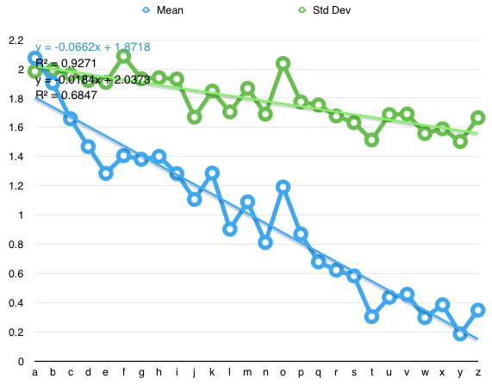

Figure x. Mean *displacement* and SD of *displacement* vs. letter

To learn about users’ ability to control pressure, we first define the *ideal position* of each character to be the position of its left-edge of its containing box. Participants applied pressure to move the cursor to different positions, among which the max position is defined as *achieved position*. We calculated the *displacement* between the average achieved position and the ideal position of each letter.

We found that the *displacement* decreases linearly by each letter, showing a decreasing tendency of the participants to overshoot as the expected pressure increased. We consider this phenomenon to be caused by the following factors:

- The difficulty with force control for letters requiring small force inputs, and the relative ease with force control for the rest of the letters;

- The force required for letters on the relatively right area, which made overshooting more difficult.

We show a decreasing trend of both the mean displacement and the standard deviation of displacement as force increases, indicating better control with larger forces by the participants.



Figure x. Mean time vs. corrected letter position for different *cursor widths*

The average selection time for a letter increases as the demanded force increased. We fitted the data against Fitts’s Law, and discovered that a logarithm function fits our data the best.

### Trend around each character

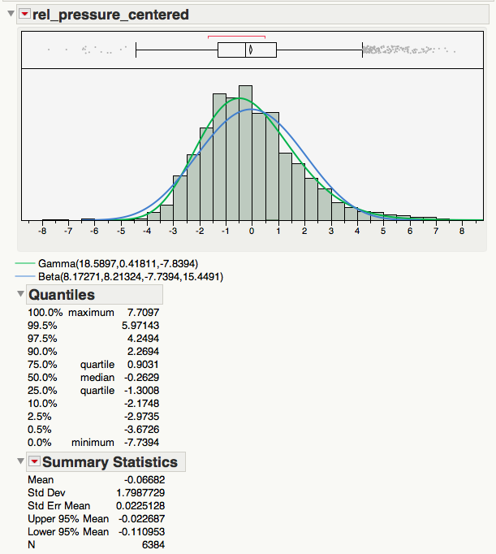

Figure x. Distribution of centered *displacement* of all characters

We centered the distributions of *displacement* of each character to 0 by subtracting the fitted mean *displacement* from the original data. We show that the overall distribution of all letters combined to be right-skewed, with a skewness of 0.6658.

### Effect of cursor width

Effect on input times: ANOVA showed significant effects of *cursor width* (F1, 6380 = 16.59, p < .0001) and *letter* (F25, 6344 = 96.13, p < .0001). The mean selection time for a cursor width of 5 is slightly higher than that of width 7.

### Other findings



Figure x. Discrepancy between the mean and median of the *displacement*

Unlike the mean displacement, which linearly decreases when pressure is increased, the median of displacement has two sudden drops in this chart: one between the letters “b” and “d”, the other between “o” and “p”. Further investigation with the distribution of the displacement revealed that the pressure of most inputs were over but near the left-edge of the letters.

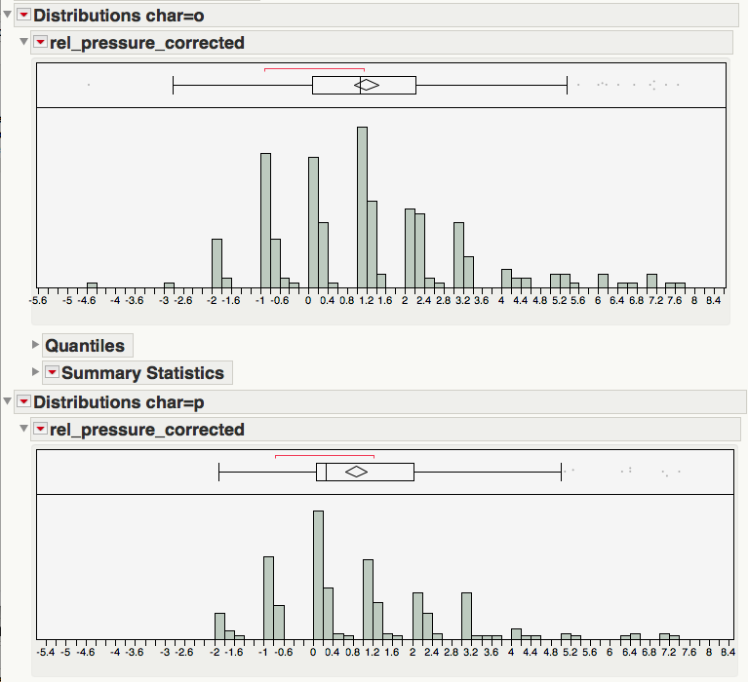

Figure x. Distribution of *displacement* for letters “o” and “p”

## Design changes

We made an improvement of design based on our previous experiments.

Considering the natural “hesitation” of users while overshooting, we added a function to move the valid selection area down along with the cursor to a lower position when lower pressure is maintained for a certain duration. (In study one, the final selection is determined by the max pressure.)

- Selecting char (dwell -> force selection/tap selection)

## Simulation

We compare simulated text entry speeds and error rates with and without applying our Bayesian model, using data from the pilot study and the pressure model we acquired from this study.

# The second prototype

# User Study 2

In this study, we evaluate the performance of ForceBoard.

## Apparatus and participants

Similar to User Study 1, we also used an iPhone 6s for this Study.

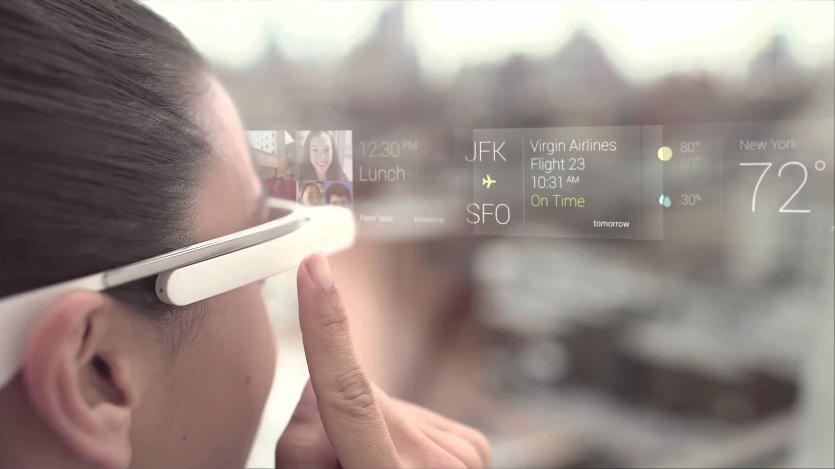

Figure x. Experiment setting for user study 2

Sixteen participants (eight males and eight females, ages 18‒33) were recruited from the university campus. (?) of them had force input experience from User Study 1. The experiment setting is illustrated in figure (?). Participants wore a Google Glass and performed the text entry tasks on an iPhone 6s. The ForceBoard interface and tasks are displayed on the Google Glass display, and the iPhone only served as an input and haptic feedback device.

## Design and procedure

## Results

# Conclusion and future work

用户对压力的控制能力

## Characteristics

需要的输入界面面积小，旁人不易察觉

## Possible applications

- 屏幕／手潮湿时进行输入

- 手套上单点输入

## Future work

- 不同用户适应的压力范围不同，可以进一步研究

- 不同的选词交互方式



# REFERENCES

1. @_CHINOSAUR. 2014. VENUE IS TOO COLD. #BINGO #CHI2016. Tweet. (1 May, 2014). Retrieved February 2, 2014 from https://twitter.com/_CHINOSAUR/status/461864317415989248
2. ACM. How to Classify Works Using ACM’s Computing Classification System. 2014. Retrieved August 22, 2014 from [http://www.acm.org/class/how_to_use.html](http://www.acm.org/class/how_to_use.html%20)
3. Ronald E. Anderson. 1992. Social impacts of computing: Codes of professional ethics. *Soc Sci Comput Rev* 10, 2: 453-469.
4. Anna Cavender, Shari Trewin, Vicki Hanson. 2014. Accessible Writing Guide. Retrieved August 22, 2014 from <http://www.sigaccess.org/welcome-to-sigaccess/resources/accessible-writing-guide/>
5. Morton L. Heilig. 1962. Sensorama Simulator, U.S. Patent 3,050,870, Filed January 10, 1961, issued August 28, 1962.
6. Jofish Kaye and Paul Dourish. 2014. Special issue on science fiction and ubiquitous computing. *Personal Ubiquitous Comput*. 18, 4 (April 2014), 765-766. <http://dx.doi.org/10.1007/s00779-014-0773-4>
7. Scott R. Klemmer, Michael Thomsen, Ethan Phelps-Goodman, Robert Lee, and James A. Landay. 2002. Where do web sites come from?: capturing and interacting with design history. In *Proceedings of the SIGCHI Conference on Human Factors in Computing Systems* (CHI '02), 1-8. <http://doi.acm.org/10.1145/503376.503378>
8. Psy. 2012. Gangnam Style. Video. (15 July 2012.). Retrieved August 22, 2014 from <https://www.youtube.com/watch?v=9bZkp7q19f0>
9. Marilyn Schwartz. 1995. *Guidelines for Bias-Free Writing.* Indiana University Press.
10. Ivan E. Sutherland. 1963. *Sketchpad, a Man-Machine Graphical Communication System*. Ph.D Dissertation. Massachusetts Institute of Technology, Cambridge, MA.
11. Langdon Winner. 1999. Do artifacts have politics? In *The Social Shaping of Technology* (2nd. ed.), Donald MacKenzie and Judy Wajcman (eds.). Open University Press, Buckingham, UK, 28-40.