## 运行截图

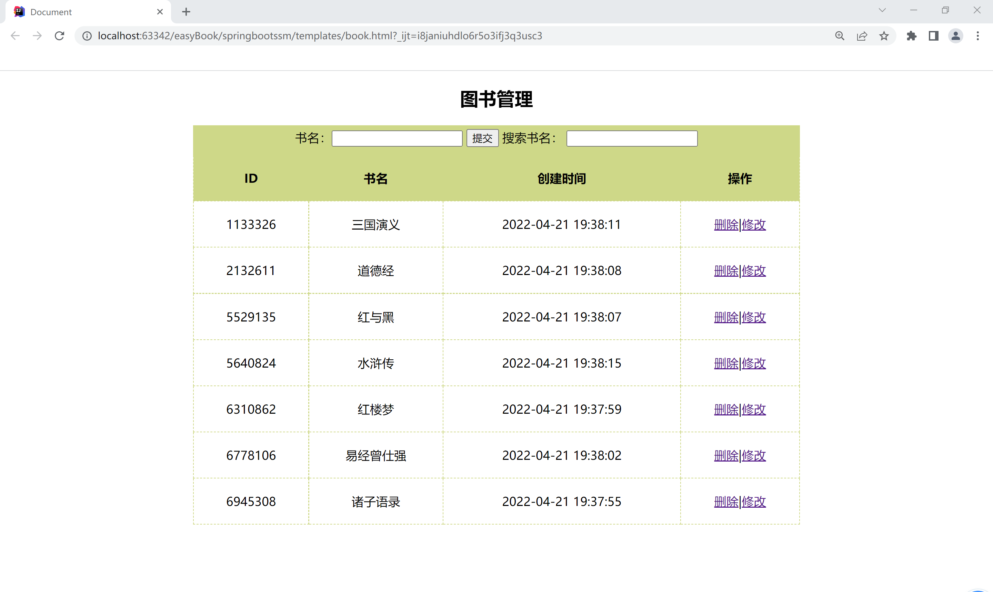

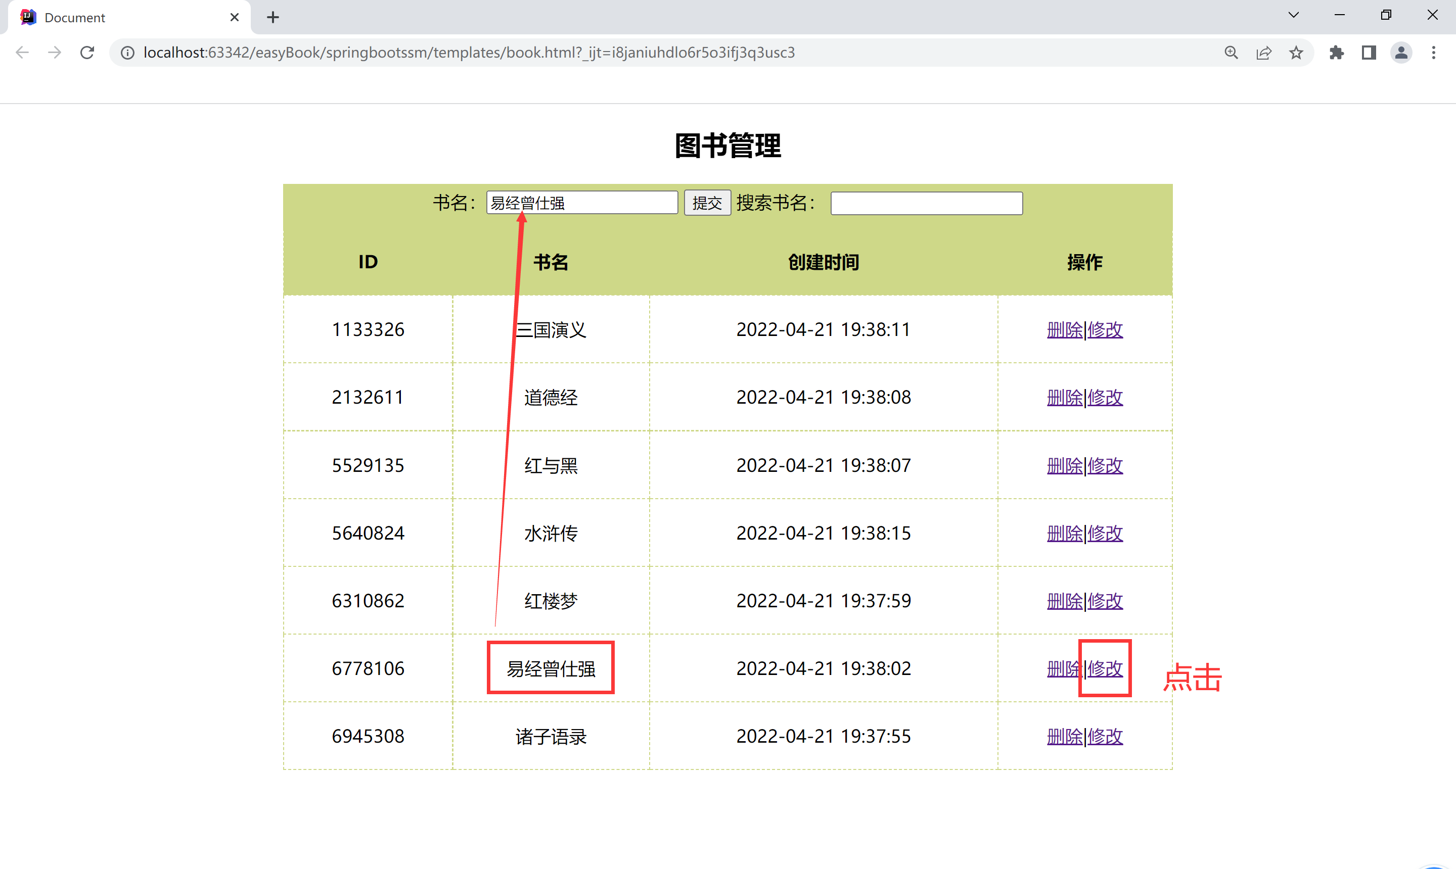

## 前端vue

|  |
| --- |
| <!DOCTYPE html> <html lang="en">  <head>  <meta charset="UTF-8" />  <meta http-equiv="X-UA-Compatible" content="IE=edge" />  <meta name="viewport" content="width=device-width, initial-scale=1.0" />  <title>Document</title>  <style>  .grid {  margin: auto;  width: 800px;  text-align: center;  }  .grid table {  border-top: 1px solid #ced888;  width: 100%;  border-collapse: collapse;  }  .grid th,  .grid td {  border: 1px dashed #ced888;  height: 40px;  line-height: 40px;  padding: 10px;  }  .grid th {  background-color: #ced888;  }  .grid .inputLine {  padding-top: 5px;  padding-bottom: 10px;  background-color: #ced888;  }  </style>  </head>  <body>  <div id="app">  <div class="grid">  <h2>图书管理</h2>  <div class="inputLine">  书名：<input type="text" name="" id="" v-model="bookInfo.name" />  <input  type="button"  value="提交"  @click="submit"  :disabled="isDisable"  />  搜索书名：  <input type="text" name="" id="" v-model="searchName" v-focus />  </div>  <table>  <thead>  <tr>  <th>ID</th>  <th>书名</th>  <th>创建时间</th>  <th>操作</th>  </tr>  </thead>  <tbody>  <tr v-for="(item,index) in bookInfo" :key="item.id">  <td>{{item.id}}</td>  <td>{{item.name}}</td>  <td>{{item.data}}</td>  <td>  <a href="" @click.prevent="delBook(item.id)">删除</a>|<a  href=""  @click.prevent="toEditBook(index)"  >修改</a  >  </td>  </tr>  </tbody>  </table>  </div>  </div>  <script src="https://cdn.jsdelivr.net/npm/vue@2/dist/vue.js"></script>  <script src="https://unpkg.com/axios/dist/axios.min.js"></script>  *<!-- 导入axios -->* <script>  Vue.directive("focus", {  inserted: function (el) {  el.focus();  },  });  Vue.filter("dateFormat", function (val, args = "") {  var dt = new Date(val);  var y = dt.getFullYear();  var m = (dt.getMonth() + 1).toString().padStart(2, "0");  var d = dt.getDate().toString().padStart(2, "0");  if (args === "yyyy-MM-dd") {  return `${y}-${m}-${d}`;  } else {  var h = dt.getHours().toString().padStart(2, "0");  var mm = dt.getMinutes().toString().padStart(2, "0");  var s = dt.getSeconds().toString().padStart(2, "0");  return `${y}-${m}-${d} ${h}:${mm}:${s}`;  }  });  var vm = new Vue({  created() {  this.getAllBooks()  },  el: "#app",  data: {  bookInfo: {  name: "",  },  searchName: "",  currentId: 0,  isDisable: true,  books: [],  modifyBookInfo:{  name: "",  id:""  },  bookDetail:{}   },  watch: {  "bookInfo.name": function (val) {  *// 是否重名* this.isDisable = this.books.some((item) => item.name === val);  },  },  methods: {   async getAllBooks(){  axios.defaults.headers.post['Content-Type'] = 'application/json'  var a = await axios.get("http://localhost/book/all/list")  this.bookInfo = a.data.data   this.books = a.data.data;  *// console.log(this.bookInfo[0].name)  // console.log(a.data.data)* },  *// 图书检索* searchBook(searchName) {  return this.books.filter(  (item) => item.name.indexOf(searchName) != -1  );  },  *// 最大的ID* getId() {  var ids = this.books.map((item) => item.id);  return Math.max(...ids);  },  *//添加图书* async addBook() {  if (this.bookInfo.name) {  *//获取ID* var id = this.getId() + 1;  var book = {  id: id,  name: this.bookInfo.name,  cDate: new Date(),  };  this.books.push(book);   axios.defaults.headers.post['Content-Type'] = 'application/json'  await axios.get('http://localhost:80/book/add/'+book.name)  .then(res=>{ console.log(res) })  this.getAllBooks()  }  },  *// 编辑图书* async modifyBook() {  this.isDisable = true;  var id = this.currentId;  console.log(this.currentId+" "+this.bookInfo.name)  this.delBook(this.currentId)  this.addBook(this.bookInfo.name)  },  toEditBook(index) {  console.log("toEditBook");  this.isDisable = true;  *// console.log(this.books[index].name)  // console.log(this.books[index].id)* this.bookInfo.name = this.books[index].name  this.currentId = this.books[index].id  this.isDisable = false  *// console.log(this.bookInfo.name)  // console.log( this.currentId )  // this.getAllBooks();* },  *// 提交* submit() {  if (this.currentId === 0) {  *//添加* this.addBook();   } else {  *//编辑* this.modifyBook();  this.currentId = 0;  }  this.bookInfo.name = "";  },  *// 删除* async delBook(id) {  this.books = this.books.filter((item) => item.id !== id);  *// "http://localhost:80/books"* await axios.get(`http://localhost:80/book/delete/`+id);  this.getAllBooks();  },  },  });  </script>  </body> </html> |

## 后端（SSMP）

Controller

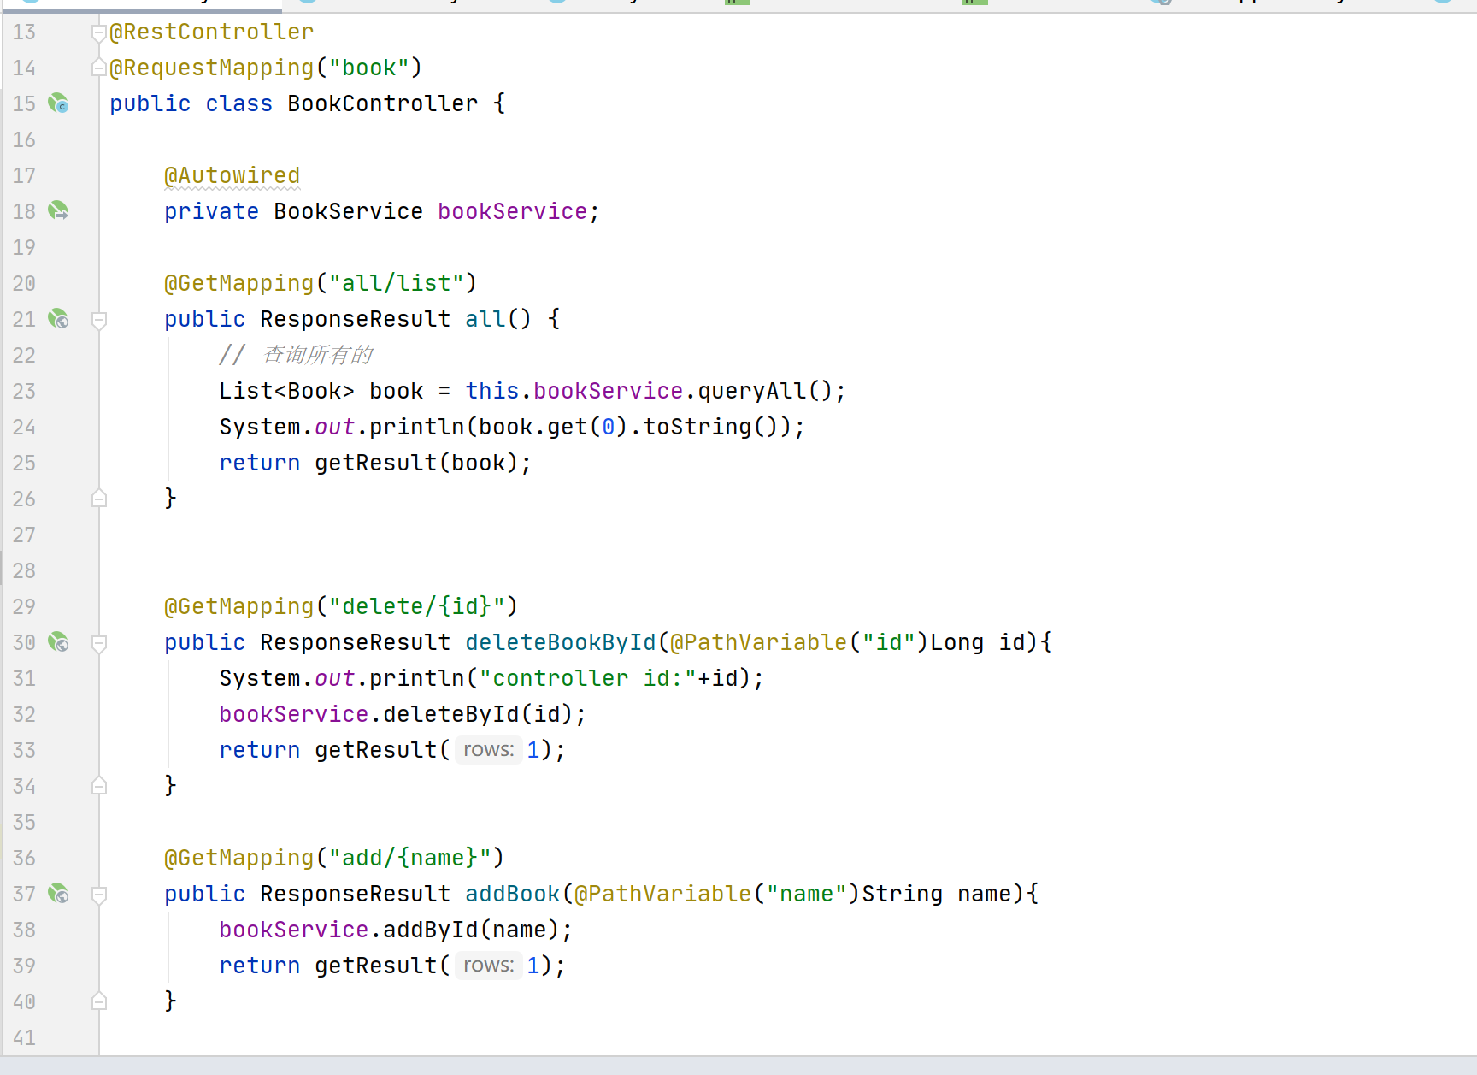

对于id采用随机7位数字

|  |
| --- |
| public int addById(String name){   String uid = "";  int length = 7;  for (Integer i = 0; i < length; i++) {  String randChar = String.*valueOf*(Math.*round*(Math.*random*() * 9));  uid = uid.concat(randChar);  }  long c = (long)(Double.*parseDouble*(uid));   SimpleDateFormat df = new SimpleDateFormat("yyyy-MM-dd HH:mm:ss");  Book book =new Book(c,name,df.format(System.*currentTimeMillis*()));  return this.bookMapper.insert(book); } |