分段线性分数转换模型实验分析
（2015-2016年度高考各科）
1. 数据分布形态
【各科统计数据情况】
km1 km2 km3 km4
count 655158 655158 655158 655158
mean 89.339251 79.031107 78.511022 142.217000
std 23.131180 37.088887 34.561786 58.444114
min 0.000000 0.000000 0.000000 0.000000
25% 81.000000 51.000000 53.000000 105.000000
50% 93.000000 84.000000 79.000000 146.000000
75% 104.000000 110.000000 109.000000 182.000000
max 138.000000 150.000000 148.000000 298.000000

【语文】：从分布形态看，具有较好的正态分布形态，有少量右偏移现象。

【数学】：分布左端（低分区）出现不规则跳跃，且占比较高。

外语：

综合：

- 分数转换情况
方案一：
参数设置：原始分数区间比例rawpoints = [0, 0.0228, 0.1587, 0.50, 0.8414, 0.9773, 1]
转换分数对应区间stdpoints = [50, 70, 85, 100, 115, 130, 150]
转换后标准差=15， 均值=100
【2015语文】
raw score percent points: [0, 0.0228, 0.1587, 0.5, 0.8414, 0.9773, 1]
raw score points: [1.0, 60.0, 81.0, 100.0, 115.0, 125.0, 145.0]
std score points: [50, 70, 85, 100, 115, 130, 150]
coefficients: {1: [0.3389, 1.0, 50], 2: [0.7142, 60.0, 70], 3: [0.7894, 81.0, 85], 4: [1.0, 100.0, 100], 5: [1.5, 115.0, 115], 6: [1.0, 125.0, 130]}
formula: ['0.3389*(x-1.0)+50', '0.7142*(x-60.0)+70', '0.7894*(x-81.0)+85', '1.0*(x-100.0)+100', '1.5*(x-115.0)+115', '1.0*(x-125.0)+130']
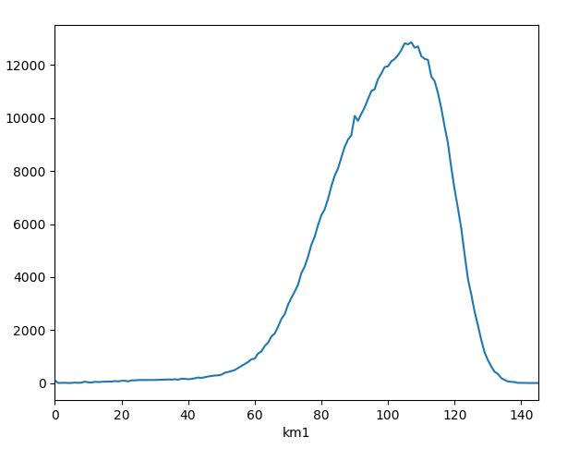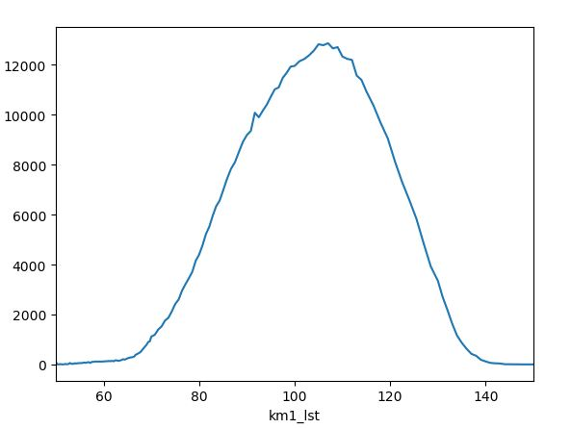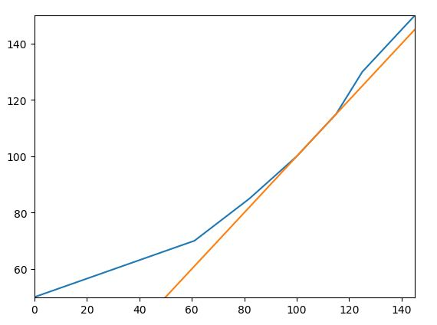
原始分数分布、转换分数分布、转换映射函数
【2015数学文】
raw score percent points: [0, 0.0228, 0.1587, 0.5, 0.8414, 0.9773, 1]
raw score points: [1.0, 15.0, 41.0, 73.0, 109.0, 128.0, 150.0]
std score points: [50, 70, 85, 100, 115, 130, 150]
coefficients: {1: [1.4285, 1.0, 50], 2: [0.5769, 15.0, 70], 3: [0.4687, 41.0, 85], 4: [0.4166, 73.0, 100], 5: [0.7894, 109.0, 115], 6: [0.909, 128.0, 130]}
formula:['1.4285*(x-1.0)+50','0.5769*(x-15.0)+70', '0.4687*(x-41.0)+85', '0.4166*(x-73.0)+100', '0.7894*(x-109.0)+115', '0.909*(x-128.0)+130']
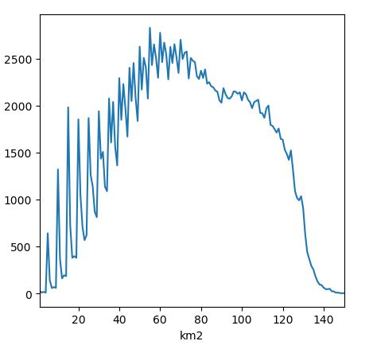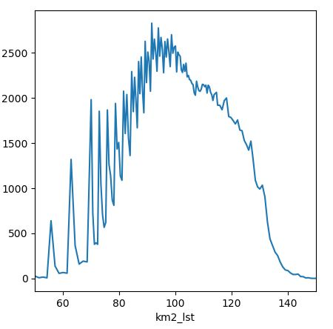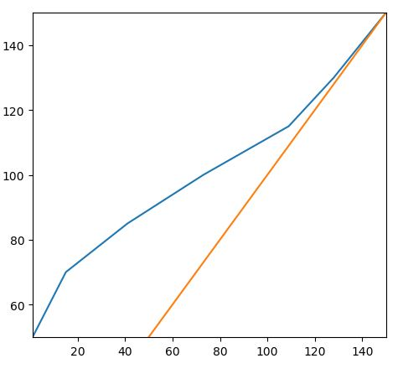
原始分数分布、转换分数分布、转换映射函数
【2015数学理】
raw score percent points: [0, 0.0228, 0.1587, 0.5, 0.8414, 0.9773, 1]
raw score points: [1.0, 15.0, 41.0, 73.0, 109.0, 128.0, 150.0]
std score points: [50, 70, 85, 100, 115, 130, 150]
coefficient: {1: [1.4285, 1.0, 50], 2: [0.5769, 15.0, 70], 3: [0.4687, 41.0, 85], 4: [0.4166, 73.0, 100], 5: [0.7894, 109.0, 115], 6: [0.909, 128.0, 130]}
formula:['1.4285*(x-1.0)+50','0.5769*(x-15.0)+70', '0.4687*(x-41.0)+85', '0.4166*(x-73.0)+100', '0.7894*(x-109.0)+115', '0.909*(x-128.0)+130']
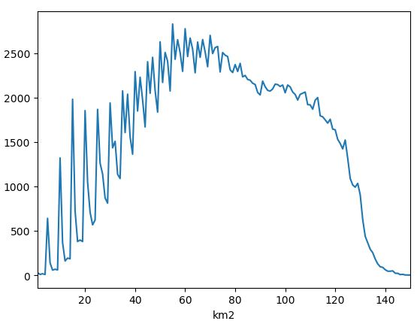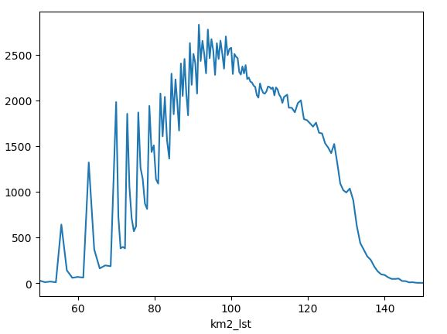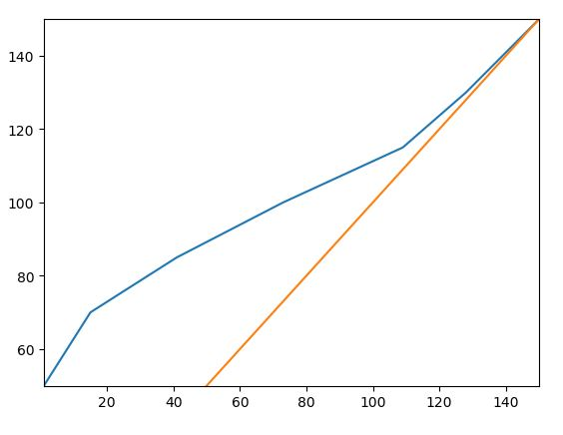
原始分数分布、转换分数分布、转换映射函数
【2015外语】
raw score points: [1.0, 31.0, 53.0, 92.0, 119.0, 135.0, 148.0]
std score points: [50, 70, 85, 100, 115, 130, 150]
coefficients: {1: [0.6666, 1.0, 50], 2: [0.6818, 31.0, 70], 3: [0.3846, 53.0, 85], 4: [0.5555, 92.0, 100], 5: [0.9375, 119.0, 115], 6: [1.5384, 135.0, 130]}
formula: ['0.6666*(x-1.0)+50', '0.6818*(x-31.0)+70', '0.3846*(x-53.0)+85', '0.5555*(x-92.0)+100', '0.9375*(x-119.0)+115', '1.5384*(x-135.0)+130']
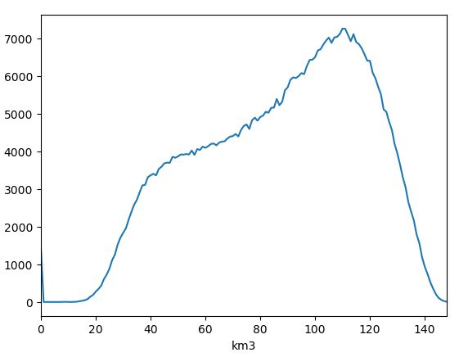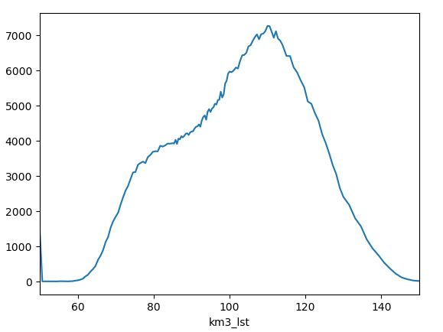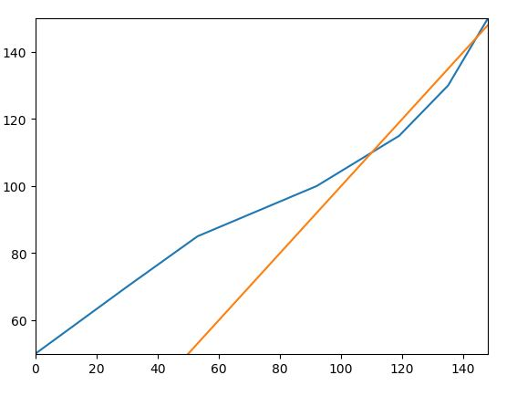
原始分数分布、转换分数分布、转换映射函数
【2016语文】
raw score points: [1.0, 57.0, 78.0, 96.0, 110.0, 120.0, 138.0]
std score points: [50, 70, 85, 100, 115, 130, 150]
coefficients: {1: [0.3571, 1.0, 50], 2: [0.7142, 57.0, 70], 3: [0.8333, 78.0, 85], 4: [1.0714, 96.0, 100], 5: [1.5, 110.0, 115], 6: [1.1111, 120.0, 130]}
formula:['0.3571*(x-1.0)+50','0.7142*(x-57.0)+70', '0.8333*(x-78.0)+85', '1.0714*(x-96.0)+100', '1.5*(x-110.0)+115', '1.1111*(x-120.0)+130']
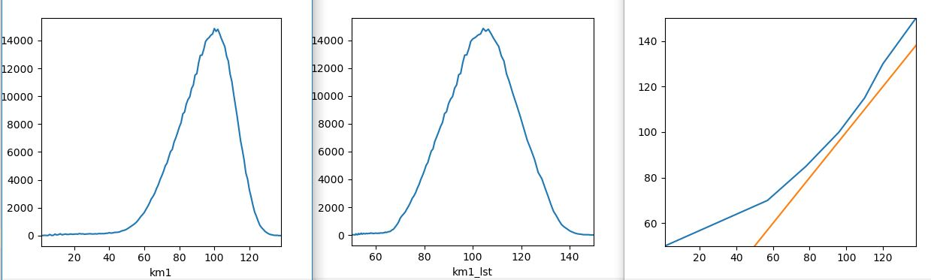
原始分数分布、转换分数分布、转换映射函数
【2016数学文】
raw score points: [1.0, 15.0, 36.0, 71.0, 112.0, 132.0, 150.0]
std score points: [50, 70, 85, 100, 115, 130, 150]
coefficent: {1: [1.4285, 1.0, 50], 2: [0.7142, 15.0, 70], 3: [0.4285, 36.0, 85], 4: [0.3658, 71.0, 100], 5: [0.75, 112.0, 115], 6: [1.1111, 132.0, 130]}
formula:['1.4285*(x-1.0)+50','0.7142*(x-15.0)+70', '0.4285*(x-36.0)+85', '0.3658*(x-71.0)+100', '0.75*(x-112.0)+115', '1.1111*(x-132.0)+130']
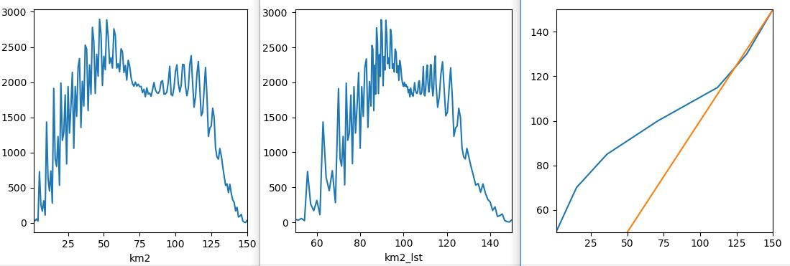
原始分数分布、转换分数分布、转换映射函数
【2016数学理】
raw score points: [1.0, 21.0, 61.0, 102.0, 124.0, 139.0, 150.0]
std score points: [50, 70, 85, 100, 115, 130, 150]
coefficients: {1: [1.0, 1.0, 50], 2: [0.375, 21.0, 70], 3: [0.3658, 61.0, 85], 4: [0.6818, 102.0, 100], 5: [1.0, 124.0, 115], 6: [1.8181, 139.0, 130]}
formula: ['1.0*(x-1.0)+50', '0.375*(x-21.0)+70', '0.3658*(x-61.0)+85', '0.6818*(x-102.0)+100', '1.0*(x-124.0)+115', '1.8181*(x-139.0)+130']
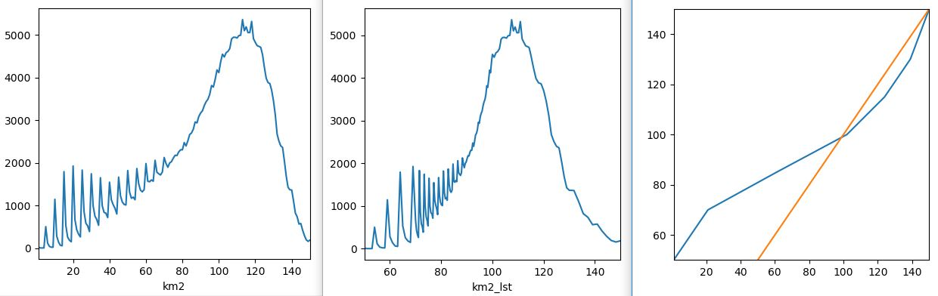
原始分数分布、转换分数分布、转换映射函数
【2016外语】
raw score points: [1.0, 31.0, 50.0, 89.0, 120.0, 134.0, 148.0]
std score points: [50, 70, 85, 100, 115, 130, 150]
coefficients: {1: [0.6666, 1.0, 50], 2: [0.7894, 31.0, 70], 3: [0.3846, 50.0, 85], 4: [0.4838, 89.0, 100], 5: [1.0714, 120.0, 115], 6: [1.4285, 134.0, 130]}
formula:['0.6666*(x-1.0)+50','0.7894*(x-31.0)+70', '0.3846*(x-50.0)+85', '0.4838*(x-89.0)+100', '1.0714*(x-120.0)+115', '1.4285*(x-134.0)+130']
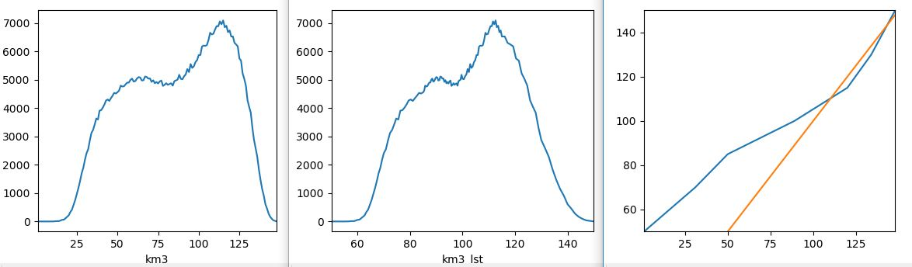
原始分数分布、转换分数分布、转换映射函数
【2017语文】
raw score points: [1.0, 66.0, 88.0, 104.0, 116.0, 125.0, 142.0]
std score points: [50, 70, 85, 100, 115, 130, 150]
coefficent: {1: [0.3076, 1.0, 50], 2: [0.6818, 66.0, 70], 3: [0.9375, 88.0, 85], 4: [1.25, 104.0, 100], 5: [1.6666, 116.0, 115], 6: [1.1764, 125.0, 130]}
formula: ['0.3076*(x-1.0)+50', '0.6818*(x-66.0)+70', '0.9375*(x-88.0)+85', '1.25*(x-104.0)+100', '1.6666*(x-116.0)+115', '1.1764*(x-125.0)+130']
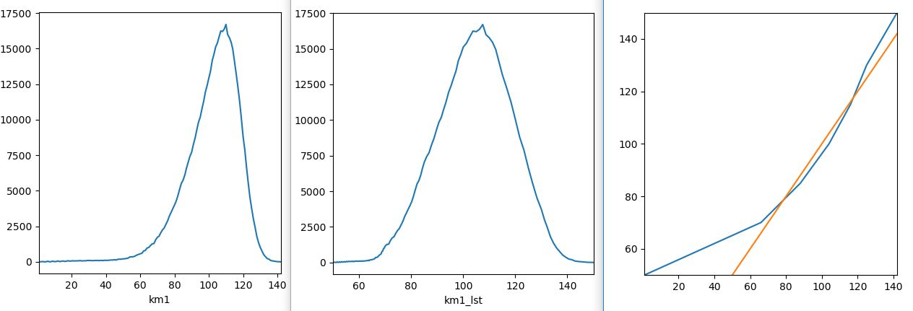
【2017数学文】
raw score points: [1.0, 15.0, 43.0, 84.0, 117.0, 134.0, 150.0]
std score points: [50, 70, 85, 100, 115, 130, 150]
coefficent: {1: [1.4285, 1.0, 50], 2: [0.5357, 15.0, 70], 3: [0.3658, 43.0, 85], 4: [0.4545, 84.0, 100], 5: [0.8823, 117.0, 115], 6: [1.25, 134.0, 130]}
formula:['1.4285*(x-1.0)+50', '0.5357*(x-15.0)+70', '0.3658*(x-43.0)+85', '0.4545*(x-84.0)+100', '0.8823*(x-117.0)+115', '1.25*(x-134.0)+130']
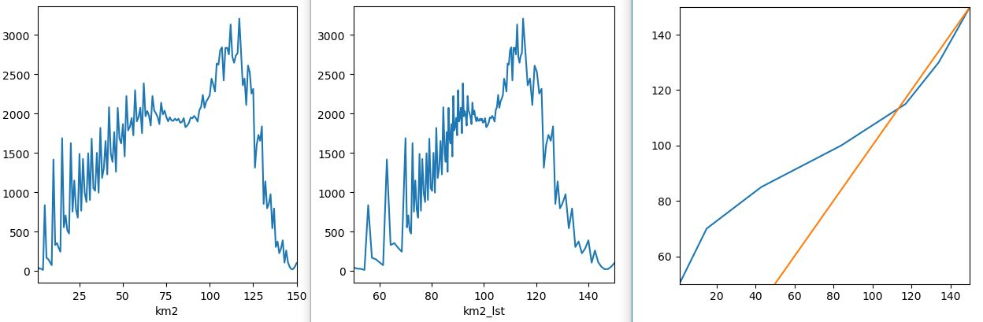
【2017数学理】
raw score points: [1.0, 26.0, 70.0, 107.0, 126.0, 141.0, 150.0]
std score points: [50, 70, 85, 100, 115, 130, 150]
coefficients: {1: [0.8, 1.0, 50], 2: [0.3409, 26.0, 70], 3: [0.4054, 70.0, 85], 4: [0.7894, 107.0, 100], 5: [1.0, 126.0, 115], 6: [2.2222, 141.0, 130]}
formula: ['0.8*(x-1.0)+50', '0.3409*(x-26.0)+70', '0.4054*(x-70.0)+85', '0.7894*(x-107.0)+100', '1.0*(x-126.0)+115', '2.2222*(x-141.0)+130']
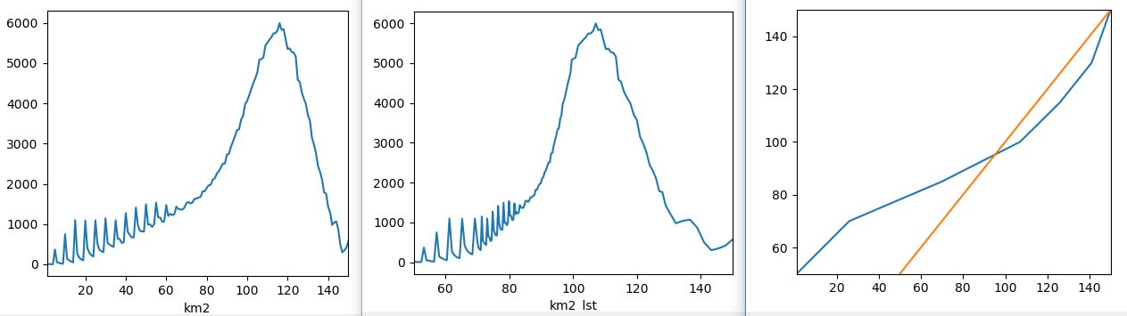
【2017外语】
raw score points: [1.0, 30.0, 49.0, 87.0, 119.0, 136.0, 150.0]
std score points: [50, 70, 85, 100, 115, 130, 150]
coefficients: {1: [0.6896, 1.0, 50], 2: [0.7894, 30.0, 70], 3: [0.3947, 49.0, 85], 4: [0.4687, 87.0, 100], 5: [0.8823, 119.0, 115], 6: [1.4285, 136.0, 130]}
formula:['0.6896*(x-1.0)+50','0.7894*(x-30.0)+70', '0.3947*(x-49.0)+85', '0.4687*(x-87.0)+100', '0.8823*(x-119.0)+115', '1.4285*(x-136.0)+130']
