几个问题

1. 多module会不会对编译速度产生影响。
2. 如何查编译各个步骤花费的时间。
3. 硬件的提高，对编译时间的改善的程度。
4. 统一编译工具版本。
5. 忽略不需要的提交.
6. 如何写一个新的脚本

1.Gradle是可以直接跑java语法的。

比如

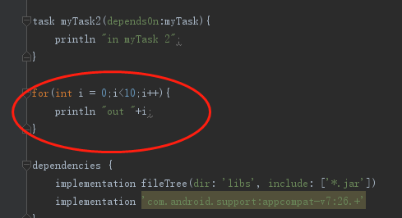

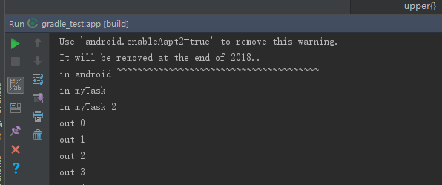

2.引用gradle，使用apply

看一看Launcher编译的时间

打印了大于50ms的任务。

JavaWithJavac，java文件到class文件过程

transformClasses，class到dex文件过程

Task spend time:

52ms :spacebase:processReleaseResources

278ms :spacebase:compileReleaseJavaWithJavac

375ms :commonset:compileReleaseJavaWithJavac

270ms :commonset:extractReleaseAnnotations

248ms :commonset:transformClassesAndResourcesWithSyncLibJarsForRelease

76ms :app:incrementalGoogleDebugJavaCompilationSafeguard

377ms :spacebase:extractReleaseAnnotations

87ms :spacebase:transformClassesAndResourcesWithSyncLibJarsForRelease

227ms :spacebase:bundleRelease

183ms :advertisement_android:mergeReleaseResources

58ms :exchange:compileReleaseJavaWithJavac

131ms :sign:compileReleaseJavaWithJavac

112ms :calendar:compileReleaseJavaWithJavac

160ms :calendar:extractReleaseAnnotations

149ms :cardlist:compileReleaseJavaWithJavac

122ms :cardlist:extractReleaseAnnotations

68ms :notes:mergeReleaseResources

638ms :notes:compileReleaseJavaWithJavac

55ms :notes:extractReleaseAnnotations

138ms :weather:extractReleaseAnnotations

59ms :search:compileReleaseJavaWithJavac

267ms :search:extractReleaseAnnotations

95ms :search:bundleRelease

1382ms :spaceresult:compileReleaseJavaWithJavac

263ms :spaceresult:extractReleaseAnnotations

90ms :spaceresult:bundleRelease

183ms :cpucool:mergeReleaseResources

2217ms :boost:compileReleaseJavaWithJavac

274ms :boost:extractReleaseAnnotations

778ms :junk:compileReleaseJavaWithJavac

245ms :junk:extractReleaseAnnotations

139ms :lscreen:mergeReleaseResources

3337ms :lscreen:compileReleaseJavaWithJavac

211ms :lscreen:extractReleaseAnnotations

236ms :app:mergeGoogleDebugResources

12346ms :app:compileGoogleDebugJavaWithJavac

68ms :app:transformResourcesWithMergeJavaResForGoogleDebug

23619ms :app:transformClassesAndResourcesWithProguardForGoogleDebug

22433ms :app:transformClassesWithDexForGoogleDebug

3170ms :app:packageGoogleDebug