实验报告
2021 年 4 月 18 日 成绩：
姓名 | 王一凡，朱忆添 | 学号 | 19061536，19061145 | 班级 | 19052713
专业 | 软件工程 |  | 课程名称 | 计算机组成原理课程实践
任课老师 | 张翔 | 指导老师 | 张翔 | 机位号
实验序号 | 2 | 实验名称 | 超前进位加法器设计实验
实验时间 | 2021.4.18 | 实验地点 | 一教223 | 实验设备号
- 实验程序源代码
顶层代码：
module verilgoEx2(A,B,F,C4,C0
);
input [3:0]A,B;
input C0;
output [3:0]F;
output C4;
assign G0 = A[0] & B[0];
assign P0 = A[0] | B[0];
assign G1 = A[1] & B[1];
assign P1 = A[1] | B[1];
assign G2 = A[2] & B[2];
assign P2 = A[2] | B[2];
assign G3 = A[3] & B[3];
assign P3 = A[3] | B[3];
assign C1 = G0 | P0&C0;
assign C2 = G1 | P1&G0 | P0&P1&C0;
assign C3 = G2 | P2&G1 | P2&P1&G0 | P2&P1&P0&C0;
assign C4 = G3 | P3&G2 | P3&P2&G1 | P3&P2&P1&G0 | P3&P2&P1&P0&C0;
assign F[0] = A[0]^B[0]^C0;
assign F[1] = A[1]^B[1]^C1;
assign F[2] = A[2]^B[2]^C2;
assign F[3] = A[3]^B[3]^C3;
endmodule
仿真代码：
module fixtureEX2;

// Inputs
reg [3:0] A;
reg [3:0] B;
reg C0;

// Outputs
wire [3:0] F;
wire C4;

// Instantiate the Unit Under Test (UUT)
verilgoEx2 uut (
.A(A),
.B(B),
.F(F),
.C4(C4),
.C0(C0)
);

initial begin
// Initialize Inputs
A = 0;
B = 0;
C0 = 0;

// Wait 100 ns for global reset to finish
#100;

// Add stimulus here

A = 4'b1000;
B = 4'b1000;
C0 = 1;

#100;

A = 4'b1001;
B = 4'b1001;
C0 = 1;

#100;

A = 4'b1011;
B = 4'b1011;
C0 = 1;

end

endmodule

二、仿真波形
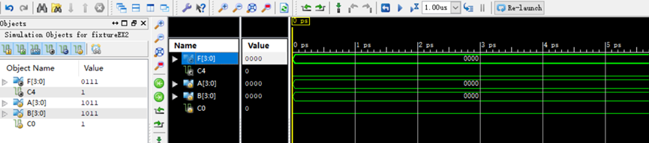

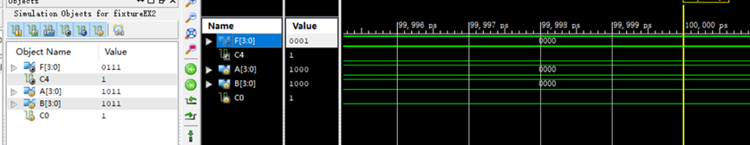

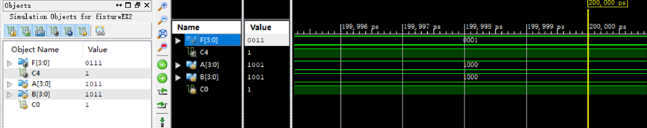

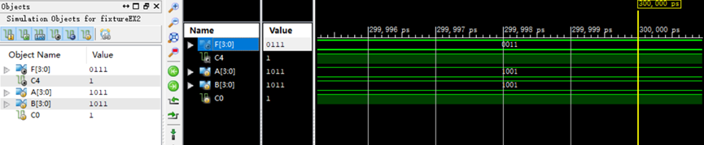

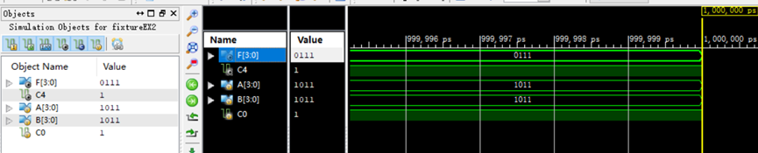

三、电路图
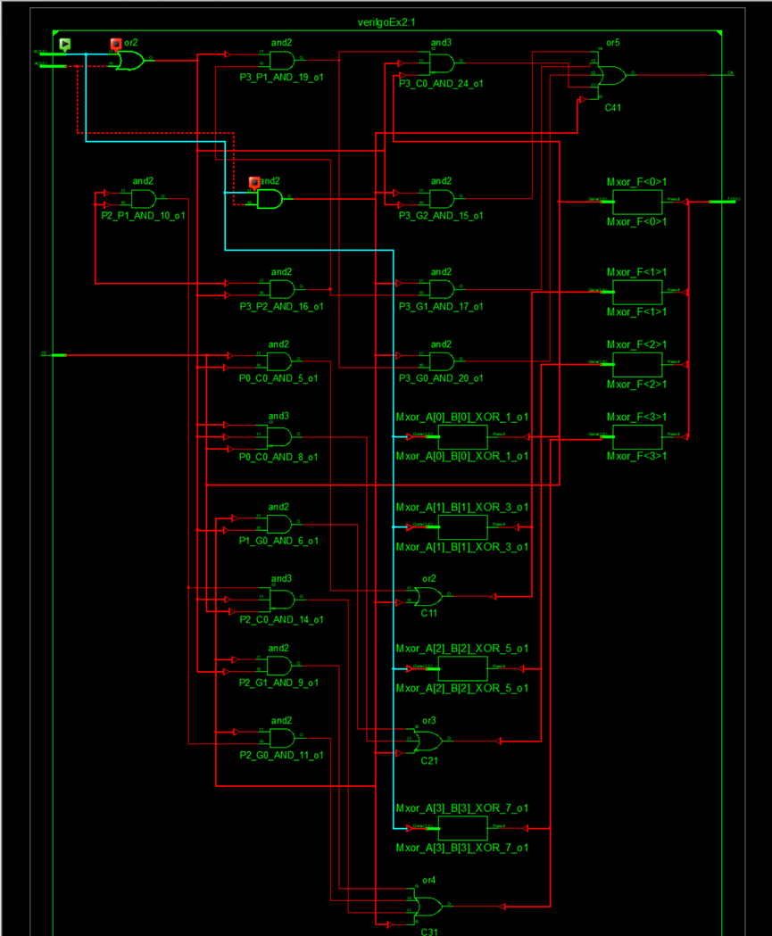

四、引脚配置（约束文件）
管脚配置：

# PlanAhead Generated physical constraints

NET "A[3]" LOC = T3;
NET "A[2]" LOC = U3;
NET "A[1]" LOC = T4;
NET "A[0]" LOC = V3;
NET "B[3]" LOC = V4;
NET "B[2]" LOC = W2;
NET "B[1]" LOC = Y4;
NET "B[0]" LOC = Y6;
NET "F[3]" LOC = R1;
NET "F[2]" LOC = P2;
NET "F[1]" LOC = P1;
NET "F[0]" LOC = N2;
NET "C0" LOC = W7;
NET "C4" LOC = M1;

# PlanAhead Generated IO constraints

NET "A[3]" IOSTANDARD = LVCMOS18;
NET "A[2]" IOSTANDARD = LVCMOS18;
NET "A[1]" IOSTANDARD = LVCMOS18;
NET "A[0]" IOSTANDARD = LVCMOS18;
NET "B[3]" IOSTANDARD = LVCMOS18;
NET "B[2]" IOSTANDARD = LVCMOS18;
NET "B[1]" IOSTANDARD = LVCMOS18;
NET "B[0]" IOSTANDARD = LVCMOS18;
NET "F[3]" IOSTANDARD = LVCMOS18;
NET "F[2]" IOSTANDARD = LVCMOS18;
NET "F[1]" IOSTANDARD = LVCMOS18;
NET "F[0]" IOSTANDARD = LVCMOS18;
NET "C0" IOSTANDARD = LVCMOS18;
NET "C4" IOSTANDARD = LVCMOS18;

NET "F[3]" PULLDOWN;
NET "F[2]" PULLDOWN;
NET "F[1]" PULLDOWN;
NET "F[0]" PULLDOWN;
NET "C4" PULLDOWN;

- 思考与探索
- 综合得到的电路图，它和我们预计的一样，完成了题目所要求的功能
- 在实验中，我们起初对实验原理不太理解，后来通过观察书中的原理讲解理解了本实验的内容。之后编写代码一切顺利。烧录到板子上后出现了led灯乱跳的问题，之后排查代码，发现没有问题，板子可能出现了信号干扰，但是我们的功能还是正常显示的。

