实验报告
2021 年 5 月 9 日 成绩：
姓名 | 王一凡，朱忆添 | 学号 | 19061536，19061145 | 班级 | 19052713
专业 | 软件工程 |  | 课程名称 | 计算机组成原理课程实践
任课老师 | 张翔 | 指导老师 | 张翔 | 机位号
实验序号 | 3 | 实验名称 | 多功能ALU设计实验
实验时间 | 2021.5.9 | 实验地点 | 一教223 | 实验设备号
- 实验程序源代码
顶层代码：
module verilogEX3(AB_SW,ALU_OP,F_LED_SW,LED);
input[2:0]AB_SW,ALU_OP,F_LED_SW;
output[7:0]LED;
wire [31:0]A,B,F;
wire ZF,OF;
Third_experiment_second T2(AB_SW,A,B);
Third_experiment_first T1(OF,ZF,ALU_OP,A,B,F);
Third_experiment_third T3(F_LED_SW,LED,F,ZF,OF);

endmodule

module Third_experiment_second(AB_SW,A,B);
input[2:0]AB_SW;
output reg[31:0]A,B;
always @(*)
begin
case(AB_SW)
3'b000:begin A=32'h0000_0000;B=32'h0000_0000;end
3'b001:begin A=32'h0000_0003;B=32'h0000_0607;end
3'b010:begin A=32'h8000_0000;B=32'h8000_0000;end
3'b011:begin A=32'h7FFF_FFFF;B=32'h7FFF_FFFF;end
3'b100:begin A=32'hFFFF_FFFF;B=32'hFFFF_FFFF;end
3'b101:begin A=32'h8000_0000;B=32'hFFFF_FFFF;end
3'b110:begin A=32'hFFFF_FFFF;B=32'h8000_0000;end
3'b111:begin A=32'h1234_5678;B=32'h3333_2222;end
default:begin A=32'h9ABC_DEF0;B=32'h1111_2222;end
endcase
end
endmodule

module Third_experiment_first(OF,ZF,ALU_OP,A,B,F);
input [2:0]ALU_OP;
input [31:0]A,B;
output reg[31:0]F;
reg C32;
output reg OF=0;
output reg ZF=0;
always @(ALU_OP or A or B)
begin
case(ALU_OP)
3'b000:F<=A&B;
3'b001:F<=A|B;
3'b010:F<=A^B;
3'b011:F<=A~^B;
3'b100:{C32,F}<=A+B;
3'b101:{C32,F}<=A-B;
3'b110:begin if(A<B) F<=32'h0000_0001;else F<=32'h0000_0000;end
3'b111:begin F<=B<<A;end
endcase
if(F==32'h0000_0000)
ZF<=1;
else
ZF<=0;
OF=C32^F[31]^A[31]^B[31];
end
endmodule

module Third_experiment_third(F_LED_SW,LED,F,ZF,OF);
input[31:0]F;
input ZF,OF;
input[2:0] F_LED_SW;
output reg[7:0] LED;
always@(*)
begin
case(F_LED_SW)
3'b000:LED=F[7:0];
3'b001:LED=F[15:8];
3'b010:LED=F[23:16];
3'b011:LED=F[31:24];
default:begin LED[7]=ZF;LED[0]=OF;LED[6:1]=6'b0;end
endcase
end

endmodule
测试代码：
module fixtureEX3;

// Inputs
reg [2:0] AB_SW;
reg [2:0] ALU_OP;
reg [2:0] F_LED_SW;

// Outputs
wire [7:0] LED;

// Instantiate the Unit Under Test (UUT)
verilogEX3 uut (
.AB_SW(AB_SW),
.ALU_OP(ALU_OP),
.F_LED_SW(F_LED_SW),
.LED(LED)
);

initial begin
// Initialize Inputs
AB_SW = 3'b001;
ALU_OP = 3'b000;
F_LED_SW = 3'b000;

#100;

AB_SW = 3'b001;
ALU_OP = 3'b001;
F_LED_SW = 3'b000;

#100;

AB_SW = 3'b001;
ALU_OP = 3'b010;
F_LED_SW = 3'b000;

end

endmodule
二、仿真波形
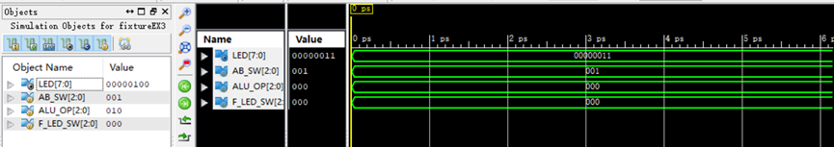

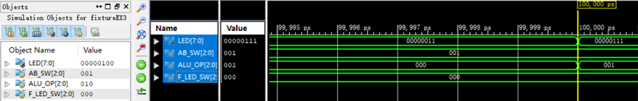
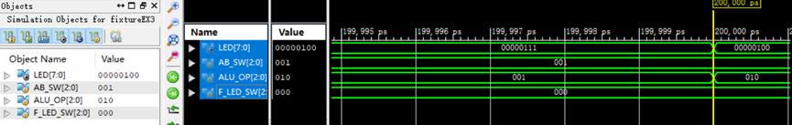

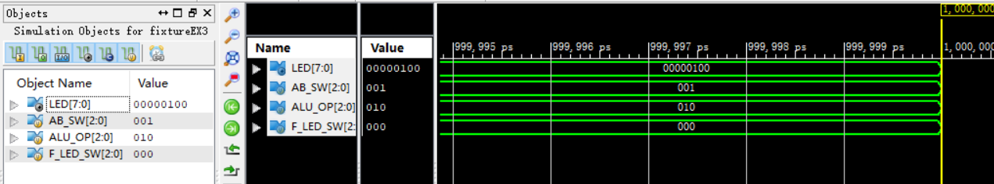
三、电路图
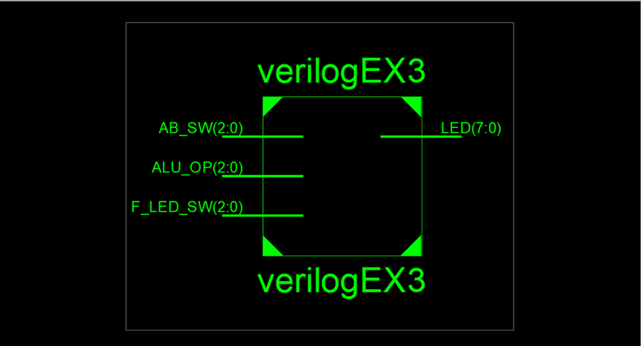

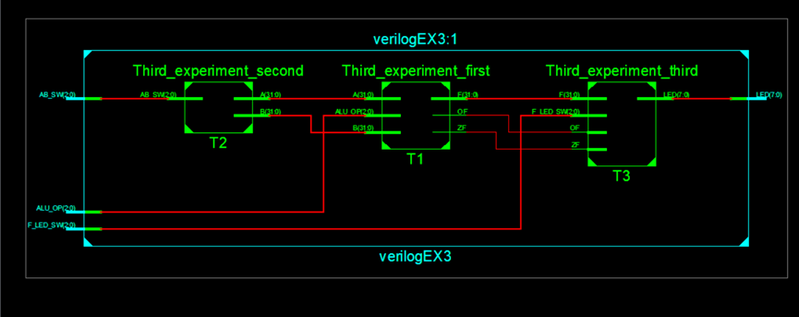

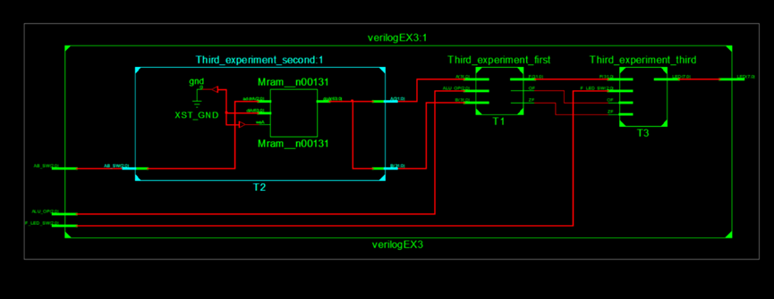

四、引脚配置（约束文件）

管脚配置：NET "ALU_OP[2]" LOC = T3; //SW7
NET "ALU_OP[1]" LOC = U3; //SW6
NET "ALU_OP[0]" LOC = T4; //SW5
NET "AB_SW[2]" LOC = V3; //SW4
NET "AB_SW[1]" LOC = V4; //SW3
NET "AB_SW[0]" LOC = W4; //SW2
NET "F_LED_SW[1]" LOC = Y4; //SW1
NET "F_LED_SW[0]" LOC = Y6; //SW0
NET "F_LED_SW[2]" LOC = R4; //BTNL

NET "LED[7]" LOC = R1; //LED7
NET "LED[6]" LOC = P2; //LED6
NET "LED[5]" LOC = P1; //LED5
NET "LED[4]" LOC = N2; //LED4
NET "LED[3]" LOC = M1; //LED3
NET "LED[2]" LOC = M2; //LED2
NET "LED[1]" LOC = L1; //LED1
NET "LED[0]" LOC = J2; //LED0

NET "ALU_OP[2]" IOSTANDARD = LVCMOS18;
NET "ALU_OP[1]" IOSTANDARD = LVCMOS18;
NET "ALU_OP[0]" IOSTANDARD = LVCMOS18;
NET "AB_SW[2]" IOSTANDARD = LVCMOS18;
NET "AB_SW[1]" IOSTANDARD = LVCMOS18;
NET "AB_SW[0]" IOSTANDARD = LVCMOS18;
NET "F_LED_SW[1]" IOSTANDARD = LVCMOS18;
NET "F_LED_SW[0]" IOSTANDARD = LVCMOS18;
NET "F_LED_SW[2]" IOSTANDARD = LVCMOS18;

NET "LED[7]" IOSTANDARD = LVCMOS18;
NET "LED[6]" IOSTANDARD = LVCMOS18;
NET "LED[5]" IOSTANDARD = LVCMOS18;
NET "LED[4]" IOSTANDARD = LVCMOS18;
NET "LED[3]" IOSTANDARD = LVCMOS18;
NET "LED[2]" IOSTANDARD = LVCMOS18;
NET "LED[1]" IOSTANDARD = LVCMOS18;
NET "LED[0]" IOSTANDARD = LVCMOS18;

NET "ALU_OP[2]" PULLDOWN;
NET "ALU_OP[1]" PULLDOWN;
NET "ALU_OP[0]" PULLDOWN;
NET "AB_SW[2]" PULLDOWN;
NET "AB_SW[1]" PULLDOWN;
NET "AB_SW[0]" PULLDOWN;
NET "F_LED_SW[1]" PULLDOWN;
NET "F_LED_SW[0]" PULLDOWN;
NET "F_LED_SW[2]" PULLDOWN;

- 思考与探索
本实验实现了and,or,xor,nor,add,sub,slt,sll的指令，没有实现mips指令集的所有核心指令，对于mips指令集还未实现的指令有逻辑类指令andi,ori,xori,算数类指令addu,addi,addiu,subu,位移类指令slti,sltu,sllv,sra,srav,srl,srlv,跳转指令jr,载入指令lw,sw,lui,跳转指令beq,bne等。

