实验报告
2021 年 5 月 16 日 成绩：
姓名 | 王一凡，朱忆添 | 学号 | 19061536，19061145 | 班级 | 19052713
专业 | 软件工程 |  | 课程名称 | 计算机组成原理课程实践
任课老师 | 张翔 | 指导老师 | 张翔 | 机位号
实验序号 | 4 | 实验名称 | 寄存器堆设计实验
实验时间 | 2021.5.16 | 实验地点 | 一教223 | 实验设备号
一、实验程序源代码
顶层模块

//////////////////////////////////////////////////////////////////////////////////
module verilogEX4(Addr,Write_Reg,Opt,Clk,Reset,A_B,LED
);
input [1:0]Opt;
input [4:0]Addr;
input Write_Reg,Clk,Reset,A_B;
output reg [7:0]LED;
wire [31:0]R_Data_A,R_Data_B;
reg [4:0]R_Addr_A,R_Addr_B;
reg [31:0]W_Data;
initial
LED <= 0;
Fourth_experiment_first F1(R_Addr_A,R_Addr_B,Write_Reg,R_Data_A,R_Data_B,Reset,Clk,Addr,W_Data);
always@(Addr or Write_Reg or Opt or A_B or R_Data_A or R_Data_B)
begin
if(Write_Reg)//写操作
begin
case(Opt) //选择写入的数据，一共四组
2'b00: begin W_Data=32'h000f_000f; end
2'b01: begin W_Data=32'h0f0f_0f00; end
2'b10: begin W_Data=32'hf0f0_f0f0; end
2'b11: begin W_Data=32'hffff_ffff; end
endcase
end
else
if(A_B)//选择读出的端口A或B
begin
R_Addr_A=Addr;//从A端口读出
case(Opt) //选择读出的位数，从低到高，每组8位，一共4组
2'b00: LED=R_Data_A[7:0];
2'b01: LED=R_Data_A[15:8];
2'b10: LED=R_Data_A[23:16];
2'b11: LED=R_Data_A[31:24];
endcase
end
else
begin
R_Addr_B=Addr; //从B端口读出
case(Opt)
2'b00: LED=R_Data_B[7:0];
2'b01: LED=R_Data_B[15:8];
2'b10: LED=R_Data_B[23:16];
2'b11: LED=R_Data_B[31:24];
endcase
end
end
endmodule

module Fourth_experiment_first(R_Addr_A,R_Addr_B,Write_Reg,R_Data_A,R_Data_B,Reset,Clk,W_Addr,W_Data);
input [4:0]R_Addr_A,R_Addr_B,W_Addr;
input Write_Reg,Reset,Clk;
input[31:0] W_Data;
output [31:0] R_Data_A,R_Data_B;
reg [31:0] REG_Files[0:31];
integer i=0;
always @ (posedge Clk or posedge Reset)
begin
if(Reset)//清零
begin
for(i=0;i<=31;i=i+1)
REG_Files[i]<=0;
end
else
begin
if(Write_Reg)
REG_Files[W_Addr]<=W_Data;
end
end
assign R_Data_A = REG_Files[R_Addr_A];
assign R_Data_B = REG_Files[R_Addr_B];

endmodule
测试代码
module fixturEX4;

// Inputs
reg [4:0] Addr;
reg Write_Reg;
reg [1:0] Opt;
reg Clk;
reg Reset;
reg A_B;

// Outputs
wire [7:0] LED;

// Instantiate the Unit Under Test (UUT)
verilogEX4 uut (
.Addr(Addr),
.Write_Reg(Write_Reg),
.Opt(Opt),
.Clk(Clk),
.Reset(Reset),
.A_B(A_B),
.LED(LED)
);
always #20 Clk = ~Clk;
initial begin
Addr = 5'b00001;
Write_Reg = 1;
Opt = 0;
Clk = 1;
Reset = 0;
A_B = 0;
#100;
Addr = 5'b00001;
Write_Reg = 0;
Opt = 0;
A_B = 0;

end

endmodule

二、仿真波形
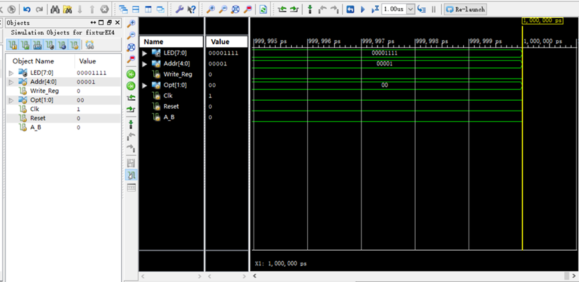

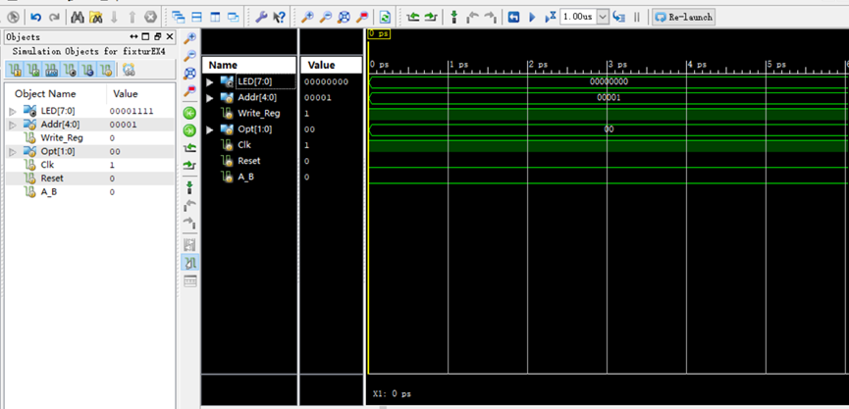

三、电路图
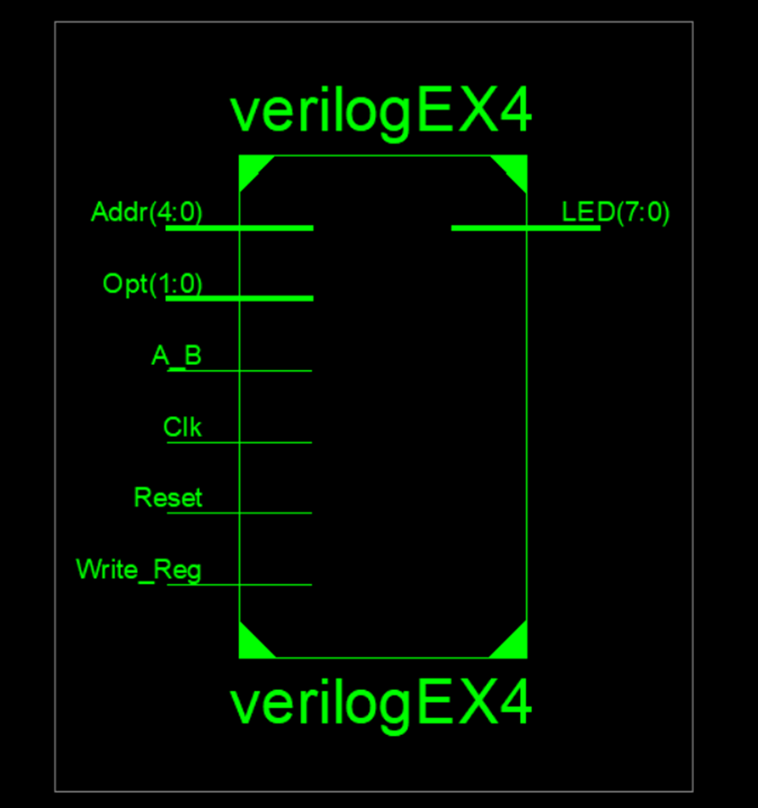

四、引脚配置（约束文件）
管脚配置：
NET "Addr[4]" LOC = T3; //SW7
NET "Addr[3]" LOC = U3; //SW6
NET "Addr[2]" LOC = T4; //SW5
NET "Addr[1]" LOC = V3; //SW4
NET "Addr[0]" LOC = V4; //SW3
NET "Write_Reg" LOC = Y4; //SW2
NET "Opt[1]" LOC = W7; //SW1
NET "Opt[0]" LOC = Y8; //SW0
NET "A_B" LOC = R4; //BTNL
NET "Clk" LOC = H4; //BTND
NET "Reset" LOC = AA8; //BTNR
NET "LED[7]" LOC = R1; //LED7
NET "LED[6]" LOC = P2; //LED6
NET "LED[5]" LOC = P1; //LED5
NET "LED[4]" LOC = N2; //LED4
NET "LED[3]" LOC = M1; //LED3
NET "LED[2]" LOC = M2; //LED2
NET "LED[1]" LOC = L1; //LED1
NET "LED[0]" LOC = J2; //LED0

NET "Addr[4]" IOSTANDARD = LVCMOS18;
NET "Addr[3]" IOSTANDARD = LVCMOS18;
NET "Addr[2]" IOSTANDARD = LVCMOS18;
NET "Addr[1]" IOSTANDARD = LVCMOS18;
NET "Addr[0]" IOSTANDARD = LVCMOS18;
NET "Write_Reg" IOSTANDARD = LVCMOS18;
NET "Opt[1]" IOSTANDARD = LVCMOS18;
NET "Opt[0]" IOSTANDARD = LVCMOS18;
NET "A_B" IOSTANDARD = LVCMOS18;
NET "Clk" IOSTANDARD = LVCMOS18;
NET "Reset" IOSTANDARD = LVCMOS18;
NET "LED[7]" IOSTANDARD = LVCMOS18;
NET "LED[6]" IOSTANDARD = LVCMOS18;
NET "LED[5]" IOSTANDARD = LVCMOS18;
NET "LED[4]" IOSTANDARD = LVCMOS18;
NET "LED[3]" IOSTANDARD = LVCMOS18;
NET "LED[2]" IOSTANDARD = LVCMOS18;
NET "LED[1]" IOSTANDARD = LVCMOS18;
NET "LED[0]" IOSTANDARD = LVCMOS18;

NET "Addr[4]" PULLDOWN;
NET "Addr[3]" PULLDOWN;
NET "Addr[2]" PULLDOWN;
NET "Addr[1]" PULLDOWN;
NET "Addr[0]" PULLDOWN;
NET "Write_Reg" PULLDOWN;
NET "Opt[1]" PULLDOWN;
NET "Opt[0]" PULLDOWN;
NET "A_B" PULLDOWN;
NET "Clk" PULLDOWN;
NET "Reset" PULLDOWN;

- 思考与探索
选择8个寄存器执行读写操作，试验记录如下，实验结果符合预期
