实验报告
2021 年 5 月 23 日 成绩：
姓名 | 王一凡，朱忆添 | 学号 | 19061536，19061145 | 班级 | 19052713
专业 | 软件工程 |  | 课程名称 | 计算机组成原理课程实践
任课老师 | 张翔 | 指导老师 | 张翔 | 机位号
实验序号 | 5 | 实验名称 | 存储器设计实验
实验时间 | 2021.5.23 | 实验地点 | 一教223 | 实验设备号
一、实验程序源代码
1：生成.coe文件
memory_initialization_radix = 16;
memory_initialization_vector = 00000820,00632020,00010fff,20006789,ffff0000,0000ffff,88888888,99999999,aaaaaaaa,bbbbbbbb;

顶层代码：
module verilogEX5(
input [7:2]Mem_Addr,
input [1:0]MUX,
input Mem_Write,
input Clk,
output reg [7:0]LED);
wire [31:0]M_R_Data;
reg [31:0]M_W_Data;
IP_EX5 uut (
.clka(Clk), // input clka
.wea(Mem_Write), // input [0 : 0] wea
.addra(Mem_Addr), // input [5 : 0] addra
.dina(M_W_Data), // input [31 : 0] dina
.douta(M_R_Data) // output [31 : 0] douta
);

always @(*)
begin
LED = 0;
M_W_Data = 0;
if(Mem_Write)
begin
case(MUX)
2'b00: M_W_Data = 32'h0000_000F;
2'b01: M_W_Data = 32'h0000_0DB0;
2'b10: M_W_Data = 32'h003C_C381;
2'b11: M_W_Data = 32'hFFFF_FFFF;
endcase
end
else
begin
case(MUX)
2'b00: LED = M_R_Data[7:0];
2'b01: LED = M_R_Data[15:8];
2'b10: LED = M_R_Data[23:16];
2'b11: LED = M_R_Data[31:24];
endcase
end

end
endmodule

测试模块代码
module fixtureEX5;

// Inputs
reg [7:2] Mem_Addr;
reg [1:0] MUX;
reg Mem_Write;
reg Clk;
// Outputs
wire [7:0] LED;
verilogEX5 uut (
.Mem_Addr(Mem_Addr),
.MUX(MUX),
.Mem_Write(Mem_Write),
.Clk(Clk),
.LED(LED)
);
always #20 Clk=~Clk;
initial begin
// Initialize Inputs
Mem_Addr = 0;
MUX = 0;
Mem_Write = 1;
Clk = 0;
#100;
Mem_Addr = 6'b000000;
MUX = 0;
Mem_Write = 0;
end

endmodule
生成ip核
按照书上步骤创建存储器IP核
1：
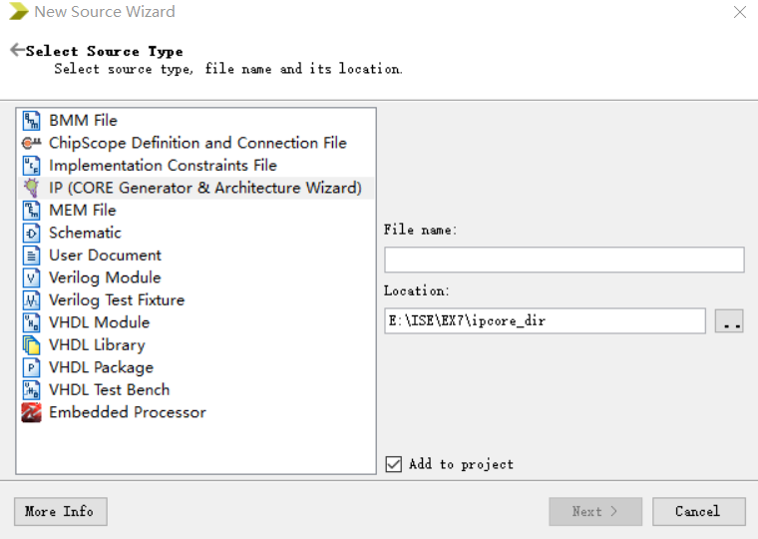
2：
选择IP核类型
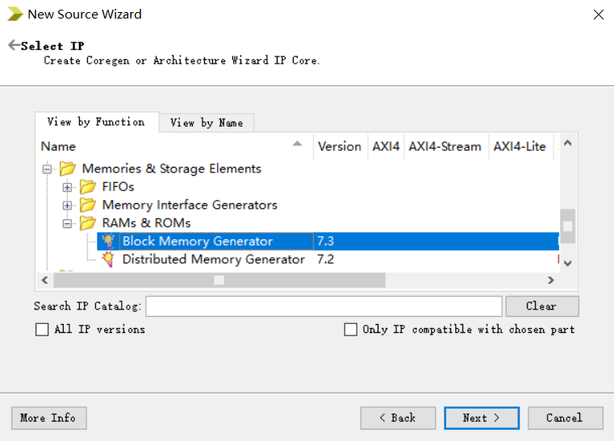

3：IP核配置页面，配置一些参数
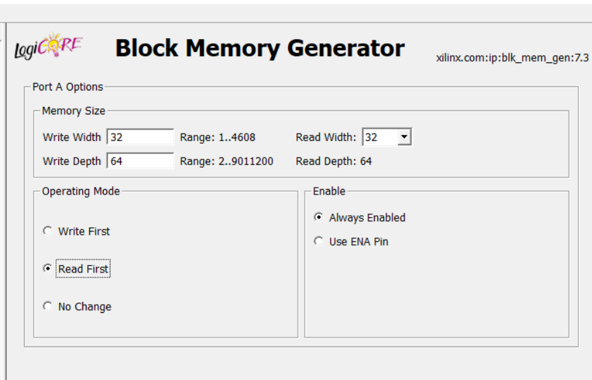
4：加载COE文件
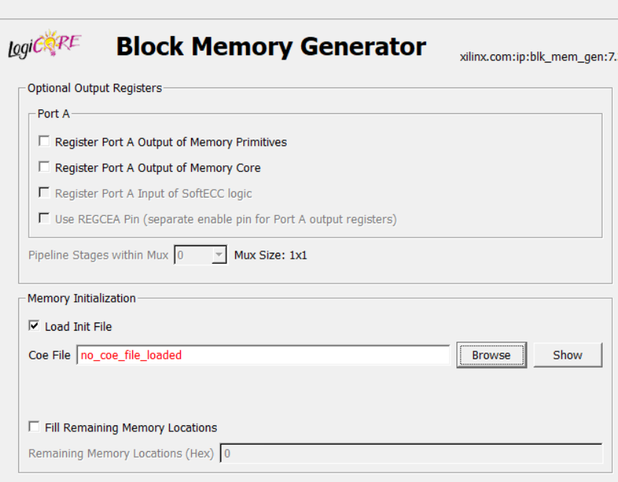

5:生成存储器核
结果截图：
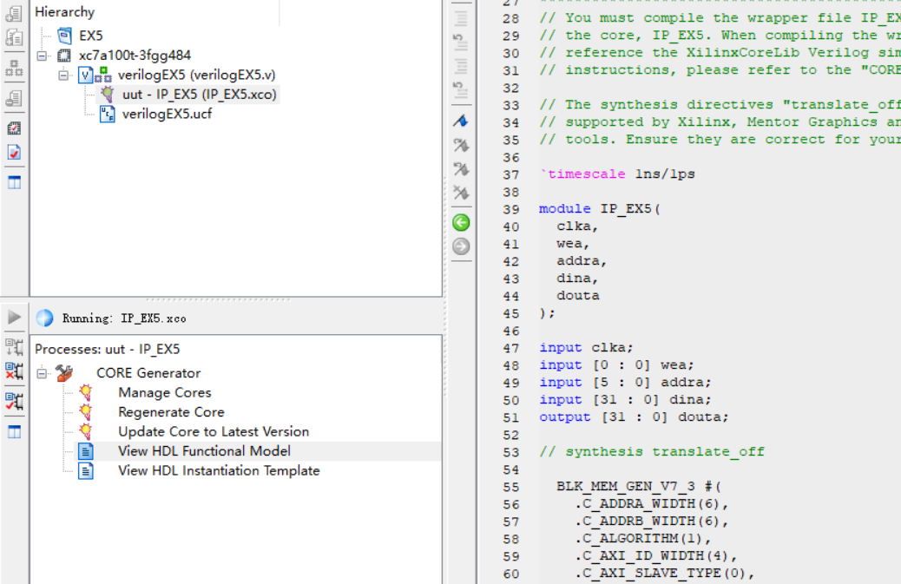

二、仿真波形
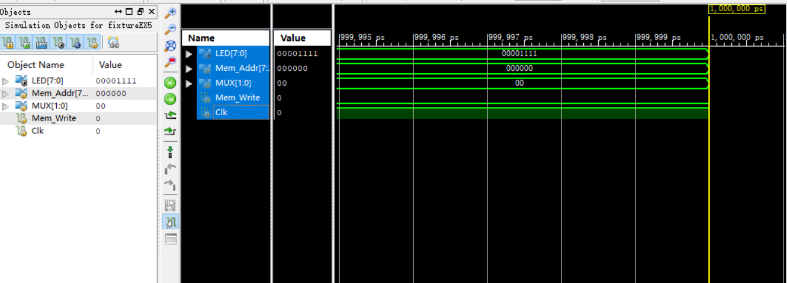

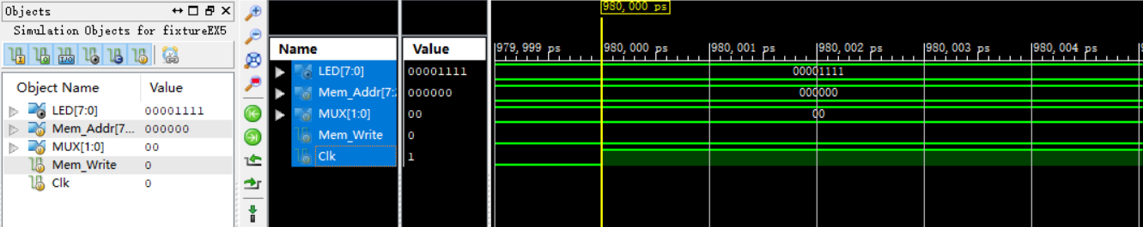

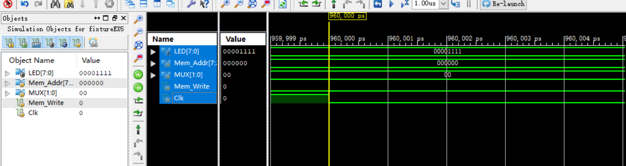

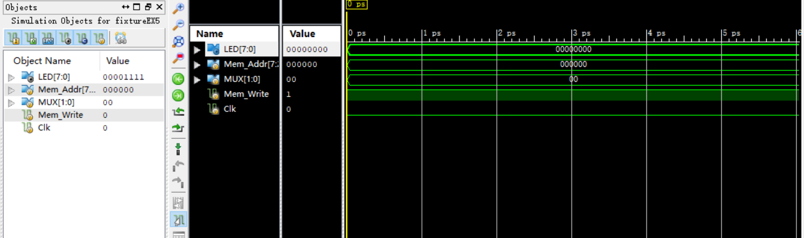

三、电路图
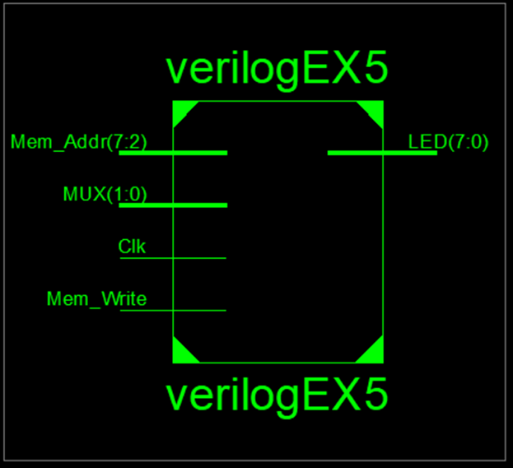

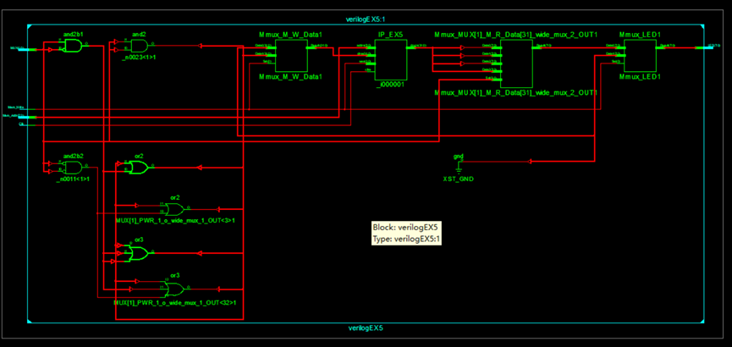

四、引脚配置（约束文件）
管脚配置：
NET "Mem_Addr[7]" LOC = T3; //SW7
NET "Mem_Addr[6]" LOC = U3; //SW6
NET "Mem_Addr[5]" LOC = T4; //SW5
NET "Mem_Addr[4]" LOC = V3; //SW4
NET "Mem_Addr[3]" LOC = V4; //SW3
NET "Mem_Addr[2]" LOC = W4; //SW2
NET "MUX[1]" LOC = AB7;
NET "MUX[0]" LOC = AB8;

NET "Mem_Write" LOC = R4; //BTNR
NET "Clk" LOC = H4; //100MHz

NET "LED[7]" LOC = R1; //LED7
NET "LED[6]" LOC = P2; //LED6
NET "LED[5]" LOC = P1; //LED5
NET "LED[4]" LOC = N2; //LED4
NET "LED[3]" LOC = M1; //LED3
NET "LED[2]" LOC = M2; //LED2
NET "LED[1]" LOC = L1; //LED1
NET "LED[0]" LOC = J2; //LED0

NET "Mem_Addr[7]" PULLDOWN;
NET "Mem_Addr[6]" PULLDOWN;
NET "Mem_Addr[5]" PULLDOWN;
NET "Mem_Addr[4]" PULLDOWN;
NET "Mem_Addr[3]" PULLDOWN;
NET "Mem_Addr[2]" PULLDOWN;
NET "MUX[1]" PULLDOWN;
NET "MUX[0]" PULLDOWN;
NET "Mem_Write" PULLDOWN;
NET "Clk" PULLDOWN;

NET "Mem_Addr[7]" IOSTANDARD = LVCMOS18;
NET "Mem_Addr[6]" IOSTANDARD = LVCMOS18;
NET "Mem_Addr[5]" IOSTANDARD = LVCMOS18;
NET "Mem_Addr[4]" IOSTANDARD = LVCMOS18;
NET "Mem_Addr[3]" IOSTANDARD = LVCMOS18;
NET "Mem_Addr[2]" IOSTANDARD = LVCMOS18;
NET "MUX[1]" IOSTANDARD = LVCMOS18;
NET "MUX[0]" IOSTANDARD = LVCMOS18;
NET "Mem_Write" IOSTANDARD = LVCMOS18;
NET "Clk" IOSTANDARD = LVCMOS18;

NET "LED[7]" IOSTANDARD = LVCMOS18;
NET "LED[6]" IOSTANDARD = LVCMOS18;
NET "LED[5]" IOSTANDARD = LVCMOS18;
NET "LED[4]" IOSTANDARD = LVCMOS18;
NET "LED[3]" IOSTANDARD = LVCMOS18;
NET "LED[2]" IOSTANDARD = LVCMOS18;
NET "LED[1]" IOSTANDARD = LVCMOS18;
NET "LED[0]" IOSTANDARD = LVCMOS18;

- 思考与探索
- 读操作实验结果记录表
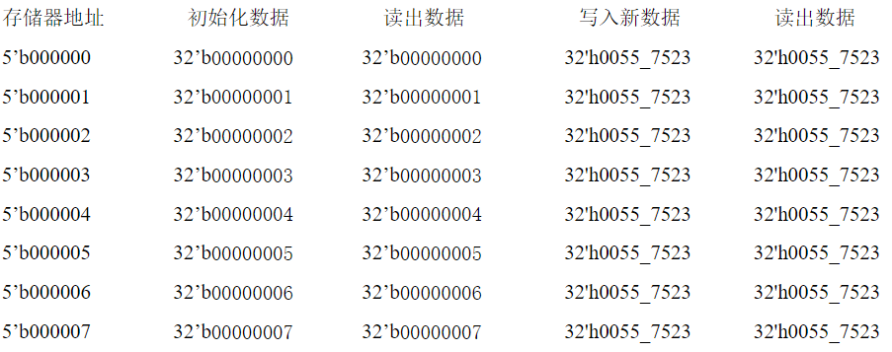
- 这些单元的数据已经被改写了。读出的数据与写入数据一致。

