实验报告
2021 年 5 月 30 日 成绩：
姓名 | 王一凡，朱忆添 | 学号 | 19061536，19061145 | 班级 | 19052713
专业 | 软件工程 |  | 课程名称 | 计算机组成原理课程实践
任课老师 | 张翔 | 指导老师 | 张翔 | 机位号
实验序号 | 7 | 实验名称 | 取指令与指令译码
实验时间 | 2021.5.30 | 实验地点 | 一教223 | 实验设备号
一、实验程序源代码
1:创建存储器IP核
.coe文件
memory_initialization_radix=16;
memory_initialization_vector=00000827 0001102b 00421820 00622020 00832820 00a33020 00463804 00a64820 01264004
00284826 01215020 01075822 00e86022 012c6824 012c7025 00c77825 00c78027 00e38820 02289004 02239804 00f3a004
0281a820 0255b025 0296b820 0296c022 02d4c822 0241d026 02d4d82b 0354e02b 02c2e820 0282f022 017af820;

2：顶层模块
module verilogEX7( clk,rst,LED,MUX,op_code,funct,rs_addr,rt_addr,rd_addr,shamt,Inst_code
);

input clk,rst;
input [1:0]MUX;
output [31:0]Inst_code;
output reg[7:0]LED;
reg [31:0]PC;
wire [31:0]PC_new;
output [5:0]op_code,funct;
output [4:0]rs_addr,rt_addr,rd_addr,shamt;
PC pc1(clk,rst,Inst_code);
always@(*)
begin
case(MUX)
2'b00:LED = Inst_code[7:0];
2'b01:LED = Inst_code[15:8];
2'b10:LED = Inst_code[23:16];
2'b11:LED = Inst_code[31:25];
endcase
end
assign op_code = Inst_code[31:26];
assign rs_addr = Inst_code[25:21];
assign rt_addr = Inst_code[20:16];
assign rd_addr = Inst_code[15:11];
assign shamt = Inst_code[10:6];
assign funct = Inst_code[5:0];

endmodule

module PC(clk,rst,Inst_code);
input clk,rst;
wire [31:0]PC_new;
reg[31:0]PC;
initial
PC = 32'h0000_0000;
output [31:0]Inst_code;
assign PC_new = PC +4;
IP_EX7 uut (
.clka(clk), // input clka
.addra(PC[7:2]), // input [5 : 0] addra
.douta(Inst_code) // output [31 : 0] douta
);
always@(negedge clk or posedge rst)
begin
if(rst)
begin PC <= 32'h0000_0000; end
else
begin PC <=PC_new; end
end
endmodule

二、仿真波形
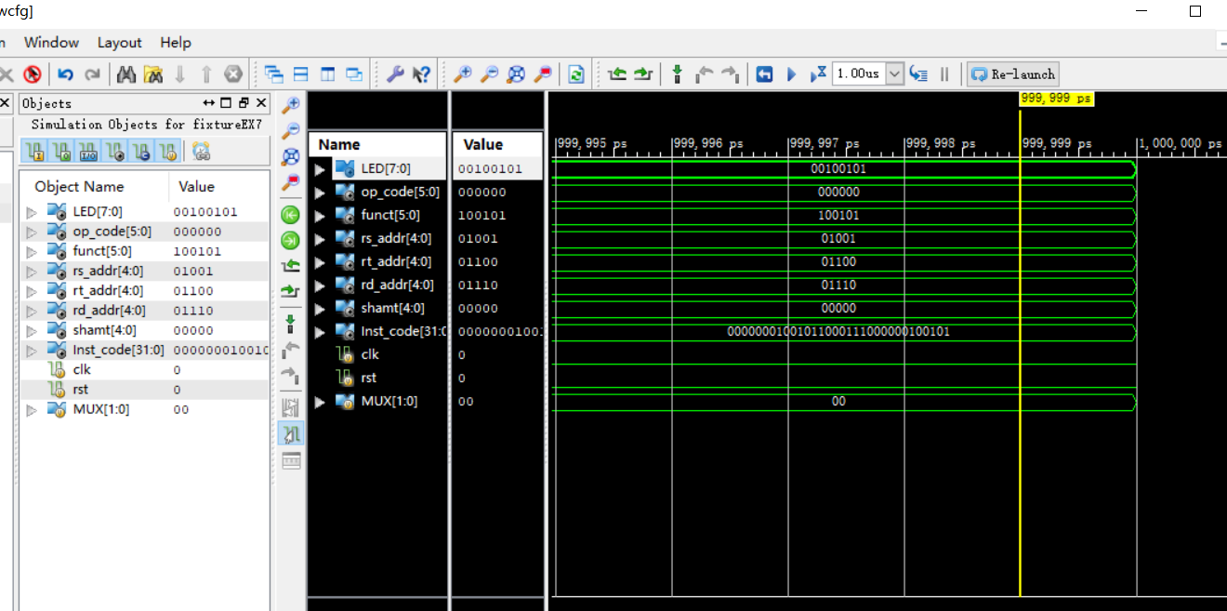

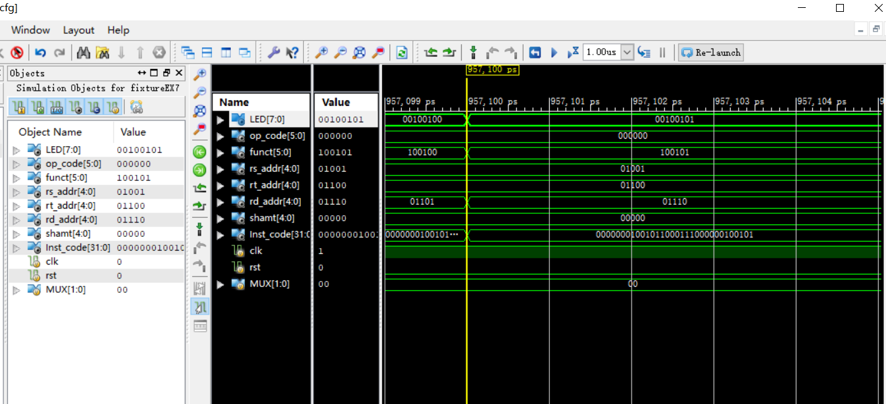

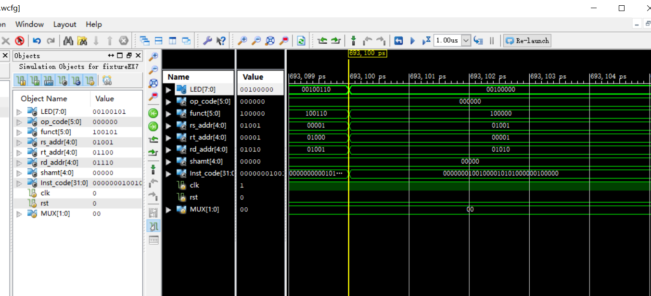

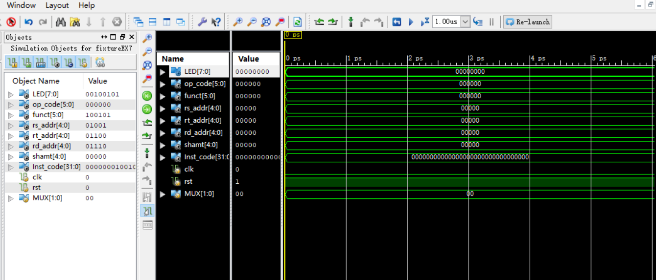

三、电路图
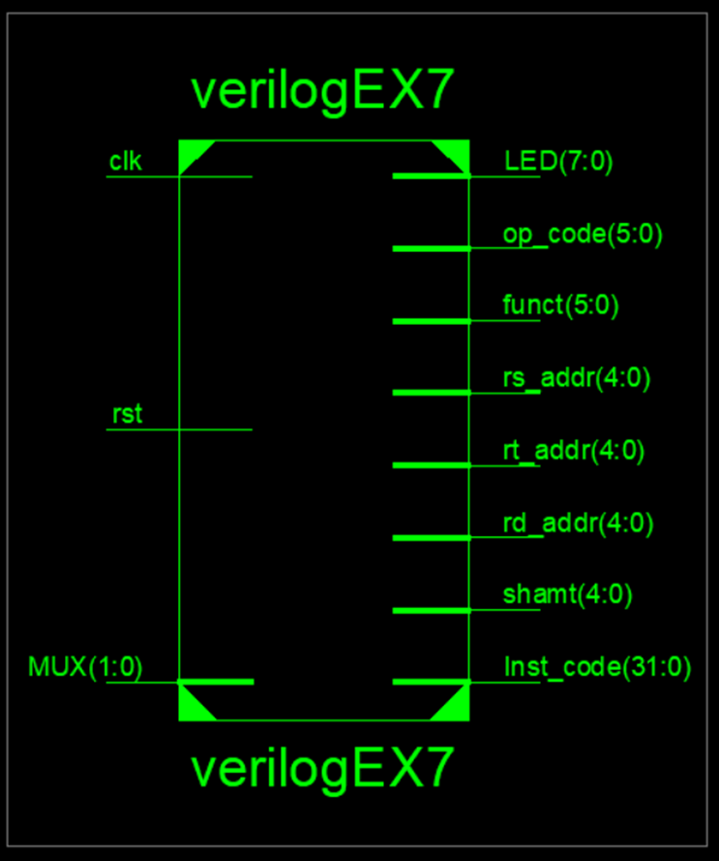

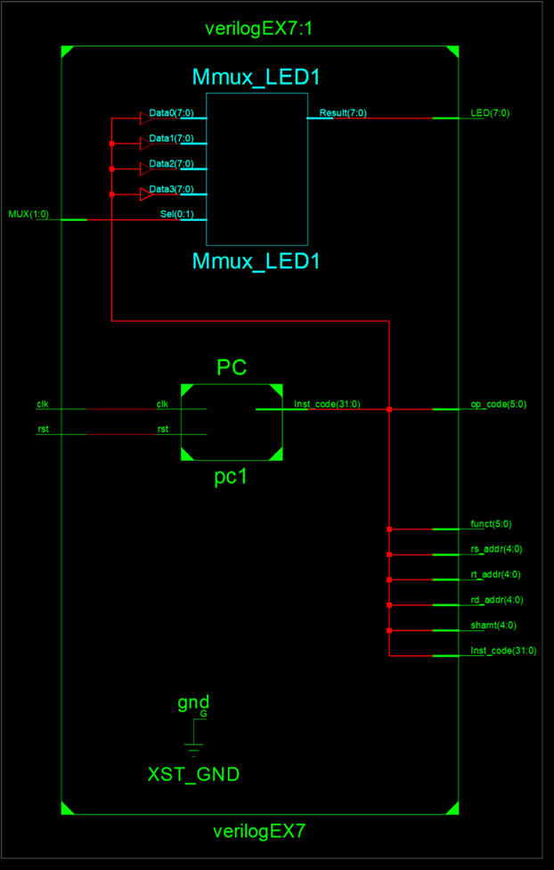

四、引脚配置（约束文件）
NET "clk" CLOCK_DEDICATED_ROUTE = FALSE;

NET "MUX[1]" LOC = T3; //SW1
NET "MUX[0]" LOC = U3; //SW0
NET "clk" LOC = AA4; //BTNR
NET "rst" LOC = R4; //BTNL

NET "LED[7]" LOC = R1; //LED7
NET "LED[6]" LOC = P2; //LED6
NET "LED[5]" LOC = P1; //LED5
NET "LED[4]" LOC = N2; //LED4
NET "LED[3]" LOC = M1; //LED3
NET "LED[2]" LOC = M2; //LED2
NET "LED[1]" LOC = L1; //LED1
NET "LED[0]" LOC = J2; //LED0

NET "MUX[1]" PULLDOWN;
NET "MUX[0]" PULLDOWN;
NET "clk" PULLDOWN;
NET "rst" PULLDOWN;
NET "clk" CLOCK_DEDICATED_ROUTE = FALSE;
NET "MUX[1]" IOSTANDARD = LVCMOS18;
NET "MUX[0]" IOSTANDARD = LVCMOS18;
NET "clk" IOSTANDARD = LVCMOS18;
NET "rst" IOSTANDARD = LVCMOS18;
NET "LED[7]" IOSTANDARD = LVCMOS18;
NET "LED[6]" IOSTANDARD = LVCMOS18;
NET "LED[5]" IOSTANDARD = LVCMOS18;
NET "LED[4]" IOSTANDARD = LVCMOS18;
NET "LED[3]" IOSTANDARD = LVCMOS18;
NET "LED[2]" IOSTANDARD = LVCMOS18;
NET "LED[1]" IOSTANDARD = LVCMOS18;
NET "LED[0]" IOSTANDARD = LVCMOS18;

- 思考与探索
思考与探索第一题：

