实验报告
2021 年 6 月 6 日 成绩：
姓名 | 王一凡，朱忆添 | 学号 | 19061536，19061145 | 班级 | 19052713
专业 | 软件工程 |  | 课程名称 | 计算机组成原理课程实践
任课老师 | 张翔 | 指导老师 | 张翔 | 机位号
实验序号 | 8 | 实验名称 | 实现R型指令CPU设计实验
实验时间 | 2021.6.6 | 实验地点 | 一教223 | 实验设备号
一、实验程序源代码
.coe文件：
memory_initialization_radix=16;
memory_initialization_vector=00000827 0001102b 00421820 00622020 00832820 00a33020 00463804 00a64820 01264004
00284826 01215020 01075822 00e86022 012c6824 012c7025 00c77825 00c78027 00e38820 02289004 02239804 00f3a004
0281a820 0255b025 0296b820 0296c022 02d4c822 0241d026 02d4d82b 0354e02b 02c2e820 0282f022 017af820;
模块代码：
module verilogEX8( clk,rst,op_code,funct,rs_addr,rt_addr,rd_addr,shamt,OF,ZF,F,ALU_OP,Inst_code
);

input clk,rst;
output [31:0]Inst_code;
output [5:0]op_code,funct;
output [4:0]rs_addr,rt_addr,rd_addr,shamt;
output [31:0]F;
output OF,ZF;
output reg [2:0]ALU_OP;
reg Write_Reg;
wire [31:0]R_Data_A,R_Data_B;
PC pc1(clk,rst,Inst_code);
assign op_code = Inst_code[31:26];
assign rs_addr = Inst_code[25:21];
assign rt_addr = Inst_code[20:16];
assign rd_addr = Inst_code[15:11];
assign shamt = Inst_code[10:6];
assign funct = Inst_code[5:0];
Fourth_experiment_first F1(rs_addr,rt_addr,Write_Reg,R_Data_A,R_Data_B,rst,~clk,rd_addr,F);
Third_experiment_first T1(OF,ZF,ALU_OP,R_Data_A,R_Data_B,F);
always@(*)
begin
Write_Reg<=0;
ALU_OP=0;
if(op_code==0)
Write_Reg<=1;
begin
case(funct)
6'b100000:ALU_OP=3'b100;
6'b100010:ALU_OP=3'b101;
6'b100100:ALU_OP=3'b000;
6'b100101:ALU_OP=3'b001;
6'b100110:ALU_OP=3'b010;
6'b100111:ALU_OP=3'b011;
6'b101011:ALU_OP=3'b110;
6'b000100:ALU_OP=3'b111;
endcase
end
end
endmodule

module PC(clk,rst,Inst_code);
input clk,rst;
wire [31:0]PC_new;
reg[31:0]PC;
initial
PC = 32'h0000_0000;
output [31:0]Inst_code;
assign PC_new = PC +4;
IP_EX8 uut(
.clka(clk), // input clka
.addra(PC[7:2]), // input [5 : 0] addra
.douta(Inst_code) // output [31 : 0] douta
);
always@(negedge clk or posedge rst)
begin
if(rst)
begin PC <= 32'h0000_0000; end
else
begin PC <= PC_new; end
end
endmodule

//Fourth_experiment_first模块（寄存器堆模块）

module Fourth_experiment_first(R_Addr_A,R_Addr_B,Write_Reg,R_Data_A,R_Data_B,Reset,Clk,W_Addr,W_Data);
input [4:0]R_Addr_A,R_Addr_B,W_Addr;
input Write_Reg,Reset,Clk;
input[31:0] W_Data;
output [31:0] R_Data_A,R_Data_B;
reg [31:0] REG_Files[0:31];
integer i=0;
initial
for(i=0;i<32;i=i+1) REG_Files[i]<=0;
always @ (posedge Clk or posedge Reset)
begin
if(Reset)
begin
for(i=0;i<=31;i=i+1)
REG_Files[i]<=0;
end
else
begin
if(Write_Reg)
REG_Files[W_Addr]<=W_Data;
end
end
assign R_Data_A = REG_Files[R_Addr_A];
assign R_Data_B = REG_Files[R_Addr_B];
endmodule

//Third_experiment_first（ALU模块）
module Third_experiment_first(OF,ZF,ALU_OP,A,B,F);
input [2:0]ALU_OP;
input [31:0]A,B;
output reg[31:0]F;
reg C32;
output reg OF;
output reg ZF;
always @(ALU_OP or A or B)
begin
OF <= 0;
C32 <= 0;
case(ALU_OP)
3'b000:F<=A&B;
3'b001:F<=A|B;
3'b010:F<=A^B;
3'b011:F<=A~^B;
3'b100:{C32,F}<=A+B;
3'b101:{C32,F}<=A-B;
3'b110:begin if(A<B) F<=32'h0000_0001;else F<=32'h0000_0000;end
3'b111:begin F<=B<<A;end
endcase
if(F==32'h0000_0000)
ZF<=1;
else
ZF<=0;
if(ALU_OP == 3'b100 || ALU_OP == 3'b101)
OF<=C32^F[31]^A[31]^B[31];
else
OF <=0;
end
endmodule

测试模块：
module fixtureEX8;

// Inputs
reg clk;
reg rst;

// Outputs
wire [5:0] op_code;
wire [5:0] funct;
wire [4:0] rs_addr;
wire [4:0] rt_addr;
wire [4:0] rd_addr;
wire [4:0] shamt;
wire OF;
wire ZF;
wire [31:0] F;
wire [2:0] ALU_OP;
wire [31:0] Inst_code;

// Instantiate the Unit Under Test (UUT)
verilogEX8 uut (
.clk(clk),
.rst(rst),
.op_code(op_code),
.funct(funct),
.rs_addr(rs_addr),
.rt_addr(rt_addr),
.rd_addr(rd_addr),
.shamt(shamt),
.OF(OF),
.ZF(ZF),
.F(F),
.ALU_OP(ALU_OP),
.Inst_code(Inst_code)
);

always #20 clk = ~clk;
initial begin
clk = 0;
rst = 1;
#2;
rst = 0;
end

endmodule

二、仿真波形
波形图：
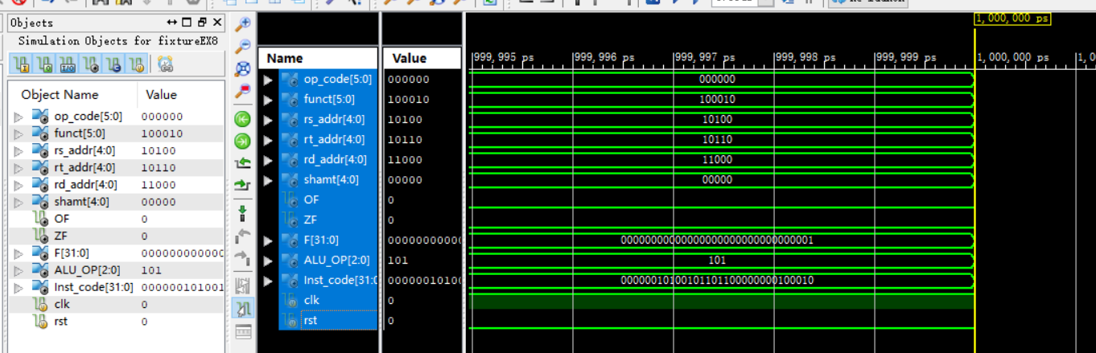

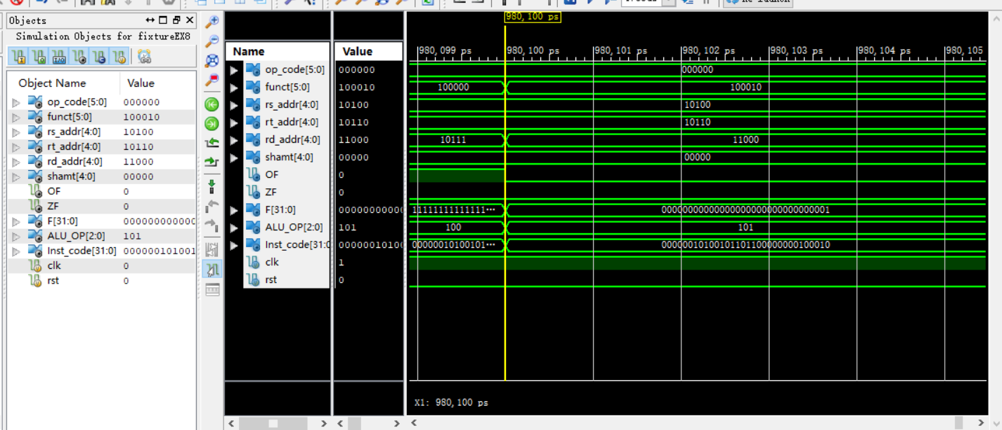

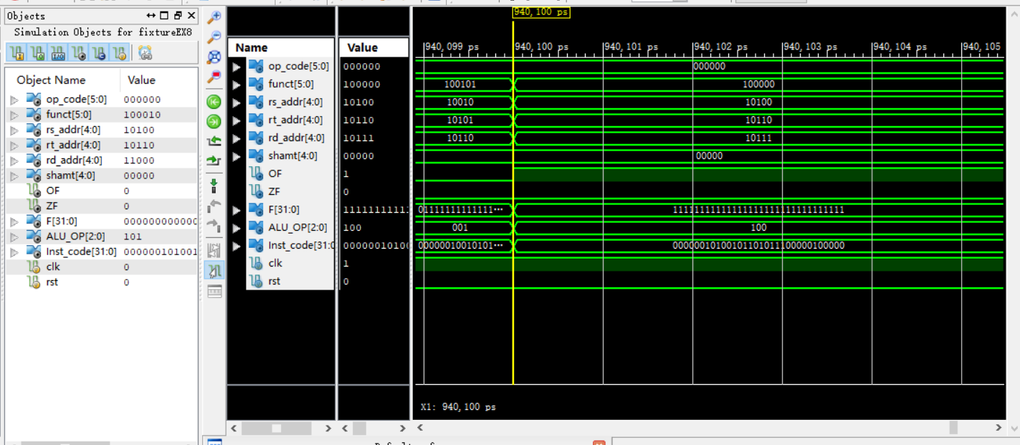

三、电路图
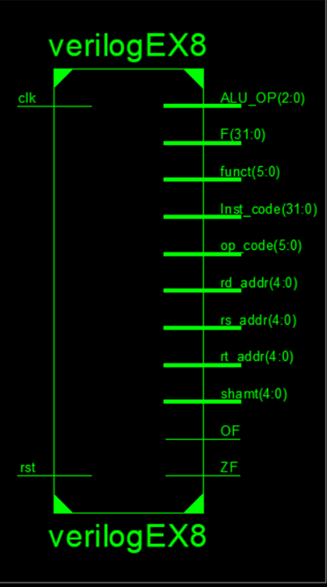

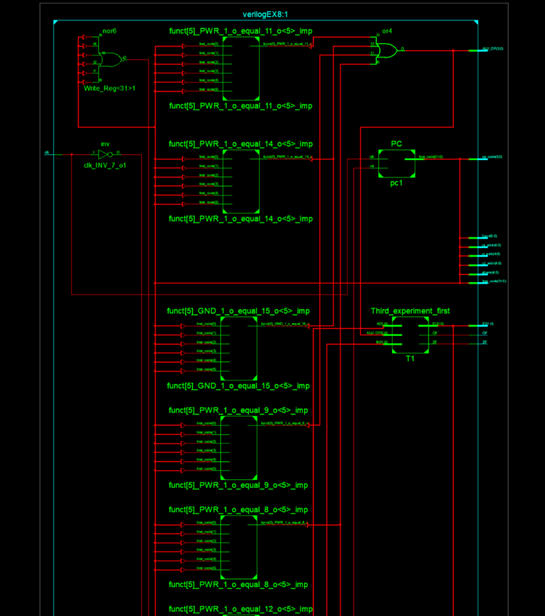

四、引脚配置（约束文件）
NET "OF" LOC = T3; //SW1
NET "ZF" LOC = U3; //SW1

NET "clk" LOC = AA4; //BTNR
NET "rst" LOC = R4; //BTNL

NET "F[31]" LOC = R1; //LED7
NET "F[30]" LOC = P2; //LED6
NET "F[29]" LOC = P1; //LED5
NET "F[28]" LOC = N2; //LED4
NET "F[27]" LOC = M1; //LED3
NET "F[26]" LOC = M2; //LED2
NET "F[25]" LOC = L1; //LED1
NET "F[24]" LOC = J2;
NET "F[23]" LOC = G1; //LED7
NET "F[22]" LOC = E1; //LED6
NET "F[21]" LOC = D2; //LED5
NET "F[20]" LOC = A1; //LED4
NET "F[19]" LOC = L3; //LED3
NET "F[18]" LOC = G3; //LED2
NET "F[17]" LOC = K4; //LED1
NET "F[16]" LOC = G4;
NET "F[15]" LOC = K1; //LED7
NET "F[14]" LOC = J1; //LED6
NET "F[13]" LOC = H2; //LED5
NET "F[12]" LOC = G2; //LED4
NET "F[11]" LOC = F1; //LED3
NET "F[10]" LOC = E2; //LED2
NET "F[9]" LOC = D1; //LED1
NET "F[8]" LOC = B1;
NET "F[7]" LOC = B2; //LED7
NET "F[6]" LOC = N3; //LED6
NET "F[5]" LOC = M3; //LED5
NET "F[4]" LOC = K3; //LED4
NET "F[3]" LOC = H3; //LED3
NET "F[2]" LOC = N4; //LED2
NET "F[1]" LOC = L4; //LED1
NET "F[0]" LOC = J4; //LED0

NET "ZF" PULLDOWN;
NET "OF" PULLDOWN;
NET "clk" PULLDOWN;
NET "rst" PULLDOWN;
NET "clk" CLOCK_DEDICATED_ROUTE = FALSE;

NET "ZF" IOSTANDARD = LVCMOS18;
NET "OF" IOSTANDARD = LVCMOS18;
NET "clk" IOSTANDARD = LVCMOS18;
NET "rst" IOSTANDARD = LVCMOS18;

NET "F[31]" IOSTANDARD = LVCMOS18;
NET "F[30]" IOSTANDARD = LVCMOS18;
NET "F[29]" IOSTANDARD = LVCMOS18;
NET "F[28]" IOSTANDARD = LVCMOS18;
NET "F[27]" IOSTANDARD = LVCMOS18;
NET "F[26]" IOSTANDARD = LVCMOS18;
NET "F[25]" IOSTANDARD = LVCMOS18;
NET "F[24]" IOSTANDARD = LVCMOS18;
NET "F[23]" IOSTANDARD = LVCMOS18;
NET "F[22]" IOSTANDARD = LVCMOS18;
NET "F[21]" IOSTANDARD = LVCMOS18;
NET "F[20]" IOSTANDARD = LVCMOS18;
NET "F[19]" IOSTANDARD = LVCMOS18;
NET "F[18]" IOSTANDARD = LVCMOS18;
NET "F[17]" IOSTANDARD = LVCMOS18;
NET "F[16]" IOSTANDARD = LVCMOS18;
NET "F[15]" IOSTANDARD = LVCMOS18;
NET "F[14]" IOSTANDARD = LVCMOS18;
NET "F[13]" IOSTANDARD = LVCMOS18;
NET "F[12]" IOSTANDARD = LVCMOS18;
NET "F[11]" IOSTANDARD = LVCMOS18;
NET "F[10]" IOSTANDARD = LVCMOS18;
NET "F[9]" IOSTANDARD = LVCMOS18;
NET "F[8]" IOSTANDARD = LVCMOS18;
NET "F[7]" IOSTANDARD = LVCMOS18;
NET "F[6]" IOSTANDARD = LVCMOS18;
NET "F[5]" IOSTANDARD = LVCMOS18;
NET "F[4]" IOSTANDARD = LVCMOS18;
NET "F[3]" IOSTANDARD = LVCMOS18;
NET "F[2]" IOSTANDARD = LVCMOS18;
NET "F[1]" IOSTANDARD = LVCMOS18;
NET "F[0]" IOSTANDARD = LVCMOS18;

- 思考与探索
因为32个LED灯都用来显示32位二进制结果了，那如何表示溢出和0呢？发现一个有趣的现象：作为输入的逻辑开关也可以接收输出的信号，当逻辑开关作为输入时，拨上开关，灯亮，如果此时代码中的输出信号也有时，两个信号或许会抵消？灯不亮。结果来看确实如此，但原理不明，也不是正确的用法，苦笑。
思考与探索第一题记录表：
序号 指令 执行结果 标志 结论
1 00000827 FFFFFFFF 00 正确
2 0001102B 0000_0001 00 正确
3 00421820 0000_0002 00 正确
4 00622020 0000_0003 00 正确
5 00832820 0000_0005 00正确
6 00A33020 0000_0007 00正确
7 00463804 0000_000E 00正确
8 00A64820 0000_000C 00正确
9 01215020 0000_7000 00正确
10 00284826 FFFF_8FFF 00正确
11 01215020 FFFF_8FFE 00正确
12 01075822 0000_6FF2 00正确
13 00E86022 FFFF_900E 00正确
14 012C6824 FFFF_800E 00正确
15 012C7025 FFFF_9FFF 00正确
16 00C77825 0000_FFFF 00正确

