|  |  |
| --- | --- |
| **To:** | Roya Solhmirzaei |
| **From:** | Team 4 - Yue Wang, Kelsee Horrom, Essam Aljahmi, and Renjie Chen |
| **Subject:** | Project 2 Memo Proposal |
| **Date:** | June 9, 2017 |

**Introduction:** In society, people have technology that they use in a broad range of ways everyday, take for example entertainment. This can benefit the society because for the user, it saves money, time and it is especially convenient. It saves money because the user does not have to buy a console such as a Xbox or Playstation to play specific types of games. It saves time because it is on the person’s device which is usually near the person at all times making it also convenient.

For example, for college students there is only so much space they have available for their things, so they think about if they want to bring their consoles, but they carry around their phones with them at all times. Another problem is while at college, students have pride in their school they are attending, but there are not many apps based on their school. With this in mind, the team objective is to use a MIT app Inventor to create an Android game based on the MSU campus.

The game must contain graphical user interface (GUI) with images, a professional appearance, and outputs of sound. Other capabilities the game can have are, GPS, storage of user information such as a high score, short message system (SMS) or text messages from the program that is in the game.

A constraint is the amount of time to figure out a design for an Android game. Also, it is hard to make a game that is not plagiarizing someone else's work because there are a wide range of games out already. After researching other games another restriction would be working out any problems in the program to make the game run on the Android phone.

One of the major issues was to make the location match the range of the GPS coordinates. Each single GPS location contains the latitudes and longitudes. In the program, it needs thousands of matching locations to complete the range of the matching area within the game. Another limit is trying to get the system’s permission to control the GPS, while in the simulator all the functions work, but on the smartphone, Google makes the security permission harder for the gamer to allow GPS availability. This means users would have to allow the game GPS accessibility through their Android phone system manually.

In addition, the game will have users spend time taking a survey to rate the game to improve it in the future. In the beginning of starting the app, users will receive a text message from the program after they put in their information. Also the user will receive notifications through text messages which adds to another problem that the team has to figure out.

**Results:** Some engineering principles to develop the expected results include teamwork, and design process. The team needs to define the problem and find out what is important. Then generate ideas for an app. Afterwards, compare each design then make a decision that best fits the requirements. Following that there is prototyping and testing. During the whole process, team members need to work together, consider sustainability of design, experimental design, make a suggestion survey for users that play the game, and follow the project timeline. Also, the team needs to avoid plagiarism in order to develop an app that is unique.

The expected result for first concept idea is that the game can detect a player's accurate location like which building in MSU they are at. The programming of the game can send the text message from player to player and can open two maps of the main page in the game which will help players enjoy the game.

The expected results for the second concept is have the players enjoy the game while having pride that their college is a game. With this in mind, the game should be relatable to all students and staff that attend MSU. The games’ expected results include SMS and keeping the scores from users. The SMS is used in the beginning for user verification and during the game to notify users.

The expected results for the third concept is it requires GPS capacity and SMS function, because the GPS capacity will provide data for the location matching. Then it will choose suitable questions for the users. In addition, the SMS function will provide users a choice to get help from their friends. So the expectation result is GPS matching with the main game system and the SMS play as the assistant function.

**Discussion:** Team 4 came up with three ideas Below there is an explanation of the three design concepts and sketches. Design Concept One: Demonstrated in Figure 1 below, when a student first plays the game, he or she must sign in an account using an Android phone. The program system will send a verification code through text message. The background of the game is an MSU building where players can only fight with the other players in that specific building. When students play this game, the program will test which building they are using GPS.

Students will go to the page of the building and will know their location by a green dot and other players by a red dot on a big map. In a small map, the players can control their location such as turn left or right, and go straight. They can also choose their player roles and weapons. The rule of the game is in the building, there are different levels of prizes in boxes giving players extra lives and so on at random. Players should get to the prize’s location as soon as possible to get the best prize.

When players meet other players, each player can only attack others one time. Each time, others will lose one life. If a player does not have any other lives, he or she will lose the game. Players cannot see other players lives. They can escape other players or win the battle. The players who attack and win get a score. The system of a game will record the player’s score and show the player's account when the player quits the game or loses the game. The player can quit or enter the game anytime. They will not have the same score the last time they played. Once players play the game again, their score will start at 0, but each score will still record in their account. Features GPS capability , SMS / text messages sent from the program , and storage of user information (i.e. a high score in a game).

The benefits of concept one are that this game is based on MSU buildings. After the game detects the player’s location, the game will send the player to the map of which building the player is in. For instance, if a player is in an engineering building, the player will find all of the players who play this game in the engineering building. If two friends play together, they will not attack each other because they have each other's ID name. A player only can see other players ID name rather than the level of player of how many lives the player has. The process of finding prizes and attacking other players is interesting for MSU students to play. The drawbacks of this concept is that players cannot make up a team and choose their weapons.

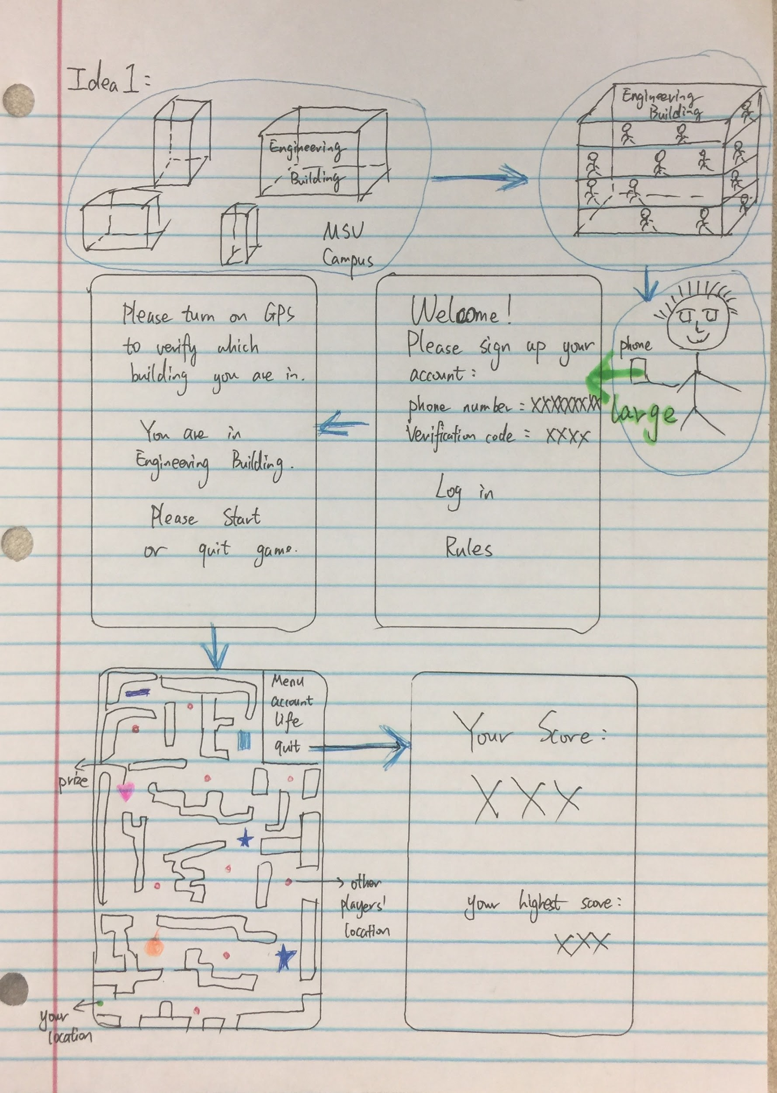

Figure 1: Concept One Sketches of Different Screens

Design Concept Two: Demonstrated in Figure 2 below, it would use MSU campus and have people pick out their characters that they want to be as students. Next, they have to go through levels which get harder as time goes on. In each level there could be different aspects like CATA buses, bicycles, cars, intoxicated people, police, parking police, puddles, snow banks, and squirrels the students would have to avoid to get across the street. After a couple of levels you have to eat at one of the places on campus like a dining hall or some food joint.

Another aspect of the game is students could rest at dorms to re-boost stamina for jump across little objects such as squirrels and trash for example. There will be a date in the corner which will be based on the school year such as the beginning of semester there will not be a hurry so the people will be walking, but near finals people will be freaking out and running. Also given on the weather it might slow or speed up the person. There will be a high score for whoever gets the most goodies per level which the gamer can collect money, paper, pencils, and an extra life anything really a student would find on the ground. The goodies will be scattered in the levels and probably will risk the life of the student. Also if the student makes it across there is advancement to the next level.

When a student gets hit the student will lose a life which the max could be five but the game starts with three. In the game, there can be messages to alert the gamer about the level for example “Today there is a football game, watch out for drunk people.” This game would use high scores, messaging in the program, interaction from the user to design their character, sound and other requirements.

Benefits of concept two include being relatable to everyone that attends MSU including staff members. There are many levels within this game that will challenge users. A drawback is there are only so many buildings and when a person completes the game there will not be any more levels available. Another drawback is holding the gamer’s interest to complete the game. There’s also the drawback that people will be playing this game while in class which is not good for MSU all together.

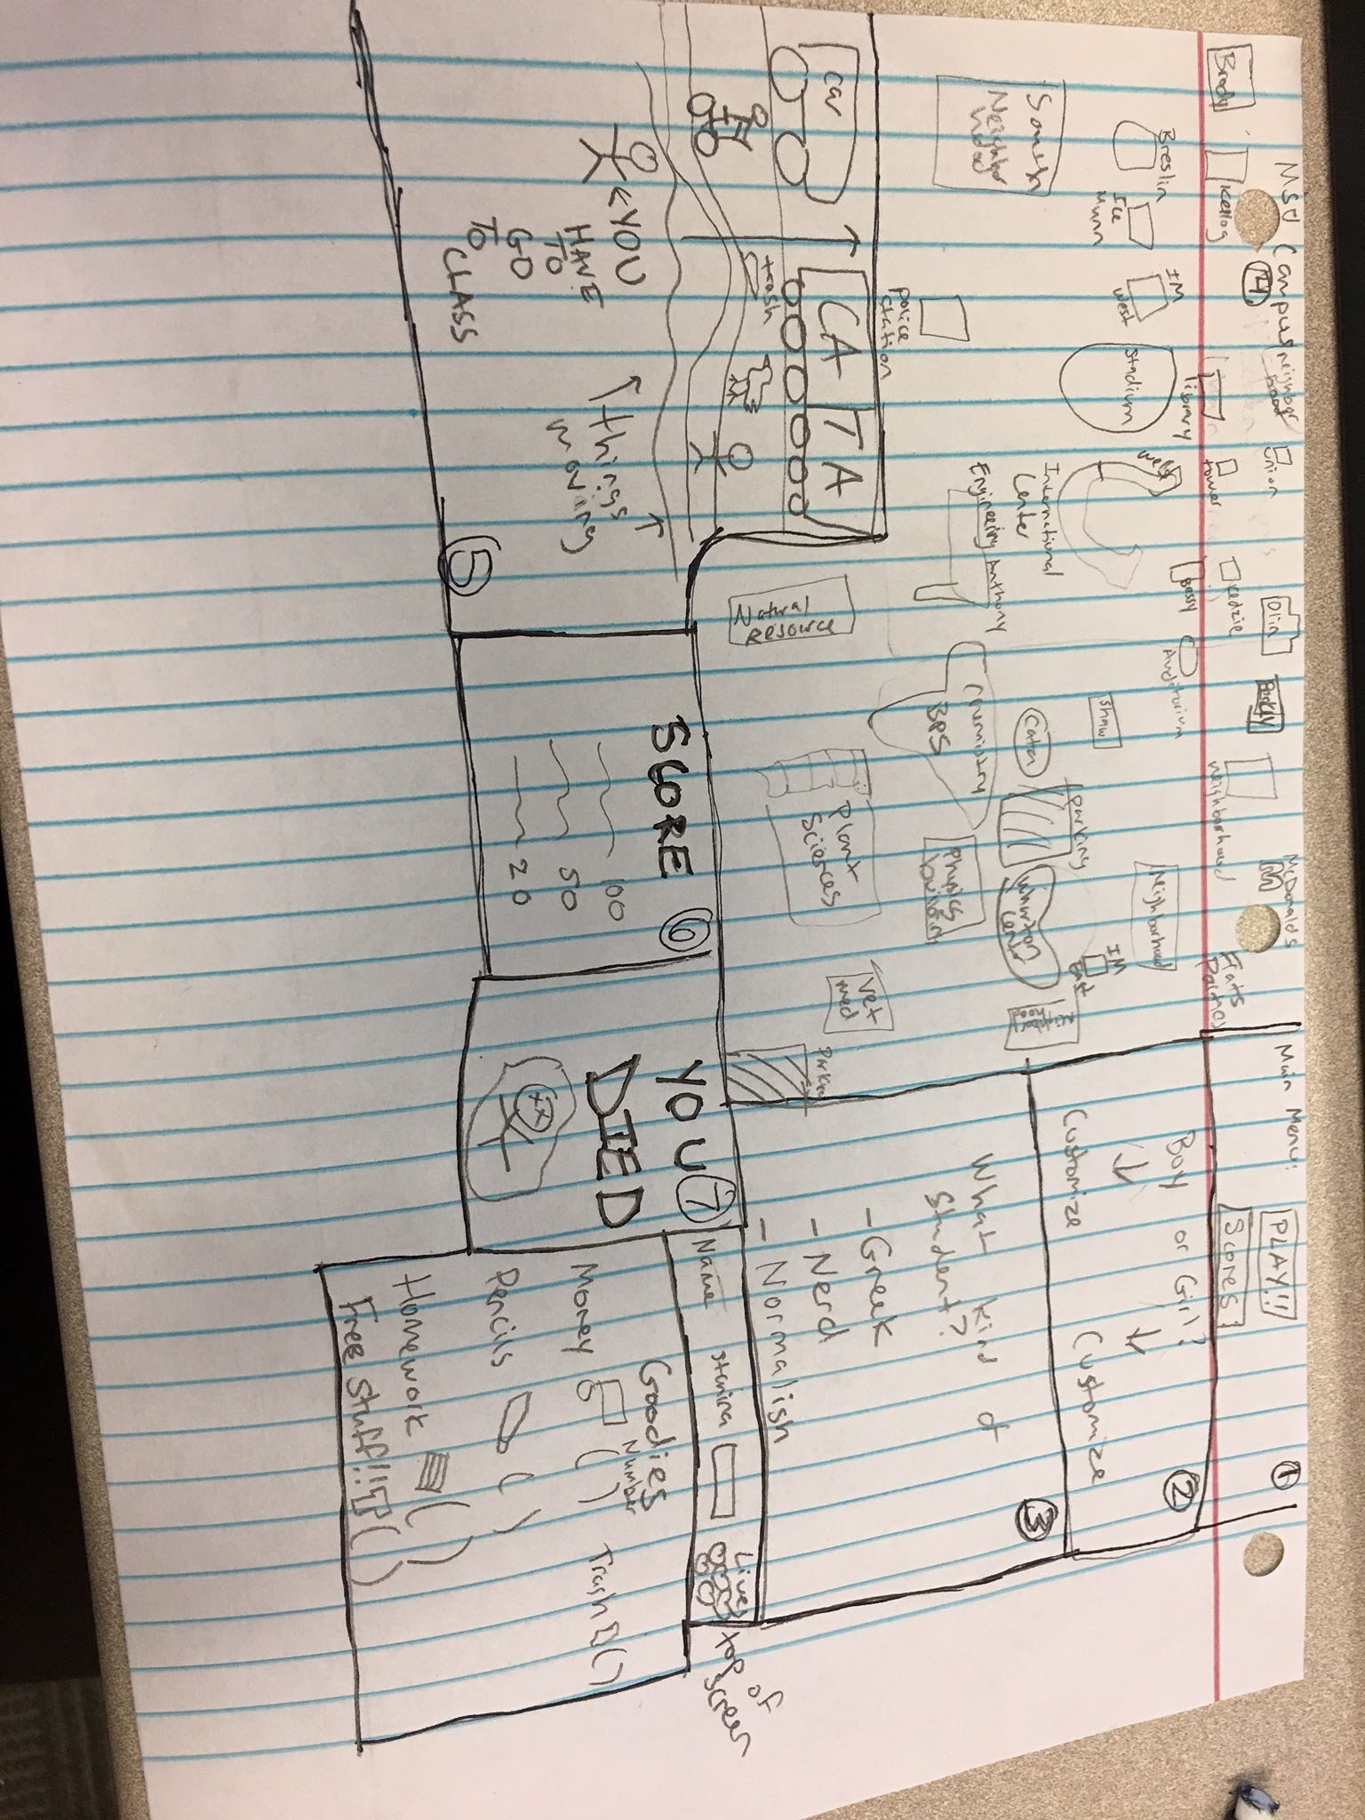

Figure 2: Concept Two Sketches of Different Screens

Design Concept Three: Demonstrated in Figure 3 below, in this game the major aspect will be the question and multiple choice based on the GPS position. For example, there are a huge number of the culture knowledge that people on campus does not know about which is important in life. which become less and less popular in recent years.

The main target of this game is to make the people such as tourists or students remember the local culture knowledge. It will also perform as a guidance application, because it provides the information about local culture and famous places in the area. In the design level, this game is based on the culture knowledge and GPS locations, for instance, when users open this app, the GPS will locate the position, then search the matching music, questions and picture from the local data or cloud data. Then users could get the information about the places and enjoy the trip and game. This is based in East Lansing and could be about history of MSU then relate to cultures that are at MSU to make people more aware of people around them.

A benefit of the third concept is having people enjoy the trips and learn background knowledge from the place they go. In fact, most of tourists do not know where to go when visiting a new destination. People should take part in travelling, which means they need to understand local people’s life, culture, or knowledge as the main goals. On the other hand, if users could understand this knowledge, then it will also help the society. However, the drawbacks of the game include the battery life will drop 20 percent or 50 percent per hour because it required many sensors to work, such as scores, and GPS.

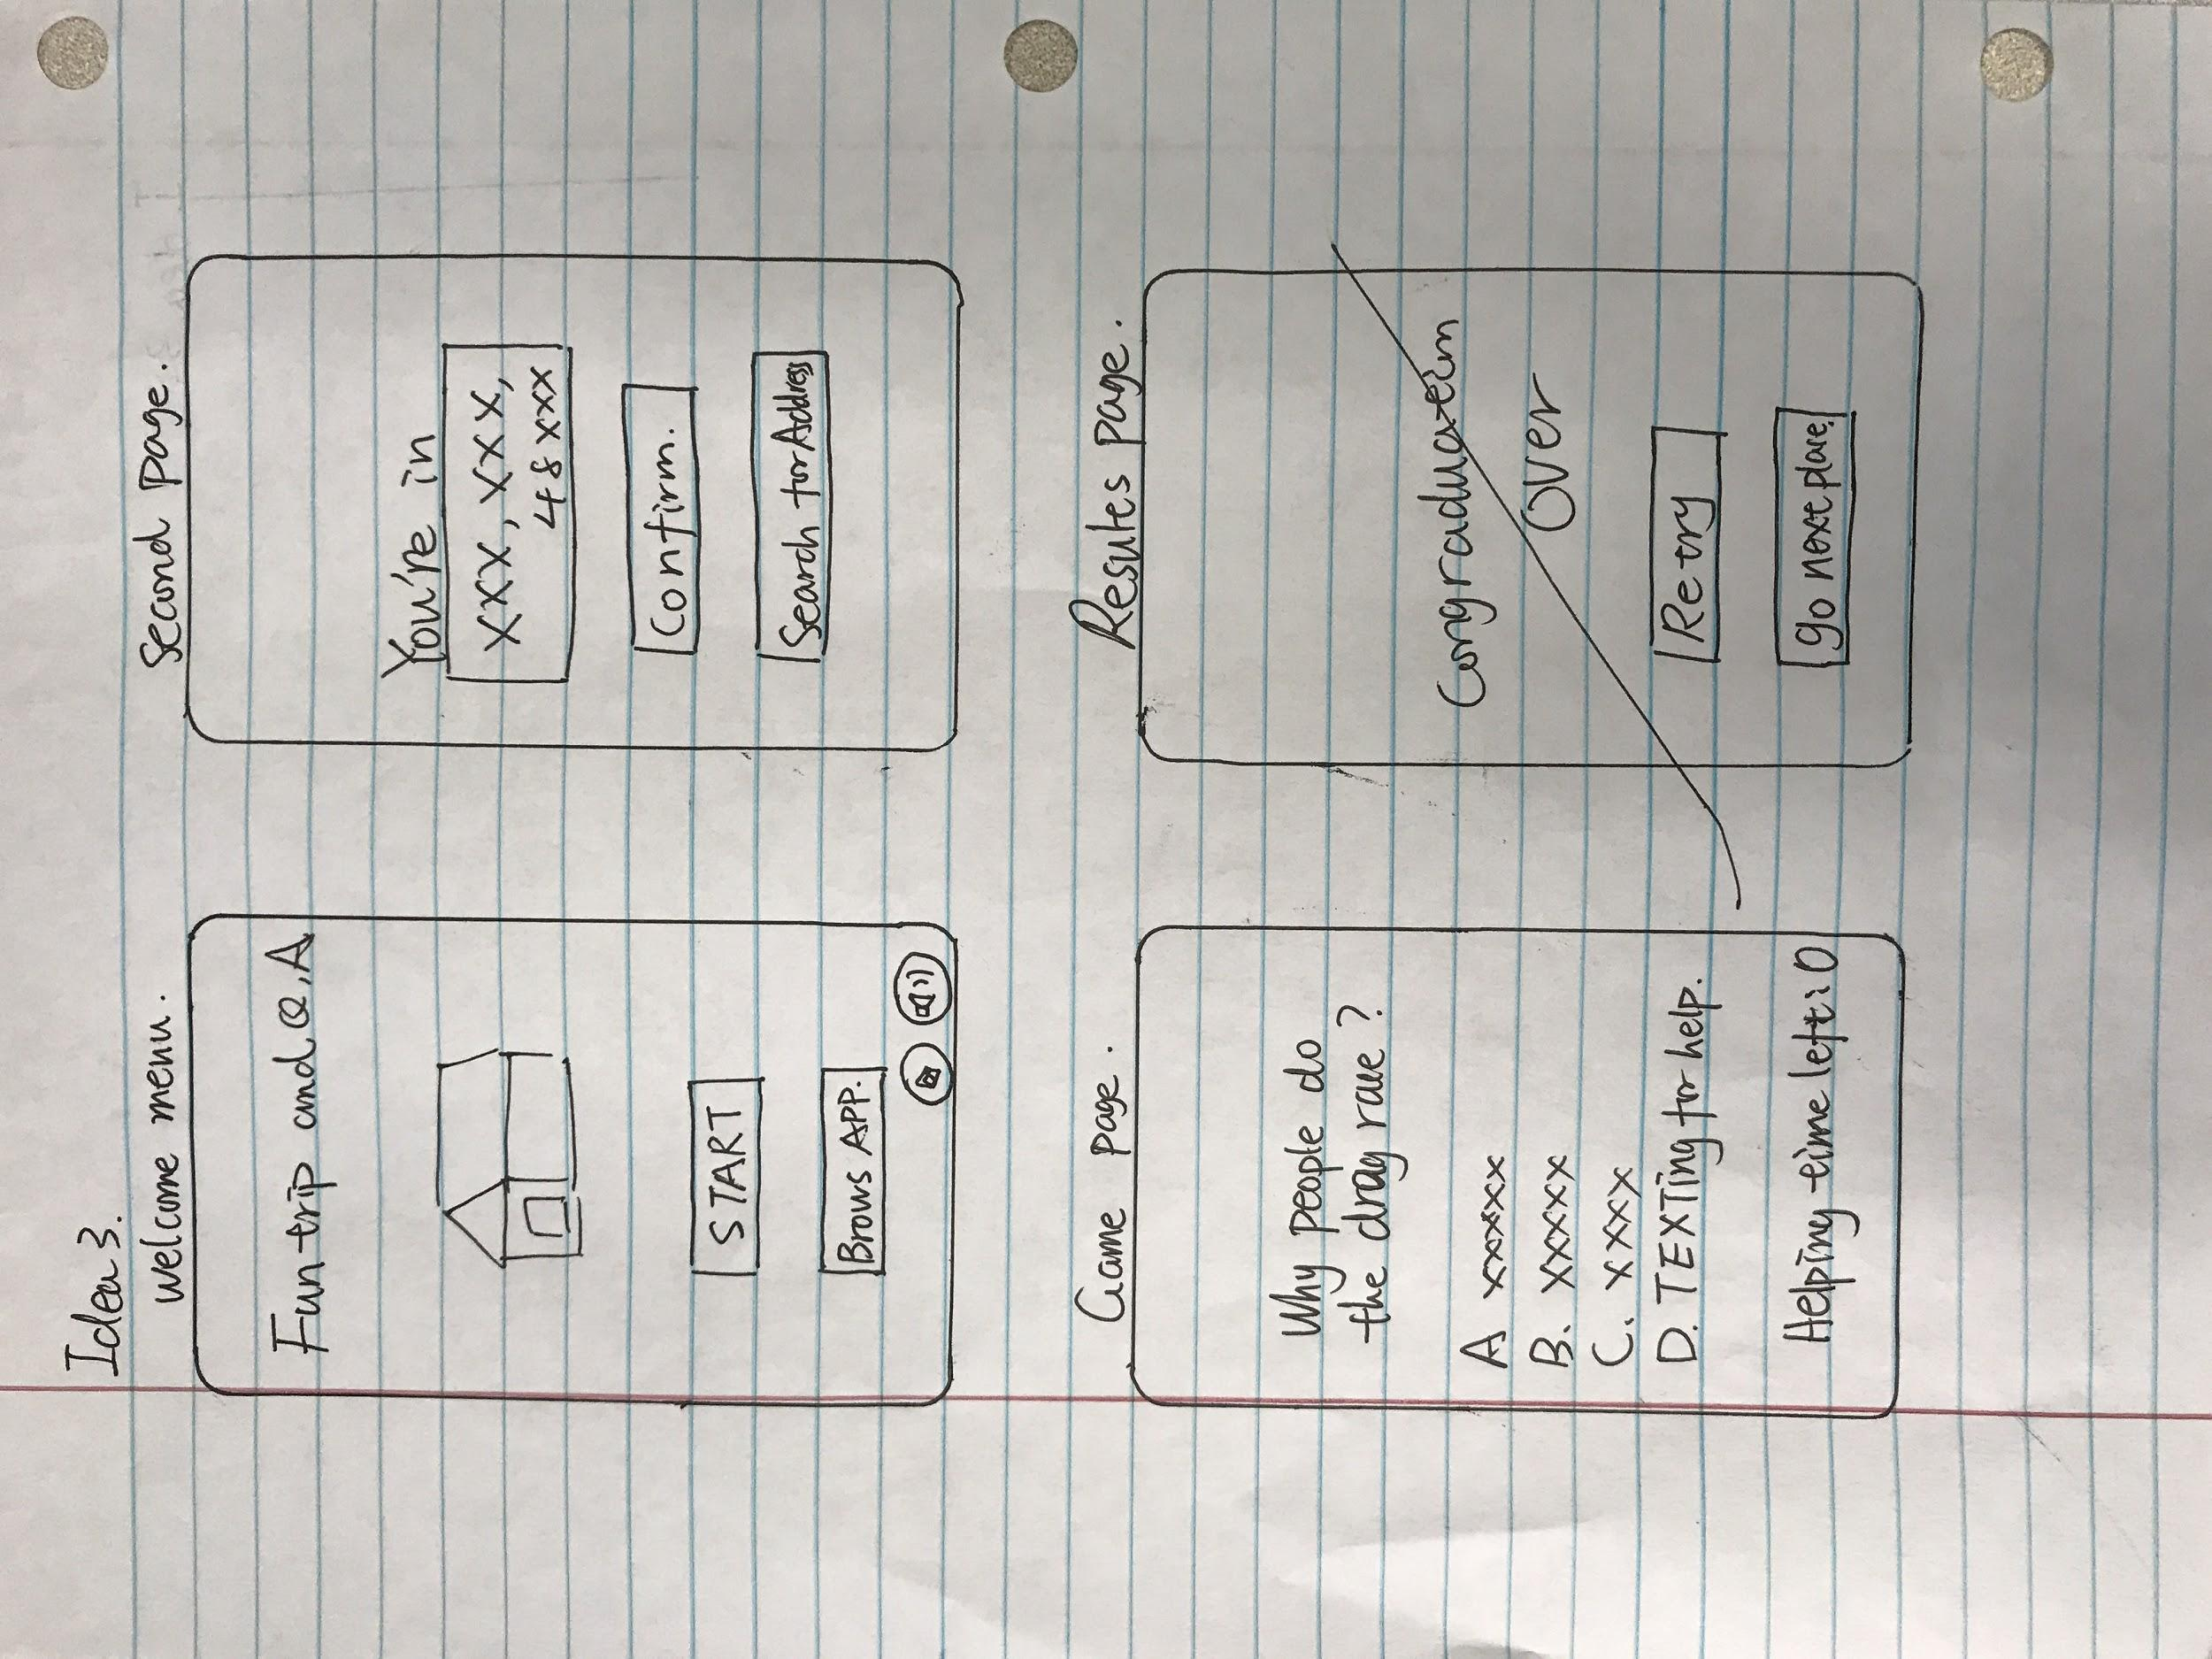

Figure 3: Idea Three Sketches of Different Screens