**Literature Reading Report: Gradual Reduction of Sugar in Soft Drinks Without Substitution as a Strategy to Reduce Overweight, Obesity, and Type 2 Diabetes: A Modelling Study**

Hui Chen

**BASIC INFORMATION**

**JOURNAL** Lancet Diabetes & Endocrinol (CiteScore 6.39, Impact Factor 24.54)

**TIME** Feb. 2016

**DOI** 10.1016/S2213-8587(15)00477-5

**AUTHORS** Yuan Ma, Feng J He, Kawther M Hashem, Yunjian Yin, Graham A MacGregor

**AFFILIATIONS** Queen Mary University of London, Peking University

**MAIN CONTENT**

**BACKGROUND** The British government's previous project of reducing salt intake has achieved remarkable results. Now, the salt content in British food is 30% - 40% less than before. Because this change is gradually completed, people do not notice the difference. This is a successful public health policy. People buy the same food, but the salt intake has decreased, and food companies will not lose profits, Instead, make healthier food. The principle of reducing sugar is similar to the principle of reducing salt. Now the author models similar strategies to be used in sugar control projects, which require reducing sugar content in sugary drinks. In the future, the author will try to study similar measures such as reducing saturated fat content. Due to the differences in the production technology of 100% juice and sugary beverage, the author considered them respectively in the analysis.

**DATA SOURCES**

1. UK soft drink sales data from 2005 to 2013 from the British Soft Drinks Association (BSDA) annual reports (Zenith International, a food and drink consultancy, from more than 100 soft drink producers)
2. National Diet and Nutrition Survey rolling programme (NDNS RP) from 2008 to 2012, with 4156 individuals (48% children, 47% men) involved
3. Household Food and Drink Waste in the UK 2012, where soft drink waste is recorded in a 7-day waste diary

**MODELING STEPS**

1. Exploratory - Soft drink consumption and BMI of adults in the UK

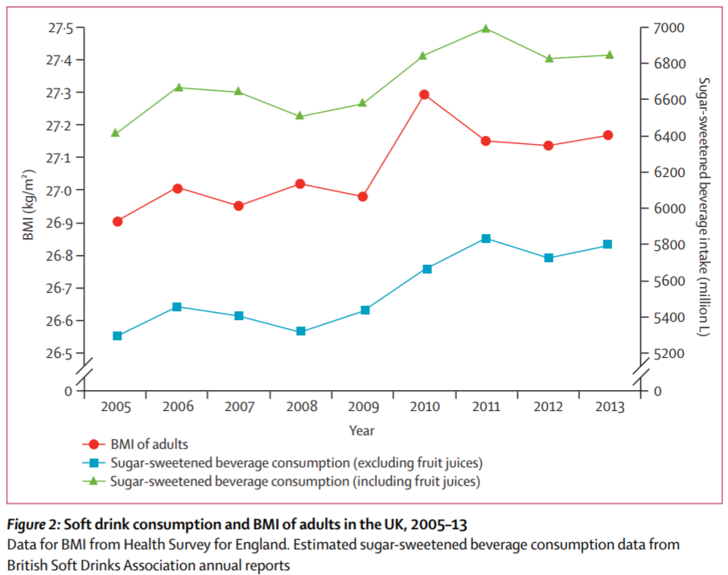

1. Main - Daily sugar-sweetened beverage consumption:

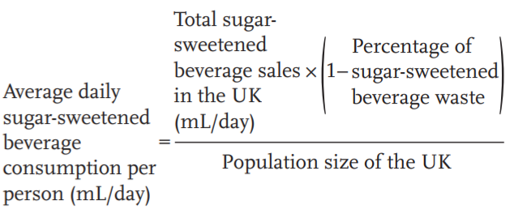

NOTE: waste (roughly 7% for general soft drink waste and 11% for fruit juices waste)

1. Main - Population distribution of sugar-sweetened beverage consumption: differences between NDNS and BSDA is regarded as identical individual under-reporting. The data in NDNS are then scaled up, so are free sugars and energy intake from consumption of sugar-sweetened beverages.
2. Main - The expected change in steady-state bodyweight for each adult at an individual level using the mathematical model proposed by Kevin Hall and colleagues.
3. Main - The number of obesity-related type 2 diabetes cases that would be prevented: a 1% reduction in BMI of the entire UK population would prevent 179 000–202 000 incident diabetes cases in two decades
4. Sensitivity Analysis - The robustness of the results with respect to the assumption that under-reporting occurred proportionally for all individuals: scenarios wherein the under-reporting of sugar-sweetened beverage consumption was higher in overweight or obese individuals and lower in normal weight or underweight individuals (with the total sugar-sweetened beverage consumption unchanged) is included in comparison, which has been the case in most dietary surveys.
5. Sensitivity Analysis - The robustness of the Kevin Hall model: i) “3500 kcal=1 lb” rule is used. ii)Christiansen and Garby model.

**MAIN RESULTS**

In short, by reducing the amount of free sugar in sugary drinks by 40% in five years and by an average of 38.4 calories / day at the end of five years, the UK's overweight rate and obesity rate can be reduced by 1.0% and 2.1%. If this initiative continues, at least 274000 new cases of type 2 diabetes can be reduced in the next 20 years, which will have a profound public health impact in the UK and even in the world.

1. Reduced consumption of sugary drinks and sugars: Daily sugar-sweetened beverage consumption contributed to 47 g (43.9%) and 49 g (44.5%) of total free sugar intake, and 182 kcal (7.1%) of the daily energy intake in adolescents and 185 kcal (6.6%) of the daily intake in young adults, both exceeding the UK SACN’s recommendation of a daily free sugar intake of no more than 5% of daily energy intake.

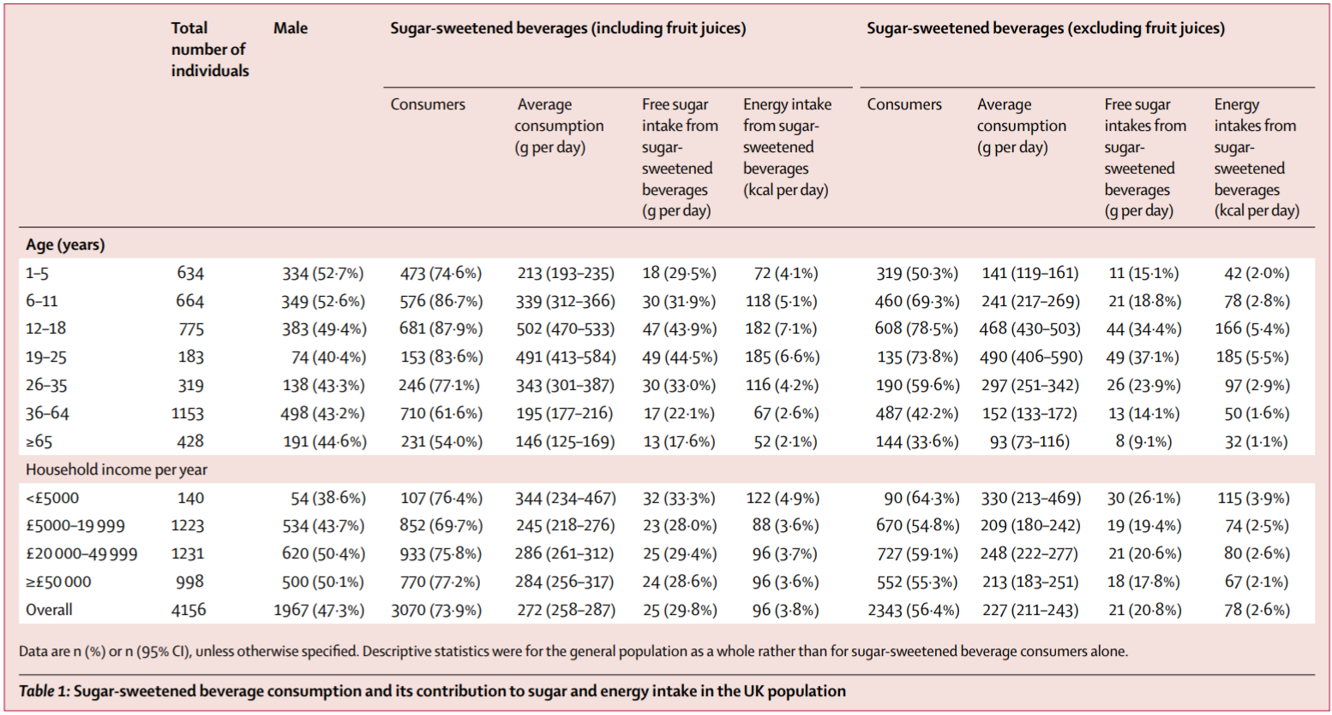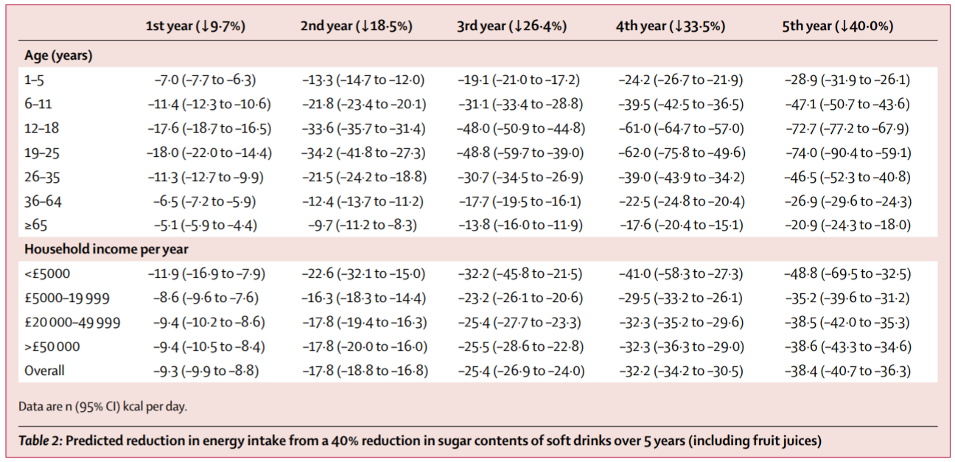

1. Weight loss: The average reduction in steady-state bodyweight is predicted to be 1.20 kg (95% CI 1.12–1.28; ﬁgure 3), resulting in a reduction in the prevalence in adults of overweight by 1.0 percentage point (from 35.5 % to 34.5%) and obese by 2.1 percentage points (from 27.8% to 25.7%). This reduction would amount to roughly 0.5 million cases of overweight and 1.0 million cases of obesity being reduced in the UK.

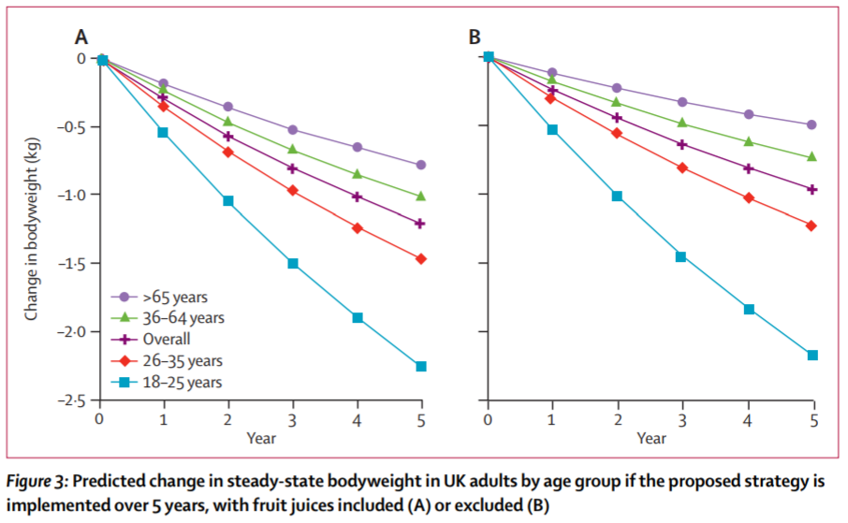

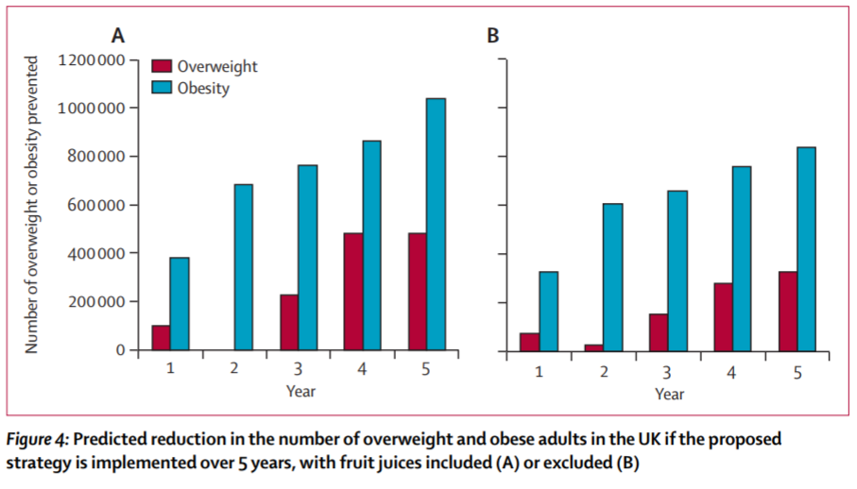

1. BMI and diabetes decline: The BMI of UK adults is predicted to be reduced from 27·48 kg/m² in 2010 to 27·06 kg/m² when the predicted reduction in bodyweight is achieved, representing a 1·5% reduction. This reduction would in turn prevent about 274 000–309 000 incident cases of type 2 diabetes over the subsequent two decades (ie, roughly 15 000 per year).
2. When juice is excluded: The predicted reduction in average BMI (from 27·48 to 27·14 kg/m²) in the analysis excluding fruit juices is estimated to prevent around 221 000–250 000 diabetes cases over two decades after the predicted reduction in bodyweight is achieved.

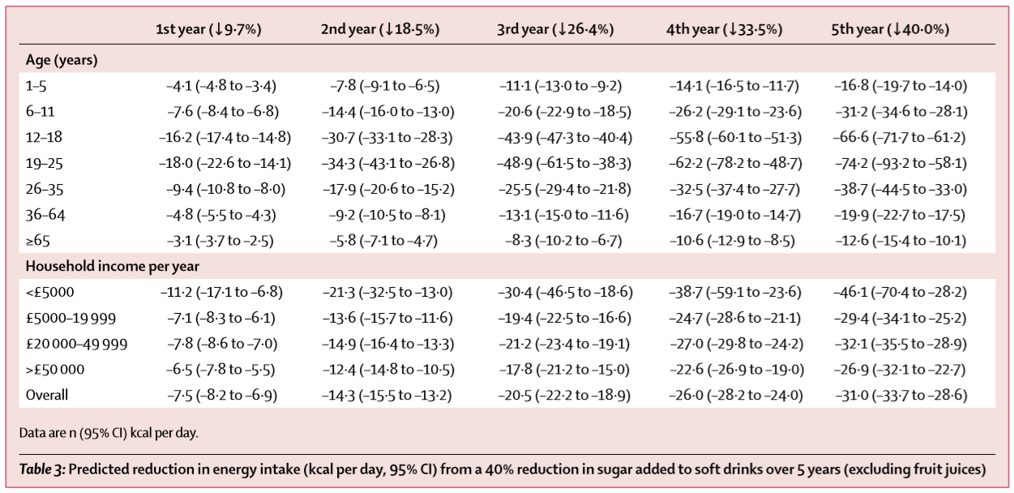

1. Sensitivity Analysis 1: With the increase in the proportion of under-reporting of sugar-sweetened beverage consumption by overweight and obese individuals and the decrease in the proportion of under-reporting by normal weight and underweight individuals, the reduction in the average bodyweight of all adults was larger than in the main analysis.
2. Sensitivity Analysis 2: If the “3500 kcal=1 lb” is used, the average cumulative reduction in energy intake would be around 14 016 kcal, which would lead to an average reduction in bodyweight of about 1·80 kg (95% CI 1·70–1·91). Alternatively, if the model proposed by Christiansen and Garby was used to predict the change in steady-state bodyweight, the average reduction would be 1·55 kg (1·44–1·65).

**ILLUMINATIONS**

1. Without changing the food environment, eﬀective behavioural interventions targeted at individuals have been shown not to be sustainable in the long term. And changing the nutritional composition of food from the production side will produce better results.
2. The reduction in sugar intake will reduce the obesity-related disease burden, including diabetes, and also lead to cost savings for health-care systems.
3. The UK's salt reduction program has produced remarkable results. This paper studies the effect of sugar reduction through modeling, and will be extended to fat reduction in the future. It is helpful for us to study public health policy from the perspective of nutrients.
4. Previous studies have found that the effect of sweet substitutes on weight loss is controversial and may further affect the reward mechanism of human body. The method adopted in this paper is to reduce sugar content year by year and cultivate consumption habits.
5. In this paper, the author also compares this policy with the tax policy, which reduces the demand by increasing the price of sugar drinks. The author thinks that the combination of tax policy and the policy discussed in this paper will produce better effect.

**EVALUATIONS**

**STRENGTHS**

1. Similar policies have proved effective.
2. National data is used to reduce bias.
3. Sales data and diary data were combined to address the highly prevalent issue of diet misreporting.
4. Robustness analysis shows that the results of this paper are conservative.

**LIMITATIONS**

1. Because it is assumed that the reported bias of different populations is the same proportion, the results of this paper may be relatively underestimated.
2. Data from multiple sources used are not necessarily proportionate.
3. Only adult weight changes are predicted. This is because the adult model is not suitable for children.

**APPENDIX**

**The Kevin & Peter Model**

If a patient wishes to change his or her body weight by a certain amount (ΔBW), how would his or her diet or physical activity have to change to maintain the goal weight? Proposed model of steady-state body-weight change, model developed by Kevin D Hall and Peter N Jordan can be described as follows:

EE=K+βEI+γFFMFFM+γFMFM+δ(FFM+FM)

where EE means energy expenditure, EI means energy intake, K is a constant, γFFM = 22 kcal·kg−1·d−1, and γFM = 3.2 kcal·kg−1·d−1 are the regression coefficients for resting metabolic rate versus fat-free mass (FFM) and fat mass (FM), respectively. It is assumed that the energy cost of most physical activities is proportional to body weight and is thus specified by the parameter δ. The parameter β accounts for the thermic effect of feeding as well as any adaptations of the EE rate beyond that predicted by body-composition change alone. Because there is significant debate as to whether such adaptations occur with weight loss, the numerical value of the parameter β was determined by the best fit to the weight-change data (described in the final paragraph of the Materials and Methods section).

When the body weight is maintained at a constant reduced level, the EE rate equals the EI rate. Therefore, if the dietary intake changes by ΔEI, and the physical activity changes by Δδ, the following equation is satisfied at the new steady state:

ΔEI=βΔEI+(γFFM+δinit+Δδ)ΔFFM+(γFM+δinit+Δδ)ΔFM+BWinitΔδ

where BWinit is the initial body weight, and ΔFM and ΔFFM are the changes in body fat and FFM, respectively. (Note that the constant, *K*, no longer appears, so we need not specify its value.) Using the fact that ΔBW = ΔFFM + ΔFM, the following equation holds for the change in FFM:

ΔFFM=[(1−β)ΔEI−BWinitΔδ−(γFM+δinit+Δδ)ΔBW]/(γFFM−γFM)

Previously published modification of the classic Forbes equation of body-composition change (22) predicts that the change in FFM is given by the following nonlinear function:

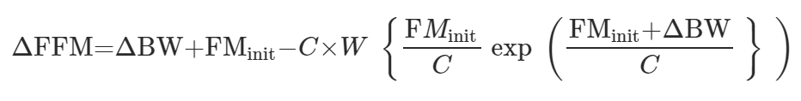

where FMinit is the initial body FM, C = 10.4 kg is the constant providing the best fit to the empirical Forbes body-composition curve, and W is the Lambert W function. Equations can be solved for the expected change in steady-state body weight, as shown in the following equation: