Report of Computer Exercise 4

Zihan Wang 2022312876

**Experiment 5**

1. Design an MLP classifier and write your own codes for it. Use TrainingSet-1 to train the MLP. Show the learning curve. Calculate the training error and the cross-validation error on the training set.

My designed MLP use SoftMax function for output activation, ReLU function for hidden activation. Also, 20% of data in training set is split for validating. I tried many combinations of the number of hidden layers and the learning rate (See the experiment log in **datafile.pdf**). Overall, the best result occurs when the number of hidden layers is 100 and the learning rate is 0.0005. The minimum training and validation error occurs in the 200th iteration. The training error is 0.296 and the validation error is 0.36.

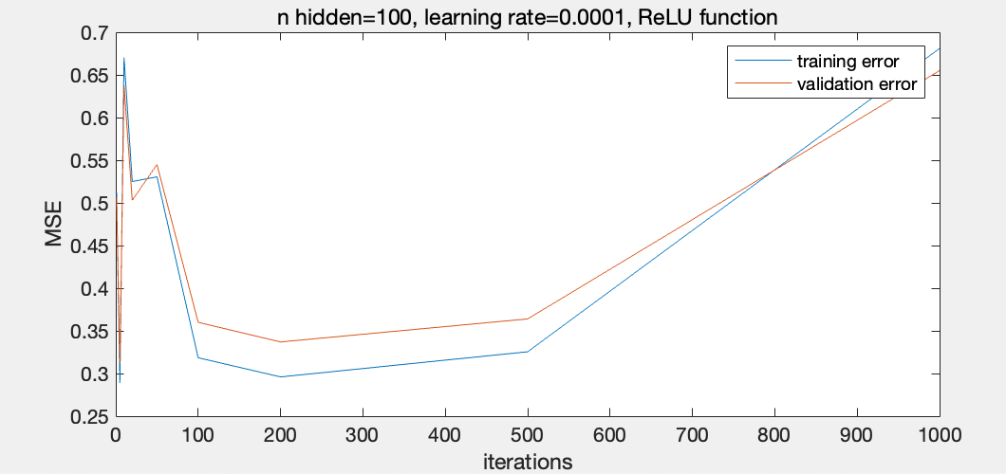

1. Apply the trained MLP classifier on TestSet-1. Calculate the test error.

The test error is 0.299 with a 100 hidden layer MLP trained in 0.0005 training rate for 200 iterations.

1. Try some different choices in the preprocessing of features and in some settings of the training procedures to study their effects on the model performance. Discuss on your observations in the experiments.

From the experiment log in **datafile.pdf** we can see that either too large (0.01) or too small (0.0001) learning rate won’t give good result. For our task, 0.0005 learning rate seems to be a more balanced option. As to the preprocessing, I found that, if only use the standard scaler without turn the exponential distributed data into Gaussian distribution, the result will also be bad.

