**MINISTRY OF EDUCATION**

DIPLOMA IN

INFORMATION COMMUNICATION TECHNOLOGY

**KENYA INSTITUTE OF CURRICULUM DEVELOPMENT STUDY NOTES**

**Computer Application II**

**MODULE 2: SUBJECT NO 5**

**Contents**

**CHAPTER 1: FINAN** 5

**CIAL APPLICATIONS** ...............................

Fundamentals of accounting 5

Definition of accounting 5

Basic Accounting Principles 5

Elements of Accounting 5

Accounting Equation 6

Double Entry Accounting System 7

The Accounting Cycle 7

Bookkeeping vs Accounting 7

Bookkeeping and Transaction Entry system 8

Single-entry system 9

Double-entry system 9

Ledgers 10

Recording Transactions 13

Understanding QuickBooks Lists 23

Transactions in QuickBooks 34

Reporting on Lists 38

**CHAPTER 2: COMPUTER AIDED DESIGN (CAD)** 40

Fundamental of technical drawing 40

Meaning and importance of computer-aided design 42

AutoCAD 44

Career and application Information of AutoCAD 44

Advantages of a CAD system 45

Features of a CAD system 45

Typical screen layout of a CAD system 49

AutoCAD's Cartesian Workspace 50

AutoCAD configuration- Units and Scales 52

Basic AutoCAD Commands 56

Projection 70

**CHAPTER 3: GEOGRAPHYCAL INFORMATION SYSTEM (GIS)** 75

What is GIS – Definition? 75

History of GIS: 76

Component of GIS: 77

Area of GIS Applications 77

GIS Data Models 78

GIS Data Types 78

Sources of Data 88

Data Input Techniques 90

CHAPTER 4: ARTIFICIAL INTELLIGENCE 95

What is Artificial Intelligence? 95

Goals of AI 95

Benefits and Challenges of Artificial Intelligence 95

Pros of Artificial Intelligence: 95

The Cons of Artificial Intelligence 96

What Contributes to AI? 97

History of AI 99

AI - Intelligent Systems 100

Meaning of Intelligence 100

Types of Intelligence 100

Composition of Intelligence 101

Difference between Human and Machine Intelligence 102

AI – Category Research Areas 103

Neural Networks 103

Robotics 105

Fuzzy Logic Systems 106

AI - Natural Language Processing 110

Expert Systems 113

Speech and Voice Recognition 119

Task Classification of AI 120

AI - Agents & Environments 122

Nature of Environments 126

Breakthroughs Unleashing AI on the World 127

**CHAPTER 1: FINANCIAL APPLICATIONS**

**Fundamentals of accounting**

**Definition of accounting**

It is a systematic process of identifying, recording, measuring, classifying, verifying, summarizing, interpreting and communicating financial information. It reveals profit or loss for a given period, and the value and nature of a firm's assets, liabilities and owners' equity. *Accounting* provides information on the.

**Basic Accounting Principles**

Accounting assumptions and principles provide the bases in preparing, presenting and interpreting general-purpose financial statements.

The basic principles that accountants follow include:

1. Accrual – Income is recognized when earned regardless of when collected, and expenses are recognized when incurred regardless of when paid.
2. Going Concern – Also known as *continuing concern concept* or *continuity assumption,* it means that a business entity will continue to operate indefinitely.
3. Accounting Entity Concept – A specific business enterprise is treated as one accounting entity,

*separate and distinct* from its owners.

1. Time Period Assumption – The indefinite life of an enterprise is subdivided into time periods or accounting periods which are usually of equal length for the purpose of preparing financial reports.
2. Monetary Unit Assumption – Transactions are recorded in terms of money *(quantifiability)*. The

currency used has a stable purchasing power *(stability).*

**Elements of Accounting**

The elements of accounting pertain to **assets**, **liabilities**, and **capital**. *Assets* are resources owned by a company; *liabilities* are obligations to creditors and lenders; and *capital* refers to the interest of the owners in the business after deducting all liabilities from all assets (or, what is left for the owners after all company obligations are paid).

**Assets:** Assets can be classified as current or non-current. An asset is considered current if it is for sale, if it can be realized within 12 month from the end of the accounting period or within the company's normal operating cycle if it exceeds 12 months. In addition, cash is generally considered current asset.

Current assets include: *Cash and Cash Equivalents, Marketable Securities, Accounts Receivable, Inventories, and Prepaid Expenses*. Assets that do not meet the criteria to be classified as current are, by default, non-current assets. Examples of non-current assets are: *Long-term Investments; Property, Plant and Equipment; and Intangibles.*

**Liabilities:** Liabilities can also be classified as current or non-current. A liability is considered current of they are payable within 12 months from the end of the accounting period, or within the company's normal operating cycle if the cycle exceeds 12 months.

Current liabilities include: *Accounts Payable, Short-term Notes Payable, Tax Payable, Accrued Expenses, and other short-term obligations.* Non-current liabilities include those that do not meet the above criteria. Examples of non-current liabilities are: *Loans Payable and Bonds Payable which are long-term in nature, and Deferred Tax Liabilities.*

**Capital:** Capital refers to the interest of the owner/s of the business. The owner's interest is the value of total assets left after all liabilities to creditors and lenders are settled. Capital is *increased by contributions by the owner/s* and *income*. It is *decreased by withdrawals by owners (dividends in corporations)* and *expenses.*

**Income:** Income refers to an increase in assets or decrease in liability, and an increase in capital other than that arising from contributions made by owner/s. Examples of income accounts include: *Sales, Service Revenue, Professional Fees, Interest Income, Rent Income, and others.*

**Expense:** Expenses result in decrease in assets or increase in liabilities, and decrease in capital other than those arising from withdrawals of the owner/s. Some examples are: *Cost of Sales, Salaries Expense, Rent Expense, Utilities Expense, Delivery Expense, and others.*

**Accounting Equation**

The accounting equation shows the relationships between the accounting elements: assets, liabilities and capital. The basic accounting equation is:

**Assets = Liabilities + Capital**

It shows that assets owned by a company are coupled with claims by creditors and lenders, and by the owners of the business.

When business transactions take place, the values of the elements in the accounting equation change. Nonetheless, the equation always stays in balance. This is due to the two-fold effect of transactions. The total change on the left side is always equal to the total change on the right. Thus, the resulting balances of both sides are equal.

The accounting equation may be rewritten as:

*Liabilities = Assets - Capital,* or *Capital = Assets - Liabilities*.

The capital element may also be spread-out into its components, and thus resulting into the expanded accounting equation:

**Assets = Liabilities + Capital - Withdrawals + Income - Expenses**

or

**Assets = Liabilities + (Capital, beginning + Additional Contributions - Withdrawals + Income - Expenses)**

**Double Entry Accounting System**

The double entry accounting system recognizes a two-fold effect in every transaction. Thus, business transactions are recorded in at least two accounts.

Under the double entry accounting system, transactions are recorded through debits and credits. Debit means left. Credit means right. The effect of recording in debit or credit depends upon the normal balance of the account debited or credited.

The general rules are: to *increase an asset*, you debit it; to *decrease an asset*, you credit it. The opposite applies to liabilities and capital: to *increase a liability or a capital* account, you credit it; to *decrease a liability or a capital* account, you debit it. *Expenses* are debited when incurred, and *income* is credited when earned.

**The Accounting Cycle**

The accounting cycle is a sequence of steps in the collection, processing, and presentation of accounting information. It is made up of the following steps:

1. Identifying and analyzing business transactions and events
2. Recording transactions in the journals
3. Posting journal entries to the ledger
4. Preparing an unadjusted trial balance
5. Recording and posting adjusting entries
6. Preparing an adjusted trial balance
7. Preparing the financial statements
8. Recording and posting closing entries
9. Preparing a post-closing trial balance

Reversing entries may be prepared at the *beginning* of the new accounting period to enable a smoother recording process. In this step, some *adjusting entries* are simply reversed. Nevertheless, reversing entries are *optional*.

**Bookkeeping vs Accounting**

It is very common for non-accountants to think that bookkeeping and accounting are of the same thing. Although they both involve the process of recording the financial transactions of a business, bookkeeping and accounting are two different topics.

**Bookkeeping** is the process of recording, in chronological order, the daily transactions of a business entity. It forms part of the accounting information system.

**Accounting** is an information system – includes the process of recording, classifying, summarizing, reporting, analyzing and interpreting the financial condition and performance of a business – in order to communicate it to stakeholders for business decision making.

**Illustration**

To provide a clear understanding of the difference between bookkeeping and accounting, take a look at this sample illustration.

Imagine there‘s one piece of apple pie divided into 6 slices. Each slice was given a corresponding name as recording, classifying, summarizing, reporting, analyzing, and interpreting. The whole one piece of apple pie is called the accounting information system which represents accounting. On the other hand, bookkeeping represents one slice of the apple pie which is recording.

**The Accounting Process**

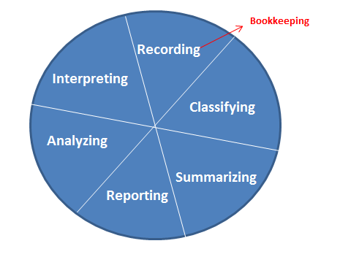

**Bookkeeping and Transaction Entry system**

Systematic recording of financial aspects of [business transactions](http://www.businessdictionary.com/definition/business-transaction.html) in appropriate [books of](http://www.businessdictionary.com/definition/books-of-account.html) [account](http://www.businessdictionary.com/definition/books-of-account.html)

Bookkeeping is the recording, on a day-today basis of the financial transactions and information pertaining to a business.

**Entry systems:** Two common bookkeeping systems used by businesses and other organizations are the single-entry bookkeeping system and the double-entry bookkeeping system. Single-entry bookkeeping uses only income and expense accounts, recorded primarily in a revenue and expense journal. Single- entry bookkeeping is adequate for many small businesses. Double-entry bookkeeping requires posting (recording) each transaction twice, using debits and credits.

**Single-entry system**

The primary bookkeeping record in single-entry bookkeeping is the cash book, which is similar to a checking (cheque) account register but allocates the income and expenses to various income and expense accounts. Separate account records are maintained for petty cash, accounts payable and receivable, and other relevant transactions such as inventory and travel expenses. These days, single entry bookkeeping can be done with DIY bookkeeping software to speed up manual calculations.

**Double-entry system**

A double-entry bookkeeping system is a set of rules for recording financial information in a financial accounting system in which every transaction or event changes at least two different nominal ledger accounts.

**Double-entry bookkeeping**, in accounting, is a system of bookkeeping so named because every entry to an account requires a corresponding and opposite entry to a different account. For instance, recording earnings of $100 would require making two entries: a debit entry of $100 to an account called "Cash" and a credit entry to an account called "Income."

In the double-entry accounting system, two accounting entries are required to record each financial transaction. These entries may occur in asset, liability, income, expense, or capital accounts. Recording of a debit amount to one or more accounts and an equal credit amount to one or more accounts results in total debits being equal to total credits for all accounts in the general ledger. If the accounting entries are recorded without error, the aggregate balance of all accounts having positive balances will be equal to the aggregate balance of all accounts having negative balances. Accounting entries that debit and credit related accounts typically include the same date and identifying code in both accounts, so that in case of error, each debit and credit can be traced back to a journal and transaction source document, thus preserving an audit trail. The rules for formulating accounting entries are known as "Golden Rules of Accounting". The accounting entries are recorded in the "Books of Accounts". Regardless of which accounts and how many are impacted by a given transaction, the fundamental accounting equation A = L + OE will hold, i.e. assets equals liabilities plus owner's equity.

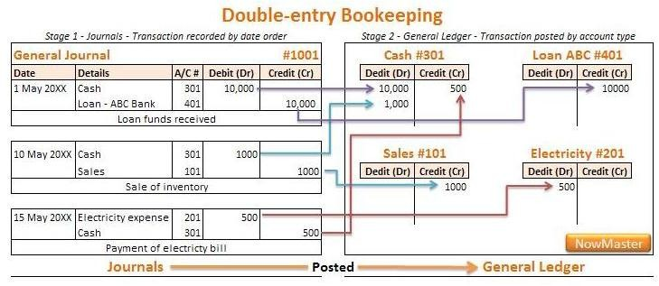

**Ledgers**

A ledger is a record of accounts. These accounts are recorded separately showing their beginning/ending balance.

A journal lists financial transactions in chronological order without showing their balance but showing how much is going to be charged in each account.

A ledger takes each financial transaction from the journal and records it into the corresponding account for every transaction listed. The ledger also sums up the total of every account which is transferred into the balance sheet and income statement. There are 3 different kinds of ledgers that deal with book-keeping. Ledgers include:

* Sales ledger, which deals mostly with the accounts receivable account. This ledger consists of the financial transactions made by customers to the business.
* Purchase ledger is a ledger that goes hand and hand with the Accounts Payable account.

This is the purchasing transaction a company does.

* General ledger representing the original 5 main accounts: assets, liabilities, equity, income, and expenses

**The ledger** is a special book in which transactions are recorded. In other words, a book in which accounts are kept.

The ledger differs from other books in the way columns are drawn to record transactions as follows:

|  |  |  |  |  |  |  |  |
| --- | --- | --- | --- | --- | --- | --- | --- |
| Dr |  |  | The Ledger | |  |  | Cr |
| Date | Details | Folio | Amount | Date | Details | Folio | Amount |
|  |  |  | $ |  |  |  | $ |

**Types of ledger:**

In a real business, there are so many accounts to keep and each account may need lots of space to record transactions for the whole accounting year. For this reason, a business usually keeps, not one, but several ledgers. These ledgers are classified into three types:

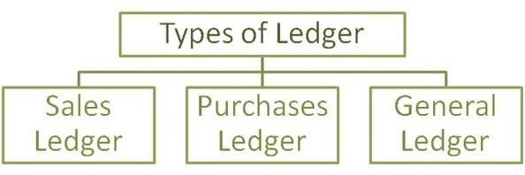

*Sales Ledger*

The book (or set of books) in which the personal accounts of credit customers are kept. A credit customer is also called a debtor.

The balance of a customer‘s account shows the amount that the customer owes the business. Therefore, the total of balances in the sales ledger is the total amount the business is owed by its credit customers. This amount is called trade receivables or accounts receivables.

Trade receivables is shown as a current asset in the balance sheet.

*Purchases Ledger*

The book (or set of books) in which the personal accounts of credit suppliers are kept. A credit supplier is also called a creditor.

The balance of a supplier‘s account shows the amount that the business owes the supplier. Therefore, the total of balances in the purchases ledger is the total amount the business owes by its credit suppliers. This amount is called trade payables or accounts payables.

Trade payables is shown as a current liability in the balance sheet.

*General Ledger*

The book (or set of books) in which all other accounts are kept.

**Account categories and debits and credits**

The kind of impact (debit or credit) that a transaction makes on each ledger account depends on which of five chart of account categories the accounts belong to.

First, there are the so-called "balance sheet" account categories:

1. **Asset accounts**: Things of value that are owned and used by the business.

Example: Cash on hand Example: Accounts receivable

1. **Liability accounts**: Debts that are owed by the business.

Example: Accounts payable Example: Salaries payable

1. **Equity accounts**: The owner's claim to business assets.

Example: Owner capital Example: Retained earnings

Secondly, there are the so-called "income statement" account categories:

1. **Revenue accounts**: The amounts earned from the sale of goods and services, or investment income, or extraordinary income.

Example: Product sales revenues

Example: Interest earned revenues

1. **Expense accounts**: Costs incurred in the course of business.

Example: Direct labor costs Example: Advertising expenses

In practice, even a small organization may list a hundred or more such accounts as the basis for its accounting system, and very large and complex organizations may use many

more. Nevertheless, for bookkeeping and accounting purposes, all named accounts fall into one of the five categories above.

Every financial transaction brings as a journal entry, then becomes a ledger entry, with at least two equal and offsetting account changes. The change in one account is called a [debit](https://www.business-case-analysis.com/double-entry-system.html) (DR) and the change in another account called a credit (CR). Whether a debit or a credit increases or decreases the account balance depends on the kind of account involved, as shown in Exhibit below:

|  |  |  |
| --- | --- | --- |
|  | **Debit (DR) Entry** ... | **Credit (CR) Entry ...** |
| **Asset acct** | Increases (adds to) account balance | Decreases (subtracts from) account balance |
| **Liability acct** | Decreases (subtracts from) account balance | Increases (adds to) account balance |
|  |  | Increases (adds to) account balance |
| **Equity acct** | Decreases (subtracts from)  account balance |
|  |  | Increases (adds to) account balance |
| **Revenue acct** | Decreases (subtracts from)  account balance |
| **Expense acct** | Increases (adds to) account balance | Decreases (subtracts from) account balance |

**Exhibit**: As debits and credits are entered into the journal and ledger for different accounts, the impact of the entry either adds to or subtracts from the current value (balance) of the accounts. Whether a debit or a

credit adds or subtracts value depends on account category—asset, liability, equity, revenue, or expense. It also depends on whether or not the account is a contra account within a category.

**Recording Transactions**

* **Credit** an entry in the right hand column of an account; credits increase liability, income, and equity accounts and decrease asset and expense accounts
* [**Debit**](https://www.boundless.com/definition/debit/)an entry in the left hand column of an account to record a debt; debits increase asset and expense accounts and decrease liability, income, and equity accounts
* [**Account**](https://www.boundless.com/definition/account/)A registry of pecuniary transactions; a written or printed statement of business dealings or debts and credits, and also of other things subjected to a reckoning or review

**T Accounts**

The simplest ledger account structure is shaped like the letter *T*. The account title and account number appear above the T. Debits (abbreviated Dr.) always go on the left side of the T, and credits (abbreviated Cr.) always go on the right.

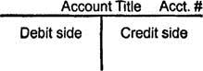

Accountants‘ record increases in asset, expense, and owner's drawing accounts on the debit side, and they record increases in liability, revenue, and owner's capital accounts on the credit side. An account's assigned **normal balance** is on the side where increases go because the increases in any account are usually greater than the decreases. Therefore, asset, expense, and owner's drawing accounts normally have debit balances. Liability, revenue, and owner's capital accounts normally have credit balances. To determine the correct entry, identify the accounts affected by a transaction, which category each account falls into, and whether the transaction increases or decreases the account's balance. You may find the following chart helpful as a reference.

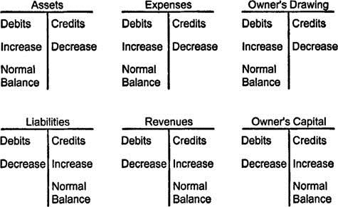

Occasionally, an account does not have a normal balance. For example, a company's checking account (an asset) has a credit balance if the account is overdrawn.

The way people often use the words *debit* and *credit* in everyday speech is not how accountants use these words. For example, the word *credit* generally has positive associations when used conversationally: in school you receive credit for completing a course, a great hockey player may be a credit to his or her team, and a hopeless romantic may at least deserve credit for trying. Someone who is familiar with these uses for *credit* but who is new to accounting may not immediately associate credits with decreases to asset, expense, and owner's drawing accounts. If a business owner loses $5,000 of the company's cash while gambling, the cash account, which is an asset, must be credited for $5,000. (The accountant who records this entry may also deserve credit for realizing that other job offers merit consideration.) For accounting purposes, think of

*debit* and *credit* simply in terms of the left‐hand and right‐hand side of a T account.

**Working Example of Account transaction**

Suppose, for example, that a company acquires assets valued at $100,000. The journal entry for the acquisition will show that an asset account *increases* $100,000, perhaps asset account "factory manufacturing equipment." Because this is an asset account, its balance increase is called a debit. However, the balance sheet may now be temporarily out of balance until there is an offsetting credit of $100,000 to another account, somewhere in the system. This could be, for instance:

* + A credit of $100,000 to another asset account, reducing that account value by $100,000. This could be the asset account "cash on hand."
  + If instead of cash, the asset purchase is financed with a bank loan, the offsetting transaction in the journal entry could be a credit to a liability account such as "bank loans payable," increasing that account value by $100,000.

The debit and the credit from the acquisition will be shown together in the journal entry, but when transferred to the ledger, they will each impact a different account summary (see the journal and ledger entry examples below).

When the journal entry is complete, the basic accounting equation holds and the balance sheet stays balanced:

Assets = Liabilities + Equities

And, for the account journal entries that follow from a single transaction: Debits = Credits

The bookkeeper or accountant dealing with journal and ledger entries faces one complication, however, in that not all accounts work additively with each other on the primary financial accounting reports—especially on the income statement and balance sheet. There are cases where one account offsets the impact of another account in the same category. These are the contra accounts that "work against" other accounts in their own categories. In some cases, the contra accounts reverse the debit and credit rules in Exhibit 3 above.

For example, an "accounts receivable" account and an "allowance for doubtful accounts" account are both asset accounts. Accounts receivable is said to carry a debit balance, meaning that debits to this account increase the account balance. "Allowance for doubtful accounts," however, is a *contra* asset account that ultimately reduces the impact (balance) contributed by "accounts receivable." "Allowance for doubtful accounts" carries a credit balance, meaning that its value is increased by a credit transaction. When these journal entries make their way into the ledger and then the financial reports, the balance sheet result is a "net accounts receivable" less than the "accounts receivable" value.

In any case, the bookkeeper or accountant working with journal entries needs to have a complete knowledge of the organization's chart of accounts and a solid command of double entry bookkeeping rules—or else, accounting software that provides clear guidance and good error checking.

**Bookkeeping Basics to Remember**

When recording an Accounting transaction or journal entry in accounting software such as QuickBooks Pro or Sage Accounting (Peachtree), program, one account is debited and another account is credited. In some cases, two accounts may receive the debit or credit. **But the total amount of the debit must equal the total amount of the credit**.

For some transactions, the Accounting software available today automatically chooses one of the accounts to either debit and credit, and the user need only select the other account. For instance, when writing a check, the software knows to credit Cash (or Checking), and the user just needs to know which account should receive the debit. However, when posting journal entries, one must know which accounts both debit and credit.

If you're new to Accounting or Bookkeeping, check out some of our beginners' tutorials on the right sidebar - especially [accounting: Making Sense of Debits and Credits](http://www.keynotesupport.com/accounting/accounting-basics-debits-credits.shtml).

**Now, let's begin!**

**Example 1: Owner invests $5,000 in the company.** Analysis: Since money is deposited into the checking account, Cash is debited (the balance increased by $5,000). What account receives a credit? An Equity account called Owner‘s Equity or Capital Contribution. Since Equity accounts are ‗negative‘ accounts, crediting this Equity account increases its balance by $5,000.

Debit Cash (increase its balance)

Credit Owner‘s Equity (increases its balance)

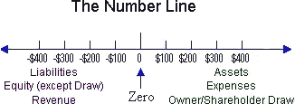

**Example 2: The Company borrowed $8,000 from a bank.** Analysis: Since the money will be deposited into the checking account, Cash is debited (the balance increased by $8,000.) The account to receive the credit is a Liability account called Loans Payable (you may create a separate account or sub-account for each loan). Liability accounts are credit accounts, so crediting the Liability account increases its negative balance by $8,000 (move to the left on the number line).

Debit Cash (increases its balance)

Credit Loans Payable (increases its balance)

**Example 3: Your bank charges you a $14 a month statement fee.** Analysis: This transaction is entered via a journal entry each month when the statement fee is identified on the bank statement. Since money was removed from the checking account, Cash must be credited (the balance decreased by $14). The Expense account called Bank Service Charges will receive the debit.

Debit Bank Fees (increases its balance) Credit Cash (decreases its balance)

**Example 4: You pay $540, via check, on the $8,000 loan acquired in Example 2. Of this amount, $500 is applied to the principal, and $40 is loan interest.** Analysis: Since a check is being written, the Accounting software will automatically credit Cash. In this case *the debit is split between two accounts*. To reflect the $500 that has been applied to the loan balance, debit the loan account. (Since it is a liability account, a debit will reduce it's balance, which is what you want.) The $40 interest paid is an expense, so debit the expense account called Interest. Remember that even though the debit is split between two accounts, the *total debit must always equal the total credit*.

Debit Loans Payable $500 (decreases its balance) Debit Interest Expense $40 (increases its balance) Credit Cash $540 (decreases its balance)

**Example 5: the Company wrote a check for $8,500 of equipment.** Analysis: Since a check was written, QBP will automatically credit Cash. We will debit an Asset account called Equipment or something similar. Note: Remember, if you purchase an item for more than about

$500, you should depreciate the item; not expense it. ($500 is a "rule of thumb," but I am not suggesting you use it.) So the Asset account receives the debit instead of an expense account. To record the depreciation, journal entries would be entered for one or more years. Always consult with your Accountant when purchasing company assets.

Debit Equipment (increases its balance) Credit Cash (decreases its balance)

*[Remember: A debit adds a positive number and a credit adds a negative number. But you NEVER put a minus sign on a number you enter into QBP.]*

**Example 6: the Company wrote a check for $318 of office supplies.** Analysis: Since a check was written, QBP will automatically credit Cash. We debit the Expense account called Office.

Debit Office (increases its balance) Credit Cash (decreases its balance)

**Example 7: the Company purchased $300 of office supplies on credit and you entered a bill into QBP.** Analysis: When you enter a bill, QBP automatically credits the Liability account called Accounts Payable. And since you purchased office supplies, the Office expense account is debited.

Debit Office (increase its balance)

Credit Accounts Payable (increases its balance)

**Example 8: You paid the bill for $300 of office supplies purchased in Example 7.** Analysis: When the bill was entered, Office was debited and A/P was credited. Now as we write a check to pay the bill, QBP will automatically credit Cash. And QBP will debit Accounts Payable - in effect, reversing the earlier credit.

Debit Accounts Payable (decreases its balance) Credit Cash (decrease its balance)



**Example 9: the Company paid $450 cash for Product A - a COGS part.** Analysis: When you write the check, QBP will automatically credit Cash. In the check window, choose the COGS account from the Expenses tab, or choose an Item from the Items tab and then the COGS account associated with the Item will be debited.

Debit COGS (increase its balance) Credit Cash (decrease its balance)

**Example 10: the Company sold Product A for $650 cash.** Analysis: When you enter the cash sale, QBP automatically debits Cash (or you could choose to deposit to Undeposited Funds - see Example 14). You will have to choose an Item for the sale … it might be ―Prod A income‖ and associated with the Sales account.

Debit Cash (increases its balance) Credit Sales (increases its balance)

**Example 11: the Company sold Product A for $650 on credit.** Analysis: When you create an invoice, you must specify an Item for each separate charge on the invoice. QBP will automatically credit the revenue account(s) associated with these Items. And QBP automatically debits the Invoice amount to A/R.

Debit Accounts Receivable (increases the balance) Credit Sales (increases the balance)

**Example 12: the Company received a payment for the $650 invoice above.** Analysis: When you created the invoice, QBP automatically debited the A/R account. When you post the invoice payment, QBP will automatically credit A/R - in effect reversing the earlier debit. QBP will debit Cash.

Debit Cash (increases the balance) Credit A/R (decreases the balance)

**Example 13: The owner’s writes himself a check for $1,000.** Analysis: Since a check was written, QBP will automatically credit Cash. The account you chose for the debit is and Equity account called Draw (Sole Proprietor) or Distribution (Corporation). Note: These are the only non-contra Equity accounts that are positive accounts and receive debits.

Debit Owner‘s Draw (increases its balance) Credit Cash (decrease its balance)

**Ledger accounts and their balancing**

|  |  |  |  |  |  |
| --- | --- | --- | --- | --- | --- |
| **Cash A/C** | | | | | |
| Dr |  |  |  |  | Cr |
| Particular | Amount |  | Particular |  | Amount |
| Investment  Loan Sales |  | 5000  8000  650 | Equipment  Bank charge Loan payment Office supply Debtor Purchases  **Bal c/d** |  | 8500  14  540  318  300  450  3528 |
|  | 10122 | |  |  | 10122 |
| **Bal b/f** |  | 3528 |  |  |  |

|  |  |  |  |  |
| --- | --- | --- | --- | --- |
| **Capital A/C** | | | | |
| Dr |  |  |  | Cr |
| Particular | Amount | Particular |  | Amount |
| **Bal c/d** | 5000 | Cash |  | 5000 |
|  | 5000 |  |  | 5000 |
|  |  | **Bal b/f** |  | 5000 |

|  |  |  |  |  |
| --- | --- | --- | --- | --- |
| **Loan A/C** | | | | |
| Dr |  |  |  | Cr |
| Particular | Amount | Particular |  | Amount |
| Cash  **Bal c/d** | 500  7500 | Cash |  | 8000 |
|  | 8000 |  |  | 8000 |
|  |  | **Bal b/f** |  | 7500 |

|  |  |  |  |  |
| --- | --- | --- | --- | --- |
| **Bank A/C** | | | | |
| Dr |  |  |  | Cr |
| Particular | Amount | Particular |  | Amount |
| **Bal c/d** | 14 | Bank charges |  | 14 |
|  | 14 |  |  | 14 |
|  |  | **Bal b/f** |  | 14 |

|  |  |  |  |  |
| --- | --- | --- | --- | --- |
| **Interest Exp A/C** | | | | |
| Dr |  |  |  | Cr |
| Particular | Amount | Particular |  | Amount |
| Cash | 40 | **Bal c/d** |  | 40 |
|  | 40 |  |  | 40 |
| **Bal b/f** | 40 |  |  |  |

|  |  |  |  |  |
| --- | --- | --- | --- | --- |
| **Equipment A/C** | | | | |
| Dr |  |  |  | Cr |
| Particular | Amount | Particular |  | Amount |
| Cash | 8500 | **Bal c/d** |  | 8500 |
|  | 8500 |  |  | 8500 |
| **Bal b/f** | 8500 |  |  |  |

|  |  |  |  |  |
| --- | --- | --- | --- | --- |
| **Office supply A/C** | | | | |
| Dr |  |  |  | Cr |
| Particular | Amount | Particular |  | Amount |
| Cash  Debtors | 318  300 | **Bal c/d** |  | 618 |
|  | 618 |  |  | 618 |
| **Bal b/f** | 618 |  |  |  |

|  |  |  |  |  |
| --- | --- | --- | --- | --- |
| **Creditor(A/P) A/C** | | | | |
| Dr |  |  |  | Cr |
| Particular | Amount | Particular |  | Amount |
| Cash  **Bal c/d** | 300  0 | Cash payable |  | 300 |
|  | 300 |  |  | 300 |
|  |  | **Bal b/f** |  | 0 |

|  |  |  |  |  |
| --- | --- | --- | --- | --- |
| **Purchases A/C** | | | | |
| Dr |  |  |  | Cr |
| Particular | Amount | Particular |  | Amount |
| Cash | 450 | **Bal c/d** |  | 450 |
|  | 450 |  |  | 450 |
| **Bal c/f** | 450 |  |  |  |

|  |  |  |  |  |
| --- | --- | --- | --- | --- |
| **Sales A/C** | | | | |
| Dr |  |  |  | Cr |
| Particular | Amount | Particular |  | Amount |
| **Bal c/d** | 1300 | Cash  Prod A |  | 650  650 |
|  | 1300 |  |  | 1300 |
|  |  | **Bal b/f** |  | 1300 |

|  |  |  |  |  |
| --- | --- | --- | --- | --- |
| **Debtors(A/R) A/C** | | | | |
| Dr |  |  |  | Cr |
| Particular | Amount | Particular |  | Amount |
| Purchase prod A | 650 | **Bal c/d** |  | 650 |
|  | 650 |  |  | 650 |
| **Bal b/d** | 650 |  |  |  |

**Trial balance statement of the account balancing**

|  |  |  |
| --- | --- | --- |
| **ABC LTD**  **Trial Balance as at 31 December 2011** | | |
|  | | |
| **Particulars** | **Debit** | **Credit** |
| Capital |  | 5,000 |
| Loan A/C |  | 7500 |
| Equipments | 8500 |  |
| Creditor |  | 0 |
| Debtors | 650 |  |
| Cash | 3528 |  |
| Sales |  | 1300 |
| Office supply A/C | 618 |  |
| Bank A/C |  | 14 |
| Interest Exp A/C | 40 |  |
| **Total** | **13336** | **13814** |

1. Following is an example of Basic Accounting Statement Samples
   1. Simple Balance Sheet statement
   2. Simple Profit and Loss stetement

|  |  |  |  |  |  |
| --- | --- | --- | --- | --- | --- |
| **My business Balance sheet as at 1/1/2016** | | | | | |
| **Dr** | | | **Cr** | | |
| **Asserts** | 32,800 | **73,900** | **Liabilities** | 49,000 | 50,450 |
| Current asserts | Current liability |
| Cash | Account payable |
| Account receivable | 300 | Accrued expenses | 450 |
| Prepaid rent | 1,000 | Unearned revenue | 1,000 |
| Inventory | 39,800 | Total current liability |
|  | Total long term liability | 99,500 |
| Total current asserts | Total liability | **149,950** |
| **long Term asserts** | 100,000 | **98,000** | **Owners equity** | 11,950 | **21,950** |
| leasehold | Owners equity |
| improvements | (2,000) | Retained earnings |
| accumulated |  | Common stock | 10,000 |
| Depleciation | 98,000 | Total Owners equity |
| total long term |
| asserts |
| Total asserts |  | **171,900** | Total liab and owners equity |  | **171,900** |

|  |  |  |  |  |  |  |  |
| --- | --- | --- | --- | --- | --- | --- | --- |
| **My business Profit and loss A/c as at 1/1/2016** | | | | | | | |
| **Dr** |  |  |  |  |  |  | **Cr** |
| **Particulars** | **Amount** | **Totals** |  | **Particulars** |  | **Amount** | **Totals** |
| Purchases  (+)Carriage in (-)returns out  **Gross Profit c/d** | 119,000  2,000  10,000 | 111,000  1000 | | Sales  (-)Returns in |  | 127000  15000 | 112,000 |
|  |  | 112,000 | |  |  |  | 112,000 |
| **Expenses**  Disc allwd Salaries Rent  Sales promotions  Losses depreciations | 5000  8000  5000  4000  7000  625 |  | 29625 | **Gross profit b/f**  Disc received  **Net profit c/d** |  |  | 1000  6000  22625 |
|  |  |  | 29625 |  |  |  | 29625 |

**Accounting application program – QuickBooks**

**Understanding QuickBooks Lists**

QuickBooks offers several methods for tracking and reporting on your accounting data so you can review how your business is doing financially. This chapter explains QuickBooks' Chart of Accounts and other lists available to help analyze your business.

With QuickBooks, you can use the following lists to analyze your business:

1. **Chart of Accounts—**For organizing your daily transactions.
2. **Items List—**For tracking the profitability of individual services and products sold.
3. **Class List—**For tracking different corporate profit centers (divisions).
4. **Customer Type List—**Capability to view your gross profit by user-defined customer types.

The QuickBooks chart of accounts is easy to set up. It might already exist if you created your file with the Express Start discussed in Chapter 1, “Getting Started with QuickBooks.” What becomes problematic for some is how to efficiently use each of the available list types when you want to segment the business reporting activity in QuickBooks. We will start first with the chart of accounts.

1. **Chart of Accounts**

The chart of accounts is a list of asset, liability, equity, income, and expense accounts to which you assign your daily transactions.

This list is one of the most important lists you will use in QuickBooks; it helps you keep your financial information organized. When this list is created with summary accounts and you use the other list types for detail, you can capture information in a timely manner, which will help you make good financial and management decisions for the business.

**Account types**

There are two main types of accounts in the QuickBooks chart of accounts:

* + [Balance sheet](http://support.quickbooks.intuit.com/support/pages/inproducthelp/core/qb2k12/contentpackage/glossary/glossary_balance.html?family=pro) accounts
  + [Income](http://support.quickbooks.intuit.com/support/pages/inproducthelp/core/qb2k12/contentpackage/glossary/glossary_incacct.html?family=pro) and [expense](http://support.quickbooks.intuit.com/support/pages/inproducthelp/core/qb2k12/contentpackage/glossary/glossary_expacct.html?family=pro) accounts

**Balance sheet accounts**

Accounts that appear on a balance sheet report. In QuickBooks, these include the following types of accounts:

* Bank
* Accounts receivable
* Accounts payable
* Fixed asset, other asset, other current asset
* Other current liability, long term liability
* Credit card
* Equity

You can think of balance sheet accounts as the money or things that you own and the debts that you owe. They include assets like bank accounts, buildings, and money that people owe you; they also include liabilities like credit cards or loans from banks.

Another category of balance sheet accounts is equity accounts. These represent the worth of your business including any investments the owners have made in the company. Your company's equity is all of your assets (what you own) minus your liabilities (what you owe). This is sometimes called the "net worth" of your company.

Each balance sheet account in QuickBooks has its own register that tracks the balance of the account. You can also see the account balances by looking at your chart of accounts.

Balance sheet is a report that summarizes the financial position of a business. A balance sheet shows the value of your company's assets, liabilities, and equity as of a particular day. It is called a balance sheet because the value of the assets is always exactly equal to the combined value of the liabilities and equity.

QuickBooks offers four different preset balance sheet reports. You'll find these reports under Company & Financial on the Report Center or Reports menu.

**Expense account**

An account that tracks and categorizes what your company is spending. (You can think of expenses as money that leaves the company.) They work like categories do in Quicken.

Unlike balance sheet accounts, expense accounts don't have their own register.

To get a list of the transactions posted to an expense account

1. Go to the Lists menu and click Chart of Accounts.
2. Select the expense account.
3. Click Reports at the bottom of the list and then click QuickReport.



**Income account**

An account that tracks the source of your company's income. (You can think of income as money that comes into the company.)

Unlike balance sheet accounts, income accounts don't have their own register. You can get a list of the transactions posted to an income account by selecting the account in the chart of accounts and clicking QuickReport.

**Account Types Details**

Understanding the chart of accounts isn‘t complicated. There are six standard account categories used for tracking the financial activity of your business: assets, liabilities, equity, income, cost of goods sold, and expense.

**Assets:** Assets include something you have purchased in the past that will be used in the future to generate economic benefit. QuickBooks offers these categories in the order of how liquid the asset is— or in simple terms, how quickly you can turn the asset into cash:

* **Bank—**Used to track your cash in and out of the business. This account type and the credit card account type are the only account types you can select as the payment account in the Pay Bills or Write Checks dialog box.
* **Accounts Receivable—**This account type requires a Customer or Customer and Job name with each entry. You use this account type when generating an invoice or credit memo transaction or when receiving a customer payment. You can create more than one Accounts Receivable account if needed. However, I do not recommend it because it adds the extra work of recording customer payments to the correct Accounts Receivable account.
* **Other Current Asset—**This account type is general in nature and includes the QuickBooks Inventory Asset and the Undeposited Funds account. The Undeposited Funds account is used like a “desk drawer” in that it holds customer payments to be totaled on a single deposit ticket.
* **Fixed Asset—**Used to track purchases of tangible property that will have a useful life of longer

than one year. Accumulated Depreciation totals are also held in this account type as a negative fixed asset.

* **Other Assets—**Intangible assets that have a life of more than one year; also any asset that is not a Fixed Asset or Current Asset.

**Liabilities:** Liabilities are the debts the company has yet to pay. QuickBooks includes these subgroups:

* **Accounts Payable—**This account type is reserved for the QuickBooks Accounts Payable account where vendor bills and bill payments reside. You can create multiple Accounts Payable accounts. However, I do not recommend it as it adds complexity in the enter bill and pay bill processes.
* **Credit Cards—**Optionally, use this grouping to track the charges and payments made against a company credit card. One benefit is that you can reconcile this account as you do your bank account and also download your credit card transactions directly into QuickBooks.
* **Other Current Liability—**This is debt that is expected to be paid within one year. This grouping includes the QuickBooks-created Payroll Liabilities account and Sales Tax Payable account, in addition to other user-defined liability accounts.
* **Long-Term Liability—**This is debt that will not be paid within one year.

**Equity:** The Equity account category holds the owners (or owners’) residual interest in the business after the liabilities are paid. Accounts in this category include common stock; owner’s investments and draws; retained earnings; and opening balance equity (an account created by QuickBooks that is discussed in more detail in “Closing Opening Balance Equity into Retained Earnings” in Chapter 15, “Reviewing Your Data”).

**Income:** Money earned from the sale of your products or services is recorded as income. Your company might have one income account or several, depending on the detail needed for your financial analysis.

Another category of income is Other Income, or income generated from the sale of a product or service not normal to your operations. Interest Income is an example of an Other Income account type.

**Cost of Goods Sold:** The Cost of Goods Sold account is for costs directly related to producing a service or good for sale. There is a direct relationship between these costs and your revenue. If your company sells a product, your cost of goods sold (COGS) expenses would be the material, labor, and other costs incurred to make and sell the product. By contrast, your office expenses for rent or advertising are considered indirect and should not be posted to the Cost of Goods Sold account type.

**Note:** When you are creating your Cost of Goods Sold accounts, consider using summary accounts, such as material, labor, and subcontract, and letting your Item List track more detail. For example, if you are a construction company and you have expenses for site work, concrete, framing, painting, and so on, rather than having a Cost of Goods Sold account for each trade, use the Item List for these. See the section ―Adding an Item‖ in this chapter for more details. Reports by item are available to break down the total of Cost of Goods Sold account into more detail.

**Expense:** An expense is recorded when an asset is used or there is an outflow of cash. The expense accounts were created during the Express Start or Advanced Setup and provide you with the basic classifications needed for properly tracking your expenses.

Although QuickBooks does not automatically create other groupings within the expenses category, a recommendation would be to group your expenses by fixed (or uncontrollable) and variable (or controllable) costs. When you review your costs, these additional groupings make easy work of determining which costs you have more control over.

You can also categorize an expense as an Other Expense, which is an expense that is not normal to your operations. You should contact your accountant for advice on what expenses are appropriate to record to an Other Expense category type.

**Adding a New Account**

If you created your own new data file using one of the methods taught in Chapter 1, you might already have the basics of your chart of accounts created for you. Let‘s think positively and use the example that your business is doing so well you have opened a new money market account with your bank. You know you need to create a new bank account in QuickBooks so that you can reconcile your banking activity with your financial institution‘s records.

Creating a New Account

To practice adding a new account record, open the sample data file as instructed in Chapter 1. If you are working in your own file, use these instructions to create a new bank (or other type of account) in your chart of accounts:

1. From the menu bar, select **Lists**, **Chart of Accounts**, or use the keyboard shortcut of Ctrl+A.
2. In the Chart of Accounts dialog box, select **New** from the Account drop-down list. Optionally, use the keyboard shortcut Ctrl+N.
3. In the Add New Account dialog box (see Figure 1 below), click the Bank option button and then click Continue.

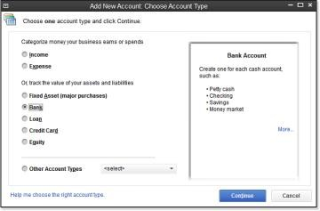

Figure1. When creating a new account, useful information about the account type is displayed on the right.

1. In the Account Name field, type **Money Market** and in the Number field (if account numbering is enabled), type **10600** (see Figure 2 below).

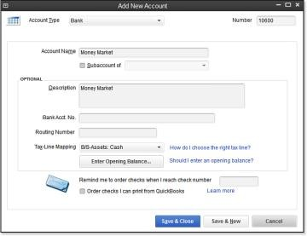

Figure 2. Adding a new account when account numbering is enabled.

1. Optionally, select the **Subaccount Of** checkbox and select the account you want to associate this account with. (Typically you would not make a bank account a subaccount of another account.)
2. Enter an optional description; this description will display in certain reports.
3. Accept the default Tax-Line Mapping, which comes from your sample data file or the choices you made when creating your own new file using the Express or Advanced Setup option

discussed in Chapter 1. You can also select the drop-down list and choose a different tax line assignment, or click the “How do I choose the right tax line?” link for more information. If opened, close the help dialog box to continue.

The tax line is necessary only if you or your accountant prepares the business‘s tax return using software that integrates with QuickBooks.

1. Click No if the Set Up Online Services dialog displays. Or if you’re working in your own data file, you might want to click Yes. More details are available in Chapter 13, “Working with Bank and Credit Card Accounts.”
2. Click Save & Close.

The Add New Account dialog box also includes several other important fields:

* **Bank Acct No.—**This information is used if you set up your QuickBooks bank account for online banking downloads. For more information, see Chapter 13.
* **Routing Number—**This information is used if you set up your QuickBooks bank account for online banking downloads (see Chapter 13).
* **Enter Opening Balance—**This button opens the Enter Opening Balance dialog box where you can enter your Statement Ending Balance and Statement Ending Date. Click the “Should I enter an opening balance?” link for help in entering these important starting numbers.

This dialog box also enables you to request a reminder to order checks when you reach a specific check number or order checks directly from Intuit.

The specific details required when creating a new account will vary depending on the type of account you are adding to the chart of accounts.

Creating a new account in the chart of accounts is simple. However, if after reviewing the content in this chapter you find the need to make corrections, read the section ―Modifying an Account in the Chart of Accounts‖ in this chapter

1. **Items**

Items are what you sell or buy and are used on all customer transactions and optionally on purchase transactions. Items provide a quick means for data entry. However, a more important role for items is to handle the behind-the-scenes accounting while tracking product- or service- specific costs and revenue detail.

**Adding an Item**

Adding items to your QuickBooks file takes some planning, but the effort will pay off with improved reporting on the different services or products your company provides.

Later in this chapter you will learn how to add multiple items at a time using the Add/Edit Multiple List Entries. In this example, you will be adding a single new Service item type to the sample data file.

Adding a New Service Item

To practice adding a new service item, open the sample data file as instructed in Chapter 1. If you are working in your own file, use these instructions to begin creating your own service items.

* 1. From the menu bar, select **Lists**, **Item List** to open the Item List dialog box.
  2. Select **New** from the Item drop-down list. Optionally, use the keyboard shortcut Ctrl+N.
  3. From the Type drop-down list select **Service**.
  4. In the Item Name/Number field, type **Inspection**.
  5. Select the **This Service Is Used in Assemblies or Is Performed by a Subcontractor or Partner** checkbox, as shown in Figure 1 below. This makes the item “two-sided,” assigning both an expense account when used with a purchase transaction and an income account when used with a sales transaction.

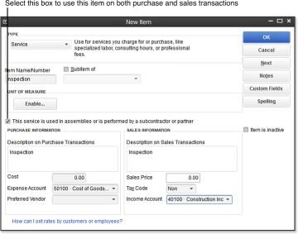

Figure 1. Items are used on customer sales transactions and purchase transactions.

* 1. In the Purchase Information text box, type **Inspection**.
  2. Enter a default Cost. This amount will default on a purchase transaction, but can also be changed at the time of entry. If you do not want a default cost for the item, leave the box blank.
  3. In the Expense Account field, select the appropriate account. For this example, we will use the Cost of Goods Sold account because the item is directly related to our Customers or Jobs.
  4. In the Preferred Vendor field assign a vendor or leave blank. When a preferred vendor is

assigned QuickBooks will pre-fill that vendor name on a purchase order transaction when the item is selected.

* 1. Accept the default description in the Sales Information text box or type a unique description.

This description will default on your sales transactions for this item. Optionally, enter a default Sales Price. This amount will default on sales transactions, but can be changed at the time of entry.

* 1. From the Tax Code drop-down list, select **Non**. In your own file, select the tax code, choosing Tax if the item is subject to sales tax or Non for nontaxable services. Check with your state’s taxing authority if you have any questions about an item or service you sell being taxable or not.
  2. From the Income Account drop-down list, for this practice, select the **Subcontracted Labor**

**Income** account.

* 1. If you are finished adding items, click OK to save and exit the New Item dialog box. If you want

to continue adding items, click Next to add another item.

**Note:** Use the Items tab on expense transactions such as Write Checks or Enter Bills to ensure that you have the detailed reporting you need to review customer or job profitability.

These reports are useful for a business owner who would like to know the profitability of individual customers or jobs.

**Item Types**

QuickBooks has 11 item types to choose from (not including the Fixed Asset Item), although some of the items might not be listed in your data file if the related feature is not enabled. You can choose the type to assign to a list item; however, each type has certain unique characteristics. Here are some general guidelines about the proper use for item types:

* **Service—**Create this type for services offered by you or your subcontractors.
* **Inventory Part—**This type displays only if you select the **Inventory and Purchase Orders Are**

**Active** checkbox on the Items & Inventory—Company Preferences tab of the Preferences dialog box. (Access the dialog box from the menu bar by selecting **Edit**, **Preferences**.) Inventory is used to track products you make or buy, place in a warehouse location, and later sell to a customer. Inventory is increased with a received purchase order or bill and is decreased on a customer invoice.

* **Inventory Assembly—**This item type is an assembling of multiple inventory components, as in a Bill of Materials. When an inventory assembly is built, the individual items (components of the assembly) are deducted from inventory and the quantity of the finished assembly product is increased. The assembly functionality is available only in QuickBooks Premier, Professional Bookkeeper, Accountant, or Enterprise.
* **Non-inventory Part—**This type is used for products you purchase but do not track as inventory.

Correct use of this type would include products you purchase that are ordered for a specific customer and directly shipped to the customer, or for materials and supplies you purchase but do not sell to the customer.

* **Other Charge—**This is a multipurpose item type. Freight, handling, and other miscellaneous types of charges are examples of the proper use of the Other Charge item type. Using this type makes it possible to segregate sales of your service or product from other types of revenue and expenses in reports.
* **Subtotal—**This type is used to add subtotal line items on sales and purchase transactions. This item is especially useful if you want to calculate a specific discount on a group of items on a customer invoice.
* **Group—**This type is used to quickly assign a grouping of individual items on sales and purchase transactions. Unlike assemblies, groups are not tracked as a separate finished unit. Groups can

save you data entry time and enable you to display or hide details on a customer’s printed invoice.

* **Discount—**This type facilitates dollar or percent deductions off what your customers owes. This

item type cannot be used on purchase transactions.

* **Payment—**This item type is not always necessary to set up. You create this item type if you record the payment directly on an invoice as a line item, such as with a Daily Sales Summary (see the QuickBooks Help for more details). On typical customer invoices, you should not record payments in this manner because there is no tracking of the customer’s check or credit card number.
* **Sales Tax Item—**This type is available only if you enabled sales tax on the Sales Tax—Company Preferences tab of the Preferences dialog box. (Access the dialog box from the menu bar by selecting **Edit**, **Preferences**.) In most cases, QuickBooks automatically assigns this item to an invoice. In some states or industries where there are multiple sales tax rates for a given sale, you can also add this item to an invoice as a separate line item.
* **Sales Tax Group—**This type is used to group multiple tax district flat-rate sales tax items that are combined and charged as one sales tax rate.

**CAUTION:** Carefully determine the correct item type to use when creating items. After they are created, the following item types cannot be changed to any other item type: service, inventory assembly, subtotal, discount, payment, sales tax item, and sales tax group.

If you find you have set up the wrong item type, correcting it might require making an accounting adjustment. To avoid using the incorrect item on future transactions, mark the item as inactive by selecting **Lists**, **Item List** from the menu bar to open the Item List dialog box. Select **Edit Item** from the Item drop-down list and then select the **Item Is Inactive** checkbox. When this box is selected, as Figure 2 below shows, the item is not included in any drop-down lists on transactions, but is included in reports if used during the period being reported.

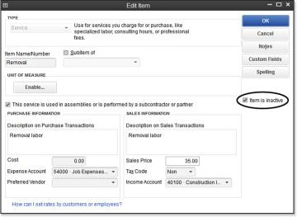

Figure 2. Marking a list item inactive only removes it from drop-down lists, not reports.

However, do not make an inventory type inactive if QuickBooks still shows available inventory quantity.

1. **Class**

Another method for segmenting your QuickBooks financial information is by using classes. The use of classes is a preference setting and must first be enabled by logging in to the data file as the Admin or External Accountant user.

To enable classes, follow these steps:

* 1. From the menu bar, select **Edit, Preferences**.
  2. In the Preferences dialog box, select the **Accounting** preference on the left.
  3. Select the **Company Preferences** tab.
  4. Select the **Use Class Tracking for Transactions** checkbox, as shown in Figure 3 below.

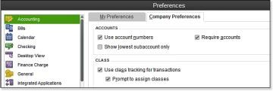

Figure 3. Class tracking provides another method for financial reporting for management purposes.

* 1. Click OK to save your changes and close the dialog box.

Classes are typically used when a company has multiple revenue-generating business types or multiple profit centers. These class list items are then assigned to each transaction, as in Figure 4. Examples of classes might be a construction company that offers either new construction or remodeling services, or a restaurant with multiple locations. In both examples, using classes that are assigned to each transaction line for both revenue and costs enables you to report profit and loss by class.

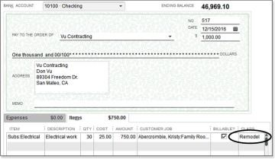

Figure 4. Assigning a class list item to a check transaction line provides additional management- reporting capabilities.

1. **Customer/Supplier Type**

You can use customer types to categorize your customers in ways that are meaningful to your business. A retailer might use customer types to track retail versus wholesale; a medical office might track types of services; a service company might track what marketing event brought in the customer. You can filter certain reports by these customer types, giving you critical information for making business management decisions. These customer types can also be useful for marketing purposes when you want to direct a letter to a specific customer type.

To create or edit a customer record and assign a customer type, follow these steps:

* 1. On the Home page, click the Customers button. Optionally, use the shortcut Ctrl+J.
  2. Double-click to select a customer name in the list that displays.
  3. In the Edit Customer dialog box, click the Additional Info tab and select a type from the Type

drop-down list. Optionally, select **<Add New>** from the drop-down list to add a new type, as shown in Figure 5.

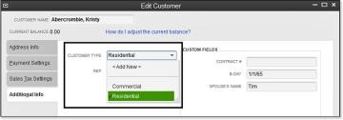

Figure 5. Assign a customer type for additional segmented reporting.

* 1. Click OK to save your changes.

Many of the customer reports can be filtered by customer type, making it another useful list for management reporting.

**Transactions in QuickBooks**

1. **Buying and selling**

A **sale** is the exchange of a commodity or money as the price of a good or a service with a customer. **Sales** (plural only) is activity related to selling or the amount of goods or services sold in a given time period as recorded in the book/QuickBooks system.

A **Purchase** is the exchange of a commodity or money as the price of a good or a service with a seller. **Purchases** (plural only) is activity related to buying or the amount of goods or services bought in a given time period as recorded in the book/QuickBooks system.

All buying and selling is done in QuickBooks from the Supplier and customer area respectively (Supplier/Custome menu or Group on the Home navigation area)

**Purchases**

in QuickBooks we can buy in two ways (use two document of transaction)

1. **Purchase order:** Used if the transaction involved an order issued for items that will be delivered and payment made on delivery or after

Procedure: Make a Purchase order for good ordered – Receive good with/without Bill for goods received – Pay bill(then/Later) for bill received

1. **Bill:** Used if the transaction involved items received on the counter on request and payment made on promptly or after

Procedure: Enter a bill of good bought – Enter payment if good were paid or let the bill outstand till when it will be paid

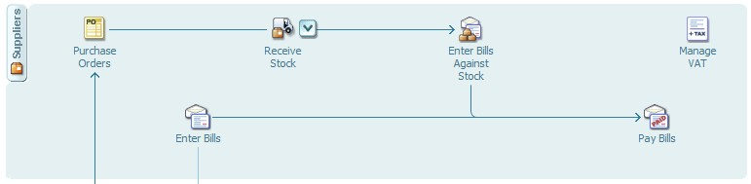

**Sales**

In QuickBooks we can buy in two ways (use two document of transaction)

1. **Invoice:** Used if the transaction involved items given on the counter(or on sale order) on request and payment made after

Procedure: Make an Invoice to outstand debt with customer – Enter Receive payment for amount cleared by a customer – Record deposit to bank

1. **Receipt:** Used if the transaction involved items given on the counter on request and payment made promptly

Procedure: Make an Receipt for items sold cash to a customer – Record deposit to bank

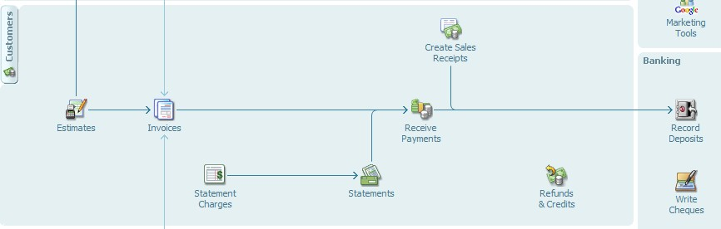

**2. QuickBooks Account Activities**

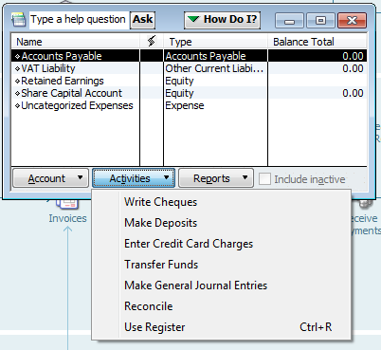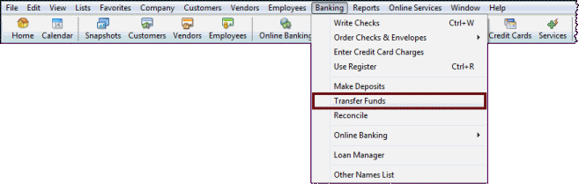

* 1. **Journal entry**

A **journal entry** is the record of a financial transaction entered into a **journal**. The **journal**

details all the financial transactions of the business and it makes **note** of which accounts these transactions affected. All **journal entries** are made using either the double **entry** or single **entry** method of bookkeeping

The Purpose of Journal Entries

Journal entries provide foundational information for all of a business's other financial reports. They're used by auditors to analyze how financial transactions impact a business.

Each entry should include the date of the transaction, the parties involved, a debit from at least one account, a credit to at least one other account, a receipt or check number, and a memo describing other details involved in the transaction – anything you might not be likely to remember months or years later.

If you purchase and use accounting system software, it will most likely take care of all these details for you. But you should be able to handle your journal entries and ledger yourself with some basic understanding of the process if you don't think that kind of expense is necessary quite yet because you're just starting out.

Double Entry Accounting with Journal entry

A journal entry using the double entry method of accounting includes a variety of information in various columns on the same line. In a double entry system, you might have a debit for the computer purchase, then a credit or increase to your overall office equipment expenses would appear on the same line but in a different column to offset the debit. These columns should be equal, such as -$2,000 as the debit and +$2,000 for the credit.

You might have to use even more columns depending on the nature of your entry, but at a minimum, there should be two, one each for debits and credits. Double entry accounting typically makes a journal entry not for the transaction itself, but for the account it affects: assets, liabilities, equity, revenue and expenses. Debits and credits to each are all noted on the same line.

At the end of the year or any other accounting period you select, all your journal entries for debits should correspond to and equal your journal entries for total credits. This means your account is "balanced."

* 1. **Moving Money between Accounts**

Note, **the process of moving cash from one bank account to another within the same business is NOT income when it comes to recording the transaction in QuickBooks** (though that would be nice for sure!).

Rather, all that is being done in this case is the transfer of funds from one asset account to another within the same business.

**Example** - a business transfers $10,000 from a Checking account into a Savings account to put the money away for a rainy day.

In QuickBooks, there are two ways to go about recording this transfer in your accounting records:

* + 1. **Use the Transfer Funds button found in the Banking option in the menu bar.**

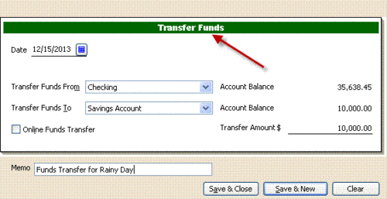

* + 1. **Use the Write Checks window**

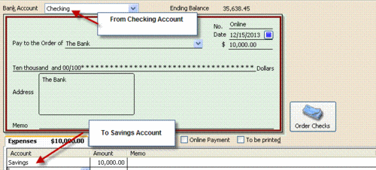

Either option gets the job done for you. Option 1 is probably easier if you move the money via an online electronic transfer and Option 2 is easier if you are actually making a physical deposit of a check at the bank.

**Even better,** by using either of the options above, **your accounting records will properly reflect the transaction being made**. No more will you have a profit and loss report showing income that doesn't exist.

1. **To make deposit, follow these steps:**
   1. Choose Banking → Make Deposits. ...
   2. Select the payments that you want to deposit. ...
   3. Click OK. ...
   4. Tell QuickBooks into which bank account you want to deposit the money. ...
   5. Specify the deposit date. ...
   6. (Optional) Add a memo description if you want to.
   7. Specify the cash-back amount.

**Reporting on Lists**

With a QuickBooks file created and lists entered, you can now review the efforts of your work. Let‘s start with a simple listing of your vendors.

1. From the menu bar select **Reports**, **List**. Take a moment of your time to review the many lists available for reporting on in this menu. Some lists will display only if the associated preference in QuickBooks is enabled.
2. Select the **Vendor Contact List**. Optionally, click the Customize Report button.
3. The Modify Report dialog opens with the Display tab selected. From the Columns listing, add or remove checkmarks to include or exclude information from the list report.
4. Click OK when finished.

Reviewing your lists before you begin entering transactions can ensure that the information provided in reports is correct.

Types of report likely to matter in a business and procedure to access them:

**Trial balance** – A list of all business account balancing

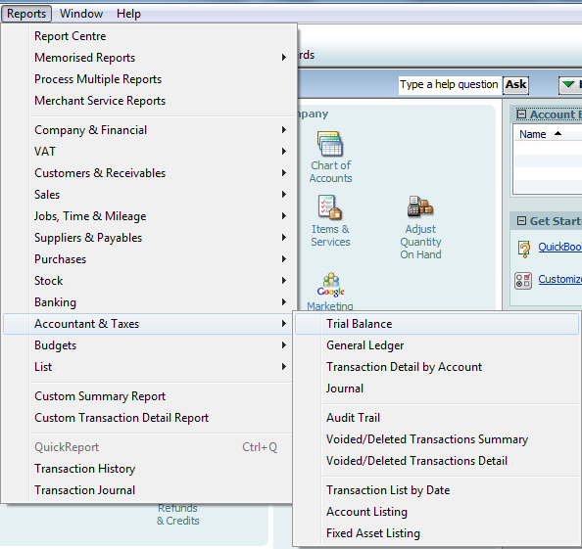

**Profit and loss statement and Balance sheet** – A summary of the business status in terms of profit/loss and assert base

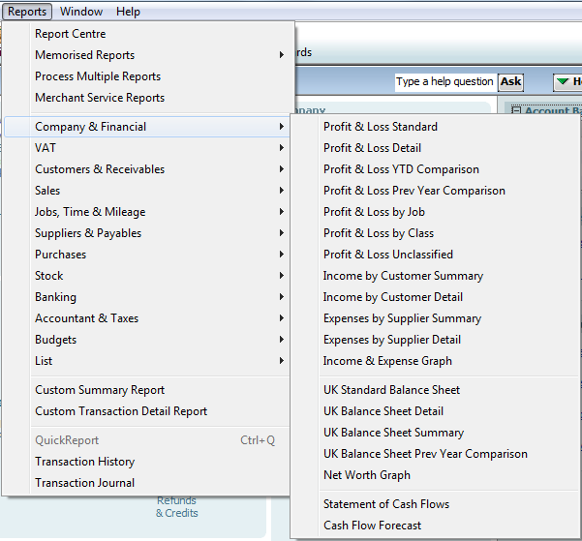

**CHAPTER 2: COMPUTER AIDED DESIGN (CAD)**

**Fundamental of technical drawing**

**Technical drawing**, also known as **drafting** or **draughting**, is the act and discipline of composing plans that visually communicate how something functions or is to be constructed. Technical drawing is essential for communicating ideas in industry and engineering. To make the drawings easier to understand, people use familiar symbols, perspectives, units of measurement, notation systems, visual styles, and page layout. Together, such conventions constitute a visual language, and help to ensure that the drawing is unambiguous and relatively easy to understand. This need for precise communication in the preparation of a functional document distinguishes technical drawing from the expressive drawing of the visual arts. Artistic drawings are subjectively interpreted; their meanings are multiply determined. Technical drawings are understood to have one intended meaning.

A *drafter*, *draftsperson*, or *draughtsman* is a person who makes a drawing (technical or expressive). A professional drafter who makes technical drawings is sometimes called a *drafting technician*.

**Methods of technical drawing**

**1. Sketching**

A sketch is a quickly executed, freehand drawing that is not intended as a finished work. In general, sketching is a quick way to record an idea for later use. Architect's sketches primarily serve as a way to try out different ideas and establish a composition before undertaking a more finished work, especially when the finished work is expensive and time consuming. Architectural sketches, for example, are a kind of diagrams. These sketches, like metaphors, are

used by architects as a means of communication in aiding design collaboration. This tool helps architects to abstract attributes of hypothetical provisional design solutions and summarize their complex patterns, hereby enhancing the design process.

**2. Manual or by instrument**

The basic drafting procedure is to place a piece of paper (or other material) on a smooth surface with right-angle corners and straight sides—typically a drawing board. A sliding straightedge known as a *T-square* is then placed on one of the sides, allowing it to be slid across the side of the table, and over the surface of the paper.

"Parallel lines" can be drawn simply by moving the T-square and running a pencil or technical pen along the T-square's edge. The T-square is used to hold other devices such as set squares or triangles. In this case the drafter places one or more triangles of known angles on the T-square— which is itself at right angles to the edge of the table—and can then draw lines at any chosen

angle to others on the page. Modern drafting tables come equipped with a drafting machine that is supported on both sides of the table to slide over a large piece of paper. Because it is secured on both sides, lines drawn along the edge are guaranteed to be parallel.

In addition, the drafter uses several **technical drawing tools** to draw curves and circles. Primary among these are the compasses, used for drawing simple arcs and circles, and the French curve, for drawing curves. A spline is a rubber coated articulated metal that can be manually bent to most curves.

**Types of technical drawings**

The two types of technical drawings are based on graphical projection. This is used to create an image of a three-dimensional object onto a two-dimensional surface.

Two-dimensional representation: uses orthographic projection to create an image where only two of the three dimensions of the object are seen.

Three-dimensional representation: also referred to as a pictorial, all three dimensions of an object are visible.

**Views**

1. A **section**, or *cross-section*, is a view of a 3-dimensional object from the position of a plane through the object.

A cross section is a common method of depicting the internal arrangement of a 3-dimensional

object in two dimensions. It is often used in technical drawing and is traditionally crosshatched. The style of crosshatching indicates the type of material the section passes through.

A 2-D cross-sectional view of a compression seal.

1. An **elevation** is a view of a 3-dimensional object from the position of a vertical plane beside an object. In other words, an elevation is a side-view as viewed from the front, back, left or right (and referred to as a *front elevation*, *[left/ right] side elevation*, and a *rear elevation*). It is the corollary to the concept of a "view" (which is always overhead and is therefore referred to as an *overhead view*).

An elevation is a common method of depicting the external configuration and detailing of a 3- dimensional object in two dimensions. Building façades are shown as elevations in architectural drawings and technical drawings.

Elevations are the most common orthographic projection for conveying the appearance of a building from the exterior. Perspectives are also commonly used for this purpose. A building elevation is typically labeled in relation to the compass direction it faces; the direction from which a person views it. E.g. the North Elevation of a building is the side that most closely faces true north on the compass.

- A **developed elevation** is a variant of a regular elevation view in which several adjacent non- parallel sides may be shown together, as if they have been unfolded. For example, the north and west views may be shown side-by-side, sharing an edge, even though this does not represent a proper orthographic projection.

1. A **plan** is a view of a 3-dimensional object from the position of a horizontal plane through, above, or below the object. In such views, the portion of the object in front of the plane is omitted to reveal what lies beyond. In the case of a floor plan, the roof and upper portion of the walls may be omitted. Elevations, top (roof) plans, and bottom plans are orthographic projections, but they are not sections as their viewing plane is outside of the object.

A plan is a common method of depicting the internal arrangement of a 3-dimensional object in two dimensions. It is often used in technical drawing and is traditionally cross-hatched. The style of crosshatching indicates the type of material the section passes through.

1. An **auxiliary view** is a view taken from an angle that is *not* one of the primary views. An auxiliary view is a view at an angle used to give deeper insight into the actual shape of the object. An auxiliary view is used to show a slanted surface in true size and shape. This is accomplished by providing a view that is perpendicular to the slanted surface.

**Meaning and importance of computer-aided design**

**Introduction to CAD (Computer aided design)**

**Computer-aided design** (CAD) is the use of computer systems to assist in the creation, modification, analysis, or optimization of a design. CAD software is used to increase the productivity of the designer, improve the quality of design, improve communications through documentation, and to create a database for manufacturing. CAD output is often in the form of electronic files for print, machining, or other manufacturing operations.

Computer-aided design is used in many fields. Its use in designing electronic systems is known as electronic design automation, or **EDA**. In mechanical design it is known as mechanical design automation (**MDA**) or **computer-aided drafting** (**CAD**), which includes the process of creating a technical drawing with the use of computer software.

CAD software for mechanical design uses either vector-based graphics to depict the objects of

traditional drafting, or may also produce raster graphics showing the overall appearance of designed objects. However, it involves more than just shapes. As in the manual drafting of technical and engineering drawings, the output of CAD must convey information, such as materials, processes, dimensions, and tolerances, according to application-specific conventions. CAD may be used to design curves and figures in two-dimensional (2D) space; or curves, surfaces, and solids in three-dimensional (3D) space.

CAD is an important industrial art extensively used in many applications, including automotive, shipbuilding, and aerospace industries, industrial and architectural design, prosthetics, and many more. CAD is also widely used to produce computer animation for special effects in movies, advertising and technical manuals, often called DCC digital content creation. The modern ubiquity and power of computers means that even perfume bottles and shampoo dispensers are designed using techniques unheard of by engineers of the 1960s. Because of its enormous economic importance, CAD has been a major driving force for research in computational geometry, computer graphics (both hardware and software), and discrete differential geometry. The design of geometric models for object shapes, in particular, is occasionally called *computer- aided geometric design* (*CAGD*).

**Uses/importance of CAD**

Computer-aided design is one of the many tools used by engineers and designers and is used in many ways depending on the profession of the user and the type of software in question.

CAD is one part of the whole Digital Product Development (DPD) activity within the Product Lifecycle Management (PLM) processes, and as such is used together with other tools, which are either integrated modules or stand-alone products, such as:

* Computer-aided engineering (CAE) and Finite element analysis (FEA)
* Computer-aided manufacturing (CAM) including instructions to Computer Numerical Control

(CNC) machines

* Photo realistic rendering and Motion Simulation.
* Document management and revision control using Product Data Management (PDM).

CAD is also used for the accurate creation of photo simulations that are often required in the preparation of Environmental Impact Reports, in which computer-aided designs of intended buildings are superimposed into photographs of existing environments to represent what that

locale will be like, where the proposed facilities are allowed to be built. Potential blockage of view corridors and shadow studies are also frequently analyzed through the use of CAD.

CAD has been proven to be useful to engineers as well. Using four properties which are history, features, parameterization, and high level constraints. The construction history can be used to look back into the model's personal features and work on the single area rather than the whole model. Parameters and constraints can be used to determine the size, shape, and other properties of the different modeling elements. The features in the CAD system can be used for the variety of tools for measurement such as tensile strength, yield strength, electrical or electro-magnetic properties. Also its stress, strain, timing or how the element gets affected in certain temperatures, etc.

**Types of CAD**

There are several different types of CAD, each requiring the operator to think differently about how to use them and design their virtual components in a different manner for each.

There are many producers of the lower-end 2D systems, including a number of free and open source programs. These provide an approach to the drawing process without all the fuss over scale and placement on the drawing sheet that accompanied hand drafting, since these can be adjusted as required during the creation of the final draft.

*3D* ***wireframe*** is basically an extension of 2D drafting (not often used today). Each line has to be manually inserted into the drawing. The final product has no mass properties associated with it and cannot have features directly added to it, such as holes. The operator approaches these in a similar fashion to the 2D systems, although many 3D systems allow using the wireframe model to make the final engineering drawing views.

*3D "dumb" solids* are created in a way analogous to manipulations of real world objects (not

often used today). Basic three-dimensional geometric forms (prisms, cylinders, spheres, and so on) have solid volumes added or subtracted from them, as if assembling or cutting real-world objects. Two-dimensional projected views can easily be generated from the models. Basic 3D solids don't usually include tools to easily allow motion of components, set limits to their motion, or identify interference between components.

***Solid Modeling*** There are two types of solid modeling

1). *3D parametric solid modeling* allows the operator to use what is referred to as "design intent". The objects and features created are modifiable. Any future modifications can be made by changing how the original part was created. If a feature was intended to be located from the center of the part, the operator should locate it from the center of the model. The feature could be located using any geometric object already available in the part, but this random placement would defeat the design intent. If the operator designs the part as it functions the parametric modeler is able to make changes to the part while maintaining geometric and functional relationships.

2). *Explicit Modellers or Direct 3D CAD Modelers* provide the ability to edit geometry without a history tree. With direct modeling once a sketch is used to create geometry the sketch is incorporated into the new geometry and the designer just modifies the geometry without needing the original sketch. As with Parametric modeling, Direct modeling has the ability to include relationships between selected geometry (e.g., tangency, concentricity).

Top end systems offer the capabilities to incorporate more organic, aesthetics and ergonomic features into designs. Freeform surface modeling is often combined with solids to allow the

designer to create products that fit the human form and visual requirements as well as they interface with the machine.

**AutoCAD**

**AutoCAD** stands for Automatic Computer Aided Design. AutoCAD is a computer-aided drafting software program used to create blueprints for buildings, bridges, and computer chips, among other things. Discover how AutoCAD is used by drafters and other professionals. **AutoCAD** is a commercial software application for 2D and 3D computer-aided design (CAD) and drafting — available since 1982 as a desktop application and since 2010 as a mobile web- and cloud-based app marketed as AutoCAD.

Developed and marketed by Autodesk, Inc. and is used across a wide range of industries, by architects, project managers, engineers, designers, and other professionals.

**Career and application Information of AutoCAD**

While drafters work in a number of specialties, the five most common specialization areas are as follows: mechanical, architectural, civil, electrical, and electronics.

* **Mechanical drafters** prepare plans for machinery and mechanical devices.
* **Architectural drafters** draw up plans for residential and commercial buildings.
* **Civil drafters** draw up plans for use in the design and building of roadways, bridges, sewer systems,

and other major projects.

* **Electrical drafters** work with electricians to prepare diagrams of wiring electrical system layouts.
* **Electronics drafters** also prepare wiring diagrams for use in the making, installing, and repairing of electronic gadgets.
* **Applications for technical drawing**

Architecture: To plan a renovation, this architect takes measurements, which he later enters into his computer-aided design software.

The art and design that goes into making buildings is known as architecture. To communicate all aspects of the shape or design, detail drawings are used. In this field, the term *plan* is often used when referring to the full section view of these drawings as viewed from above. Architectural drawings describe and document an architect's design.

Engineering: Engineering can be a very broad term. It stems from the Latin *ingenerare*, meaning "to create". Because this could apply to everything that humans create, it is given a narrower definition in the context of technical drawing. Engineering drawings generally deal with mechanical engineered items, such as manufactured parts and equipment.

Engineering drawings are usually created in accordance with standardized conventions for layout, nomenclature, interpretation, appearance (such as typefaces and line styles), size, etc.

Its purpose is to accurately and unambiguously capture all the geometric features of a product or a component. The end goal of an engineering drawing is to convey all the required information that will allow a manufacturer to produce that component.

**Advantages of a CAD system**

* **Decrease in error percentage**: As the CAD software makes use of some of the best tools, the percentage of error that occurred because of manual designing is significantly reduced.
* **Decrease in effort**: When it comes to the amount of effort that was needed for the sake of designing the different models, it has been reduced significantly because the software automates most of the task.
* **Saves time**: When you are using the computer aided design software, it will save your time and you can make better and more efficient designs in shorter time duration.
* **Easy to edit**: When you are making designs, you may find the need to make alterations.

When you are using computer aided design software, it will be much easier to make any changes because you can fix the errors and modify the drawings easily.

* **Code re-use**: As the entire task is carried out with the help of computer tools, it removes the problem of duplication of labor, you can copy the different parts of code and design which can then be reused multiple times over and over again.
* **Improved accuracy**: There is absolutely no doubt about the fact that the kind of accuracy that CAD software will offer can never be achieved by opting for manual drawings. You have tools to measure the precision, skill and accuracy level of the designs.
* **Easy to share**: The CAD tools make it easier to save the files and store it in a way that you can use it time and again and send it without any unwanted hassles too.

**Features of a CAD system** Key Features and Benefits  **Document**

AutoCAD is synonymous with documentation for good reason.

Drive your projects from concept to completion with the powerful documentation tools in AutoCAD. Work faster with automation, management, and editing tools that minimize repetitive tasks and speed your time to completion.

No matter your project‘s size or scope, y AutoCAD can help you meet the challenge with AutoCAD — continuously leading and innovating documentation for over 25 years.

**Communicate**

With AutoCAD, communication is a seamless operation.

Share critical design data securely, efficiently, and accurately with AutoCAD.

Experience the benefits of native DWG™ support, the worlds most widely used design data format, allowing you to keep everyone in the loop at all times.

Take your ideas to the next level with presentation-ready graphics, rendering tools, and some of the best plotting and 3D printing capabilities in the business. It‘s communication at its best.  **Explore**

AutoCAD gives you 3D power to explore your ideas in almost any shape imaginable.

AutoCAD and a blank canvas have a lot in common. Both give you the ability to create the previously unimaginable. But AutoCAD provides the flexibility to explore design ideas in both 2D and 3D, with intuitive tools that help your concepts become real. The world is your canvas — what will you create next?

**Customize**

Customize and configure AutoCAD in ways you never thought possible.

Your job is unique. Your software should be as well. Customizing AutoCAD to meet your unique needs is easier than you ever thought possible. Configure your settings, extend the

software, build custom workflows, develop your own application or leverage one already built. Some think you have to choose between flexibility and power. With AutoCAD, you can have both.

**Document**

|  |  |
| --- | --- |
| **Feature** | **Benefit** |
| Parametric Drawing | Dramatically slash your design revision time with parametric drawing. By  defining persistent relationships between objects, parallel lines remain parallel and concentric circles remain centered, all automatically. |
| Sheet Sets | Organization isn‘t a luxury. The AutoCAD Sheet Set Manager organizes your  drawing sheets, reduces steps to publish, automatically creates layout views, links sheet set information into title blocks and plot stamps, and performs tasks across a sheet set so everything is in one convenient place. |
| Annotation Scaling | Spend less time creating and managing multiple items across multiple layers.  With annotation scaling tools, you can create a single annotative-type object that automatically resizes to reflect the current viewport or model-space scale. |
| Text Editing | Now you can easily manipulate text by viewing, sizing, and positioning text as  you type. Adjust the text  ‘s appearance as needed using familiar tools common in text-editing applications, including paragraph and column tools to achieve professional-quality formatting. |
| Multiple Leaders | With multileader tools, creating and editing leaders is a breeze. Define  multileader styles to  provide consistency across leaders, add multiple leader lines to a single leader object, and even include bubbles or blocks as leader content. |
| Tables | Increase your productivity by automating the tedious task of creating and  maintaining tables. You can define table styles to easily apply consistent table formatting including fonts, colors, borders, and much more. |
| Data Extraction | Quickly and easily extract property data from objects in drawings (including  blocks and attributes) and drawing information with the Data Extraction wizard. The extracted data can then be automatically output to a table or an external file. |
| Data Linking | Easily link Microsoft®Office Excel®data to your AutoCAD designs for  consistency and efficiency. Data links can be updated in both directions, reducing the need to update tables or external spreadsheets independently. All  linked information can easily be kept current and in sync automatically. |
| Dynamic Blocks | Save time and standardize drawings with ease. With Dynamic Blocks, you no  longer have to redraw repetitive standard components, and you can reduce your cumbersome block libraries in the process. Dynamic Blocks make individual  block geometry editable and reduce the need to define a new block for every  variation of shape and size. |
| Layer Management | Create and edit layer properties faster, and reduce errors at the same time. With  the  Layer Dialog box, changes are instantly reflected in the drawing as they are made in the dialog. |
| Prompts and Editing | Focus on the design, not the tools. Dynamic Input displays a command line type  of prompt right at the cursor so you can launch commands, view dimensions, and enter values without even having to look at the command line. With the Quick  Properties menu you can dramatically save time by viewing and modifying  relevant object properties right at your cursor. |
| Efficient User | Interface Working with several files doesn‘t have to be painful anymore. The  Quick View feature uses thumbnails in addition to file names, so you can |

visually find and open the correct drawing file and layout even faster than before. Within the Menu Browser you can also quickly browse files, examine thumbnail images, and get detailed information about file size and file creator.

Communicate

|  |  |
| --- | --- |
| **Feature** | **Benefit** |
| DWG | Save and share files with confidence. DWG technology from Autodesk is the  genuine and one of the most accurate ways to store and share design data when working with anyone in the industry. |
| PDF Integration | Sharing and reusing designs has never been easier in AutoCAD thanks to a long  list of upgrades made in the name of streamlined communication. Publish PDF files directly from AutoCAD drawings and attach and snap to PDF files as  underlays. |
| Autodesk Design  Review | With built-in tools to publish and import DWF™ files within AutoCAD,  collaborating on projects is more seamless than ever. Autodesk®Design Review software is the free, integrated, digital solution for clients or vendors to view,  print, and mark up designs without needing the original software. |
| Autodesk Impression  3 (Available to subscription customers only) | Supercharge your design presentations with a hand-drawn look. Autodesk®  Impression software lets you create compelling presentation-ready graphics directly from your DWG and DWF files. |
| Photo-realistic  Rendering | With the latest in rendering technology, you can create stunning models in less  time.  Capabilities include a slider control that graphically displays the trade-off between time and rendering quality. |
| 3D Printing | Do more than just visualize your designs—make them real. Your design can now  sit in the palm of your hand with your 3D printer or through a connected service provider. ShowMotion With ShowMotion®technology, you have the power to  create camera animations to navigate through your design. The ShowMotion  control panel displays thumbnail images of the view categories and view shots saved in the drawing. |

Explore

|  |  |
| --- | --- |
| **Feature** | **Benefit** |
| Free-Form Design | You now have the power to design ideas in almost any form you can imagine.  Simply push/ pull faces, edges, and vertices to model complex shapes, add smooth surfaces, and much more. |
| Solid and Surface  Modeling | Shape your ideas in 3D just like you have in 2D. With an easy-to-learn  environment for creating both solids and surfaces, you can now create and edit 3D shapes with the familiarity of 2D tools. |
| Visualization | Visualize your ideas like never before. Choose from over 300 materials, apply  photometric lighting, and control the display to create highly accurate, photo- realistic rendered images. |
| 3D Navigation | Walk or fly through a model with the click of a button. Quickly rotate and orient  any solid or surface model with the ViewCube®tool, or pan, center, and zoom on |

any object with the SteeringWheels®tool.

Customize

|  |  |
| --- | --- |
| **Feature** | **Benefit** |
| Programming  Interface | Take advantage of our flexible development platform to boost your productivity.  With direct access to database structures, the graphics system, and native command definitions, you can specialize design and drafting applications to  perfectly fit your needs. |
| Action Recorder | Save time and increase productivity by automating repetitive tasks without  requiring the assistance of a CAD manager. Now you can record tasks, add text messages, and request user input, then quickly select and play back recorded macros. |
| Autodesk Partner  Products and Services | Get the most out of thousands of Autodesk‘s software partners from around the  world. These partners can further enhance your software with a broad range of fully integrated and interoperable solutions no matter what you‘re designing. |
| Autodesk Developer  Network | If you‘re creating innovative software built on AutoCAD, you‘ll want to join the  Autodesk®Developer Network. Training and support enables your software or plug-in to tightly integrate with your workflow with the latest AutoCAD release. |
| Ribbon User Interface | Pump up overall drafting productivity with the ribbon interface. The ribbon is  both easily customizable and expandable so that it can be optimized for each user and can help meet each company‘s standards. |

**Typical screen layout of a CAD system**

**AutoCAD's program window is divided into eight major areas:**

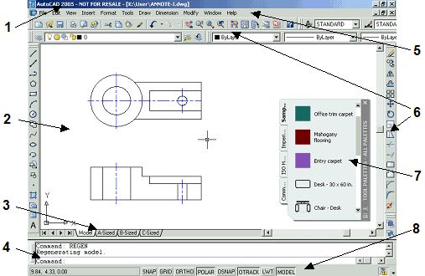

1. The **Title Bar** is located across the top of the window. At the right end of the title bar are the standard Windows buttons for minimizing the window, resizing the window, and exiting the program.
2. The **Drawing Windows** are the areas of the screen where the drawings appear. Inside the drawing window, crosshairs indicate the current pointer location. The lower left corner of the window may also display a pair of arrows, called the UCS icon, that indicates the current drawing plane. Drawing windows can be resized, minimized, and maximized.
3. The **Layout Tabs** divide your working area into the Model, where you draw the full-sized objects, and any number of layouts, where you prepare the drawing to print. You select a tab to switch to it.
4. The **Command Line** is the single most important part of the AutoCAD interface. All commands and functions are issued through this small text window located at the bottom of the screen.
5. The **Pull-down Menus** provide easy access to AutoCAD commands and settings.
6. **Toolbars** contain buttons for commonly used commands. There are many toolbars, each of which contains buttons for related commands. Six toolbars are open by default: Standard and Styles (below the pull-down menus), Layers and Properties (below Standard), Draw and Modify (along the left and right edges of the screen). To open other toolbars, right-click on any tool

button to bring up a shortcut menu, and select the toolbar you want.

1. **Tool Palettes** Tool Palettes offer quick access to often-used drawing components and commands. The palette window can be turned on or off as needed. For the beginning of class, close the Tool Palettes window by picking the "x" at the top of the window.
2. The **Status Bar** displays and allows you to change many of AutoCAD's drafting settings. You may see an additional window called the Sheet Set Manager when you open AutoCAD. This is an advanced feature for organizing sets of drawings and sheets. For the beginning of class, close this window by picking the "x" at the top of the window.

**AutoCAD's Cartesian Workspace How AutoCAD Locates Points** AutoCAD uses Cartesian (X,Y) coordinates to indicate locations in a drawing. Points are located by designating a horizontal (X) and vertical

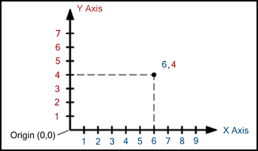

1. istance as measured from the origin (0,0). (There is also a third coordinate, Z, which is used only in 3D drawing.)

Many commands in AutoCAD require that the user input a point. For example,

in order to draw a line, you must tell AutoCAD where to begin and end the line. You can specify the point in one of two basic methods:

* 1. Picking a point on the screen with the pointing device.
  2. Typing in coordinates at the Command: prompt (when it is requesting point entry) in the form X,Y. For example, the point (6,4) would be typed at the keyboard as 6,4.

**Finding Coordinates: the ID Command**

AutoCAD displays the current coordinate location of the cursor in the Status Bar. You can also have AutoCAD report the coordinates of any point you pick. The ID command (Inquiry toolbar) reports on the Command Line the X, Y, and Z coordinates of any point you pick on the screen.



**Drawings Are Created at Full Scale** AutoCAD's Cartesian workspace is essentially unlimited in size. Whatever the object you are creating, you will typically draw it at full scale. Whether you are drawing a building that's 100 meters by 200 meters, a city that's 10 square miles, or an IC chip that is 0.1" by 0.1", you always draw in the real units of the object. Your drawing area is a big as you need it to be. In fact, the entire solar system can be drawn at full scale in AutoCAD. (Scaling the drawing only becomes necessary when it is printed.)

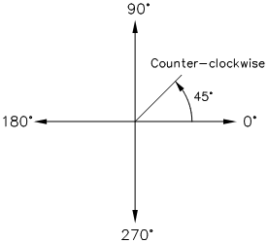

**Points in Cartesian Workspace**

Besides being enormous, the AutoCAD

drawing plane is also remarkably precise. Each point you enter in AutoCAD has an accuracy of 14 significant digits (1.0000000000000).

**How AutoCAD Measures Angles**

Along with the Cartesian coordinate system, you also need to understand how angles work in AutoCAD. This will be crucial for coordinate entry, rotating objects, and for working with arcs. AutoCAD measures angles in a counter-clockwise direction relative to the positive X-axis.

**Entering Points in AutoCAD**

You can enter points directly on the command line using three different systems.

The one you use will depend on which is more applicable for the situation. The three systems are as follows:

1. **ABSOLUTE CO-ORDINATES** - Using this method, you enter the points as they relate to the

origin of the WCS. To enter a point just enter in the exact point as **X,Y.**

1. **RELATIVE CO-ORDINATES** - This allows you to enter points in relation to the first point you have entered. After you've entered one point, the next would be entered as **@X,Y**. This means that AutoCAD will draw a line from the first point to another point X units over and Y units up relative to the previous point.
2. **POLAR CO-ORDINATES** - You would use this system if you know that you want to draw a line a certain distance at a particular angle. You would enter this as **@D<A**. In this case, D is the distance and A is the angle. Example: @10<90 will draw a line 10 units straight up from the first point.

The three ways of entering co-ordinates shown above are the **ONLY** way AutoCAD accepts input. First decide which style you need to use, and then enter as shown.

Remember that **X** is always before **Y** (alphabetical). Don't forget the '**@**' symbol when you are entering relative points. Any typing error or omission will give you results you don't want. If you

make a mistake and need to see what you typed, press F2 to bring up the text screen and check your typing. (Press F2 to get back to your drawing.)

**AutoCAD configuration- Units and Scales**

**Introduction**

Among the most important concepts that newcomers to AutoCAD need to get to grips with are those of drawing scale and drawing units. You cannot start creating sensible drawings with AutoCAD until you are familiar with scale, units and the commands you use to control them. This tutorial discusses these concepts, starting with the two most commonly asked questions in this subject area.

**At what scale should I draw?**

As a general rule, everything you draw with AutoCAD will be drawn full size. This often comes as quite a surprise to those who are new to CAD and have spent a number of years working on a drawing board. When you start drawing with AutoCAD you do not have to decide upon a drawing scale as you do when using a drawing board. When drawing on paper you must decide do draw at say, 1:20 or 1:200 depending upon the size of the object that you are drawing so that your scaled drawing will fit on the drawing sheet, be that A3 or A1. In AutoCAD you do not need to decide upon a drawing scale until you come to print the drawing and because the scaling of your drawing takes place at the printing stage, you can create drawings at a scale of 1:1. This has particular advantages because you can, for example, measure lengths, areas and volumes within an AutoCAD drawing and not need to compensate for any scale factor.

**Am I drawing in metres or millimetres?**

Most people who use AutoCAD, draw using *decimal drawing units*. What these drawing units represent is entirely up to the individual. However, you must decide what units you will use before you start drawing. One drawing unit could represent one millimetre, one centimetre, one metre, kilometre, mile, furlong or fathom. It is entirely up to you. However, in most parts of the world it is common practice to work in either millimetres or metres. Which of these two units you use will largely depend upon the type of drawing you are creating. For example, if you were creating a detail drawing of a flight of steps, you would most likely use millimetres (Architects will almost always use millimetres). If, on the other hand you are drawing a landscape masterplan, you would probably want to work in metres (Landscape Architects and Civil Engineers usually use metres).

By way of example, consider a drawing where you need to draw a footpath in plan. The footpath is two metres wide. If you are working in millimetres, the footpath would be drawn 2,000 drawing units wide but if you are working in metres, the footpath would be drawn just 2 drawing units wide. To translate this into practical terms, if you had drawn one edge of the path and you intended to draw the other edge using the Offset command, you would enter either "2,000" or "2" for the offset value depending upon whether you were using millimetres or metres respectively.

Although decimal drawing units are the most commonly used, you can configure AutoCAD to work with other types of drawing units. To change the unit type, you must use the Drawing Units dialogue box.

**Units Control**



Toolbar none

Pull-down Format Units… Keyboard UNITS

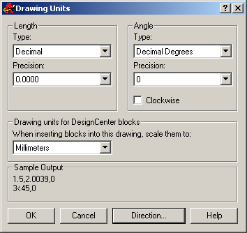

When you start the Units command, the first thing you see is the Drawing Units dialogue box, shown on the right. The dialogue box is divided into four main sections. The upper two are "Length", which refers to linear units and "Angles", referring to angular units. Settings for linear units and angular units can be made independently and in each case, you can control both the type and precision. In addition, the Angles section also allows you to specify the direction in which angles are measured. See below for more details.

A third section, entitled Drawing units for Design Center blocks allows you to assign a specific unit to the drawing so that when blocks are inserted via the AutoCAD Design Centre, they will automatically be scaled. The final section, Sample Output, gives you a preview of the drawing units as they will be displayed using the current settings.

**Linear Units**

You can see from the dialogue box that there are five different linear unit types for you to choose from, one of which is "Decimal", the default. The table below shows the effect of the different unit settings on two drawing unit values to give you an idea how the various settings might be used along with a brief description.

|  |  |  |  |
| --- | --- | --- | --- |
| **Unit Type** | **1.5 Drawing Units** | **1500 Drawing Units** | **Description** |
| Decimal | 1.5000 | 1500.0000 | Metric or SI units |
| Scientific | 1.5000E+00 | 1.5000E+03 | Decimal value raised to a power |
| Engineering | 0'-1.5000" | 125'-0.0000" | Feet and decimal inches |
| Architectural | 0'-1 1/2" | 125'-0" | Feet and fractional inches |
| Fractional | 1 1/2 | 1500 | Whole numbers and fractions |

Notice that when you change the unit type, the co-ordinate display on the status bar changes to show co-ordinates using the current unit type. Changing the unit type also affects the way distances, areas and volumes are reported when using the appropriate inquiry command.

For the most part you should not need to change the unit type. Units such as "Architectural" and "Engineering" are there mainly for AutoCAD users in the USA where Feet and Inches are still in common use.

**Angular Units**

Looking at the Drawing Units dialogue box again, you will notice that there are also five angular unit types. The default is decimal degrees, but there are other options. The table below shows the effect of the different unit types on two angular unit values. As with the linear units, there are not many circumstances under which you would want to use anything other than the default.

|  |  |  |  |
| --- | --- | --- | --- |
| **Unit Type** | **12.5 Angular Units** | **180 Angular Units** | **Description** |
| Decimal Degrees | 12.500 | 180.000 | Metric units |
| Deg/Min/Sec | 12d30'0" | 180d0'0" | Degrees, Minutes and Seconds |
| Grads | 13.889g | 200.000g | 400 grads = 360 degrees |
| Radians | 0.218r | 3.142r | 2 Pi radians = 360 degrees |
| Surveyor | N 77d30'0" E | W | Compass bearings |

AutoCAD also allows you to control the direction in which angular units are measured and the position of the start angle. By default, AutoCAD starts with the zero angle at the 3 o'clock position (East) with angles increasing in an anti-clockwise direction. For the most part this does

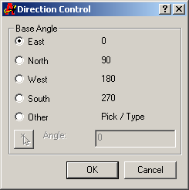

not present any problems once you get used to the idea. However, there are specific situations where it may be desirable to have the zero angle at the 12 o'clock position (North) and angles increasing in a clockwise direction. For example, if you are working on a surveyors drawing or a map base, this latter situation enables you to specify angles with respect to North. To change the direction of angular measurement, use the Clockwise check box in the Angle section of the Drawing Units dialogue box. When this box is checked, positive angles are measured in a clockwise direction, when it is not checked (the default), positive angles are measured in an anti- clockwise direction.

To change the start angle, click on the "Direction…" button in the Drawing Units dialogue box. The Direction Control dialogue box appears. You can set the Base Angle to any of the circle quadrants by clicking on the appropriate radio button or you can set it to a specific angle with the "Other" option. You can enter a specific angle into the edit box or you can pick an angle using the Pick an angle button. The ability to specify an "Other" or user angle can be useful if, for example, your drawing is not oriented to North but where you still want angular measurements to be made with respect to North. To change the direction of angular measurement, simply click on the appropriate radio button.

**Unit Precision**

The Drawing Units dialogue box can also be used to set the precision of linear and angular units. By default, AutoCAD sets the linear unit precision to four places of decimal, so distances appear in the form 0.0000. Angular unit precision is set to whole degrees only.

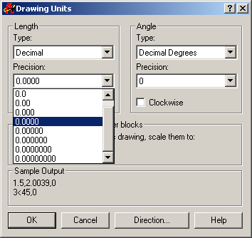

To change the precision with which linear and angular values are displayed, simply click the down arrow against the appropriate drop-down list (see illustration on the left) and select the number of decimal places required. The default setting of four decimal places is usually adequate for linear units. It is, however, often necessary to change the precision for angular units. Working in whole degrees does not usually give an adequate level of detail for many drawing functions. However, you do not *need* to change the precision of either linear or angular units unless you have a specific reason for doing so.

Changing the unit precision does not make your drawing more accurate, it just means that the co- ordinate display on the status bar and the results from the various inquiry commands will be displayed with a higher degree of precision. The *accuracy* of your drawing will be determined by the values you enter for the size of objects when you draw and edit them and by the correct use of the various object snaps and drawing aids.

**Basic AutoCAD Commands**

These commands may be used at any time, but are mainly called upon more during the beginning of the drawing process.

**Commands for Setting the Drawing Environment**

These commands may be used at any time, but are mainly called upon more during the beginning of the drawing process.

* **Units:** Specifies the display format and precision. This command dictates whether the units are displayed as decimals or as a fraction, as well as how many decimal places the number will go. Also specifies how angles will be represented, either as decimal degrees, radians, etc., as well as how angles will be measured, i.e. clockwise vs. counterclockwise.
* **Limits:** Sets limits to the boundary and size of the current drawing. The user must specify the lower left-hand corner and the upper right-hand corner. This setting may be turned on or off – when on, points may not be specified outside the currently set limits.
* **Qtext:** Quick text – may be turned on or off, like the Limits command. When switched on, text is

displayed in rectangles, showing the extent of the text. When off, just the text is displayed, without the rectangle.

* **Viewres:** Performs two functions: first, it lets the user disable fast zoom, which makes sense when conforming a more modern version of AutoCAD to an earlier one that lacks the fast zoom capability. Second, Viewres allows the user to control the smoothness and speed of circles and arcs drawn in the display. The user does this by choosing the number of sides circles will have. It is recommended this value be set at 2000.
* **Blipmode:** Blips are small crosses used to mark screen positions that the user has pointed to. They can be useful reference points, but too many of them can crowd the screen, making it difficult for the user to see. Engaging Blipmode allows the small crosses to stay up in the wake of the pointer, and turning it off makes them disappear. Blips are not part of the final drawing and are removed when the drawing is complete.
* **Fill:** When this command is engaged, solids, traces, wide polylines, and donuts that are drawn are then filled in with color, as opposed to just being outlines. This command does not affect the drawing’s plotted output, and, when using this command, there is a trade-off between regeneration time and the image’s quality.
* **Status:** This command simply lists, on the Text Screen, the current drawing environment, the modes, and statuses that are engaged for this drawing.

**Commands for Drawing Entities**

Once the drawing environment has been set, these commands are used to actually draw the entities.

* **Line:** Allows for the sequential drawing of one or more straight lines. Once engaged, this command elicits a prompt of “From point:”, at which point the user specifies a starting point for a line, or they may press RETURN, which starts the line at the end of the previous line or arc that was drawn. Next, the prompt “To point:” is displayed, allowing the user to specify a sequence of points to which the line will extend. They may also type the letter C to close the polygon, or the letter U to undo the previous line segment, or they may simply press RETURN to complete the command.
* **Point:** Draws a single marker/point, which is, by default, a single dot, but may be changed to something else if desired.
* **Circle:** Draws a circle by letting the user specify the center point, then dictating the circle’s size by entering a value for either the circle’s radius or its diameter. Another option to creating a circle with this command is to specify three points on the circle’s circumference, two end-points of its diameter, or its radius along with two other lines or circles to which the new circle will be tangential.
* **Arc:** This command draws arcs, and, like circles, may be dictated in one of several ways. The various methods for constructing arcs with this command are as follows: (1) specify three different points,

(2) starting point, center, and end point, (3) starting point, center, and included angle, (4) starting point, center, and length of chord, (5) starting point, ending point, and radius, (5) starting point, ending point, and included angle, (6) starting point, ending point, and starting direction, and finally,

(7) starting point and direction of previous line or arc, plus ending point.

* **Ellipse:** Ellipses are constructed by specifying the two end points of one of the major or minor axes, followed by a distance value defining half the length of the other axis.
* **Pline:** Draws 2D polylines, which are continuous sequences of straight lines and/or arc segments with varying line length, dictated by the user. You are able to close a polyline to form a polygon. It also may be helpful to know that polylines may be exploded into separate line and arc entities if necessary.
* **Polygon:** Draws regular polygons by entering the number of edges, then specifying the shape’s center and radius, or by locating the endpoints of any of its edges. Once created, polygons are to be treated as closed polylines.
* **Hatch:** Within one or many closed boundaries, a cross-hatch pattern may be created with the Hatch command. The boundaries must be well-defined, otherwise, the cross-hatch may leak out unexpectedly. The user may select pre-determined patterns supplied by AutoCAD, or they may enter their own and add them to the set that’s already there.
* **Bhatch:** A newer command in the AutoCAD quiver, it helps the user to better use the previously discussed Hatch command. It supports boundary hatching, allowing the user to pick a point that is adjacent to the boundary they wanted, and this new command lets AutoCAD search for the nearest entity, then constructs a closed boundary by tracing in a counterclockwise fashion to look for intersection points as well as connecting lines or arcs. Bhatch is convenient in that it allows the user to preview adjustments without having to start over each time.
* **Dtext:** Allows you to draw text dynamically, changing text height and rotation, allowing it to be moved, centered, stretched between two points, aligned, overscored, underscored, have symbols added, fonts changed, etc.

**Utility Commands**

These are some basic and useful commands that may be used more than other more specific commands.

* **Redraw:** Refreshes the program and re-displays the graphics on the screen, but without extraneous graphics, such as blips, that may have been left behind from earlier operations.
* **Save:** Saves all current changes and drawings to be saved to the disk. As with any important project done on a computer, it’s best to get into the habit of saving regularly, especially during long drawing sessions, to prevent any work from being lost.
* **End:** Finishes the current session, saves the work, and takes you back to AutoCAD’s main menu.
* **Quit:** Finishes the current session, but does NOT save the changes that were made to the current drawing, then returns you to the main menu.

**Drawing and Manipulation Commands**

These commands alter your drawings, allowing you to enlarge and reduce views, maintain graphic accuracy, and manipulate space and viewports, among other things.

**Moving Around the Drawing Area**

* **Zoom Scale:** Allows the user to enter a magnification or reduction factor. Numbers less than 1 will reduce the drawing, those greater than 1 will expand it. The Zoom Scale amount is applied to the entire drawing, and doesn’t change the actual size of the entities, simply the magnification.
* **Zoom Extents:** Commands AutoCAD to display all of the current drawing’s graphics, using the largest possible image, not necessarily extending it to the user-defined limits.
* **Zoom All:** Displays the drawing to the drawing limits.
* **Zoom Window:** Prompts the user to define which part of the drawing is to be magnified, by defining

the lower left-hand and upper right-hand corners of the box to be zoomed in on.

* **Zoom Center:** The user enters a point, which the program uses as the center of an area to be magnified, then they enter a value to be applied to the new, magnified image’s height.
* **Zoom Left Corner:** Like Zoom Center, the specified point is the lower left-hand corner of the new

display.

* **Zoom Previous:** Commands the program to revert back to the prior view displayed. Up to five views may be stacked up for comparison.
* **Zoom Dynamic:** The most powerful of the Zoom options, it allows for quick movement around the drawing.
* **Pan:** Permits panning across the current drawing without changing the scale.
* **Vpoint:** Establishes a viewpoint from anywhere in space, which may be entered as a 3D point, a spherical point, or dynamic (simply press RETURN instead of entering a specific point).
* **Dview:** Provides a dynamic tool for viewing an object in 3D as either a parallel projection or a perspective. Using a camera along with target concept, AutoCAD is able to manipulate the viewing position, direction of view, focal length, and viewing distance.
* **Plan:** Puts the user back in plan view when done working in 3D.

**Model Space, Paper Space, Viewports**

* **Tilemode:** Switching Tilemode to off (setting the value to 0), turns AutoCAD to paper space. Setting the value to 1, AutoCAD switches to model space.
* **Vports:** Only available when Tilemode is on, it allows the user to establish up to 16 viewports on the screen, so that each one holds a different view of the drawing. You are able to work in only one viewport at a time, but may easily move among the different ones.
* **View:** Saves the current view under a name the user specifies, or restores a previously saved view, and may be used in model or paper space,
* **Mview:** Used when Tilemode is off, Mview creates and defines various viewports’ characteristics

while in paper space. They may be turned on and off and linked with views that have been previously saved with the previous View command.

* **Mspace:** Also used when Tilemode is off, this command allows the user to switch to model space,

then edit their drawing inside a paper space viewport.

* **Pspace:** With Tilemode off and model space active, the user may switch back to paper space and edit graphics.

**Drawing Tools**

* **UCS:** The User Coordinate System (UCS) is set up to be positioned and oriented anywhere in 3D space. After the UCS is implemented, the previous 2D drawing is now done in the X-Y plane of the new UCS. The user is now able to easily draw anywhere in space, and also aids when drawing in 2D.
* **Snap:** Sets up a grid that is both invisible and orthogonal, square or rectangular, which all points entered with the mouse may be locked onto.
* **Grid:** This command sets up a visible grid of white dots that is used for referencing purposes.
* **Axis:** Similar to the Grid command, except the white dots are replaced with two intersecting axes with tick marks.
* **Ortho:** When turned on, Ortho mode makes all lines drawn with the mouse parallel to the axes.
* **Osnap:** (Object Snap) In Osnap’s “Running Mode”, it allows points to be precisely located on

reference points of existing objects. They may be overridden by selecting different object snap modes for a specific entry.

* **Aperture:** Sets the size of the Osnap target box, where values ranging from 1-50 screen units are valid.

**Deletion Commands**

Only two commands are in this group, used to delete objects and entities.

* **Erase:** This removes a selected group of entities, which may be entered before or after the command itself is entered.
* **Oops:** Restores the most recently deleted object group from using the previous Erase command.

This command may not be repeated, as it only restores one group of deleted objects.

**Transformation Commands**

The following group of commands allows the user to select a group of objects that need to be transformed in one way or another.

* **Move:** The user may dictate the direction and length of a move of specified objects by indicating two points which define a vector between the objects.
* **Copy:** Similar to the Move command, Copy does not affect the original group of objects, with the copied objects being completely independent of the original objects.
* **Rotate:** Providing a specific base point and angle, the user may rotate an object of their choosing

with this command. Negative angles will provide a clockwise rotation, while a positive angle gives a counterclockwise rotation.

* **Scale:** Enlarge or shrink a selected group of objects by selecting a base point for the scaling as well as applying a factor for which to scale.
* **Mirror:** This command produces a mirror copy of a selected object group by specifying the two ends of the mirror line. Then, the mirrored objects may be deleted or kept, depending upon the user’s preference.
* **Stretch:** Allows the user to move a portion of a drawing while retaining its connections to other parts of the drawing, thus stretching it out. Blocks, Hatch patterns, and Text entities may NOT be stretched.
* **Array:** Produces multiple copies of selected objects that are arranged in a rectangular or circular pattern.
* **Offset:** Constructs a new entity parallel to an existing one. This could be a single line, polyline, arc, circle, or curve.

**Error Recovery Commands**

These commands bring back errors made during the editing process.

* **U:** The U command undoes the most recent drawing or editing and may be used repeatedly, all the way back to the beginning of the session.
* **Redo:** This command is used immediately after an error to redo what was undone.
* **Undo:** This is like the U command but a bit more complicated. It is able to undo several commands at once, allows the user to set mark points and later undo back to those points, and to group operations together and undo them simultaneously.

**Commands that Change Existing Entities**

These commands allow different editing changes to be made to existing entities.

* **Change:** This command covers a lot of ground, with two basic main capabilities: first, use this command to change properties that all entities possess, for example, layer name, color, line type. Second, change the geometry and attributes of specific types of entities.
* **Pedit:** This is the command used to make changes to polylines, such as width, taper, closing an opening, breaking one into two, moving, adding, and deleting vertices, etc.
* **Break:** This command splits an already existing line, arc, circle, or polyline into two separate parts, producing an erased portion in between them.
* **Trim:** This command trims parts of certain objects in a drawing in order to finish them precisely at

some cutting edge (or edges) that are established by one or more other objects. One or several lines, arcs, circles or polylines must first be identified to serve as cutting edges, which may be selected by any of the methods available. Next, pointing is used to select the parts of the objects that are to be trimmed. Many objects may be selected in this way for trimming, including ones that had been specified as cutting edges.

* **Extend:** Complementing the Trim command, Extend operates similarly, but the selected lines are extended to end exactly at the specified boundary edges.
* **Fillet:** This command connects two existing lines, circles, or arcs by adding an arc with a specific radius (a fillet), and allows the user to change the current default radius prior to filleting.
* **Chamfer:** Like the Fillet command, this one chamfers, or cuts away, as in carpentry, corners with a straight edge.
* **Divide:** Divides an object into a specified number equal parts, from 2 to 32,767 parts.
* **Measure:** This measures an object, from one end to the other.

**Enquiry Commands**

This final group of AutoCAD commands are used to obtain information a drawing‘s object‘s position and nature.

* **List:** Lists stored information about any selected entities found within the current drawing.
* **Dist:** Calculates and displays the distance and angle between two points in a drawing.
* **Area:** Calculates and displays any region’s area and perimeter, as long as it is defined by a sequence of specified points on the drawing, as long as they form a closed polygon.

**Note:** The command are to be used in the command line, this commands may be accessed in respective tool bars as tools

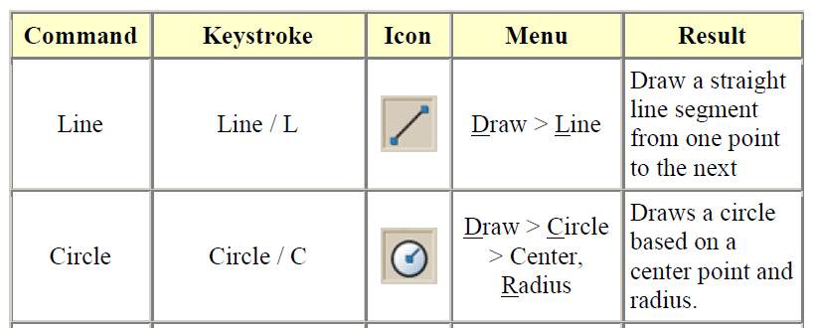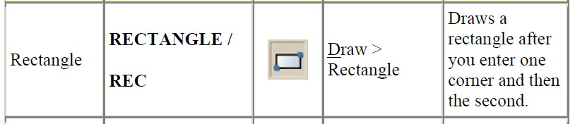

1. **Tools**

**Drawing tools –** on the drawing tool bar or Drawing menu

**Modifying tools –** on the Modifying toolbar or modifying menu

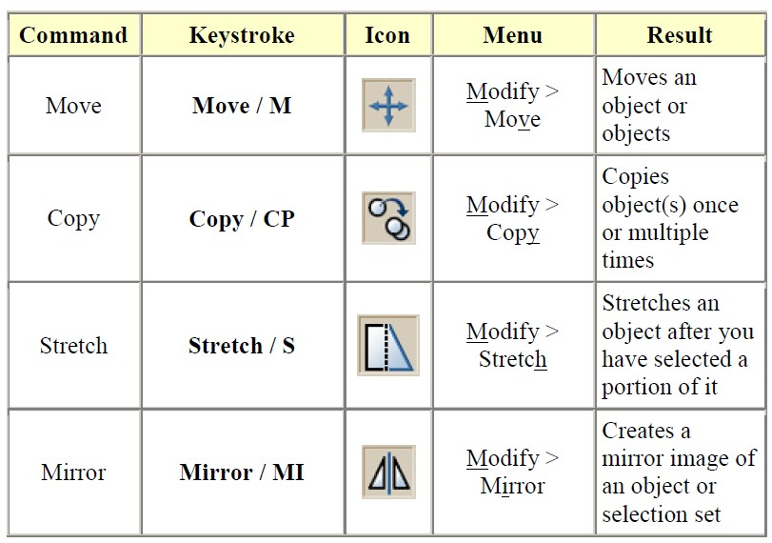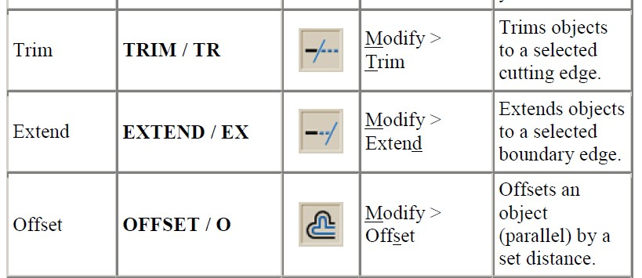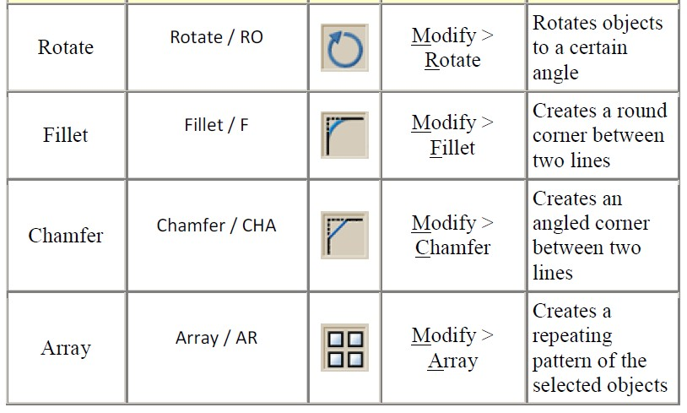

**Dimensioning tools –** on the Dimensioning toolbar or Dimensioning menu

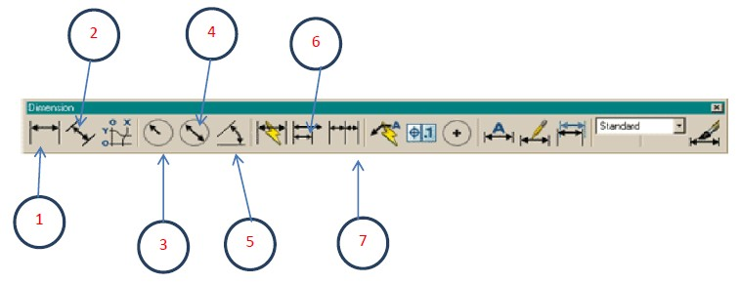

1. **Linear** dimensions are used for dimensioning either horizontal or vertical distances.
2. **Aligned** dimensions will measure the actual length of an angled line parallel.
3. **Radius** dimensions will give you the radius of either arcs or circles.
4. **Diameter** dimensions are used on circles.
5. **Angular** dimensions will measure the angle between two lines that you pick.
6. **Baseline** dimensions are a special type – elements with a common baseline
7. **Continued** dimensions are a special type – elements that dimension from a previous dimension
8. **Object Snaps**

Suppose you want to draw a line from the center of the circle to the middle of the vertical line you extended earlier. AutoCAD has a feature that makes this very easy. These are the Object Snaps (or

Osnaps "Oh-Snaps"). Type **OS** <ENTER> You will see this dialog box appear.

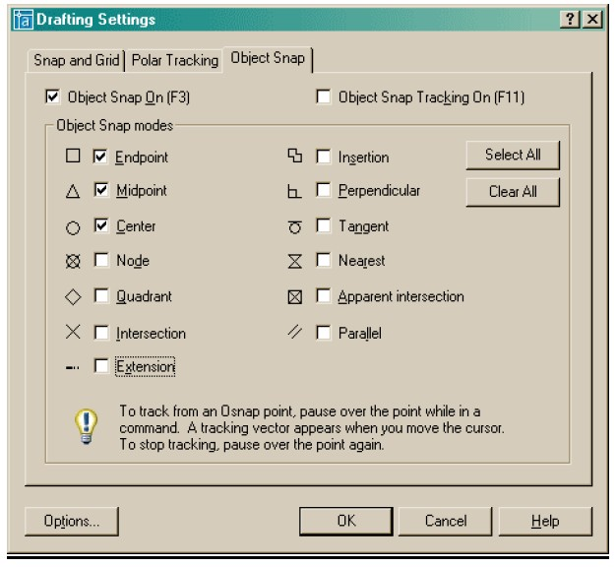

**Endpoint** - snaps to either the beginning or the end of an object such as a line -

**END**

**Midpoint** - snaps to the exact middle of a line or an arc - **MID Center** - snaps to the center-point of a circle or arc - **CEN Node** - snaps to 'nodes' (not covered in this course) - **NOD**

**Quadrant** - snaps to any of the four quadrants of a circle - **QUA**

**Intersection** - snaps to the point where two object cross - **INT Extension** - Snaps to the phantom extension of an arc or line - **EXT**

**Insertion** - snaps to the insertion point of an object (such as a block or text) - **INS Perpendicular** - will snap so that the result is perpendicular to line selected - **PER Tangent** - snaps to create a line tangent to a circle or arc - **TAN**

**Nearest** - will find the closest point an object and snap to that point - **NEA Parallel** -Snaps parallel to a specified line - **PAR**

**None** - temporarily turns off all Osnaps. (Pressing your F3 Key is quicker) - **NON Osnap settings** - opens the Osnap dialog box.

**Temporary Tracking** - Creates a temporary tracking point (see Object Tracking).

**From** - Allows you to select a point, and then denote a new location 'from' that point using relative co-ordinates. This can save you the time of drawing (and erasing) construction lines.

1. **Layers**

A LAYER is a CAD feature used to organize drawings (organize drawing to sections for else of management). On format menu, click Layers then use the Layer manager window that appears to

organize the drawing

i.e. Create different layers(from layers toolbar) and properties and draw on respective layers.

1. **Blocks**

A BLOCK is a collection of simple entities (lines, arcs, circles, text, etc.) that form a more complex

entity that normally represents an object in the real world, e.g. a door, a chair, a window, a computer. Select the various drawing entities and on drawing menu, choose block to create a single entity of the drawing.

**E. Hatch**

Hatching in AutoCAD is a way of filling in areas of your drawing with a preformatted pattern to represent certain materials. It is usually used in sectional views.

There are two types of hatching you can use.

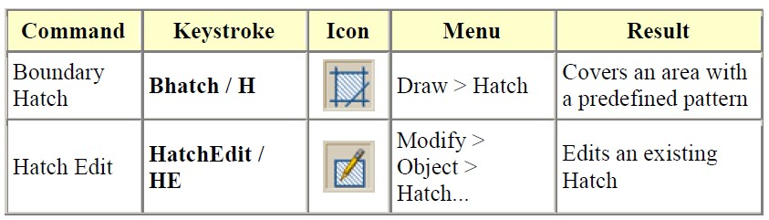

**Steps**

On drawing menu, choose hatch then cover an area with preformatted pattern.

**3-D CAD Concept**

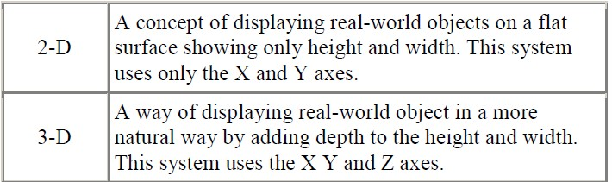

**Terminology**

**Elevation** - The difference between an object being at zero on the Z-axis and the height that it is above zero.

**Extrude** - The extrude command raises the shape of a 2D outline into a 3D solid. For example, a circle would be extruded into a cylinder.

**Face** - The simplest true 3-D surface.

**Facet** - A three or four sided polygon that represents a piece (or section) of a 3-D surface. **Hidden line removal** - A way of hiding lines that would not be visible if you were viewing the actual object you have drawn in AutoCAD. (Command: HIDE)

**Region** - A 2-D area consisting of lines, arcs, etc.

**Thickness** - A property of lines and other objects that give them a 3-D like appearance.

**Z-Axis** - The third axis that defines the depth.

**UCS** - The User Co-ordinate System. This is defined by the user.

**WCS** World Co-ordinate System is define as the default CAD origin

**Types of 3D Models**

Several types of 3D modeling are available in AutoCAD. Each of these 3D modeling technologies offer a different set of capabilities.

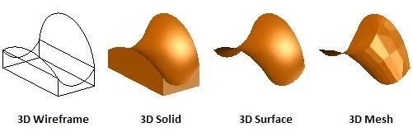

**Wireframe Models:**

1. Consists of lines, arcs, and curves that define the object
2. There are no surfaces. Objects appear as outlines only
3. Time consuming to make it part

**Surface Models**

1. Represent a thin layer or shell of the shape of an object
2. Made up of edges and surfaces
3. Surfaces models are created by using sweeping, lofting, or revolving 2D lines or arcs

**Solid Models**

1. Are made up of **surfaces** and the **volume** inside
2. Solid models have properties of mass, volume, center of gravity, and moments-of-inertia
3. You can easily create 3D **primitives** such as boxes, cones, cylinders, and spheres or create 3D models from sweeping, lofting, or extruding 2D **closed** objects or profiles.

**Mesh Models**

1. Consists of vertices, edges, and faces that use triangles and quads to define the 3D shape
2. Meshes have to mass properties
3. Meshes allow greater ability to manipulate and deform surfaces
4. You can covert meshes into solid models

* Wireframe modeling is useful for initial design iterations and as reference geometry, serving as a 3D framework for subsequent modeling or modification.
* Solid modeling is efficient to use, easy to combine primitives and extruded profiles, and offers mass properties and sectioning capabilities.
* Surface modeling offers fine control over curved surfaces for precise manipulation and analysis.
* Mesh modeling provides freeform sculpting, creasing, and smoothing capabilities.

A 3D model can include combinations of these technologies, and you can convert between them. For example, you can convert a primitive 3D solid pyramid to a 3D mesh to perform mesh smoothing. You can then convert the mesh to a 3D surface or back to a 3D solid to take advantage of their respective modeling features.

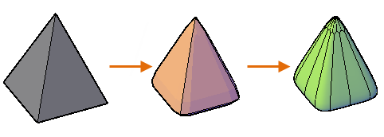

**3D AutoCAD (Advantages of 3D models)**

* Models can be rotated or viewed from any position
* You can generate **section** and **auxiliary views**
* You can **remove hidden lines** and do **realistic shading**
* You can run **part interference checks** for **engineering analysis**
* You can add **lighting** and **realistic rendering** to models
* You can **create animations**
* You can **extract manufacturing data** for making the part

**Developing a 3-D object**

To start developing a 3D object, we have two options

1. Develop an object in 2D (circle, rectangle, polygon, but not lines) then activate the property of the object find thickness property and add some value for thickness (extrude)
2. Go to view menu – 3D views and choose either of the isometric views and start developing the 3-D object along all its axis (X, Y, Z)

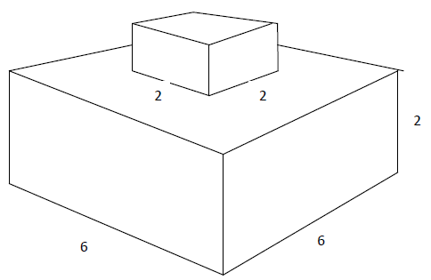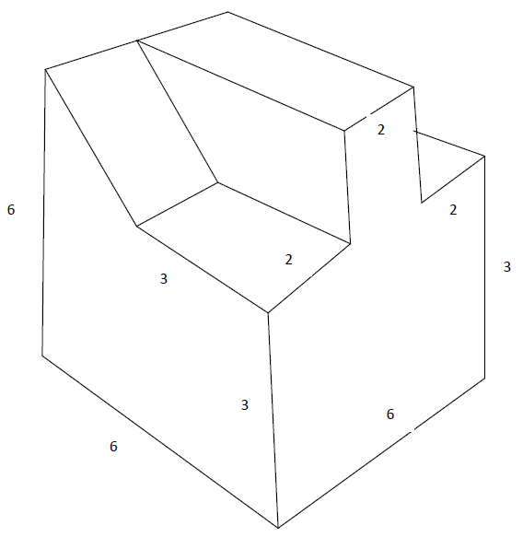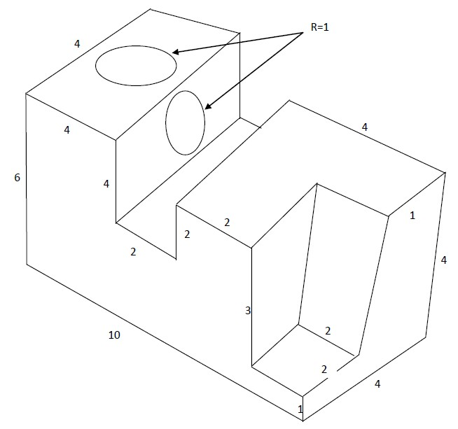

**Projection**

When three-dimensional graphics are displayed on a flat computer screen or printed on paper, they must be projected onto the viewing plane. A projection is a way of converting positions in 3D space into locations in the 2D viewing plane. Engineering supports two types of projections- parallel and perspective-for each view.

**Types of Projections**

The projections are classified according to the method of taking the projection on the plane. Classifications of projection are: Perspective and Parallel

**Parallel Projections**

A parallel projection projects objects in 3D space onto the 2D viewing plane along parallel rays. The figure below shows a parallel projection; note that two objects that are the same size but at different locations still appear to be the same size when projected onto the viewplane.

*Figure : In a Parallel Projection, Rays Do Not Converge at the Eye*

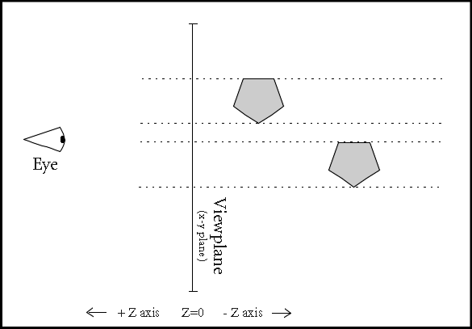

**Perspective Projections**

A perspective projection projects objects in 3D space onto the 2D viewing plane along rays that converge at the eye position. The figure below shows a perspective projection; note that objects that are farther from the eye appear smaller when projected onto the viewplane.

*Figure: In a Perspective Projection, Rays Converge at the Eye*

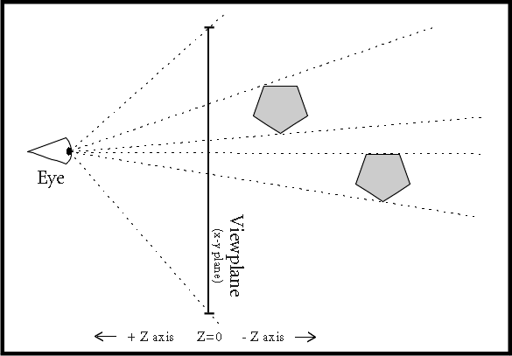

**Parallel projection**

When you look at a machine, you see that the machine has planes based on parallel lines. For example, a [lathe machine](http://www.brighthubengineering.com/manufacturing-technology/64501-lathe-machines-used-in-industry/) has a rectangular base, which is a combination of parallel lines. If parallel lines are drawn to represent the parallel lines actually present on the machine, we call it a parallel projection. This type of projection is widely used by draftsman and architects to make

blueprints and schematics.

1. **Orthographic Projection**

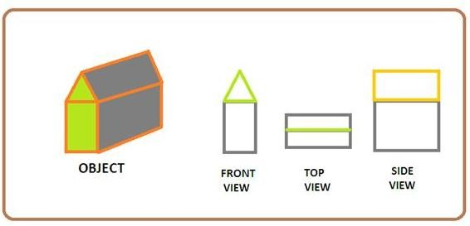

Orthographic projection is the most common parallel projection due to its simplicity. It is represented using three views; front view, side view and top view. In graphical terms, you need to draw the object in XY plane, YZ plane, and ZX plane, separately.

To draw the front view you just imagine how the object looks at front. Don‘t think about slope of the object, just draw whatever it looks. Similarly, the top and side view of the object can be drawn (refer the image).

Through this projection, accurate measurement can be obtained because all the views are drawn using same scale. However, it doesn‘t provide a realistic projection of a 3-D model; besides, it requires multiple views to feel the object design.

The orthographic projection can be drawn two ways, first angle projection and third angle projection. Both of them have differences only in the positioning of various views. In first angle projection, the front view is placed onto first quadrant; top and side view are placed onto the forth and second quadrants, respectively. In the third angle projection, the third quadrant is used for front view; whereas top and side view are placed onto the second and forth quadrants.

1. **Axonometric Projection**

Axonometric projection is a type of parallel projection. Drawing the object in this method is

somewhat complex because it requires only one image to draw the 3-D structure of the object onto a plane paper. Suppose you are using a projector and an object is placed in front of projector lines. Now, you can see the image of 3-D object onto a 2-D plane just behind the object. This projection is nothing but an axonometric projection.

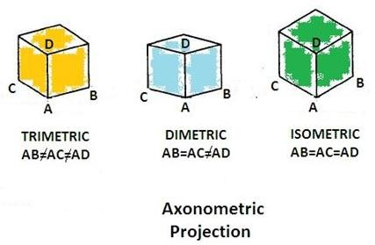

Axonometric projection is classified into three categories depending upon orientation of the object.

The **first and most convenient type is isometric**. In this type of projection, angles between the three axes are equal. As the diagram says, if we project a cube onto a 2-D surface, you see all the three sides AB, AC, and AD are equal.

The **second type is diametric projection**, in which only two angles between the axes are equal. You can see the diagram in which only two sides AB and AC are equal.

The **third is trimetric projection** that can be drawn using three axes having different angles between them. It‘s the most common type of axonometric projection and the object can be placed anywhere with respect to the observer.

All these methods are used for furniture and structural design. Axonometric projection is good for rectangular structures rather than curved objects.

1. **Oblique Projection**

Oblique projection is comparatively easier than axonometric projection. It requires only one image and traditional equipments to draw any object. In this method, first you need to draw the

front view or side view and then draw rest of the object with respect to it.

* + Draw the front or side view of the object just like in orthographic projection.
  + The measurements drawn backwards must be in the scale equal to half of the actual measurement.
  + The lines drawn backwards should have the angle in between 300 to 450; however it is convenient if you use 450 angles.

Oblique projection is further divided into two types based on scaling.

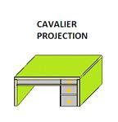

|  |  |  |
| --- | --- | --- |
|  | The first one is cavalier projection, in which the length in X and Z axis are  drawn in scale 1:1 and there is no required scaling for the length of the Y- axis. It is very easy to draw and often used for drawing an object when you can use only your hands such as drawing a cube on the blackboard. The most common use of this type of projection is in military fortification. | |
| The other type is cabinet projection. Unlike cavalier  projection, this method uses the 2:1scale to draw lengths in X and Z direction, respectively. Besides, lengths in Y-axis must also be scaled properly. This projection is very useful in furniture industries. |  |

**Perspective Projection**

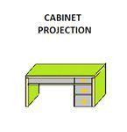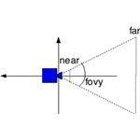

Perspective projection doesn‘t use parallel lines to project an object, instead it is a projection

along the lines emerging from a single point. Due to this, the nearer part appears bigger than distant part. This is much like the working of our eyes in respect to depth perception. For example, when we see a railway line, it appears converging towards a single point called the vanishing point. View of the object feels more realistic using this projection.

You can use any type of projection for drawing an object onto plane surface. However, it requires good imagination power so as the object would become more realistic. The scaling must be done properly to avoid distortion. Always use clips to place the drawing sheet rigidly on the desk. Furthermore, use clean equipment to draw a neat and clean image.

**CHAPTER 3: GEOGRAPHYCAL INFORMATION SYSTEM (GIS)**

### What is GIS – Definition?

**Geographic Information System (GIS) is a computer system build to capture, store, manipulate, analyze, manage and display all kinds of spatial or geographical data.** GIS applications are tools that allow end users to perform spatial query, analysis, edit spatial data and create hard copy maps. In simple way GIS can be define as an image that is referenced to the earth or has x and y coordinate and it‘s attribute values are stored in the table. These x and y coordinates are based on different projection system and there are various types of projection system. Most of the time GIS is used to create maps and to print. To perform the basic task in GIS, layers are combined, edited and designed.

GIS can be used to solve the location based question such as ―What is located here‖ or Where to find particular features? GIS User can retrieve the value from the map, such as how much is the forest area on the land use map. This is done using the query builder tool. Next important features of the GIS is the capability to combine different layers to show new information. For example, you can combine elevation data, river data, land use data and many more to show information about the landscape of the area. From map you can tell where is high lands or where is the best place to build house, which has the river view . GIS helps to find new information.

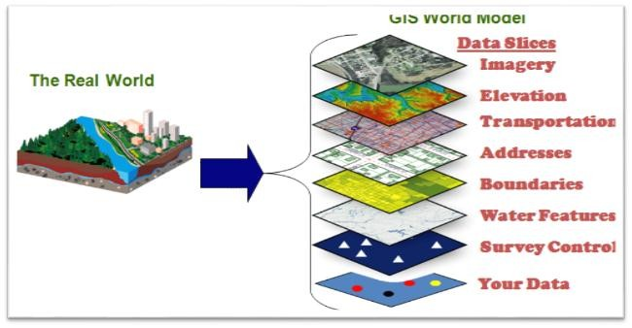

*Figure: Gis Model*

**How GIS Works:**

* Visualizing Data: The geographic data that is stored in the databases are displayed in the GIS software.
* Combining Data: Layers are combined to form a maps of desire.
* The Query: To search the value in the layer or making a geographic queries.

#### Definition by others:

*A geographic information system (GIS) lets us visualize, question, analyze, and interpret data to understand relationships, patterns, and trends. (ESRI)*

*In the strictest sense, a GIS is a computer system capable of assembling, storing, manipulating, and displaying geographically referenced information (that is data identified according to their locations). (USGS)*

#### Advantage of GIS:

* + Better decision made by government people
  + Improve decision making with the help of layered information
  + Citizen engagement due to better system
  + Help to identify communities that is under risk or lacking infrastructure
  + Helps in identifying criminology matters
  + Better management of natural resources
  + Better communication during emergency situation
  + Cost savings due to better decision
  + Finding different kinds of trends within the community
  + Planning the demographic changes

### History of GIS:

Modern GIS has seen series of development. GIS has evolved with the computer system. Here are the brief events that has happened for the development of the GIS system.

**Year 1854** – The term GIS that used scientific method to create maps was used by John Snow in 1854. He used points on London residential map to plot outbreak of Cholera.

**Year 1960** – Modern computerized GIS system began in year 1960.

**Year 1962** – Dr. Roger Tomlinson created and developed Canadian Geographic Information System (CGIS) to store, analyze and manipulate data that was collected for the Canada Land Inventory (CLI). This software had the capacity to overlay, measurement and digitizing (converting scan hardcopy map to digital data). It is never provided in commercial format but Dr. Tomlinson is the father of GIS.

**Year 1980** – This period saw rise of commercial GIS software‘s like M&S Computing, Environmental Systems Research Institute (ESRI) and Computer Aided Resource Information System (CARIS). These all software were similar to CGIS with more functionality and user- friendliness. Among all the above the most popular today is ESRI products like ArcGIS, ArcView which hold almost 80 % of global market.

### Component of GIS:

**Hardware:** Hardware is the physical component of the computer and GIS runs on it. Hardware may be hard disk, processor, motherboard and so on. All these hardware work together to function as a computer. GIS software run on these hardware. Computer can be standalone called desktop or server based. GIS can run on both of them.

**Software:** GIS Software provides tools and functions to input and store spatial data or geographic data. It provides tool to perform geographic query, run analysis model and display geographic data in the map form. GIS software uses Relation Database Management System (RDBMS) to store the geographic data. Software talks with the database to perform geographic query.

**Data:** Data are the fuel for the GIS and the most important and expensive component. Geographic data are the combination of physical features and it‘s information which is stored in the tables. These tables are maintained by the RDBMS. The process of capturing the geographic data are called digitization which is the most tedious job. It is the process of converting scanned hardcopy maps into the digital format. Digitization is done by tracing the lines along the geographic features for example to capture a building you will trace around the building on the image.

**People:** People are the user of the GIS system.

People use all above three component to run a GIS system. Today‘s computer are fast and user friendly which makes it easy to perform geographic queries, analysis and displaying maps. Today everybody uses GIS to perform their daily job.

### Area of GIS Applications

Major areas of GIS application can be grouped into five categories as follows.

**Facilities Management:** Large scale and precise maps and network analysis are used mainly for utility management. AM/FM is frequently used in this area.

**Environment and Natural Resources Management:** Medium or small scale maps and overlay techniques in combination with aerial photographs and satellite images are used for management of natural resources and environmental impact analysis.

**Street Network:** Large or medium scale maps and spatial analysis are used for vehicle routing, locating house and streets etc.

**Planning and Engineering:** Large or medium scale maps and engineering models are used mainly in civil engineering.

**Land Information System:** Large scale cadastre maps or land parcel maps and spatial analysis are used for cadastre administration, taxation etc.

### GIS Data Models

A GIS stores information about the world as a collection of thematic layers that can be linked together by geography. This simple but extremely powerful and versatile concept has proven invaluable for solving many real-world problems from tracking delivery vehicles, to recording details of planning applications, to modeling global atmospheric circulation. The thematic layer approach allows us to organize the complexity of the real world into a simple representation to help facilitate our understanding of natural relationships.

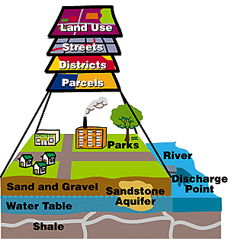

The thematic layer approach allows us to organize the complexity of the real world

### GIS Data Types

The basic data type in a GIS reflects traditional data found on a map. Accordingly, GIS technology utilizes two basic types of data. These are:

* **Spatial data:** describes the absolute and relative location of geographic features.
* **Attribute data:** describes characteristics of the spatial features. These characteristics can be quantitative and/or qualitative in nature. Attribute data is often referred to as tabular data.

The coordinate location of a forestry stand would be spatial data, while the characteristics of that forestry stand, e.g. cover group, dominant species, crown closure, height, etc., would be attribute data. Other data types, in particular image and multimedia data, are becoming more prevalent with changing technology. Depending on the specific content of the data, *image data* may be considered either spatial, e.g. photographs, animation, movies, etc., or attribute, e.g. sound, descriptions, narration's, etc.

**Spatial Data Models**

Traditionally spatial data has been stored and presented in the form of a map. Three basic types of spatial data models have evolved for storing geographic data digitally. These are referred to as:

1. **Vector**;
2. **Raster**;
3. **Image**.

The following diagram reflects the two primary spatial data encoding techniques. These are vector and raster. Image data utilizes techniques very similar to raster data, however typically lacks the internal formats required for analysis and modeling of the data. Images reflect *pictures* or *photographs* of the landscape.

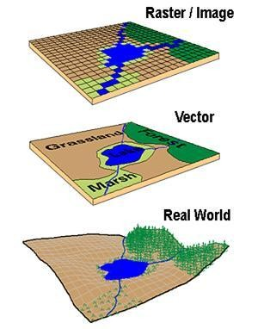

Representation of the real world and showing differences in how a vector and a raster GIS will represent this real world.

**Vector Data Formats**

All spatial data models are approaches for storing the spatial location of geographic features in a database. Vector storage implies the use of vectors (directional lines) to represent a geographic feature. Vector data is characterized by the use of sequential points or *vertices* to define a linear segment. Each vertex consists of an X coordinate and a Y coordinate.

Vector lines are often referred to as *arcs* and consist of a string of vertices terminated by a *node*. A node is defined as a vertex that starts or ends an arc segment. Point features are defined by one coordinate pair, a vertex. Polygonal features are defined by a set of closed coordinate pairs. In vector representation, the storage of the vertices for each feature is important, as well as the connectivity between features, e.g. the sharing of common vertices where features connect.

**Vector Data:** There are three types of vector data, points, lines and polygons. These data are created by digitizing the base data. They store information in x, y coordinates. Vectors models are used to store data which have discrete boundaries like country borders, land parcels and roads.

**Several different vector data models exist, however only two are commonly used in GIS data storage.**

The most popular method of retaining spatial relationships among features is to explicitly record adjacency information in what is known as the topologic data model. Topology is a mathematical concept that has its basis in the principles of feature adjacency and connectivity.

The **topologic data structure** is often referred to as an *intelligent data structure* because spatial relationships between geographic features are easily derived when using them. Primarily for this reason the topologic model is the dominant vector data structure currently used in GIS technology. Many of the complex data analysis functions cannot effectively be undertaken without a topologic vector data structure. Topology is reviewed in greater detail later on in the book.

The secondary vector data structure that is common among GIS software is the **computer-aided drafting (CAD) data structure**. This structure consists of listing elements, not features, defined by strings of vertices, to define geographic features, e.g. points, lines, or areas. There is considerable redundancy with this data model since the boundary segment between two polygons can be stored twice, once for each feature. The CAD structure emerged from the development of computer graphics systems without specific considerations of processing geographic features. Accordingly, since features, e.g. polygons, are self-contained and independent, questions about the adjacency of features can be difficult to answer. The CAD vector model lacks the definition of spatial relationships between features that is defined by the topologic data model.

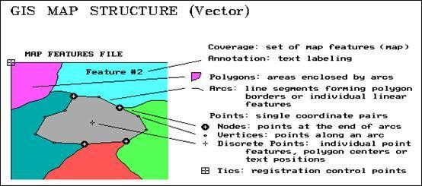

GIS MAP Structure - VECTOR systems (Adapted from Berry)

**Raster Data Formats**

Raster data models incorporate the use of a *grid-cell* data structure where the geographic area is divided into cells identified by row and column. This data structure is commonly called *raster*. While the term raster implies a regularly spaced grid other *tessellated* data structures do exist in grid based GIS systems. In particular, the quadtree data structure has found some acceptance as an alternative raster data model.

**Raster Data:** Raster data store information of features in cell based manner. Satellite images, photogrammetry and scanned maps are all raster based data. Raster model are used to store data which varies continuously as in aerial photography, a satellite image or elevation values (DEM- Digital Elevation Model).

The size of cells in a tessellated data structure is selected on the basis of the data accuracy and the resolution needed by the user. There is no explicit coding of geographic coordinates required since that is implicit in the layout of the cells. A raster data structure is in fact a matrix where any coordinate can be quickly calculated if the origin point is known, and the size of the grid cells is known. Since grid-cells can be handled as two-dimensional arrays in computer encoding many analytical operations are easy to program. This makes tessellated data structures a popular choice for many GIS software. Topology is not a relevant concept with tessellated structures since adjacency and connectivity are implicit in the location of a particular cell in the data matrix.

Several tessellated data structures exist, however only two are commonly used in GIS's. The most popular cell structure is the regularly spaced matrix or *raster* structure. This data structure involves a division of spatial data into regularly spaced cells. Each cell is of the same shape and size. Squares are most commonly utilized.

Since geographic data is rarely distinguished by regularly spaced shapes, cells must be classified as to the most common attribute for the cell. The problem of determining the proper resolution for a particular data layer can be a concern. If one selects too coarse a cell size then data may be overly generalized. If one selects too fine a cell size then too many cells may be created resulting in a large data volume, slower processing times, and a more cumbersome data set. As well, one can imply accuracy greater than that of the original data capture process and this may result in some erroneous results during analysis.

As well, since most data is captured in a vector format, e.g. digitizing, data must be converted to the raster data structure. This is called *vector-raster conversion.* Most GIS software allows the user to define the raster grid (cell) size for vector-raster conversion. It is imperative that the original scale, e.g. accuracy, of the data be known prior to conversion. The accuracy of the data, often referred to as the resolution, should determine the cell size of the output raster map during conversion.

Most raster based GIS software requires that the raster cell contain only a single discrete value. Accordingly, a data layer, e.g. forest inventory stands, may be broken down into a series of raster maps, each representing an attribute type, e.g. a species map, a height map, a density map, etc. These are often referred to as *one attribute maps*. This is in contrast to most conventional vector

data models that maintain data as *multiple attribute maps*, e.g. forest inventory polygons *linked* to a database table containing all attributes as columns. This basic distinction of raster data storage provides the foundation for quantitative analysis techniques. This is often referred to as *raster or map algebra*. The use of raster data structures allow for sophisticated mathematical modelling processes while vector based systems are often constrained by the capabilities and language of a relational DBMS.

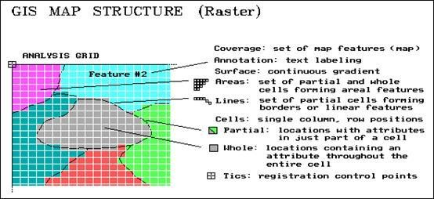

GIS MAP Structure - RASTER systems (Adapted from Berry)

This difference is the major distinguishing factor between vector and raster based GIS software. It is also important to understand that the selection of a particular data structure can provide advantages during the analysis stage. For example, the vector data model does not handle continuous data, e.g. elevation, very well while the raster data model is more ideally suited for this type of analysis. Accordingly, the raster structure does not handle linear data analysis, e.g. shortest path, very well while vector systems do. It is important for the user to understand that there are certain advantages and disadvantages to each data model.

The selection of a particular data model, vector or raster, is dependent on the source and type of data, as well as the intended use of the data. Certain analytical procedures require raster data while others are better suited to vector data.

**Image Data**

Image data is most often used to represent graphic or pictorial data. The term *image* inherently reflects a graphic representation, and in the *GIS world*, differs significantly from raster data. Most often, image data is used to store remotely sensed imagery, e.g. satellite scenes or orthophotos, or ancillary graphics such as photographs, scanned plan documents, etc. Image data is typically used in GIS systems as background display data (if the image has been rectified and georeferenced); or as a graphic attribute. Remote sensing software makes use of image data for image classification and processing. Typically, this data must be converted into a raster format (and perhaps vector) to be used analytically with the GIS.

Image data is typically stored in a variety of de facto industry standard proprietary formats. These often reflect the most popular image processing systems. Other graphic image formats, such as TIFF, GIF, PCX, etc., are used to store ancillary image data. Most GIS software will read such formats and allow you to display this data.

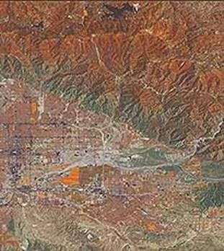

Image data is most often used for remotely sensed imagery such as satellite imagery or digital orthophotos.

Vector and Raster - advantages and disadvantages

There are several advantages and disadvantages for using either the vector or raster data model to store spatial data. These are summarized below.

|  |  |
| --- | --- |
| **Vector Data** | |
| **Advantages :**   1. Data can be represented at its original resolution and form without generalization. 2. Graphic output is usually more aesthetically pleasing (traditional cartographic representation); 3. Since most data, e.g. hard copy maps, is in vector form no data conversion is required. 4. Accurate geographic location of data is maintained. 5. Allows for efficient encoding of | **Disadvantages:**   1. The location of each vertex needs to be stored explicitly. 2. For effective analysis, vector data must be   converted into a topological structure. This is often processing intensive and usually requires extensive data cleaning. As well, topology is static, and any updating or editing of the vector data requires re-building of the topology.   1. Algorithms for manipulative and analysis functions are complex and may be processing intensive. Often, this inherently limits the functionality for large data sets, e.g. a large |

|  |  |
| --- | --- |
| topology, and as a result more efficient  operations that require topological information, e.g. proximity, network analysis. | number of features.   1. Continuous data, such as elevation data, is not effectively represented in vector form. Usually substantial data generalization or interpolation is required for these data layers. 2. Spatial analysis and filtering within polygons is impossible |
| **Raster Data** | |
| **Advantages :**  **1)** The geographic location of each cell is implied by its position in the cell matrix. Accordingly, other than an origin point,  e.g. bottom left corner, no geographic coordinates are stored.   1. Due to the nature of the data storage technique data analysis is usually easy to program and quick to perform. 2. The inherent nature of raster maps, e.g. one attribute maps, is ideally suited for mathematical modeling and quantitative analysis. 3. Discrete data, e.g. forestry stands, is accommodated equally well as continuous data, e.g. elevation data, and facilitates the   integrating of the two data types.   1. Grid-cell systems are very compatible with raster-based output devices, e.g. electrostatic plotters, graphic terminals. | **Disadvantages:**   1. The cell size determines the resolution at which the data is represented. 2. It is especially difficult to adequately represent   linear features depending on the cell resolution. Accordingly, network linkages are difficult to establish.   1. Processing of associated attribute data may be cumbersome if large amounts of data exists. Raster maps inherently reflect only one attribute or characteristic for an area. 2. Since most input data is in vector form, data must undergo vector-to-raster conversion. Besides increased processing requirements this may introduce data integrity concerns due to generalization and choice of inappropriate cell size. 3. Most output maps from grid-cell systems do not conform to high-quality cartographic needs. |

It is often difficult to compare or rate GIS software that use different data models. Some personal computer (PC) packages utilize vector structures for data input, editing, and display but convert to raster structures for any analysis. Other more comprehensive GIS offerings provide both integrated raster and vector analysis techniques. They allow users to select the data structure appropriate for the analysis requirements. Integrated raster and vector processing capabilities are most desirable and provide the greatest flexibility for data manipulation and analysis.

**Attribute Data Models**

**A separate data model is used to store and maintain attribute data for GIS software.** These data models may exist internally within the GIS software, or may be reflected in external commercial Database Management Software (DBMS). A variety of different data models exist for the storage and management of attribute data. The most common are:

* + Tabular
  + Hierarchial
  + Network
  + Relational
  + Object Oriented

The tabular model is the manner in which most early GIS software packages stored their attribute data. The next three models are those most commonly implemented in database management systems (DBMS). The object oriented is newer but rapidly gaining in popularity for some applications. A brief review of each model is provided.

**Tabular Model**

The simple tabular model stores attribute data as sequential data files with fixed formats (or comma delimited for ASCII data), for the location of attribute values in a predefined record structure. This type of data model is outdated in the GIS arena. It lacks any method of checking data integrity, as well as being inefficient with respect to data storage, e.g. limited indexing capability for attributes or records, etc.

**Hierarchical Model**

The hierarchical database organizes data in a *tree* structure. Data is structured downward in a *hierarchy* of tables. Any level in the hierarchy can have unlimited *children*, but any *child* can have only one *parent*. **Hierarchial DBMS have not gained any noticeable acceptance for use within GIS**. They are oriented for data sets that are very stable, where primary relationships among the data change infrequently or never at all. Also, the limitation on the number of parents that an element may have is not always conducive to actual geographic phenomenon.

**Network Model**

The network database organizes data in a network or *plex* structure. Any column in a plex structure can be linked to any other. Like a tree structure, a plex structure can be described in terms of *parents* and *children*. This model allows for children to have more than one parent.

**Network DBMS have not found much more acceptance in GIS than the hierarchical DBMS**. They have the same flexibility limitations as hierarchical databases; however, the more powerful structure for representing data relationships allows a more realistic modelling of geographic phenomenon. However, network databases tend to become overly complex too easily. In this regard it is easy to lose control and understanding of the relationships between elements.

**Relational Model**

The relational database organizes data in *tables*. Each table, is identified by a unique table name, and is organized by *rows* and *columns*. Each column within a table also has a unique name. Columns store the values for a specific attribute, e.g. cover group, tree height. Rows represent one record in the table. In a GIS each row is usually linked to a separate spatial feature, e.g. a forestry stand. Accordingly, each row would be comprised of several columns, each column containing a specific value for that geographic feature. The following figure presents a sample table for forest inventory features. This table has 4 rows and 5 columns. The forest stand number would be the *label* for the spatial feature as well as the *primary key* for the database table. This

serves as the linkage between the spatial definition of the feature and the attribute data for the feature.

|  |  |  |  |  |
| --- | --- | --- | --- | --- |
| **UNIQUE STAND NUMBER** | **DOMINANT COVER GROUP** | **AVG. TREE HEIGHT** | **STAND SITE INDEX** | **STAND AGE** |
| **001** | DEC | 3 | G | 100 |
| **002** | DEC-CON | 4 | M | 80 |
| **003** | DEC-CON | 4 | M | 60 |
| **004** | CON | 4 | G | 120 |

Data is often stored in several tables. Tables can be joined or referenced to each other by common columns (relational fields). Usually the common column is an identification number for a selected geographic feature, e.g. a forestry stand polygon number. This identification number acts as the *primary key* for the table. The ability to join tables through use of a common column is the essence of the relational model. Such relational joins are usually ad hoc in nature and form the basis of for querying in a relational GIS product. Unlike the other previously discussed database types, relationships are implicit in the character of the data as opposed to explicit characteristics of the database set up.

The relational database model is the most widely accepted for managing the attributes of geographic data.

There are many different designs of DBMSs, but in GIS the relational design has been the most useful. In the relational design, data are stored conceptually as a collection of tables. Common fields in different tables are used to link them together. This surprisingly simple design has been so widely used primarily because of its flexibility and very wide deployment in applications both within and without GIS.

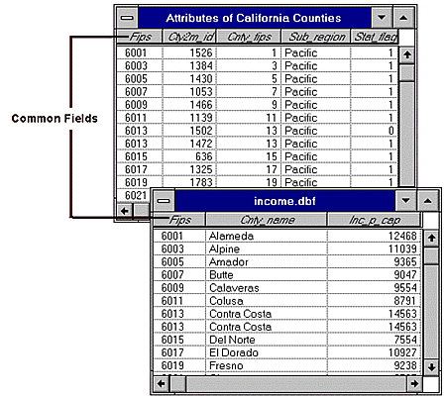

In the relational design, data are stored conceptually as a collection of tables. Common fields in different tables are used to link them together.

In fact, most GIS software provides an *internal* relational data model, as well as support for *commercial off-the-shelf* (COTS) relational DBMS'. COTS DBMS' are referred to as *external* DBMS'. This approach supports both users with small data sets, where an internal data model is sufficient, and customers with larger data sets who utilize a DBMS for other corporate data storage requirements. With an external DBMS the GIS software can simply *connect* to the database, and the user can make use of the inherent capabilities of the DBMS. External DBMS' tend to have much more extensive querying and data integrity capabilities than the GIS' internal relational model. The emergence and use of the external DBMS is a trend that has resulted in the proliferation of GIS technology into more traditional data processing environments.

The relational DBMS is attractive because of its:

1. simplicity in organization and data modelling.
2. flexibility - data can be manipulated in an ad hoc manner by joining tables.
3. efficiency of storage - by the proper design of data tables redundant data can be minimized; and
4. the non-procedural nature - queries on a relational database do not need to take into account the internal organization of the data.

The relational DBMS has emerged as the dominant commercial data management tool in GIS implementation and application.

The following diagram illustrates the basic linkage between a vector spatial data (topologic model) and attributes maintained in a relational database file.

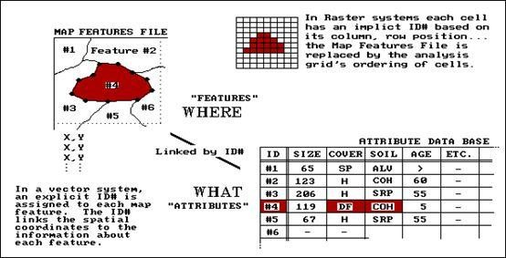

Basic linkages between a vector spatial data (topologic model) and attributes maintained in a relational database file (From Berry)

**Object-Oriented Model**

The object-oriented database model manages data through *objects*. An object is a collection of data elements and operations that together are considered a single entity. The object-oriented database is a relatively new model. This approach has the attraction that querying is very natural, as features can be bundled together with attributes at the database administrator's discretion. To date, only a few GIS packages are promoting the use of this attribute data model. However, initial impressions indicate that this approach may hold many operational benefits with respect to geographic data processing. Fulfilment of this promise with a commercial GIS product remains to be seen.

### Sources of Data

As previously identified, two types of data are input into a GIS, spatial and attribute. The data input process is the operation of encoding both types of data into the GIS database formats.

The creation of a clean digital database is the most important and time consuming task upon which the usefulness of the GIS depends. The establishment and maintenance of a robust spatial database is the cornerstone of a successful GIS implementation.

As well, the digital data is the most expensive part of the GIS. Yet often, not enough attention is given to the quality of the data or the processes by which they are prepared for automation.

The general consensus among the GIS community is that 60 to 80 % of the cost incurred during implementation of GIS technology lies in data acquisition, data compilation and database development.

A wide variety of data sources exist for both spatial and attribute data. The most common general sources for spatial data are:

* + hard copy maps;
  + aerial photographs;
  + remotely-sensed imagery;
  + point data samples from surveys; and
  + existing digital data files.

Existing hard copy maps, e.g. sometimes referred to as *analogue maps*, provide the most popular source for any GIS project.

Potential users should be aware that while there are many private sector firms specializing in providing digital data, federal, provincial and state government agencies are an excellent source of data. Because of the large costs associated with data capture and input, government departments are often the only agencies with financial resources and manpower funding to invest in data compilation. British Columbia and Alberta government agencies are good examples. Both provincial governments have defined and implemented province wide coverage of digital base map data at varying map scales, e.g. 1:20,000 and 1:250,000. As well, the provincial forestry agencies also provide thematic forest inventory data in digital format. Federal agencies are also often a good source for base map information. An inherent advantage of digital data from government agencies is its cost. It is typically inexpensive. However, this is often offset by the data's accuracy and quality. Thematic coverages are often not up to date. However, it is important to note that specific characteristics of government data varies greatly across North America.

Attribute data has an even wider variety of data sources. Any textual or tabular data than can be referenced to a geographic feature, e.g. a point, line, or area, can be input into a GIS. Attribute data is usually input by manual keying or via a bulk loading utility of the DBMS software. ASCII format is a de facto standard for the transfer and conversion of attribute information.

The following figure describes the basic data types that are used and created by a GIS.

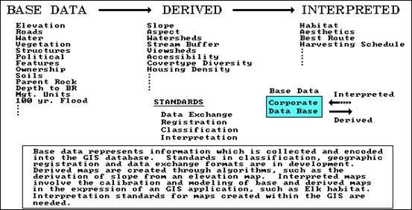

The basic data types that are used and created by a GIS (after Berry).

### Data Input Techniques

Since the input of attribute data is usually quite simple, the discussion of data input techniques will be limited to spatial data only. There is no single method of entering the spatial data into a GIS. Rather, there are several, mutually compatible methods that can be used singly or in combination.

The choice of data input method is governed largely by the application, the available budget, and the type and the complexity of data being input.

There are at least four basic procedures for inputting spatial data into a GIS. These are:

* + Manual digitizing;
  + Automatic scanning;
  + Entry of coordinates using coordinate geometry; and the
  + Conversion of existing digital data.

**Digitizing**

While considerable work has been done with newer technologies, the overwhelming majority of GIS spatial data entry is done by manual digitizing. A digitizer is an electronic device consisting of a table upon which the map or drawing is placed. The user traces the spatial features with a hand-held magnetic pen, often called a *mouse* or cursor. While tracing the features the coordinates of selected points, e.g. vertices, are sent to the computer and stored. All points that are recorded are registered against positional control points, usually the map corners, that are keyed in by the user at the beginning of the digitizing session. The coordinates are recorded in a user defined coordinate system or map projection. Latitude and longitude and UTM is most often used. The ability to adjust or transform data during digitizing from one projection to another is a

desirable function of the GIS software. Numerous functional techniques exist to aid the operator in the digitizing process.

*Digitizing* can be done in a *point mode*, where single points are recorded one at a time, or in a *stream mode*, where a point is collected on regular intervals of time or distance, measured by an X and Y movement, e.g. every 3 metres. Digitizing can also be done blindly or with a graphics terminal. Blind digitizing infers that the graphic result is not immediately viewable to the person digitizing. Most systems display the digitized linework as it is being digitized on an accompanying graphics terminal.

Most GIS's use a *spaghetti mode* of digitizing. This allows the user to simply digitize lines by indicating a start point and an end point. Data can be captured in point or stream mode. However, some systems do allow the user to capture the data in an arc/node topological data structure. The arc/node data structure requires that the digitizer identify nodes.

Data capture in an arc/node approach helps to build a topologic data structure immediately. This lessens the amount of post processing required to *clean* and build the topological definitions. However, most often digitizing with an arc/node approach does not negate the requirement for editing and cleaning of the digitized linework before a complete topological structure can be obtained.

The building of topology is primarily a post-digitizing process that is commonly executed in *batch mode* after data has been cleaned. To date, only a few commercial vector GIS software offerings have successfully exhibited the capability to build topology interactively while the user digitizes.

Manual digitizing has many advantages. These include:

1. Low capital cost, e.g. digitizing tables are cheap;
2. Low cost of labour;
3. Flexibility and adaptability to different data types and sources;
4. Easily taught in a short amount of time - an easily mastered skill
5. Generally the quality of data is high;
6. Digitizing devices are very reliable and most often offer a greater precision that the data warrants; and
7. Ability to easily register and update existing data.

For raster based GIS software data is still commonly digitized in a vector format and converted to a raster structure after the building of a clean topological structure. The procedure usually differs minimally from vector based software digitizing, other than some raster systems allow the user to define the resolution size of the grid-cell. Conversion to the raster structure may occur

*on-the-fly* or afterwards as a separate conversion process.

**Automatic Scanning**

A variety of scanning devices exist for the automatic capture of spatial data. While several different technical approaches exist in scanning technology, all have the advantage of being able

to capture spatial features from a map at a rapid rate of speed. However, as of yet, scanning has not proven to be a viable alternative for most GIS implementation. Scanners are generally expensive to acquire and operate. As well, most scanning devices have limitations with respect to the capture of selected features, e.g. text and symbol recognition. Experience has shown that most scanned data requires a substantial amount of manual editing to create a clean data layer. Given these basic constraints some other practical limitations of scanners should be identified. These include :

1. hard copy maps are often unable to be removed to where a scanning device is available, e.g. most companies or agencies cannot afford their own scanning device and therefore must send their maps to a private firm for scanning;
2. hard copy data may not be in a form that is viable for effective scanning, e.g. maps are of poor quality, or are in poor condition;
3. geographic features may be too few on a single map to make it practical, cost-justifiable, to scan;
4. often on *busy* maps a scanner may be unable to distinguish the features to be captured from the surrounding graphic information, e.g. dense contours with labels;
5. with raster scanning there it is difficult to read unique labels (text) for a geographic feature effectively; and
6. scanning is much more expensive than manual digitizing, considering all the cost/performance issues.

Consensus within the GIS community indicates that scanners work best when the information on a map is kept very clean, very simple, and uncluttered with graphic symbology.

The sheer cost of scanning usually eliminates the possibility of using scanning methods for data capture in most GIS implementations. Large data capture shops and government agencies are those most likely to be using scanning technology.

Currently, general consensus is that the quality of data captured from scanning devices is not substantial enough to justify the cost of using scanning technology. However, major breakthroughs are being made in the field, with scanning techniques and with capabilities to automatically clean and prepare scanned data for topological encoding. These include a variety of *line following* and *text recognition* techniques. Users should be aware that this technology has great potential in the years to come, particularly for larger GIS installations.

**Coordinate Geometry**

A third technique for the input of spatial data involves the calculation and entry of coordinates using coordinate geometry (COGO) procedures. This involves entering, from survey data, the explicit measurement of features from some known monument. This input technique is obviously very costly and labour intensive. In fact, it is rarely used for natural resource applications in GIS. This method is useful for creating very precise cartographic definitions of property, and accordingly is more appropriate for land records management at the cadastral or municipal scale.

**Conversion of Existing Digital Data**

A fourth technique that is becoming increasingly popular for data input is the conversion of existing digital data. A variety of spatial data, including digital maps, are openly available from a wide range of government and private sources. The most common digital data to be used in a GIS is data from CAD systems. A number of data conversion programs exist, mostly from GIS software vendors, to transform data from CAD formats to a raster or topological GIS data format. Several ad hoc standards for data exchange have been established in the market place. These are supplemented by a number of government distribution formats that have been developed. Given the wide variety of data formats that exist, most GIS vendors have developed and provide data exchange/conversion software to go from their format to those considered common in the market place.

Most GIS software vendors also provide an ASCII data exchange format specific to their product, and a programming subroutine library that will allow users to write their own data conversion routines to fulfil their own specific needs. As digital data becomes more readily available this capability becomes a necessity for any GIS. Data conversion from existing digital data is not a problem for most technical persons in the GIS field. However, for smaller GIS installations who have limited access to a *GIS analyst* this can be a major stumbling block in getting a GIS operational. Government agencies are usually a good source for technical information on data conversion requirements.

Some of the data formats common to the GIS marketplace are listed below. Please note that most formats are only utilized for graphic data. Attribute data is usually handled as ASCII text files. Vendor names are supplied where appropriate.

|  |  |
| --- | --- |
| **IGDS - Interactive Graphics Design Software (Intergraph / Microstation)** | This binary format is a standard in the turnkey CAD market and has become a de facto standard in Canada's mapping industry. It is a proprietary format, however most GIS software vendors provide DGN translators. |
| **DLG - Digital Line Graph (US Geological Survey)** | This ASCII format is used by the USGS as a distribution standard and consequently is well utilized in the United States. It is not used very much in Canada even though most software vendors provide two way conversion to DLG. |
| **DXF - Drawing Exchange Format (Autocad)** | This ASCII format is used primarily to convert to/from the Autocad drawing format and is a standard in the engineering discipline. Most GIS software vendors provide a DXF translator. |
| **GENERATE - ARC/INFO**  **Graphic Exchange Format** | A generic ASCII format for spatial data used by the ARC/INFO software to accommodate generic spatial data. |
| **EXPORT - ARC/INFO**  **Export Format** . | An exchange format that includes both graphic and attribute data. This format is intended for transferring ARC/INFO data from one hardware platform, or site, to another. It is also often used for archiving.  ARC/INFO data. This is not a published data format, however some GIS and desktop mapping vendors provide translators. |

EXPORT format can come in either uncompressed, partially compressed, or fully compressed format

A wide variety of other vendor specific data formats exist within the mapping and GIS industry. In particular, most GIS software vendors have their own proprietary formats. However, almost all provide data conversion to/from the above formats. As well, most GIS software vendors will develop data conversion programs dependant on specific requests by customers. Potential purchasers of commercial GIS packages should determine and clearly identify their data conversion needs, prior to purchase, to the software vendor.

# CHAPTER 4: ARTIFICIAL INTELLIGENCE

## What is Artificial Intelligence?

According to the father of Artificial Intelligence, John McCarthy, it is *“The science and engineering of making intelligent machines, especially intelligent computer programs”.*

Artificial Intelligence is a way of **making a computer, a computer-controlled robot, or a software think intelligently**, in the similar manner the intelligent humans think.

AI is accomplished by studying how human brain thinks, and how humans learn, decide, and work while trying to solve a problem, and then using the outcomes of this study as a basis of developing intelligent software and systems.

## Goals of AI

* + **To Create Expert Systems** − The systems which exhibit intelligent behavior, learn, demonstrate, explain, and advice its users.
  + **To Implement Human Intelligence in Machines** − Creating systems that understand, think, learn, and behave like humans.

**Benefits and Challenges of Artificial Intelligence**

*People fear artificial intelligence, but balancing AI pros and cons suggests it's a necessary evil – and even vital in places.*

**Pros of Artificial Intelligence:**

The pros of artificial intelligence are numerous.

1. **Mundane tasks:** humans get bored, machines don't. Let them do the humdrum jobs. "A.I. allows for more intricate process automation, which increases productivity of resources and takes repetitive, boring labor off the shoulders of humans. They can focus on creative tasks instead," said Felicia Schneiderhan, CEO of 30SecondToFly, an AI virtual travel assistant.
2. **Faster actions and decisions:** A.I. and cognitive technologies help in making faster actions and decisions. "Areas like automated fraud detection, planning and scheduling further demonstrate this benefit," said Kalyan Kumar, executive vice president at HCL Technologies, an IT services provider in India.
3. **Machine Learning:** [Big Data](http://www.datamation.com/big-data/what-is-big-data.html) means datasets in the petabytes, far too much for a human to sift through. AI can chew through that data as fast as the Xeon processors in the servers can go and derive insights from the data much faster than any human could.

CloudPassage co-founder and CTO Carson Sweet argues this isn‘t actual AI. "A lot of the big data processing and analysis being attributed to AI is really just the work of machine learning. True AI would need to take things so much further; toward genuine self-learning using artificial neural networks that emulate the structure and functions of neural networks in human brains," he said.

1. **Error-Free Processing:** To error is human. Computers don't. The only mistakes they make is when you don't program them properly. AI processing will insure error-free processing of data, no matter how large the dataset. Judgement calls, however, are a different matter.

"Computers are 'stupid,' but that is their brilliance - they demand such a high level of rigor and AI adds quantitative rigor on top of that, that to use AI at all you first have to ask yourself the very challenging but stimulating question of what you're trying to do, with a new level of acuity," said Dr. Nathan Wilson, CTO and co-founder of Nara Logics, synaptic intelligence company.

1. **Taking the Risk:** AI-powered machines are doing jobs humans either can't do or would have to do very carefully. Space exploration is one of them. The Mars rover Curiosity is an example. It is freely roaming Mars because it examines the landscape as it explores and determines the best path to take. The result is that Curiosity is learning to think for itself.
2. **Better research outcomes:** "AI-based technologies like computer vision help in achieving better outcomes through improved prediction, which can include medical diagnosis, oil exploration and demand forecasting," said Kumar.

**The Cons of Artificial Intelligence**

The Cons of Artificial Intelligence provoke a gut-level response.

1. **Job losses:** There is no way around it, AI will cost lesser-skilled people their jobs. Robots have already taken many jobs on assembly lines and as AI gets better at doing complex tasks, even more low-skill jobs will be taken.

"AI will create much more wealth than it destroys, but it will not be equitably distributed, especially at first," said Wilson. Driverless cars is one obvious singular tech that will displace millions of human drivers fairly quickly, although the recent fatality involving a Tesla car on auto-drive may have set the whole effort back a bit.

The changes will be subliminally felt and not overt, said Wilson. "A tax accountant won‘t one day receive a pink slip and meet the robot that is now going to sit at her desk. Rather, the next time the tax accountant applies for a job, it will be a bit harder to find a job."

1. **A concentration of power:** AI could mean a lot of power will be in the hands of a few who are controlling it. "AI de-humanizes warfare as the nations in possession of advanced AI technology can kill humans without involving an actual human to pull the trigger," said Schneiderhan.
2. **Bad calls:** AI does not have the ability to make a judgement call and may never get that ability.

A really good example happened in Sydney, Australia in 2014, when there was a shooting and hostage drama downtown. People began ringing up Uber to get out of the affected area, and because of the surge in demand in a concentrated area, Uber's algorithms fell back on the trusted economics of supply-and-demand and ride rates skyrocketed.

The Uber algorithms didn't take into account the violent crisis impacting downtown, and affected riders didn't care. They were livid that they had been gouged at a time of crisis. It forced Uber to

reevaluate how it handles such emergencies. Perhaps in the future it will handle them better, but for a few Aussies, it left a bad taste in their mouths.

"There is nothing artificial about intelligence," said Kartik Iyengar, senior vice president of IoT

& Skylab at VirtusaPolaris, a global IT consulting and technology services company. "Intelligence is a fine balance of emotions and skill that is constantly developing. Today, shades of gray exist when we make judgements. Our behavior is an outcome of the world around us – the more artificial it becomes, the more our definitions are subject to deciding on simply right or wrong, rather than the quick mid-course corrections that make us human. Replacing adaptive human behavior with rigid, artificial intelligence could cause irrational behavior within ecosystems of people and things."

1. **Judgement calls, part 2:** The Uber situation highlights the fact that unless all such solutions are anticipated and specifically programmed to be out of bounds, an AI can arrive at a situation and implement it to the detriment of people or the environment. Dr. Tim Lynch, who has a doctorate in the psychology of computers and intelligent machines, calls this "Perverse Instantiation."

What that means is an AI can be programmed with a benign goal but implement it in a perverse manner just because the solution is logical and expeditious. "So if there is a problem with the food supply, an AI's solution may be to reduce the population by any means available rather than find ways to increase food production or decrease food waste," he said.

In short, an ultimate pro and con of artificial intelligence: AI still isn't all that smart.

## What Contributes to AI?

Artificial intelligence is a science and technology based on disciplines such as Computer Science, Biology, Psychology, Linguistics, Mathematics, and Engineering. A major thrust of AI is in the development of computer functions associated with human intelligence, such as reasoning, learning, and problem solving. Out of the following areas, one or multiple areas can contribute to build an intelligent system.

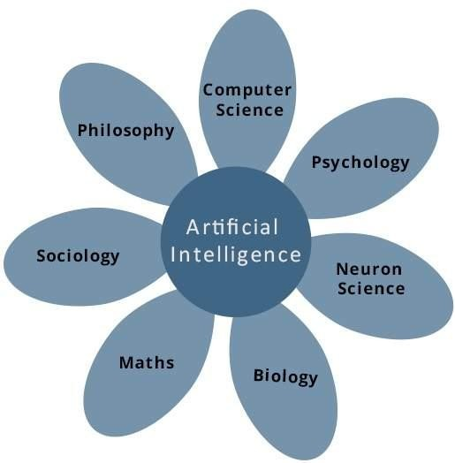

**Programming Without and With AI**

The programming without and with AI is different in following ways −

|  |  |
| --- | --- |
| **Programming Without AI** | **Programming With AI** |
| A computer program without AI can answer the  **specific** questions it is meant to solve. | A computer program with AI can answer the  **generic** questions it is meant to solve. |
| Modification in the program leads to change in its  structure. | AI programs can absorb new modifications by  putting highly independent pieces of information together. Hence you can modify even a minute piece of information of program without affecting its structure. |
| Modification is not quick and easy. It may lead to  affecting the program adversely. | Quick and Easy program modification. |

## Applications of AI

AI has been dominant in various fields such as −

* + **Gaming** − AI plays crucial role in strategic games such as chess, poker, tic-tac-toe, etc., where machine can think of large number of possible positions based on heuristic knowledge.
  + **Natural Language Processing** − It is possible to interact with the computer that understands natural language spoken by humans.
  + **Expert Systems** − There are some applications which integrate machine, software, and special information to impart reasoning and advising. They provide explanation and advice to the users.
  + **Vision Systems** − These systems understand, interpret, and comprehend visual input on the computer. For example,
    - A spying aeroplane takes photographs, which are used to figure out spatial information or map of the areas.
    - Doctors use clinical expert system to diagnose the patient.
    - Police use computer software that can recognize the face of criminal with the stored portrait made by forensic artist.
  + **Speech Recognition** − Some intelligent systems are capable of hearing and comprehending the language in terms of sentences and their meanings while a human talks to it. It can handle different accents, slang words, noise in the background, change in human‘s noise due to cold, etc.
  + **Handwriting Recognition** − The handwriting recognition software reads the text written on paper by a pen or on screen by a stylus. It can recognize the shapes of the letters and convert it into editable text.
  + **Intelligent Robots** − Robots are able to perform the tasks given by a human. They have sensors to detect physical data from the real world such as light, heat, temperature, movement, sound, bump, and pressure. They have efficient processors, multiple sensors and huge memory, to exhibit intelligence. In addition, they are capable of learning from their mistakes and they can adapt to the new environment.

## History of AI

Here is the history of AI during 20th century −

|  |  |
| --- | --- |
| **Year** | **Milestone / Innovation** |
| 1923 | Karel Čapek play named ―Rossum's Universal Robots‖ (RUR) opens in London, first use  of the word "robot" in English. |
| 1943 | Foundations for neural networks laid. |
| 1945 | Isaac Asimov, a Columbia University alumni, coined the term *Robotics*. |
| 1950 | Alan Turing introduced Turing Test for evaluation of intelligence and published  *Computing Machinery and Intelligence.* Claude Shannon published *Detailed Analysis of Chess Playing* as a search. |
| 1956 | John McCarthy coined the term *Artificial Intelligence*. Demonstration of the first running  AI program at Carnegie Mellon University. |
| 1958 | John McCarthy invents LISP programming language for AI. |
| 1964 | Danny Bobrow's dissertation at MIT showed that computers can understand natural  language well enough to solve algebra word problems correctly. |
| 1965 | Joseph Weizenbaum at MIT built *ELIZA*, an interactive problem that carries on a dialogue  in English. |
| 1969 | Scientists at Stanford Research Institute Developed *Shakey*, a robot, equipped with  locomotion, perception, and problem solving. |
| 1973 | The Assembly Robotics group at Edinburgh University built *Freddy*, the Famous Scottish  Robot, capable of using vision to locate and assemble models. |
| 1979 | The first computer-controlled autonomous vehicle, Stanford Cart, was built. |
| 1985 | Harold Cohen created and demonstrated the drawing program, *Aaron*. |
| 1990 | Major advances in all areas of AI −   * Significant demonstrations in machine learning |

|  |  |
| --- | --- |
|  | * Case-based reasoning * Multi-agent planning * Scheduling * Data mining, Web Crawler * natural language understanding and translation * Vision, Virtual Reality * Games |
| 1997 | The Deep Blue Chess Program beats the then world chess champion, Garry Kasparov. |
| 2000 | Interactive robot pets become commercially available. MIT displays *Kismet*, a robot with  a face that expresses emotions. The robot *Nomad* explores remote regions of Antarctica and locates meteorites. |

## AI - Intelligent Systems

While studying artificially intelligence, you need to know what intelligence is. This chapter covers Idea of intelligence, types, and components of intelligence.

### Meaning of Intelligence

The ability of a system to calculate, reason, perceive relationships and analogies, learn from experience, store and retrieve information from memory, solve problems, comprehend complex ideas, use natural language fluently, classify, generalize, and adapt new situations.

### Types of Intelligence

As described by Howard Gardner, an American developmental psychologist, the Intelligence comes in multifold −

|  |  |  |
| --- | --- | --- |
| **Intelligence** | **Description** | **Example** |
| Linguistic intelligence | The ability to speak, recognize, and use  mechanisms of phonology (speech sounds), syntax (grammar), and semantics (meaning). | Narrators, Orators |
| Musical intelligence | The ability to create, communicate with, and  understand meanings made of sound, understanding of pitch, rhythm. | Musicians,  Singers, Composers |
| Logical-mathematical  intelligence | The ability of use and understand relationships in  the absence of action or objects. Understanding complex and abstract ideas. | Mathematicians,  Scientists |
| Spatial intelligence | The ability to perceive visual or spatial  information, change it, and re-create visual images without reference to the objects, construct 3D images, and to move and rotate them. | Map readers,  Astronauts, Physicists |
| Bodily-Kinesthetic  intelligence | The ability to use complete or part of the body to  solve problems or fashion products, control over fine and coarse motor skills, and manipulate the objects. | Players, Dancers |
| Intra-personal  intelligence | The ability to distinguish among one‘s own  feelings, intentions, and motivations. | Gautam Buddhha |
| Interpersonal | The ability to recognize and make distinctions | Mass |

|  |  |  |
| --- | --- | --- |
| intelligence | among other people‘s feelings, beliefs, and  intentions. | Communicators,  Interviewers |

You can say a machine or a system is **artificially intelligent** when it is equipped with at least one and at most all intelligences in it.

### Composition of Intelligence

The intelligence is intangible. It is composed of −

* + Reasoning
  + Learning
  + Problem Solving
  + Perception
  + Linguistic Intelligence

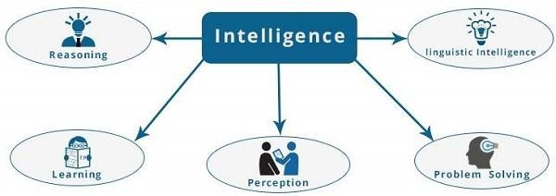

Let us go through all the components briefly −

* + **Reasoning** − It is the set of processes that enables us to provide basis for judgement, making decisions, and prediction. There are broadly two types −

|  |  |
| --- | --- |
| **Inductive Reasoning** | **Deductive Reasoning** |
| It conducts specific observations to makes  broad general statements. | It starts with a general statement and examines  the possibilities to reach a specific, logical conclusion. |
| Even if all of the premises are true in a  statement, inductive reasoning allows for the conclusion to be false. | If something is true of a class of things in  general, it is also true for all members of that class. |
| Example − "Nita is a teacher. All teachers are  studious. Therefore, Nita is studious." | Example − "All women of age above 60 years  are grandmothers. Shalini is 65 years. Therefore, Shalini is a grandmother." |

* **Learning** − It is the activity of gaining knowledge or skill by studying, practising, being taught, or experiencing something. Learning enhances the awareness of the subjects of the study.

The ability of learning is possessed by humans, some animals, and AI-enabled systems. Learning is categorized as −

* + **Auditory Learning** − It is learning by listening and hearing. For example, students listening to recorded audio lectures.
  + **Episodic Learning** − To learn by remembering sequences of events that one has witnessed or experienced. This is linear and orderly.
  + **Motor Learning** − It is learning by precise movement of muscles. For example, picking objects, Writing, etc.
  + **Observational Learning** − To learn by watching and imitating others. For example, child tries to learn by mimicking her parent.
  + **Perceptual Learning** − It is learning to recognize stimuli that one has seen before. For example, identifying and classifying objects and situations.
  + **Relational Learning** − It involves learning to differentiate among various stimuli on the basis of relational properties, rather than absolute properties. For Example, Adding ‗little less‘ salt at the time of cooking potatoes that came up salty last time, when cooked with adding say a tablespoon of salt.
  + **Spatial Learning** − It is learning through visual stimuli such as images, colors, maps, etc. For Example, A person can create roadmap in mind before actually following the road.
  + **Stimulus-Response Learning** − It is learning to perform a particular behavior when a certain stimulus is present. For example, a dog raises its ear on hearing

doorbell.

* **Problem Solving** − It is the process in which one perceives and tries to arrive at a desired solution from a present situation by taking some path, which is blocked by known or unknown hurdles.

Problem solving also includes decision making, which is the process of selecting the best suitable alternative out of multiple alternatives to reach the desired goal are available.

* **Perception** − It is the process of acquiring, interpreting, selecting, and organizing sensory information.

Perception presumes sensing. In humans, perception is aided by sensory organs. In the domain of AI, perception mechanism puts the data acquired by the sensors together in a meaningful manner.

* **Linguistic Intelligence** − It is one‘s ability to use, comprehend, speak, and write the verbal and written language. It is important in interpersonal communication.

### Difference between Human and Machine Intelligence

* Humans perceive by patterns whereas the machines perceive by set of rules and data.
* Humans store and recall information by patterns, machines do it by searching algorithms. For example, the number 40404040 is easy to remember, store, and recall as its pattern is simple.
* Humans can figure out the complete object even if some part of it is missing or distorted; whereas the machines cannot do it correctly.

## AI – Category Research Areas

The domain of artificial intelligence is huge in breadth and width. While proceeding, we consider the broadly common and prospering research areas in the domain of AI −

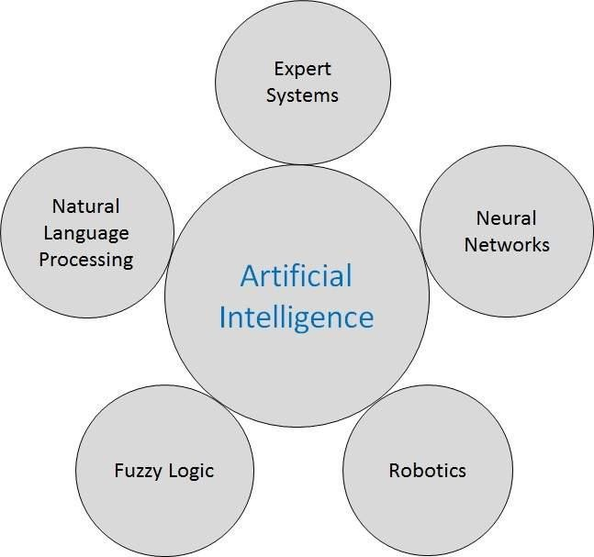

### Neural Networks

Yet another research area in AI, neural networks, is inspired from the natural neural network of human nervous system.

**What are Artificial Neural Networks (ANNs)?**

The inventor of the first neurocomputer, Dr. Robert Hecht-Nielsen, defines a neural network as − "...a computing system made up of a number of simple, highly interconnected processing elements, which process information by their dynamic state response to external inputs.”

**Basic Structure of ANNs**

The idea of ANNs is based on the belief that working of human brain by making the right connections can be imitated using silicon and wires as living **neurons** and **dendrites**.

The human brain is composed of 100 billion nerve cells called **neurons.** They are connected to other thousand cells by **Axons.** Stimuli from external environment or inputs from sensory organs

are accepted by dendrites. These inputs create electric impulses, which quickly travel through the neural network. A neuron can then send the message to other neuron to handle the issue or does not send it forward.

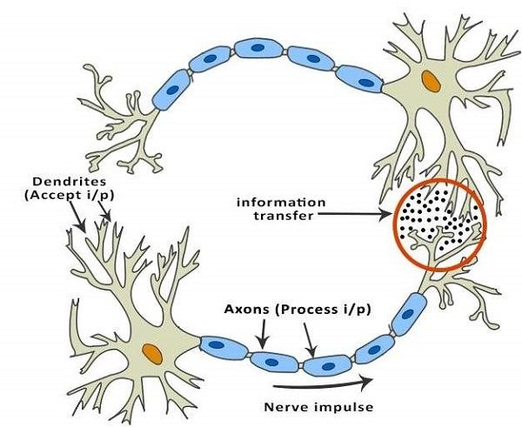

ANNs are composed of multiple **nodes**, which imitate biological **neurons** of human brain. The neurons are connected by links and they interact with each other. The nodes can take input data and perform simple operations on the data. The result of these operations is passed to other neurons. The output at each node is called its **activation** or **node value.**

Each link is associated with **weight.** ANNs are capable of learning, which takes place by altering weight values. The following illustration shows a simple ANN −

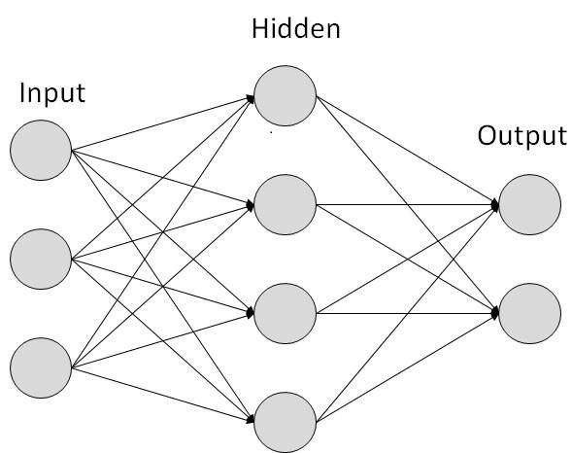

**Types of Artificial Neural Networks**

There are two Artificial Neural Network topologies − **FeedForward** and **Feedback.**

**FeedForward ANN**

The information flow is unidirectional. A unit sends information to other unit from which it does not receive any information. There are no feedback loops. They are used in pattern generation/recognition/classification. They have fixed inputs and outputs.

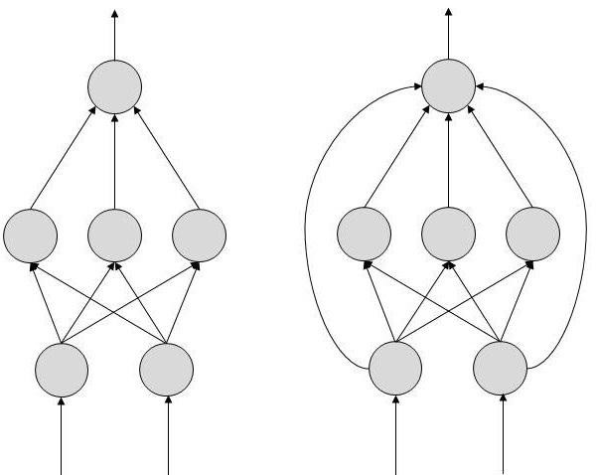

**FeedBack ANN**

Here, feedback loops are allowed. They are used in content addressable memories.

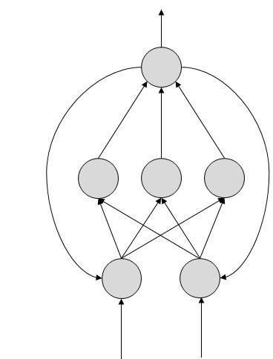

### Robotics

Robotics is a domain in artificial intelligence that deals with the study of creating intelligent and efficient robots.

**What are Robots?**

Robots are the artificial agents acting in real world environment.

**Objective**

Robots are aimed at manipulating the objects by perceiving, picking, moving, modifying the physical properties of object, destroying it, or to have an effect thereby freeing manpower from doing repetitive functions without getting bored, distracted, or exhausted.

**What is Robotics?**

Robotics is a branch of AI, which is composed of Electrical Engineering, Mechanical Engineering, and Computer Science for designing, construction, and application of robots.

**Aspects of Robotics**

* + The robots have **mechanical construction**, form, or shape designed to accomplish a particular task.
  + They have **electrical components** which power and control the machinery.
  + They contain some level of **computer program** that determines what, when and how a robot does something.

**Difference in Robot System and Other AI Program**

Here is the difference between the two −

|  |  |
| --- | --- |
| **AI Programs** | **Robots** |
| They usually operate in computer-  stimulated worlds. | They operate in real physical world |
| The input to an AI program is in symbols  and rules. | Inputs to robots is analog signal in the form of speech  waveform or images |
| They need general purpose computers to  operate on. | They need special hardware with sensors and effectors. |

**Robot Locomotion**

Locomotion is the **mechanism** that makes a robot capable of moving in its environment. There are various types of locomotions −

* + Legged
  + Wheeled
  + Combination of Legged and Wheeled Locomotion
  + Tracked slip/skid

### Fuzzy Logic Systems

Fuzzy Logic Systems (FLS) produce acceptable but definite output in response to incomplete, ambiguous, distorted, or inaccurate (fuzzy) input.

**What is Fuzzy Logic?**

Fuzzy Logic (FL) is a method of reasoning that resembles human reasoning. The approach of FL imitates the way of decision making in humans that involves all intermediate possibilities between digital values YES and NO.

The conventional logic block that a computer can understand takes precise input and produces a definite output as TRUE or FALSE, which is equivalent to human‘s YES or NO.

The inventor of fuzzy logic, Lotfi Zadeh, observed that unlike computers, the human decision making includes a range of possibilities between YES and NO, such as −

|  |
| --- |
| CERTAINLY YES |
| POSSIBLY YES |
| CANNOT SAY |
| POSSIBLY NO |
| CERTAINLY NO |

The fuzzy logic works on the levels of possibilities of input to achieve the definite output.

**Implementation**

* It can be implemented in systems with various sizes and capabilities ranging from small micro-controllers to large, networked, workstation-based control systems.
* It can be implemented in hardware, software, or a combination of both.

**Why Fuzzy Logic?**

Fuzzy logic is useful for commercial and practical purposes.

* It can control machines and consumer products.
* It may not give accurate reasoning, but acceptable reasoning.
* Fuzzy logic helps to deal with the uncertainty in engineering.

**Fuzzy Logic Systems Architecture**

It has four main parts as shown −

* **Fuzzification Module** − It transforms the system inputs, which are crisp numbers, into fuzzy sets. It splits the input signal into five steps such as −

|  |  |
| --- | --- |
| **LP** | x is Large Positive |
| **MP** | x is Medium Positive |
| **S** | x is Small |
| **MN** | x is Medium Negative |
| **LN** | x is Large Negative |

* **Knowledge Base** − It stores IF-THEN rules provided by experts.
* **Inference Engine** − It simulates the human reasoning process by making fuzzy inference on the inputs and IF-THEN rules.
* **Defuzzification Module** − It transforms the fuzzy set obtained by the inference engine into a crisp value.

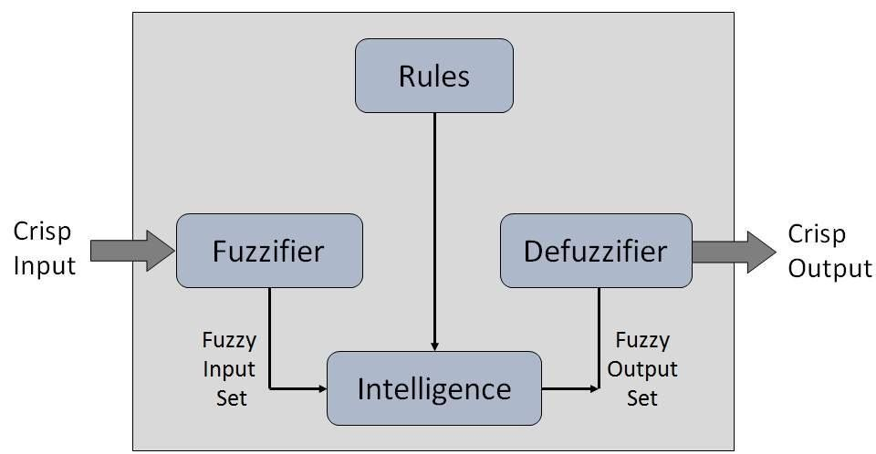

The **membership functions work on** fuzzy sets of variables.

**Membership Function**

Membership functions allow you to quantify linguistic term and represent a fuzzy set graphically. A **membership function** for a fuzzy *set A* on the universe of discourse X is defined as μA:X → [0,1].

Here, each element of *X* is mapped to a value between 0 and 1. It is called **membership value** or **degree of membership**. It quantifies the degree of membership of the element in *X* to the fuzzy set *A*.

* x axis represents the universe of discourse.
* y axis represents the degrees of membership in the [0, 1] interval.

There can be multiple membership functions applicable to fuzzify a numerical value. Simple membership functions are used as use of complex functions does not add more precision in the output.

All membership functions for **LP, MP, S, MN,** and **LN** are shown as below −

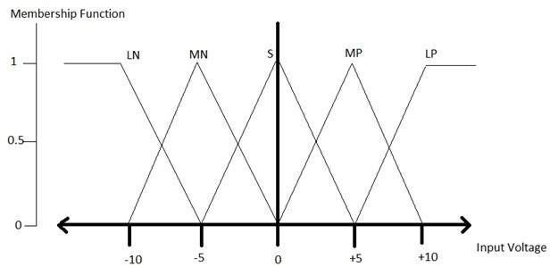

The triangular membership function shapes are most common among various other membership function shapes such as trapezoidal, singleton, and Gaussian.

Here, the input to 5-level fuzzifier varies from -10 volts to +10 volts. Hence the corresponding output also changes.

**Example of a Fuzzy Logic System**

Let us consider an air conditioning system with 5-level fuzzy logic system. This system adjusts the temperature of air conditioner by comparing the room temperature and the target temperature value.

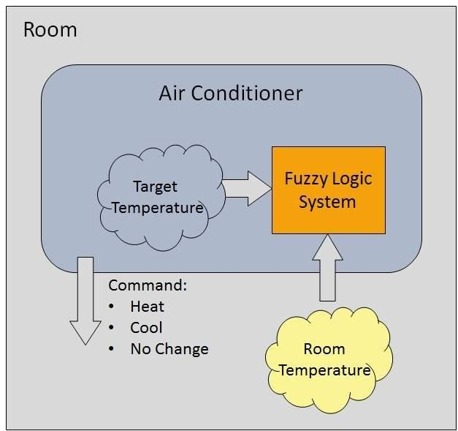

### AI - Natural Language Processing

Natural Language Processing (NLP) refers to AI method of communicating with an intelligent systems using a natural language such as English.

Processing of Natural Language is required when you want an intelligent system like robot to perform as per your instructions, when you want to hear decision from a dialogue based clinical expert system, etc.

The field of NLP involves making computers to perform useful tasks with the natural languages humans use. The input and output of an NLP system can be −

* Speech
* Written Text

**Components of NLP**

There are two components of NLP as given −

1. **Natural Language Understanding (NLU)**

Understanding involves the following tasks −

* + Mapping the given input in natural language into useful representations.
  + Analyzing different aspects of the language.

1. **Natural Language Generation (NLG)**

It is the process of producing meaningful phrases and sentences in the form of natural language from some internal representation.

It involves −

* + **Text planning** − It includes retrieving the relevant content from knowledge base.
  + **Sentence planning** − It includes choosing required words, forming meaningful phrases, setting tone of the sentence.
  + **Text Realization** − It is mapping sentence plan into sentence structure. The NLU is harder than NLG.

**Difficulties in NLU**

NL has an extremely rich form and structure.

It is very ambiguous. There can be different levels of ambiguity −

* + **Lexical ambiguity** − It is at very primitive level such as word-level.
  + For example, treating the word ―board‖ as noun or verb?
  + **Syntax Level ambiguity** − A sentence can be parsed in different ways.
  + For example, ―He lifted the beetle with red cap.‖ − Did he use cap to lift the beetle or he lifted a beetle that had red cap?
  + **Referential ambiguity** − Referring to something using pronouns. For example, Rima went to Gauri. She said, ―I am tired.‖ − Exactly who is tired?
  + One input can mean different meanings.
  + Many inputs can mean the same thing.

**NLP Terminology**

* + **Phonology** − It is study of organizing sound systematically.
  + **Morphology** − It is a study of construction of words from primitive meaningful units.
  + **Morpheme** − It is primitive unit of meaning in a language.
  + **Syntax** − It refers to arranging words to make a sentence. It also involves determining the structural role of words in the sentence and in phrases.
  + **Semantics** − It is concerned with the meaning of words and how to combine words into meaningful phrases and sentences.
  + **Pragmatics** − It deals with using and understanding sentences in different situations and how the interpretation of the sentence is affected.
  + **Discourse** − It deals with how the immediately preceding sentence can affect the interpretation of the next sentence.
  + **World Knowledge** − It includes the general knowledge about the world.

**Steps in NLP**

There are general five steps −

* + **Lexical Analysis** − It involves identifying and analyzing the structure of words. Lexicon of a language means the collection of words and phrases in a language. Lexical analysis is dividing the whole chunk of txt into paragraphs, sentences, and words.
  + **Syntactic Analysis (Parsing)** − It involves analysis of words in the sentence for grammar and arranging words in a manner that shows the relationship among the words. The sentence such as ―The school goes to boy‖ is rejected by English syntactic analyzer.

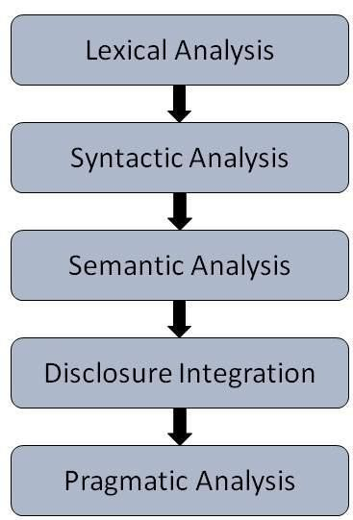

* + **Semantic Analysis** − It draws the exact meaning or the dictionary meaning from the text.

The text is checked for meaningfulness. It is done by mapping syntactic structures and objects in the task domain. The semantic analyzer disregards sentence such as ―hot ice- cream‖.

* + **Discourse Integration** − The meaning of any sentence depends upon the meaning of the sentence just before it. In addition, it also brings about the meaning of immediately succeeding sentence.
  + **Pragmatic Analysis** − During this, what was said is re-interpreted on what it actually meant. It involves deriving those aspects of language which require real world knowledge.

**Implementation Aspects of Syntactic Analysis**

There are a number of algorithms researchers have developed for syntactic analysis, but we consider only the following simple methods −

**Context-Free Grammar** - It is the grammar that consists rules with a single symbol on the left-hand side of the rewrite rules. Let us create grammar to parse a sentence − “The bird pecks the grains”

**Top-Down Parser** - Here, the parser starts with the S symbol and attempts to rewrite it into a sequence of *terminal symbols* that matches the classes of the words in the input sentence until it consists entirely of terminal symbols.

These are then checked with the input sentence to see if it matched. If not, the process is started over again with a different set of rules. This is repeated until a specific rule is found which describes the structure of the sentence.

### Expert Systems

Expert systems (ES) are one of the prominent research domains of AI. It is introduced by the researchers at Stanford University, Computer Science Department.

**What are Expert Systems?**

The expert systems are the computer applications developed to solve complex problems in a particular domain, at the level of extra-ordinary human intelligence and expertise.

**Characteristics of Expert Systems**

* + High performance
  + Understandable
  + Reliable
  + Highly responsive

**Capabilities of Expert Systems**

The expert systems are capable of −

* + Advising
  + Instructing and assisting human in decision making
  + Demonstrating
  + Deriving a solution
  + Diagnosing
  + Explaining
  + Interpreting input
  + Predicting results
  + Justifying the conclusion
  + Suggesting alternative options to a problem

They are incapable of −

* + Substituting human decision makers
  + Possessing human capabilities
  + Producing accurate output for inadequate knowledge base
  + Refining their own knowledge

**Components of Expert Systems**

The components of ES include −

* + Knowledge Base
  + Inference Engine
  + User Interface

Let us see them one by one briefly −

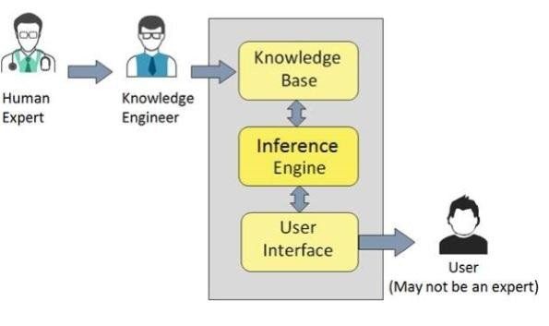

**Knowledge Base**

It contains domain-specific and high-quality knowledge. Knowledge is required to exhibit intelligence. The success of any ES majorly depends upon the collection of highly accurate and precise knowledge.

What is Knowledge?

The data is collection of facts. The information is organized as data and facts about the task domain. **Data, information,** and **past experience** combined together are termed as knowledge.

**Components of Knowledge Base**

The knowledge base of an ES is a store of both, factual and heuristic knowledge.

* + **Factual Knowledge** − It is the information widely accepted by the Knowledge Engineers and scholars in the task domain.
  + **Heuristic Knowledge** − It is about practice, accurate judgement, one‘s ability of evaluation, and guessing.

**Knowledge representation**

It is the method used to organize and formalize the knowledge in the knowledge base. It is in the form of IF-THEN-ELSE rules.

**Knowledge Acquisition**

The success of any expert system majorly depends on the quality, completeness, and accuracy of the information stored in the knowledge base.

The knowledge base is formed by readings from various experts, scholars, and the **Knowledge Engineers**. The knowledge engineer is a person with the qualities of empathy, quick learning, and case analyzing skills.

He acquires information from subject expert by recording, interviewing, and observing him at work, etc. He then categorizes and organizes the information in a meaningful way, in the form of IF-THEN-ELSE rules, to be used by interference machine. The knowledge engineer also monitors the development of the ES.

**Inference Engine**

Use of efficient procedures and rules by the Inference Engine is essential in deducting a correct, flawless solution.

In case of knowledge-based ES, the Inference Engine acquires and manipulates the knowledge from the knowledge base to arrive at a particular solution.

In case of rule based ES, it −

* + Applies rules repeatedly to the facts, which are obtained from earlier rule application.
  + Adds new knowledge into the knowledge base if required.
  + Resolves rules conflict when multiple rules are applicable to a particular case.

To recommend a solution, the Inference Engine uses the following strategies −

* + Forward Chaining
  + Backward Chaining

Forward Chaining

It is a strategy of an expert system to answer the question, **“What can happen next?”**

Here, the Inference Engine follows the chain of conditions and derivations and finally deduces the outcome. It considers all the facts and rules, and sorts them before concluding to a solution.

This strategy is followed for working on conclusion, result, or effect. For example, prediction of share market status as an effect of changes in interest rates.

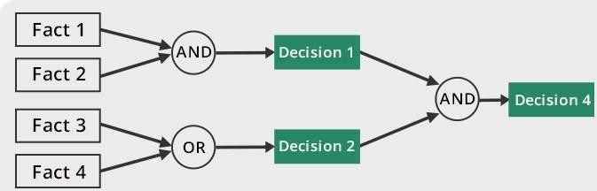

Backward Chaining

With this strategy, an expert system finds out the answer to the question, **“Why this happened?”**

On the basis of what has already happened, the Inference Engine tries to find out which conditions could have happened in the past for this result. This strategy is followed for finding out cause or reason. For example, diagnosis of blood cancer in humans.

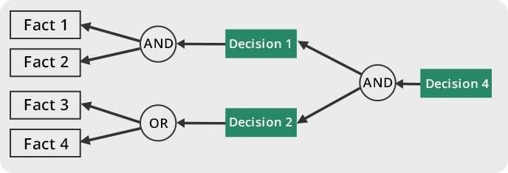

**User Interface**

User interface provides interaction between user of the ES and the ES itself. It is generally Natural Language Processing so as to be used by the user who is well-versed in the task domain. The user of the ES need not be necessarily an expert in Artificial Intelligence.

It explains how the ES has arrived at a particular recommendation. The explanation may appear in the following forms −

* + - Natural language displayed on screen.
    - Verbal narrations in natural language.
    - Listing of rule numbers displayed on the screen.

The user interface makes it easy to trace the credibility of the deductions.

Requirements of Efficient ES User Interface

* + - It should help users to accomplish their goals in shortest possible way.
    - It should be designed to work for user’s existing or desired work practices.
    - Its technology should be adaptable to user’s requirements; not the other way round.
    - It should make efficient use of user input.

**Expert Systems Limitations**

No technology can offer easy and complete solution. Large systems are costly, require significant development time, and computer resources. ESs have their limitations which include

−

* + - Limitations of the technology
    - Difficult knowledge acquisition
    - ES are difficult to maintain
    - High development costs

**Applications of Expert System**

The following table shows where ES can be applied.

|  |  |
| --- | --- |
| **Application** | **Description** |
| Design Domain | Camera lens design, automobile design. |
| Medical Domain | Diagnosis Systems to deduce cause of disease from observed data,  conduction medical operations on humans. |
| Monitoring Systems | Comparing data continuously with observed system or with prescribed  behavior such as leakage monitoring in long petroleum pipeline. |
| Process Control Systems | Controlling a physical process based on monitoring. |
| Knowledge Domain | Finding out faults in vehicles, computers. |
| Finance/Commerce | Detection of possible fraud, suspicious transactions, stock market  trading, Airline scheduling, cargo scheduling. |

**Expert System Technology**

There are several levels of ES technologies available. Expert systems technologies include −

* + - **Expert System Development Environment** − The ES development environment includes hardware and tools. They are −
      * Workstations, minicomputers, mainframes.
      * High level Symbolic Programming Languages such as **LIS**t **P**rogramming (LISP) and **PRO**grammation en **LOG**ique (PROLOG).
      * Large databases.
  + **Tools** − They reduce the effort and cost involved in developing an expert system to large extent.
* Powerful editors and debugging tools with multi-windows.
* They provide rapid prototyping
* Have Inbuilt definitions of model, knowledge representation, and inference design.
  + **Shells** − A shell is nothing but an expert system without knowledge base. A shell provides the developers with knowledge acquisition, inference engine, user interface, and explanation facility. For example, few shells are given below −
* Java Expert System Shell (JESS) that provides fully developed Java API for creating an expert system.
* *Vidwan*, a shell developed at the National Centre for Software Technology, Mumbai in 1993. It enables knowledge encoding in the form of IF-THEN rules.

**Development of Expert Systems: General Steps**

The process of ES development is iterative. Steps in developing the ES include −

**Identify Problem Domain**

* + The problem must be suitable for an expert system to solve it.
  + Find the experts in task domain for the ES project.
  + Establish cost-effectiveness of the system.

**Design the System**

* + Identify the ES Technology
  + Know and establish the degree of integration with the other systems and databases.
  + Realize how the concepts can represent the domain knowledge best.

**Develop the Prototype**

From Knowledge Base: The knowledge engineer works to −

* + Acquire domain knowledge from the expert.
  + Represent it in the form of If-THEN-ELSE rules.

**Test and Refine the Prototype**

* + The knowledge engineer uses sample cases to test the prototype for any deficiencies in performance.
  + End users test the prototypes of the ES.

**Develop and Complete the ES**

* + Test and ensure the interaction of the ES with all elements of its environment, including end users, databases, and other information systems.
  + Document the ES project well.
  + Train the user to use ES.

**Maintain the ES**

* + Keep the knowledge base up-to-date by regular review and update.
  + Cater for new interfaces with other information systems, as those systems evolve.

**Benefits of Expert Systems**

* + - **Availability** − They are easily available due to mass production of software.
    - **Less Production Cost** − Production cost is reasonable. This makes them affordable.
    - **Speed** − They offer great speed. They reduce the amount of work an individual puts in.
    - **Less Error Rate** − Error rate is low as compared to human errors.
    - **Reducing Risk** − They can work in the environment dangerous to humans.
    - **Steady response** − They work steadily without getting motional, tensed or fatigued.

## Speech and Voice Recognition

These both terms are common in robotics, expert systems and natural language processing. Though these terms are used interchangeably, their objectives are different.

|  |  |
| --- | --- |
| **Speech Recognition** | **Voice Recognition** |
| The speech recognition aims at understanding and  comprehending **WHAT** was spoken. | The objective of voice recognition is to recognize  **WHO** is speaking. |
| It is used in hand-free computing, map, or menu  navigation. | It is used to identify a person by analysing its  tone, voice pitch, and accent, etc. |
| Machine does not need training for Speech  Recognition as it is not speaker dependent. | This recognition system needs training as it is  person oriented. |
| Speaker independent Speech Recognition systems  are difficult to develop. | Speaker dependent Speech Recognition systems  are comparatively easy to develop. |

**Working of Speech and Voice Recognition Systems**

The user input spoken at a microphone goes to sound card of the system. The converter turns the analog signal into equivalent digital signal for the speech processing. The database is used to compare the sound patterns to recognize the words. Finally, a reverse feedback is given to the database.

This source-language text becomes input to the Translation Engine, which converts it to the target language text. They are supported with interactive GUI, large database of vocabulary, etc.

**Real Life Applications of AI Research Areas**

There is a large array of applications where AI is serving common people in their day-to-day lives −

|  |  |  |
| --- | --- | --- |
| **Sr.No.** | **Research Areas** | **Example** |
| 1 | **Expert Systems**  Examples − Flight-tracking systems, Clinical systems. |  |
| 2 | **Natural Language Processing**  Examples: Google Now feature, speech recognition, Automatic voice output. |  |
| 3 | **Neural Networks**  Examples − Pattern recognition systems such as face recognition, character recognition, handwriting recognition. |  |
| 4 | **Robotics**  Examples − Industrial robots for moving, spraying, painting, precision checking, drilling, cleaning, coating, carving, etc. |  |
| 5 | **Fuzzy Logic Systems**  Examples − Consumer electronics, automobiles, etc. |  |

**Task Classification of AI**

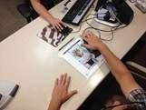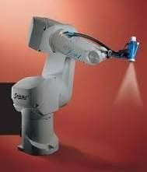

The domain of AI is classified into **Formal tasks, Mundane tasks,** and **Expert tasks.**

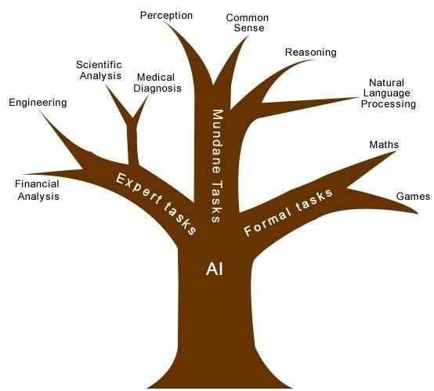

|  |  |  |
| --- | --- | --- |
| **Task Domains of Artificial Intelligence** | | |
| **Mundane (Ordinary) Tasks** | **Formal Tasks** | **Expert Tasks** |
| Perception   * Computer Vision * Speech, Voice | * Mathematics * Geometry * Logic * Integration and Differentiation | * Engineering * Fault Finding * Manufacturing * Monitoring |
| Natural Language Processing   * Understanding * Language Generation * Language Translation | Games   * Go * Chess (Deep Blue) * Ckeckers | Scientific Analysis |
| Common Sense | Verification | Financial Analysis |
| Reasoning | Theorem Proving | Medical Diagnosis |
| Planing |  | Creativity |
| Robotics |  |  |

|  |  |  |
| --- | --- | --- |
| * Locomotive |  |  |

Humans learn **mundane (ordinary) tasks** since their birth. They learn by perception, speaking, using language, and locomotives. They learn Formal Tasks and Expert Tasks later, in that order.

For humans, the mundane tasks are easiest to learn. The same was considered true before trying to implement mundane tasks in machines. Earlier, all work of AI was concentrated in the mundane task domain.

Later, it turned out that the machine requires more knowledge, complex knowledge representation, and complicated algorithms for handling mundane tasks. This is the reason **why AI work is more prospering in the Expert Tasks domain** now, as the expert task domain needs expert knowledge without common sense, which can be easier to represent and handle.

## AI - Agents & Environments

An AI system is composed of an agent and its environment. The agents act in their environment. The environment may contain other agents.

**What are Agent and Environment?**

An **agent** is anything that can perceive its environment through **sensors** and acts upon that environment through **effectors.**

* + - A **human agent** has sensory organs such as eyes, ears, nose, tongue and skin parallel to the sensors, and other organs such as hands, legs, mouth, for effectors.
    - A **robotic agent** replaces cameras and infrared range finders for the sensors, and various motors and actuators for effectors.
    - A **software agent** has encoded bit strings as its programs and actions.

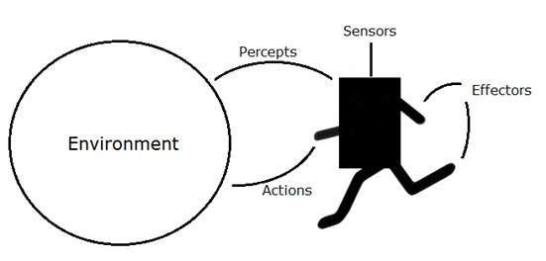

**Agent Terminology**

* + **Performance Measure of Agent** − It is the criteria, which determines how successful an agent is.
  + **Behavior of Agent** − It is the action that agent performs after any given sequence of percepts.
  + **Percept** − It is agent‘s perceptual inputs at a given instance.
  + **Percept Sequence** − It is the history of all that an agent has perceived till date.
  + **Agent Function** − It is a map from the precept sequence to an action.

**Rationality**

Rationality is nothing but status of being reasonable, sensible, and having good sense of judgment.

Rationality is concerned with expected actions and results depending upon what the agent has perceived. Performing actions with the aim of obtaining useful information is an important part of rationality.

**What is Ideal Rational Agent?**

An ideal rational agent is the one, which is capable of doing expected actions to maximize its performance measure, on the basis of −

* + Its percept sequence
  + Its built-in knowledge base

Rationality of an agent depends on the following four factors −

* + The **performance measures**, which determine the degree of success.
  + Agent‘s **Percept Sequence** till now.
  + The agent‘s **prior knowledge about the environment**.
  + The **actions** that the agent can carry out.

A rational agent always performs right action, where the right action means the action that causes the agent to be most successful in the given percept sequence. The problem the agent solves is characterized by Performance Measure, Environment, Actuators, and Sensors (PEAS).

**The Structure of Intelligent Agents**

Agent‘s structure can be viewed as −

* + Agent = Architecture + Agent Program
  + Architecture = the machinery that an agent executes on.
  + Agent Program = an implementation of an agent function.

Simple Reflex Agents

* + They choose actions only based on the current percept.
  + They are rational only if a correct decision is made only on the basis of current precept.
  + Their environment is completely observable.

**Condition-Action Rule** − It is a rule that maps a state (condition) to an action.

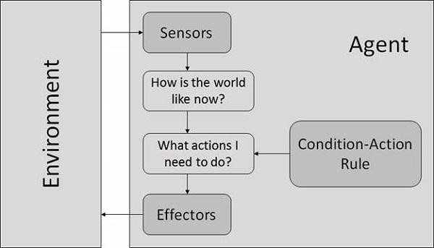

Model Based Reflex Agents

They use a model of the world to choose their actions. They maintain an internal state.

**Model** − The knowledge about ―how the things happen in the world‖.

**Internal State** − It is a representation of unobserved aspects of current state depending on percept history.

**Updating the state requires the information about −**

* + How the world evolves.
  + How the agent’s actions affect the world.

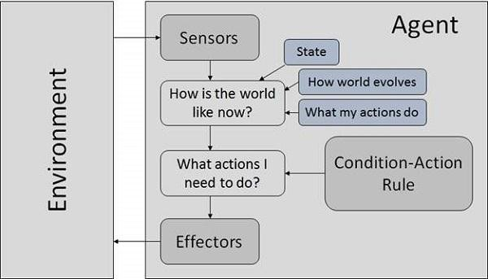

Goal Based Agents

They choose their actions in order to achieve goals. Goal-based approach is more flexible than reflex agent since the knowledge supporting a decision is explicitly modeled, thereby allowing for modifications.

**Goal** − It is the description of desirable situations.

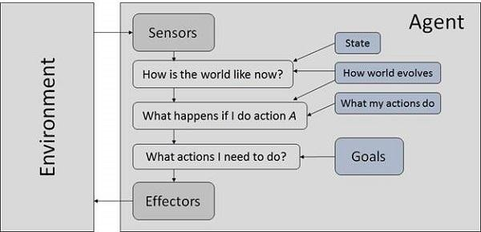

Utility Based Agents

They choose actions based on a preference (utility) for each state. Goals are inadequate when −

* + There are conflicting goals, out of which only few can be achieved.
  + Goals have some uncertainty of being achieved and you need to weigh likelihood of success against the importance of a goal.

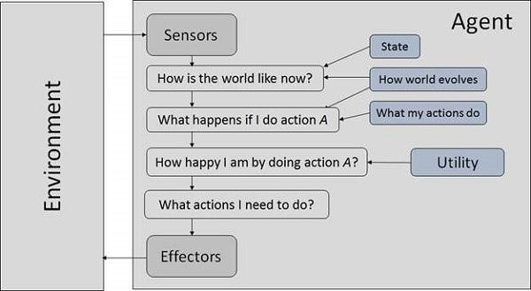

## Nature of Environments

Some programs operate in the entirely **artificial environment** confined to keyboard input, database, computer file systems and character output on a screen.

In contrast, some software agents (software robots or softbots) exist in rich, unlimited softbots domains. The simulator has a **very detailed, complex environment**. The software agent needs to choose from a long array of actions in real time. A softbot designed to scan the online preferences of the customer and show interesting items to the customer works in the **real** as well as an **artificial** environment.

The most famous **artificial environment** is the **Turing Test environment**, in which one real and other artificial agents are tested on equal ground. This is a very challenging environment as it is highly difficult for a software agent to perform as well as a human.

### Turing Test

The success of an intelligent behavior of a system can be measured with Turing Test.

Two persons and a machine to be evaluated participate in the test. Out of the two persons, one plays the role of the tester. Each of them sits in different rooms. The tester is unaware of who is

machine and who is a human. He interrogates the questions by typing and sending them to both intelligences, to which he receives typed responses.

This test aims at fooling the tester. If the tester fails to determine machine‘s response from the human response, then the machine is said to be intelligent.

**Properties of Environment**

The environment has multifold properties −

* **Discrete / Continuous** − If there are a limited number of distinct, clearly defined, states of the environment, the environment is discrete (For example, chess); otherwise it is continuous (For example, driving).
* **Observable / Partially Observable** − If it is possible to determine the complete state of the environment at each time point from the percepts it is observable; otherwise it is only partially observable.
* **Static / Dynamic** − If the environment does not change while an agent is acting, then it is static; otherwise it is dynamic.
* **Single agent / Multiple agents** − The environment may contain other agents which may be of the same or different kind as that of the agent.
* **Accessible / Inaccessible** − If the agent‘s sensory apparatus can have access to the complete state of the environment, then the environment is accessible to that agent.
* **Deterministic / Non-deterministic** − If the next state of the environment is completely determined by the current state and the actions of the agent, then the environment is deterministic; otherwise it is non-deterministic.
* **Episodic / Non-episodic** − In an episodic environment, each episode consists of the agent perceiving and then acting. The quality of its action depends just on the episode itself. Subsequent episodes do not depend on the actions in the previous episodes. Episodic environments are much simpler because the agent does not need to think ahead.

**Breakthroughs Unleashing AI on the World**

AI researchers have predicted that AI is right around the corner, yet until a few years ago it seemed as stuck in the future as ever. There was even a term coined to describe this era of meager results and even more meager research funding: the AI winter. Has anything really changed?

Yes. Three recent breakthroughs have unleashed the long-awaited arrival of artificial intelligence:

1. **Cheap parallel computation**

Thinking is an inherently parallel process, billions of neurons firing simultaneously to create synchronous waves of cortical computation. To build a neural network—the primary architecture of AI software—also requires many different processes to take place simultaneously. Each node of a neural network loosely imitates a neuron in the brain—mutually interacting with its neighbors to make sense of the signals it receives. To recognize a spoken word, a program must be able to hear all the phonemes in relation to one another; to identify an image, it needs to see

every pixel in the context of the pixels around it—both deeply parallel tasks. But until recently, the typical computer processor could only ping one thing at a time.

That began to change more than a decade ago, when a new kind of chip, called a graphics processing unit, or GPU, was devised for the intensely visual—and parallel—demands of videogames, in which millions of pixels had to be recalculated many times a second. That required a specialized parallel computing chip, which was added as a supplement to the PC motherboard. The parallel graphical chips worked, and gaming soared. By 2005, GPUs were being produced in such quantities that they became much cheaper. In 2009, Andrew Ng and a team at Stanford realized that GPU chips could run neural networks in parallel.

That discovery unlocked new possibilities for neural networks, which can include hundreds of millions of connections between their nodes. Traditional processors required several weeks to calculate all the cascading possibilities in a 100 million-parameter neural net. Ng found that a cluster of GPUs could accomplish the same thing in a day. Today neural nets running on GPUs are routinely used by cloud-enabled companies such as Facebook to identify your friends in photos or, in the case of Netflix, to make reliable recommendations for its more than 50 million subscribers.

1. **Big Data**

Every intelligence has to be taught. A human brain, which is genetically primed to categorize things, still needs to see a dozen examples before it can distinguish between cats and dogs. That's even more true for artificial minds. Even the best-programmed computer has to play at least a thousand games of chess before it gets good. Part of the AI breakthrough lies in the incredible avalanche of collected data about our world, which provides the schooling that AIs need.

Massive databases, self-tracking, web cookies, online footprints, terabytes of storage, decades of search results, Wikipedia, and the entire digital universe became the teachers making AI smart.

1. **Better algorithms**

Digital neural nets were invented in the 1950s, but it took decades for computer scientists to learn how to tame the astronomically huge combinatorial relationships between a million—or 100 million—neurons. The key was to organize neural nets into stacked layers. Take the relatively simple task of recognizing that a face is a face. When a group of bits in a neural net are found to trigger a pattern—the image of an eye, for instance—that result is moved up to another level in the neural net for further parsing. The next level might group two eyes together and pass that meaningful chunk onto another level of hierarchical structure that associates it with the pattern of a nose. It can take many millions of these nodes (each one producing a calculation feeding others around it), stacked up to 15 levels high, to recognize a human face. In 2006, Geoff

Hinton, then at the University of Toronto, made a key tweak to this method, which he dubbed

―deep learning.‖ He was able to mathematically optimize results from each layer so that the learning accumulated faster as it proceeded up the stack of layers. Deep-learning algorithms accelerated enormously a few years later when they were ported to GPUs. The code of deep learning alone is insufficient to generate complex logical thinking, but it is an essential component of all current AIs, including IBM's Watson, Google's search engine, and Facebook's algorithms.

This perfect storm of parallel computation, bigger data, and deeper algorithms generated the 60- years-in-the-making overnight success of AI. And this convergence suggests that as long as these technological trends continue—and there's no reason to think they won't—AI will keep improving.

As it does, this cloud-based AI will become an increasingly ingrained part of our everyday life. But it will come at a price. Cloud computing obeys the law of increasing returns, sometimes called the network effect, which holds that the value of a network increases much faster as it grows bigger. The bigger the network, the more attractive it is to new users, which makes it even bigger, and thus more attractive, and so on. A cloud that serves AI will obey the same law. The more people who use an AI, the smarter it gets. The smarter it gets, the more people use it. The more people that use it, the smarter it gets. Once a company enters this virtuous cycle, it tends to grow so big, so fast, that it overwhelms any upstart competitors. As a result, our AI future is likely to be ruled by an oligarchy of two or three large, general-purpose cloud-based commercial intelligences.