INCLUDING AN HTML FORM IN A MODULE (e.g. <http://www.radreport.org/template/0000048>)

1. Create the form

Create an appropriate encounter type, e.g., *Radiology*

Download or create a new form - the form was downloaded, with its css information – see other attachment - from http://www.radreport.org/template/0000048

Each observation will need an associated concept – add the concepts to the concept dictionary, as needed:

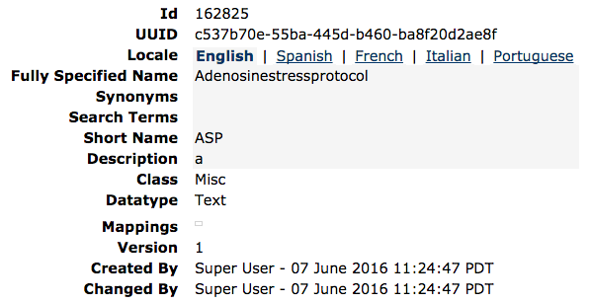

This might be added to the form as:

<p>

<obs conceptId="162825" labelText="Adenosine stress protocol:" rows="4" cols="80"/>

</p>

2. Make the form accessible:

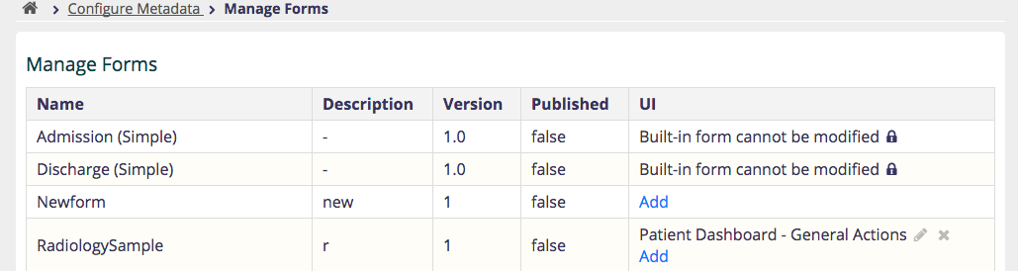

3. Provide a link to the form for reporting

<a href="/openmrs/htmlformentryui/htmlform/enterHtmlFormWithStandardUi.page?patientId=7&amp;visitId=1&amp;formUuid=95f926aa-07c6-4ee2-8f66-2f7fbcf2cc4c&amp;returnUrl=%2Fopenmrs%2Fbasictest%2FhelloWorld.page">

Explaining the link in its parts:

**<a href="/openmrs/htmlformentryui/htmlform/enterHtmlFormWithStandardUi.page?**

This is the URL used to enter the form

**patientId=7**

Patient id used for observations

**&amp;visitId=1**

Associate this form with the visit – this might be the visit associated with the radiology order

**&amp;formUuid=95f926aa-07c6-4ee2-8f66-2f7fbcf2cc4c**

Uuid of the form to use

**&amp;returnUrl=%2Fopenmrs%2Fbasictest%2FhelloWorld.page">**

Where to return after the form is saved

It is suggested to add the link to a page, create the form and use it. Then, check the data added to the following tables, which are linked:

Visit, form, obs, encounter, htmlformentry_html_form