Hands – On Lab

**Workshop 3**

1. Write a function that takes the base and height of a triangle and returns its area.

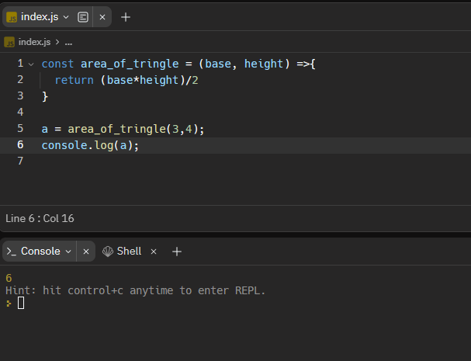

1. You are counting points for a basketball game, given the amount of 2 – pointer scored and 3 – pointer scored, find the final points for the team and return the value.

1. Create a function that takes a number as an argument. Add up all the numbers from 1 to the number you passed to the function.

1. Create a function that returns true if there is at least one prime number in the given range (n1 to n2) inclusive, false otherwise.

1. Generate a random number (do research) and store it in a variable. Write a program to take input from the user and tell them whether their guessed number is correct, greater or lesser than the original number. (100 – number of guesses) is the score of user. The program is expected to terminate once the number is guessed. The number should be between 1 – 100.

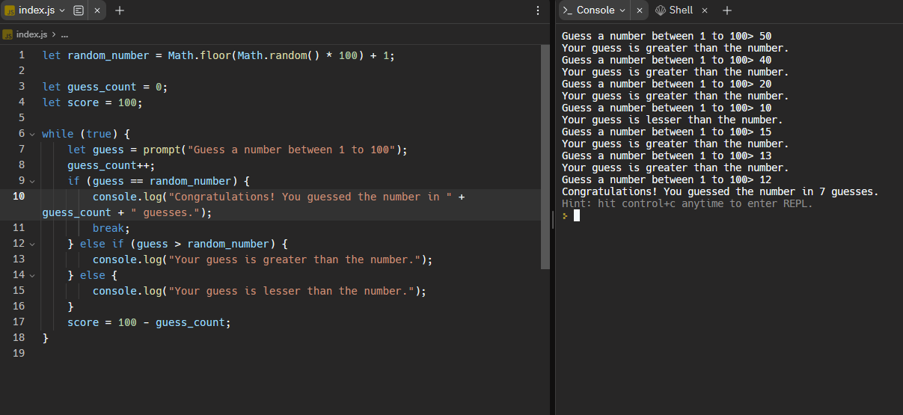

1. Const age = [23,34,12,54,23,54,11,9,29,17,15,19,20,21,13,7]
2. Filter the array of ages who can apply for citizenships.

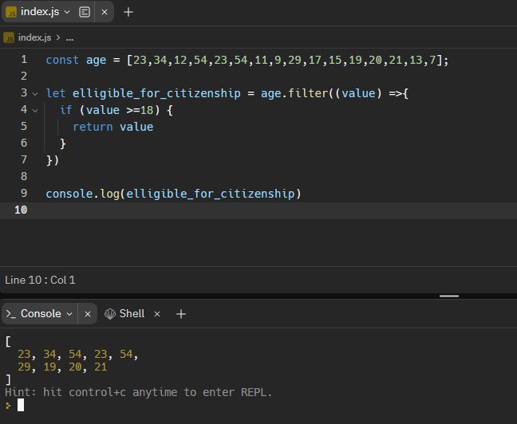

1. Find the average age of a given array.

Const companies = [

{ name: "XYZ", category: "Retail", start: 1991, end: 20012 },

{ name: "ABC", category: "Finance", start: 1981, end: 2004 },

{ name: "DGF", category: "Finance", start: 1976, end: 2008 },

{ name: "LFT", category: "Retail", start: 1971, end: 1979 },

{ name: "MND", category: "Retail", start: 1995, end: 2010 },

{ name: "HCK", category: "Technology", start: 1987, end: 2011 },

{ name: "BMC", category: "Technology", start: 1989, end: 2009 },

{ name: "TIC", category: "Retail", start: 1993, end: 2005 },

{ name: "NAC", category: "Technology", start: 1991, end: 2010 },

{ name: "ITC", category: "Finance", start: 1998, end: 2016 }

];

1. Filter the retail companies

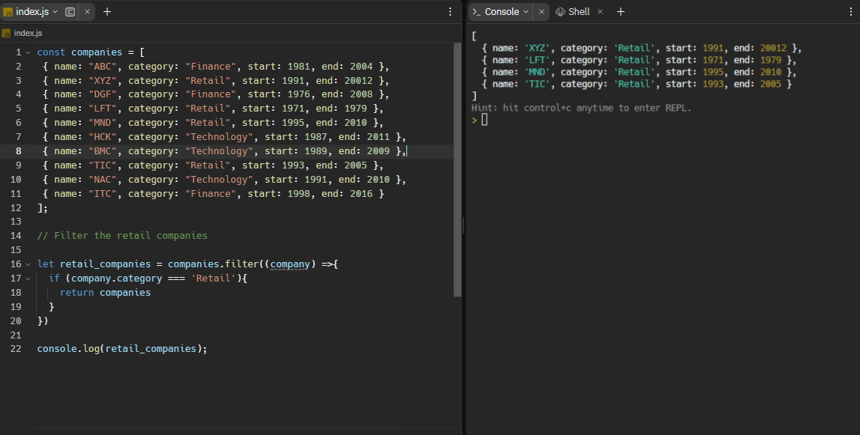

1. Get the 80s companies from the array.

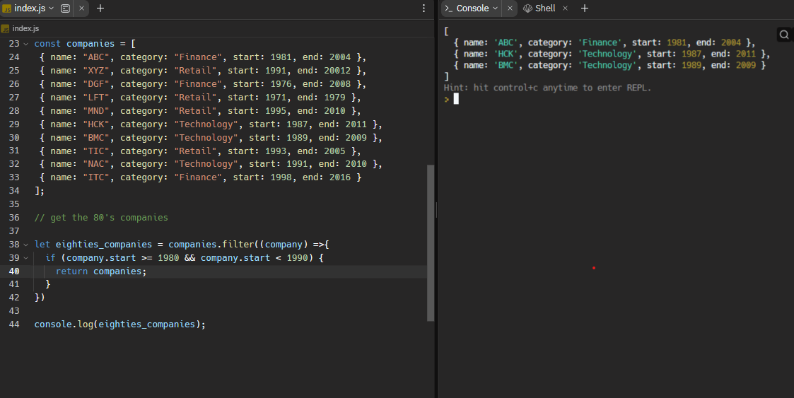

1. Get the companies that lasted for 10 or more years.

