登录界面

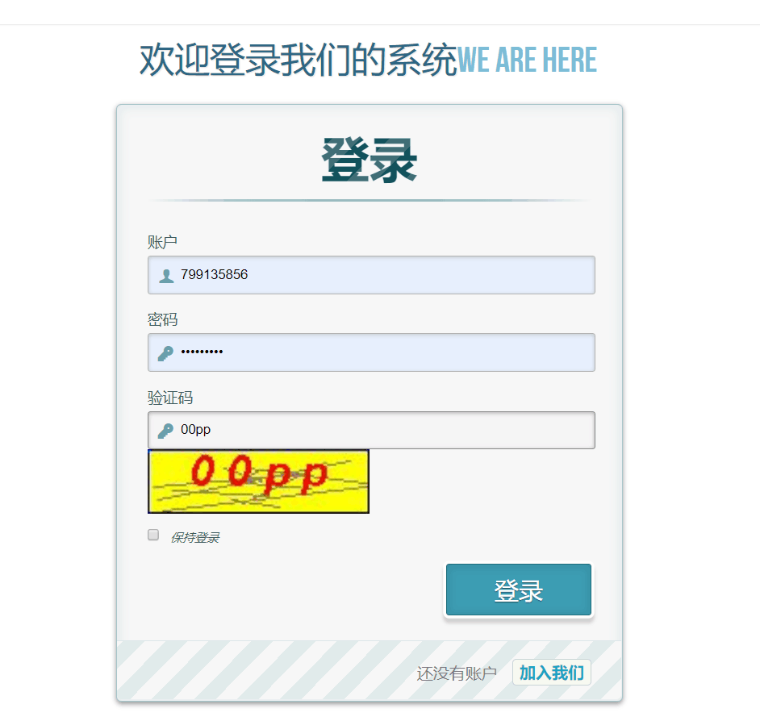

注册界面：

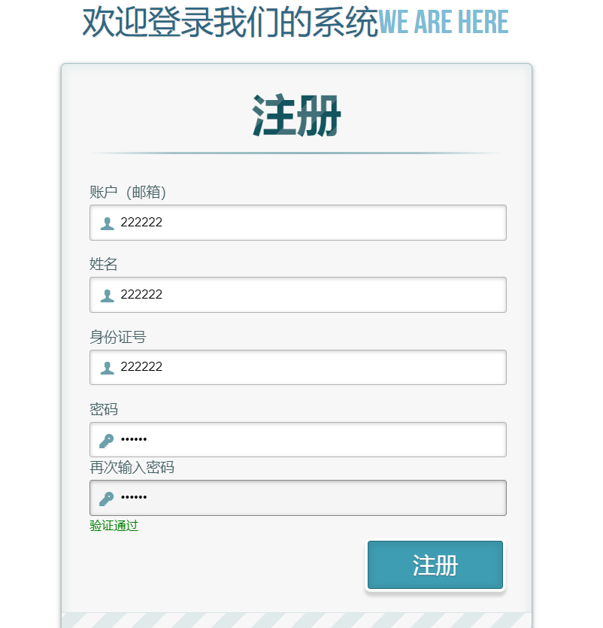

附录：

<%

String path = request.getContextPath();

String mainPange = path+"/index.jsp";

String checkLogin = path+"/Login";

//System.out.println(path);

%>

<style type=*"text/css"*>

*#btncode*{

width: *100px*;

height: *30px*;

background-color: *#ff3000*;

border: *0*;

border-radius: *5px*;

color: *#fff*;

}

*#btncode.on* {

background-color: *#eee*;

color: *#ccc*;

cursor: *not-allowed*;

}

</style>

<script type=*"text/javascript"*>

$(document).ready(**function**(){

$("#submitLogin").click(**function**(){

$.ajax({

url : "${pageContext.request.contextPath}/UserLogin", //后台查询验证的方法

dataTpye : "json",

data : {

"username" : $('#username').val(),

"password" : $('#password').val(),

"usercode" : $('#usercode').val()

},

type : "post",

success : **function**(msg) {

//根据后台返回前台的msg给提示信息加HTML

**if** ("true" == msg) {

window.location.href="/RentCar/userinfo.jsp?qmail="+$('#username').val();

} **else** **if**("false1" == msg) {

// 账号不存在

//alert("登录失败，请检查用户名密码后重试");

document.getElementById("tishi").innerHTML="<font size='2' color='red'>输入的验证码有误，请检查后重试</font>";

}**else** **if**("false2" == msg){

document.getElementById("tishi").innerHTML="<font size='2' color='red'>密码错误，请检查后重试</font>";

}

},

error:**function**(){ //请求失败的回调方法

alert("登录失败，请重试");

}

});

});

$("#btncode").click(**function**(){

$.ajax({

url : "${pageContext.request.contextPath}/CreateMailCode", //后台查询验证的方法

dataTpye : "json",

data : {

"mail" : $('#username').val()

},

type : "post",

success : **function**(msg) {

},

error:**function**(){ //请求失败的回调方法

alert("获取验证码失败，请重试");

}

});

});

});

</script>

<body>

<div class=*"container"*>

<!-- Codrops top bar -->

<div class=*"codrops-top"*>

<span class=*"right"*>

<strong><a href=*"login.jsp"* class=*"to_register"*>管理员登录</a></strong>

<strong>小型汽车租赁系统</strong>

</span>

<div class=*"clr"*></div>

</div><!--/ Codrops top bar -->

<header>

<h1>欢迎登录我们的系统<span>We are here</span></h1>

</header>

<div style="text-align:*center*;clear:*both*;">

<script src=*"/gg_bd_ad_720x90.js"* type=*"text/javascript"*></script>

<script src=*"/follow.js"* type=*"text/javascript"*></script>

</div>

<section>

<div id=*"container_demo"* >

<!-- hidden anchor to stop jump http://www.css3create.com/Astuce-Empecher-le-scroll-avec-l-utilisation-de-target#wrap4 -->

<a class=*"hiddenanchor"* id=*"toregister"*></a>

<a class=*"hiddenanchor"* id=*"tologin"*></a>

<div id=*"wrapper"*>

<div id=*"login"* class=*"animate form"*>

<form action=*"#"* autocomplete=*"on"*>

<h1>登录</h1>

<p>

<label for=*"username"* class=*"uname"* data-icon=*"u"* > 账户 </label>

<input id=*"username"* name=*"username"* required=*"required"* type=*"text"* placeholder=*"myusername or mymail@mail.com"*/>

</p>

<div id=*"pwdlogin"*>

<p>

<label for=*"password"* class=*"youpasswd"* data-icon=*"p"*> 密码 </label>

<input id=*"password"* name=*"password"* required=*"required"* type=*"password"* placeholder=*"eg. X8df!90EO"* />

</p>

</div>

<div id=*"codelogin"* style="display:*none*">

<p>

<label for=*"password"* class=*"youpasswd"* data-icon=*"p"*> 验证码登陆<button id=*"btncode"* type=*"button"* >获取验证码</button></label>

<input id=*"usercode"* name=*"code"* required=*"required"* type=*"text"* placeholder=*"eg. X8df!90EO"* />

</p>

</div >

<p>

<button id=*"cbtn"* onclick="changemethod()">验证码登陆</button>

<button id=*"mbtn"* style="display:*none*" onclick="changemethod1()">密码登陆</button>

</p>

<span id=*"tishi"*></span>

<p class=*"keeplogin"*>

<input type=*"checkbox"* name=*"loginkeeping"* id=*"loginkeeping"* value=*"loginkeeping"* />

<label for=*"loginkeeping"*>保持登录</label>

</p>

<p class=*"login button"*>

<input id=*"submitLogin"* type=*"button"* value=*"登录"* />

</p>

<p class=*"change_link"*>

还没有账户

<a href=*"#toregister"* class=*"to_register"*>加入我们</a>

</p>

</form>

</div>

<div id=*"register"* class=*"animate form"*>

<form action=*"/RentCar/UserSign"* method=*"POST"* autocomplete=*"on"*>

<h1> 注册 </h1>

<p>

<label for=*"usernamesignup"* class=*"uname"* data-icon=*"u"*>账户（邮箱）</label>

<input id=*"usernamesignup"* name=*"username"* required=*"required"* type=*"text"* placeholder=*"mysuperusername690"* />

</p>

<p>

<label for=*"username"* class=*"uname"* data-icon=*"u"* > 姓名 </label>

<input id=*"username"* name=*"name"* required=*"required"* type=*"text"* />

</p>

<p>

<label for=*"username"* class=*"uname"* data-icon=*"u"* > 身份证号 </label>

<input id=*"username"* name=*"idcard"* required=*"required"* type=*"text"* />

</p>

<div>

<p>

<label for=*"passwordsignup"* class=*"youpasswd"* data-icon=*"p"*>密码 </label>

<input id=*"passwordsignup"* name=*"password"* required=*"required"* type=*"password"* placeholder=*"eg. X8df!90EO"*/>

</p>

</div>

<div>

<p>

<label for=*"passwordsignup_confirm"* class=*"youpasswd"* data-icon=*"p"*>再次输入密码</label>

<input id=*"passwordsignup_confirm"* onkeyup="validate()" name=*"passwordsignup_confirm"* required=*"required"* type=*"password"* placeholder=*"eg. X8df!90EO"*/>

</p>

</div>

<span id=*"tishi1"*></span>

<p class=*"signin button"*>

<input type=*"submit"* value=*"注册"*/>

</p>

<p class=*"change_link"*>

已经有账户？

<a href=*"#tologin"* class=*"to_register"*> 登录 </a>

</p>

</form>

</div>

</div>

</div>

</section>

</div>

<script>

**function** validate() {

**var** pwd1 = document.getElementById("passwordsignup").value;

**var** pwd2 = document.getElementById("passwordsignup_confirm").value;

**if**(pwd1 == pwd2) {

                  document.getElementById("tishi1").innerHTML="<font size='2' color='green'>验证通过</font>";

                  document.getElementById("submit").disabled = **false**;

              }

**else** {

                  document.getElementById("tishi1").innerHTML="<font size='2' color='red'>两次密码不相同</font>";

                document.getElementById("submit").disabled = **true**;

              }

          }

**function** changemethod(){

document.getElementById('mbtn').style.display = 'block';

document.getElementById('codelogin').style.display = 'block';

document.getElementById('pwdlogin').style.display = 'none';

document.getElementById('cbtn').style.display = 'none';

}

**function** changemethod1(){

document.getElementById('mbtn').style.display = 'none';

document.getElementById('codelogin').style.display = 'none';

document.getElementById('pwdlogin').style.display = 'block';

document.getElementById('cbtn').style.display = 'block';

}

$("#btncode").click(btnCheck);

/**

* [btnCheck 按钮倒计时常用于获取手机短信验证码]

*/

**function** btnCheck() {

$("#btncode").addClass("on");

**var** time = 5;

$("#btncode").attr("disabled", **true**);

**var** timer = setInterval(**function**() {

**if** (time == 0) {

clearInterval(timer);

$("#btncode").attr("disabled", **false**);

$("#btncode").html("再次获取");

$("#btncode").removeClass("on");

} **else** {

$('#btncode').html(time+"秒");

console.log("time is %d", time);

time--;

}

}, 1000);

}

</script>

用户注册界面：

<div id=*"register"* class=*"animate form"*>

<form action=*"/RentCar/DoSign"* method=*"POST"* autocomplete=*"on"*>

<h1> 注册 </h1>

<p>

<label for=*"usernamesignup"* class=*"uname"* data-icon=*"u"*>用户名</label>

<input id=*"usernamesignup"* name=*"username"* required=*"required"* type=*"text"* placeholder=*"mysuperusername690"* />

</p>

<p>

<label for=*"passwordsignup"* class=*"youpasswd"* data-icon=*"p"*>密码 </label>

<input id=*"passwordsignup"* name=*"password"* required=*"required"* type=*"password"* placeholder=*"eg. X8df!90EO"*/>

</p>

<p>

<label for=*"passwordsignup_confirm"* class=*"youpasswd"* data-icon=*"p"*>再次输入密码</label>

<input id=*"passwordsignup_confirm"* onkeyup="validate()" name=*"passwordsignup_confirm"* required=*"required"* type=*"password"* placeholder=*"eg. X8df!90EO"*/>

</p>

<span id=*"tishi1"*></span>

<p class=*"signin button"*>

<input type=*"submit"* value=*"注册"*/>

</p>

<p class=*"change_link"*>

已经有账户？

<a href=*"#tologin"* class=*"to_register"*> 登录 </a>

</p>

</form>

</div>