**反向保理潜在客户识别的简单规则**

**第一阶段：识别核心企业和上下游供应链企业**

1. ​**识别核心企业**​：通过总采购金额、订单数量等指标筛选出核心企业（B12和B40）。

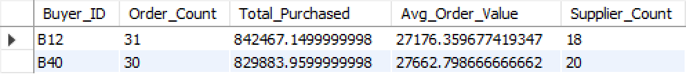

1. ​**检查供应商的双重身份**​：确定哪些供应商同时也是买家，为多级供应链分析做准备。

数据集内没有双重身份的厂商，没有多级供应链。

1. ​**分析核心企业的供应商**​：分别对B12和B40的供应商进行分析，按交易总额排序，找出主要供应商。

B12的核心供应商为：S16和S8



B40的核心供应商为：S10和S5



**第二阶段：供应商风险评估与融资策略匹配**

1. ​**供应商可靠性评估**​：计算每个供应商的平均可靠性得分，并根据得分给出增信建议。

B12供应商风险评估

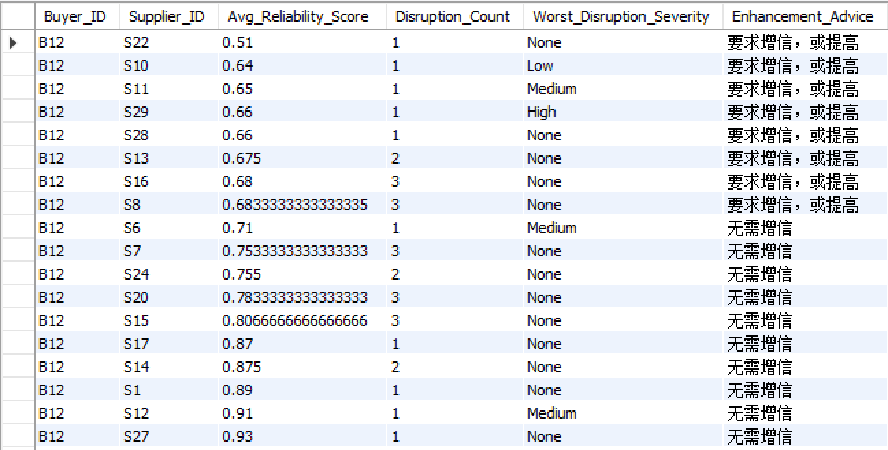

B40供应商风险评估

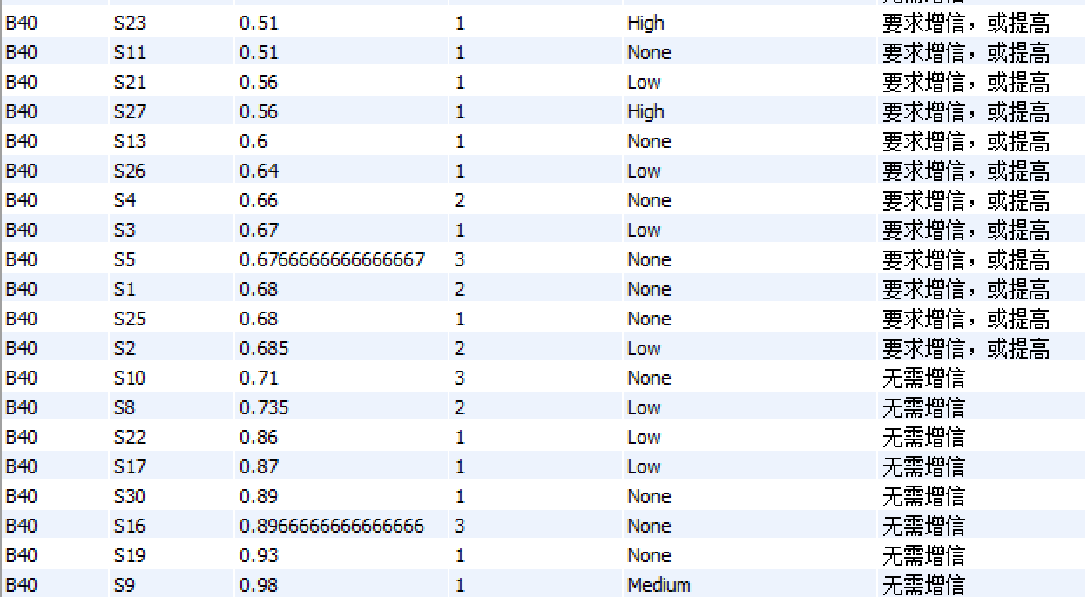

1. ​**风险分级与融资策略**​：根据可靠性得分将供应商分为A、B、C三级，并为每级设计不同的融资方案。

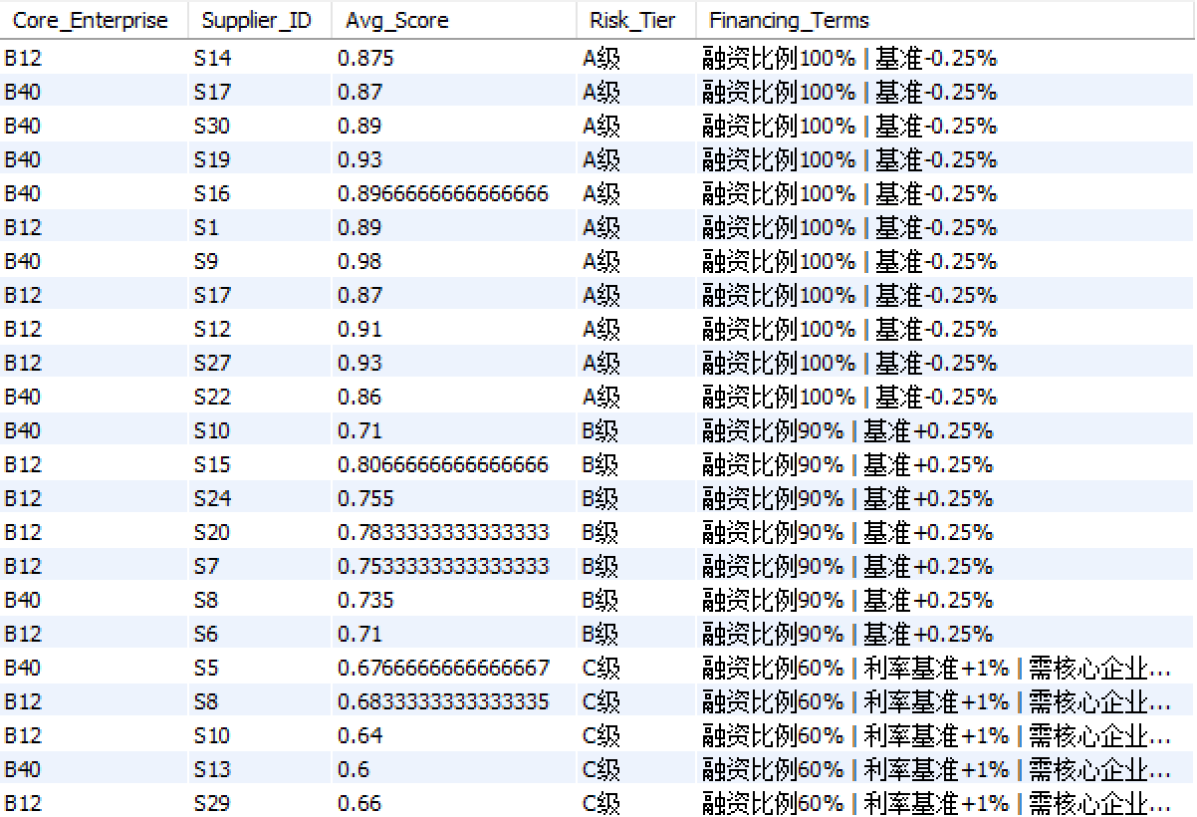

**第三阶段：持续监控**

1. ​**监控核心企业付款延迟**​：计算每个核心企业每月的平均付款延迟，并监控延迟的环比增加情况（超过5天触发预警）。

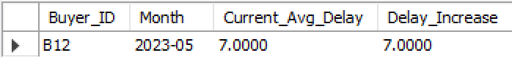

仅有核心企业B12在2023年5月触发付款延迟预警。

1. ​**监控供应商可靠性变化**​：计算每个供应商每月平均可靠性得分的环比变化，若单月下降超过0.25则触发预警。

预警名单如下

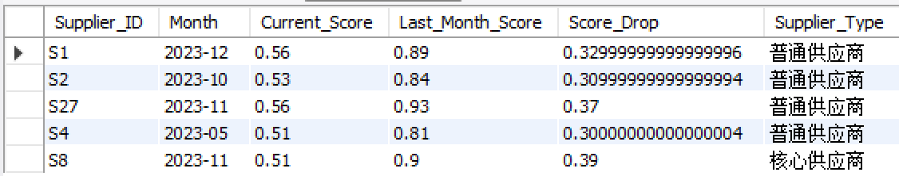

*Mysql代码*

-- 第一步：识别核心企业和上下游供应链企业 (按总采购金额排序)

-- 1.1 按照订单总额、订单次数、平均订单价值、供应商数量来识别核心企业

SELECT

Buyer_ID,

COUNT(DISTINCT `Order_ID`) AS Order_Count, -- 订单总数，反映业务频繁度

SUM(`Order_Value_USD`) AS Total_Purchased, -- 总采购金额，核心指标

AVG(`Order_Value_USD`) AS Avg_Order_Value, -- 平均订单价值

COUNT(DISTINCT `Supplier_ID`) AS Supplier_Count -- 供应商数量，反映供应链广度

FROM raws

GROUP BY Buyer_ID

HAVING COUNT(DISTINCT `Order_ID`) >= 30 and SUM(`Order_Value_USD`) > 80000

ORDER BY

Total_Purchased DESC; -- 按总采购额降序排列，排名最高的就是最核心的企业

-- 至此我们找到两个关键的核心企业，b12和b40

-- 还要检查供应商是否同时有买家和供应商双重身份，从而决定下一步是否梳理多级供应商

SELECT Supplier_ID

FROM raws

WHERE Supplier_ID IN (SELECT DISTINCT Buyer_ID FROM raws);

-- 这里的buyers和suppliers是带前缀编码的字符串，所以肯定不会重复。

-- 1.2 查询核心企业(B12和B40)的主要供应商及合作情况

SELECT

`Supplier_ID`,

SUM(`Order_Value_USD`) AS Total_Contract_Value, -- 与该供应商的总交易额

COUNT(`Order_ID`) AS Transaction_Count, -- 交易次数

AVG(`Order_Value_USD`) AS Avg_Transaction_Value, -- 平均交易额

MIN(`Order_Date`) AS First_Transaction_Date, -- 首次合作时间

MAX(`Order_Date`) AS Last_Transaction_Date, -- 最近合作时间

AVG(`Delay_Days`) AS Avg_Delay_Days -- 平均交付延迟天数(评估供应稳定性)

FROM

raws

WHERE

Buyer_ID = 'B12' -- 指定核心企业ID

GROUP BY

`Supplier_ID`

ORDER BY

SUM(`Order_Value_USD`) DESC; -- 按交易总额降序，排名最高的就是最重要的战略供应商即S16和S8

SELECT

`Supplier_ID`,

SUM(`Order_Value_USD`) AS Total_Contract_Value, -- 与该供应商的总交易额

COUNT(`Order_ID`) AS Transaction_Count, -- 交易次数

AVG(`Order_Value_USD`) AS Avg_Transaction_Value, -- 平均交易额

MIN(`Order_Date`) AS First_Transaction_Date, -- 首次合作时间

MAX(`Order_Date`) AS Last_Transaction_Date, -- 最近合作时间

AVG(`Delay_Days`) AS Avg_Delay_Days -- 平均交付延迟天数(评估供应稳定性)

FROM

raws

WHERE

Buyer_ID = 'B40'

GROUP BY

`Supplier_ID`

ORDER BY

SUM(`Order_Value_USD`) DESC; -- 按交易总额降序，排名最高的就是最重要的战略供应商即S10和S5

-- 1.3 评估所有供应商的可靠性，这里设置简单规则，如果主供应商平均可靠性分数低于0.70，则要求企业增信

-- 1.3 评估所有供应商的可靠性

SELECT

`Buyer_ID`,

`Supplier_ID`,

AVG(`Supplier_Reliability_Score`) AS Avg_Reliability_Score,

COUNT(CASE WHEN `Disruption_Type` IS NOT NULL THEN 1 END) AS Disruption_Count,

MAX(`Disruption_Severity`) AS Worst_Disruption_Severity,

-- 增加一个简单规则

CASE

WHEN AVG(`Supplier_Reliability_Score`) < 0.7 THEN '要求增信，或提高'

ELSE '无需增信'

END AS Enhancement_Advice

FROM

raws

WHERE

`Buyer_ID` IN ('B40', 'B12')

GROUP BY

`Buyer_ID`, `Supplier_ID` -- 分别计算给B12和B40供货的供应商是否需要增信

ORDER BY

`Buyer_ID`, Avg_Reliability_Score ASC; -- 按分数升序排列，风险高的（分数低的）排在前面

-- 2 简单规则的供应商风险分级与融资策略匹配

SELECT

`Buyer_ID` AS Core_Enterprise,

`Supplier_ID`,

AVG(`Supplier_Reliability_Score`) AS Avg_Score,

-- 风险分级

CASE

WHEN AVG(`Supplier_Reliability_Score`) >= 0.85 THEN 'A级'

WHEN AVG(`Supplier_Reliability_Score`) BETWEEN 0.7 AND 0.84 THEN 'B级'

ELSE 'C级'

END AS Risk_Tier,

-- 差异化融资方案

CASE

WHEN AVG(`Supplier_Reliability_Score`) >= 0.85 THEN '融资比例100% | 基准-0.25%'

WHEN AVG(`Supplier_Reliability_Score`) BETWEEN 0.7 AND 0.84 THEN '融资比例90% | 基准+0.25%'

ELSE '融资比例60% | 利率基准+1% | 需核心企业担保'

END AS Financing_Terms

FROM raws

WHERE `Buyer_ID` IN ('B12','B40')

GROUP BY `Buyer_ID`, `Supplier_ID`;

-- 3 持续监控核心企业和供应商交易状况

-- 3.1 监控核心企业付款延迟恶化

SELECT

Buyer_ID,

Month,

Current_Avg_Delay,

Delay_Increase

FROM (

SELECT

Buyer_ID,

DATE_FORMAT(Order_Date, '%Y-%m') AS Month,

AVG(Delay_Days) AS Current_Avg_Delay,

AVG(Delay_Days) - LAG(AVG(Delay_Days), 1) OVER (

PARTITION BY Buyer_ID

ORDER BY DATE_FORMAT(Order_Date, '%Y-%m')

) AS Delay_Increase

FROM raws

WHERE Buyer_ID IN ('B12','B40')

GROUP BY Buyer_ID, DATE_FORMAT(Order_Date, '%Y-%m')

) AS monthly_delays

WHERE Delay_Increase >= 5; -- 付款延迟按月环比增加超过5天就触发预警

-- 3.2 监控供应商可靠性（简单规则月平均可靠性下降0.25触发）

-- 3.2 监控供应商可靠性

SELECT

Supplier_ID,

Month,

Current_Score,

Last_Month_Score,

Score_Drop,

-- 核心供应商标识

CASE

WHEN Supplier_ID IN ('S16', 'S8', 'S10', 'S5') THEN '核心供应商'

ELSE '普通供应商'

END AS Supplier_Type

FROM (

SELECT

Supplier_ID,

DATE_FORMAT(Order_Date, '%Y-%m') AS Month,

AVG(Supplier_Reliability_Score) AS Current_Score,

LAG(AVG(Supplier_Reliability_Score), 1) OVER (

PARTITION BY Supplier_ID

ORDER BY DATE_FORMAT(Order_Date, '%Y-%m')

) AS Last_Month_Score,

(LAG(AVG(Supplier_Reliability_Score), 1) OVER (

PARTITION BY Supplier_ID

ORDER BY DATE_FORMAT(Order_Date, '%Y-%m')

) - AVG(Supplier_Reliability_Score)) AS Score_Drop,

Buyer_ID

FROM raws

WHERE Buyer_ID IN ('B12', 'B40')

GROUP BY Supplier_ID, DATE_FORMAT(Order_Date, '%Y-%m'), Buyer_ID

) AS supplier_scores

WHERE Score_Drop > 0.25; -- B12和B40的供应商单月可靠性下降超过0.25触发