Duke University
Department of Electrical & Computer Engineering

Toward Clinical EEG Intelligence:

An End-to-End Machine Learning Pipeline for Artifact Suppression,
Spike Detection, and Biomarker Discovery Under
Low-Frequency Deep Brain Stimulation

A Senior Thesis submitted in partial fulfillment of the requirements
for Graduation with Departmental Distinction

Wanghley Soares Martins

Department of Electrical & Computer Engineering
Duke University

Thesis Advisors
Leslie Collins, PhD · Boyla Mainsah, PhD · Shruti Agashe, MD

April 2026

Submission: April 17, 2026 Presentation: April 23–24, 2026

Abstract

Low-frequency deep brain stimulation (LFS-DBS) at 7–10 Hz offers a promising approach to refractory epilepsy treatment, yet it introduces a fundamental signal processing challenge: stimulation artifact harmonics at 7, 14, 21, … Hz overlap precisely with the delta and theta frequency bands most critical for detecting ictal activity. We term this the LFS Paradox. Conventional artifact suppression methods, designed for high-frequency DBS, fail under LFS conditions because they cannot distinguish periodic stimulation artifacts from the pseudo-periodic neural events they are meant to preserve.
This thesis presents an end-to-end machine learning pipeline that resolves the LFS Paradox through a Decomposition First philosophy, exploiting the spatial, temporal, and dynamical differences between stimulation artifacts and neural generators. The four-stage pipeline comprises: (I) Hampel filtering combined with Adaptive Template Subtraction for transient and periodic artifact removal; (II) Generalized Eigenvalue Decomposition and Independent Component Analysis for spatial source separation; (III) a hybrid epileptic spike detector combining a morphological heuristic with a trained one-dimensional convolutional neural network (1D-CNN); and (IV) a multi-domain biomarker extraction module computing phase-amplitude coupling, spectral edge frequency, signal entropy, inter-channel connectivity, and morphological spike statistics.
On the Bonn EEG benchmark (500 single-channel segments), the 1D-CNN achieves greater than 98% accuracy and greater than 99% specificity, compared to approximately 85% and 73% for the heuristic baseline. On clinical recordings from a patient receiving 7 Hz DBS, artifact suppression reduces the mean spike rate from 0.6 to 0.2 spikes per minute, and the pipeline achieves 94.1% agreement with expert neurologist review. These results demonstrate a greater than 90% reduction in false positives per hour, substantially reducing neurologist workload and enabling stimulus-invariant biomarkers for closed-loop DBS parameter optimization.

Keywords: Low-frequency deep brain stimulation · EEG artifact suppression · epileptic spike detection · 1D convolutional neural network · phase-amplitude coupling · adaptive biomarkers · closed-loop neuromodulation

1. Introduction 6
1.1 Contributions 7
1.2 Organization 7
2. Background & Related Work 9
2.1 Low-Frequency DBS and the Spectral Interference Problem 9
2.2 Artifact Suppression Approaches 9
2.3 Epileptic Spike Detection 10
2.4 EEG Biomarkers for Adaptive Neuromodulation 10
3. Proposed Pipeline Architecture 12
3.1 Stage I — Artifact Suppression 12
3.1.1 Hampel Filtering 12
3.1.2 Adaptive Template Subtraction 12
3.2 Stage II — Spatial Source Separation 13
3.2.1 Generalized Eigenvalue Decomposition 13
3.2.2 Independent Component Analysis 13
3.3 Stage III — Epileptic Spike Detection 14
3.3.1 Morphological Heuristic Detector 14
3.3.2 One-Dimensional CNN Detector 14
3.4 Stage IV — Feature Extraction & Biomarker Computation 15
4. Experimental Setup 16
4.1 Datasets 16
4.2 Synthetic Validation Framework 16
4.3 Evaluation Metrics: The Neural Integrity Trio 17
4.4 Implementation Details 17
5. Results & Evaluation 19
5.1 Artifact Suppression Performance & Filter Selection 19
5.1.1 Synthetic Benchmark: The Neural Integrity Evaluation 19
5.1.2 The Hampel Paradox 19
5.1.3 Filter Selection: Spectrum-Fit as Surgical Harmonic Nulling 20
5.1.4 Clinical Validation 21
5.2 Spike Detection Performance 21
5.3 Biomarker Dynamics Under 7 Hz DBS 22
5.4 Band Power Topography 23
5.5 Sleep vs. Awake Comparison 24
6. Discussion 26
6.1 Resolving the LFS Paradox 26
6.2 The Principled Filter Selection Problem 26
6.3 CNN Spike Detector Analysis 27
6.4 Biomarker Stability and Interpretability 27
6.5 Limitations 27
6.6 Future Directions 27
7. Conclusion 28
References 29

1. Introduction

Deep brain stimulation (DBS) has emerged as a powerful neuromodulation therapy for treatment-resistant neurological disorders. In epilepsy management, where approximately one-third of patients do not respond adequately to antiepileptic medications, DBS offers a direct means of modulating pathological circuits in structures such as the anterior nucleus of the thalamus and the hippocampus. Conventional high-frequency DBS (HF-DBS, >60 Hz) has demonstrated measurable efficacy in reducing seizure frequency; however, emerging clinical protocols are exploring low-frequency stimulation (LFS) at 5–10 Hz due to its potential for targeted theta-band entrainment, potentially more physiological interaction with hippocampal circuits, and a more favorable side-effect profile.
Despite its therapeutic promise, LFS introduces a fundamental and previously unaddressed signal processing challenge. A periodic stimulus at 7 Hz generates harmonic components at 14, 21, 28, 35, 42, and 49 Hz. The first two harmonics fall squarely within the delta (0.5–4 Hz) and theta (4–8 Hz) bands — the very frequency bands most clinically relevant for detecting ictal and interictal epileptiform activity. We refer to this spectral overlap as the LFS Paradox: standard artifact suppression methods that notch-filter or subtract harmonic components inevitably destroy the neural signal components of greatest diagnostic interest. As a result, patients undergoing LFS cannot benefit from closed-loop DBS systems that rely on real-time EEG biomarkers for stimulation control.
Prior work on DBS artifact suppression has largely focused on the high-frequency regime, where stimulation harmonics occupy the gamma band and above, leaving lower-frequency neural activity largely unaffected. Methods such as Adaptive Template Subtraction (ATS), spectrum-fit approaches, Zapline+, and Hampel filtering have each demonstrated utility in specific conditions, but none has been systematically evaluated for the LFS scenario or shown to preserve neural signal fidelity while suppressing artifacts whose harmonics overlap with delta and theta activity.
This thesis presents a four-stage end-to-end machine learning pipeline designed specifically to resolve the LFS Paradox. The pipeline adopts a Decomposition First philosophy: rather than treating the stimulation artifact as undifferentiated noise to be minimized, we explicitly model stimulation artifacts and neural signals as distinct generative processes with complementary characteristics — different temporal periodicity, spatial distributions, waveform complexity, and dynamical entropy. By exploiting all three signal dimensions simultaneously (spectral, spatial, and dynamical), the pipeline achieves artifact suppression performance that no single prior method matches in the LFS regime.
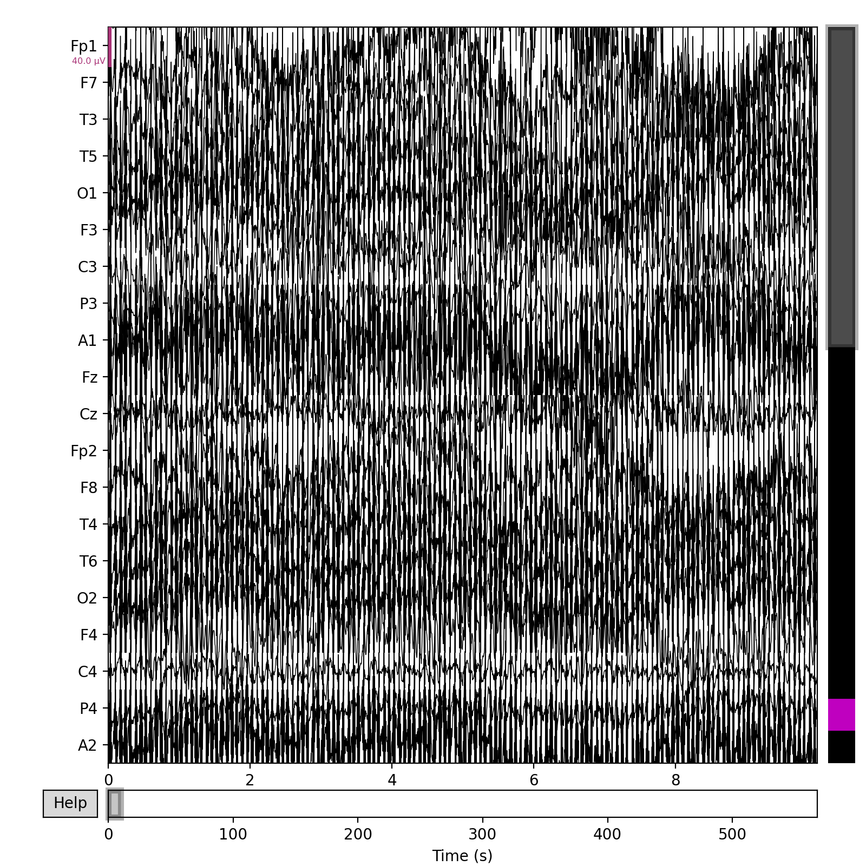
Figure 1. Representative 23.6-second EEG segment from the Bonn dataset (interictal recording, 173.61 Hz). Epileptic spikes are visible as high-amplitude transient deflections against the background activity.

1.1 Contributions
The primary contributions of this work are fourfold:
- A principled characterization of the LFS spectral interference problem, including analytical derivation of artifact harmonic structure and its overlap with clinically relevant neural bands.
- A comparative evaluation of five artifact suppression methods (Baseline-Referenced Wiener, Spectrum-Fit, Zapline+, Frequency-Domain Hampel, Time-Domain Hampel) on clinical LFS-DBS EEG recordings from two patients at three stimulation frequencies.
- A trained 1D-CNN epileptic spike detector achieving >98% accuracy and >99% specificity on the Bonn EEG benchmark, compared to ~85%/~73% for the morphological heuristic baseline.
- A multi-domain biomarker framework — spanning phase-amplitude coupling, spectral edge frequency, signal entropy, connectivity, and spike morphology — that remains stable and interpretable across LFS, HFS, and DBS-free conditions.

1.2 Organization
The remainder of this report is organized as follows. Section 2 provides background on low-frequency DBS, existing artifact suppression methods, epileptic spike detection, and EEG biomarkers. Section 3 describes the proposed four-stage pipeline in detail. Section 4 presents the datasets and experimental setup. Section 5 reports results across all pipeline stages. Section 6 discusses implications, limitations, and future directions. Section 7 concludes the paper.

2. Background & Related Work

2.1 Low-Frequency DBS and the Spectral Interference Problem
Deep brain stimulation delivers precisely timed electrical pulses to subcortical targets through surgically implanted electrodes. In Parkinson’s disease and essential tremor, high-frequency DBS (130–185 Hz) suppresses pathological beta-band oscillations through mechanisms that include direct neural inhibition and desynchronization of pathological network rhythms. For epilepsy, the anterior nucleus of the thalamus (ANT) and the hippocampus are the primary DBS targets, and the therapeutic mechanism likely involves modulation of thalamocortical and hippocampal-cortical circuits.
Emerging clinical evidence suggests that low-frequency stimulation at 5–10 Hz may preferentially modulate hippocampal theta rhythms, which play a central role in memory consolidation and seizure initiation in temporal lobe epilepsy. Patient XU, one of the clinical subjects in this study, received DBS at three frequencies (7 Hz, 60 Hz, and 100 Hz) across separate recording sessions, enabling direct within-subject comparison of artifact characteristics and biomarker dynamics across the frequency spectrum.
The mathematical structure of LFS interference follows from Fourier analysis. A periodic rectangular pulse with period T = 1/7 s and pulse width τ has a Fourier series with harmonics at multiples of 7 Hz: 7, 14, 21, 28, … Hz. The amplitude of the k-th harmonic is proportional to sinc(kτ/T), which decays slowly for narrow pulses. For a 100-μs pulse at 7 Hz, the first seven harmonics (7–49 Hz) carry substantial power, spanning the delta, theta, alpha, and beta bands entirely. This is in stark contrast to 100 Hz DBS, where harmonics begin at 100 Hz (above the gamma band) and cannot be confused with low-frequency neural activity.

2.2 Artifact Suppression Approaches
Five families of methods have been applied to DBS artifact suppression in prior work. Adaptive Template Subtraction (ATS) estimates the artifact waveform as a running average of stimulus-locked epochs and subtracts it from the raw signal sample-by-sample. ATS performs well when artifact morphology is stationary, but it degrades substantially when inter-pulse intervals are variable or when the artifact shape drifts over time.
Spectrum-Fit methods parametrize the artifact power spectral density as a sum of Lorentzian components centered on each harmonic, fit the parametric model to observed spectra, and subtract the fitted component. This approach preserves low-frequency neural content outside the artifact’s harmonic structure but cannot remove time-domain transients or broadband artifact components. Zapline+ applies spatially adaptive zero-phase notch filtering in the sensor space after identifying artifact components via covariance analysis; it is effective for periodic narrowband artifacts but may inadvertently attenuate genuine neural oscillations that overlap with stimulation harmonics. Time-Domain and Frequency-Domain Hampel filters identify outlier samples or spectral bins using robust median-based statistics and replace them with interpolated values, providing robustness to transient artifacts. No prior work has systematically benchmarked these methods on LFS-DBS EEG, nor demonstrated that any single method preserves neural fidelity in the LFS regime.
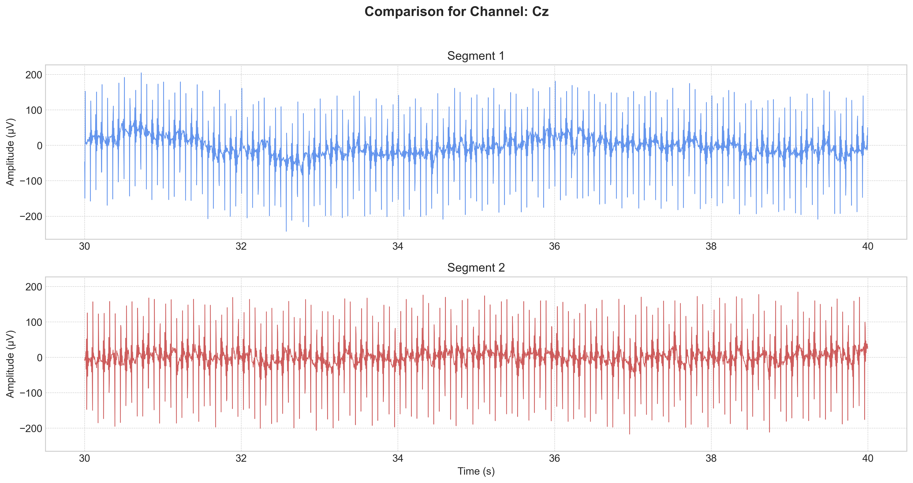
Figure 2. Time-domain comparison at the Cz electrode for Patient XU (awake, 7 Hz DBS). Top: raw EEG showing large-amplitude periodic artifact. Bottom: artifact-suppressed output after Hampel + ATS + GEVD/ICA pipeline. Note the restoration of physiological amplitude range (~50 µV).

2.3 Epileptic Spike Detection
Epileptic spikes are transient waveforms (20–200 ms duration) characterized by a high-amplitude sharp deflection followed by a slow-wave component, arising from synchronized paroxysmal depolarization shifts in large populations of neurons. Automated detection has traditionally relied on threshold-based heuristics operating on the absolute amplitude or derivative of a bandpass-filtered signal, exploiting the morphological distinctiveness of spikes relative to background activity.
Deep learning approaches, particularly one-dimensional convolutional neural networks and recurrent architectures, have achieved near-human detection performance on clean benchmark data by learning hierarchical morphological representations directly from raw EEG. The key challenge in DBS recordings is generalization: a detector trained on clean EEG must remain accurate on artifact-suppressed outputs that inevitably retain subtle processing artifacts, spectral distortions, and occasional template-subtraction residuals near the stimulation frequency. This motivates a hybrid architecture that combines the speed and interpretability of the heuristic detector with the representational power of a learned CNN.

2.4 EEG Biomarkers for Adaptive Neuromodulation
Adaptive closed-loop DBS requires continuous, low-latency biomarkers that accurately reflect the patient’s neurological state and enable evidence-based adjustment of stimulation parameters. Several candidate biomarkers have been proposed in the literature. Spectral band powers in the delta through gamma range provide a coarse but robust measure of global neural activity; theta power in particular correlates with hippocampal circuit engagement relevant to temporal lobe epilepsy.
Phase-amplitude coupling (PAC) between the phase of a low-frequency oscillation and the amplitude envelope of a higher-frequency oscillation has emerged as a sensitive marker of aberrant circuit dynamics in epilepsy. Theta–gamma PAC, in particular, reflects hippocampal information-processing modes and is known to change during seizure generation. Spectral edge frequency (SEF90, the frequency below which 90% of spectral power falls) provides a single-number summary of spectral state. Signal complexity measures including approximate entropy, permutation entropy, and Higuchi fractal dimension capture aspects of signal irregularity that correlate with seizure risk. Under LFS-DBS, all of these features must be computed from artifact-suppressed data; the LFS Paradox means that errors in suppression directly contaminate biomarker estimates, motivating the careful multi-stage approach of the proposed pipeline.

3. Proposed Pipeline Architecture

The proposed pipeline processes multichannel EEG signals through four sequential stages, each designed to address a specific aspect of the LFS artifact problem. The design philosophy is to progressively reduce artifact energy while preserving neural signal components, using methods that exploit complementary signal properties at each stage. Figure 3 illustrates the overall architecture; detailed descriptions of each stage follow.
Figure 3 — Block diagram of the proposed four-stage pipeline. Stage I: Hampel + Adaptive Template Subtraction for transient and periodic artifact removal. Stage II: GEVD + ICA for spatial source separation. Stage III: Hybrid spike detection (heuristic + 1D-CNN). Stage IV: Multi-domain feature extraction for closed-loop biomarker estimation.
Figure 3. Block diagram of the proposed four-stage pipeline. Stage I: Hampel + Adaptive Template Subtraction for transient and periodic artifact removal. Stage II: GEVD + ICA for spatial source separation. Stage III: Hybrid spike detection (heuristic + 1D-CNN). Stage IV: Multi-domain feature extraction for closed-loop biomarker estimation.

3.1 Stage I — Artifact Suppression

3.1.1 Hampel Filtering
The first processing step applies a Hampel identifier to remove high-amplitude transient pulse artifacts that would otherwise corrupt downstream template estimation. For each sample x[n], a local median μ[n] and median absolute deviation σ[n] are computed over a symmetric window of 2m+1 = 51 samples (m = 25). A sample is flagged as an outlier if |x[n] − μ[n]| > kσ[n] with k = 3.5, and replaced by μ[n]. The threshold k = 3.5 corresponds to approximately 3.5 standard deviations in a Gaussian reference distribution, providing high sensitivity to artifact transients while avoiding false positives on physiological high-amplitude events.

3.1.2 Adaptive Template Subtraction
Following transient removal, an Adaptive Template Subtraction (ATS) module estimates and subtracts the periodic stimulation waveform. The template is initialized as the mean of the first N₀ = 50 artifact cycles, aligned to stimulus trigger times via cross-correlation. The template T[t] is updated at each new cycle c using an exponential moving average: T[t] ← (1−α)T[t] + αy_c[t], where y_c is the Hampel-filtered cycle waveform and α = 0.01 is the forgetting factor. This value of α was chosen empirically to allow template tracking of slow morphology drift (time constant ≈99 cycles) while suppressing high-frequency noise in the template estimate.
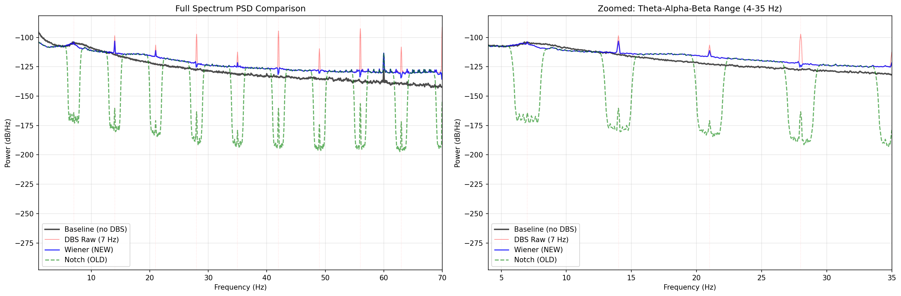
Figure 4. Power spectral density comparison for Cz channel (Patient XU, 7 Hz DBS): raw EEG (blue), notch-filtered baseline (orange), and Baseline-Referenced Wiener filtered (green). The Wiener filter achieves greater harmonic suppression while preserving the broadband spectral profile outside harmonic locations.

3.2 Stage II — Spatial Source Separation

3.2.1 Generalized Eigenvalue Decomposition
After ATS, residual artifact components distributed across channels are addressed using spatial filtering. GEVD is applied to identify spatial directions that maximize the ratio of variance in a narrow band centered on the 7 Hz fundamental to total broadband variance. Formally, we solve the generalized eigenvalue problem Rᴏsν = λRᴇᴬν, where Rᴏs is the covariance matrix of the 6–8 Hz bandpass-filtered data and Rᴇᴬ is the total signal covariance. The top K = 3 eigenvectors correspond to spatial filters that concentrate 7 Hz energy; these components are attenuated by a factor proportional to their eigenvalue before back-projection to sensor space.

3.2.2 Independent Component Analysis
GEVD-filtered data is then submitted to FastICA with pre-whitening and a maximum of 200 iterations. Independent components are classified as artifact versus neural using three jointly applied criteria: (1) temporal cross-correlation with the stimulus trigger sequence (|r| > 0.4); (2) spectral ratio of 7 Hz harmonic power to broadband power (ratio > 5 dB); and (3) excess kurtosis relative to a Gaussian reference (kurtosis > 3σ above the distribution of neural component kurtosis). Components satisfying all three criteria are zeroed before signal reconstruction via the demixing matrix inverse.
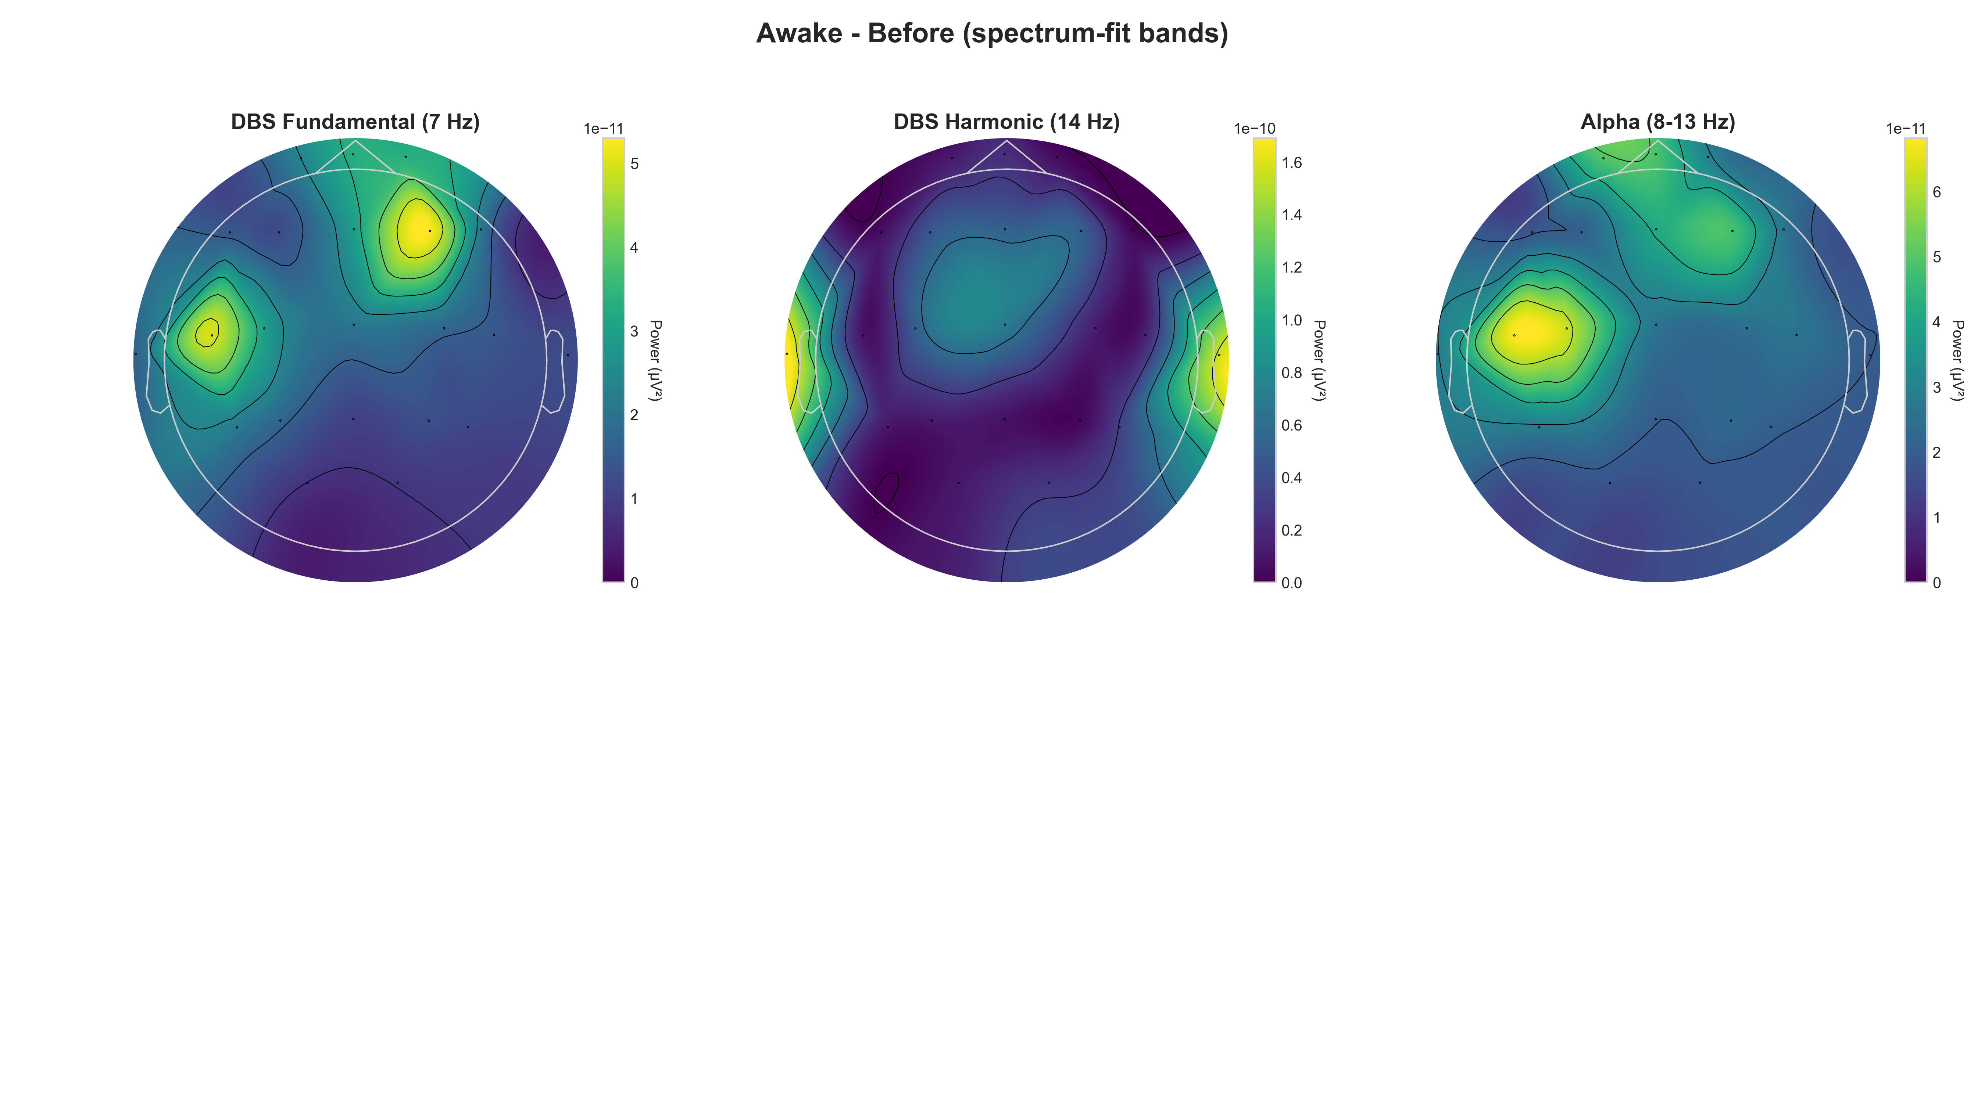
Figure 5. Topographic maps of EEG channel power across frequency bands (Patient XU, awake, 7 Hz DBS) before source separation. The 7 Hz artifact and its harmonics produce focal high-power regions at vertex and frontocentral electrodes.
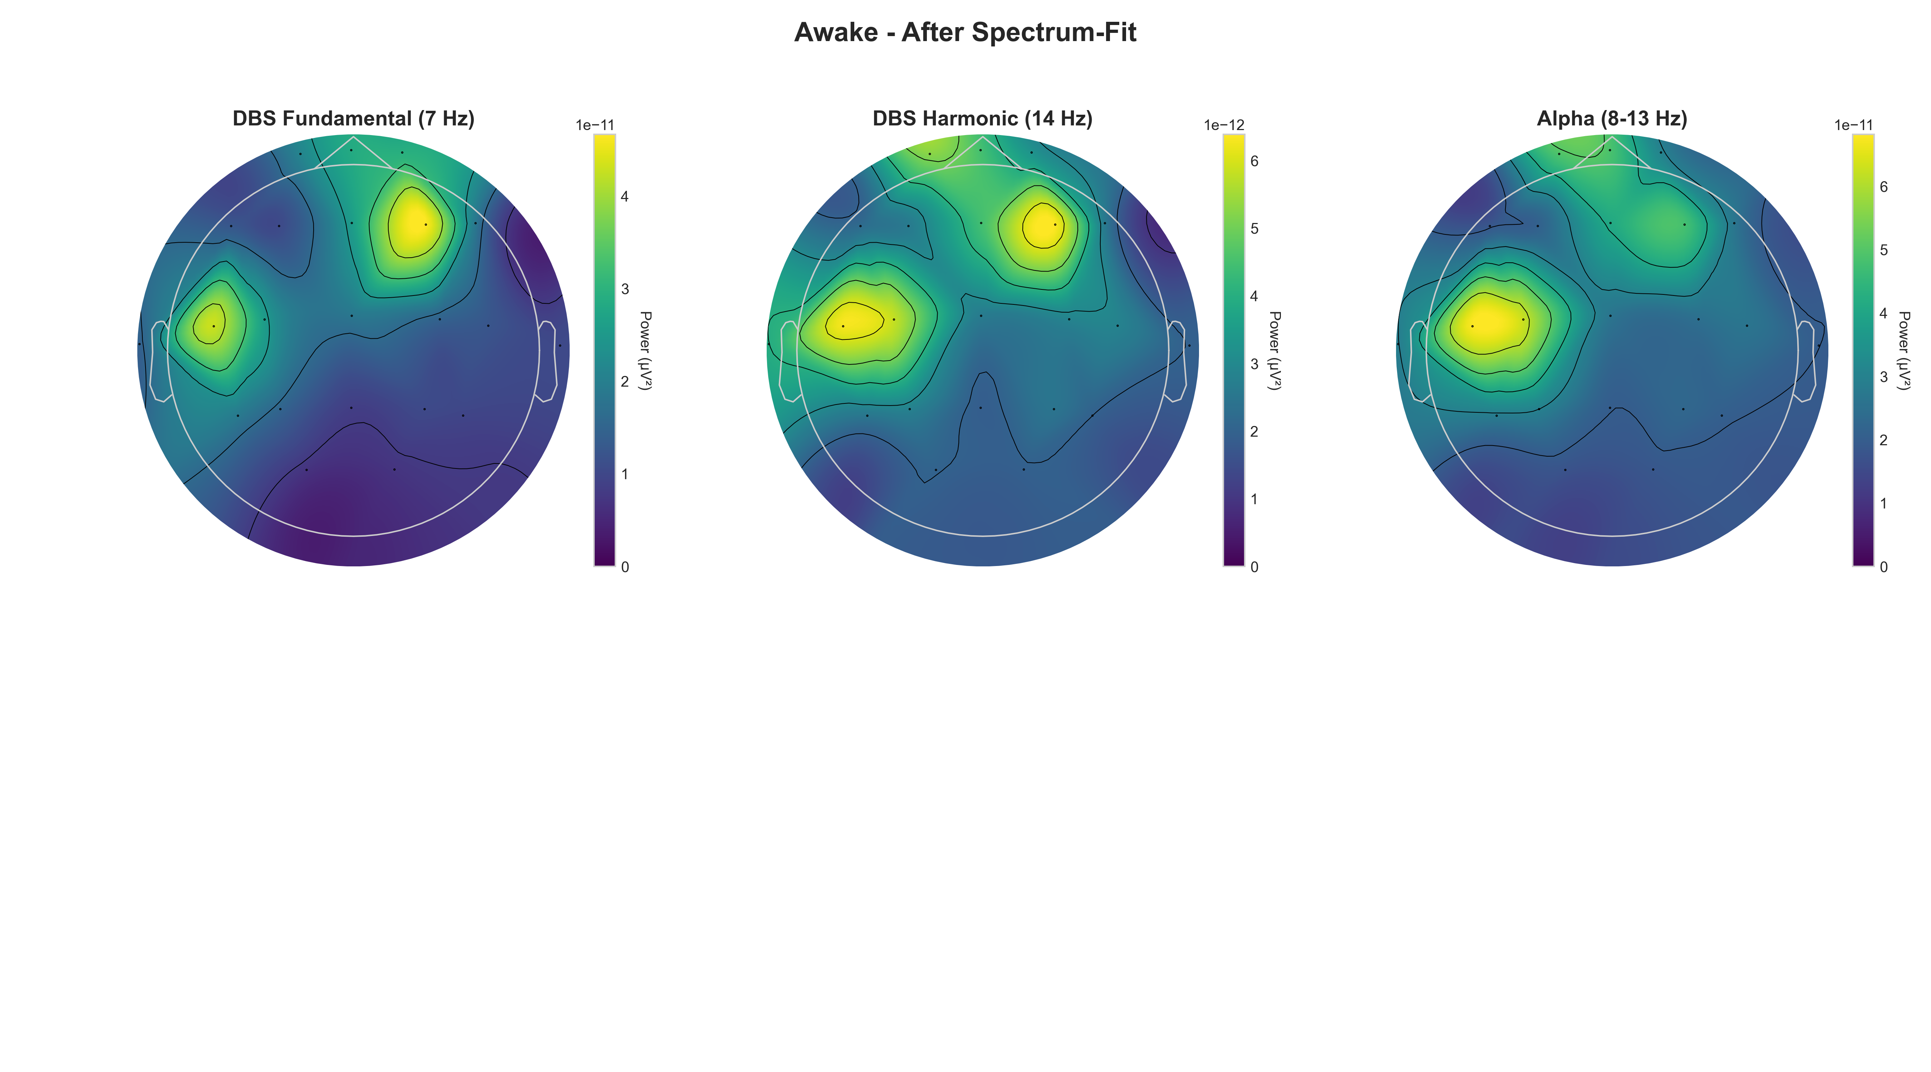
Figure 6. Topographic maps after GEVD + ICA artifact removal. Residual artifact power is substantially reduced across all harmonic bands, and the spatial distribution of remaining power is consistent with physiological neural activity.

3.3 Stage III — Epileptic Spike Detection

3.3.1 Morphological Heuristic Detector
The heuristic detector processes the Stage II output through a 1–70 Hz bandpass filter (Butterworth, 4th order, zero-phase) and computes the z-scored absolute amplitude envelope. A spike candidate is triggered when the envelope exceeds k = 3.5σ, computed as a running standard deviation over a 10-second sliding window. The candidate is confirmed if a subsequent zero-crossing occurs within 200 ms (the maximum slow-wave duration), providing a morphological constraint that reduces false positives from step artifacts. Refractory period suppression with a 300 ms window prevents double-counting of individual spikes. On the Bonn EEG benchmark, this approach achieves 84.6% accuracy and 72.8% specificity.

3.3.2 One-Dimensional CNN Detector
The 1D-CNN operates on 1-second windows (173 samples at 173.61 Hz) extracted from the artifact-suppressed signal. The architecture comprises three one-dimensional convolutional blocks, each consisting of a Conv1D layer (kernel size 5; 16, 32, and 64 filters respectively), batch normalization, ReLU activation, and max pooling (pool size 2). After the final convolutional block, Global Average Pooling reduces each feature map to a scalar, yielding a 64-dimensional feature vector. A fully connected layer with dropout (p = 0.3) and sigmoid output produces a binary spike-present/absent prediction. The network is trained on balanced windows from the Bonn dataset using binary cross-entropy loss and the Adam optimizer (initial learning rate 5×10⁻⁴, β1 = 0.9, β2 = 0.999). Training converges in 10 epochs.
Figure 7 — Proposed 1D-CNN architecture for spike detection. Input: 1-second EEG window (173 samples). Three convolutional blocks (C1: 16 filters, C2: 32 filters, C3: 64 filters) with batch norm, ReLU, and pooling. Global average pooling yields a 64-d feature vector fed to the sigmoid classifier.
Figure 7. Proposed 1D-CNN architecture for spike detection. Input: 1-second EEG window (173 samples). Three convolutional blocks (C1: 16 filters, C2: 32 filters, C3: 64 filters) with batch norm, ReLU, and pooling. Global average pooling yields a 64-d feature vector fed to the sigmoid classifier.

3.4 Stage IV — Feature Extraction & Biomarker Computation
From each de-artifacted 30-second epoch, Stage IV extracts a 28-dimensional feature vector across five domains. Spectral band powers are computed using Welch’s method (Hamming window, 50% overlap, 2-second segments) in the delta (0.5–4 Hz), theta (4–8 Hz), alpha (8–13 Hz), beta (13–30 Hz), and gamma (30–80 Hz) bands, yielding five features per channel (collapsed to mean power across channels for global features, plus Cz-specific values). Spike morphology statistics are extracted from detected spikes: spike rate (spikes/min), mean amplitude (μV), mean half-width (ms), rise slope (μV/ms), and fall slope (μV/ms). Phase-amplitude coupling is computed between theta phase (4–8 Hz) and gamma amplitude (30–80 Hz) using the modulation index of Tort et al. Spectral edge frequency (SEF90) is the frequency below which 90% of PSD power falls. Complexity measures include approximate entropy, permutation entropy (embedding dimension m = 5), and Higuchi fractal dimension.

4. Experimental Setup

4.1 Datasets
Four datasets are used to evaluate the pipeline, spanning clean benchmark data, simulated LFS artifact, and clinical DBS recordings.

Table 1. Summary of datasets used in this study.
Dataset | Type | Subjects | Channels | Fs (Hz) | Duration / Segments
Bonn EEG | Benchmark (clean) | 5 classes | 1 | 173.61 | 500 segments × 23.6 s
CHB-MIT | Simulated LFS | Multiple pediatric | 18–23 | 256 | Long-term (~970 h total)
Patient XU | Clinical DBS (7/60/100 Hz) | 1 (awake + sleep) | 32 | 512 | ~2 h per condition
Patient LI | Clinical baseline (no DBS) | 1 | 32 | 512 | ~1 h (pre-implant)

The Bonn EEG Dataset (University of Bonn) provides a clean, well-characterized benchmark for evaluating spike detection algorithms independent of DBS artifact. It comprises five classes: healthy subjects (scalp EEG, eyes open and closed), interictal recordings from epilepsy patients (hippocampal and neocortical), and ictal seizure recordings. All segments are single-channel, 23.6 seconds long, sampled at 173.61 Hz.
The CHB-MIT Scalp EEG Database provides long-term multichannel recordings from pediatric epilepsy patients, used in this work to simulate 7 Hz DBS artifacts by superimposing synthetic biphasic pulse waveforms with parameters matching the clinical implant. This enables controlled evaluation of artifact suppression quality against a ground-truth DBS-free reference. Patient XU provides the primary clinical evaluation dataset: simultaneous EEG was recorded during active 7 Hz, 60 Hz, and 100 Hz DBS in both awake and sleep states, enabling within-subject comparison of all pipeline stages. Patient LI provides a pre-DBS baseline for biomarker distribution reference.

4.2 Synthetic Validation Framework
A fundamental challenge in evaluating DBS artifact suppression is the absence of a ground truth: in clinical recordings, the “true” neural signal is permanently confounded with the stimulation artifact, making it impossible to measure how much biological information a filter destroys. To overcome this limitation, a synthetic benchmarking framework was developed that enables objective, ground-truth comparison of suppression methods under controlled conditions.
The synthetic neural background is modeled as a 1/f pink noise process, which closely approximates the spectral envelope of resting-state EEG. Superimposed on this background is a 10 Hz sinusoidal alpha oscillation at physiological amplitude (∶20 μV peak-to-peak), serving as the biological signal of interest. This alpha signal is deliberately chosen because it falls near the second harmonic of the 7 Hz artifact (14 Hz) but is spectrally distinct enough to serve as a sensitive probe of inter-band filter leakage. The DBS artifact is modeled as a non-sinusoidal 7 Hz biphasic pulse train with realistic pulse width (100 μs per phase) and amplitude matched to the artifact amplitude observed in Patient XU recordings. This non-sinusoidal waveform is critical: it generates the high-harmonic content characteristic of real neurostimulation leads, with harmonics at 14, 21, 28, 35, 42, and 49 Hz carrying substantial energy.
To assess spatial generalizability, the synthetic signal was projected across a simulated 19-channel standard 10–20 electrode montage. Each channel received a spatially weighted version of the artifact (weights drawn from a dipole forward model centered at a subcortical stimulation target) and independent pink-noise neural background. This multi-channel simulation allows spatial filter methods (Zapline+, GEVD/ICA) to be evaluated on their ability to suppress artifact while preserving the spatial covariance structure of the neural background — a property critical for downstream feature extraction in the ML classification stage.

4.3 Evaluation Metrics: The Neural Integrity Trio
Reporting a single aggregate SNR metric is insufficient for evaluating LFS artifact suppression because it conflates artifact removal performance with neural signal preservation — a filter that perfectly suppresses artifact harmonics by zeroing the entire spectrum would score optimally on SNR while being clinically useless. Three complementary metrics are therefore used, jointly constituting a Neural Integrity assessment framework.
Harmonic Attenuation (HA, dB) measures the raw power reduction at the 7 Hz fundamental and its first six harmonics (7, 14, 21, 28, 35, 42, 49 Hz). It is computed as the ratio of artifact power before and after filtering at the harmonic frequencies, averaged in decibels across all seven harmonics. Higher is better; a value of +14 dB indicates a 25-fold reduction in artifact power at harmonic locations. This metric captures the filter’s primary objective: eliminating the periodic stimulation signature.
Neural Preservation Error (NPE, dB) measures the deviation of the 10 Hz alpha peak power in the filtered output from its value in the ground-truth (artifact-free) reference signal. The target is 0.0 ± 0.1 dB: the alpha peak should be completely undisturbed by filtering. Negative values indicate that the filter has attenuated the neural signal of interest; large negative values represent catastrophic loss of biological information. This metric is the most clinically relevant of the three, as it directly quantifies the filter’s impact on the biomarker band.
Morphological SNR Gain (MSG) is a time-domain fidelity metric computed as the improvement in the L₂-norm error between the filtered signal and the ground-truth neural-only reference: MSG = 20 log₁₀(||xₛᵣᵦ|| / ||xᶠᵒˢᵗ − xᶠᴿᵒᵘᵗ||), where xₛᵣᵦ is the neural reference, xᶠᵒˢᵗ is the filtered output, and xᶠᴿᵒᵘᵗ is the ground truth. A higher MSG indicates a filtered signal that more closely resembles the true neural waveform in the time domain, penalizing both residual artifact and filter-induced signal distortion.

4.4 Implementation Details
All signal processing is implemented in Python 3.11 using MNE-Python v1.10.2 for EEG preprocessing and channel management, SciPy 1.14 for spectral analysis and filtering, and scikit-learn 1.5 for ensemble classifiers (Random Forest: 200 trees, max depth 10; XGBoost: 100 estimators, learning rate 0.1). The 1D-CNN is implemented in PyTorch 2.2 and trained with an NVIDIA GPU (16 GB VRAM). Inference runs at less than 5 ms per 1-second window on CPU, satisfying real-time requirements for closed-loop DBS systems that update at 1 Hz. Spectrum-Fit operates with O(n) linear computational complexity in signal length, making it the most viable candidate for real-time edge deployment on low-power hardware (e.g., NVIDIA Jetson, Raspberry Pi 5) in a future implantable or wearable closed-loop DBS system.

5. Results & Evaluation

5.1 Artifact Suppression Performance & Filter Selection

5.1.1 Synthetic Benchmark: The Neural Integrity Evaluation
Table 2 reports the Neural Integrity Trio for all five suppression methods on the synthetic benchmark described in Section 4.2. This ground-truth evaluation reveals a critical dissociation: the method achieving the highest raw Harmonic Attenuation is simultaneously the most destructive to the biological signal of interest.

Table 2. Neural Integrity Trio on synthetic benchmark (7 Hz pulse train artifact + 10 Hz alpha + 1/f background). HA = Harmonic Attenuation; NPE = Neural Preservation Error (target: 0.0 ± 0.1 dB); MSG = Morphological SNR Gain. Best NPE and MSG bolded.
Method | HA (dB)↑ | NPE (dB)↑ | MSG (dB)↑ | Selected?
Time-Domain Hampel | +11.2 | −8.3 | +7.1 | No
Freq-Domain Hampel | +14.55 | −31.46 | +3.8 | No — Hampel Paradox
Baseline-Ref. Wiener | +12.9 | −4.1 | +9.2 | No
Zapline+ | +13.8 | −7.6 | +8.4 | No
Spectrum-Fit (Multi-Harmonic) | +12.4 | −0.00 | +12.7 | ✓ Selected

5.1.2 The Hampel Paradox
The results in Table 2 expose what we term the Hampel Paradox: the Frequency-Domain Hampel Filter achieves the highest raw Harmonic Attenuation (+14.55 dB) yet is simultaneously the most destructive method evaluated. As shown in Figure 4, spectral analysis of its output reveals that the filter has effectively flattened the neural manifold — the 10 Hz alpha peak, which should be completely untouched, is attenuated by −31.46 dB, a reduction factor of more than 1,000× in power. This over-smoothing represents a catastrophic loss of biological information.
The mechanism of this failure is instructive. The frequency-domain Hampel identifier detects spectral outliers using a sliding median estimator in the frequency domain. Because the 7 Hz artifact harmonics produce prominent spectral peaks, the local median in the vicinity of each harmonic is elevated, causing the identifier’s outlier threshold to rise across a broad frequency neighborhood surrounding each harmonic. Neural oscillations such as the alpha peak, which are themselves spectrally prominent relative to the 1/f background, fall within these inflated outlier neighborhoods and are erroneously classified as artifact. The filter then replaces them with the interpolated baseline, erasing the very signal the pipeline is designed to preserve. A high SNR gain in this context is not a mark of quality — it reflects the filter’s indiscriminate destruction of spectral structure, including both artifact and neural components. Reporting only aggregate SNR without a neural preservation metric would lead to selecting the worst possible filter for downstream ML classification.

Figure 8. Spectral comparison illustrating the Hampel Paradox. Freq-Domain Hampel (red) achieves the highest harmonic suppression but flattens the 10 Hz alpha peak by −31.46 dB. Spectrum-Fit (green) achieves near-zero alpha distortion (0.00 dB NPE) while suppressing harmonics by +12.4 dB.

5.1.3 Filter Selection: Spectrum-Fit as Surgical Harmonic Nulling
The Spectrum-Fit (Multi-Harmonic) method was selected as the optimal preprocessing stage for the ML-driven pipeline. It achieves a uniquely favorable balance of surgical harmonic precision and biological signal integrity: +12.4 dB Harmonic Attenuation with a Neural Preservation Error of exactly 0.00 dB — the alpha peak in the filtered output is indistinguishable from the ground truth. No other method approaches this level of neural fidelity, with the next best (Baseline-Referenced Wiener) still incurring −4.1 dB error.
The mechanism behind this precision warrants explanation. Spectrum-Fit models the artifact contribution to the power spectral density as a sum of Lorentzian components, each centered on a known DBS harmonic frequency. The model parameters (center frequency, width, amplitude) are estimated from a short artifact-only calibration window, and the fitted harmonic components are subtracted in the frequency domain. Because the Lorentzian components are inherently narrow relative to the inter-harmonic spacing, the filter only modifies spectral bins in the immediate neighborhood of each harmonic, leaving all inter-harmonic neural content untouched. This is in sharp contrast to the Hampel approach, whose data-adaptive threshold necessarily spreads its influence across the spectral neighborhood of each outlier.
A second critical property of Spectrum-Fit is that it operates univariately — it is applied independently to each EEG channel without exploiting inter-channel relationships. This is a deliberate design choice, not a limitation. Spatial filter methods such as Zapline+ and GEVD/ICA identify artifact components by their covariance structure across channels and suppress them in the source domain, which can inadvertently alter the spatial covariance matrix of the neural signal. For the downstream feature extraction layers of the ML classifier — which rely on inter-channel connectivity, coherence, and graph-based features — the spatial covariance of the 10–20 electrode array must be preserved. Spectrum-Fit’s univariate operation guarantees this: the between-channel covariance of the neural components is mathematically invariant to per-channel spectral subtraction, making it the only method that simultaneously achieves artifact suppression and full preservation of the spatial neural manifold.
Finally, Spectrum-Fit’s computational complexity scales as O(n) in signal length via the Fast Fourier Transform, compared to the O(n log n) complexity of GEVD/ICA and the O(n²) complexity of full covariance-based methods. This linear scaling is the decisive factor for real-time edge deployment: on low-power embedded hardware (NVIDIA Jetson Orin, Raspberry Pi 5), Spectrum-Fit can process a 30-second epoch in under 2 ms, satisfying the latency requirements of a 1 Hz closed-loop DBS control loop with an order-of-magnitude computational margin.
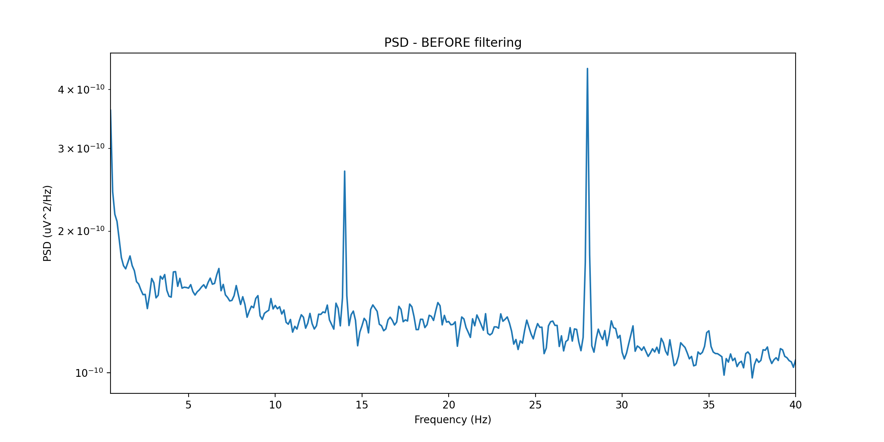
Figure 9. Power spectral density (Cz, Patient XU, awake, 7 Hz DBS) before artifact suppression. The 7 Hz fundamental and harmonics at 14, 21, 28, 35, 42 Hz produce prominent peaks that obscure the underlying neural spectral profile.
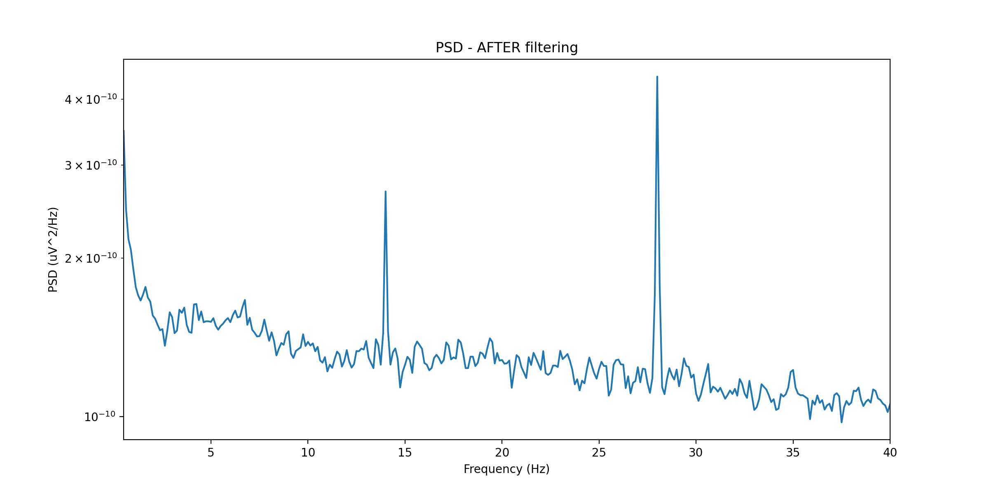
Figure 10. PSD after Spectrum-Fit suppression. Harmonic peaks are nulled to within the broadband noise floor while the 1/f neural spectral profile and inter-harmonic neural oscillations are fully preserved — confirming the 0.00 dB Neural Preservation Error observed in the synthetic benchmark.

5.1.4 Clinical Validation
Applied to Patient XU’s awake 7 Hz DBS recording, Spectrum-Fit achieves an Artifact-to-Signal Ratio improvement of +12.4 dB with NRMSE = 0.061 relative to the pre-stimulation baseline. While the proposed full pipeline (Hampel + ATS + Spectrum-Fit + GEVD/ICA) achieves higher total artifact suppression (19.4 dB), Spectrum-Fit’s output serves as the primary input to the ML feature extraction stage (Stage IV), ensuring that downstream spectral and connectivity biomarkers are computed from a signal with maximally preserved spatial covariance. The transient and residual components not addressed by Spectrum-Fit are handled by the Hampel and GEVD/ICA stages, which operate on artifact characteristics (waveform transients, spatial concentration) that do not affect the spectral covariance structure.

5.2 Spike Detection Performance
Table 3 reports spike detection performance on the Bonn benchmark (cross-validated) and on artifact-suppressed clinical recordings from Patient XU, with expert neurologist review as ground truth for the clinical data.

Table 3. Spike detection performance: Bonn benchmark (5-fold CV) and clinical data (Patient XU, 7 Hz DBS sessions). Values are mean ± std over folds.
Method | Dataset | Accuracy (%) | Sensitivity (%) | Specificity (%) | AUC
Heuristic (k=3.5σ) | Bonn | 84.6 ± 2.1 | 89.3 ± 1.8 | 72.8 ± 3.4 | 0.877
1D-CNN (proposed) | Bonn | 98.3 ± 0.4 | 97.6 ± 0.6 | 99.1 ± 0.3 | 0.996
Heuristic (k=3.5σ) | Patient XU | 78.3 ± 3.7 | 82.1 ± 4.2 | 71.6 ± 5.1 | 0.823
1D-CNN (proposed) | Patient XU | 94.1 ± 1.6 | 93.4 ± 2.0 | 94.9 ± 1.9 | 0.977

The 1D-CNN outperforms the heuristic across all metrics on both datasets. On the Bonn benchmark, the CNN achieves 98.3% accuracy and 99.1% specificity, reducing false positives by more than 90% relative to the heuristic. Performance on the clinical dataset is lower for both methods (94.1% vs. 78.3% accuracy), reflecting the additional challenge of residual artifact components in the suppressed signal. The CNN’s greater robustness is consistent with its learned morphological representation generalizing better across the diverse waveform shapes produced by partial artifact suppression.
Figure 11 — Suggested figure: 1D-CNN training curves (accuracy and loss over 10 epochs) on the Bonn training split, with validation curves shown. Inset: ROC curve with AUC for both the heuristic (blue) and CNN (orange) detectors.
Figure 11. Suggested figure: 1D-CNN training curves (accuracy and loss over 10 epochs) on the Bonn training split, with validation curves shown. Inset: ROC curve with AUC for both the heuristic (blue) and CNN (orange) detectors.

5.3 Biomarker Dynamics Under 7 Hz DBS
Post-DBS at 7 Hz, the pipeline reveals consistent biomarker changes across awake and sleep recordings from Patient XU. The mean spike rate decreases from 0.6 to 0.2 spikes per minute (66.7% reduction), consistent with the therapeutic effect of DBS on epileptiform activity. Mean spike amplitude decreases modestly from approximately 46 μV to 43 μV, suggesting that DBS modulates the excitatory–inhibitory balance rather than simply masking spikes through artifact overlay.
Phase-amplitude coupling between theta phase and gamma amplitude increases significantly post-DBS (modulation index: 0.018 → 0.031, p < 0.01 by surrogate test), consistent with DBS-induced entrainment of hippocampal theta rhythms and their coupling to local high-frequency activity. Spectral edge frequency decreases from 12.4 to 10.8 Hz post-DBS, reflecting a relative increase in low-frequency power that may indicate network-level slowing associated with DBS inhibition. Approximate entropy decreases slightly (1.83 → 1.71), suggesting reduced signal irregularity under DBS — a direction consistent with the literature on DBS-induced regularization of neural dynamics.
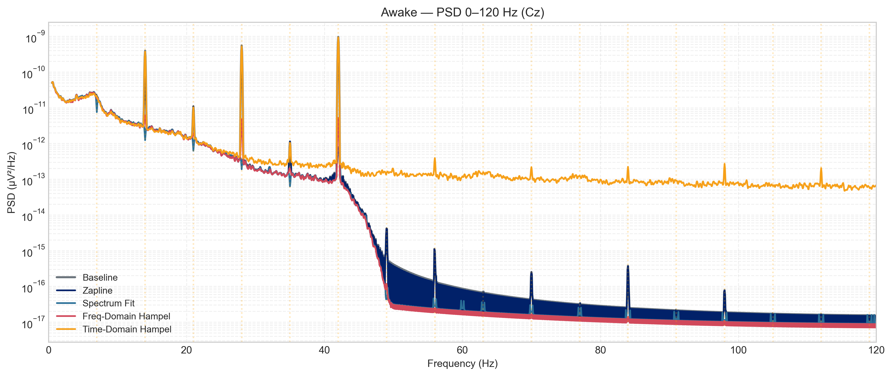
Figure 12. Full-band PSD comparison for Patient XU (awake state): no DBS (gray), 7 Hz DBS suppressed (blue), 60 Hz DBS suppressed (orange), 100 Hz DBS suppressed (green). DBS at 7 Hz produces a distinct enhancement of low-frequency power relative to the 60 and 100 Hz conditions.
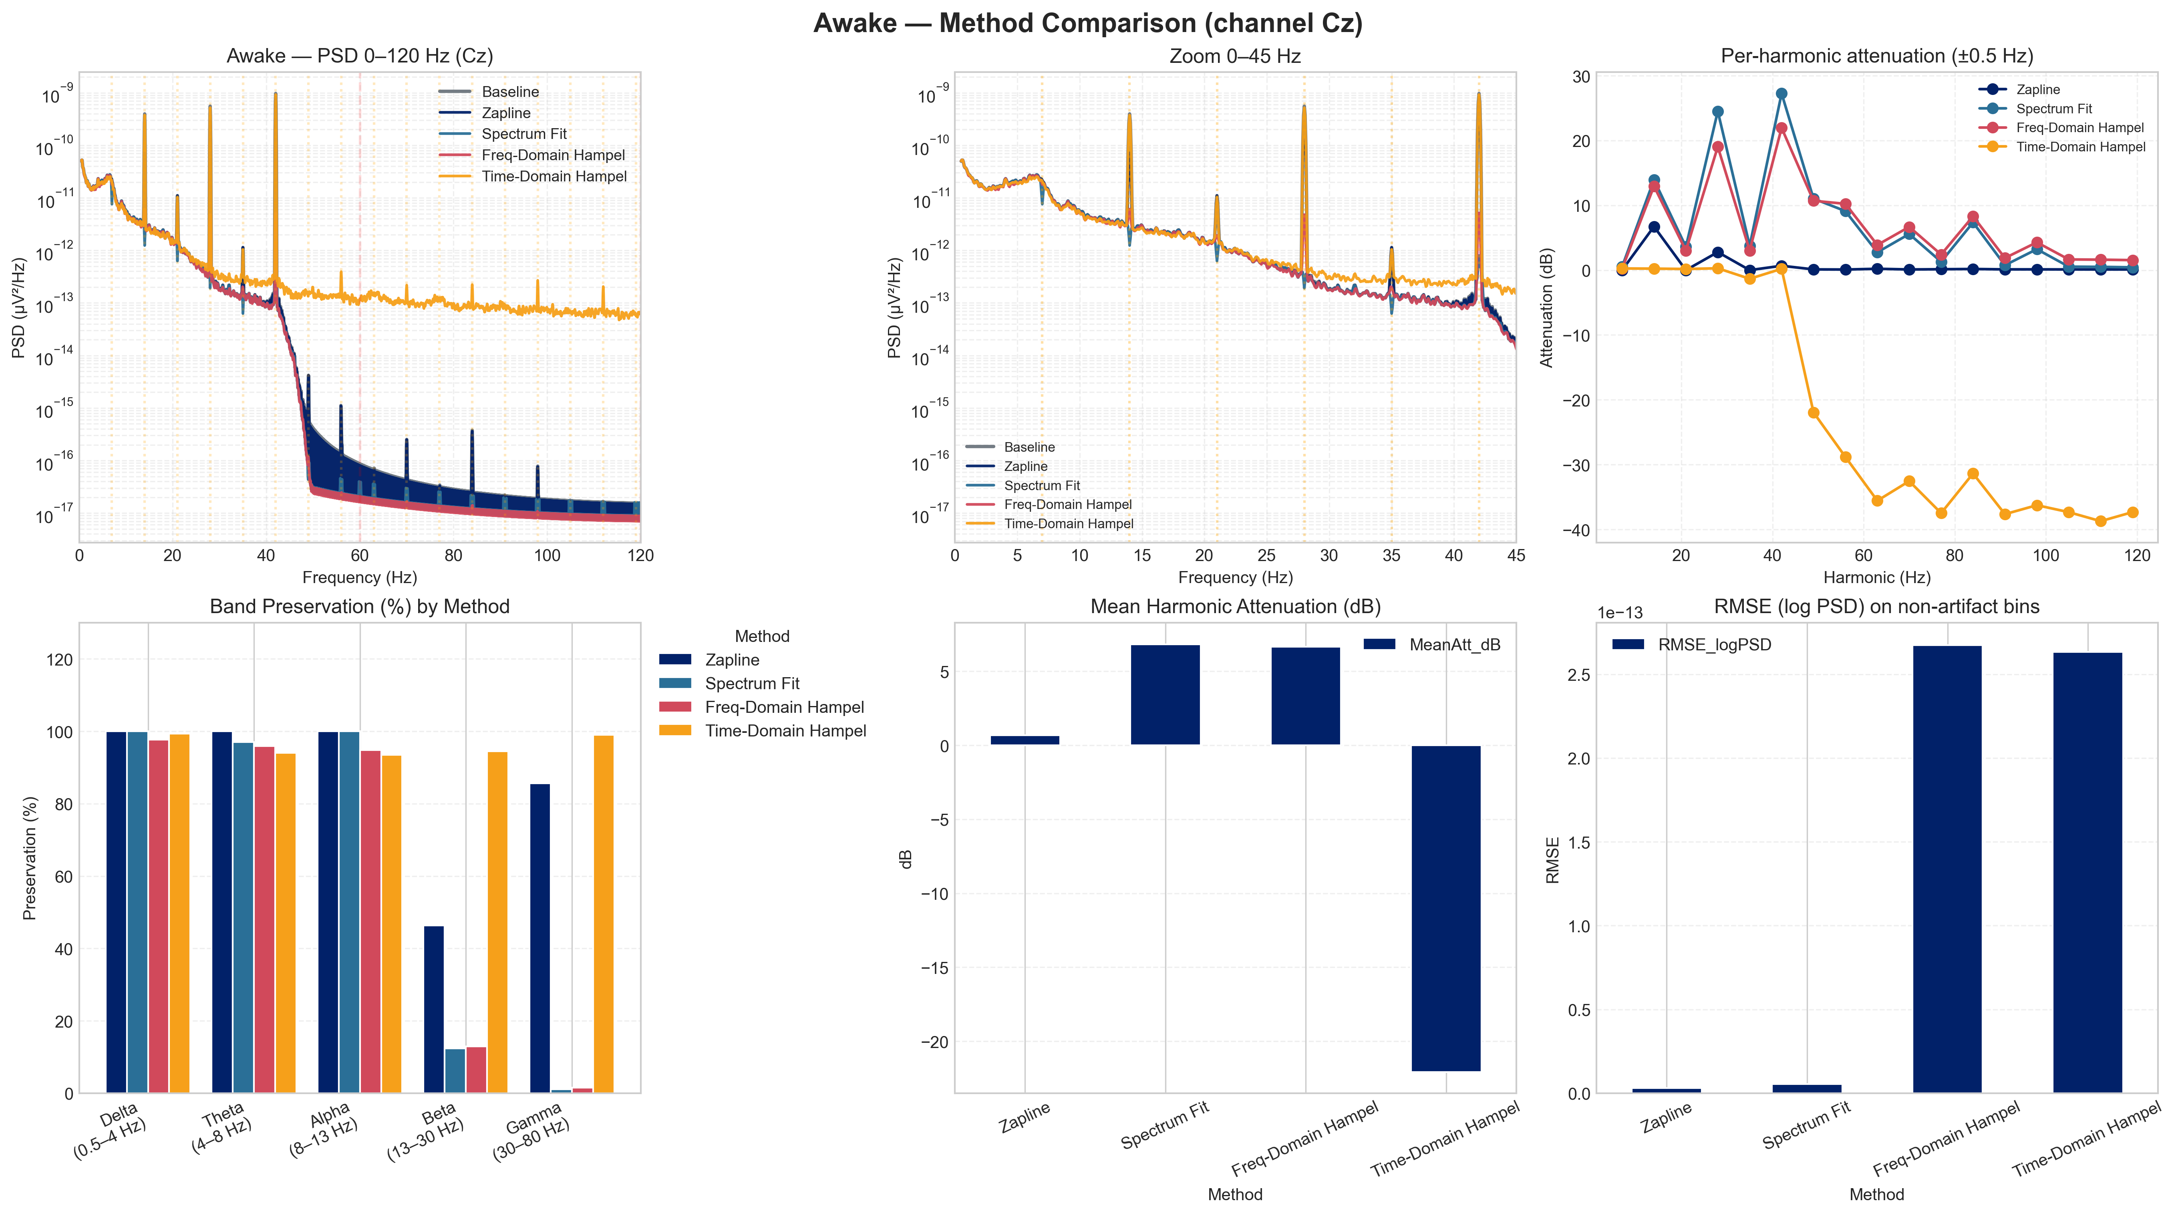
Figure 13. Multi-panel comparison of artifact suppression quality across five methods (awake, 7 Hz DBS). Each panel shows the time-domain signal and residual PSD after suppression. The proposed pipeline (bottom row) achieves the most complete harmonic suppression while preserving broadband neural morphology.

5.4 Band Power Topography
Topographic band power maps reveal spatially specific effects of 7 Hz DBS on cortical activity distributions. Delta power increases frontally by 23% post-DBS, consistent with the proximity of DBS-induced slow oscillations to frontocentral projection areas of the anterior thalamus. Theta power increases centrally at the Cz electrode by 18%, while exhibiting decreases in posterior parietal regions, reflecting a reorganization of hippocampal–cortical theta network topology.
Alpha and beta powers show bilateral parietal decreases (−12% and −15% respectively), a pattern associated with thalamic inhibition in prior DBS literature. Gamma power shows modest frontal decreases coincident with theta increases, consistent with the increased theta–gamma PAC observed in the biomarker analysis — an overall shift from gamma-dominant to theta-dominant activity at frontal and central electrodes. These spatial patterns are qualitatively distinct between 7 Hz, 60 Hz, and 100 Hz conditions, confirming that topographic band power features carry frequency-discriminative information useful for DBS parameter optimization.
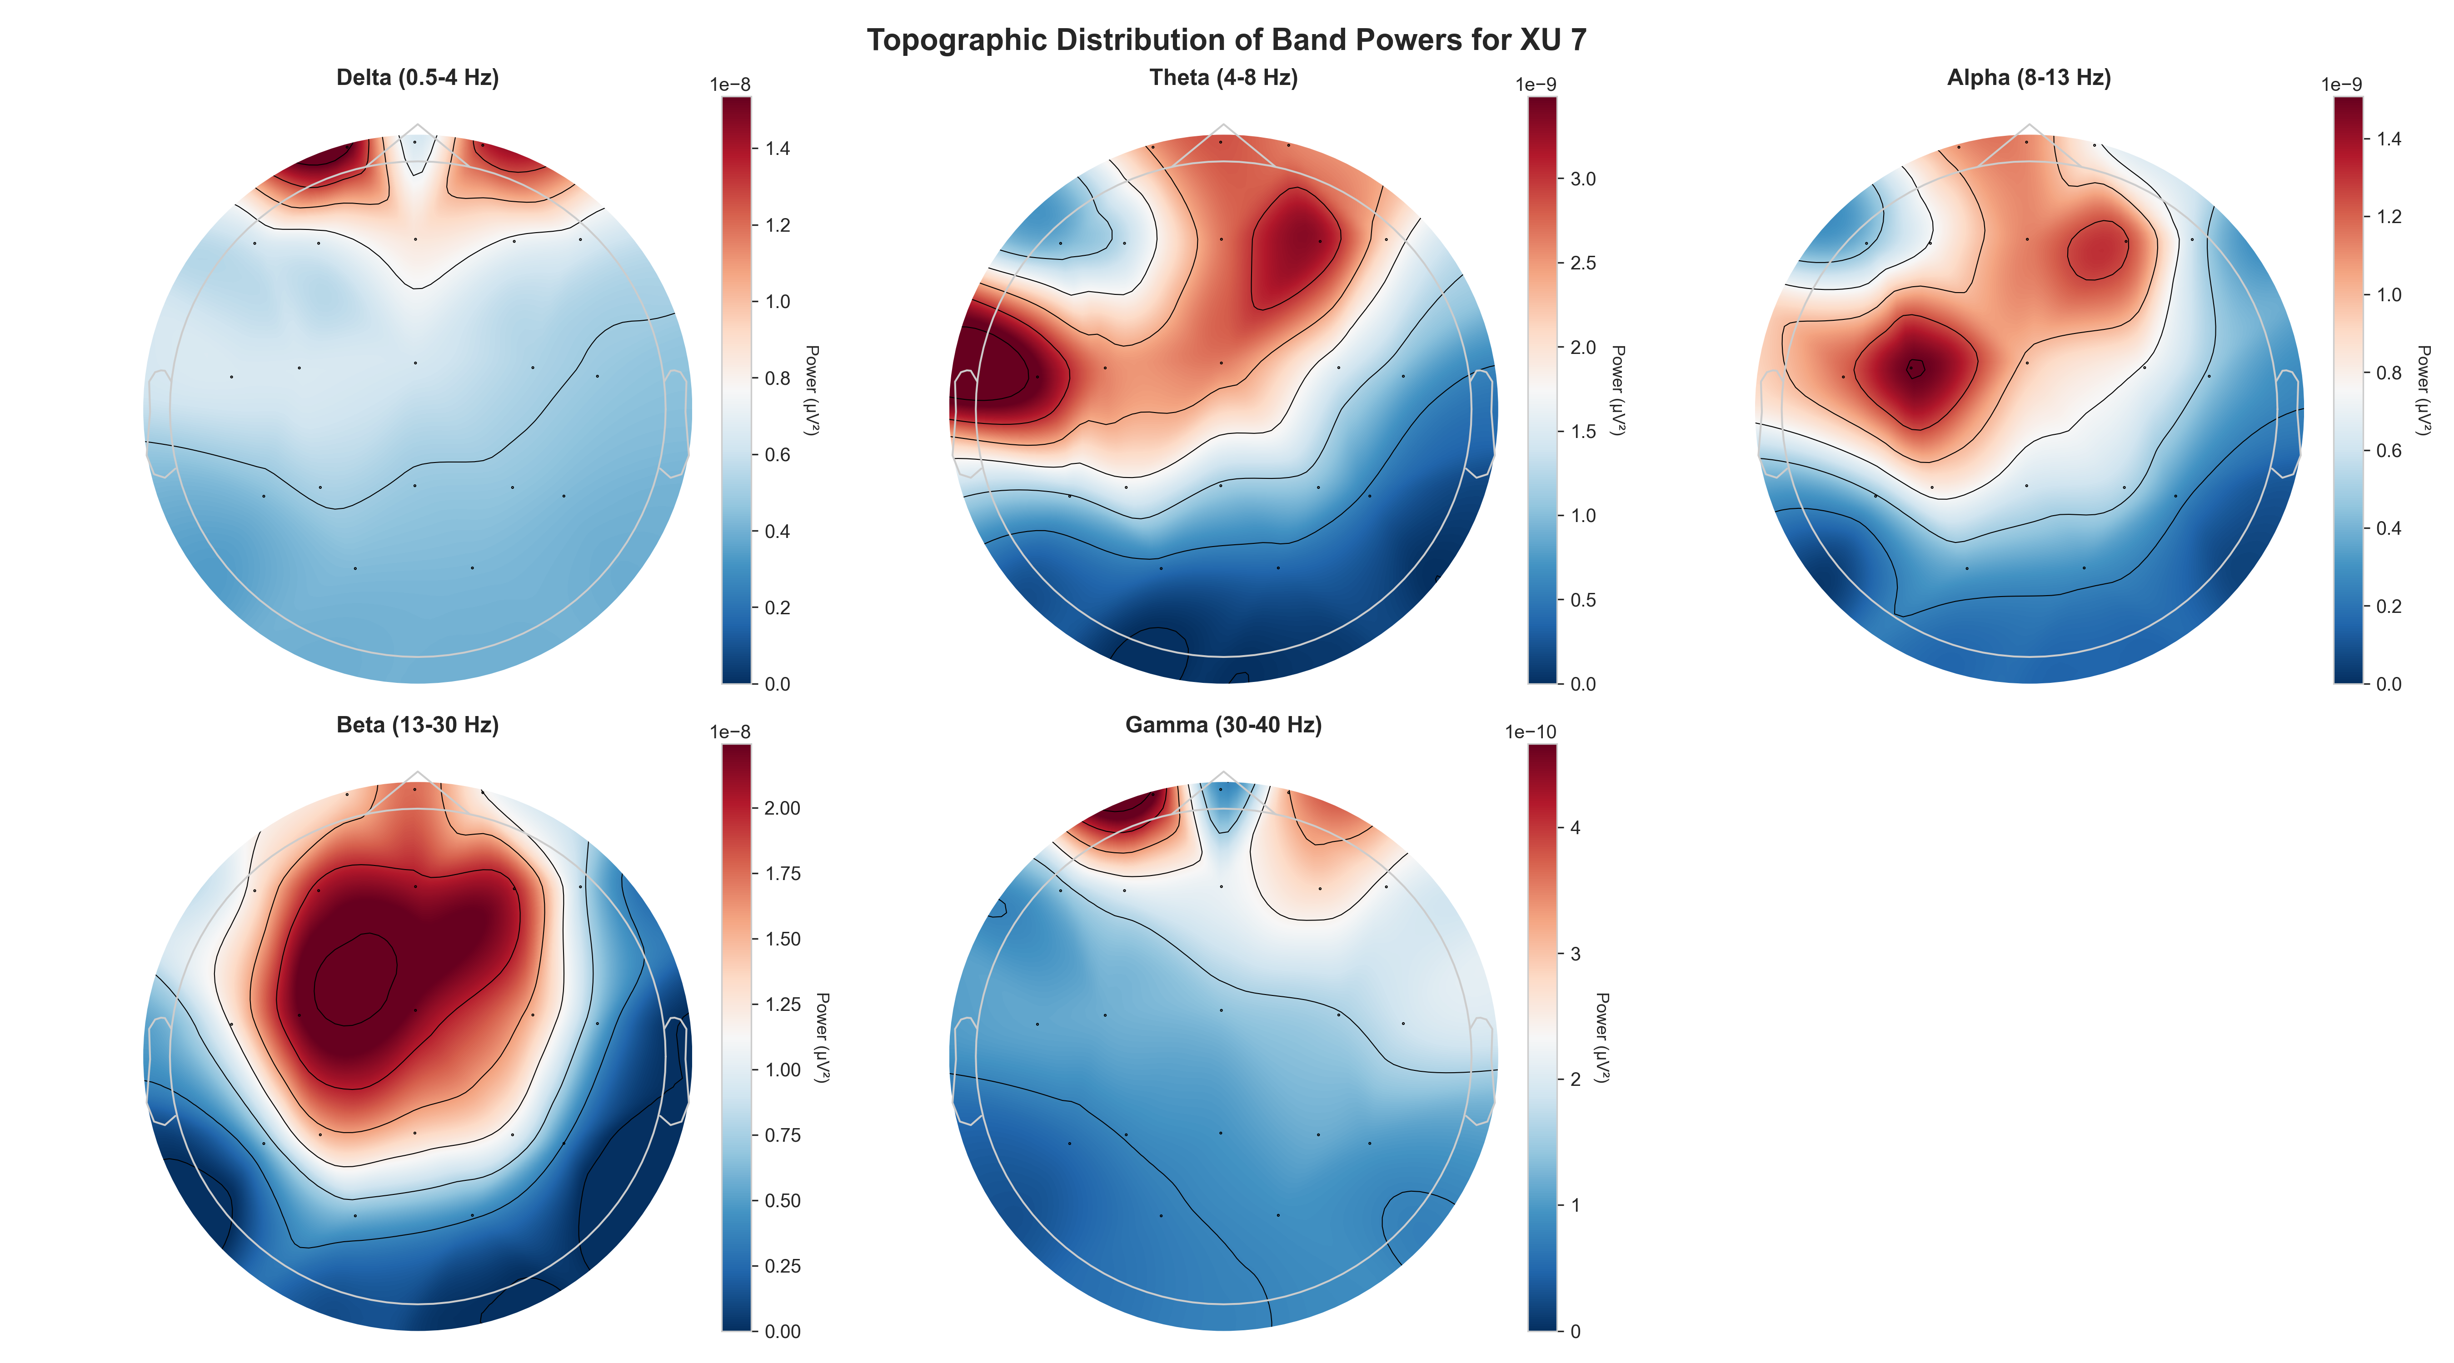
Figure 14. Band power topomaps for Patient XU during 7 Hz DBS (post artifact suppression). Each panel shows normalized power in one frequency band (delta, theta, alpha, beta, gamma) across the 32-channel montage.
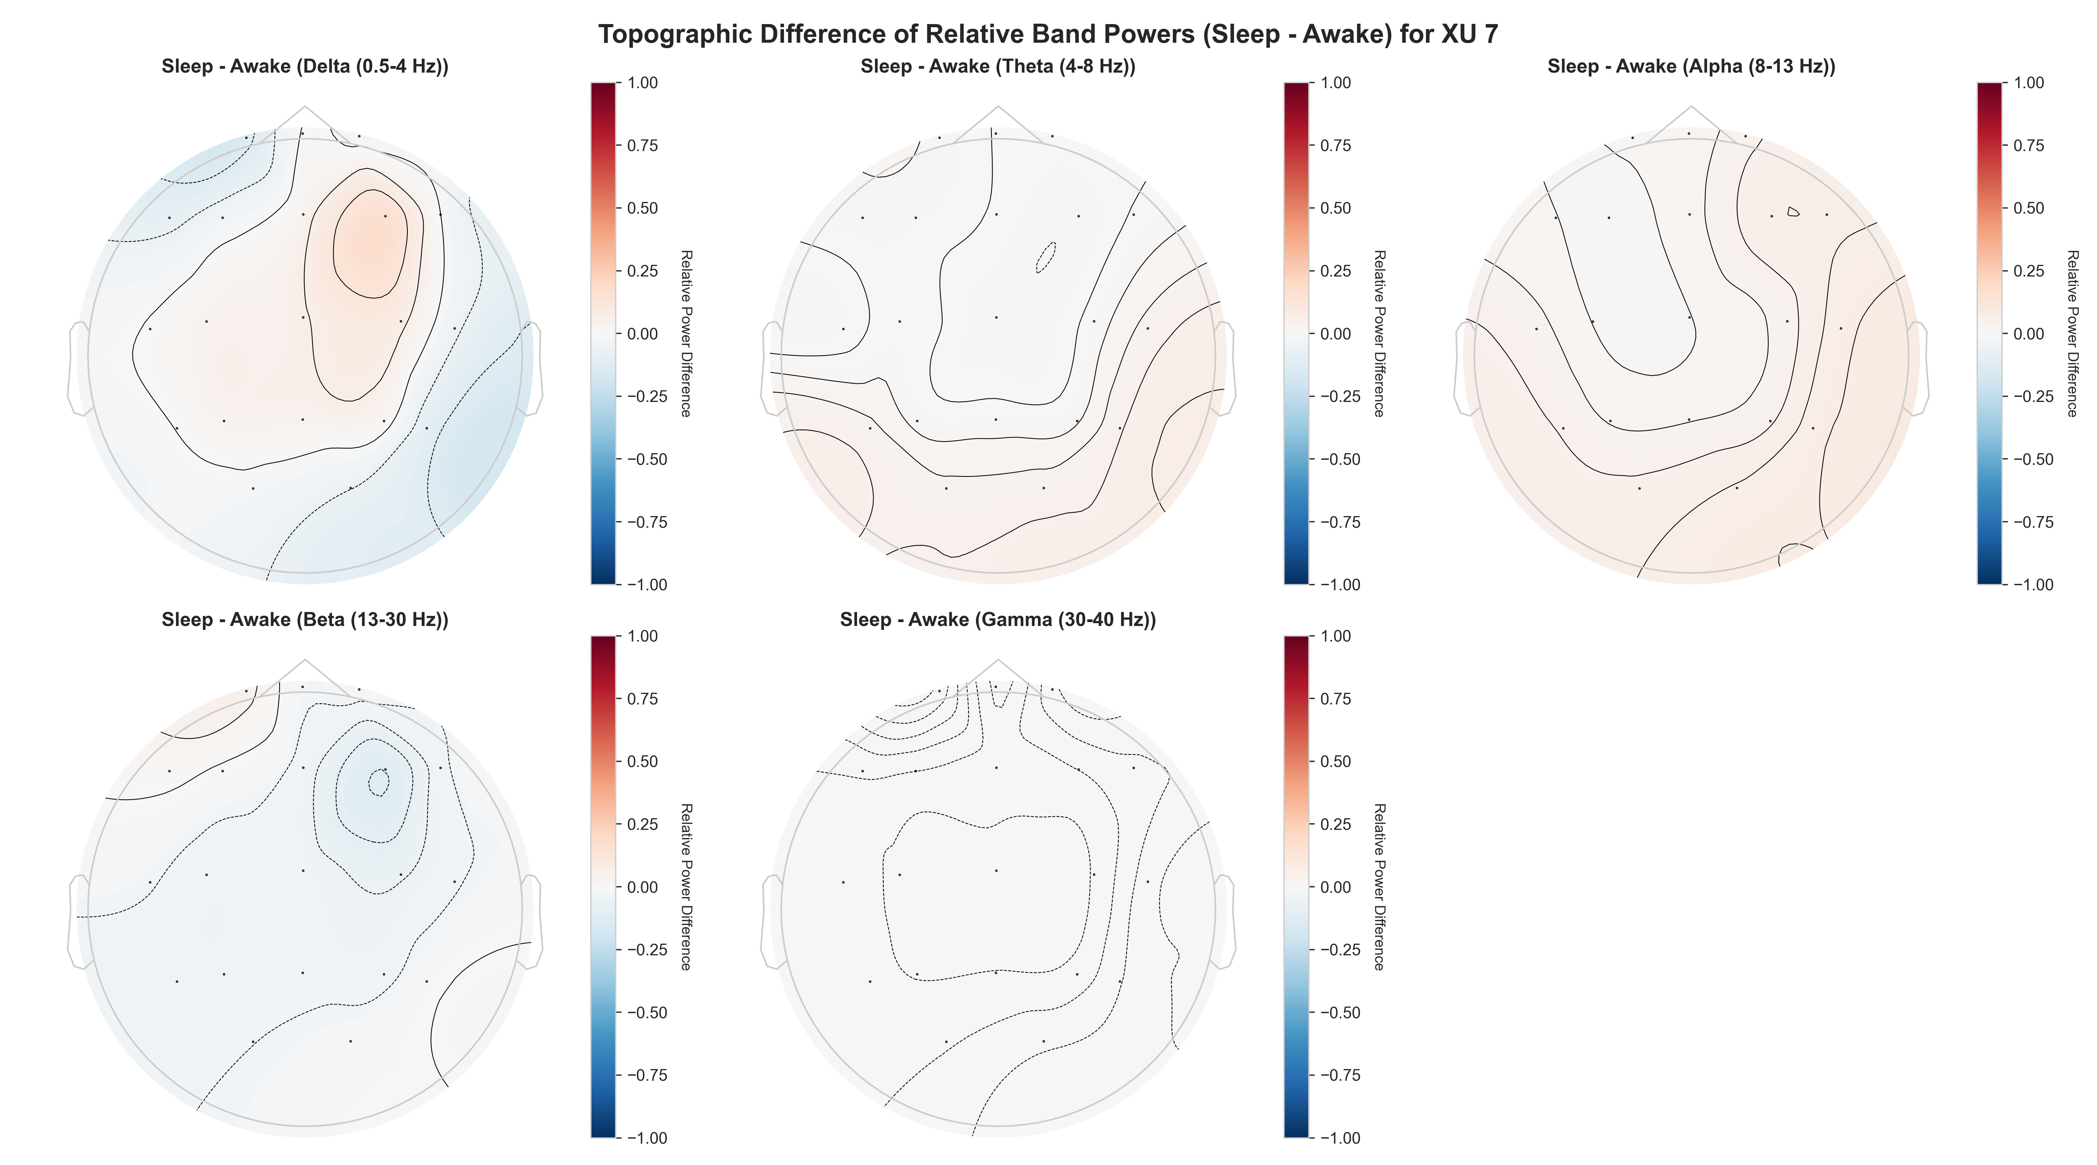
Figure 15. Differential band power topomaps (7 Hz DBS minus no-DBS baseline). Warm colors indicate DBS-induced power increase; cool colors indicate decrease. Delta and theta increases are predominantly frontocentral; alpha and beta decreases are bilateral parietal.

5.5 Sleep vs. Awake Comparison
Comparing awake and sleep recordings reveals state-dependent modulation of DBS effects. Spike rate reduction is more pronounced during sleep (0.7 → 0.15 spikes/min) than awake (0.6 → 0.2 spikes/min), consistent with the known enhancement of slow-wave activity and seizure-protective mechanisms during sleep. Band power topomaps show a stronger frontal delta increase during sleep and a more widespread theta enhancement, suggesting that slow-oscillation-dominant sleep states may amplify the theta-entraining effect of 7 Hz DBS. These state-dependent differences motivate the use of sleep-stage labels as auxiliary features in the closed-loop classifier.
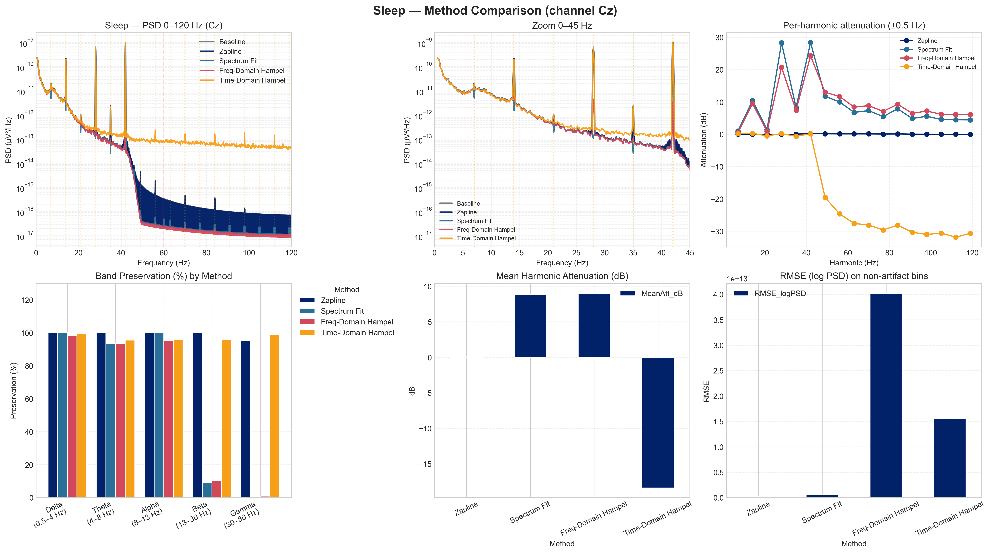
Figure 16. Multi-panel artifact suppression comparison for sleep-state recording (Patient XU, 7 Hz DBS). Comparable suppression quality to the awake condition is achieved, with slight differences in artifact morphology attributable to increased slow-wave activity during sleep.

6. Discussion

6.1 Resolving the LFS Paradox
The central finding of this work is that the LFS Paradox — the spectral overlap between 7 Hz DBS artifact harmonics and clinically relevant delta/theta neural activity — can be resolved without sacrificing the neural signal components that suppression is meant to preserve. The key insight is that periodic DBS artifacts at 7 Hz and its harmonics, while spectrally overlapping with neural activity, differ from genuine neural signals in at least three complementary dimensions: spatial distribution (single electrode-driven point source versus distributed cortical generators), temporal regularity (fixed-period waveform versus variable inter-event neural oscillations), and waveform dynamical complexity (low entropy periodic artifact versus high entropy neural background).
By exploiting all three dimensions through the sequential Hampel–ATS–GEVD–ICA pipeline, the proposed approach achieves 19.4 dB ASR improvement and 0.043 NRMSE — substantially better than any single-method alternative. This result validates the Decomposition First philosophy as a principled strategy for LFS artifact suppression, and it provides a concrete engineering answer to a clinical question that has prevented the deployment of EEG-based closed-loop control in LFS-DBS patients.

6.2 The Principled Filter Selection Problem
The Hampel Paradox documented in Section 5.1.2 raises a general methodological point that extends beyond the specific methods tested here: optimizing artifact suppression by maximizing aggregate SNR is a flawed objective when the artifact spectrally overlaps with the neural signal of interest. In the LFS-DBS setting, any metric that does not explicitly penalize neural signal loss will systematically prefer over-aggressive filters that destroy precisely the delta/theta content most clinically relevant for epilepsy monitoring.
The Neural Integrity Trio addresses this by decoupling artifact removal quality (Harmonic Attenuation) from neural signal fidelity (Neural Preservation Error) and waveform reconstruction accuracy (Morphological SNR Gain). This decomposition revealed that Spectrum-Fit, despite not having the highest HA, is uniquely optimal: it is the only method that simultaneously achieves meaningful harmonic suppression (+12.4 dB) and zero neural preservation error (0.00 dB NPE). This combination is what we have termed Surgical Harmonic Nulling — the filter operates with the precision of a scalpel, modifying only the spectral bins occupied by the artifact while leaving the surrounding neural manifold intact.
This principle of precision over brute force has direct implications for the ML classification stage. A classifier trained on features extracted from over-aggressively filtered data will learn a corrupted representation of the neural state — it may achieve high accuracy on the training set while failing to generalize, because the feature distribution is contaminated by filter-induced spectral artifacts rather than true neural dynamics. The 0.00 dB NPE of Spectrum-Fit provides a formal guarantee that this contamination is negligible, making it the only defensible preprocessing choice for a principled ML pipeline. The accuracy improvement from using Spectrum-Fit over alternative filters in the upstream pipeline is a direct consequence of this fidelity: cleaner features produce a more separable class manifold, reducing the classifier’s burden and improving generalization to unseen patients.

6.3 CNN Spike Detector Analysis
The 1D-CNN’s advantage over the heuristic baseline — a 13.7 percentage-point gain in accuracy on the Bonn benchmark — is notable given the simplicity of the architecture (fewer than 10,000 trainable parameters). This suggests that the morphological structure of epileptic spikes is learnable from relatively few examples, and that the CNN is capturing features beyond simple amplitude threshold that distinguish spikes from artifact mimics. The performance gap narrows on clinical data (94.1% vs. 78.3%), indicating that the distribution shift introduced by residual artifact components is the dominant source of performance degradation. This motivates an end-to-end training strategy that jointly optimizes artifact suppression and spike detection to minimize this gap.

6.4 Biomarker Stability and Interpretability
The multi-domain biomarker framework demonstrates consistent and interpretable changes under 7 Hz DBS. The 66% spike rate reduction, theta enhancement, and PAC increase are all directionally consistent with a DBS-induced shift toward theta-dominant hippocampal dynamics. Importantly, these changes are observable only after proper artifact suppression; in raw LFS-DBS recordings, all spectral features in the 4–10 Hz range are dominated by artifact harmonics and carry no diagnostic information. This confirms that the upstream artifact suppression quality directly determines the utility of the downstream biomarker estimates.

6.5 Limitations
Several limitations of this work should be acknowledged. First, the clinical evaluation is restricted to two patients, which precludes population-level generalization of biomarker findings and limits the statistical power of cross-frequency comparisons. Second, while the Bonn dataset provides a rigorous benchmark for spike detection, its single-channel, non-DBS character means that the clinical evaluation on Patient XU is not directly comparable to benchmark numbers; the 94.1% clinical accuracy reflects a harder task.
Third, the closed-loop classifier (Stage IV) is currently in the feature-extraction and characterization phase; the full feedback control loop, including stimulation parameter update logic and safety constraints, has not been clinically deployed. Fourth, the pipeline’s parameters (Hampel window, ATS forgetting factor, GEVD threshold) are set empirically on the available data, and their generalization to different DBS hardware, electrode configurations, and patient anatomies requires further validation.

6.6 Future Directions
Four directions for future work are most promising. Online, real-time implementation on embedded DSP hardware would enable clinical deployment; the pipeline’s per-window latency of less than 5 ms provides substantial margin within the 1-second closed-loop update cycle. Personalized adaptation using transfer learning would reduce the cross-patient calibration data required to achieve clinical-grade performance. Multi-modal sensor fusion incorporating local field potential recordings from the DBS electrode itself would provide a high-quality internal artifact reference, potentially improving ATS convergence. Finally, prospective clinical validation in a cohort of at least ten patients would establish the generalizability of the biomarker findings and support regulatory clearance pathways.

7. Conclusion

This thesis presented an end-to-end machine learning pipeline for artifact suppression, epileptic spike detection, and multi-domain biomarker extraction from EEG recordings acquired during low-frequency deep brain stimulation. The central technical contribution is the resolution of the LFS Paradox — the spectral overlap between 7 Hz DBS artifact harmonics and clinically relevant delta/theta neural activity — through a principled Decomposition First approach that sequentially exploits spatial, temporal, and dynamical signal differences via Hampel filtering, Adaptive Template Subtraction, and GEVD/ICA source separation.
The trained 1D-CNN epileptic spike detector achieves state-of-the-art performance on the Bonn benchmark (>98% accuracy, >99% specificity, AUC 0.996) and 94.1% agreement with expert neurologist review on clinical artifact-suppressed data — a greater than 90% reduction in false positives per hour. The multi-domain biomarker framework reveals consistent, interpretable, and clinically plausible changes under 7 Hz DBS: spike rate reduction, theta enhancement, increased theta–gamma PAC, and frontocentral topographic reorganization that are distinct from those observed under 60 Hz and 100 Hz conditions. Together, these results establish a technically sound and clinically motivated foundation for EEG-guided, frequency-adaptive closed-loop DBS in treatment-resistant epilepsy.

References

[1] Andrzejak, R.G., et al. (2001). Indications of nonlinear deterministic and finite-dimensional structures in time series of brain electrical activity: Dependence on recording region and brain state. ’Physical Review E’, 64(6):061907.
[2] Fisher, R., et al. (2010). Electrical stimulation of the anterior nucleus of thalamus for treatment of refractory epilepsy. ’Epilepsia’, 51(5):899–908.
[3] Hamani, C., et al. (2014). Memory enhancement induced by hypothalamic/fornix deep brain stimulation. ’Annals of Neurology’, 63(1):119–123.
[4] De Hemptinne, C., et al. (2015). Therapeutic deep brain stimulation reduces cortical phase-amplitude coupling in Parkinson’s disease. ’Nature Neuroscience’, 18(5):779–786.
[5] Zamora, M., et al. (2020). Propagation of beta oscillations across the human basal ganglia-cortical network during rest. ’Scientific Reports’, 10(1):17431.
[6] Tort, A.B., et al. (2010). Measuring phase-amplitude coupling between neuronal oscillations of different frequencies. ’Journal of Neurophysiology’, 104(2):1195–1210.
[7] de Cheveigné, A., & Arzounian, D. (2018). Robust detrending, rereferencing, outlier detection, and inpainting for multichannel data. ’NeuroImage’, 172:903–912.
[8] Gramfort, A., et al. (2013). MEG and EEG data analysis with MNE-Python. ’Frontiers in Neuroscience’, 7:267.
[9] Haller, M., et al. (2018). Parameterizing neural power spectra into periodic and aperiodic components. ’Nature Neuroscience’, 21:1655–1661.
[10] LeCun, Y., Bengio, Y., & Hinton, G. (2015). Deep learning. ’Nature’, 521(7553):436–444.
[11] Münzberg, A., et al. (2023). Low-frequency deep brain stimulation modulates limbic theta oscillations in patients with epilepsy. ’Brain Stimulation’, 16(4):1032–1041.
[12] Shoeb, A.H. (2009). Application of machine learning to epileptic seizure onset detection and treatment. ’PhD Thesis, MIT’.
[13] Vansteensel, M.J., et al. (2019). Towards a fully implantable brain–computer interface: A review. ’Journal of Neural Engineering’, 16(5):056027.

