Peter Reintjes

Museum of Life and Science

Durham, NC 27704

November 19, 2014

Dr. Marshall Edgell  
President, Innatrix Inc.  
250 Bell Tower Drive  
Chapel Hill, NC 27599-7063

Dear Dr. Edgell:

I strongly support your current endeavor and reiterate my willingness to serve as a member of the Innatrix Scientific Advisory Board. I have enjoyed our collaboration in the past, and look forward to assisting you to improve the reliability and bring down the cost of running PACE experiments.

The project appears to have far-reaching potential, given the possibilities of PACE and enhanced PACE technologies to attack the most important problems in pharmacology -- resistance, side-effects, and even waste stream contamination -- by moving away from small molecules and expanding the realm of modified and optimized proteins.

Although my contributions will principally be in the mechanical, electrical, and software areas of the project, the basic science and goals of your project make it one of the most interesting and potentially important projects I have ever worked on. My career-long interest in protein structure problems, from supporting Jane Richardson’s team with the UNC Grip project (1978) to the protein interaction visualization work for GlaxoSmithKline (2007) may help to explain my enthusiasm for my modest role as instrumentation consultant.

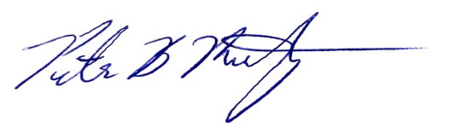Sincerely,

Peter Reintjes   
 Exhibits Engineer