**Brief introduction of my Ph.D Research**

**Wangjiang Wu, 04/28/2025**

**School of Biomedical engineering, Southern Medical University**

Talbot–Lau grating interferometer (GI) can provide valuable tri-contrast [absorption, differential phase contrast (DPC), and dark field (DF)] information about the samples to be imaged. However, the source grating G0 presents severe challenges associated with fabrication and limited efficiency. In this study, a novel cold-cathode flat-panel X-ray source (FPXS) with microarray anode target was proposed for GI computed tomography as shown in Fig.1, which can eliminate the use of G0. Its cathode is characterized as densely arranged ZnO nanowires (NWs) to provide large amounts of electrons, whereas the micro periodic distributed Al-Mo-Al strips were used as the anode target to generate the structured X-ray illumination required for Talbot–Lau GI. The performance of the source was fully studied by accurately modeling its geometry via EGSnrc. The flat-panel X-ray source GI computed tomography was then simulated by using the Fresnel–Kirchhoff diffraction theory. Furthermore, a polymethyl methacrylate (PMMA) cylinder and a Shepp–Logan phantom were used to evaluate the imaging performance of the system. Due to the elimination of G0, our proposed flat-panel source GI has 153.05% higher X-ray photons utilization efficiency than the conventional Talbot–Lau GI, which results in tri-contrast images with less noise. The proposed X-ray source can replace the laboratory source and grating G0 and may provide new possibilities for Talbot–Lau GI. This work has been published in **IEEE Transactions on Nuclear Science (DOI: 10.1109/TNS.2023.3327904)**.

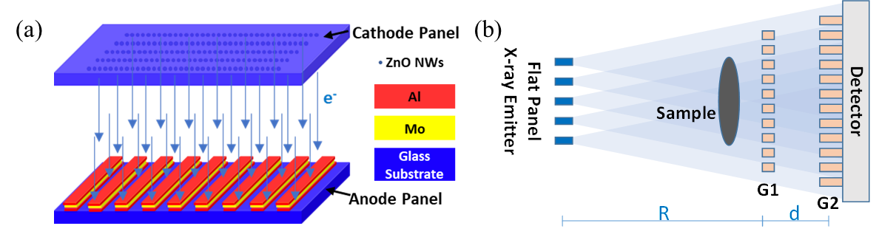

Fig. 1. (a) The schematic of the proposed coherent FPXS, and (b) The schematic of the proposed FPXS grating interferometer (GI).

For the practical application of the system, we are required to obtain the X-ray source distribution of the FPXS in advance. However, the X-ray source distribution of the FPXS at the generating plane (Mo target) is unknown and cannot be directly measured, which hinders its practical use. To solve the above question, we proposed the coded aperture imaging system to decode the source distribution of the FPXS as shown in Fig. 2, which is composed of a FPXS, a coded mask, and a detector. The FPXS can be deemed as an array of densely distributed X-ray point sources. Each component point source of the FPXS generates a slightly different shadow of the mask on the detector. Thus, for the whole FPXS, an aliased projection image was obtained. Our aim is to reconstruct the X-ray source distribution of the FPXS from the aliased projection. Besides, the maximum-likelihood expectation-maximization (ML-EM) algorithm was derived to reconstruct the source distribution. Both Monte Carlo (MC) simulation and real experiments were conducted to demonstrate the effectiveness of the proposed method. In the real experiments, the X-ray emission shapes formed by placing lead plates on the surface of the anode substrate of two FPXSs (No.1 and No.2) were successfully reconstructed. The mean intensity of FPXS No.1 and No.2 were 0.77 a.u. and 0.85 a.u., respectively. The proposed method achieved the reconstruction of the source distribution of the FPXS. Moreover, knowing and then compensating the nonuniformity distribution of the FPXS is paramount for future novel and practical applications of the X-ray source. This work has been submitted and is now **under review**.

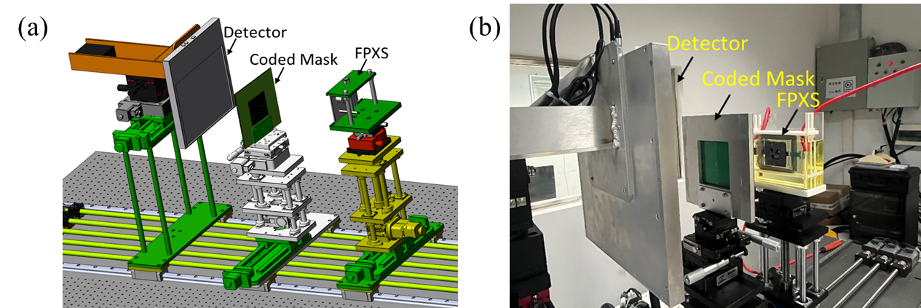

Fig. 2. Decoding the spatial distribution of the FPXS by using coded aperture imaging (CAI). (a) The schematic of the proposed CAI system, and (b) The real CAI system with the FPXS immersed in an oil container.

Currently we are building the real FPXS based grating interferometer system as shown in Fig. 3, which is composed of the FPXS, G0, G1, sample stage, G2, and detector. If the G0 is not required, it can be moved out of the X-ray beam path. Up to now, some Moiré fringes are generated by using the real experiment system, which is prerequisite for the tri-contrast signals extraction. More interesting results will be updated soon.

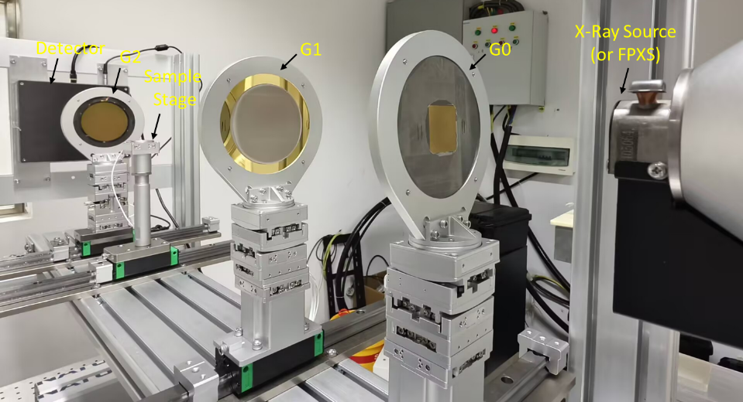

Fig. 3. FPXS based X-ray grating interferometer for tri-contrast images (absorption, phase contrast, and scatter) acquisition.