**summary**

**Result:**

After running 3 pairwise combinations of sequence, I summarized the comparing result in the following table.

|  |  |  |  |
| --- | --- | --- | --- |
|  | Human-mouse | Human-random | Mouse-random |
| Hamming distance | 23 | 210 | 219 |
| Percentage identity | 89.6% | 5.4% | 5.9% |
| Blosum62 score | 1091 | -250 | -250 |

Human-mouse:

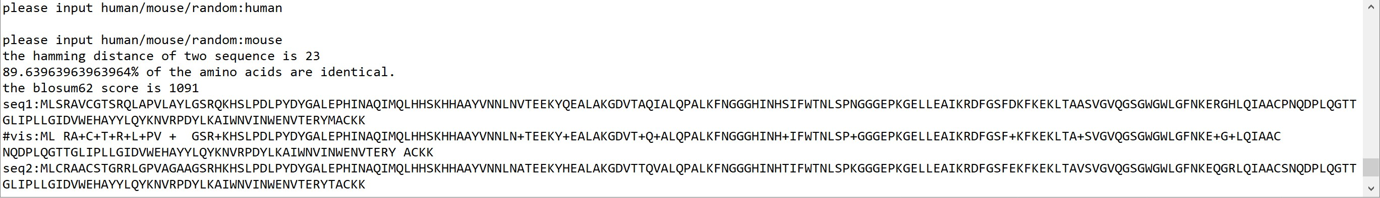

Human-random:

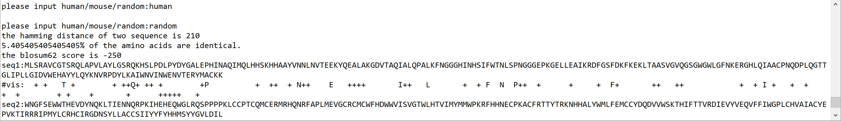

Mouse-random:

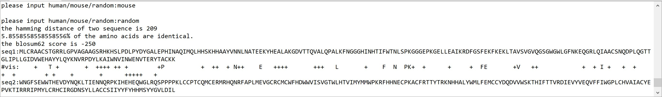

Mouse and human sequences are about 16(16.59/15.18) times more similar than compared to a random sequence according to the percentage identity.

The BLOSUM score of human-mouse shows 1341 gap comparing with human/mouse-random sequence.

**Explanation:**

As sequences become more distant, more mismatched amino acid pairs and gaps appear.

Large changes in physicochemical properties of the substituted amino acids are likely to make a protein less functional and therefore less likely to occur during evolution.

Identical or similar amino acids are more likely to be a signature of evolutionary constraint between two sequences.

Thus, human and mouse shows a similarity of sequence.