

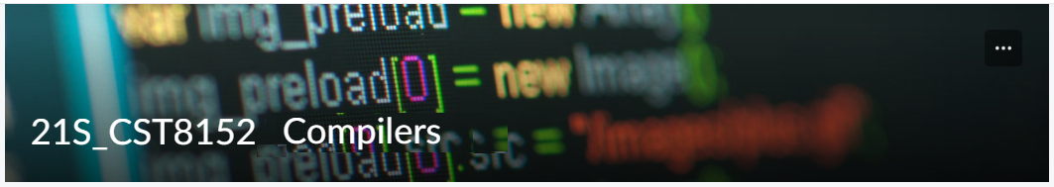

MODEL TASK FOR ASSIGNMENT 2.1 – Babel

Team: [Jay Patel] - Id: [041-028-206]
/ [Jordan Kent] - Id: [040-607-241]

- Note: This task is part of the Assignment 2 from Compilers Course. Any problem, contact your lab professor.

PART 1: RE – Regular Expression (1.5 mark)

Lexeme Classes: Define the classes to be used in your regular expression:

Answer:
C = [A-Za-z0-9] (Letters)
P =. (Period)
E = ; (End of Line)
O = [^LPCE] (Other chars)
V = $(variable delimiter)

Define the RE to be used for: variables, literals and keywords:

Answer:
* Variables:
VID: CC?+V {variable name}

* Literals:
CL: PC+P {Comment Literal}
Key: C+E {keyword literel}

* Keywords: {isA, hasA, hasAN, diagram, class, object, field, function, make, new, start, finish, consoleOpen, consoleClose}

PART 2: TD – Transition Diagram (1.5 marks)

Activity: Starting from the previous lexeme classes and obeying the RE, it is possible to define the automata for your language:

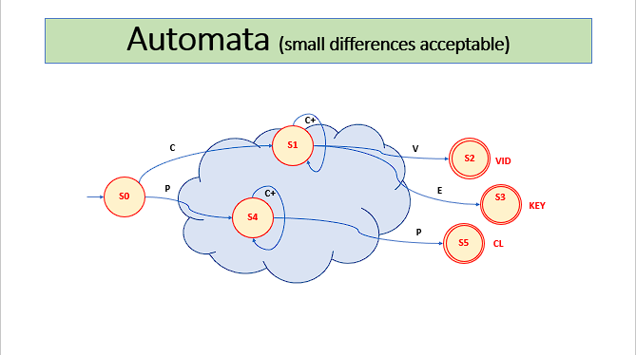

PART 3: TT – Transition Table (2 marks)

Activity: Now, it is possible to define the TT for these lexemes:

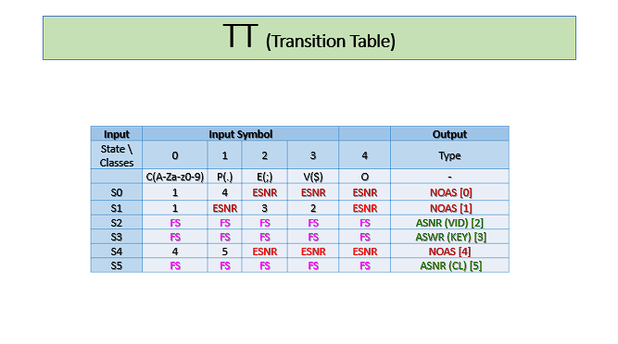

Update: Oct 2nd 2022.

Adapted from resources developed by Prof. Svillen Ranev (Algonquin College, 2019)

