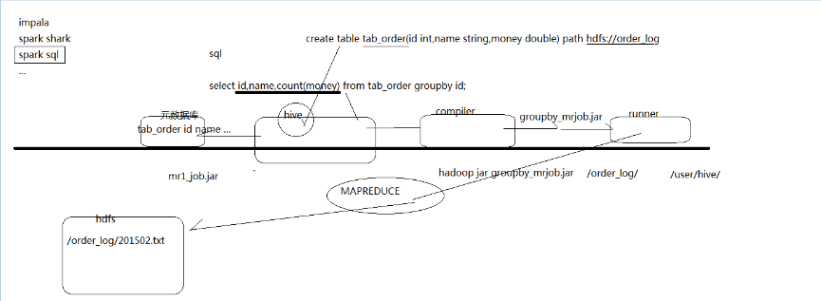

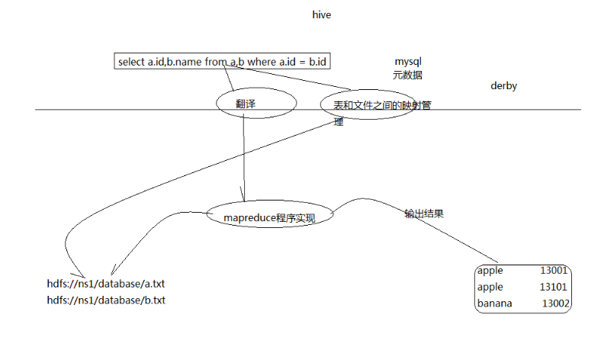

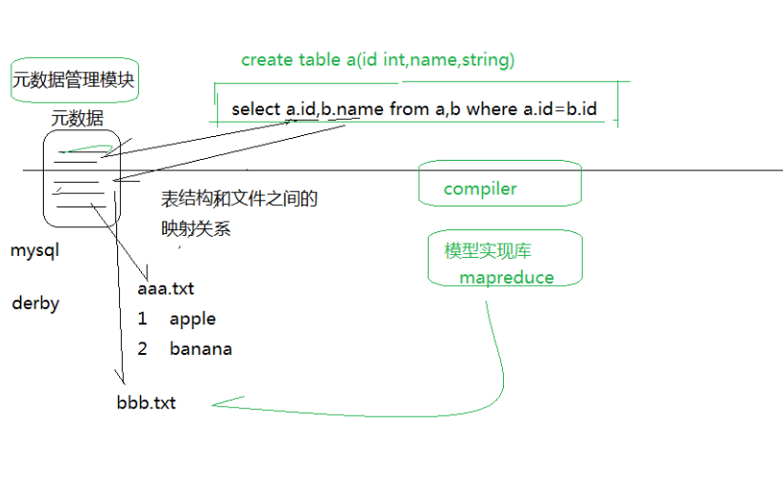

https://www.yiibai.com/hive/hive_data_types.html

https://www.cnblogs.com/biehongli/p/7699578.html

https://blog.csdn.net/u013980127/article/details/52604882

Hive只在一个节点上安装即可

1.上传tar包

2.解压

tar -zxvf hive-0.9.0.tar.gz -C /cloud/

3.配置mysql metastore（切换到root用户）

配置HIVE_HOME环境变量

rpm -qa | grep mysql

rpm -e mysql-libs-5.1.66-2.el6_3.i686 --nodeps

rpm -ivh MySQL-server-5.1.73-1.glibc23.i386.rpm

rpm -ivh MySQL-client-5.1.73-1.glibc23.i386.rpm

修改mysql的密码

/usr/bin/mysql_secure_installation

（注意：删除匿名用户，允许用户远程连接）

登陆mysql

mysql -u root -p

4.配置hive

cp hive-default.xml.template hive-site.xml

修改hive-site.xml（删除所有内容，只留一个<property></property>）

添加如下内容：

<property>

<name>javax.jdo.option.ConnectionURL</name>

<value>jdbc:mysql://weekend01:3306/hive?createDatabaseIfNotExist=true</value>

<description>JDBC connect string for a JDBC metastore</description>

</property>

<property>

<name>javax.jdo.option.ConnectionDriverName</name>

<value>com.mysql.jdbc.Driver</value>

<description>Driver class name for a JDBC metastore</description>

</property>

<property>

<name>javax.jdo.option.ConnectionUserName</name>

<value>root</value>

<description>username to use against metastore database</description>

</property>

<property>

<name>javax.jdo.option.ConnectionPassword</name>

<value>root</value>

<description>password to use against metastore database</description>

</property>

5.安装hive和mysq完成后，将mysql的连接jar包拷贝到$HIVE_HOME/lib目录下

如果出现没有权限的问题，在mysql授权(在安装mysql的机器上执行)

mysql -uroot -p

#(执行下面的语句 *.*:所有库下的所有表 %：任何IP地址或主机都可以连接)

GRANT ALL PRIVILEGES ON *.* TO 'root'@'%' IDENTIFIED BY '123' WITH GRANT OPTION;

FLUSH PRIVILEGES;

Hive是基于Hadoop的一个数据仓库，可以将结构化的数据文件映射为一张表，并提供类sql查询功能，Hive底层将sql语句转化为mapreduce任务运行。相对于用java代码编写mapreduce来说，Hive的优势明显：快速开发，人员成本低，可扩展性（自由扩展集群规模），延展性（支持自定义函数）。

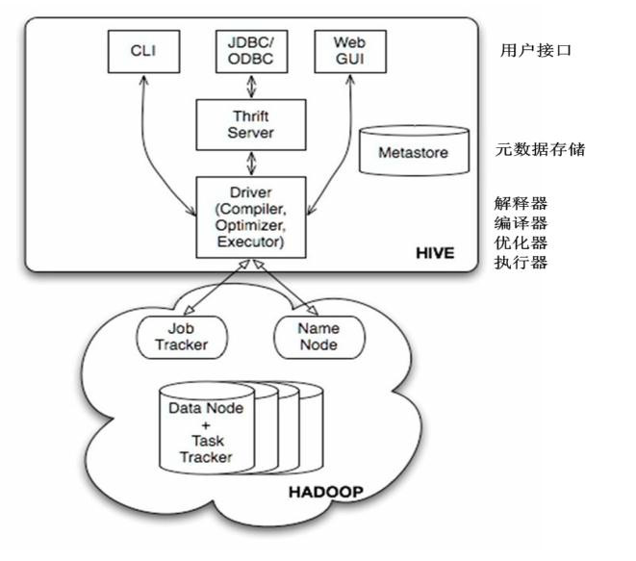

原子数据类型：TINYINT SMALLINT INT BIGINT FLOAT DOUBLE BOOLEAN STRING

复杂数据类型：STRUCT MAP ARRAY

建表语句：

DDL：

创建内部表：

create table mytable(

id int,

name string)

row format delimited fields terminated by '\t' stored as textfile;

强制删除，移动到hdfs回收站。Drop database a_db cascade；

常见外部表：关键字 external

create external table mytable2(

id int,

name string)

row format delimited

fields terminated by '\t'

location '/user/hive/warehouse/mytable2';

创建分区表：分区字段要写在partiton by（）

create table mytable3(

id int,

name string)

partitioned by(sex string) row format delimited fields terminated by '\t'stored as textfile;

静态分区插入数据

load data local inpath '/root/hivedata/boy.txt' overwrite into table mytable3 partition(sex='boy');

增加分区：

alter table mytable3 add partition (sex='unknown') location '/user/hive/warehouse/mytable3/sex=unknown';

删除分区：alter table mytable3 drop if exists partition(sex='unknown');

分区表默认为静态分区，可转换为自动套分区

set hive.exec.dynamic.partition=true;

set hive.exec.dynamic.partition.mode=nonstrict;

给分区表灌入数据：

insert into table mytable3 partition (sex) select id,name,'boy' from student_mdf;

查询表分区：show partitions mytable3;

查询分区表数据：select * from mytable3;

查询表结构：desc mytable3;

DML:

重命名表：alter table student rename to student_mdf

增加列：alter table student_mdf add columns (sex string);

修改列名：alter table student_mdf change sex gender string;

替换列结构：alter table student_mdf replace columns (id string, name string);

装载数据：（本地数据）load data local inpath '/home/lym/zs.txt' overwrite into student_mdf;

（HDFS数据）load data inpath '/zs.txt' into table student_mdf;

插入一条数据：insert into table student_mdf values('1','zhangsan');

创建表接收查询结果：create table mytable5 as select id, name from mytable3;

导出数据：（导出到本地）insert overwrite local directory '/root/hivedata/mytable5.txt' select * from mytable5;

（导出到HDFS）

insert overwrite directory 'hdfs://master:9000/user/hive/warehouse/mytable5_load' select * from mytable5;

数据查询：

select * from mytable3; 查询全表

select uid,uname from student; 查询学生表中的学生姓名与学号字段

select uname,count(*) from student group by uname; 统计学生表中每个名字的个数

常用的功能还有 having、order by、sort by、distribute by、cluster by；等等

关联查询中有

内连接：将符合两边连接条件的数据查询出来

select * from t_a a inner join t_b b on a.id=b.id;

左外连接：以左表数据为匹配标准，右边若匹配不上则数据显示null

select * from t_a a left join t_b b on a.id=b.id;

右外连接：与左外连接相反

select * from t_a a right join t_b b on a.id=b.id;

左半连接：左半连接会返回左边表的记录，前提是其记录对于右边表满足on语句中的判定条件。

select * from t_a a left semi join t_b b on a.id=b.id;

全连接(full outer join)：

select * from t_a a full join t_b b on a.id=b.id;

in/exists关键字(1.2.1之后新特性)：效果等同于left semi join

select * from t_a a where a.id in (select id from t_b);

select * from t_a a where exists (select * from t_b b where a.id = b.id);

shell操作Hive指令：

-e：从命令行执行指定的HQL

-f：执行HQL脚本

-v：输出执行的HQL语句到控制台

内置函数

查看内置函数：show functions;

显示函数的详细信息：DESC FUNCTION abs;

重要常用内置函数：

sum()--求和

count()--求数据量

avg()--求平均值

distinct--去重

min--求最小值

max--求最大值

自定义函数：

1.先开发一个简单的Java类，org.apache.hadoop.hive.ql.exec.UDF，重载evaluate方法

import org.apache.hadoop.hive.ql.exec.UDF;

public final class AddUdf extends UDF {

public Integer evaluate(Integer a, Integer b) {

if (null == a || null == b) {

return null;

} return a + b;

}

public Double evaluate(Double a, Double b) {

if (a == null || b == null)

return null;

return a + b;}

}

2.打成jar包上传到服务器

3.将jar包添加到hive add jar /home/lan/jar/addudf.jar;

4.创建临时函数与开发好的class关联起来

CREATE TEMPORARY FUNCTION add_example AS 'org.day0914.AddUdf';

5.使用自定义函数 SELECT add_example(scores.math, scores.art) FROM scores;

销毁临时函数：DROP TEMPORARY FUNCTION add_example;

JDBC程序来创建数据库

import java.sql.SQLException;

import java.sql.Connection;

import java.sql.ResultSet;

import java.sql.Statement;

import java.sql.DriverManager;

public class HiveCreateDb {

private static String driverName = "org.apache.hadoop.hive.jdbc.HiveDriver";

public static void main(String[] args) throws SQLException {

// Register driver and create driver instance

Class.forName(driverName);

// get connection

Connection con = DriverManager.getConnection("jdbc:hive://localhost:10000/default", "", "");

Statement stmt = con.createStatement();

stmt.executeQuery("CREATE DATABASE userdb");

System.out.println(“Database userdb created successfully.”);

con.close();

}

}

set hive.cli.print.header=true;

CREATE TABLE page_view(viewTime INT, userid BIGINT,

page_url STRING, referrer_url STRING,

ip STRING COMMENT 'IP Address of the User')

COMMENT 'This is the page view table'

PARTITIONED BY(dt STRING, country STRING)

ROW FORMAT DELIMITED //按行分

FIELDS TERMINATED BY '\001' //以by后面的字符分块

STORED AS SEQUENCEFILE; TEXTFILE //存储格式

//sequencefile

create table tab_ip_seq(id int,name string,ip string,country string)

row format delimited

fields terminated by ','

stored as sequencefile;

insert overwrite table tab_ip_seq select * from tab_ext;

//create & load

create table tab_ip(id int,name string,ip string,country string)

row format delimited

fields terminated by ','

stored as textfile;

load data local inpath '/home/hadoop/ip.txt' into table tab_ext; //导入文件

//或者直接hadoop -put

//external

CREATE EXTERNAL TABLE tab_ip_ext(id int, name string,

ip STRING,

country STRING)

ROW FORMAT DELIMITED FIELDS TERMINATED BY ','

STORED AS TEXTFILE

LOCATION '/external/hive';

// CTAS 用于创建一些临时表存储中间结果

CREATE TABLE tab_ip_ctas

AS

SELECT id new_id, name new_name, ip new_ip,country new_country

FROM tab_ip_ext

SORT BY new_id;

//insert from select 用于向临时表中追加中间结果数据

create table tab_ip_like like tab_ip;

insert overwrite table tab_ip_like

select * from tab_ip;

//PARTITION

create table tab_ip_part(id int,name string,ip string,country string)

partitioned by (part_flag string)

row format delimited fields terminated by ',';

load data local inpath '/home/hadoop/ip.txt' overwrite into table tab_ip_part

partition(part_flag='part1');

load data local inpath '/home/hadoop/ip_part2.txt' overwrite into table tab_ip_part

partition(part_flag='part2');

select * from tab_ip_part;

select * from tab_ip_part where part_flag='part2';

select count(*) from tab_ip_part where part_flag='part2';

alter table tab_ip change id id_alter string;

ALTER TABLE tab_cts ADD PARTITION (partCol = 'dt') location '/external/hive/dt';

show partitions tab_ip_part;

//write to hdfs

insert overwrite local directory '/home/hadoop/hivetemp/test.txt' select * from tab_ip_part where part_flag='part1';

insert overwrite directory '/hiveout.txt' select * from tab_ip_part where part_flag='part1';

//array

create table tab_array(a array<int>,b array<string>)

row format delimited

fields terminated by '\t'

collection items terminated by ',';

示例数据

tobenbrone,laihama,woshishui 13866987898,13287654321

abc,iloveyou,itcast 13866987898,13287654321

select a[0] from tab_array;

select * from tab_array where array_contains(b,'word');

insert into table tab_array select array(0),array(name,ip) from tab_ext t;

//map

create table tab_map(name string,info map<string,string>)

row format delimited

fields terminated by '\t'

collection items terminated by ';'

map keys terminated by ':';

示例数据：

fengjie age:18;size:36A;addr:usa

furong age:28;size:39C;addr:beijing;weight:180KG

load data local inpath '/home/hadoop/hivetemp/tab_map.txt' overwrite into table tab_map;

insert into table tab_map select name,map('name',name,'ip',ip) from tab_ext;

//struct

create table tab_struct(name string,info struct<age:int,tel:string,addr:string>)

row format delimited

fields terminated by '\t'

collection items terminated by ','

load data local inpath '/home/hadoop/hivetemp/tab_st.txt' overwrite into table tab_struct;

insert into table tab_struct select name,named_struct('age',id,'tel',name,'addr',country) from tab_ext;

//cli shell

hive -S -e 'select country,count(*) from tab_ext' > /home/hadoop/hivetemp/e.txt

有了这种执行机制，就使得我们可以利用脚本语言（bash shell,python）进行hql语句的批量执行

select * from tab_ext sort by id desc limit 5;

select a.ip,b.book from tab_ext a join tab_ip_book b on(a.name=b.name);

//UDF

select if(id=1,first,no-first),name from tab_ext;

hive>add jar /home/hadoop/myudf.jar;

hive>CREATE TEMPORARY FUNCTION my_lower AS 'org.dht.Lower';

select my_upper(name) from tab_ext;

//CLUSTER create table tab_ip_cluster(id int,name string,ip string,country string)

clustered by(id) into 3 buckets;

load data local inpath '/home/hadoop/ip.txt' overwrite into table tab_ip_cluster;

set hive.enforce.bucketing=true;

insert into table tab_ip_cluster select * from tab_ip;

select * from tab_ip_cluster tablesample(bucket 2 out of 3 on id);

创建带桶的数据表

#设置变量,设置分桶为true, 设置reduce数量是分桶的数量个数

set hive.enforce.bucketing = true;

set mapreduce.job.reduces=4;

hive> create table if not exists tb_stud(id int,name string,age int)

> partitioned by(clus string)

> clustered by(id) sorted by(age) into 2 buckets #分桶，根据id进行分桶，分成2个桶。

> row format delimited

> fields terminated by ',';

OK

Time taken: 0.194 seconds

hive> load data local inpath '/home/hadoop/data_hadoop/tb_clustered' overwrite into table tb_stud partition (clus='20171211');

Loading data to table test.tb_stud partition (clus=20171211)

Partition test.tb_stud{clus=20171211} stats: [numFiles=1, numRows=0, totalSize=38, rawDataSize=0]

OK

Time taken: 0.594 seconds