3GPP TR 28.912 V19.0.0 (2025-09)
Technical Report

3rd Generation Partnership Project;
Technical Specification Group Services and System Aspects;
Study on enhanced intent driven management services for mobile networks (Release 19)
 | 
The present document has been developed within the 3rd Generation Partnership Project (3GPP TM) and may be further elaborated for the purposes of 3GPP.
The present document has not been subject to any approval process by the 3GPP Organizational Partners and shall not be implemented.
This Specification is provided for future development work within 3GPP only. The Organizational Partners accept no liability for any use of this Specification.
Specifications and Reports for implementation of the 3GPP TM system should be obtained via the 3GPP Organizational Partners' Publications Offices.

3GPP
Postal address

3GPP support office address
650 Route des Lucioles - Sophia Antipolis
Valbonne - FRANCE
Tel.: +33 4 92 94 42 00 Fax: +33 4 93 65 47 16
Internet
http://www.3gpp.org

Copyright Notification
No part may be reproduced except as authorized by written permission.
The copyright and the foregoing restriction extend to reproduction in all media.

© 2025, 3GPP Organizational Partners (ARIB, ATIS, CCSA, ETSI, TSDSI, TTA, TTC).
All rights reserved.

UMTS™ is a Trade Mark of ETSI registered for the benefit of its members
3GPP™ is a Trade Mark of ETSI registered for the benefit of its Members and of the 3GPP Organizational Partners
LTE™ is a Trade Mark of ETSI registered for the benefit of its Members and of the 3GPP Organizational Partners
GSM® and the GSM logo are registered and owned by the GSM Association

Contents
Foreword 5
1 Scope 7
2 References 7
3 Definitions of terms, symbols and abbreviations 7
3.1 Terms 7
3.2 Symbols 7
3.3 Abbreviations 8
4 Issue investigations and potential solutions for new capabilities 8
4.1 Issue#4.1: intent driven approach for RAN energy saving 8
4.1.1 Description 8
4.1.2 Potential requirements 8
4.1.3 Potential solutions 8
4.2 Issue#4.2: Intent conflicts 9
4.2.1 Description 9
4.2.2 Potential requirements 10
4.2.3 Potential Solution 10
4.3 Issue#4.3: Enhancement of radio network intent expectation 13
4.3.1 Description 13
4.3.2 Potential solutions 13
4.4 Issue#4.4: 5GC related intent expectation 14
4.4.1 Description 14
4.4.2 Potential requirements 14
4.4.3 Potential solutions 14
4.4.3.1 Potential 5GC specific IntentExpectation 14
4.4.3.2 Potential solution for 5GC fault management 15
4.4.3.3 Potential solution for 5GC optimization 15
4.5 Issue#4.5: Intent Report 16
4.5.1 Description 16
4.5.2 Potential requirements 17
4.5.3 Potential solutions 17
4.5.3.1 Potential solution #1 17
4.5.3.2 Potential solution #2 19
4.5.3.3 Potential solution #3 20
4.5.3.4 Potential solution #4 21
4.5.3.5 Potential solution #5 21
4.5.3.6 Comparison and analysis of potential solutions 22
4.6 Issue#4.6: Intent-driven Closed Loop control 25
4.6.1 Description 25
4.6.2 Potential requirements 26
4.6.3 Potential solutions 26
4.7 Issue#4.7: Monitoring intent fulfilment information 26
4.7.1 Description 26
4.7.2 Potential requirements 27
4.7.3 Potential solutions 27
4.8 Issue#4.8: Enablers for Intent Fulfilment 27
4.8.1 Description 27
4.8.2 Use cases 27
4.8.2.1 Testing Intent-driven MnS Capabilities 27
4.8.2.2 Mapping of Intents to MLEntities capabilities 28
4.8.2.3 Intent-driven SON orchestration 28
4.8.2.4 Intent-driven for MDA 28
4.8.3 Potential requirements 29
4.8.4 Possible solutions 29
4.8.4.1 Testing Intent-driven MnS Capabilities 29
4.8.4.2 Mapping of Intents to AI/ML Entities capabilities 29
4.8.4.3 Intent-driven SON orchestration 30
4.8.4.4 Intent-driven for MDA 32
4.9 Issue#4.9: Intent fulfilment feasibility check 33
4.9.1 Description 33
4.9.2 Potential requirements 33
4.9.3 Potential solutions 34
4.10 Issue#4.10: Intent handling capability obtaining 34
4.10.1 Description 34
4.10.2 Potential solutions 34
4.11 Issue#4.11: Enhancement of generic Information model definition 35
4.11.1 Description 35
4.11.2 Potential solutions 35
5 Issue investigations and potential solutions for the requirements documented in TS 28.312 36
5.1 Issue# 5.1: Solution for radio service intent expectation 36
5.1.1 Description 36
5.1.2 Potential solutions 36
5.2 Issue# 5.2: Enhancement for service support expectation 36
5.2.1 Description 36
5.2.2 Potential solutions 36
6 Issue investigations and potential solutions for collaboration with other SDOs 37
6.1 Issue#6.1: Comparison of 3GPP intent management operations and TM Forum intent management operations 37
6.1.1 Description 37
6.1.2 Potential solutions 37
6.2 Issue#6.2: Comparison of 3GPP Intent procedures and TM Forum Intent management functionality 37
6.2.1 Description 37
6.2.2 Potential solutions 38
6.3 Issue#6.3: Potential deployment scenarios for intent interface 38
6.3.1 Description 38
6.3.2.1 Potential deployment scenario#1 39
6.3.2.2 Potential deployment scenario#2 39
7 Conclusion and recommendation 40
7.1 Conclusion and recommendation for new capabilities 40
7.1.1 Issue#4.1: intent driven approach for RAN energy saving 40
7.1.2 Issue#4.2: Intent conflicts and intents containing contradictions 40
7.1.3 Issue#4.3: Enhancement of radio network intent expectation 40
7.1.4 Issue#4.4: 5GC related intent expectations 41
7.1.5 Issue#4.5: Intent Report 41
7.1.6 Issue#4.6: Intent-driven Closed Loop control 41
7.1.7 Issue#4.7: Monitoring intent fulfilment information 41
7.1.8 Issue#4.8: Enablers for Intent Fulfilment 41
7.1.8.1 Testing Intent-driven MnS Capabilities 41
7.1.8.2 Mapping of Intents to ML Entities capabilities 41
7.1.8.3 Intent-driven SON orchestration 42
7.1.8.4 Intent-driven for MDA 42
7.1.9 Issue#4.9: Intent fulfilment feasibility check 42
7.1.10 Issue#4.10: Intent handling capability obtaining 42
7.1.11 Issue#4.11: Enhancement of generic Information model definition 42
7.2 Conclusion and recommendation for the solution for requirements documents in TS 28.312 42
7.2.1 Issue# 5.1: Solution for radio service intent expectation 42
7.2.2 Issue# 5.2: Enhancement for service support expectation 43
7.3 Conclusion and recommendation for collaboration with other SDOs 43
Annex A (informative): Change history 44

Foreword
This Technical Report has been produced by the 3rd Generation Partnership Project (3GPP).
The contents of the present document are subject to continuing work within the TSG and may change following formal TSG approval. Should the TSG modify the contents of the present document, it will be re-released by the TSG with an identifying change of release date and an increase in version number as follows:
Version x.y.z
where:
x the first digit:
1 presented to TSG for information;
2 presented to TSG for approval;
3 or greater indicates TSG approved document under change control.
y the second digit is incremented for all changes of substance, i.e. technical enhancements, corrections, updates, etc.
z the third digit is incremented when editorial only changes have been incorporated in the document.
In the present document, modal verbs have the following meanings:
shall indicates a mandatory requirement to do something
shall not indicates an interdiction (prohibition) to do something
The constructions "shall" and "shall not" are confined to the context of normative provisions, and do not appear in Technical Reports.
The constructions "must" and "must not" are not used as substitutes for "shall" and "shall not". Their use is avoided insofar as possible, and they are not used in a normative context except in a direct citation from an external, referenced, non-3GPP document, or so as to maintain continuity of style when extending or modifying the provisions of such a referenced document.
should indicates a recommendation to do something
should not indicates a recommendation not to do something
may indicates permission to do something
need not indicates permission not to do something
The construction "may not" is ambiguous and is not used in normative elements. The unambiguous constructions "might not" or "shall not" are used instead, depending upon the meaning intended.
can indicates that something is possible
cannot indicates that something is impossible
The constructions "can" and "cannot" are not substitutes for "may" and "need not".
will indicates that something is certain or expected to happen as a result of action taken by an agency the behaviour of which is outside the scope of the present document
will not indicates that something is certain or expected not to happen as a result of action taken by an agency the behaviour of which is outside the scope of the present document
might indicates a likelihood that something will happen as a result of action taken by some agency the behaviour of which is outside the scope of the present document
might not indicates a likelihood that something will not happen as a result of action taken by some agency the behaviour of which is outside the scope of the present document
In addition:
is (or any other verb in the indicative mood) indicates a statement of fact
is not (or any other negative verb in the indicative mood) indicates a statement of fact
The constructions "is" and "is not" do not indicate requirements.

1 Scope
The present document investigates new areas for enhancing the intent driven management services of 5G network. It identifies and documents key issues and evaluates potential solutions, and provides recommendations for the normative work.

2 References
The following documents contain provisions which, through reference in this text, constitute provisions of the present document.
- References are either specific (identified by date of publication, edition number, version number, etc.) or non-specific.
- For a specific reference, subsequent revisions do not apply.
- For a non-specific reference, the latest version applies. In the case of a reference to a 3GPP document (including a GSM document), a non-specific reference implicitly refers to the latest version of that document in the same Release as the present document.
[1] 3GPP TR 21.905: "Vocabulary for 3GPP Specifications".
[2] 3GPP TS 28.312: "Management and orchestration; Intent driven management services for mobile networks"
[3] 3GPP TS 28.541: "Management and orchestration; 5G Network Resource Model (NRM); Stage 2 and stage 3".
[4] 3GPP TS 28.554: "Management and orchestration; 5G end to end Key Performance Indicators (KPI)".
[5] 3GPP TS 28.535: "Management and orchestration; Management services for communication service assurance; Requirements"
[6] 3GPP TR 28.908: "Study on Artificial Intelligence/Machine Learning (AI/ ML) management".
[7] 3GPP TS 28.104: "Management and orchestration; Management Data Analytics (MDA)".

3 Definitions of terms, symbols and abbreviations

3.1 Terms
For the purposes of the present document, the terms given in TR 21.905 [1] and the following apply. A term defined in the present document takes precedence over the definition of the same term, if any, in TR 21.905 [1].

3.2 Symbols
Void.

3.3 Abbreviations
For the purposes of the present document, the abbreviations given in TR 21.905 [1] and the following apply. An abbreviation defined in the present document takes precedence over the definition of the same abbreviation, if any, in TR 21.905 [1].

4 Issue investigations and potential solutions for new capabilities

4.1 Issue#4.1: intent driven approach for RAN energy saving

4.1.1 Description
Operators are aiming at decreasing power consumption in 5G networks to lower their operational expense with energy saving management solutions. Energy saving is achieved by executing the energy saving actions with suitable parameter configurations, e.g. energy saving state switch, start time and end time, the energy saving thresholds. However, the various combinations of energy saving actions can lead to conflicts. For example, different energy saving actions may be contradictory, or the energy saving actions may conflict with other activities (e.g. network optimization actions). Moreover, it is not straightforward to evaluate the influence on service experience (e.g. UL/DL RAN UE throughput, latency) of energy saving actions beforehand, which makes it difficult to balance the energy saving effect and service experience, for example the energy saving actions may deteriorate the service experience. To avoid affecting the service experience, MnS consumer may express energy saving target with the maximum value of RAN energy consumption in intent expectation, and MnS producer is able to choose an optimal value of RAN energy consumption to save energy as much as possible in the context to satisfy the service experience.
As TS 28.312 [2] described, an intent focuses more on describing the "What" needs to be achieved but less on "How" that outcomes should be achieved, which not only relieves the burden of the consumer knowing implementation details but also leaves room to allow the producer to explore alternative options and find optimal solutions. So, introducing the intent approach for energy saving, which can enable the 3GPP management system to analyse and select the optimal balance between the energy saving effect and service experience by utilizing some intelligence mechanisms. In intent driven approach, a MnS consumer expresses intent expectation for RAN energy saving in the specified area to a MnS producer, which may include the RAN energy saving target (e.g. the maximum value of target RAN energy consumption, reduction radio of energy consumption) and service experience (e.g. RAN UE throughput, latency), as well as the frequencies and RATs to be considered for energy saving. MnS producer analyses and determines the optimal RAN energy saving solution (i.e. a set of energy saving actions) to satisfy MnS consumer's intent expectation for RAN energy saving.
It is important to investigate the model for intent expectation for RAN energy saving based on the generic intent model and radio network expectation defined in TS 28.312 [2].

4.1.2 Potential requirements
REQ-Intent_RAN_EnergySaving: The intent driven MnS shall have capability enabling MnS consumer to express intent containing an expectation on RAN energy saving for the specified area to MnS producer.

4.1.3 Potential solutions
The RadioNetworkExpectation can be reused for expectation on RAN energy saving with some extension.
- Following attributes defined in RadioNetworkExpectation in TS 28.312 [2] can be reused.
- The attribute "coverageAreaPolygonContext", "coverageTACContext" and "pLMNContext" can be used by MnS consumer to specify the area that the intent expectation for RAN energy saving applied.
- The attribute "nRFqBandContext" and "rATContext" can be used by MnS consumer to specify the frequencies and RATs to be considered for energy saving.
- The attribute "aveULRANUEThptTarget", "aveDLRANUEthptTarget", "lowULRANUEThptRatioTarget" and "lowDLRANUEThptRatioTarget" can be used by MnS consumer to specify the service experience to be assured when achieving the energy saving target.
- Following attributes need to be defined in RadioNetworkExpectation for the expectation on radio network energy saving.
- Attribute "RanEnergyConsumptionTarget" describes the energy consumption that the intent expectation is applied, which including attributes: targetName, targetCondition and targetValueRange. The concrete targetValueRange see corresponding KPI "EC_{NG-RAN}" definition in clause 6.7.3.4.1 in TS 28.554 [4].
- Attribute "RanEnergyEfficiencyTarget" describes the energy efficiency that the intent expectation is applied, which including attributes: targetName, targetCondition and targetValueRange. The concrete targetValueRange see corresponding KPI "EEMN,DV" definition in clause 6.7.1.1 in TS 28.554 [4].

4.2 Issue#4.2: Intent conflicts

4.2.1 Description
The MnS consumer may create an intent containing two or more intent expectations, and each intent expectation may contain multiple expectation targets. For example, a Radio Network related intent may express an intent with targets on radio network parameters (e.g., downlink transmit power, remote electrical tilt) or on KPIs (e.g., DL UE throughput target, average RSRP target, coverage area). On receiving and after analysing the intent, the MnS producer may realize that the intent expectations or expectation targets in one intent are contradicted, i.e. the MnS producer may detect conflicts in the intent. Also, an intent is considered to have conflict with other intents if the requirements (includes intent expectation and corresponding expectation targets) stated in one intent is conflicted with the requirements (includes intent expectation and corresponding expectation targets) stated in another intent. Following are the intent related conflict scenarios:
- Target conflict, which represents the conflict between two or more expectation targets within the same intent expectation.
- Expectation conflict, which represents the conflict between two or more intent expectations with the same intent
- Intent conflict, which represents the conflict between two or more different intents.
For example, consider two targets target_1=: throughput > threshold_1 and target_2=: interference < threshold_2, and while trying to achieve target_1, target_2 gets degraded, so the producer will see that the targets are conflicting. There is intent conflict between them if they are in different intents, but there is expectation conflict or target conflict between them if they are in the same intent.
Conflicts related to the above intents can also be classified according to the following principles. Subsequently, different solutions can be customized based on different classifications of conflicts to solve the same kind of intent related conflicts.
- Explicit conflict, which represents the conflict between two intents can be identified by the intent model information. For example, for target_3 and target_4, they have different requirements for latency indicators. By analysing the intent model description information, it can be identified that these two targets have target conflicts.
- Implicit conflict, which represents the conflict between two intents cannot be identified by the intent model information. Conflicts will appear only in the process of intent operation. For example, one intent is to increase throughput, and the other intent is to reduce the resource consumption of virtual machines. From the perspective of intent model, the conflict between the two intents cannot be identified by definition. But in the process of intent operation, increasing throughput may increase the utilization of virtual machine resources. At this time, it will conflict with the intent to reduce virtual machine resources.
For the intent conflict, the two or more intents may be proposed by the same MnS consumer, or may be proposed by different MnS consumers. An example of the latter is that the MnS producer cannot satisfy the intents of two MnS consumers simultaneously. From the perspective of intent creation time, conflicting intentions may be proposed at different time, so a newer intent may be in conflict with an intent that is being executed but has not yet been fulfilled. The MnS producer may terminate the intent execution task(s) to avoid the conflicted intents are executed simultaneously until the intent conflict is solved.
When such conflicts are detected, the MnS producer needs to notify the MnS consumer about the conflict, indicating the intent, intent expectations or expectation targets which give rise to the conflict. Additionally, the MnS producer may also notify the MnS consumer about the additional information (e.g. the impact for other expectation targets when fulfil the specified expectation targets in the same or different intent) for the conflict. The MnS producer can also provide solutions regarding intent conflicts, such as termination of the whole intent, recommended intent (e.g. recommended expectations or targets, or termination of part of intent), or updating the execution time of the intent.
Thereby, the MnS consumer may take actions (e.g. modify and delete the intent or intent expectation or expectation targets,) to address such intent conflict or MnS consumer may give some intent conflict handling guidelines (e.g. assign priority for such intent or intent expectation or expectation targets) to MnS producer to solve such intent conflict or eliminate the terminated state which is caused by the reason of conflict detected.

4.2.2 Potential requirements
REQ-Intent_conflict-CON-1: The intent driven MnS should have the capability to inform the authorized MnS consumer about intent related conflicts (both explicit and implicit conflicts) as soon as they are identified (either during creation or operation), including intent conflict, expectation conflict and target conflict.
REQ-Intent_conflict-CON-2: The intent driven MnS should have the capability to allow the authorized MnS consumer to give intent conflict handling guidelines to MnS producer to solve such intent conflict and potentially affect the terminated state which is caused by the reason of conflict detected.
REQ-Intent_conflict-CON-3: The intent driven MnS should have the capability to inform the authorized MnS consumer about possible solutions related conflicts, including suggesting to terminate intent instances, recommended intent instances, or recommended execution time of the intent instances.

4.2.3 Potential Solution
When the MnS producer detects a conflict on an intent, an intent expectation or an expectation target, following activities will be taken by MnS producer:
- The MnS producer should notify the MnS consumer whenever such a conflict is detected with intent, intent expectations or expectation targets specified which give rise to the conflict.
- The MnS producer may execute one of the following options to handle the conflict based on the intent conflict handling guidelines configured by MnS consumer:
1. The MnS producer rejects the intent and sends the notification of the rejection message to MnS consumer providing the cause for rejection as the conflict. Additionally, the intent progress status should be marked as terminated with the reason as conflict detected.
2. The MnS producer continues to execute the intent and selects the best alternative targets that can be satisfied.
3. The MnS producer provides to the MnS consumer an indication of the best alternative targets can be satisfied and asks the MnS consumer to either approve or reject the alternative targets.
4 The MnS producer provides to the MnS consumer a recommended context (e.g. execution time as context) of the intent instance and asks the MnS consumer to either accept or reject the alternative context information.
5. The MnS producer determines the intent to terminate or suspend based on priority attribute and preemption attribute such as intent preemption capability and intent preemption protect. And then, the MnS producer asks the MnS consumer to approve the determination of the MnS producer.
Multiple methods may be available on how to derive best alternative targets can be satisfied. As an example, each Intent, intent expectation or expectation target may be characterized by a priority and the guideline from the MnS consumer may be to apply the highest priority intent, intent expectation or expectation target. The MnS producer can preliminarily obtain an overall optimal solution then applies this guideline to accept one of the Intent, intent expectation or expectation targets. The others are rejected providing a notification with the reason as conflict and potentially affect terminated state which is caused by the reason of conflict detected. Another example is such best alternative targets can be derived based on compromise derived from information given by the MnS consumers whose Intents, intent expectations or expectation targets are conflicting. Example information to derive such a compromise may be the relative priorities of the intent, intent expectations and expectation targets or their relative utilities.
Note that the computation: of the compromised value may depend and vary based on the specified target(s). For example, consider the two intents: (i) intent 1 {target: TTT = t₁} and (ii) intent 2 {target: TTT = t₂}. In this case, the compromised value of TTT can be calculated as (t₁ + t₂)/2.
However, if the contradiction example is considered in Expectation conflict of 4.2.1 (target_1=: throughput > threshold_1 and target_2=: interference < threshold_2), in this case MnS producer has to determine the common factor(s) such as the specific network parameters because of which these two targets cannot be satisfied simultaneously. After that, MnS producer may average the values of the common factor(s) which are needed to satisfy target_1 and target_2.
The proposed solution options are feasible for all the possible intent related conflicts. The options are not mutually exclusive but can be combined by the MnS consumer as needed.
For example, given 4 intent instances resulting in conflicts, the MnS producer may select that: the expectation of intent instance 1 can be modified to expectation 1; expectation 2, and the targets of intent instance 2 can be modified to target 1, target 2, and intent instance 3 is recommended to be cancelled, while intent instance 4 is recommended to be executed at some other time. Then the notified MnS consumer can update or cancel its intent instance according to the solution information provided by the MnS producer.
The proposed solution options have the potential to reject one of the intents that caused the intent conflicts. The rejected intent should not be re-executed until the ongoing intent is completed because the same intent conflict may occur if the intent is re-executed until the ongoing intent is not completed.
Intent priority level and preemption: If executed intent and new intent are in conflict and terminating executed intent will solve, MnS producer may use priority level, preemption capability and preemption protect. MnS producer may terminate executed intent if same priority level intent conflicts, executed intent preemption capability is preemptable and new intent preemption capability is preemption.
Extend the Intent <<IOC>> with the following attribute:
- The attribute "intent priority level" can be used by MnS consumer to specify the priority of the intent.
The following two attributes are used for intent management:
- The attribute "intent preemption capability" can be used by MnS consumer to specify the preemption capability, whether it will triggered, or will not be triggered,
- The attribute "intent preemption protection" can be used by MnS consumer to specify the preemption protection, whether it is not preemptable, or preemptable.
When new intent is created, MnS producer detects new intent and existing intent are in conflict. MnS producer can handle as follows:
Step 1. check intent priority level of intents which are in conflict.
Step 2.
- In case intent priority level are different, MnS producer prioritize higher priority level intent, if the new intent is prioritized, go to step 4
- In case intent priority level are same, MnS producer check the intent preemption capability of new intent and intent preemption protection of existing one, and handle as Step3.
Step 3.
- If intent preemption protection of existing intent is not preemptable, MnS producer prioritize existing intent (cannot proceed new intent)
- If intent preemption protection of existing intent is preemptable and intent preemption capability of new intent triggers, MnS producer prioritizes the new intent over the existing intent. (go to step 4)
- If intent preemption protect of existing intent is preemptable and intent preemption capability of new intent do not trigger, MnS producer prioritizes the existing intent (cannot proceed new intent)
Step 4.
When the new intent is prioritized over the existing intent which has conflict with the new intent, the MnS producer can take the following actions (Either A or B)
A. Terminate or suspend the existing intent and send notification to the MnS consumer (for example, in the case of emergency etc.)
B. Notify the conflict and ask for approval of termination or suspension.
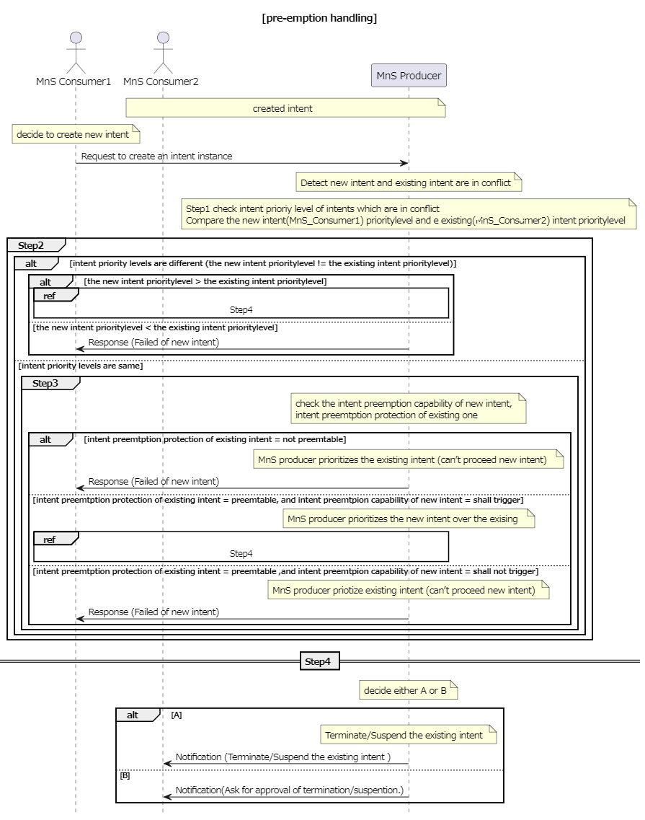
Figure 4.2.3-1
The solutions are feasible and should be expanded in the normative phase.

4.3 Issue#4.3: Enhancement of radio network intent expectation

4.3.1 Description
In TS 28.312 [2], the radio network expectation is defined in clause 6.2.2.1.1, which is used to support the use case and requirements for clause 5.1.1 Intent containing an expectation for delivering radio network, clause 5.1.4 Intent containing an expectation on coverage performance to be assured and clause 5.1.5 Intent containing an expectation on RAN UE throughput performance to be assured. Following aspects for radio network expectation need to be enhanced:
- Enhancement Aspect1: In existing radio network expectation, only Polygon Area and TAC are specified to represent the coverage area. However, in some scenarios, the MnS consumer may express the radio network expectation targets for the coverage area which is represented by a list of Cell (e.g. CGI).
- Enhancement Aspect2: In clause 5.1.5 Intent containing an expectation on RAN UE throughput performance to be assured, the sentence "optional performance scope (e.g. specific service type, specific UE groups)" is described, which means MnS consumer may express the radio network expectation targets for the specific service type or UE groups instead of the whole radio network.
- Enhancement Aspect3: In existing radio network expectation, only coverage and RAN UE throughput related expectation targets are defined to support coverage performance and RAN UE throughput performance assurance use case. The capacity performance is important for radio network delivering and assurance, so the corresponding radio network capacity performance requirements need to be defined in Radio network expectation.
- Enhancement Aspect4: In clause 5.1.1 Intent containing an expectation for delivering radio network use case, transport setting parameters (including OM transport information and NG transport information) are described in the MnS consumer's expectation for delivering a radio network. It means when the MnS consumer expresses its intent expectation to the MnS producer for delivering a radio network, MnS consumer needs to specify the expected transport information for the radio network to be delivered to support the connection with other network parts (including 5GC network node, transport network node and management system).
- Enhancement Aspect5: Radio network may have different distributions of users in different time periods, and these differences have certain periodic characteristics in time and space. For example, in the university area, users are mainly in teaching buildings during the day, and users are mainly in dormitory buildings at night. In this case, during the day, teaching buildings are busy while at night, they are idle. Therefore, in view of the difference in the distribution of users in different time periods in same area, it is necessary to defined different time periods as contexts.

4.3.2 Potential solutions
Regarding the Enhancement Aspect 1, it proposes to add attribute "cellContext" in ObjectContext for RadioNetworkExpectation in Clause 6.2.2.1.1.2 to represent the coverage area.
Regarding the Enhancement Aspect 2, it proposes to add attribute "targetedScopeContext" in ObjectContext for RadioNetworkExpectation in Clause 6.2.2.1.1.2. The contextValueRange of "targetedScopeContext" is dataType modelled as tuple [SNSSAI, 5QI]. If MnS consumer only expresses the expectation targets for specific SNSSAI, then the 5QI of the tuple should be absent. If MnS consumer only expresses targets for specific 5QI, then the SNSSAI of the tuple should be absent. If MnS consumer expresses the expectation targets for specific combination of SNSSAI and 5QI, both SNSSAI and 5QI needs to be present.
Regarding the Enhancement Aspect 3, it proposes to add radio network capacity related expectation targets in ExpectationTargets for RadioNetworkExpectation, the radio network capacity related expectation targets can be highUlPrbLoadRatioTarget, highDlPrbLoadRatioTarget, maxNumberofUETarget (specifies the maximum number of UEs may access the network) and activityFactorTarget (specifies the percentage value of the amount of simultaneous active UEs to the total number of UEs). In case of radio network delivering scenario, the radio network capacity related expectation targets can be maxNumberofUETarget and activityFactorTarget. In case of radio network assurance, the radio network capacity related expectation targets are highUlPrbLoadRatioTarget and highDlPrbLoadRatioTarget.
Regarding the Enhancement Aspect 4, it proposes to add transport related contexts (including NgInterfaceContext, OMInterfaceContext and NextHopContext) in ObjectContexts for RadioNetworkExpectation in Clause 6.2.2.1.1.2. NgInterfaceContext represents the context of transport connection to 5GC, which includes a list NGlocalIPaddress and NGremoteIPaddress. OMInterfaceContext represents the context of transport connection to the management system, which includes a list of OMlocalIPaddress and OMremoteIPaddress. The NextHopContext provides information to identify ingress node (s) which are part of a transport network and the attachment circuit between the radio network and the transport network, which includes a list of nextHopInfo defined in TS 28.541[3].
Regarding the Enhancement Aspect 5, it proposes to add attribute "timeContext" in ObjectContext for RadioNetworkExpectation in TS 28.312 [2] Clause 6.2.2.1.1.2 to represent the expectation is expressed for specific time periods.

4.4 Issue#4.4: 5GC related intent expectation

4.4.1 Description
TS 28.312 [2] describes the generic requirements of intent-driven MnS in clause 5.2. The generic information model definition and scenario specific IntentExpectation definition are given in clause 6.2 in TS 28.312 [2].
Intent driven management may affect management scenarios of 5G Core network which include 5G Core NF provisioning, 5G Core network performance management, 5G Core network fault management and 5G Core network optimization. In this key issue, this study should investigate the potential solution(s) of intent expression of 5G Core network intent expectation.
The 5GC intent expectation may include the specific Expectation Targets related to 5GC subnetwork management and Expectation Targets of 5GC NF management. Intent driven management may affect various management scenarios of 5G Core network. This study is to investigate potential solution(s) for intent expression, including defining expectations for a specific set of these scenarios.
The 5GC intent expectation should investigate the potential solution(s) to extend the generic information model of intent IOC to support 5GC specific intent expectation.

4.4.2 Potential requirements
REQ-Intent_GEN_CON_01: The Intent driven MnS shall have the capability to allow MnS producer provide the results of the intent fulfilment to MnS Consumers.
REQ-Intent_Deploy_NF_CON_01: The intent driven MnS for 5GC shall have capability to allow MnS consumer to express Intent expectation for deployment of 5GC NFs or subnetwork.
REQ-Intent_Opt_5GC_CON_01: The intent driven MnS for 5GC shall have capability to allow MnS consumer to express Intent expectation for 5GC performance assurance.

4.4.3 Potential solutions

4.4.3.1 Potential 5GC specific IntentExpectation
The generic information model for intent should be used to provide specific IntentExpectation related to 5GC management.
The IntentExpectation for core network is used to represent MnS consumer's expectation for 5GC subnetwork or 5GC NF. The ExpectationObject should indicate the 5GC subnetwork or 5GC NF:
- In case of the intent expectation is not for a specific instance or MnS consumer has no knowledge of the DN of the instance, the attribute of objecttype need to be specified as 5GC subnetwork or the type of 5GC NF.
- In case of intent expectation is for a specific instance and MnS consumer has the knowledge of the DN of the instance, the attribute of objectInstance needs to be specified.
When IntentExpectation represents an Intent to deliver 5GC subnetwork 5GC related ExpectationTargets.
It should be provided to describe the information of 5GC subnetwork, such as network scale, network coverage, etc.
When IntentExpectation represents an Intent to deliver 5GC NF, 5GC related ExpectationTargets should be provided, such as supported features of 5GC NF, and related end point interfaces information.
When IntentExpectation represents an Intent for 5GC performance assurance, the performance KPIs for 5GC subnetwork or NF are considered as network characteristics, so the performance assurance KPI name and value can be included as values of ExpectationTargets for IntentExpectation. The IntentExpectations in service assurance IntentExpectation diverse and depend on management scenarios. The examples of the performance KPIs related to 5GC which can be used as ExpectationTargets are Established PDU session number, maximum registered subscribers and the inter-AMF handover number for 5GC subnetwork.

4.4.3.2 Potential solution for 5GC fault management
The IntentExpectation for core network is used to represent MnS consumer's expectation for 5GC.
The intent driven management for 5GC fault management can use intent expectation to express the intent of the fault detection and recovery intent for 5GC. When IntentExpectation represents an Intent for 5GC fault management, 5GC related ObjectContext should be provided, such as the information of 5GC NF.
The name and value of ExpectationTargets can be used to provide particular inputs of fault detection and recovery. The alarm notification of particular events and fault types are set to be reported. The expectation target for input requirements of fault detection related to 5GC can be set to support the alarm notification by particular periodic time.
NOTE: The intent expectation can be enhanced to support the fault recovery expectations. One example is that the intent of fault recovery expectation can be expressed to move the traffic to new 5GC NFs which are collocated.
The intent expectation may contain the information related to the 5GC NF or 5GC subnetwork, so the scope the intent expectation applied are provided in intentExpectation field and fulfilment report.
As an example, in case that the intent driven MnS consumer is to express the intent expectation for 5GC fault management, the following attributes to intent driven management of 5GC fault management:
- The new "expectationTargets" for 5GC fault management could be added in intentExpectation.
- Attribute "recoveryResponseTimeTarget" represents MnS consumer's requirements for reducing recovery response time to a certain value, which is a Integer value.
- Attribute "failureTimeTarget" represents MnS consumer's requirements for reducing network and service failure time to a certain value within a period time.
- The intent expectation may contain the information related to the 5GC NF or 5GC subnetwork, so the scope the intent expectation applied are provided in intentExpectation field and fulfilment report. The objectContexts can be enhanced to contain that information related to the 5GC NFs and 5GC subnetwork.
- Attribute"plMNInfoContext"describes the PLMN(s) supported by the 5GC NF or 5GC subnetwork that the intent expectation is applied, the ObjectContext include attributes: contextAttribute, contextCondition and contextValueRange. The targetValueRange see corresponding attribute " plMNInfoList" in TS 28.541 [3].

4.4.3.3 Potential solution for 5GC optimization
The IntentExpectation for core network is used to represent MnS consumer's expectation for 5GC.
The 5GC optimization is a fundamental solution that can support to optimize and keep particular one or more than one 5GC performance KPI(s) of 5GC, so some scenarios of 5GC optimization can be also used to support 5GC service assurance. For example, the core network may be set to increase energy efficiency of 5GC during period of time. Another example is that increasing a particular usage ratio of virtual resource consumption is set to core network according to the service request during a period of time, so this optimization intent expectation can be addressed by invoking provisioning MnS to update the 5GC NFs.
When IntentExpectation represents an Intent for 5GC optimization, 5GC related ObjectContext should be provided.
The particular name and value of performance KPI related to 5GC can be set as value of ExpectationTargets for IntentExpectation. Optionally, the value of TargetContexts can be included to show the information of network context of this ExpectationTarget when necessary.
As an example, in case that the intent driven MnS consumer is to express the intent expectation for 5GC energy saving optimization, the following enhancements to intent driven management of 5GC optimization can be added:
- The new expectationTargets for 5GC energy efficiency could be added in intentExpectation. The example of 5GC energy efficiency could be set to reduce the energy consumption by N percentage (e.g., 5 %). The period of time should be added as an input in expectationContexts field in intentExpectation when applicable.
- The intent expectation may contain the information related to the 5GC NF or 5GC subnetwork, so the scope the intent expectation applied are provided in intentExpectation field and fulfilment report. The objectContexts can be enhanced to contain that information related to the 5GC NFs and 5GC subnetwork.

4.5 Issue#4.5: Intent Report

4.5.1 Description
In TS 28.312 [2], the Fulfilment information (including the intentFulfilmentInfo, expectationFulfilmentInfo and targetFulfilmentInfo) are defined for the MnS consumer to monitor the intent fulfilment information. The intent report also can contain the current and optional predicted value for performance indicated by corresponding expectation targets (e.g. WeakRSRPRatio for the weakRSRPRatioTarget, Average UL RAN UE Throughput for aveULRANUEThptTarget), which can be used by MnS consumer to validate whether the intent is really fulfilled and to evaluate whether the intent (especially for expectation targets) needs to be updated if needed (improve the target value when corresponding target is fulfilled or reduce the target value when corresponding target is not fulfilled or not fulfilled with the reason of target confliction). Besides, intent conflict information and intent fulfilment feasibility check information which send by MnS producer to MnS consumer is another type of intent report information. So, following are the three types of information needs to be monitored by MnS consumer:
- Intent Fulfilment information, which represents the properties of a specific fulfilment information for an aspect of the intent (i.e. either an expectation, a target or the whole intent). The detailed information see clause 6.2.1.3.5 in TS 28.312 [2].
- Achieved values for targets, which represent current performance values for corresponding expectation targets.
- Intent conflict information, which represents conflict type (i.e. intent conflict, expectation conflict and target conflict) and possible solution recommendation to address the conflicts.
- Intent fulfilment feasibility check information, which indicates that the intent is feasible or infeasible. Intent fulfilment feasibility check information is provided after MnS producer automatically performs feasibility check when receive the intent creation and modification request from MnS consumer.
Different MnS consumer may have different requirements for intent report (e.g. Some MnS consumer may want to have corresponding performance value information while others do not want. Different MnS consumer may want to calculate or monitor the performance value in different period).
While the report (with the current performance values for corresponding expectation targets) is provided at the end of each observation period, the consumer may also wish to know whether the fulfilment info was consistent for the entire observation period. For example, the intent expectation may be reported FULFILLED at the end of observation period. However, it may be possible that within observation period the intent expectation was NOTFULFILLED. The consumer may wish to know this information. This information can be important for the MnS consumer to understand whether the observation period they specified need an update (e.g. shortened) or not. Moreover, it helps the MnS consumer to understand whether their expectation is fulfilled during the entire observation period which also gives transparency to the MnS consumer to update their observation period and/or expectations targets specified in the intent.
MnS consumer can also require different intent reports to be generated in different situations. Based on the content selection criteria, MnS consumer can obtain reports of different content according to different conditions. For example, possible to ask for a report about all elements of the intent when the system is getting degraded. If the system complies again, a shorter report might be sufficient.
Reports also can be generated and sent based on events. Events describe significant situations in the operation of intent, and indicate that the intent has reached a particular state. For example, these events can include intent being accepted, intent being rejected, or intent being degraded, etc. The intent driven MnS should allow MnS consumers to require for which events, a report is generated by MnS producer. Moreover, MnS consumers can propose other customized requirements for intent report, such as combining complex requirements for frequency, triggering events, and content selection.

4.5.2 Potential requirements
REQ-Intent_Driven_MnS_Report-1: The intent driven MnS should have the capability to enable the MnS consumer to request intent report information.
REQ-Intent_Driven_MnS_Report-2: The intent driven MnS should have the capability to enable the MnS consumer to obtain intent report information with current performance value for corresponding expectation targets.
REQ-Intent_Driven_MnS_Report-3: The intent driven MnS should have the capability to enable the MnS consumer to obtain intent report information with intent fulfilment information.
REQ-Intent_Driven_MnS_Report-4: The intent driven MnS should have the capability to enable the MnS consumer to obtain intent report information with intent conflict information.
REQ-Intent_Driven_MnS_Report-5: The intent driven MnS should have the capability to enable the MnS consumer to obtain intent report information with intent fulfilment feasibility check information.
REQ-Intent_Driven_MnS_Report-6: The intent driven MnS should have capability enabling MnS consumer to specify the content of the report.
REQ-Intent_Driven_MnS_Report-7: The intent driven MnS should have capability enabling MnS consumer to configure the frequency of the intent reporting.
REQ-Intent_Driven_MnS_Report-8: The intent driven MnS should allow MnS consumers to receive reports, with different content and intervals according to its specified requirements.
REQ-Intent_Driven_MnS_Report-9: The intent driven MnS should allow MnS consumer to obtain reports with current values for specified expectation targets.
REQ-Intent_Driven_MnS_Report-10: The intent driven MnS should have capability enabling MnS consumer to obtain intent report information with current context information for corresponding expectation targets.
REQ-Intent_Driven_MnS_Report-11: The intent driven MnS should allow reports to contain information on whether the fulfilment info was consistent throughout the observation period.
REQ-Intent_Driven_MnS_Report_12: The intent driven MnS should have capability enabling MnS consumer to specify the content selection criteria of the report.

4.5.3 Potential solutions

4.5.3.1 Potential solution #1
This solution extends the existing model in TS 28.312 [2] by adding new attributes to the Intent IOC to indicate what is to be observed, and a new IntentReport IOC to enable the MnS consumer to obtain the intent report information.
The following specific changes would be made:
- Extend the Intent <<IOC>> with the following attributes:
- "reportingPeriod", represents MnS consumer's requirements for the reporting period. The performance value for corresponding Expectation Targets will be reported at the end of each period.
- Introduce the IntentReport <<IOC>> to represent the intent fulfilment information, intent conflict information intent fulfilment feasibility check information and current performance values for the Expectation Targets in the associated Intent. The MnS consumer can use the "getMOIAttributeValue" operation to query the IntentReport <<IOC>> to obtain the intent report information and/or subscribe the "notifyMOIAttributeValueChanges" notification to obtain the intent report information The IntentReport <<IOC>> includes the following attributes:
- "intentReference", to reference (DN) the associated Intent instance.
- "reportIndicator", to enable/disable (Boolean) reporting for associated Intent instance.
- "intentFulfimentInfo", to represent the fulfilment information for intent, intent expectation and expectation targets. For detailed information see clause 6.2.1.3.5 in TS 28.312[2].
- "intentConflictInfo", to represent the intent conflict information that should be informed to the MnS consumer. For detailed intent conflict information see clause 4.2.3.
- "intentFeasibilityCheckInfo", to represent the intent fulfilment feasibility check information that should be informed to the MnS consumer.
- "targetAchieveValues", to represent the current performance value for the ExpectationTargets.
- "lastUpdated", timestamp (DateTime) of latest update.
This could result in NRM for Intent Reporting as follows:
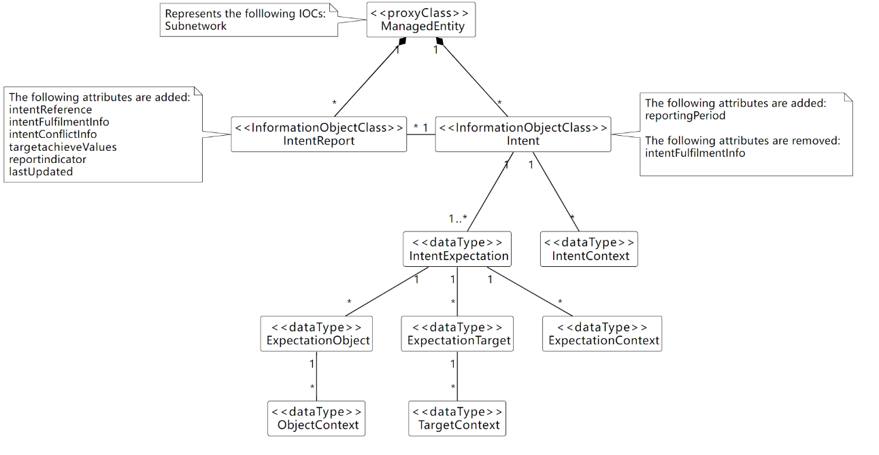
Figure 4.5.3.1-1
Observations on this approach:
- Different MnS consumers can query different attributes of IntentReport to obtain corresponding Intent instance report information.
- Different MnS consumers can subscribe to attribute value change notifications for IntentReport <<IOC>> to obtain the notification for different intent report information.
Several benefits are listed below for the solution:
- Separates the intent expectation information (generated by MnS consumer) and intent monitor information (generated by MnS producer).
- MnS consumer can manage Intent instance and IntentReport instances separately.
- Intent <<IOC>> is aligned with intent definition (expectations including requirements, goals and constraints given to a 3GPP system).

4.5.3.2 Potential solution #2
This solution extends the existing model in TS 28.312 [2] by adding new attributes to the Intent IOC to indicate what is to be observed, and a new IntentReport IOC to report the achieved values.
The following specific changes could be made:
- Extend the IntentExpectation <<dataType>> with the following attribute:
- "observationTime", represents MnS consumer's requirements for the observation period of performance value for corresponding Expectation Targets. The performance value for corresponding Expectation Targets will be observed from the start of each observation period, then at the end of each observation period, the value will be derived and configured.
- Introduce the "achieveValue" attribute in the ExpectationTarget to represent the performance value for the ExpectationTarget. Then the MnS consumer can use the "getMOIAttributeValue" operation to query the Intent <<IOC>> to obtain the achieveValue for a given ExpectationTarget.
This could result in NRM for Intent Reporting as follows:
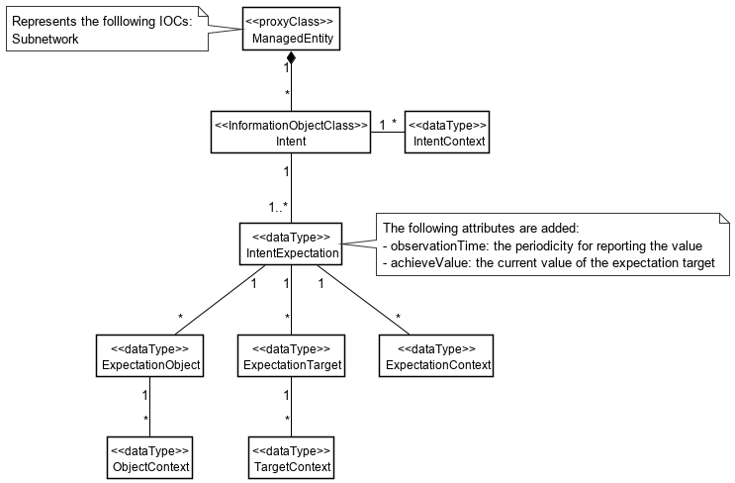
Figure 4.5.3.2-1
The above solution would require, per Intent, that:
- MnS Consumer configures each IntentExpectation to be reported with "observationTime=N".
- For each period N, MnS Producer reports the achieveValue.
- For every period N, MnS Producer updates the achieveValue of each expectation target.
- MnS Consumer queries achieveValue of interested targets.
Note: It would "achieveValue" be current value (per Solution #1, as available in NRM at time of reporting), or some other computed value for the interval is not addressed in the present document. If computed, the definition and format could vary based on which attribute(s) are included.
Observations on this approach:
- It Should avoid mix-and-match of observability.
- For attributes defined in NRM, existing subscription mechanism can be used to monitor updates. E.g. "achieveValue" proposed in this solution.
- For content not defined in NRM, new notifications would need to be defined for the intent content to be reported. E.g. associated PM/KPI.
- The configuration of the report output is contained in the Intent itself.
- MnS Consumer would need to query (i.e. polling). Notifications would be preferred.
- Since the observationTime of each IntentExpectation is configured separately, MnS Consumer would need to be aware of how relatively up-to-date each value is.
- It Should use of the term "report" which can be misleading, as there is no 'report' object (e.g. NRM, file, stream). This solution is completely notification based.

4.5.3.3 Potential solution #3
This solution would not modify the existing model in TS 28.312 [2]. A separate IntentReportCtrl IOC is proposed. The IntentReport IOC is used to contain the output of the expectation targets, as well as other status information currently contained in Intent. The latter would be removed to further separate the configuration of the Intent, from the monitoring/reporting of it throughout its lifecycle.
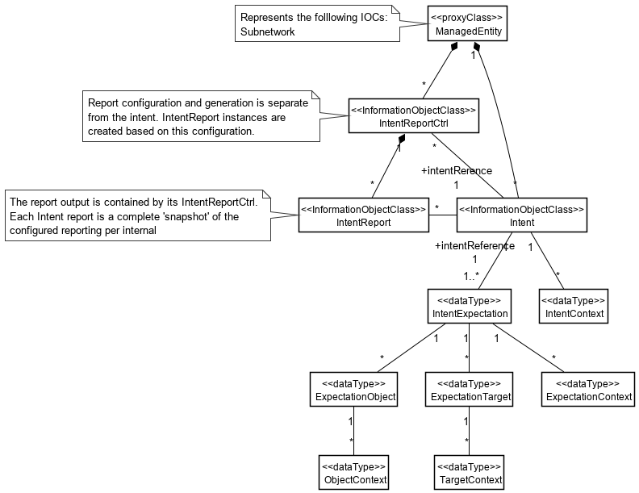
Figure 4.5.3.3-1
The above solution would require, per Intent, that:
- MnS Consumer configures each IntentReportCtrl with "reportingPeriod=N", and reference "intentReference" to the Intent instance for which the report is to be produced.
- For each period N, MnS Producer generates an IntentReport instance.
- For every period N, MnS Producer "snapshots" the Intent values.
- MnS Consumer receives notification of the new IntentReport instance.
Observations on this approach:
- The configuration of the report output is external to the Intent itself, and supports ability to configure different reports per Intent. The content (i.e. attributes) and reporting intervals can be different for each report generated.
- Each report is a complete " snapshot" of the Intent at time of generation, available in NRM.
- MnS Consumer does not need to handle different "observationIntervals" per attribute within same Intent.

4.5.3.4 Potential solution #4
This solution does not modify the existing model in TS 28.312 [2]. A separate IntentReportJob IOC is proposed, along with a file/stream based Intent report similar to other performance reporting.
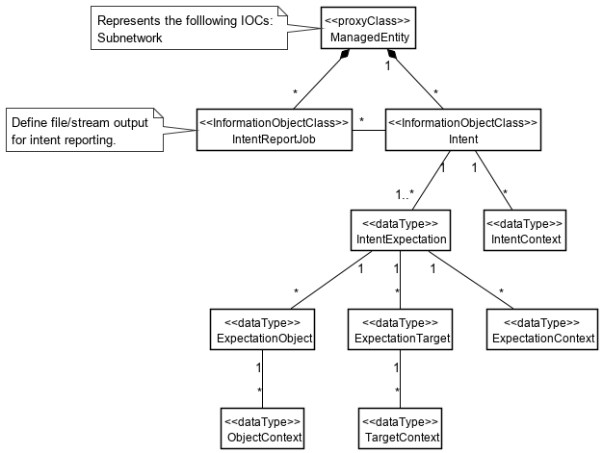
Figure 4.5.3.4-1

The above solution would require, per Intent, that:
- MnS Consumer configures each IntentReportJob control for file or streaming output, and a reference "intentReference" to the Intent instance for which the report is to be produced.
- For every period N, MnS Producer outputs the report content as configured in the job.
- for file based, MnS Consumer receives notification of the new Intent report file.
- for stream, MnS Consumer receives streaming content.
Observations on this approach:
- This approach is consistent with other performance related reporting.
- Each report should be complete and self-describing, and suitable for offline processing and/or archival.
- A schema will need to be agreed, perhaps based on the existing PM/KPI formats.

4.5.3.5 Potential solution #5
This solution would modify the existing model in TS 28.312 [2] to add configuration of notifications of achieved values. The values to be notified are defined directly in the Intent.
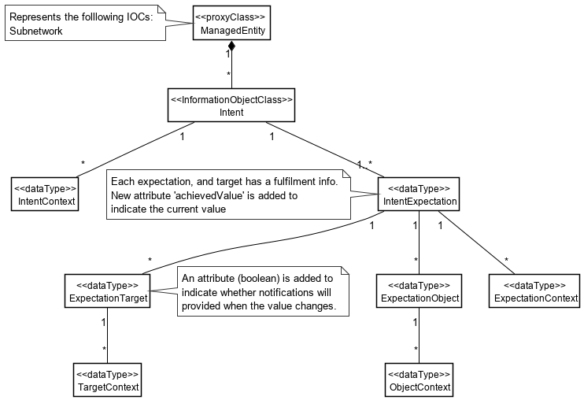
Figure 4.5.3.5-1
- MnS Consumer configures each Intent with 'reportIndicator=True' for values to be monitored.
- MnS Consumer subscribes to the "achieveValues" in IntentExpection.
- MnS Consumer receives notifications each time a new value is available.
Observations on this approach:
- The configuration of the report output is contained in the Intent itself, and is a Boolean. This effectively limits the content of the report to a single report per Intent.
- This approach is different than subscribing to attribute notifications.
- The notifications required, and how they represent values in NRM and/or derived values not in the NRM, needs to be defined.
- There would be no "report" objects with this approach.

4.5.3.6 Comparison and analysis of potential solutions
Following table give overview of comparison of potential solutions for intent report.
Table 4.5.3.6-1: Comparison and analysis of potential solutions for intent report
Solution No | Solution description | Pros | Cons
Solution#1 | Following changes proposed based on existing intent NRM fragment:  Report Control: Extend the Intent IOC with attribute "observationPeriod" to represent MnS consumer's requirements for the observation period.  Report Method: Query or subscribe-notification.  Report Model: Introduce the IntentReport IOC to represent the intent report/monitor information in the associated Intent. And Different MnS consumers can query/subscribe different attributes of the same IntentReport instance to corresponding intent report information.  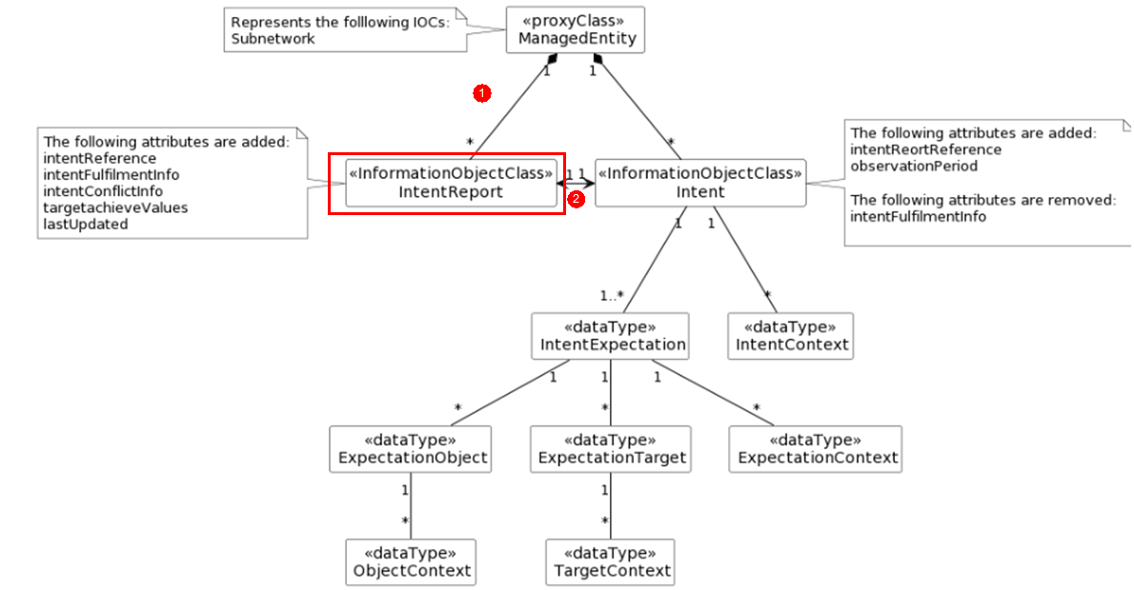 | - Separates the intent expectation information (generated by MnS consumer) and intent monitor information (generated by MnS producer).  - MnS consumer can manage Intent instance and IntentReport instances separately.  - Intent <<IOC>> is aligned with intent definition (expectations including requirements, goals and constraints given to a 3GPP system)  - Use the CRUD operation/notification to obtain intent report information, no need to introduce new operation for intent report. | - Needs to move the intentfulfilment information in Intent IOC to new IntentReport IOC.
Solution#2 | Following changes proposed based on existing intent NRM fragment:  Report Control: Extend the Intent IOC with attribute "observationPeriod" to represent MnS consumer's requirements for the observation period.  Report method: Query or subscribe-notification.  Report model: Extend the Intent IOC to contain all intent report information. Different MnS consumers can query different attributes of Intent instance obtain corresponding Intent instance report information.  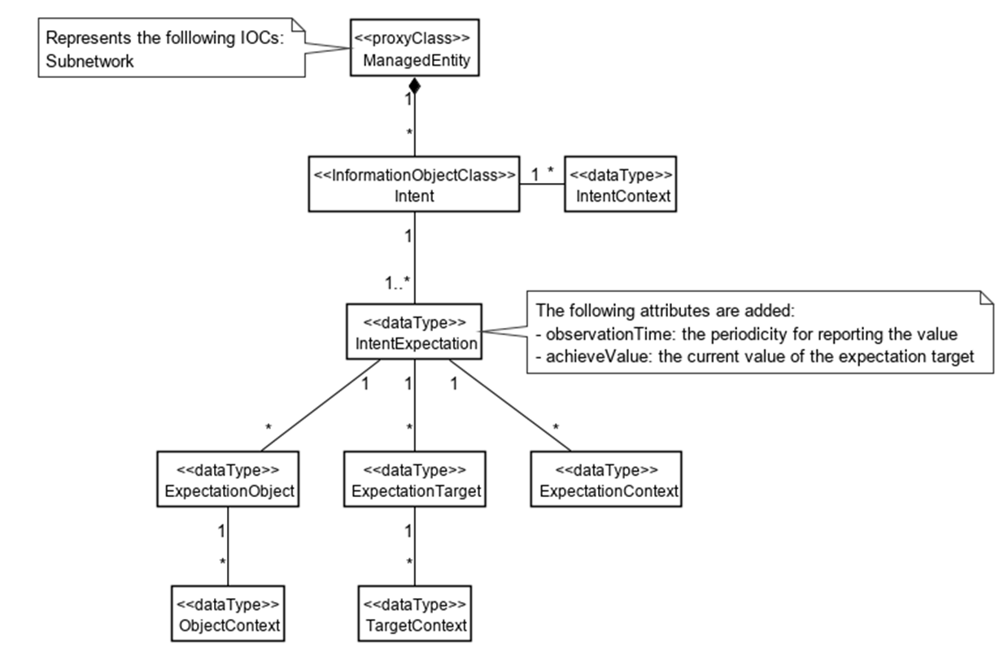 | - Less impact on existing intent model in TS 28.312 | - Mix intent expectation information and intent monitor information in the Intent IOC, which is not aligned with intent definition (expectations including requirements, goals and constraints given to a 3GPP system).
Solution#3 | Following changes proposed based on existing intent NRM fragment:  Report Control: Introduce the separate IntentReportCtrl instance to contain the observation period for corresponding consumer. Different MnS consumer configure its own IntentReportJob to specify the observation period and intent report content to be obtained.  Report Method: Query or subscribe-notification.  Report Model: Introduce the separate IntentReport instance to contain intent report information for corresponding consumer. Different MnS consumer query/subscribe its own IntentReport instance to obtain the intent report information.  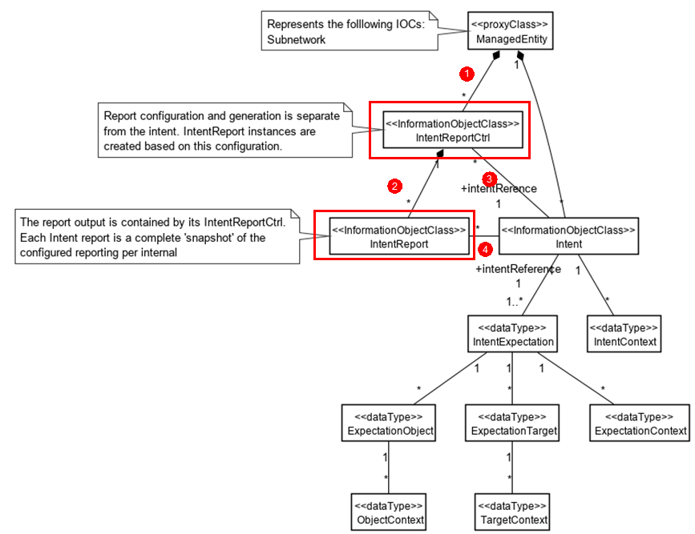 | - The observation period for the intent report information of the same intent for different consumer can be different.  - Intent <<IOC>> is aligned with intent definition (expectations including requirements, goals and constraints given to a 3GPP system) | - Complex and Duplicated to maintain different IntentReport instances associated to same Intent instance for different MnS consumer.  - Needs to move the intentfulfilment information in Intent IOC to new IntentReport IOC.
Solution#4 | Following changes proposed based on existing intent NRM fragment:  Report Control: Introduce the separate IntentReportJob instance to contain the observation period and report method for corresponding consumer. Different MnS consumer configure its own IntentReportJob to specify the observation period and intent report content to be obtained.  Report Method: File reporting or streaming reporting.  Report Model: No need to model intent report  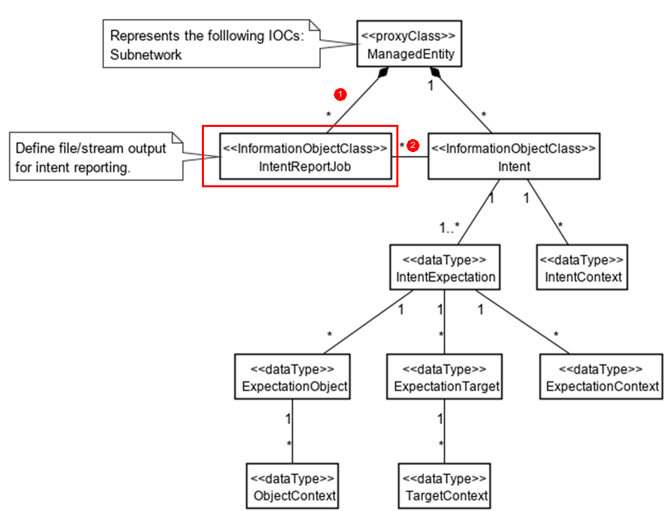 | - Less impact on existing intent model in TS 28.312  - Efficiency if there is a large amount of data to be reported. | - More operations (file reporting operation or streaming reporting operation) needs to be introduced for intent driven MnS.  - Needs to define the file format and streaming format for intent report  - Needs to remove the intentfulfilment information from Intent IOC
Solution#5 | Following changes proposed based on existing intent NRM fragment:  Report Control: Introduce the indicator to specify which value needs to be notified.  Report Method: Query or subscribe-notification.  Report Model: Extend the Intent IOC to contain all intent report information. Different MnS consumers can query different attributes of Intent instance obtain corresponding Intent instance report information.   | - Less impact on existing intent model in TS 28.312 | - Mix intent expectation information and intent monitor information in the Intent IOC, which is not aligned with intent definition (expectations including requirements, goals and constraints given to a 3GPP system).

4.6 Issue#4.6: Intent-driven Closed Loop control

4.6.1 Description
A Closed Loop (CL) is an entity that implements the capabilities to get data, analyse it, generate decision and execute those decision on the network in general. It is implemented in four stages (i.e. monitor, analyse, decide and execute) and one or multiple stages may be implemented by a specific component (i.e. MnF). The detailed definition and concept for closed loop see TS 28.535 [5]. MnS producer of CL management services may implement a Closed-loop Control (CC) to support control capabilities for managing or controlling the closed loop.
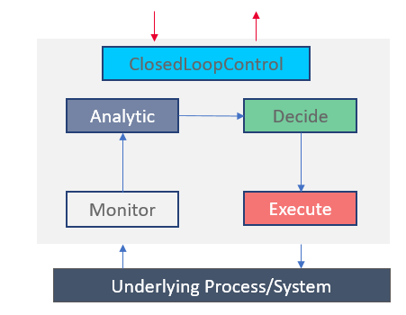
Figure 4.6.1-1: Example relations among closed loop components
Given a set of deployed network functions and/or management functions, the Closed-Loop Control may configure different network and management functions to achieve the desired closed loop goals based on intents with the input "context" (e.g. capabilities, control or use case) provided by the operator, as illustrated by Figure 4.6.1-2. Within the intent driven system, the MnS producer for intent driven MnS may play the role of closed loop control to implement the intent driven closed loop or interact with closed loop control to control the closed loop.
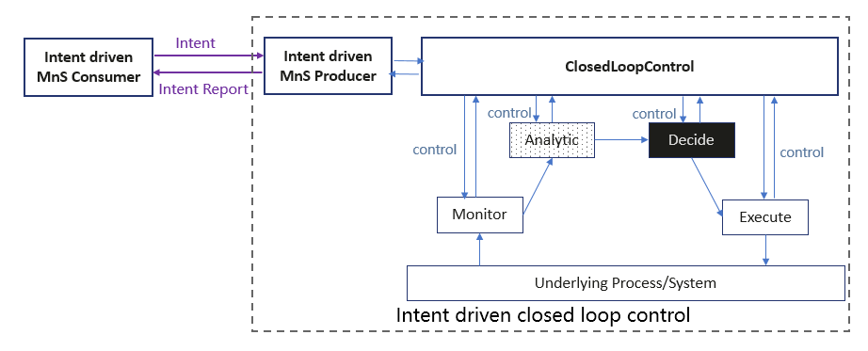
Figure 4.6.1-2: Using Intents towards Closed-Loop Control to automate closed loops management and control

4.6.2 Potential requirements
REQ-Intent_GEN_CON_01: The 3GPP management systems shall support a capability to allow a consumer (e.g. an operator) to express an intent to enable the provider of CL management to configure a CL based on an intent that expresses the intent expectations as closed loop goals, KPI, SLS, SLA targets, input-output pairs or capabilities
REQ-Intent_GEN_CON_02: The 3GPP management systems shall support a capability to allow a consumer (e.g. an operator) to express an intent to enable the provider of CL management to configure its constituent management functions and goals to achieve the expectations of the intent.
REQ-Intent_GEN_CON_03: The 3GPP management systems shall support a capability to inform an authorized consumer (e.g. an operator) about closed loops and management functions serving the intent.

4.6.3 Potential solutions
Introduce an expectation with targets which capture the objectives for an entity that undertakes optimization. The expectation may be termed as network optimization expectation. The network optimization expectation may be expressed for a network slice or a network slice subnet i.e. the expectation object may be a network slice or a network slice subnet. This enables the MnS Producer to take steps, e.g., configure closed loops or the goals thereof intended to deliver on those targets.
The network optimization expectation targets may express the desired optimization outcomes. Depending on the stated targets, the MnS producer may as such configure one or more closed loops or optimization functions to achieve the desired targets. The network optimization expectation targets may for example be KPI targets that the optimization is required to achieve.
The network optimization expectation may include relative prioritizations of the different targets which indicate the relative interests of the intent MnS consumer on the different optimization targets.
Introduce the list of Closed loop Identifiers (e.g., DN of AssuranceClosedControlLoop) in IntentReport IOC to represent the closed loop instance(s) used to satisfy the intent.

4.7 Issue#4.7: Monitoring intent fulfilment information

4.7.1 Description
In TS 28.312 [2], MnS Producer can deploy or configure corresponding managed entities to satisfy the intent. During the execution of intention, MnS producer continuously monitors intent fulfilment information. One scenario is that an intent may take a long period of policies execution to be satisfied. During the execution of the intent, something may happen, such as a new intent coming, a change in the execution environment. The MnS producer needs to monitor the intent fulfilment information so that policies can be adjusted in time. Another scenario is that the intent contains temporal information, such as how long the consumer could wait before the intent is initially satisfied, which refers to maximum duration. For example, MnS consumer can express the expectation that the coverage targets for certain radio network needs to be ensured in one hour, which means MnS producer have one hour to take/adjust actions to ensure the expected coverage targets for radio network. When the maximum unfulfilled duration is specified, the MnS producer may optimize its intent fulfilment plan, e.g., to decide different actions to be applied on the managed entities or to use different managed services, so that the intent can be fulfilled within the duration. The MnS producer needs to response the intent fulfilment information to the MnS consumer at the beginning and during the execution of the intent.

4.7.2 Potential requirements
REQ-Intent_execution_monitoring-CON-1: The intent driven MnS Producer should have the capability to allow the authorized MnS consumer to request intent fulfilment information periodically or event-triggered.
REQ-Intent_execution_monitoring-CON-2: The intent driven MnS Producer should have the capability to inform the authorized MnS consumer about intent fulfilment information periodically or event-triggered.
REQ-Intent_execution_monitoring-CON-3: The intent driven MnS Producer should have the capability to allow the authorized MnS Consumer to provide the deadline expressing the maximum duration before the intent is initially satisfied or the latest time point by which the intent should be satisfied.

4.7.3 Potential solutions
See clause 4.5.3, intent fulfilment information is one kind of intent report information.
To support REQ-Intent_execution_monitoring-CON-3, an attribute "fulfilmentDeadline" needs to be introduced in Intent IOC to represent MnS's requirements for the maximum unfulfilled duration before the intent is initially satisfied.
The fulfilmentDeadline may be an attribute of the whole intent or one of the expectations of the intent.

4.8 Issue#4.8: Enablers for Intent Fulfilment

4.8.1 Description
Management Functions such as SON functions and MDA functions may use AIML capabilities (either of a decision-making capability or an analysis capability) as defined in TR 28.908 [6]). In RAN, there is a complex inter-dependency among the control parameters (e.g., Transmit power, Antenna tilt) and the KPIs (e.g., throughput, load, handover) which inter-dependency also varies with time and several other real-life factors. For an operator to simultaneously manage multiple control parameters and KPIs, the operator has to learn the complex inter-dependency and its variations. Yet specific optimizations can be done using SON Functions and non-SON AI/ML enabled functions, which focus on optimizing specific targets through specific control parameters.
Intent driven management may rely on these SON or MDA and AI/ML capabilities to accomplish the desired automation. Such Intent driven management may rely on ML-based solutions with or those without an entity that orchestrates the ML solutions (so called ML orchestration).
Correspondingly, the 3GPP management system should support these and other enablers are needed to realize or support the fulfilment of intents.

4.8.2 Use cases

4.8.2.1 Testing Intent-driven MnS Capabilities
By focussing more on "What" needs to be achieved and less on "How" that outcome should be achieved, intents require that the intent-driven MnS consumer lets the intent-driven MnS producer make crucial decisions needed to achieve the "What". In this way, the intent-driven MnS producer takes away the important network management control away from the MnS consumer. However, before such important control can be given away, MnS consumer needs to be sure that the intent-driven MnS producer works in an expected manner, i.e. that the outcomes of the intent-driven MnS producer matches with the MnS consumer's expectations.

4.8.2.2 Mapping of Intents to MLEntities capabilities
To rely on AI/ML for execution, a consumer my need to request the intent driven management service producer to return which AI/ML capabilities can be applied to specific intent management requirements (e.g., the enablers for satisfying the type of intent target). For this, the intent driven management service producer should be able to inform the consumer of the set of ML Entities that together achieve the consumer's intent management requirements.
For intents specifically, the complexity of the stated intents may significantly vary - from simple intents which may be fulfilled with a call to a single ML Entity to complex intents that may require an intricate orchestration of multiple ML Entities. For simple intents, it may be easy to employ the one or multiple ML Entities. For complex intents, it may be required to employ multiple ML Entities along with a corresponding functionality that manages their inter-related execution. The usage of the ML Entities requires the awareness of the AI/ML capabilities and interrelations to each other and to the desired intent management requirements.
Figure 4.8.2.2-1: Mapping intent management requirements to AI/ML Capabilities
Given the knowledge of available AI/ML capabilities and their relation to automation requirements, the consumer may wish to request an intent to be fulfilled using specific AI/ML capabilities. The Intent driven management should enable allow the consumer to make such a request and to fulfil the intent for the consumer as requested.
Figure 4.8.2.2-2: Request intent fulfilment within information for using/excluding AI/ML capabilities

4.8.2.3 Intent-driven SON orchestration
Although SON focusses on the optimization of parameters based on operator stated targets, even when using SON to manage the radio parameters and KPIs, the complex interactions do remain critical. In TS 28.312 [2], an intent focuses more on describing the "What" needs to be achieved but less on "How" that outcome should be achieved. As such, intent-driven MnS can work as the interface between Operator and SON. Using that interface the Operator can specify the customization the Operator wants on certain radio parameters and/or KPIs, and the intent-driven MnS can generate appropriate commands to be executed by SON to achieve those targets. For example, the operator may state requirements for specific SON functions (SFs) that are responsible for optimizing the KPIs and/or control parameters specified within the intent. Such customizations may include specific values expected as outcomes on certain parameters or metrics.

4.8.2.4 Intent-driven for MDA
As described in TS 28.104 [7], multiple MDA capabilities have been defined for different analysis purposes. Within one MDARequest, it is allowed for a consumer to indicate more than one MDA capabilities that the consumer may be interested in. In addition, an intent may also include multiple ExpectationTargets with different aspects. As such, intent-driven MnS can work as the interface between the Operator and MDA function. Using that interface the consumer can specify what the consumer wants for a specific subnetwork or network function in an intent, and the intent-driven MnS can initiate appropriate request to MDA function asking for analysis and feedback that help the intent-driven MnS to achieve those targets in the intent. For example, an operator may state requirements for the performance behaviours of a network slice specified within the intent, the requirements may include SLS requirement together with the requirement related to energy consumption, the intent-driven MnS then request analysis to specific MDA functions capable for SLS analysis and energy saving analysis. The intent MnS may decide how to handle intent based on the analysis report from MDA functions.

4.8.3 Potential requirements
REQ-Intent_TEST_1: The intent-driven MnS shall have the capability to enable an authorized MnS consumer to request for the testing of intent-driven capabilities provided by an MnS producer.
REQ-MLCAPTEST-1 The intent driven MnS should have a capability to enable an authorized consumer to request the MnS producer to return capabilities of one or more ML Entities to support specified intent management requirements.
REQ-MLCAPTEST-2 The intent driven MnS should have a capability to enable an authorized consumer to request the MnS producer to fulfil an intent by using or excluding specific AI/ML capabilities
REQ-Intent_SON_1: The intent driven MnS shall have the capability to enable a consumer to state an intent requesting for the SON Functions (SFs) responsible for optimizing the KPIs and/or control parameters specified in the intent.
REQ-Intent_SON_2: The intent driven MnS shall have the capability to enable a consumer to state an intent requesting to execute SON functions needed optimize the KPIs and/or control parameters specified in the intent.
REQ-Intent_MDAS_1: The intent driven MnS shall have the capability to enable a MnS consumer to state an intent requesting for MDA function to do analysis related to one or more MDA capabilities specified in the intent.

4.8.4 Possible solutions

4.8.4.1 Testing Intent-driven MnS Capabilities
The intent-driven MnS consumer should be able to test the intent-driven MnS at any point of time. For the test, there may be some intents already available to the MnS consumer. Alternatively, MnS consumer can also use new, customized intents.
Main purpose of the test is to check if the intent-driven MnS behaves the way MnS consumer expects it to behave. To achieve that, MnS consumer specifies the expected outcome from executing an intent beforehand. For already available intents, these outcomes may already have been defined. For new intents, the MnS consumer may list the expected outcomes and indicate that the intent is an intent under test. The intent IOC should be extended to indicate whether an intent is an intent under test or not. After the intent is executed, the MnS producer may send a detailed report to MnS consumer that contains all the information related to the outcome of the intent execution. The present document may be used by MnS consumer to check if the expectations are fulfilled. Alternatively, the MnS consumer may already send the list of expectation(s) to MnS producer beforehand. The MnS producer may use this list to compare the outcome(s) and send a report to MnS consumer about the intent expectation fulfilment. The intent fulfilment or intent report should be extended to information on whether the test has been successful or not.
This solution outline is feasible for enabling intent MnS consumers to test the appropriateness of intent MnS producers for the desired intents or classes of intents. This solution may be expanded in the normative phase.

4.8.4.2 Mapping of Intents to AI/ML Entities capabilities
The intent driven MnS producer may rely on available AI/ML capabilities to accomplish the desired intent. Such available AI/ML capabilities may need to be discovered by the consumers as a first step before consumer can request for those AI/ML capabilities to be applied for the intent. Furthermore, the mapping of the discovered AI/ML capabilities to intents needs to be performed. Finally, the according configuration and instructions for execution based on the available AI/ML capabilities is needed in order to achieve desired outcome. For example, in the case of intent fulfilment system leveraging on AI/ML capabilities, the discovered available AI/ML capabilities may be to the extent possible, mapped to incoming user or operators' intents.
The solution requires to:
- Introduce the AIML_capability_mapping_report <<datatype>>, which is generated by intent driven MnS producer
- When an intent driven MnS Producer receives the desired intent management requirements from intent driven MnS Consumer e.g., network operator with a request for a mapping to available AI/ML Entities and their capabilities, the intent driven MnS Producer provides such a mapping of the MLEntities and capabilities e.g. as an AIML_capability_mapping_report to the intent driven MnS consumer to satisfy the received request. The AIML_capability_mapping_report <<datatype>> include the AI/ML capabilities information defined in TR 28.908 [6].
- Support intent creation with specific AI/ML Entities to be used or excluded to fulfil the intent as context information.
- When subsequently, the MnS Producer receives the desired intent targets with the context for the specific AI/ML Entities to be used or excluded, the MnS Producer derives the configuration or execution instructions for the selected AI/ML Entities according to the received intent targets and the context for the specific AI/ML Entities, and provides such configuration or execution instructions to AI/ML Entities
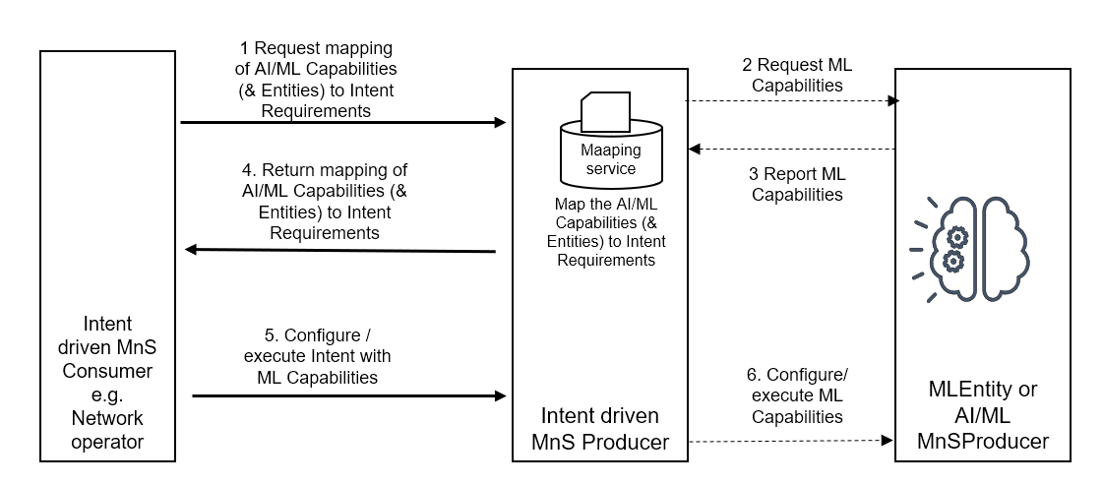
Figure 4.8.4.2-1: Discovery and use of ML capabilities for Intent fulfilment
The solution described in clause 4.8.4 adopts the NRM-based approach, which reuses the existing provisioning MnS operations and notifications. Introducing the AIML_capability_mapping_report <<datatype>> the intent driven MnS Producer can inform its potential intent driven MnS consumers about the AI/ML capabilities it relies on to accomplish intent fulfilment. The intent driven MnS consumers can then request for specific capabilities to be applied for their intents. Therefore, the solution described in clause 4.8.4.1 is a feasible solution.

4.8.4.3 Intent-driven SON orchestration
For an intent to be fulfilled via SON orchestration, the intent needs to relate to network control parameter or to network KPIs. Relatedly, the intent driven SON orchestrator needs to characterize the received into one of three categories represented by table 4.8.4.3-1
Table 4.8.4.3-1
Type | Description | Example intents
Type 1 | Fulfils one of:  Intent parameters defined on network control parameters, and no context defined  Intent context defined on network control parameters, and no parameters defined  Both Intent context and intent parameters defined on network control parameters | Increase cell X TXP  Make cell X TXP remain constant  Make cell X TXP constant and change RET by 3 degrees
Type 2 | Fulfils one of:  Intent parameters defined on KPI, and no context defined  Intent context defined on KPI, and no parameter defined  Both Intent context and intent parameters defined on KPI | Reduce cell X interference  Avoid increase in cell X interference  Increase cell X throughput without changing interference
Type 3 | Fulfils one of:  Intent parameters defined on network control parameters while Intent context defined on KPI,  Intent parameters defined on KPI while Intent context defined on network control parameters | Make cell X TXP constant and reduce interference  Change cell X TXP to 45 dBm without changing interference

Accordingly, given this evaluation within the MnS producer, if the intent does not relate to any of the three categories above, the Intent-driven SON orchestration should inform the intent consumer that the intent cannot be executed via SON orchestration. For this, an attribute may be added in the fulfilmentInfo or intent report for the failure or success of SON orchestration for intent fulfilment. Similarly, an attribute may be added in the FulfilmentInfo <<datatype>> or intent report for indicating when the intent is not in the scope of SON orchestration.
Moreover, when executing via SON, the Intent-driven SON orchestration may observe contradictions in the intent – i.e. cases where targets on different expectation are in conflict. The Intent-driven SON orchestration should inform the intent MnS consumer of such contradictions which occur in the SON orchestration but not necessarily in the intent. For this, an attribute may be added in the FulfilmentInfo <<datatype>> or intent report for a contradiction detected in the SON orchestration.
The related sequence of actions is highlighted by the figure 4.8.4.3-1.
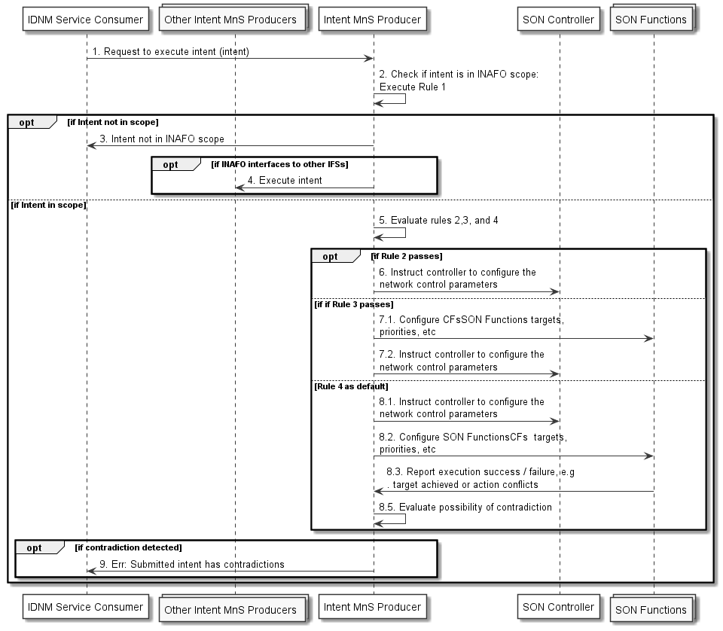
Figure 4.8.4.3-1: Intent-driven SON orchestration

4.8.4.4 Intent-driven for MDA
For an intent, whether it can be fulfilled or not, the intent ExpectationTarget, e.g. the network or network function KPIs, can be analysed by MDA function(s). In this solution, when intent MnS producer receives an intent, it needs to check whether the ExpectationTarget contained in the intent is in scope of the supportedMDACapabilities of the correlated MDA function(s). For example, in the service support expectation scenario as described in TS 28.312 [2], if the included ExpectationTarget contains dLLatencyTarget or uLLatencyTarget, the correlated MDA function needs to have latency analysis capability.
If the correlated MDA function does not support the capability to fulfil the ExpectationTarget contained in the intent, the intent MnS producer should inform the intent consumer that the intent cannot be fulfilled because of lack of capability of MDA function. Similar method as described in clause 4.8.4.3 could be used that an attribute may be added in the fulfilmentInfo <<datatype>> or intent report for indicating when the intent is not in the scope of the supportedMDACapabilities of the correlated MDA function.
If the correlated MDA function supports the capability to fulfil the ExpectationTarget contained in the intent, the intent MnS producer should request the MDA report of the expectation targets (createMOI of MDARequest).
NOTE: The information included in the MDArequest is based on the intent has received and implementation, e.g. the value of requestedMDAOutputs can base on the expectationTargets described in the intent, the value of analyticsScope can base on the expectationObject described in the intent, other attributes included in MDArequest can base on context information included in the intent.
The related sequence of actions is highlighted by the figure 4.8.4.4-1.
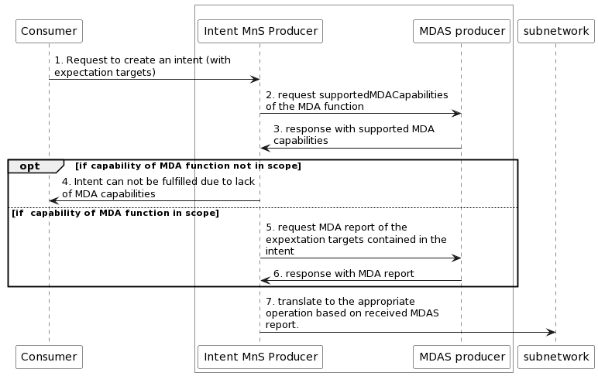
Figure 4.8.4.4-1

4.9 Issue#4.9: Intent fulfilment feasibility check

4.9.1 Description
The option for MnS producer automatically feasibility check when receive the intent creation and modification request from MnS consumer is described in TS 28.312 [2]. However, the intent fulfilment feasibility check capability which can be used by MnS consumer to request intent-driven MnS producer to check the feasibility for intent fulfilment before intent creation is missing. This functionality can be used to assist MnS consumer to generate the suitable intent information.
When intent-driven MnS producer receiving the request, the intent fulfilment feasibility check may be performed to determine which intents are feasible, including check the satisfaction of intent fulfilment and potential conflicts between one or more intents.
When the intent fulfilment feasibility check is accomplished, MnS producer needs to notify the MnS consumer about the result of feasibility check, indicates that the intent is feasible or infeasible. In addition, the MnS producer may also notify the MnS consumer about the reason why the intent is infeasible (e.g. the intent conflict, the satisfaction of intent fulfilment lowering than threshold).

4.9.2 Potential requirements
REQ-Intent_Driven_MnS: The intent-driven MnS producer shall have capability enabling MnS consumer to request to check the feasibility for intent fulfilment.
REQ-Intent_Driven_MnS: The intent-driven MnS producer shall have capability to inform the authorized MnS consumer about the result of intent fulfilment feasibility check, including feasible and infeasible.
REQ-Intent_Driven_MnS: The intent-driven MnS producer shall have capability to inform the authorized MnS consumer about the infeasible reason if intent fulfilment feasibility check result is infeasible.

4.9.3 Potential solutions
The MnS producer may inform the intent fulfilment feasibility check result and the infeasible reason to MnS consumer when the intent fulfilment feasibility check is finished. Following activities will be taken by MnS consumer:
- If the intent fulfilment feasibility check result is indicating the request as feasible, MnS consumer will carry on to request creation of or modification to the intent instance (as described in TS 28.312 [2] Clause 6.3.2).
- In case the intent fulfilment feasibility check result is infeasible, MnS consumer may update the intent information based on infeasible reason and may trigger the intent fulfilment feasibility check again.

4.10 Issue#4.10: Intent handling capability obtaining

4.10.1 Description
In TS 28.312 [2], clause 4.2.2 described that Intent-driven MnS producer (which can be intent handling MnF) have the following capabilities: validate the intent, translate the received intent to executable actions and evaluate the result/information about the intent fulfilment, and clause 6.2.2 defined different scenario specific intent expectations with different ExpectationObjects and ExpectationTargets to support different use cases. In network, multiple intent handling functions maybe deployed to support different kinds of intents. Different intent handling functions maybe deployed to support different intent expectation object domains, e.g. intent handling function A is deployed to handle the radio network related intents, intent handling function B is deployed to handle the 5GC network related intents, while intent handling function C is deployed to handle the service related intents. Or different intent handling functions are deployed to support different areas of the same intent expectation object domain, e.g. intent handling function D is deployed to support to handle the intent for radio network in Area#1, while intent handling function E is deployed to support to handle the intent for radio network in Area#2.
Before MnS consumer expresses the intent expectation targets and expectation objects to MnS producer (i.e. intent handling MnF), MnS consumer may want to know what expectation targets and expectation objects can be supported by MnS producer. Based on such supported expectation targets information and expectation objects information, the MnS consumer may use such information to select the proper intent handling MnF to express the intent.

4.10.2 Potential solutions
Following are the proposed solution based on generic intent information model defined in TS 28.312 [2]:
The new IntentHandlingFunction <<IOC>> contained by ManagedEntity <<proxyClass>> is introduced, and change the Intent <<IOC>> to be contained by IntentHandlingFunction <<IOC>>. The IntentHandlingFunction <<IOC>> includes a list of supportedIntentHandlingCapability <<datatype>> which represent intent handling function's capabilities in support of intent handling. The supportedIntentHandlingCapability <<datatype>> includes attribute "supportedExpectationObjects" and/or attribute "supportedExpectationTargets".
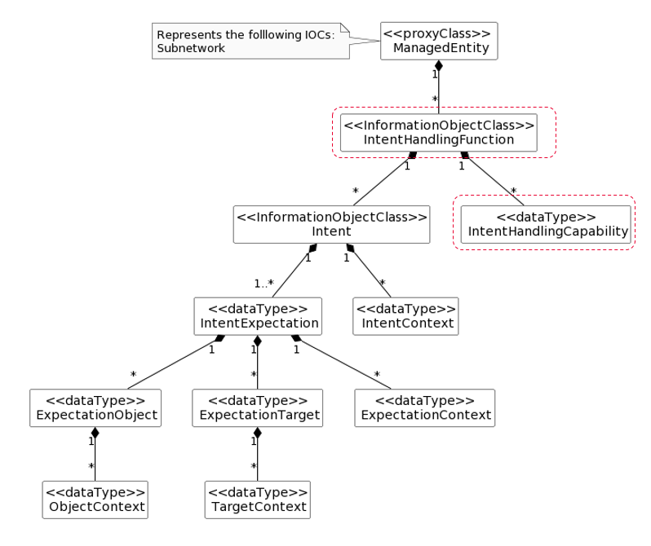
Figure 4.10.2-1: Enhancement of generic intent information model (The red highlighted box are the enhanced part)
Based on the enhancement of generic intent information model, MnS consumer can query the IntentHandlingFunction <<IOC>> to obtain the intent handling capability information, and express the intent for a specific intent handling function. An authorized MnS consumer also can use the DN of IntentHandlingFunction instance to query all Intent instances handled by corresponding intent handling function.

4.11 Issue#4.11: Enhancement of generic Information model definition

4.11.1 Description
In TS 28.312 [2], the generic intent information model (including the Intent, IntentExpectation, ExpectationObject, ExpectationTarget, Context and Fulfilment) are defined. Following aspects for generic intent information model need to be enhanced:
- Enhancement Aspect 1: the intent activate/de-activate intent management capabilities are described in clause 4.2.2 in TS 28.312 [2], which enable the MnS consumer to request to suspend an intent on the MnS producer side or cancel the suspension for a suspended intent on the MnS producer side. The intent is suspended represents the state that the intent is not be considered for fulfilment. However, currently there is no mechanism defined to enable the MnS consumer to request to suspend an intent on the MnS producer or cancel the suspension for a suspended intent on the MnS producer.
- Enhancement Aspect 2: the attribute "fulfilmentStatus" is defined to indicate whether the intent is fulfilled or not fulfilled. However, the observation period for the intent fulfilment evaluation is not defined.

4.11.2 Potential solutions
Regarding the Enhancement Aspect 1, it proposes to add attribute "intentAdminState" in Intent <<IOC>>, the allowed value can be "ACTIVATED" and "DE-ACTIVATED". In case MnS consumer want to suspend an intent, MnS consumer can request MnS producer to configure attribute "intentAdminState" with value "De-ACTIVATED". In case MnS consumer want to resume an intent on the MnS producer side when the intent is suspended, MnS consumer can request MnS producer to configure attribute "intentAdminState" with value "ACTIVATED".
Regarding the Enhancement Aspect 2, it proposes to reuse attribute "observationTime" defined in clause 4.5.1 to represent the period for evaluating the fulfilment information for corresponding Expectation Targets, IntentExpectation and Intent. The fulfilment information will be observed from the start of each observation period, then evaluated and derived at the end of each observation period. MnS producer configures the attributes related to intent fulfilment information at the end of each observation period also.

5 Issue investigations and potential solutions for the requirements documented in TS 28.312

5.1 Issue# 5.1: Solution for radio service intent expectation

5.1.1 Description
In TS 28.312 [2], the use case and requirements for intent containing an expectation for delivering a radio service is described in clause 5.1.2. However, corresponding radio service intentExpectation is missing in clause 6.2.2 Scenario specific IntentExpectation definition. The intentExpectation for radio service needs to be defined by utilizing the construct of the generic IntentExpectation <<dataType>> with set of allowed values and concrete dataTypes specified.

5.1.2 Potential solutions
The Radio Service Expectation needs to be defined by utilizing the construct of the generic IntentExpectation <<dataType>> with set of allowed values and concrete dataTypes specified.
The objectType of the Radio Service Expectation can be Radio Service.
The ObjectContexts for the Radio Service Expectation may include coverageAreaPolygonContext, coverageTACContext, and serviceTypeContext. All these ObjectContexts include attributes: contextAttribute, contextCondition and contextValueRange. The concrete contextValueRange see corresponding attribute definition in RANSliceSubnetProfile in TS 28.541 [3].
The ExpectationTargets for Radio Service Expectation may include maxNumberofUEsTarget, activityFactorTarget, dLThptPerUETarget, uLThptPerUETarget, uEMobilityLevelTargetTarget, uESpeedTarget, dLLatencyTarget, uLLatencyTarget, dLMaxPktSizeTarget,and uLMaxPktSizeTarget. All these ExpectationTargets include attributes: targetName, targetCondition and targetValueRange. The concrete targetValueRange see corresponding attribute definition in RANSliceSubnetProfile in TS 28.541 [3].

5.2 Issue# 5.2: Enhancement for service support expectation

5.2.1 Description
In TS 28.312 [2], the use case and requirements for intent containing an expectation for delivering a service is described in clause 5.1.3. The corresponding service intent expectation is defined in clause 6.2.2.1.2 Service Support Expectation. However, the IntentExpectation<<dataType>> for Service Support Expectation is missing the concrete definitions for user experience. Service Support Expectation needs to be enhanced to add userExperienceContext and userExperienceTarget into the construct of the IntentExpectation<<dataType >>.

5.2.2 Potential solutions
In TS 28.312 [2] clause 6.2.2.1.2.2 ObjectContexts, The ObjectContexts for Service Support Expectation may be enhanced to include userExperienceContext, the userExperienceContext includes attributes: contextAttribute, contextCondition and contextValueRange. The concrete userExperienceContext is not defined in the present document.
In TS 28.312 [2] clause 6.2.2.1.2.3 ExpectationTargets, The ExpectationTargets for Service Support Expectation may be enhanced to include userExperienceTarget. The userExperienceTarget includes attributes: targetName, targetCondition and targetValueRange. The concrete userExperienceTarget is not defined in the present document.

6 Issue investigations and potential solutions for collaboration with other SDOs

6.1 Issue#6.1: Comparison of 3GPP intent management operations and TM Forum intent management operations

6.1.1 Description
TM Form defines the Intent Management operations, which includes intent management operations between Intent Owner and Intent Handler for TM Forum intent. TS 28.312 [2] clause 6.1 also defines the Management operations for Intent, which includes the intent management operations between MnS consumer and MnS producer for 3GPP intent. However, the comparison of 3GPP intent management operations and TM Forum intent management operations is missing, which can provide the guidelines for transform functionality between TM Forum intent management operations and 3GPP intent management operations for the potential intent interface deployment scenario#2 in clause 6.3.2.2.

6.1.2 Potential solutions
The following table illustrates the comparison between 3GPP intent management operations (defined in TS 28.312[2]) and TM Forum intent management operations.
Table6.1.2-1 the comparison between 3GPP Intent Management operations and TM Forum intent management operations
3GPP Intent management operations | TM Forum Intent management operations
createMOI operation, the MOI is instance of intent IOC | Set Intent
modifyMOIAttributes operation, the MOI is instance of intent IOC
getMOIAttributes operation, the MOI is instance of intent IOC | Retrieve Intent
deleteMOI operation, the MOI is instance of intent IOC | Remove Intent
notifyMOIAttributeValueChanges Notification for the attribute "intentFulfillmentInfo" in the instance of intent IOC | Intent Report Event

6.2 Issue#6.2: Comparison of 3GPP Intent procedures and TM Forum Intent management functionality

6.2.1 Description
TM Forum defines Intent management functionality in TMF921A [2], which includes intent management interactions between Intent Owner and Intent Handler for TM Forum intent. TS 28.312 [1] clause 6.3 defines the procedures for intent management interactions for 3GPP intent between MnS consumer and MnS producer. However, the comparison of 3GPP Intent procedures and TM Forum Intent management functionality is missing, which can provide the guidelines for transform functionality between TM Forum intent management functionality and 3GPP intent procedure for the potential intent interface deployment scenario#2 in clause 6.3.2.2

6.2.2 Potential solutions
The following table illustrates the comparison between TM Forum intent management functionality and the 3GPP intent management procedures defined in TS 28.312 [1].
Those which are not currently comparable are excluded.
Table6.2.2-1 Comparison of 3GPP Intent Management procedures and TM Forum Intent management functions
3GPP Intent management procedure | TM Forum Intent management functionality
Create an Intent | Create a new Intent
Query an Intent | Retrieve intent
Modify an Intent | Modify existing intent
Delete an Intent | Remove intent

Note: There is additional functionality defined in TMF which is not included above, i.e. Judge/Preference, Probe, and Best/Propose interactions.

6.3 Issue#6.3: Potential deployment scenarios for intent interface

6.3.1 Description
TS 28.312 [2] described different kinds of intents which can be applicable for different kinds of standardized reference interfaces based on roles related to 5G networks and network slicing management. See below:
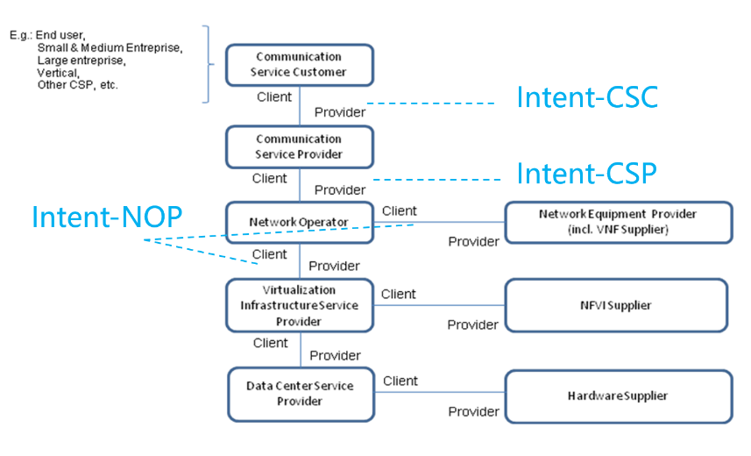
Figure 6.3.1-1 Roles related to 5G networks and network slicing management
3GPP specifies the intent driven MnS (including management operations and intent model) to manage 3GPP network and services, and provides interoperability capability between MnS consumer and MnS producer, TM Forum defines the intent management API (including management operations and intent model) between intent owner and intent handler.
For the management of 3GPP network and services, currently there is no description for the deployment scenarios for intent interface.

6.3.2 Potential deployment scenarios

6.3.2.1 Potential deployment scenario#1
In this deployment scenario, 3GPP intent driven MnS (defined in TS 28.312 [2]) can be applicable for following kinds of standardized reference interfaces for the management of 3GPP network and services:
- Management interactions for Intent-NOP between NOP and NEP;
- Management interactions for Intent-CSP between CSP and NOP;
- Management interactions for Intent-CSC between CSC and CSP;
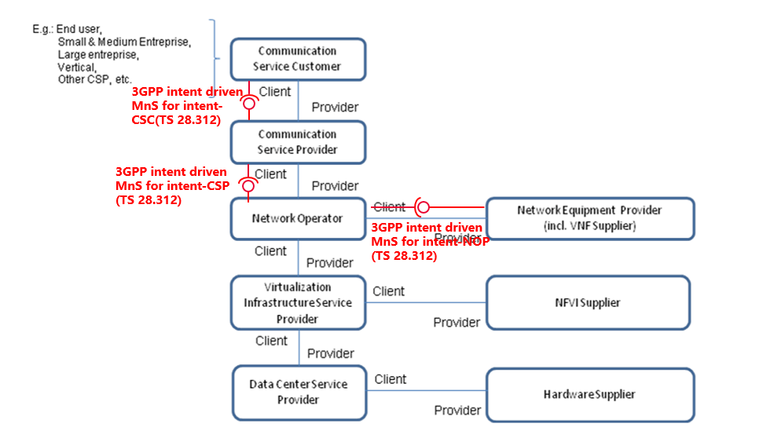
Figure 6.3.2.1-1: Potential intent interface deployment scenario#1

6.3.2.2 Potential deployment scenario#2
In this deployment scenario, 3GPP intent driven MnS can be applicable for following kinds of standardized reference interfaces for the management of 3GPP network and services:
- Management interactions for Intent-NOP between NOP and NEP;
- Management interactions for Intent-CSP between CSP and NOP;
TM Form intent management API can be applicable for following kinds of standardized reference interfaces for the management of 3GPP network and services:
- Management interactions for Intent-CSC between CSC and CSP;
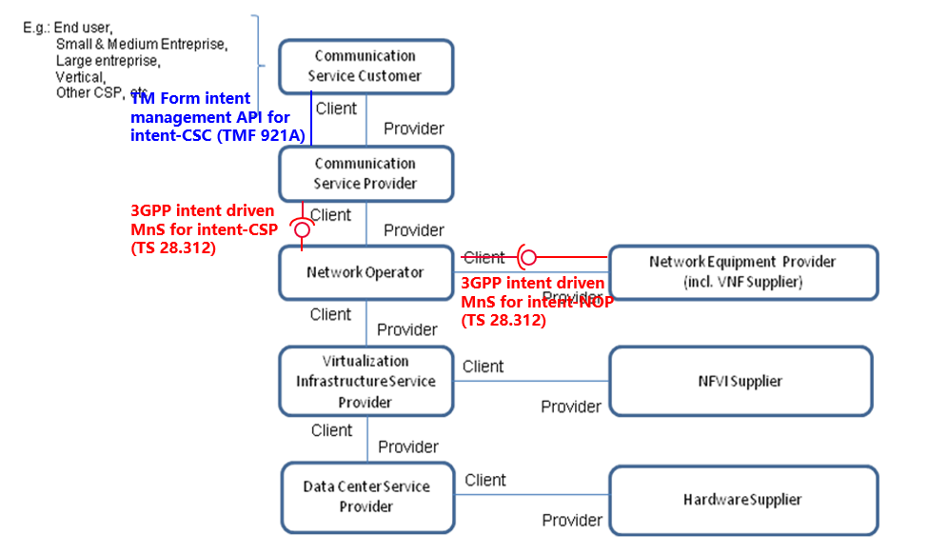
Figure 6.3.2.2-1: Potential intent interface deployment scenario#2
In this intent interface deployment scenario, following contents can be used as guidelines for transformation functionality between TM Forum intent management API for intent-CSC and 3GPP intent driven MnS for intent-CSP.- Mapping the 3GPP and the TM Forum intentExpectation Models described in Annex C in TS 28.312 [2].
- Comparison of 3GPP intent management operations and TM Forum intent management operations described in clause 6.1.2.
- Comparison of 3GPP Intent procedures and TM Forum Intent management functionality described in clause 6.2.2.

7 Conclusion and recommendation

7.1 Conclusion and recommendation for new capabilities

7.1.1 Issue#4.1: intent driven approach for RAN energy saving
It is recommended to introduce the scenario and requirements for intent driven approach for RAN energy saving, and define corresponding scenario specific IntentExpectation definition (including introducing new expectation targets for RAN Energy Consumption and RAN Energy Efficiency).
The detailed solution see clause 4.1.3.

7.1.2 Issue#4.2: Intent conflicts and intents containing contradictions
It is recommended to introduce three intent related conflict scenarios, including Target conflict, Expectation conflict and Intent conflict. Also recommend to introduce the notification information provided by MnS producer when such a conflict is detected with the specified intent, intent expectations or expectation targets which give rise to the conflict. Additionally, MnS consumer can give intent conflict handling guidelines to MnS producer as contexts to solve such intent conflict.

7.1.3 Issue#4.3: Enhancement of radio network intent expectation
It is recommended to enhance the existing radio network intent expectation to support following aspects:
- Support MnS consumer to express the radio network expectation targets for the coverage area represented by a list of Cells.
- Support MnS consumer to express the radio network expectation targets for the specific service type or UE groups instead of the whole radio network.
- Support MnS consumer to express the radio network capacity targets (including Maximum HighUL/DLPRB Load Ratio) for the specified areas.
- Support MnS consumer to express the radio network transport contexts (including NgInterfaceContext, OMInterfaceContext and NextHopContext) for delivering a radio network for a specified area.
- Support MnS consumer to express the radio network expectation targets for specific time periods.
The detailed solution see clause 4.3.2.

7.1.4 Issue#4.4: 5GC related intent expectations
It is recommended to introduce the IntentExpectation for core network by utilizing the construct of the generic IntentExpectation <<dataType>> with set of allowed values and concrete dataTypes, including the objectType, ObjectContext and ExpectationTargets for the 5GC to represent MnS consumer's expectation for 5GC.
The detailed solution see clause 4.4.3.1.

7.1.5 Issue#4.5: Intent Report
It is recommended to introduce the new IntentReport <<IOC>> to represent the three types of intent report information. In the associated Intent, including intent fulfilment information, achieved values for targets and intent conflict information. The MnS consumer can query the IntentReport <<IOC>> to obtain the intent report information and/or subscribe for update notifications to obtain intent report information.
A proposed solution is detailed in clause 4.5.3.1 which will provide the basis for the solution.

7.1.6 Issue#4.6: Intent-driven Closed Loop control
It is recommended to introduce a network optimization expectation which capture the desired optimization targets for a specific network scope and which then enable the MnS producer to configure one or more closed loops with goals to achieve the optimization targets.
The detailed solution see clause 4.6.3.

7.1.7 Issue#4.7: Monitoring intent fulfilment information
It is recommended to introduce the attribute "executionTime" in Intent <<IOC>> to allow MnS consumer to represent the requirements for the execution time of the intent.
Intent report related conclusion see the Intent Report in clause 7.1.5.

7.1.8 Issue#4.8: Enablers for Intent Fulfilment

7.1.8.1 Testing Intent-driven MnS Capabilities
It is recommended to introduce to the normative specification a new attribute to indicate whether an intent is an intent under test or not. Relatedly, it is recommended to introduce the new attribute to indicate if the test has been successful or not
The detailed solution see clause 4.8.4.1.

7.1.8.2 Mapping of Intents to ML Entities capabilities
It is recommended to introduce the AIML_capability_mapping_report <<datatype>> with which the intent driven MnS Producer can inform its potential intent driven MnS consumers about the AI/ML capabilities it relies on to accomplish intent fulfilment. Additionally, it is recommended to introduce an attribute on the intent object that used by an intent driven MnS consumer to request for specific capabilities to be applied for their intents.

7.1.8.3 Intent-driven SON orchestration
It is recommended (as proposed in clause 4.8.4.3) to introduce attributes in the fulfilmentInfo <<datatype>> or intent report to support intents using SON orchestration. These attributes indicate the failure or success of fulfilling the intent using SON orchestration, or if the intent is not in the scope if SON orchestration. These attributes may also indicate failures such as contradictions detected in the SON orchestration.
This solution is only applicable using SON functions to support intents

7.1.8.4 Intent-driven for MDA
It is recommended to introduce new attribute in the fulfilmentInfo <<datatype>> or intent report for indicating when the intent expectation cannot be fulfilled and it is because of the expectation target is not in the scope of the supportedMDACapabilities of the correlated MDA function.

7.1.9 Issue#4.9: Intent fulfilment feasibility check
The study identified the issue for feasibility check in following two options:
- Option#1: MnS producer automatically conducts feasibility check when it receives the intent creation or modification request from MnS consumer.
- Option#2: MnS consumer requests intent-driven MnS producer to check the feasibility of intent fulfilment before making intent creation or modification request.
Regarding Option#1, it is recommended to introduce the feasibility check result info (including feasibilityResult and inFeasibleReason) in intent report model to allow the MnS consumer to obtain the feasibility check result.
Regarding Option#2, there is no concrete solution identified in the present document. So, it is recommended to further investigate the solution in the future.

7.1.10 Issue#4.10: Intent handling capability obtaining
It is recommended to introduce the new IntentHandlingFunction <<IOC>>, which includes a list of supportedIntentHandlingCapability <<datatype>> which represent intent handling function's capabilities in support of intent handling. Change the Intent <<IOC>> to be contained by IntentHandlingFunction <<IOC>>.
The detailed solution see clause 4.10.2

7.1.11 Issue#4.11: Enhancement of generic Information model definition
It is recommended to enhance the existing generic intent information model support following aspects:
- Introduce attribute "intentAdminState" in Intent <<IOC>> to allow MnS consumer to suspend and resume an intent.
- Introduce attribute "observationTime" in Intent <<IOC> to allow MnS consumer to specify the observation period for the intent fulfilment evaluation
- The detailed solution see clause 4.11.2.

7.2 Conclusion and recommendation for the solution for requirements documents in TS 28.312

7.2.1 Issue# 5.1: Solution for radio service intent expectation
It is recommended to introduce the RadioServiceExpectation by utilizing the construct of the generic IntentExpectation <<dataType>> with set of allowed values and concrete dataTypes, including the objectType, ObjectContext and ExpectationTargets for the radio service intent expectation as one of the scenario specific intent expectation.
The detailed solution see clause 5.1.2.

7.2.2 Issue# 5.2: Enhancement for service support expectation
It is recommended to add userExperienceContext and userExperienceTarget into the construct of the IntentExpectation<< dataType >>, to enhance the concrete definitions for user experience.
The userExperienceContext includes attributes: contextAttribute, contextCondition and contextValueRange. The concrete userExperienceContext is not defined in the present document.
The userExperienceTarget includes attributes: targetName, targetCondition and targetValueRange. The concrete userExperienceTarget is not defined in the present document.
So, it is recommended to further investigate the solution in future release.

7.3 Conclusion and recommendation for collaboration with other SDOs
It is recommended to introduce the intent interface deployment scenarios (including deployment scenario#1 described in clause 6.3.2.1 and deployment scenario#2 described in clause 6.3.2.2) for the management of 3GPP network and services in the Annex of TS 28.312 [2].
To support the deployment scenario#2, It is also recommended the following content to be added in the Annex of TS 28.312 [2] as guidelines for the transformation functionality between TM Forum intent management API for intent-CSC to 3GPP intent driven MnS for intent-CSP.
- Comparison of 3GPP intent management operations and TM Forum intent management operations described in clause 6.1.2.
- Comparison of 3GPP Intent procedures and TM Forum Intent management functionality described in clause 6.2.2.
The detailed solution see clause 6.1.2, clause 6.2.2 and clause 6.3.2.

Annex A (informative):
Change history

Change history
Date | Meeting | TDoc | CR | Rev | Cat | Subject/Comment | New version
2022-04 | SA5#142e | S5-222244 |  |  |  | TR 28.912_000 | 0.0.0
2022-04 | SA5#142e | S5-222255  S5-222256  S5-222620  S5-222569 |  |  |  | 1.pCR TR 28.912 Add scope  2.pCR TR 28.912 Add structure  3.pCR TR 28.912 Add key issue for intent driven approach for RAN energy saving  4.pCR TR 28.912 Add potential requirements for intent conflict information | 0.1.0
2022-05 | SA5#143e | S5-223568  S5-223569  S5-223570  S5-223571 |  |  |  | 1. pCR TR 28.912 add key issues for 5GC intent expectation  2. pCR TR 28.912 Add potential solutions for RAN energy saving to clause 4.1.2  3. pCR TR 28.912 add key issue for missing solution for radio service intent expectation  4. pCR TR 28.912 add key issue for enhancement of radio network intent expectation | 0.2.0
2022-07 | SA5#144e | S5-224358  S5-224359  S5-224360  S5-224361  S5-224362  S5-224363 |  |  |  | 1.pCR TR 28.912 Add issue for intent Report  2.pCR 28.912 Intent-driven Closed Loop Composition  3.pCR TR 28.912 Update issue for intent conflict  4.pCR TR 28.912 add potential solution for 5GC intent expectation  5.pCR TR 28.912 Add conclusion and recommendation for existing issues  6.pCR TR 28.912 Add issue for mapping intent operations between 3GPP and TM Forum | 0.3.0
2022-08 | SA5#145e | S5-225198  S5-225200  S5-225202  S5-225421  S5-225680  S5-225681  S5-225682  S5-225683  S5-225684  S5-225685  S5-225686  S5-225687  S5-225688  S5-225689  S5-225690  S5-225691  S5-225692  S5-225414 |  |  |  | 1. pCR TR 28.912 Rapporteur clean up  2. pCR TR 28.912 Update Issue#4.3 enhancement of radio network intent expectation to include the context for transport  3. pCR TR 28.912 Add conclusion and recommendation for existing key issues  4. pCR TR 28.912 Update issue for enhancement of radio network intent expectation  5. pCR 28.912 Potential solution on Intent conflicts  6. pCR 28.912 Add potential solutions for intent conflict  7. pCR TR 28.912 add potential solution for 5GC fault management  8. pCR TR 28.912 add potential solution for 5GC optimization  9. pCR 28.912 Add key issue for intent execution monitoring  10. pCR TR28.912 Key issue on enablers for Intent Fulfilment  11. pCR TR 28.912 Add key issue for intent feasibility check  12. pCR TR 28.912 Add issue for Intent handling capability obtaining  13. pCR TR 28.912 Add issue for enhancement of generic intent information model definition  14. pCR TR28.912 use case on Intent to AIML Capability Mapping  15. pCR 28.912 Solution on AIMLEntity Capability Discovery and mapping  16. pCR TR 28.912 Intent driven SON orchestration  17. Rel-18 pCR TR 28.912 Add TMF procedure mappings  18. pCR 28.912 issue#4.2.1 Intent conflicts description enhancement | 0.4.0
2022-09 | SA#97e | SP-220952 |  |  |  | Presented for information | 1.0.0
2022-11 | SA5#146 | S5-226165  S5-226167  S5-226398  S5-226901  S5-226902  S5-226903  S5-226904  S5-226905  S5-226907  S5-226911  S5-226912  S5-226995 |  |  |  | 1. pCR TR 28.912 Rapporteur clean up  2. pCR TS 28.912 Add conclusion and recommendation for existing key issue  3. pCR TR28.912 Solution on intent fulfilment feasibility check  4. pCR TR 28.912 Update the description of Issue#4.2 intent report  5. pCR TR 28.912 Add Intent Reporting requirements  6. pCR TR 28.912 Add Intent Reporting Solutions  7. pCR TR 28.912 Update issue for Intent conflicts potential solution  8. pCR 28.912 Add priority to potential solution for intent conflicts  9. pCR TR 28.912 Potential Solution on enablers for Intent Fulfilment  10. pCR TR 28.912_new_capability_for_enabler_of_MDAS  11. pCR TR28.912 Update Solution on 5GC related intent expectation  12. pCR TS 28.912 Update Issues related to collaboration and alignment with other SDOs | 1.1.0
2023-03 | SA5#147 | S5-232205  S5-232323  S5-232778  S5-232781  S5-232782  S5-232783  S5-232784  S5-232786  S5-232788  S5‑232789  S5-232790  S5-232791  S5-232792  S5-232814  S5-232901  S5-232951  S5-232991 |  |  |  | 1. pCR TR 28.912 Rapporteur clean up  2. pCR TR 28.912 Recommend Solution for Intent Reporting  3. pCR TS 28.912 Update Issue#4.7 Monitoring intent fulfilment information  4. pCR TR 28.912 Add conclusion and recommendation for monitoring intent fulfilment  5. pCR 28.912 update potential solution for 5GC related intent expectation  6. pCR TR 28.912 Add Comparison and analysis of potential solutions  7. pCR 28.921 Transparent Intent Reporting Window  8. pCR TR 28.912 Add enhancement aspect6 and potential solution for user experience assurance  9. pCR 28.912 Add potential solution for intent conflicts  10. pCR 28.912 Add reexecution point of intent after intent conflicts resolution  11. pCR TR 28.912 Add conclusion and recommendation for issues related to collaboration with other SDOs  12. pCR TS 28.912 Add conclusion and recommendation for issues which need further investigation  13. pCR TR 28.912 Additions to Conclusion and recommendation  14. pCR TR 28#4.x user service experience based RAN energy saving  15. pCR TR 28.912 Address the inconsistent issue for intent report  16. pCR TS 28.912 Conclusion on Testing Intent-driven MnS Capabilities  17. pCR 28.912 add potential solution for intent-driven for MDA | 1.2.0
2023-04 | SA5#148e | S5-233275  S5-233558  S5-233559  S5-233560  S5-233561  S5-233562  S5-233563  S5-233564  S5-233565  S5-233566  S5-233567  S5-233568  S5-233585 |  |  |  | 1. pCR TR 28.912 Correct the wrong target and context definition in Issue#5.2  2. pCR TR 28.912 Potential Solution on Intent-driven Closed Loop control  3. pCR TR 28.912 Update the Issue#4.6 Intent-driven closed loop control  4. Rel18 pCR TR 28.912 Add intent fulfilment feasibility information into intent report  5. pCR 28.912 Intent fulfilment feasibility check and corresponding solutions  6. Rel18 pCR TR 28.912 Clarification on Issue 4.1 intent driven approach for RAN energy saving  7. Rel18 pCR TR 28.912 Clarification on Issue 4.2 Intent conflicts  8. pCR 28.912 issue#4.5.1 Intent report description enhancement  9. pCR 28.912 Clarifying the use of ObjectContext and defining another value Property for configuration expectations  10 pCR TR 28.912 Add conclusion and recommendation for enhancement for service support expectation  11. pCR TR 28.912 Rapporteur on clause 4  12. pCR TR 28.912 Rapporteur clean up on clause 6  13. pCR 28.912 issue#4.5.2.1 Intent report potential solution#1 enhancement | 1.3.0
2023-06 | SA#100 | SP-230645 |  |  |  | Presented for approval | 2.0.0
2023-06 | SA#100 |  |  |  |  | Upgrade to change control version | 18.0.0
2023-06 | SA#100 |  |  |  |  | EditHelp review | 18.0.1
2025-09 | SA#109 | - | - | - | - | Update to Rel-19 version (MCC) | 19.0.0

