Why can equal results lead to different scientific futures: How humans and AI jointly form the conditions for further discovery
AI participates in mathematical research and sustained scientific work. How does historically situated human–agent practice form capacities that change subsequent problem-solving conditions? Mathematicians warn that AI’s problem-solving gains can diverge from mathematical goals: understanding, method development and transmission, training researchers and asking new questions. OpenAI’s Navier–Stokes account describes intermediate results organised into conditions for later work; persistent agents make retaining, accessing, revising and using these conditions operational.¹–³ Our account examines how relations between problems, methods, evidence and responsibilities are formed and rebuilt; mathematics establishes insufficiency and sufficient repair, while process records trace formation, revision and reuse. A finite construction shows that equal specified current readouts need not determine the next correction: readout-only correction has a positive lower bound on error, removed by a compact state-aware rule. Recorded programmes undergo feedback-driven revision and changed-target reuse. Counterintuitively, one revision relinquishes local exactness so a non-zero residual cancels an inherited-state term and improves the whole: earlier work can create conditions requiring reconstruction of a previously successful operation. Separately, in a selected known-proof completion, shared declarations become a premise used downstream: with explicit researcher-written applicability guidance, the third candidate is accepted in saved compilation; the comparison remains incomplete. Convergence, unchanged versions and execution-dependent contrasts remain; no general history effect is established. The separation and records distinguish obtaining results from sustaining their future usability, making the formation, adoption, maintenance and reconstruction of research conditions an explicit research object with identifiable people, records and tools, inspectable processes and testable consequences.

Introduction
Mathematicians’ statement warns that growing AI success in producing answers need not also form the understanding, methods and capacities for further inquiry that mathematical practice seeks.¹ It treats problem solving as a means towards understanding, training as a way of building understanding and the ability to ask new questions, and explanation, refinement and transmission within the community as conditions for methods and ideas to become usable by others.
OpenAI’s published Navier–Stokes (NS) account illustrates a complementary relation: intermediate results can become conditions for subsequent research through judgement, organisation and actual adoption.² After the Euler result, the researchers selected NS as the most promising direction, redirected agents from other problems and supplied that result to the continuing groups. Codex subsequently consolidated insights across groups into guidance for further work. The account also reports an update to a more extensively trained model during the effort, so these events describe an organised process with several changing factors. In persistent Codex workflows, working files, notes, context transitions and tool feedback make retaining and revising earlier work concrete operations.³ These settings expose a common question: when people and AI produce useful results, what conditions do they also form for inquiry to continue?
Our central question is how humans and agents, through historically situated joint practice, form capacities that change their own conditions of problem solving. Our candidate answer concerns the relations connecting problems, methods, evidence and responsibilities: research can form the conditions for subsequent research, and these conditions can themselves require maintenance or reconstruction. The same declared result need not determine how it can be checked, corrected or developed next. We establish one precise limitation on a result-centred description: equality of a specified current readout can leave an unavoidable discrepancy between the corrections required by different successor states. Preserving a compact, relevant state removes that discrepancy. “Equal” names a specified product, observation or current function, not a complete causal state; “scientific futures” names subsequent duties within stated tools, permissions and resources. Compact preservation and legitimate reconstruction are positive sufficient cases.
This distinction has established foundations. Proofs convey methodological knowledge beyond statements, and productivity need not coincide with understanding.⁴,⁵ Retrieval-assisted proving studies the availability of premises; truth-maintenance systems maintain reasons and revise dependent beliefs.⁶,⁷ Predictive representations characterise state through future action-dependent consequences, and equivalent expressive resources can have different optimisation dynamics.⁸,⁹ Organisational routines link situated performances with patterns they preserve and change.¹⁰ These accounts already address use, change and relationships. Our explanatory contribution is to organise the production, adoption and reconstruction of research conditions as a connected object of comparison: a usable method interface, an evidential obligation or an allocation of checking can be an outcome of earlier work and a condition of later work. We operationalise this object by separating what is available from what is actually used, what remains sufficient from what must be reconstructed, and a specified output from the state required for continuation. The finite witness and the two kinds of process record make different parts of these distinctions inspectable. Accordingly, an output comparison and a comparison of what can be done next need not hold the same things fixed.
Recent studies make this distinction timely. Research on model warmth tests a relation between desirable conversational properties rather than assuming their compatibility.¹¹ Model-collapse research examines how generated outputs alter later training conditions.¹² Paper2Agent converts papers and computational resources into interactive, executable research objects.¹³ Our concern is complementary: once a result or tool is available, how is its applicability established, used and reconstructed when its consequences expose a new requirement? We do not claim a newly discovered law of memory or proof application. We make this relation inspectable through a finite non-sufficiency result, a constructive repair, actual mathematical revision and successor-use records, and a known-proof application whose generated premise is consumed downstream. The mathematical result specifies a distinction between comparisons; the coefficient records make revision and changed-target reuse inspectable; and the Lean record shows a generated premise actually being consumed.

Practice makes future conditions
Consider a bounded research system containing people, agents, records, tools and the relevant environment. Let $x_{t}$ denote its causally relevant state and $P_{t}=M(x_{t})$ a specified present product or observation. Its recorded history $H_{t}$ is evidence about how it reached that state, not a substitute for the state itself. A research arrangement links a problem to an admissible method, a method to evidence, and evidence to a participant or procedure authorised to use, challenge or revise it. These links have concrete carriers: parameter bindings, proof interfaces, test provenance, access rules, methodological explanations and assignments of responsibility. They may be explicit, distributed across participants or only partly recorded.
Four comparisons must therefore be separated. Product equivalence fixes a declared output or observation. Record equivalence fixes selected stored material. Complete causal-state equivalence fixes the relevant system and environment, rather than just their documentation. Finally, operational sufficiency is relative to a future regime $F$: specified duties, tools, permissions, resources and a declared family of continuation policies. Two states are equivalent under $F$ when their relevant future outcomes and costs have the same law under those matched policies. A proof, an error value or a list of lemmas can be equal while the other comparisons are not. If complete causal states and transition rules are equal, an unencoded historical force cannot explain different futures.
A research episode begins with an arrangement that makes some actions possible: a problem formulation, methods that participants know how to use, evidence with an assigned scope, and responsibilities for checking it. Joint work produces more than a saved answer when it changes this arrangement. A tested estimate may justify choosing a new route; a proof may expose a reusable parameter substitution; a failed derivation may identify a missing hypothesis. The relevant carrier can be a formula, an executable file, an explanation, a test receipt or a person’s acquired method. Formation is identified by an actual construction or revision history, not inferred merely because a useful object exists.
Adoption is the next distinct operation. A result becomes a working condition when it constrains a real decision or is instantiated as the premise of another inference. The resulting action produces consequences: a test confirms a limited range, a compiler rejects a binding, or a new application reveals that the evidence did not cover the intended case. Such feedback can leave the method unchanged, narrow its scope, alter an interface, or change who must check the claim. The changed arrangement becomes a reproduced research condition only when it participates in another action. Figure 1 distinguishes the established separation from its recorded operational instances. This sequence explains why accumulating correct outputs and maintaining future usability can coincide, but need not do so.
The human organiser belongs inside this sequence. Marx’s third thesis on Feuerbach challenges accounts that place the educator outside the process of change.¹⁴ Mao’s account of practice centres renewed action and revision under changed conditions.¹⁵ Here these ideas determine the boundary of the research system: selection, diagnosis, methodological explanation, checking labour and their possible errors must be recorded alongside agent behaviour. They do not prove a computational mechanism. In the retained study, human interventions altered the task and supplied an applicability strategy. Treating that contribution as free, infallible background would misattribute jointly organised performance to the model alone.
Three operations have different evidential requirements. U1, using an existing method, includes applying a known theorem with the right substitutions. U2, forming a method through practice, requires a newly established procedure or relation with an identifiable production history; constructing a particular proof object is a narrower instance than discovering a general method. U3, reconstructing a method under changed conditions, requires a documented change in what the method must handle, a corresponding reconstruction and evidence of subsequent use. These operations need not occur in order or in every episode. A stable classical method may remain sufficient. A never-formed condition is not a lost one; an available but unused method is not forgotten; and restoration of a previously available arrangement differs from first formation or new reconstruction.
The account yields three conditional propositions. First, if a later duty depends on an applicability relation not determined by a specified current product, product equality alone cannot warrant continuation equality; the mathematical example below provides one exact case. Second, if a preserved or reconstructed interface supplies all required observations, updates and operations within budget, a more elaborate historical carrier is unnecessary for that regime. Third, a claim that joint practice produced a capacity requires a trace of formation, actual use and relevant consequences, not just a correlation between archive size and a final score. These propositions change what a comparison holds fixed: current output, available information, adopted working relation and complete state are different controls. An intervention that changes a purportedly relevant relation but leaves the predicted consequence unchanged, without repair through another route, would narrow its proposed role. Stable classical methods and adequate single-system implementations are substantive sufficient cases, not failed controls.

Equal readouts, different corrections
The mathematical witness has a precise explanatory role: under its stated observation restriction, a present result does not determine the correction required next, whereas a compact state-aware operation does. A specified present readout is insufficient for exact correction across two admissible successor states. The source NS work uses a fixed primary wave and a covariance operator; positive amplitudes and an integral matrix support later signed corrections while retaining a quadratic remainder.¹⁶ We examine its explicitly derived coefficient reduction. Let $z$ be the actual amplitude relative to a fixed base, $p$ the target squared amplitude, $r=p−z^{2}$ the residual readout and $g$ an applied increment. Writing $u=z−1$, the complete consequence is
$$E=(z+g)^{2}−p=(2g+g^{2}−r)+2ug. (1)$$
The first term is the pure correction residual at the fixed base; the second contains the effect of the state already produced. Reducing the first term need not reduce their sum. Thus a continuation cannot be described solely as solving the same fresh problem repeatedly: the previous operation changes what the next one must receive.
Fix $0<r≤1/4$ and $0<v≤1/8$, and consider $z_{±}=1±v$ with targets $p_{±}=z_{±}^{2}+r$. These two states have the same declared readout $r$. Any deterministic action depending only on that readout must use the same $g$, giving
$$E_{±}=g^{2}+2(1±v)g−r, E_{\text{+}}−E_{\text{−}}=4vg. (2)$$
Both residuals cannot vanish: that would require $g=0$ and hence $r=0$. More strongly,
$$\inf_{g∈R}\text{max}\left\{|E_{\text{+}}|,|E_{\text{−}}|\right\}=2v\left(\sqrt{1+r}−1\right)>0. (3)$$
To see the bound, write the maximum as $|g^{2}+2g−r|+2v|g|$. On $g≥0$ its minimum occurs at $g=\sqrt{1+r}−1$; on $[−2,0]$ it is at least $r$, and reflection of the remaining negative branch adds a positive offset. Supplementary Note 2 gives the piecewise proof. The restriction is explicit: the same deterministic action sees only $r$, whereas $z_{±}$ and $p_{±}$ differ. This is not equality of complete current function, nor an assumption that the model in the later case ignored its state.
Adding the relevant state gives a constructive alternative. For $r∈[−1/2,1/2]$ and $u∈[−1/4,1/4]$, let $z=1+u$ and $w=\sqrt{z^{2}+r}$. The radicand is at least $1/16$. Define smooth core functions
$$C_{\text{*}}(r,u)=−\frac{1}{2z}, B_{\text{*}}(r,u)=−\frac{1}{2z(w+z)^{2}}. (4)$$
With a smooth cutoff $Φ$ equal to one on $|r|≤1/4$, $|u|≤1/8$ and zero outside the stated outer rectangle, the operation
$$g=\frac{r}{2}+Φ\left\{r^{2}B_{\text{*}}+urC_{\text{*}}\right\} (5)$$
satisfies $g=w−z$ and $E=0$ in the inner region. Outside the outer rectangle it returns to the signed linear correction; the transition remains smooth. The relevant state and a compact operation thus suffice for exact local correction. Positivity and all denominators are checked on an open neighbourhood of the stated outer rectangle, with no evaluation of a square root across a negative radicand.
This witness gives the title a precise meaning (Fig. 2): equality of a declared present quantity can coexist with a positive lower bound for observation-restricted correction, and the separation can disappear when the required state is preserved or reconstructed. These are standard algebraic tools applied to a specified continuation problem. Extending the construction to weighted wave classes requires the source derivative, support and multiplier assumptions. Neither the local witness nor a finite numerical check independently proves the global NS theorem, universal norm improvement or the properties of arbitrary generated code. Supplementary Note 2 states this mathematical scope once alongside the preserved counterexamples.

When compact inheritance is enough
A compact record can preserve continuation without preserving the entire history. Suppose a compact record $c=C(x)$ supports the observations, permitted actions, successor updates and costs required by a declared family of future duties. Under common joint kernels, matched exogenous-input laws and the initial-history conditions of Supplementary Note 3, factorisation through $c$ and a common compact-state update reproduce the relevant finite continuation law. This is the standard sufficient-state composition principle, proved by induction in Supplementary Note 3 and consistent with predictive representations.⁸ The result includes the transitions: reproducing today’s answer alone is insufficient. Legitimate rederivation also supplies a sufficient route when its construction and retrieval costs fit the specified budget.
The scientific problem is consequently not to maximise retained history. It is to identify what must remain actionable as the duties change. A compact interface, a conventional method or a single integrated solver can be fully sufficient; copying an entire transcript may add no value. An archive can preserve information without making it usable at the relevant time. Conversely, a summary can preserve the right conditions without preserving their entire production history. A shift to new duties can invalidate a previous sufficiency judgement, making the representation or method itself a legitimate object of further practice. This is the transition from inheritance to reconstruction, rather than an assumption of inevitable degradation.

Recorded revision and continued use
The coefficient records connect the distinction in equation (1) to actual formation, feedback-driven revision and subsequent use: an exact pure component can leave a whole residual through its interaction with the inherited state. Archived coefficient studies record actual revision and reuse under changed targets. Four formation episodes in an assistance comparison and eight in a version-adoption comparison produced 52 recorded stages and 104 completed model returns. Real programmes, feedback and the resulting amplitude fields were carried forward to changed targets. The common operation was $g=r/2+Φ(r,u)[r^{2}B(r,u)+urC(r,u)]$; the agent supplied $B,C$, while the investigators supplied the template, cutoff, sources and duties. These observations directly instantiate equation (1), but not a complete NS construction. Two post-selected traces make the mathematical content of this continuation explicit (Fig. 3; Supplementary Note 9).
In one assistance episode, the initially formed rule retained $B_{0}=−1/[2(1+\sqrt{1+r})^{2}]$ and $C_{0}=0$. Writing $s=\sqrt{1+r}$, it gives $g=s−1$. At formation, the declared core was evaluated from the fixed base, so the pure residual also described the complete residual. In the subsequent duty, the actual state produced by that work was inherited rather than reset. The same rule still made the pure residual exactly zero, but its full successor residual was $2u(s−1)$.
Within this first continuation, the initial, draft and final versions used the same incoming state and target at each matched coordinate. The agent’s first revision introduced $C_{1}=−1/[s(1+s)]$, changing the complete residual to $−u^{2}r/(1+r)$. After numerical feedback, it produced a smooth secant expression for $C$, while retaining $B_{0}$. On the declared core this gives $g=\sqrt{(1+u)^{2}+r}−(1+u)$ and an exactly zero complete residual. Crucially, the revised pure residual is generally non-zero: it cancels the inherited-state cross term. Correct continuation here required relinquishing a locally exact subresult, not improving every component separately.
The recorded next continuation received and retained that actual programme and used its predecessor’s state for a changed target. The within-duty version comparison documents reconstruction; the subsequent duty documents inheritance and actual renewed use. Because the inherited state and target changed, the latter is not another comparison under the same conditions. The programme’s availability and its adoption as a condition of further work are separately visible in this record.
A second episode recorded $B=−1/8$ and successive programmes with $C=−1/2$, $−1/2+u/2$, and $−1/2+u/2−u^{2}/2$. These were generated, applied and passed onward, rather than inserted retrospectively by the analyst. For $u=aτ$ and $r=bτ^{3}$, their whole residuals generally begin at orders $τ^{5}$, $τ^{6}$ and $τ^{7}$. The later duty was evaluated on the actual inherited field, not a reset base. This is a finite instance of revision under a changed target and renewed use. It is not a new general series method: the coefficients follow a familiar expansion, and the original explanation of one remaining term contained a sign error that is distinguished from the effective programme in Supplementary Note 9.
These traces are process evidence, not substitutes for the original comparisons. Seven of eight version pairs had identical initial and revised code; five final responses across the two studies were empty. In the fixed outer region, any valid programme applied $r/2$, whereas an empty final response applied no update. This route dominated large positive or negative aggregate contrasts. All original denominators and outcomes are retained, including the separately authorised supplementary observation replacing an unavailable analysis slot without resolving its historical unknown request. No stable average assistance or adoption benefit was established. Earlier finite-scalar comparisons also converged after adaptation. Thus revision and renewed use were observed, whereas their general causal advantage remains unresolved. This distinction replaces neither null results with selected successes nor executed work with a claim that no continuation occurred.

An available result becomes a premise
A separate proof-completion record shows an existing mathematical result being made usable by a supplied consumer, at a different location in the covariance construction. The recorded task completes hclose inside the supplied Lean theorem compact_chart_pair_bounds.¹⁷,¹⁸ The outer proof and two relevant lemma declarations were identical in the two conditions. An additional note in one condition explained how to apply those results to the current obligation. This deliberately selected, known-proof task supplies a local record of turning existing mathematics into an accepted premise; it is not a controlled instantiation of the two-state lower bound in equation (3).
The common mathematical assumption bounds a pulse-ratio error on an interval of length $L_{n}$. The available integral estimate expects the interval, denominator and centre in terms of $R_{n}^{2}$. A second common lemma states $R_{n}^{2}=L_{n}$. The obligation is therefore not to discover a missing numerical inequality, but to transport the entire dependent premise into the representation required by the integral estimate. Rewriting interval membership alone is insufficient: the conclusion obtained from that membership must also be rewritten. Figure 4 locates the exact application and its fixed downstream use.
After this transport, the supplied integral lemma yields
$$|\overline{H}(P)_{ij}−H_{0}(ξ)_{ij}|≤\frac{e+dc}{R_{n}}≤\frac{e+d|c|}{R_{n}}=\frac{Q}{R_{n}}≤ρ. (6)$$
Here $d≥0$, $R_{n}>0$, $Q=e+d|c|≥0$, and the last comparison is already provided. The symbol $e$ denotes the source error coefficient, not the residual $E$ in equation (1). No division by $Q$ is required, so the case $Q=0$ is retained. The resulting hclose object is passed to the pre-written hmargin application, which supplies margins subsequently combined with column-scale bounds to construct ZeroOrderBounds. This is actual consumption of a local proof object by downstream code, not an inferred relevance relation. The pulse construction, integral estimate, compactness argument and downstream plan themselves were supplied.
Abstractly, a result $L:∀θ, A(θ)→C(θ)$ becomes usable for a consumer requiring $I$ only after an admissible parameter choice, evidence for $A(θ)$ and any necessary transport from $C(θ)$ to $I$ have been supplied. This is ordinary proof composition, not a new logical mechanism. It specifies the concrete relation observed here: common declarations did not by themselves determine whether a usable instance was constructed within the available work sequence. A correct compact record of that instantiation could be sufficient. The empirical case concerns application, whereas equations (1)–(5) concern state-dependent correction. Their correspondence is explanatory, not a claim that the two experiments or causal mechanisms are identical.

What the recorded comparison establishes
The saved record contains six returned model requests and five compiled candidates (Fig. 4). The applicability-guided condition produced two rejected candidates, then a third accepted candidate. The declarations-only condition first reached the 32,768-token output limit without a visible proof body; its next two candidates were rejected. The accepted body was mechanically inserted into the common enclosing theorem, whose saved Lean output reports the exact local type and dependencies propext, Classical.choice and Quot.sound. Acceptance here denotes that retained compilation record; the local target’s meaning and the status of subsequent verification are stated separately in Methods.¹⁹
Both final candidates invoked the relevant integral lemma and scale identity. The final declarations-only body converted the interval-membership hypothesis, but returned an inequality still expressed using $L_{n}$ where the expected type used $R_{n}^{2}$. The accepted candidate completed the representation change and the scalar comparison. The difference is therefore narrower and more informative than “one condition found the theorem and the other did not”. It identifies where an available result failed to become a consumer-ready premise. The guided condition’s earlier failures are retained alongside this success; the first truncated comparison request is not labelled a mathematically refuted proof.
The investigators selected this gap after several broader workflows had been modified or stopped. The guided note was researcher-written procedural information, not a blind summary of history; it added 332 initial input tokens. Realised computation also differed: guided requests used 25,757 input and 20,781 output tokens, compared with 12,124 and 41,009, respectively, in the comparison. Compiler feedback and subsequent inputs were consequently different. The experiment documents this local application sequence and its recorded contrast. It does not establish a general success rate, efficiency advantage or causal effect isolated from extra guidance and context use. Position and presentation are plausible alternatives in light of previous context-use research.²⁰ No history-retrieval or compression manipulation occurred in the final protocol.
The proof-completion episode records use of existing methods, formation of a particular proof object and feedback-based revision of that object. Its downstream consumer was supplied, so it does not by itself test reconstruction for a new duty. The coefficient episodes do contain changed-target revision and renewed use, under an investigator-provided interface. These complementary records support the existence of particular application and reconstruction processes, not autonomous formation of every condition in the theoretical cycle. Their distinct inputs, tasks and sampling prevent their treatment as independent confirmations of one general effect.
These distinctions also prevent several different histories from receiving the same explanation. An empty terminal return records no final programme, not proof that a method was never formed; a draft may already exist. Identical code can still be adopted and used on an inherited state. A failed conversion of an existing lemma concerns applicability at the consumer interface, not absence of the lemma. Changed-target revision followed by renewed use is documented in the coefficient traces; first non-formation, an available method never adopted, and restoration of a lost arrangement remain distinct theoretical possibilities rather than additional observed categories in these records. Formation of the accepted proof object does not measure a change in human understanding.
In the coefficient trace, the earlier rule remained available; what changed was its relation to the inherited state and target. The record therefore locates reconstruction of applicability and subsequent adoption, rather than disappearance of the method.

Conditions for further discovery
The account makes the formation, adoption and reconstruction of usable research conditions an explicit object of explanation and evaluation. Its established mathematical separation is specific and constructive: a declared current readout need not determine the correction required next, and relevant state can provide a compact sufficient repair. Actual records show both a formed programme being revised and reused under changed targets and an available theorem being made into a premise consumed by downstream code. In the former, improving the complete result could require abandoning exactness of a component. Together these contributions connect an exact distinction between comparisons to inspectable operations in joint practice. They make result production and the maintenance of usable research conditions distinguishable objects of inquiry, without requiring long histories to be intrinsically valuable or a new force beyond ordinary state and transition descriptions.
For mathematical understanding and training, the finite separation changes the comparison that matters. Equal assessed answers do not establish that learners can check assumptions, recognise another use or formulate the next problem. Evaluation can therefore pair a current result with a later duty requiring a stated relation—such as adapting a method after a hypothesis changes—and record both. The human prediction is that differences appear where the necessary relation is not fixed by the assessed product and cannot be reconstructed within budget. If a compact explanation or ordinary rederivation restores transfer, it is a successful educational design, not a failure to demonstrate historical necessity. If matched product performance also predicts all prespecified continuation duties across such interventions, the proposed additional distinction is unnecessary in that setting. Testing these claims requires actual human activity; Lean acceptance is evidence about a proof object, not a measure of understanding.¹,⁴,⁵
For research organisation, an intermediate result has value both as a finding and as a possible change to the next research arrangement. It can redirect a route, shift the evidential responsibility between participants, or justify reallocating resources. Recording only the final output obscures the labour that makes these changes workable. A contribution record should therefore distinguish production, applicability work, actual adoption and continuing maintenance; it should also record unsuccessful coordination and corrections to human judgement. The NS process account motivates this distinction without separating the effects of transfer, model changes, resources and selection.² Organisational research can test this relation where duties and access can be documented. A handoff intervention can track changes in checking or research routes, then test whether another carrier restores the same outcome and cost. Equivalent compact handoffs demonstrate preservation of the relevant conditions; no change without such restoration narrows the proposed relation’s role.¹⁰
For persistent agents, a completed task can be evaluated by what remains possible afterwards: correction under new evidence, adjustment of scope and reconstruction of a method for a changed objective. Pinned Codex sources make notes, context transitions and historical access distinct operations; their availability does not establish that the right conditions are preserved.³ Executable-paper systems provide another useful carrier.¹³ The design question is what state or application interface must survive, who can revise it, and whether the revision is used. A compact certified interface, reliable classical routine or integrated solver may satisfy these requirements without a long transcript. Conversely, preserving every message may still fail to make the relevant relationship actionable. These predictions require specified future duties, budgets and observations of restoration; they do not license inferring alienation or loss of agency from one failed proof attempt.
Written proofs, executable checks, preserved programmes and complete comparison records provide a basis for independent reproduction and extension. The present work is responsible for its finite claims, their assumptions and these traceable instances. Mathematical training can investigate how current achievement relates to later checking and method transfer; organisational research can track how adoption changes responsibilities and research routes; persistent-agent research can test what must remain actionable for correction and adaptation. Each extension has to specify its duties and costs and retain cases in which compact records, classical methods or rederivation suffice. The common question is not simply how many results a system produces, but what its work leaves people and agents able to do next.

References
- Avila, A. et al. A Severe Misalignment of AI in Mathematics. Public statement (11 September 2026). doi:10.5281/zenodo.22737750.
- OpenAI. On the Navier–Stokes Millennium Prize Problem. Published process account (8 September 2026; updated 10 September 2026). https://openai.com/index/navier-stokes-solution/.
- OpenAI. Codex. Selected public sources at commit a8964cb1bad67bc26a826fb07d1bef99c6a3f008: context-window handler and history-notes extension (2026). Supplied immutable snapshot and licence; https://github.com/openai/codex/tree/a8964cb1bad67bc26a826fb07d1bef99c6a3f008.
- Rav, Y. Why do we prove theorems? Philosophia Mathematica 7, 5–41 (1999). doi:10.1093/philmat/7.1.5.
- Messeri, L. & Crockett, M. J. Artificial intelligence and illusions of understanding in scientific research. Nature 627, 49–58 (2024). doi:10.1038/s41586-024-07146-0.
- Yang, K. et al. LeanDojo: theorem proving with retrieval-augmented language models. Advances in Neural Information Processing Systems 36 (2023). arXiv:2306.15626.
- Doyle, J. A Truth Maintenance System. MIT Artificial Intelligence Laboratory, AI Memo 521 (1979). https://dspace.mit.edu/entities/publication/5377b306-4ecc-4687-b1f5-78cbb4a0543a.
- Littman, M. L., Sutton, R. S. & Singh, S. Predictive representations of state. Advances in Neural Information Processing Systems 14 (2001).
- Arora, S., Cohen, N. & Hazan, E. On the optimization of deep networks: implicit acceleration by overparameterization. Proceedings of Machine Learning Research 80, 244–253 (2018).
- Feldman, M. S. & Pentland, B. T. Reconceptualizing organizational routines as a source of flexibility and change. Administrative Science Quarterly 48, 94–118 (2003). doi:10.2307/3556620.
- Ibrahim, L., Hafner, F. S. & Rocher, L. Training language models to be warm can reduce accuracy and increase sycophancy. Nature 652, 1159–1165 (2026). doi:10.1038/s41586-026-10410-0.
- Shumailov, I. et al. AI models collapse when trained on recursively generated data. Nature 631, 755–759 (2024). doi:10.1038/s41586-024-07566-y.
- Miao, J., Davis, J. R., Zhang, Y., Pritchard, J. K. & Zou, J. Reimagining research papers as interactive and reliable AI agents. Nature (2026). doi:10.1038/s41586-026-11044-y.
- Marx, K. Theses on Feuerbach, especially theses II–III (1845). In Marx/Engels Selected Works, Vol. 1, 13–15 (Progress Publishers, Moscow, 1969; W. Lough trans.; text edited by Engels).
- Mao, Z. On practice: on the relation between knowledge and practice, between knowing and doing (July 1937). In Selected Works of Mao Tse-tung, Vol. 1 (Foreign Languages Press; online primary-text edition at Marxists Internet Archive). https://www.marxists.org/reference/archive/mao/selected-works/volume-1/mswv1_16.htm.
- OpenAI. Finite Time Blowup for Navier–Stokes. Public manuscript, 166-page version consulted 20 September 2026. https://cdn.openai.com/pdf/32d9f210-8b73-45e0-91bc-82a30aef8a9a/navier-stokes.pdf.
- OpenAI. NavierStokesAndEuler, commit f9e8bc5b38b6e212696e8a30e3e91517af887bbd. File NavierStokes/PrimaryCovarianceBounds.lean; retained original in the study archive (2026).
- de Moura, L. & Ullrich, S. The Lean 4 theorem prover and programming language. In Automated Deduction—CADE 28, 625–635 (2021). doi:10.1007/978-3-030-79876-5_37.
- Lean Project. Validating a Lean Proof. The Lean Language Reference, accessed 20 September 2026. https://lean-lang.org/doc/reference/latest/ValidatingProofs/.
- Liu, N. F. et al. Lost in the middle: how language models use long contexts. Transactions of the Association for Computational Linguistics 12, 157–173 (2024). doi:10.1162/tacl_a_00638.

Figure legends
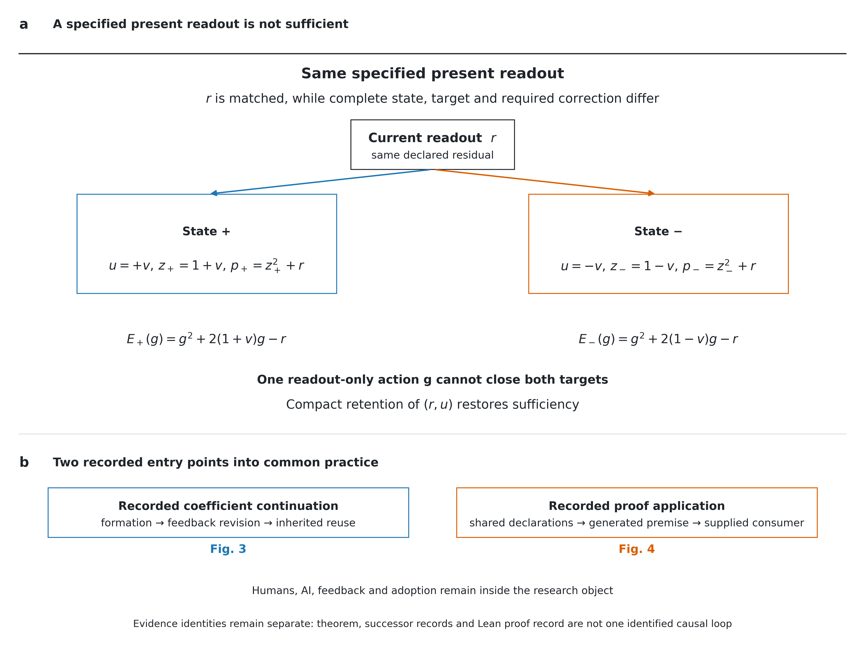
Fig. 1 | A specified current readout is not a sufficient scientific state. a, The analytical witness fixes the declared current readout $r$ while allowing different complete states and targets. For $0<r≤1/4$ and $0<v≤1/8$, the two states have $u=±v$, $z_{±}=1±v$ and $p_{±}=z_{±}^{2}+r$. A correction that depends only on $r$ must be shared and cannot close both targets. Retaining the compact pair $(r,u)$ repairs this non-sufficiency. The comparison concerns a specified present readout, not equality of complete causal states or an identified causal effect of history. b, Two archived entry points into common practice are then separated by evidence identity: coefficient continuation (Fig. 3) and proof application (Fig. 4). The theorem, the successor records and the Lean proof record are linked conceptually but are not merged into one identified causal loop.
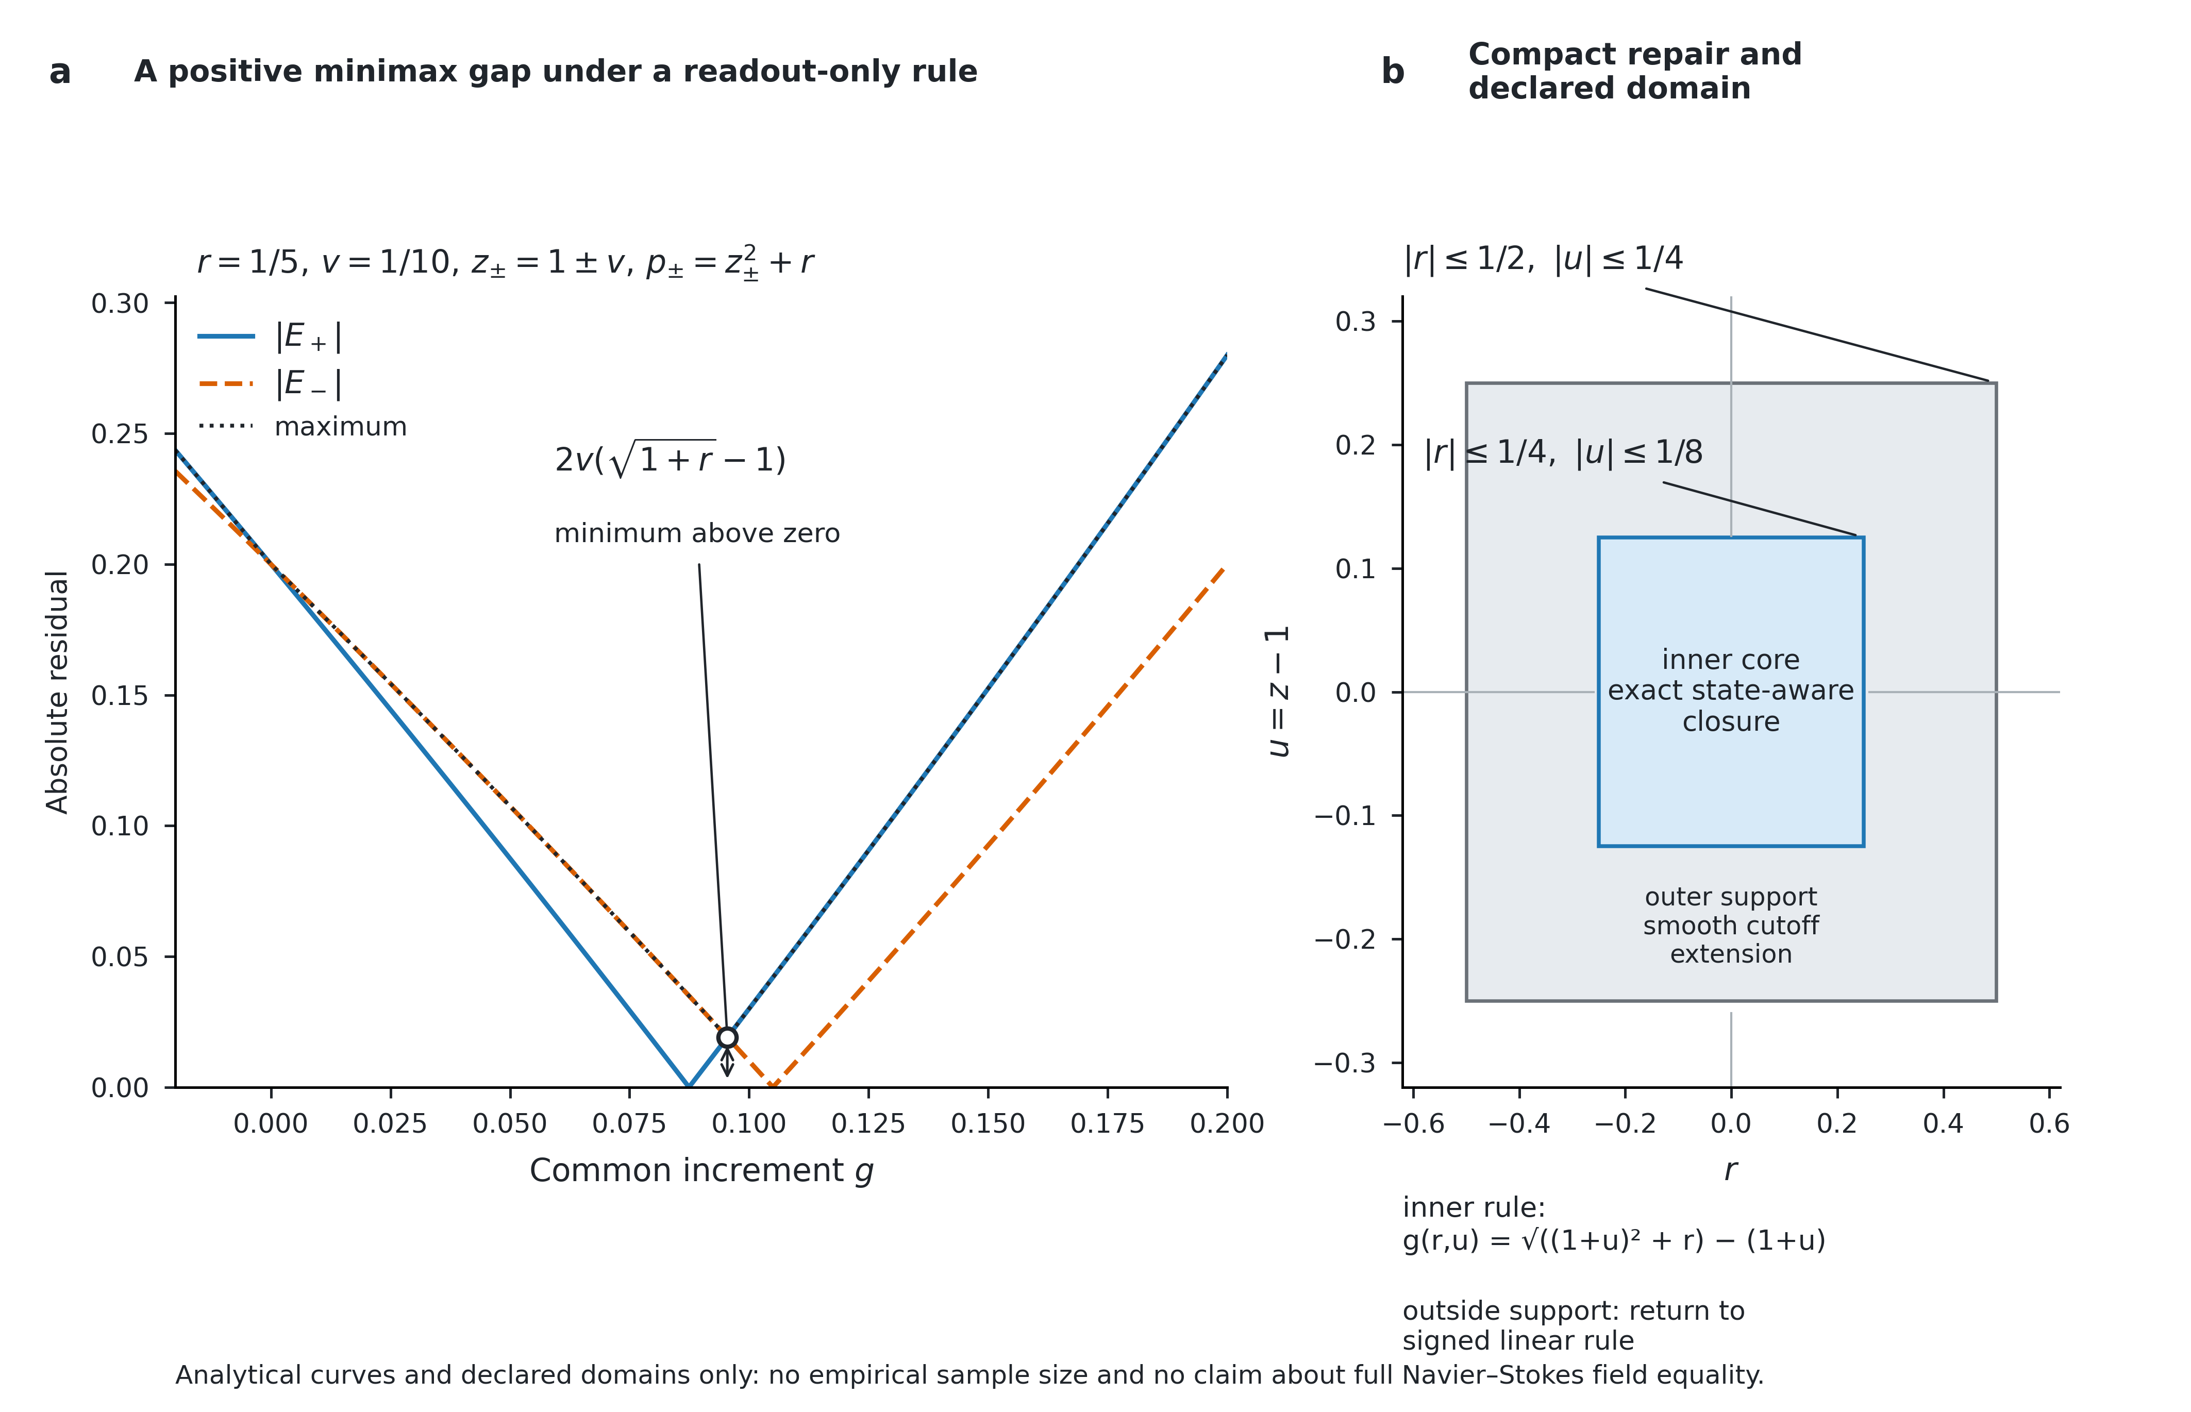
Fig. 2 | Positive minimax separation and compact repair. a, Curves show $|E_{\text{+}}|$, $|E_{\text{−}}|$ and their maximum for the exact witness at $r=1/5$ and $v=1/10$. The minimum of the maximum is the positive distance $2v(\sqrt{1+r}−1)$ above the zero line. These are analytical values, not experimental samples. b, The state-aware rule is exact on the inner rectangle $|r|≤1/4$, $|u|≤1/8$. A smooth extension is declared on the outer support $|r|≤1/2$, $|u|≤1/4$, and the signed linear rule operates outside the support. The panel displays domain structure rather than a statistical experiment.
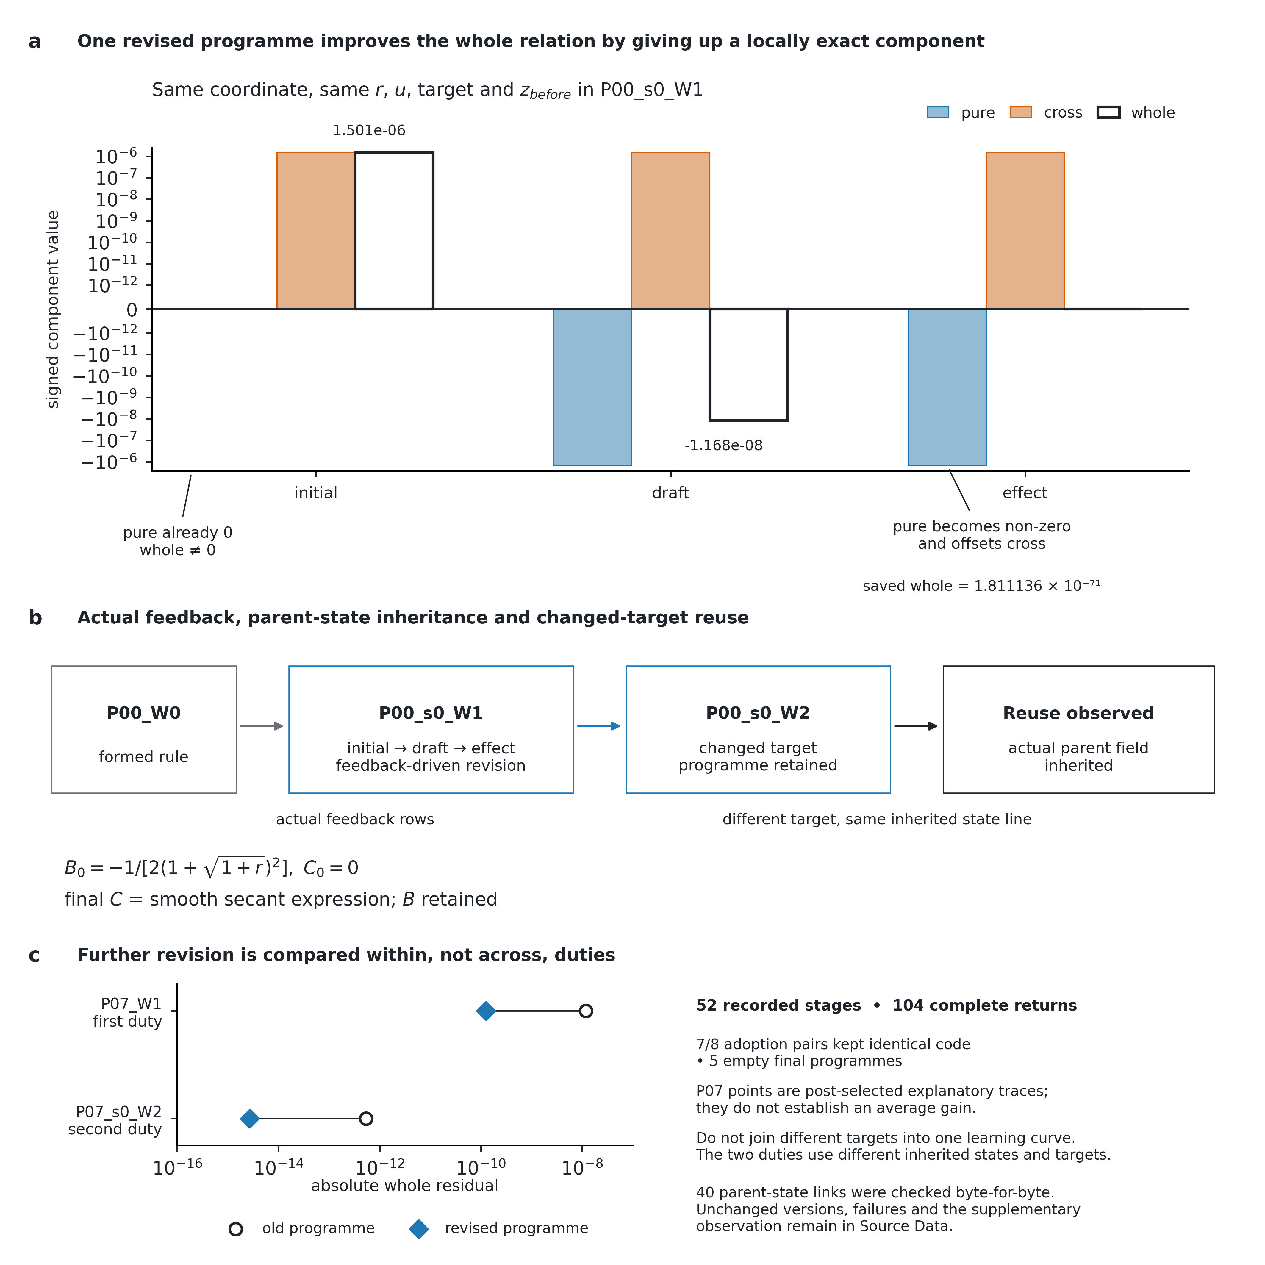
Fig. 3 | Actual programme revision, inheritance and renewed use. a, In assistance episode P00_s0_W1, the same coordinate, $r$, $u$, target and $z_{before}$ are shown for the initial, draft and final effect versions. The displayed decomposition is $pure=g^{2}+2g−r$, $cross=2ug$, and $whole=pure+cross$. Initially, the pure term is exactly zero while the whole residual is not. After revision, the pure term is no longer zero, but it cancels the cross term; the saved final whole residual is retained as $1.811136×{10}^{−71}$ rather than replaced by an artificial zero. b, The process panel preserves actual feedback-driven revision, programme identity, parent-state inheritance and changed-target reuse from P00_W0 through P00_s0_W1 to P00_s0_W2. c, P07 compares old and revised programmes separately within two distinct duties. These are not connected into one learning curve because the duties use different inherited states and targets. The figure retains the full-cohort boundary: 52 recorded stages, 104 completed returns, 7/8 unchanged adoption versions, 5 empty terminal programmes, and the boundary that these post-selected traces do not establish a general average benefit.
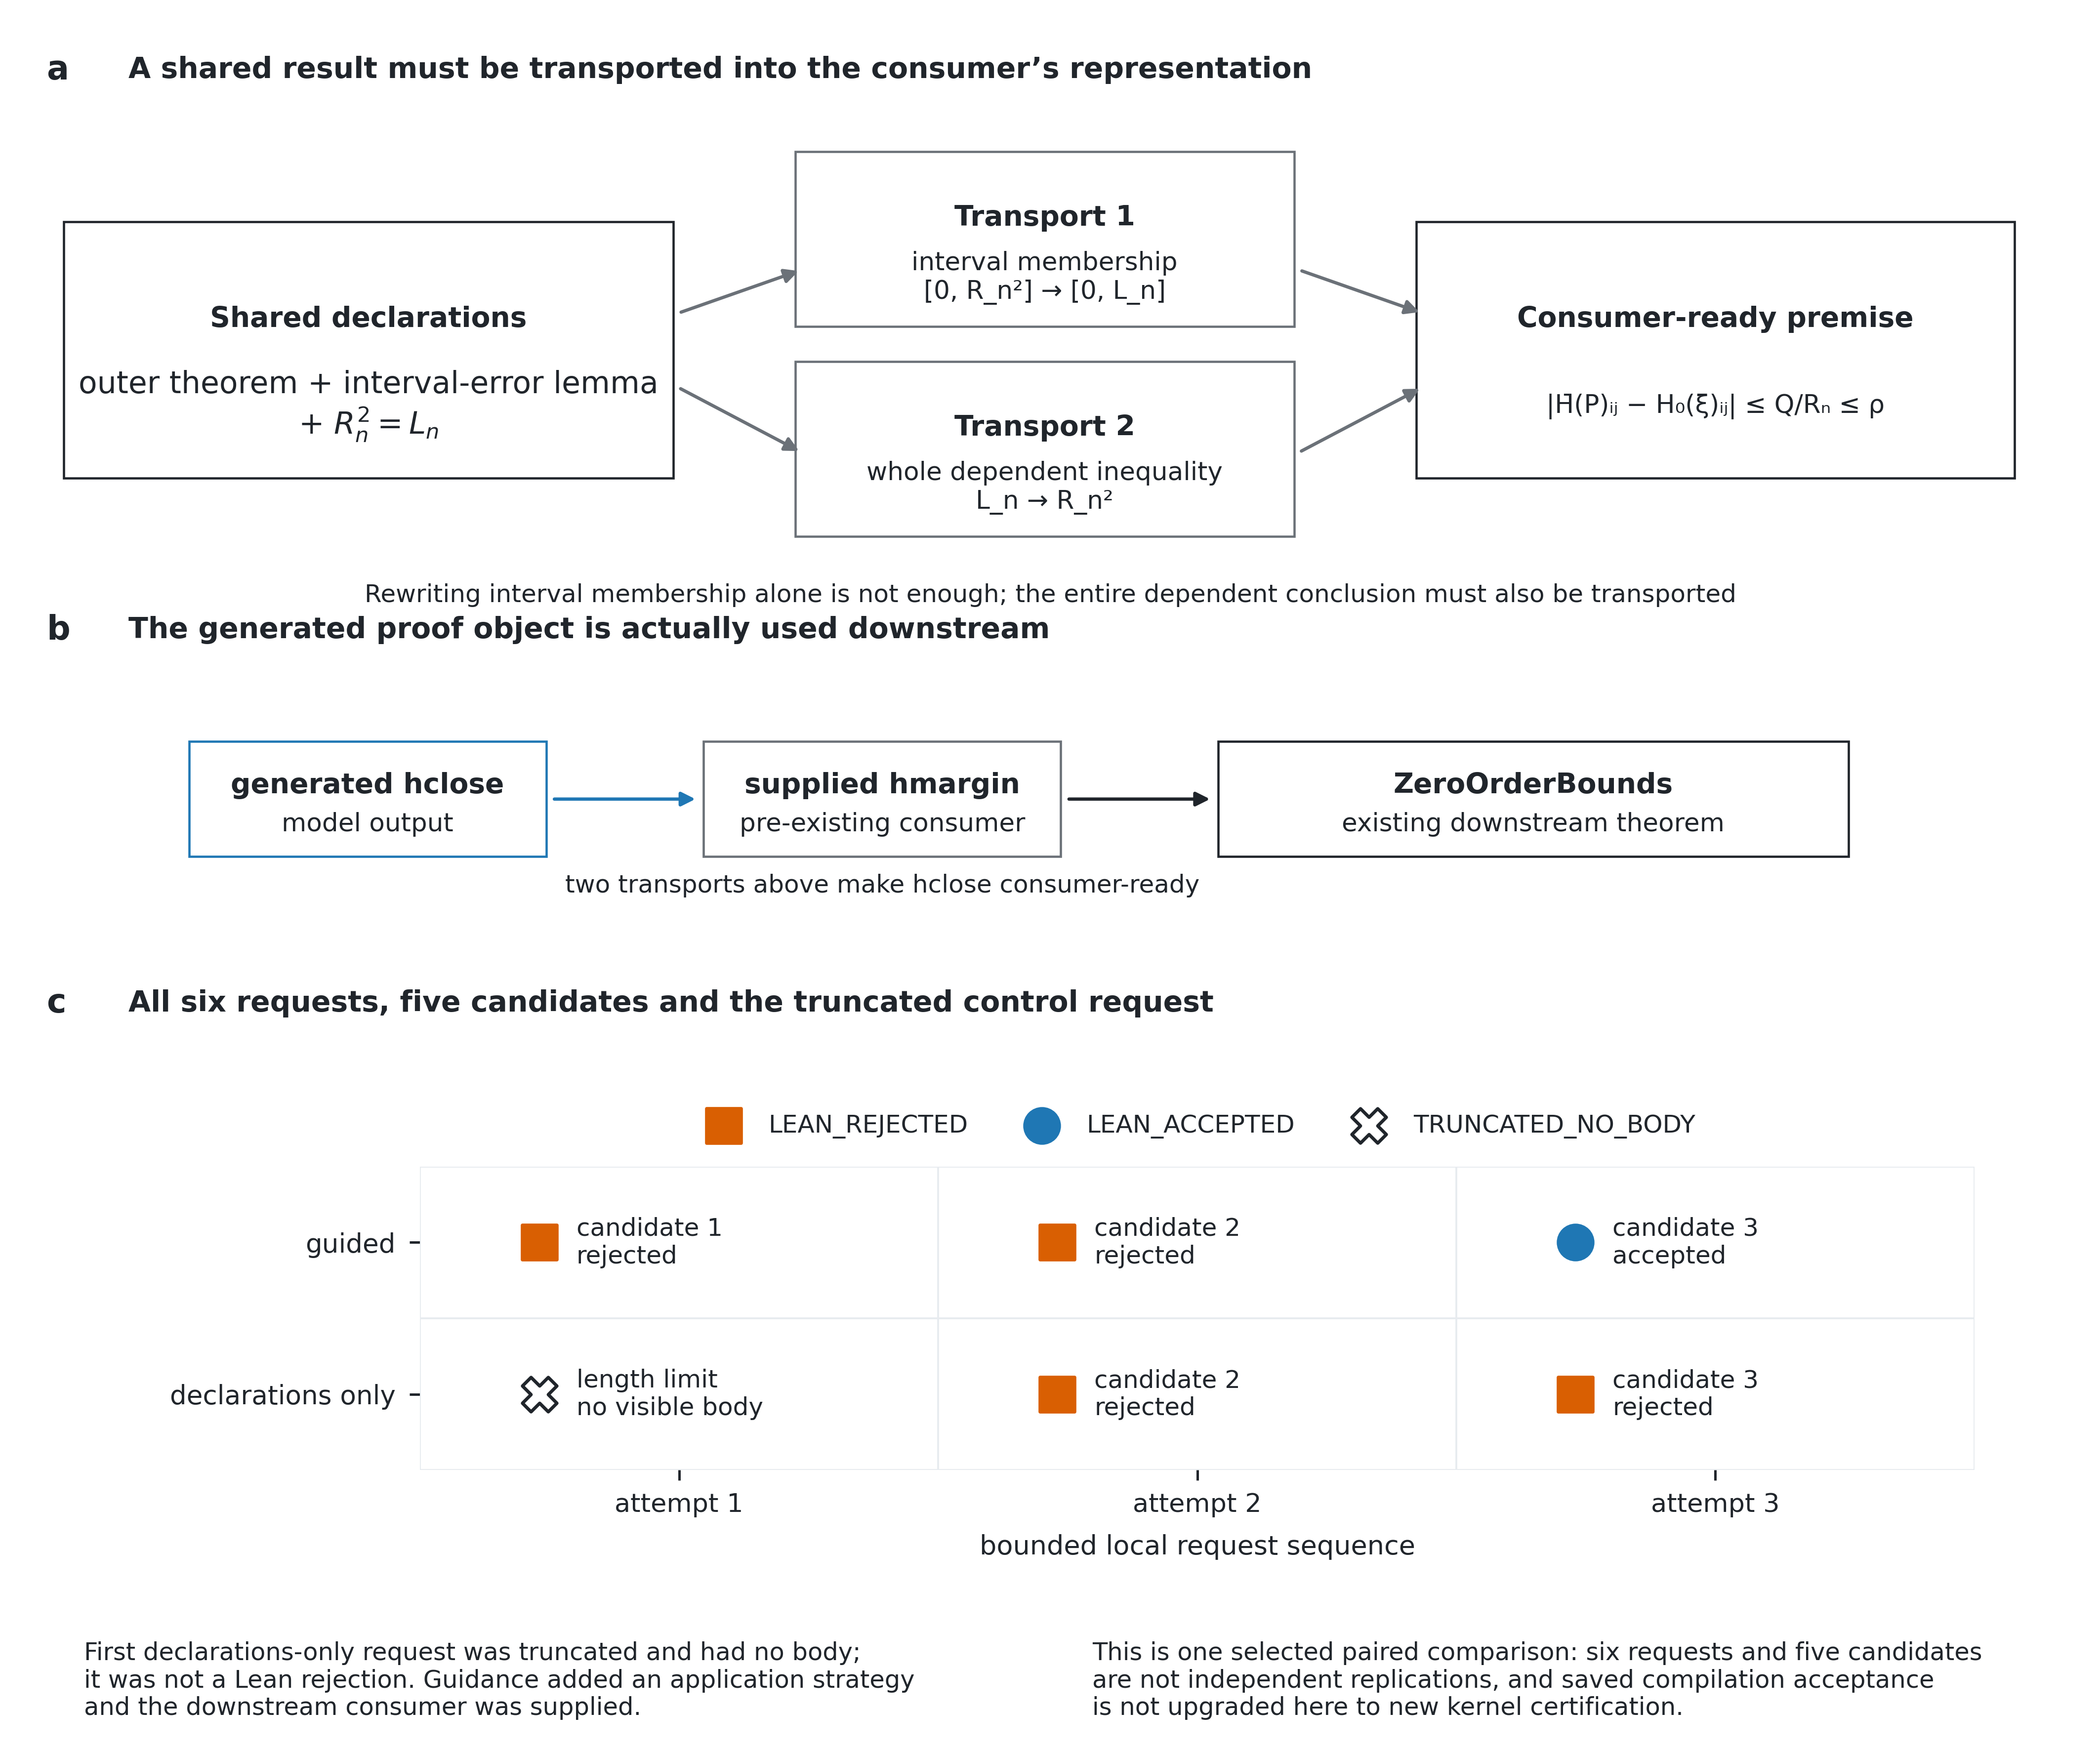
Fig. 4 | A generated proof object is made usable and actually used. a, The proof first transports interval membership into the source hypothesis’s representation, then transports the resulting dependent inequality back into the consumer’s representation; membership transport alone is insufficient. b, The generated hclose is explicitly distinguished from the supplied downstream consumers hmargin and ZeroOrderBounds; the chain generated hclose $→$ supplied hmargin $→$ ZeroOrderBounds is an observed use relation. c, All six requests in the selected paired proof-completion comparison are shown. The guided condition produced two rejected candidates followed by one recorded acceptance. The declarations-only condition first terminated at the token limit with no visible proof body; this first control request is therefore truncated rather than a Lean rejection. The next two declarations-only candidates were rejected. Six requests and five candidates are one bounded comparison, not independent replications, and saved compilation acceptance is not upgraded here to new kernel certification.

Methods

Study basis and evidence scope
This study combines a conditional analytical examination of research continuation with retrospective analyses of retained coefficient-continuation and proof-completion records. The sources include dated theoretical and design documents, the original mathematical source, common task materials, generated candidates, compiler records and prior analyses. The analysis uses the preserved proof-completion archive, the separate coefficient-continuation archive and independently logged deterministic reanalysis. It adds no new model responses or experimental units. Newly executed checks are dated and logged separately from historical compilation and prior audits. Supplementary Notes 1, 5 and 6 distinguish each evidence identity.

Theory and mathematical scope
A future regime specifies duties, tool semantics, permissions, resource limits and the continuation policies being compared. Output equivalence is relative to a declared observation $M$, and future equivalence is relative to the chosen regime, including the outcome and cost measures. Neither is a claim about complete causal-state equality. For the finite witness, the observation is precisely $r$ and the restricted policy is a deterministic real increment depending only on $r$. We do not assume that a language model obeys that restriction. The two targets differ because $p_{±}=z_{±}^{2}+r$. The minimax result is an analytic derivation inherited from the earlier theoretical materials; its full proof and the state-aware sufficient construction are given in Supplementary Note 2. Symbolic checks and an illustrative deterministic figure are additional checks; the all-quantifier result is established by the piecewise proof.
The smooth cutoff construction has declared inner and outer rectangles. Positivity of the radicand and denominators establishes analyticity of the specified core functions on a neighbourhood of the outer rectangle. Transferring this local operation to the source wave classes additionally requires their fixed-stage, derivative, support and multiplier hypotheses. We do not claim that arbitrary generated expressions satisfy them, that physical norms improve monotonically, or that this rewrite independently proves a full NS replacement theorem. Earlier source-relative PDE arguments, recorded computational checks and independently certified mathematics are separate evidence classes. Supplementary Notes 2–3 also state the sufficient-state boundary and its cost assumptions.

Mathematical source and local target
The source is the retained NavierStokes/PrimaryCovarianceBounds.lean at the recorded OpenAI repository commit. Its role is a local covariance bound within the published construction, not an original theorem of this study. The fixed outer theorem chooses uniform constants and a scale threshold before the pulse, chart parameter and target multiplier. Its local gap is the assertion that every entry of normalizedPair P is within $ρ$ of H0 p. The source identifier p is written $ξ$ in the paper; slotRadius r0 h n is $R_{n}$; ChartScales.slotLength r0 h n is $L_{n}$; source coefficients E,D are written $e,d$; and $c$ is PulseCovariance.concentrationConstant a A b B. The source positivity, compactness, pulse estimates and column-mass results are premises of this task, not model outputs.
Both conditions received the exact outer template with one marked proof-body hole and the full relevant declarations of normalizedPair_entry_error and slotRadius_sq. The additional note in the guided condition identifies the needed interval/denominator/centre conversion, the integral-error application and the scalar comparison. It does not contain the final tactic body, but it does provide an explicit solution strategy. Full inputs, all five candidate bodies, the truncated-response status and the accepted downstream line are retained in Supplementary Note 5 and the evidence archive. No claim of equal full informational state is made.

Selection, generation and feedback
The final protocol was selected after researcher-directed modification of broader reconstruction workflows. The investigator explicitly authorised a known-proof comparison with the last local step left to the model. Both conditions used a maximum of three requests. The retained seed root was 1,775,273,732, increased by attempt; the recorded arm order was guided then declarations-only. Equal attempt seeds do not imply identical stochastic trajectories under different prompts. Each later request included the condition’s own visible candidate and compiler feedback, when available. At most the final 12,000 characters of each output stream were exposed as feedback, with truncation marked; complete streams were retained. Models returned Lean proof-body text without live shell, history-retrieval or search tools. The enclosing source was filled mechanically without semantic correction of the generated body.
The recorded serving alias was qwen3.8-27b-fp8-a256k-nomtp-c1, with local model-root basename Qwen3.8-27B-FP8. The deployment records specify 262,144-token context, one globally active generation, MTP disabled, half-precision computation, tensor parallelism 2, turboquant_k8v4 KV configuration, piecewise capture size 4 and safe synchronisation. Sampling used temperature 1, top-p 0.95, top-k 20, presence penalty 0, repetition penalty 1 and an active end-of-sequence rule, with recorded medium thinking. Per-request output was limited to 32,768 tokens including reasoning; input allowance was 196,608. These are historical configuration records, not independently verified current service properties or model weights. There was no imposed client generation deadline in this final run.

Recorded acceptance and compilation
Five non-empty proof bodies were inserted into the identical template and compiled in the retained Lean 4.34.0-rc2 environment. The first declarations-only request had finish_reason=length and no visible body, so no compiler was invoked for that response. Recorded compilation took approximately 13–14 seconds per candidate. Non-fatal cache/permission warnings in the saved compiler outputs remain part of the evidence; the logs have not been cleaned into idealised feedback. The successful record contains a zero return code, the exact enclosing type check and the printed axiom dependencies. Failed outputs may list sorryAx because their proof remains incomplete; this is not evidence of deliberate use of an axiom to evade the task.
Record analysis reread the original handoff and reran the auditor in an isolated output directory. It verified the 859 payload identities, reconstructed all six response streams, matched the five candidate insertions and compiler receipts, and checked the 243 shared work-tree files outside the candidate module. The original collector duplicated two mirrored reasoning fields; their bytes are retained and the duplication documented. Only visible proof bodies and compiler feedback entered later requests; server usage is the token source. These record checks were followed by offline recompilation of the five unchanged saved candidates under Lean 4.34.0-rc2 and the pinned dependencies. The ordinary Lean replay reproduced one acceptance and four rejections; the truncated request has no candidate to compile. This checks the saved candidates with the same compiler family, not with an independent kernel.¹⁹

Sources and supplementary checks
The Codex background refers to the supplied snapshot at commit a8964cb1bad67bc26a826fb07d1bef99c6a3f008, including the new-context handler and history-notes extension, backend and tools. The handler requests a new window without summarising the conversation. The extension exposes note and historical-content operations through a backend; the selected client files do not establish the server’s internal storage or the behaviour of all releases. Public source semantics, our experimental implementation and opaque internal state are different evidence classes. The mathematical community’s statement supplies a purpose-level argument, not measured general decline, and the NS process account is attributed to its publisher rather than treated as an isolated causal experiment.
Two ancillary records have distinct provenance. The independent diagnostic is a separate Codex task with its own stated same-start materials and retained local compilation records; it was interrupted and did not complete the full NS goal. Its model and tool environment differ from the final comparison, and its input boundary is not independent certification of blindness. The researcher recheck is a reference-exposed derivation and algebra check; its own account explicitly records no new Lean compilation. Neither record is pooled with the formal six-request comparison.

Evidence interpretation and analysis
In the proof-completion study, the unit of observation is one selected obligation and its paired bounded attempt sequences. The six requests, five candidates, matrix entries and compiler messages are not independent samples. We report every attempt, the exact endpoint, visible tactic differences and realised resources. No population success rate, p-value, confidence interval or general efficiency estimate is inferred. The guided prompt adds 332 initial input tokens and procedural information; feedback sequences diverge. Additional explanation, context arrangement, unequal realised effort and stochastic variation remain possible explanations of the observed contrast. Both final candidates locate the relevant lemmas, which supports a specific diagnosis of application failure but does not isolate a unique cognitive mechanism.
The passage from hclose to hmargin is an observed source-level use of a generated object by a supplied consumer. It does not show that the agent designed the downstream programme, changed its general method or adapted an acquired relation to a new duty. Earlier zero, mixed, stopped and unrun studies retain their original identities in Supplementary Note 6. The separately executed coefficient-continuation evidence is detailed in Supplementary Note 9. Neither its selected favourable traces nor this local proof completion replaces an original study endpoint. Supplementary Note 7 distinguishes observed reconstruction from still-unidentified causal and cross-domain claims.

Archived successor studies
The assistance study recorded four formation episodes with two shared archived ancestors, followed by two continuations in each of two feedback conditions. The adoption study recorded eight new formation episodes, a common assisted first continuation, and two subsequent version-adoption branches per episode. The totals are 20 and 32 stages. Later targets were fixed modifications of the preceding targets; each continuation read its actual predecessor’s amplitude array and programme inventory. The agent wrote two real expressions inside a supplied smooth-cutoff update family. Both branches could retain or reconstruct accessible programmes. These were coefficient-workbench duties, not generation of full NS fields.
The completed-record analysis uses 40 assistance returns and 64 adoption returns. One additional assistance request remains historically unknown; a separately authorised supplementary observation occupies its analysis slot without recovering that request. No unit is added by this editorial reanalysis. The complete stage counts include one empty final programme in assistance and four in adoption. The original protocol treated these as no applied update, even where a usable draft existed. This historical rule is preserved, not corrected after the fact. Initial and revised code were exactly equal in seven of eight adoption pairs. The original treatment-minus-control family contrasts and complete denominators are reported in Supplementary Note 9 rather than conditioned on valid final outputs.
Two traces, assistance episode P00 and adoption episode P07, are selected after examining the results for their inspectable mathematical content. The programmes, original visible text, feedback rows and parent-state references were reread directly from the archived files. A separate interpreter recomputed their displayed safe-core operations at 100-digit precision, while direct arithmetic checked all 18,720 terminal field rows. Forty inherited-state arrays were matched to predecessor outputs and source hashes. The few displayed coordinates are within-duty illustrations, not independent experimental units or estimates of average improvement. The whole-residual identities are derived analytically from the actual programmes. Their series properties do not license monotone improvement for every source, point or physical norm.

Data availability
Figure Source Data, the complete mathematical task inputs, all five saved proof candidates, six visible proof-completion responses and compilation records, and source-mapped coefficient-continuation records are included in the accompanying review-support archive, MAOFIELD_REVIEW_SUPPORT.zip. The successor material preserves all recorded terminal outcomes and original study denominators, with separately identified explanatory traces. Provenance maps identify every supplied excerpt and any privacy transformation. The full retained scientific raw records, with file-level provenance, are archived at https://doi.org/10.5281/zenodo.22904604. This broader sharing scope does not enlarge the analysis inputs, observation units or original denominators. The associated preprint is https://doi.org/10.5281/zenodo.22905100. Original data, text and figures are CC BY 4.0 and original code Apache-2.0, to the extent of the contributor’s rights; third-party rights and notices remain in force.

Code availability
The review-support archive contains figure-generation sources, exact mathematical checks, raw-record reanalysis, the successor-record audit and assembly/replay scripts for the five saved Lean candidates. REPRODUCIBILITY/README.md identifies the input and output of each offline command and its verification layer. Default entry points do not contact a model service. The one-command entry point uses packaged Python and Lean 4.34.0-rc2 environments, verifies the raw-data identities, reruns the mathematical and record checks, and recompiles the five unchanged saved candidates offline. Ordinary Lean replay has been executed; independent-kernel verification remains unexecuted. Third-party notices accompany their sources. The repository is https://github.com/Wangziqi0/MaoField/tree/nature-main, with the fixed release tagged nature-v8-r3. Software, original study data and packaged reproduction environments are archived at https://doi.org/10.5281/zenodo.22905103. Missing environment assets can be downloaded from that fixed GitHub release and are hash-verified before use; mathematical analysis and candidate compilation then run offline. The older main branch and R3.0 history remain distinct.

AI use and research attribution
The archived studies used model-generated programmes or proof bodies, investigator-designed tasks and guidance, and Codex-based execution. AI assistance was also used in source organisation, deterministic analysis, drafting and figure preparation, with these outputs checked against the retained records and mathematical arguments. This revision adds no new experimental model responses. Source-mathematics authorship, investigator steering and checking, generated artefacts and computational verification are distinct contributions. AI systems are not designated as authors.

Additional information
Supplementary Information is available for this paper.

Extended Data
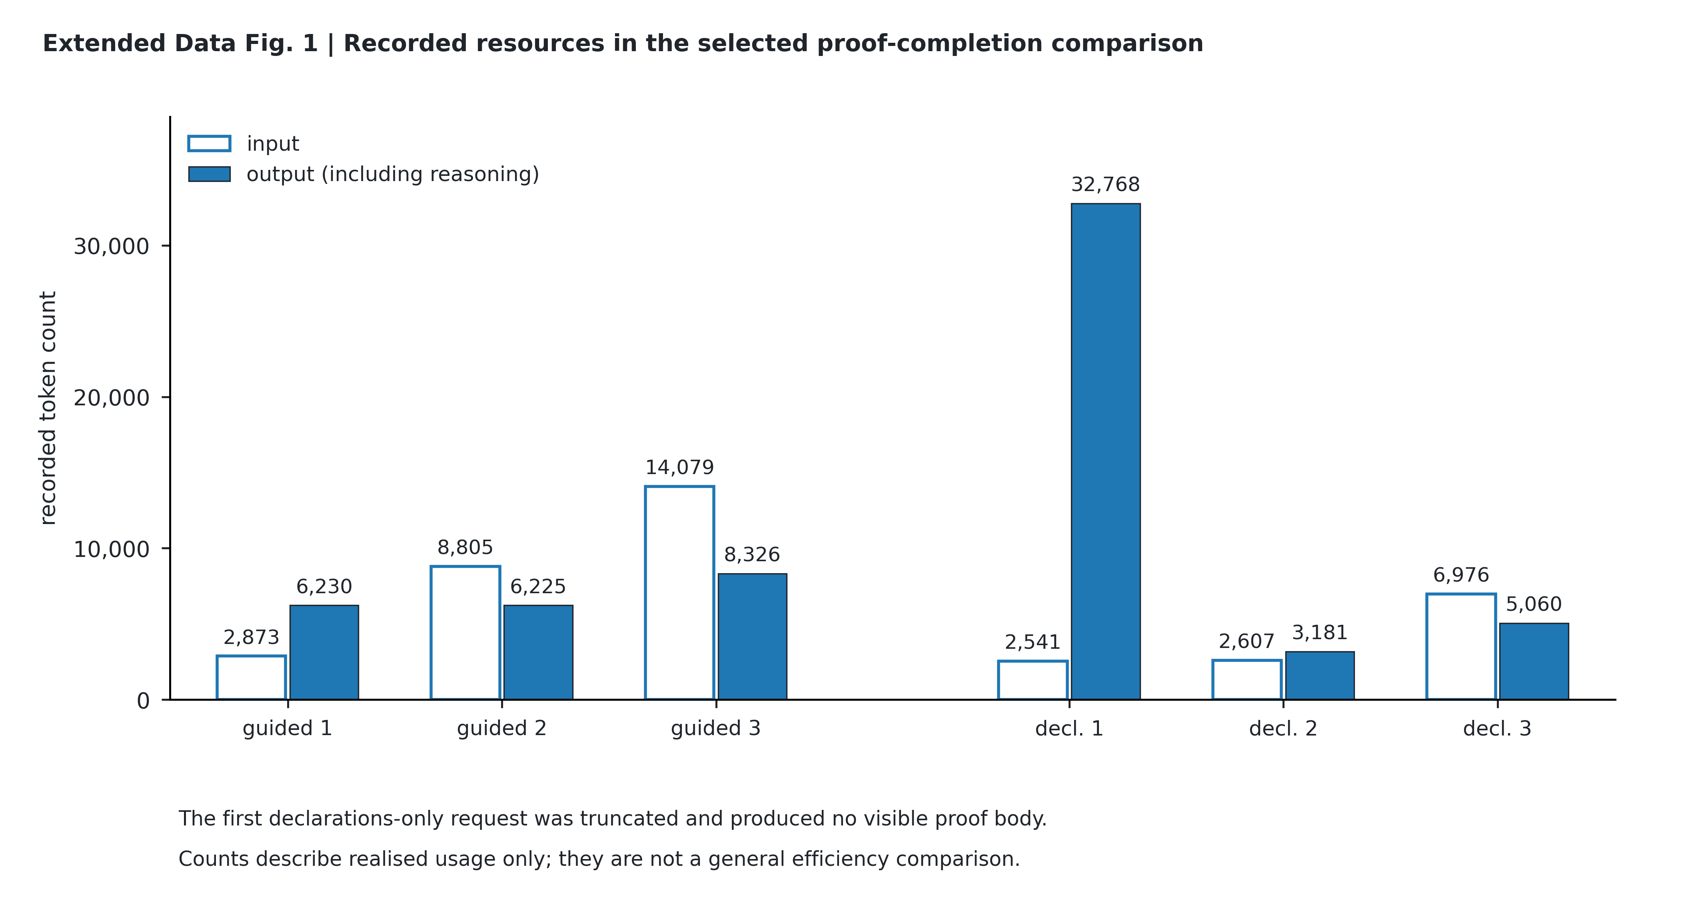
Extended Data Fig. 1 | Recorded token use, not efficiency. The six input and output counts are reproduced from the supplied source-data table. Output includes reasoning. The first declarations-only response reaches its configured limit without a visible proof body. Guided inputs grow with their own candidates and compiler feedback. The figure describes realised work in this one comparison; equal request limits did not equalise realised computation, and no general efficiency advantage is inferred.
Extended Data Table 1 | Earlier workflows retain their identities. Supplementary Note 6 lists the retained pre-hclose design history, including stopped or unrun branches. The coefficient-continuation and proof-completion rows are supported by raw-record reanalysis; older rows retain their historical-report identity. The completed successor studies are separately identified, not pooled with the proof-completion pair. Their failed, unchanged, truncated, unknown and NOT_RUN states do not become positive evidence because the final local completion was accepted.
Recorded workflow | Retained outcome | Evidence status
Full-endpoint workflow | Four branches; 55 requests; no writes | Earlier exploration
Adapted continuation | 40 requests; no writes; PI stop | Stopped
Dynamic organisation | 23 requests; no writes | Earlier exploration
Material preparation | 16 preparation calls; packet not accepted; four branches unrun | Preparation failure
Fixed-material continuation | 23 requests; no writes; three remaining branches unrun | Earlier exploration
Precompiled-source continuation | 42 requests; no writes; stop | Stopped
Independent Codex diagnostic | Own specified same-start task; saved local compilation; PI stop | Separate diagnostic, not a formal effect control
Researcher recheck | Full reference seen; algebra recheck; no new Lean compilation | Reference-exposed verification
Final hclose pair | Six requests; five candidates; guided third accepted | Present local record
Coefficient assistance / adoption | 52 stages; 104 completed returns. Actual revision and reuse; 5 empty finals; 7/8 equal adoption versions. | Executed; raw reanalysis. No established average benefit.

