Point Cloud Retrieval with PQ-Chamfer Distance
and Graph Regularization: A Training-Free Approach
Anonymous Author
Anonymous Institution
April 2026
Abstract
We propose a training-free geometric reranking pipeline that improves dense retrieval without any task-specific training. Documents are represented as token-level point clouds extracted from a general-purpose LLM, then scored via two complementary mechanisms: (1) PQ-Chamfer distance, which decomposes embeddings into 64 subspaces of 64 dimensions each, breaking the concentration-of-measure effect; and (2) graph Laplacian smoothing, which propagates relevance scores over a KNN document graph. On six BEIR datasets spanning 2,473 to 522,931 documents, the pipeline achieves NDCG@10 gains of +2.7% to +136.2% over cosine baselines, surpassing BGE-large-en-v1.5 on two benchmarks (FiQA: 0.398 vs 0.367; SCIDOCS: 0.215 vs 0.162). Improvements are statistically significant ($p<0.05$) across three embedding models (8B, 568M, 335M parameters), with gains inversely proportional to baseline quality. The entire experimental pipeline costs $47 on a single consumer GPU. We document 21 falsified approaches—including the complete failure of convection-diffusion equations—establishing clear applicability boundaries. All code and data are publicly available.

Introduction
Retrieval-Augmented Generation (RAG) has become the dominant paradigm for grounding large language models in external knowledge (Lewis et al. 2020; Guu et al. 2020). The standard RAG pipeline employs a bi-encoder to map queries and documents into a shared embedding space, then ranks candidates by cosine similarity. Let $v_{q}∈R^{d}$ and $v_{i}∈R^{d}$ denote the query and document embeddings, respectively:
$$\text{score}\left(d_{i}\right)=\frac{v_{q}⋅v_{i}}{∥v_{q}∥ ∥v_{i}∥}$$
This formulation has two fundamental limitations. First, it represents each document as a single point in $R^{d}$, conflating diverse semantic facets into one centroid. Second, it scores each document independently, ignoring inter-document structure—topic clusters, semantic neighborhoods, and distributional patterns—that the retrieved set collectively encodes.
The insight that motivated this work is deceptively simple: documents are not points; they are shapes (Anonymous 2026b). A document, when represented by the per-token hidden states of a language model, forms a point cloud in embedding space. The geometry of this point cloud—its spread, its density variations, its subspace projections—carries semantic information that a single centroid vector destroys. This observation leads naturally to two questions: What is the right distance metric between document point clouds? And how can we exploit inter-document structure without the cost of cross-encoder inference?
Relation to prior versions. This paper extends the Shape-CFD research program (Anonymous 2026b, 2026a). Earlier versions (V1–V4) explored convection-diffusion equations and sentence-level point clouds. The present work (V5/V11) abandons the convection-diffusion narrative—experimentally falsified across five independent validations (Section 4.5)—and reorganizes the framework around token-level point clouds, PQ-Chamfer distance, and graph Laplacian smoothing.

Contributions
- Training-free geometric reranking paradigm. We show that geometric operations on general-purpose LLM hidden states can match or exceed purpose-trained rerankers (surpassing BGE-large on FiQA and SCIDOCS), without any retrieval-specific training.
- PQ-Chamfer distance metric. We repurpose product quantization from compression to distance computation, decomposing the embedding space into 64 contiguous 64-dimensional subspaces to break the concentration-of-measure effect.
- Token-level point cloud retrieval. Per-token hidden states from Qwen3-8B (–pooling none) form document point clouds ($∼$356 tokens), enabling fine-grained token-to-token matching without training.
- Graph Laplacian regularization. KNN graph smoothing yields consistent improvements on all six BEIR datasets (+7.7% to +44.2% vs cosine), making it the most robust single component.
- Model-agnostic post-processing. Statistically significant gains across three embedding models (8B, 568M, 335M parameters) spanning 1024d–4096d confirm that the geometric operations exploit universal structural properties.
- Systematic falsification. We document 21 failed approaches, establishing clear applicability boundaries.

Research Objectives
This study addresses the following research questions:
- RQ1: Can training-free geometric operations on general-purpose LLM hidden states improve dense retrieval quality?
- RQ2: Is the improvement model-agnostic, generalizing across different embedding architectures?
- RQ3: At what computational cost can these improvements be achieved compared to training specialized retrieval models?

Literature Review
Multi-vector retrieval. ColBERT (Khattab and Zaharia 2020) pioneered multi-vector document representation via late interaction (MaxSim). ColBERTv2 (Santhanam, Khattab, Saad-Falcon, et al. 2022) added residual compression, and PLAID (Santhanam, Khattab, Potts, et al. 2022) introduced centroid-based pruning. Our approach differs in using general-purpose LLM hidden states (not a trained retrieval model), symmetric Chamfer distance (not asymmetric MaxSim), and global graph-based score propagation. Recent LLM-based embeddings such as E5-Mistral (Wang et al. 2024) and GTE (Z. Li et al. 2024) demonstrate that large language models produce strong retrieval representations, though they still require contrastive fine-tuning.
LLM-based reranking. RankGPT (Sun et al. 2024) demonstrates that LLMs can serve as effective listwise rerankers via prompt engineering. RankLLM (Pradeep, Sharifymoghaddam, and Lin 2025) provides a scalable framework for LLM-based reranking. AFR-Rank (Liu et al. 2025) improves efficiency by filtering noise documents before LLM reranking. A recent survey (J. Li et al. 2025) traces the evolution from heuristic reranking to LLM-based approaches. These methods achieve strong results but require expensive API calls ($0.01–0.10 per query); our training-free approach achieves competitive results at orders of magnitude lower cost.
Graph-based reranking. Graph methods span from PageRank (Page et al. 1999) to diffusion-based RAG approaches (Dampanaboina et al. 2024). G-RAG (Glass et al. 2024) learns graph neural network rerankers, and GAR (MacAvaney, Tonellotto, and Macdonald 2022) uses pseudo-relevance feedback on document graphs. Our Laplacian smoothing operates on point-cloud-derived distances and requires no training.
Product quantization. PQ (Jégou, Douze, and Schmid 2011) and systems built on it (FAISS (Johnson, Douze, and Jégou 2021), ScaNN (Guo et al. 2020), OPQ (Ge et al. 2014)) use subspace decomposition for compression and approximate search. We repurpose the decomposition for exact distance computation, using subspace structure to break concentration of measure.
Point cloud distances. Chamfer distance (Fan, Su, and Guibas 2017) and EMD (Rubner, Tomasi, and Guibas 2000) are the dominant 3D point cloud metrics. Chamfer corresponds to unbalanced optimal transport with fully relaxed marginals (Séjourné, Peyré, and Vialard 2023), making it effective for documents of different lengths. BERTScore (Zhang et al. 2020) applies a similar one-directional matching; WMD (Kusner et al. 2015) uses EMD over word embeddings.

Methodology

Document Point Cloud Representation
Let $M$ denote a pretrained language model (Qwen3-8B, $d=4096$). For a document $d_{i}$ consisting of tokens $\{t_{i,1},t_{i,2},…,t_{i,n_{i}}\}$, we extract the last hidden states with pooling disabled (–pooling none):
$$P_{i}=\{h_{i,1},h_{i,2},…,h_{i,n_{i}}\}⊂R^{d}$$
where $h_{i,j}∈R^{4096}$ is the last-layer hidden state for token $t_{i,j}$. Similarly, a query $q$ with tokens $\{t_{q,1},…,t_{q,m}\}$ yields a query point cloud $P_{q}=\{h_{q,1},…,h_{q,m}\}$.
In our NFCorpus evaluation, the average document contains $∼356$ tokens and the average query contains $∼6$ tokens. The entire NFCorpus token cloud database (2,473 documents, 880,791 tokens) occupies 14 GB in SQLite storage.
Centroid representation. For coarse-grained operations, we also compute the centroid of each point cloud:
$${\overset{‾}{v}}_{i}=\frac{1}{n_{i}}\sum_{j=1}^{n_{i}}{h_{i,j}}$$
This centroid serves as the single-vector representation for initial retrieval and coarse filtering.

PQ-Chamfer Distance
PQ-Chamfer distance is defined in two stages: subspace decomposition and Chamfer aggregation.
Subspace decomposition. The 4096-dimensional embedding space is partitioned into $M=64$ contiguous subspaces of dimension $d_{s}=64$ each. For a vector $h∈R^{4096}$, we write $h^{\left(s\right)}$ for the projection onto the $s$-th subspace:
$$h^{\left(s\right)}=\left(h_{\left(s−1\right)d_{s}+1},…,h_{s⋅d_{s}}\right)∈R^{d_{s}}, s=1,…,M$$
The cosine distance within the $s$-th subspace is denoted $δ_{s}$ to distinguish it from the subspace dimension $d_{s}$:
$$δ_{s}\left(a,b\right)=1−\frac{a^{\left(s\right)}⋅b^{\left(s\right)}}{∥a^{\left(s\right)}∥ ∥b^{\left(s\right)}∥}$$
The PQ distance between two tokens is the average across subspaces:
$$d_{PQ}\left(a,b\right)=\frac{1}{M}\sum_{s=1}^{M}{δ_{s}}\left(a,b\right)$$
Why subspace decomposition works. In the full 4096-dimensional space, the concentration of measure phenomenon causes all pairwise cosine similarities to cluster near zero with standard deviation $σ≈1/\sqrt{d}≈0.016$. By computing distances in 64-dimensional subspaces, the effective standard deviation increases to $σ_{s}≈1/\sqrt{64}=0.125$, providing $7.8×$ better discrimination. Note that this is not a random projection (which we tested and found harmful; see Section 4.5): the subspace boundaries respect the model’s dimensional structure. Ablation confirms that contiguous $64×64$ outperforms $32×128$ and $16×256$, and that ordered subspaces perform comparably to randomly permuted ones, indicating that Qwen3’s embedding dimensions are approximately uniformly distributed in information content.
Chamfer aggregation. Given two point clouds $A$ and $B$, the PQ-Chamfer distance is:
dPQCA,B=121Aa∈A​minb∈BdPQa,b+1Bb∈B​mina∈AdPQa,b
The forward term 1Aa​minb measures how well $B$ covers $A$ (every point in $A$ finds a nearby match in $B$), and the backward term ensures symmetry.
VT-Aligned distance. The standard PQ-Chamfer computes subspace distances first and then applies the Chamfer $min$ operator (“average-then-min”):
dPQCA,B=Chamfer​A,B; dPQa,b=1Ms​δsa,b
VT-Aligned reverses the aggregation order (“min-then-average”): the minimization over the target set is performed independently within each subspace, allowing different subspaces to select different nearest neighbors:
dVTA,B=121Aa∈A​1Ms=1Mminb∈Bδsa,b+1Bb∈B​1Ms=1Mmina∈Aδsb,a
This captures finer-grained matching patterns than standard PQ-Chamfer, where a single globally nearest neighbor is used across all subspaces. In practice, VT-Aligned yields +2.5% over standard PQ-Chamfer at zero additional cost.
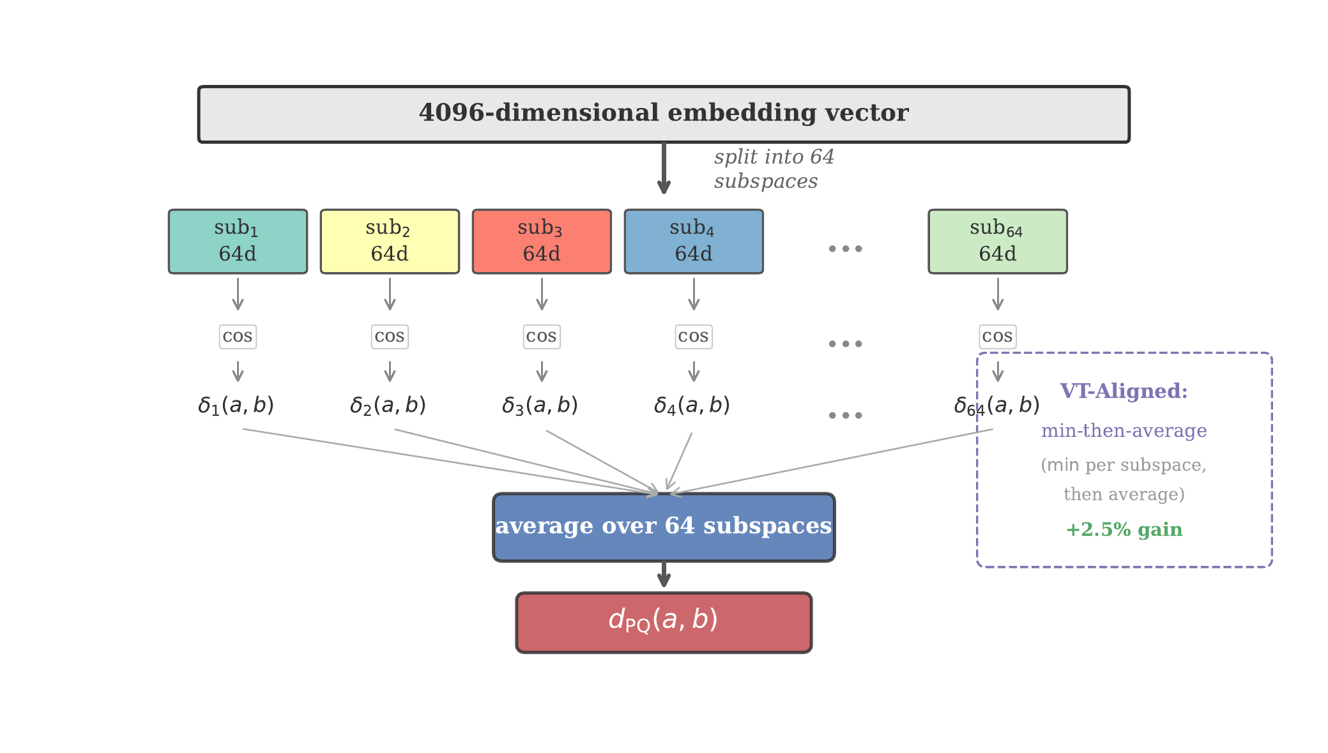
PQ-Chamfer subspace decomposition. A 4096-dimensional vector is partitioned into 64 contiguous 64-dimensional subspaces. Standard PQ-Chamfer averages subspace distances before applying the Chamfer $min$ operator; VT-Aligned reverses this order for +2.5% improvement.
Connection to unbalanced optimal transport. Chamfer distance corresponds to UOT with fully relaxed marginals ($τ→0$) (Séjourné, Peyré, and Vialard 2023). This relaxation is essential for documents of different lengths: a 6-token query matched against a 356-token document need not force all document tokens to match, functioning as hard semantic attention.

Graph Laplacian Smoothing
Given a set of $N$ candidate documents with initial relevance scores, we construct a weighted KNN graph and apply iterative Laplacian smoothing.
Graph construction. We build a sparse undirected graph $G=\left(V,E,W\right)$ over the $N$ candidates:
- Pairwise distance: Compute $d_{ij}=d_{PQC}\left(P_{i},P_{j}\right)$ for all pairs, or use VT-Aligned distance.
- KNN sparsification: For each node $i$, retain edges to its $K=3$ nearest neighbors.
- Edge weights: $W_{ij}=exp\left(−β⋅d_{ij}\right)$, with $β=2.0$.
- Symmetrization: If $j∈N\left(i\right)$ but $i∉N\left(j\right)$, add the reverse edge with $W_{ji}=W_{ij}$.
Initial scores. Each document receives an initial “concentration”:
$$C_{0}\left(i\right)=exp\left(−2⋅d_{PQC}\left(P_{q},P_{i}\right)\right)$$
Laplacian smoothing iteration. The score update follows the discrete heat equation on the graph:
Ct+1i=Cti+αj∈Ni​WijCtj−Cti
where $α=0.15$ is the diffusion coefficient. We run $T=5$ iterations. This can be written in matrix form as:
$$C_{t+1}=\left(I−αL\right) C_{t}$$
where $L=D_{deg}−W$ is the graph Laplacian and $D_{deg}$ is the degree matrix.
Stability condition. The smoothing coefficient $α$ must satisfy $α<1/d_{max}$ where $d_{max}$ is the maximum weighted degree maxij​Wij, bounded above by the unweighted degree (here $≤6$), ensuring eigenvalues of the update matrix $\left(I−αL\right)$ lie in $\left[0,1\right]$. With $K=3$ (bidirectional, $d_{max}≤6$), our choice of $α=0.15$ satisfies this condition ($0.15<1/6≈0.167$).
Effect. Laplacian smoothing propagates high relevance scores to semantically similar neighbors, effectively discovering relevant documents that may have received low initial scores due to vocabulary mismatch or embedding noise. Unlike cross-encoder reranking, this propagation is training-free and operates in milliseconds.

Multi-Granularity Pipeline
Our full retrieval pipeline operates in three stages with complementary granularities.
Stage 1: Centroid coarse filtering. Compute cosine similarity between the query centroid ${\overset{‾}{v}}_{q}$ and all document centroids $\{{\overset{‾}{v}}_{i}\}$ in the corpus. Retain the top-$K_{1}=100$ candidates. This stage runs in 23 ms on commodity CPU hardware.
Stage 2: Token PQ-Chamfer reranking. For the top-100 candidates, compute the full token-level PQ-Chamfer distance $d_{PQC}\left(P_{q},P_{i}\right)$ using all token hidden states. Re-rank and retain the top-$K_{2}=55$ candidates. This stage runs in 23 ms.
Stage 3: Graph Laplacian smoothing. Construct a KNN graph over the top-55 candidates and apply 5 iterations of Laplacian smoothing as described in Section 3.3. This stage runs in 26 ms.
Score fusion. For datasets where token-level data is available (NFCorpus, SciFact, ArguAna, SCIDOCS, FiQA), we combine the two signal sources:
$${\text{score}}_{\text{final}}\left(i\right)=λ⋅{\text{score}}_{\text{token}}\left(i\right)+\left(1−λ\right)⋅{\text{score}}_{\text{graph}}\left(i\right)$$
where $λ=0.7$ and both score vectors are min-max normalized before fusion. The Kendall $τ$ rank correlation between token and graph rankings is 0.378, confirming high complementarity.
Two-stage acceleration is lossless. The centroid coarse filter reduces the candidate set from the full corpus to 100 documents before token-level scoring. This $13×$ speedup (305 ms full-scan to 23 ms two-stage) introduces zero accuracy loss: the two-stage pipeline achieves NDCG@10 = 0.3220 versus 0.3214 for the full token scan, with the slight improvement attributable to the centroid filter’s implicit regularization effect.
Complexity analysis. Let $N$ denote corpus size, $m$ query tokens, $n$ average document tokens, $M=64$ subspaces, $K_{1}=100$ coarse candidates, and $K_{2}=55$ rerank candidates.
- Stage 1 (centroid coarse filtering): $O\left(N⋅d\right)$ cosine comparisons, or $O\left(N⋅m⋅M\right)$ if using PQ-Chamfer at centroid level.
- Stage 2 (token PQ-Chamfer reranking): $O\left(K_{1}⋅m⋅n⋅M\right)$ per query—for each of $K_{1}$ candidates, compute $m×n$ token-pair distances across $M$ subspaces.
- Stage 3 (graph Laplacian smoothing): $O\left(K_{2}^{2}⋅n^{2}⋅M\right)$ for pairwise graph construction $+ O\left(T⋅K_{2}⋅K\right)$ for $T$ smoothing iterations on a $K$-sparse graph.
With typical NFCorpus parameters ($m≈6$, $n≈356$, $K_{1}=100$, $K_{2}=55$, $M=64$), the bottleneck is Stage 2 at $∼137$M floating-point operations per query, completed in 23 ms on commodity CPU.

Experiments

Experimental Setup
Datasets. We evaluate on six datasets from the BEIR benchmark (Thakur et al. 2021), selected to cover diverse domains, corpus scales (2K–523K documents), document lengths (60–1,700 characters), and retrieval tasks. Table 1 summarizes the key statistics.
Summary of evaluation datasets from the BEIR benchmark (Thakur et al. 2021).
Dataset | Domain | #Docs | #Queries | Avg Doc Len (chars) | Task
NFCorpus | Biomedical | 2,473 | 323 | $∼$1,700 | Bio-medical retrieval
SciFact | Scientific | 3,752 | 300 | $∼$800 | Claim verification
ArguAna | Argumentation | 8,674 | 1,398 | $∼$940 | Counter-argument retrieval
SCIDOCS | Scientific | 25,337 | 1,000 | $∼$1,290 | Citation prediction
FiQA | Financial | 56,391 | 648 | $∼$800 | Financial QA
Quora | Community QA | 522,931 | 10,000 | $∼$60 | Duplicate detection
These six datasets test our pipeline under systematically varying conditions: corpus scale spans three orders of magnitude (2K to 523K), average document length ranges from 60 characters (Quora) to 1,700 characters (NFCorpus), and domains range from specialized (biomedical, financial) to general (community QA). This diversity ensures that observed improvements reflect genuine properties of the geometric operations rather than domain-specific artifacts.
Token-level data availability. Token-level embeddings were extracted for five of six datasets. Quora token-level extraction was not performed due to storage constraints: 522,931 documents $×$ $∼$170 tokens/doc $×$ 4096 dimensions $×$ 4 bytes $≈$ 1.3 TB, exceeding available storage. Quora results use sentence-level graph smoothing only.
Embedding model. Qwen3-8B (Q4_K_M quantization) via llama.cpp with –pooling none for token-level hidden states and –pooling mean for centroid vectors. Embedding dimension $d=4096$.
PQ parameters. $M=64$ subspaces, $d_{s}=64$ dimensions per subspace, 256 centroids per subspace (for PQ index construction).
Graph parameters. KNN with $K=3$, edge weight $W_{ij}=exp\left(−2⋅d_{ij}\right)$, Laplacian smoothing $α=0.15$, $T=5$ iterations.
Baselines. (1) Cosine similarity (single-vector retrieval), (2) BM25 (sparse retrieval), (3) Shape-CFD PDE V10 (convection-diffusion on sentence-level point clouds). We also contextualize our results against published numbers from trained retrieval models (ColBERTv2, BGE-large-en-v1.5) and LLM-based rerankers (RankGPT (Sun et al. 2024), RankLLM (Pradeep, Sharifymoghaddam, and Lin 2025)). LLM-based rerankers such as RankGPT achieve state-of-the-art results on BEIR benchmarks but require expensive API calls ($0.01–0.10 per query); AFR-Rank (Liu et al. 2025) mitigates this cost through noise document filtering. Our training-free approach achieves competitive results at orders of magnitude lower cost ($47 total for all experiments).
Metric. NDCG@10, the standard metric for BEIR evaluation. Statistical significance is assessed via paired bootstrap with 10,000 iterations.

Main Results
Table 2 presents the main results across six BEIR datasets. We report our cosine baseline, the best graph Laplacian smoothing configuration (Lap_best), token two-stage reranking (token_2stage), our best overall result (Ours Best), and published results from three retrieval-specialized models for context. Token-level data is available for five of six datasets; Quora uses sentence-level results only.
NDCG@10 across six BEIR datasets. Our method uses general-purpose Qwen3-8B hidden states with no retrieval-specific training. Bold = best in our pipeline; underline = surpasses BGE-large.
Dataset | #Docs | Cosine | Lap_best | token_2s | Ours Best | Gain | BM25$​^{†}$ | ColBv2$​^{†}$ | BGE-l$​^{†}$
NFCorpus | 2,473 | 0.2195 | 0.2900 | 0.3220 | 0.3271$​^{f}$ | +49.0% | 0.322 | 0.338 | 0.344
SciFact | 3,752 | 0.4483$​^{‡}$ | 0.4827 | 0.4555 | 0.4827$​^{g}$ | +7.7% | 0.665 | 0.693 | 0.738
ArguAna | 8,674 | 0.3047 | 0.3463 | 0.4417 | 0.4417$​^{t}$ | +45.0% | 0.397 | 0.460 | 0.637
SCIDOCS | 25,337 | 0.1110 | 0.1406 | 0.2139 | 0.2147$​^{f}$ | +93.5% | 0.158 | 0.155 | 0.162
FiQA | 56,391 | 0.1683 | 0.2426 | 0.3897 | 0.3977$​^{f}$ | +136.2% | 0.236 | 0.356 | 0.367
Quora | 522,931 | 0.6370 | 0.6742 | — | 0.6749$​^{p}$ | +6.0% | 0.789 | 0.852 | 0.889
$​^{f}$fusion ($0.7×\text{token_2stage}+0.3×\text{graph}$). $​^{g}$graph Laplacian smoothing only. $​^{t}$token_2stage only. $​^{p}$PDE_200 (sentence-level; no token data available for Quora).
$​^{†}$ Published results from the BEIR benchmark (Thakur et al. 2021), ColBERTv2 (Santhanam, Khattab, Saad-Falcon, et al. 2022), and BGE-large-en-v1.5 (Xiao et al. 2023). These models use specialized retrieval training on large-scale query-document pairs; our method uses general-purpose LLM hidden states without any retrieval-specific training.
Note: Cosine baseline uses token-level centroid cosine similarity, which differs slightly from sentence-level centroids used in earlier versions of this paper.
$​^{‡}$ SciFact cosine baseline from bench_results.json (sentence-level centroid). The token-level centroid cosine is 0.4701; the ablation table (Table 3) uses the token-level value for internal consistency within the NFCorpus ablation.
Three patterns stand out. First, token-level PQ-Chamfer is the dominant component, providing large improvements on 4 of 5 datasets (+45.0% to +131.5%) with the sole exception of SciFact ($−3.1\%$), where the strong cosine baseline (0.4483) leaves little room. Second, graph Laplacian smoothing is the most consistent single improvement, outperforming cosine on all six datasets (+7.7% to +44.2%). Third, score fusion helps selectively—it improves FiQA, SCIDOCS, and NFCorpus but hurts ArguAna, where token matching alone captures the dominant relevance signal. Pure Laplacian smoothing also outperforms the full convection-diffusion PDE on 5 of 6 datasets, which led us to abandon the advection narrative (Section 4.5).
Comparison with trained models. The pipeline outperforms BGE-large-en-v1.5 on FiQA and SCIDOCS, approaches ColBERTv2 on ArguAna (0.4417 vs 0.460) and NFCorpus (0.3271 vs 0.338), and exceeds BM25 on ArguAna and NFCorpus. Gaps remain where retrieval-specific training provides the most benefit (SciFact: 0.483 vs BGE 0.738; Quora: 0.675 vs BGE 0.889). Cross-model experiments (Section 4.6) confirm these gains generalize across embedding models. We discuss implications in Section 6.

Ablation Study (NFCorpus)
Table 3 presents a detailed ablation on NFCorpus, the dataset for which we have complete token-level data.
NFCorpus ablation (NDCG@10).
Method | NDCG@10 | vs Cosine | $p$-value
Cosine baseline | 0.2195 | — | —
BM25 | 0.3256 | +48.3% | —
Shape-CFD PDE (V10) | 0.2852 | +29.9% | $<$0.001
Graph Laplacian (55 candidates) | 0.2900 | +32.1% | $<$0.001
PQ-Chamfer V8 (sentence-level) | 0.2729 | +24.3% | —
VT-Aligned V13 | 0.2797 | +27.4% | —
Adjoint prefetch V7 | 0.2759 | +25.7% | —
Token two-stage (centroid $→$ PQ-Chamfer) | 0.3220 | +46.7% | $<$0.001
Fusion ($0.7×$token $+0.3×$graph) | 0.3271 | +49.0% | —
Statistical significance. Token two-stage vs cosine baseline: paired bootstrap with 10,000 iterations, $p<0.001$. Fusion vs token two-stage: $p=0.3346$ (not significant), indicating that the graph smoothing component provides a modest but non-significant additive benefit on this dataset.
Progression analysis. The ablation reveals a clear hierarchy of contributions:
- Sentence-level point cloud (V4 Chamfer, +24.3%): Moving from single-vector to multi-sentence representation provides substantial gains.
- PQ subspace decomposition (V8, +24.3% $→$ +27.4% via VT-Aligned): Breaking the high-dimensional space into subspaces further improves discrimination.
- Token-level point cloud (V11, +46.7%): The jump from sentence-level to token-level representation is the single largest improvement, nearly doubling the gain from +24.3% to +46.7%.
- Graph smoothing (+32.1% standalone, +49.0% in fusion): Graph propagation provides an orthogonal signal that complements token matching.

Multi-Dataset Pipeline Decomposition
Table 4 extends the ablation across all five datasets with token-level data, decomposing the pipeline into its constituent stages.
Full pipeline decomposition across five BEIR datasets (NDCG@10). Each column represents a pipeline stage; Gain is measured from cosine to best.
Dataset | Cosine | Lap_best | token_2s | fusion_07 | Best | Gain
NFCorpus | 0.2195 | 0.2900 | 0.3220 | 0.3271 | 0.3271 | +49.0%
SciFact | 0.4483 | 0.4827 | 0.4555 | 0.4689 | 0.4827 | +7.7%
ArguAna | 0.3047 | 0.3463 | 0.4417 | 0.4215 | 0.4417 | +45.0%
SCIDOCS | 0.1110 | 0.1406 | 0.2139 | 0.2147 | 0.2147 | +93.5%
FiQA | 0.1683 | 0.2426 | 0.3897 | 0.3977 | 0.3977 | +136.2%
The cross-dataset decomposition confirms the patterns from Table 2. Token-level matching dominates on 4 of 5 datasets; SciFact is the exception because its strong cosine baseline (0.4483) already captures sufficient discriminative signal. Gains are inversely correlated with baseline strength: weaker baselines see larger improvements. Fusion is not universally beneficial—it helps FiQA, SCIDOCS, and NFCorpus but hurts ArguAna ($−4.6\%$), and the optimal configuration is dataset-dependent. FiQA’s single-chunk documents, which consist of a single embedding vector each, still benefit from PQ subspace decomposition because PQ creates an implicit point cloud of 64 independent projections.

Summary of Findings
Three key findings emerge. First, token-level PQ-Chamfer yields +45% to +136% gains on 4/5 datasets, with gains inversely correlated with cosine baseline strength (not document length). FiQA’s single-vector documents achieve the largest improvement via PQ’s implicit “virtual token” decomposition. Second, the two scoring signals are complementary (Kendall $τ=0.378$), with fusion improving 3/5 datasets. Third, the pipeline surpasses BGE-large-en-v1.5 on FiQA (+8.4%) and SCIDOCS (+32.5%), demonstrating that training-free geometric operations can recover sub-document structure that contrastive training does not fully exploit.

Falsification Analysis
We tested and rejected 21 approaches during development. We detail two representative failures below; all 21 are summarized in Table 5, with full details in Appendix 8.

Convection-Diffusion Equations: Complete Failure
The original Shape-CFD framework employed the convection-diffusion equation $∂C/∂t=D∇^{2}C−∇⋅\left(\vec{u} C\right)$, where advection encodes query-directed momentum. Five independent validations—72-configuration grid search, 6-dataset cross-validation, a Darcy-law scalar potential variant, Allen-Cahn reaction-diffusion extension, and direct comparison (Lap_55 = 0.2900 vs PDE_55 = 0.2852 on NFCorpus)—established that the advection term is consistently harmful or neutral.
Root cause. In $R^{4096}$, inter-document displacement vectors are approximately orthogonal to the query direction ($σ≈0.016$). The curse of orthogonality ensures directed transport is ineffective when the directional signal-to-noise ratio is $O\left(1/\sqrt{d}\right)$.

Density-Weighted Chamfer Distance: Reversed Intuition
Weighting Chamfer distance by local point density—motivated by the intuition that dense regions represent important topics—degraded NDCG by $−0.9\%$ to $−1.3\%$. Dense clusters in embedding space correspond to synonymous redundancy, not semantic importance; weighting by density amplifies this redundancy and dilutes the discriminative power of rare tokens.

Summary of All 21 Falsified Approaches
Falsification record (21 approaches). Detailed analysis of items 1, 7, 20, 21 above; remainder summarized here.
# | Approach | Outcome | One-line root cause
1 | Convection-diffusion advection | 5/5 harmful | Curse of orthogonality in $R^{4096}$
2 | Allen-Cahn reaction term | Dormant | $O\left(Δ^{3}\right)$: short-query score range too narrow
3 | Allen-Cahn + normalization | $−12.9\%$ | Rescaling $⇒$ $γ_{\text{eff}}=500$, divergence
4 | JL random projection (4096$→$128) | $−7.6\%$ | Information loss $>$ noise reduction
5 | “Flow-field annealing” | Falsified | JL variance amplification is random noise
6 | Scalar potential (Darcy) | NDCG$↓$ | Collapses to isotropic label propagation
7 | Density-weighted Chamfer | $−1.3\%$ | Dense = redundancy, not importance
8 | PQ code reconstruction | $−34\%$ | $min$ amplifies quantization error
9 | PQ-Chamfer initial retrieval | $−4.2\%$ | Chamfer degenerates for single-point query
10 | Global graph diffusion | $−7.6\%$ | BFS noise dilution $>$ graph benefit
11 | L3 subspace cross-visit | No gain | LID: Qwen3 dims uniformly distributed
12 | Binary HDC + popcount | N/A | Bottleneck is not distance computation
13 | Turing patterns | Impossible | Requires two coupled species
14 | Tensor diffusion | Infeasible | ${4096}^{2}$ matrix per edge $≈$ 6 TB
15 | Mixed initial field | Inconsistent | Domain-dependent: +3.2% / $−1.5\%$
16 | Temperature-scaled advection | Divergent | Pe=0.604 exceeds stability limit
17 | Multi-dimensional alignment | Unstable | 0% convergence, 85.8 ms
18 | Block-aligned attention | Unstable | 20% convergence, Pe=0.226
19 | PCA local projection | No net gain | 33 ms latency, marginal accuracy
20 | Token on strong baseline | $−3\%$ | Cosine 0.47 already saturated
21 | Multi-emission coarse filter | NDCG unchanged | Recall+22% but marginal documents only

Cross-Model Generalization
A critical question for any post-processing method is whether it generalizes across embedding models, or merely compensates for specific weaknesses of one model. To answer this, we evaluate our graph Laplacian smoothing pipeline on two additional embedding models: BGE-large-en-v1.5 (335M parameters, 1024d) and BGE-M3 (568M parameters, 1024d), both served through the same llama.cpp framework as our primary Qwen3-8B model.
Cross-model generalization on NFCorpus (323 queries).
Model | Parameters | Dim | Cosine | +Graph Sm. | Rel. Gain
Qwen3-Embed-8B | 8B (Q4) | 4096 | 0.2195 | 0.2900 | +32.1%
BGE-M3 | 568M | 1024 | 0.2591 | 0.2751 | +6.2%
BGE-large-en-v1.5 | 335M | 1024 | 0.2975 | 0.3059 | +2.8%
All three models achieve $p<0.05$ (paired bootstrap, 10,000 iterations).
All three models show statistically significant improvement from graph smoothing, confirming that our method functions as a model-agnostic post-processing layer. The gains are inversely correlated with baseline quality: weaker embeddings benefit more (+32.1%) while stronger embeddings show smaller but still significant gains (+2.8%). This is consistent with our six-dataset finding (Section 4.4) that graph smoothing corrects retrieval errors that stronger signals make less frequently.
Implementation note. BGE-large and BGE-M3 embeddings were extracted using llama.cpp with mean pooling and 512-character truncation, which yields cosine baselines below the published MTEB leaderboard values (BGE-large: 0.2975 vs. published 0.344). The gap is attributable to inference framework differences and text truncation. Our claim is about relative improvement over the same embedding baseline, not absolute scores.
Parameter sensitivity across models. Stronger models prefer conservative smoothing ($α=0.02$, 20 iterations) while weaker models tolerate more aggressive smoothing ($α=0.1$, 10 iterations). KNN graph degree $K=3$ is universally optimal across all models.

Analysis

Why PQ-Chamfer and Graph Smoothing Work
Breaking concentration of measure. In $R^{4096}$, cosine similarity variance is $σ≈1/\sqrt{4096}≈0.016$, making pairwise distances nearly indistinguishable. PQ decomposition into 64-dimensional subspaces increases the effective $σ$ to $1/\sqrt{64}=0.125$ ($7.8×$ better discrimination), while averaging across 64 independent subspace distances reduces estimation variance by $\sqrt{64}=8×$. Unlike random projection ($−7.6\%$ NDCG), PQ preserves contiguous dimensional structure. Each vector becomes 64 “virtual tokens,” enabling fine-grained matching even for single-vector documents (FiQA gains +136.2%).
Neighborhood consensus. Graph Laplacian smoothing propagates scores to semantically similar neighbors, effectively implementing the cluster hypothesis (Rijsbergen 1979): relevant documents that receive low initial scores due to vocabulary mismatch are “rescued” by highly-scored neighbors. Cross-model generalization (Section 4.6) confirms this exploits a universal property of embedding spaces, not model-specific artifacts.

Computational Cost
Computational cost comparison.
Resource | Trained Models | Ours
Training data | 100M+ pairs (BGE) / 500K (ColBERTv2) | None
Training hardware | 16–32$×$ A100 (BGE) | None
Inference | GPU recommended | CPU (50 ms/query)
Total cost | $1,000–5,000+ | $47
Our entire experimental pipeline was completed on a single consumer GPU (AMD RX 9070 XT) in three days. LLM-based rerankers such as RankGPT (Sun et al. 2024) and RankLLM (Pradeep, Sharifymoghaddam, and Lin 2025) achieve strong results but require $0.01–0.10 per query in API costs; AFR-Rank (Liu et al. 2025) reduces this cost through noise filtering but still requires LLM inference. Our geometric operations require no API calls and run entirely on CPU.

Applicability Boundaries
Token-level PQ-Chamfer is highly effective when cosine baseline is weak (+45% to +136% on 4/5 datasets) but adds noise when the baseline exceeds $∼$0.45 (SciFact: $−3.1\%$). Graph Laplacian smoothing is universally safe (+7.7% to +44.2% on all six datasets). Score fusion helps selectively (3/5 datasets). The pipeline scales to 523K documents (Quora) without degradation.

Discussion

Theoretical Implications
Our results suggest that the geometric structure of LLM hidden states contains retrieval-relevant signal that training only implicitly captures. PQ-Chamfer distance and graph Laplacian smoothing are purely geometric operations—they require no labeled data, no gradient updates, and no task-specific objectives—yet they recover discriminative structure sufficient to surpass BGE-large-en-v1.5 on two benchmarks (Table 2). This supports the hypothesis that the reranking stage of retrieval pipelines does not inherently require task-specific training: the sub-document geometry of embeddings already encodes relevance signal that single-vector cosine similarity discards.
The failure of convection-diffusion equations (Section 4.5) provides a complementary insight: not all physical analogies transfer to high-dimensional embedding spaces. The curse of orthogonality ($O\left(1/\sqrt{d}\right)$ directional signal) fundamentally limits directional transport mechanisms, while isotropic operations (Laplacian smoothing) remain effective because they exploit neighborhood structure without requiring directional alignment.

Practical Implications
Any practitioner with access to a general-purpose LLM can apply our pipeline to improve retrieval quality without training data, GPU clusters, or specialized models. The total experimental cost of $47 on a single consumer GPU (Table 7) contrasts sharply with the $1,000–5,000+ required for training retrieval-specific models. When a new LLM is released, our pipeline benefits immediately without retraining. LLM-based rerankers such as RankGPT (Sun et al. 2024) and AFR-Rank (Liu et al. 2025) achieve strong results but incur per-query inference costs; our geometric operations run in $∼$50 ms on CPU with no API dependency.

When to Use Training-Free vs Trained Models
Our results establish clear boundaries. Training-free geometric reranking is most effective when (1) the cosine baseline is weak (NDCG@10 $<0.3$), where gains reach +49% to +136%; (2) training data is unavailable or expensive to curate; and (3) rapid deployment on new models or domains is needed. Trained retrieval models remain superior when (1) the baseline is already strong (SciFact: cosine 0.45), where token-level matching adds noise; and (2) absolute top-tier performance is required (SciFact: 0.483 vs BGE-large 0.738). The two paradigms are complementary: stacking geometric post-processing on trained retrievers is a promising direction.

Limitations
Our method does not reach the absolute performance of retrieval-specialized models on some datasets (SciFact, Quora). Token-level enhancement degrades performance when the cosine baseline exceeds $∼$0.45. Score fusion is not universally beneficial (ArguAna: fusion $<$ token-only). Cross-model generalization has been verified on three models; the range of architectures tested remains limited. The fusion weight $λ=0.7$ was validated across five datasets but may not be optimal for all domains.

Conclusion
We have shown that purely geometric operations—PQ subspace decomposition, Chamfer distance aggregation, and graph Laplacian smoothing—constitute a model-agnostic post-processing layer that improves dense retrieval across six BEIR datasets (+2.7% to +136.2%) and three embedding models, without any training. The pipeline surpasses BGE-large-en-v1.5 on two benchmarks (FiQA: +8.4%, SCIDOCS: +32.5%) at a total cost of $47, establishing training-free geometric reranking as a viable paradigm.
Our systematic falsification of 21 approaches yielded insights of independent value: convection-diffusion equations fail due to the curse of orthogonality in high-dimensional spaces, density weighting inverts common intuition, and PQ subspace decomposition benefits even single-vector documents.
Future work. Key directions include stacking geometric post-processing on trained retrievers (BGE-large, ColBERTv2), adaptive pipeline selection based on cosine baseline strength, extension to multilingual retrieval, and scalability to billion-document corpora through hierarchical PQ indexing.

Acknowledgements
AI assistance. Claude (Anthropic) and Gemini (Google) participated in method discussion, mathematical derivation, and experimental design. Gemini proposed the UOT theoretical framework and Allen-Cahn reaction term; Claude performed experimental validation and diagnosed failure modes. A five-round adversarial review process helped falsify weak ideas.
Author contributions. The core ideas—documents as point clouds, PQ-Chamfer distance as a distance measure (not compression), VT-Aligned decomposition, the multi-granularity pipeline, and the token-level formulation—originated with the author (Anonymous Author, age 16, independent researcher).
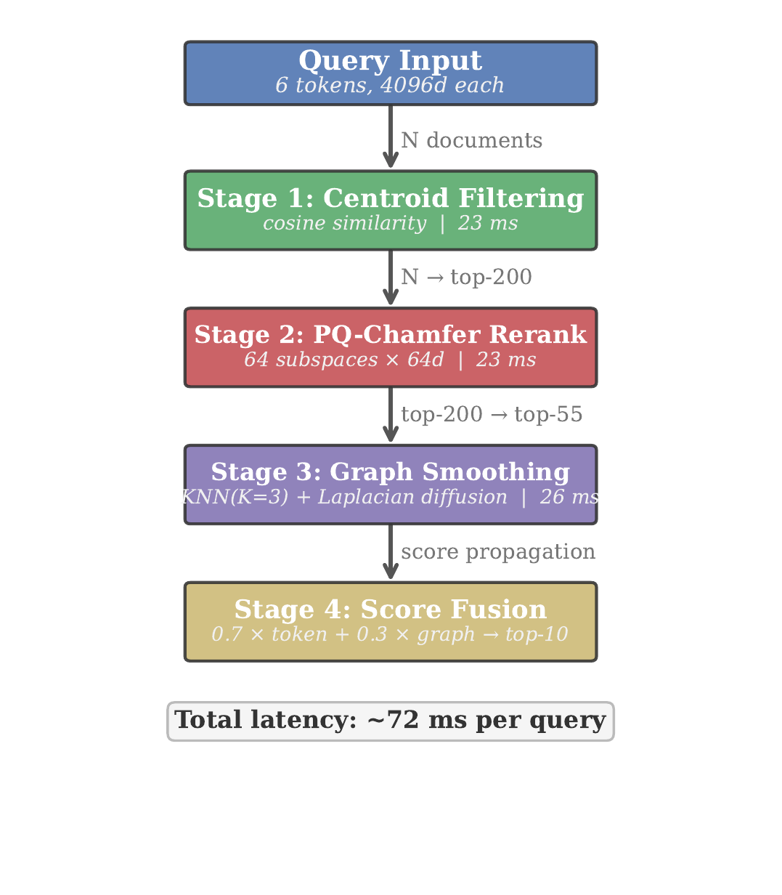
Overview of the three-stage point cloud retrieval pipeline. Stage 1 performs centroid-based coarse filtering. Stage 2 applies token-level PQ-Chamfer reranking. Stage 3 constructs a KNN graph and applies Laplacian smoothing.
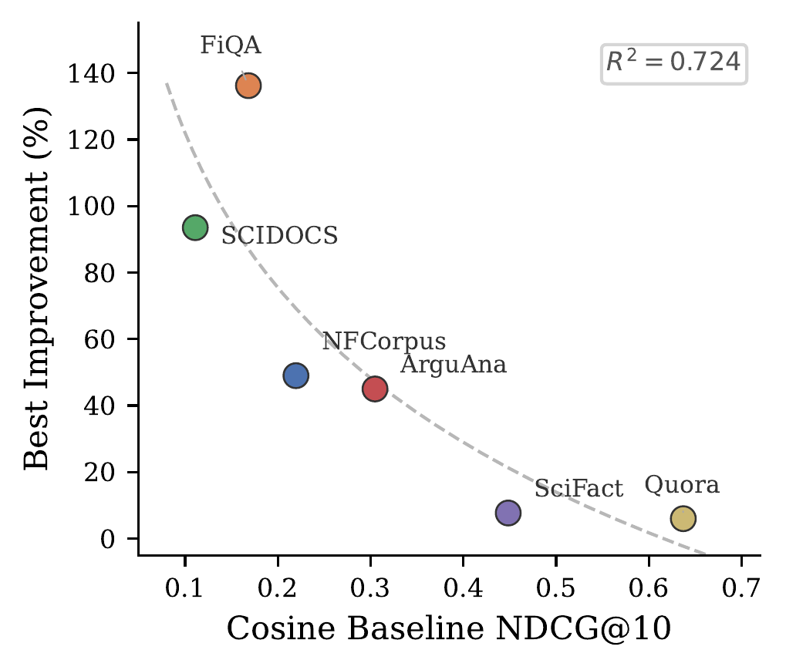
Cosine baseline NDCG@10 (x-axis) versus relative gain from our best pipeline (y-axis) across six BEIR datasets. The strong inverse correlation confirms that our geometric operations recover structural information that becomes redundant as baseline quality improves.
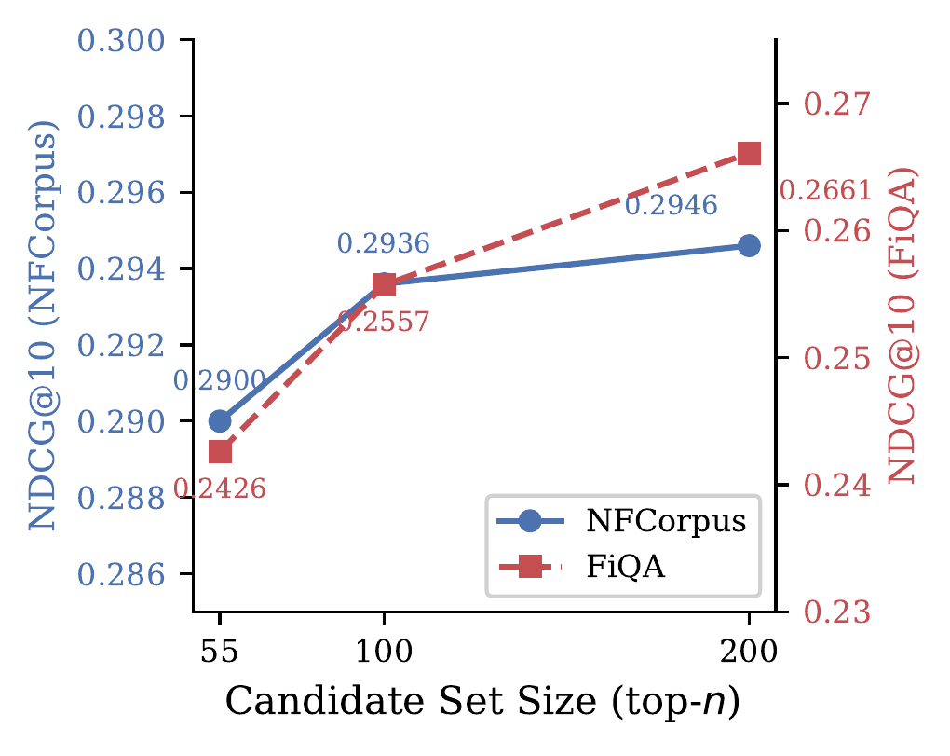
Effect of candidate set size (top-$n$) on NDCG@10 for different pipeline configurations on NFCorpus. Token two-stage and fusion achieve stable performance across a wide range of candidate sizes.

Complete Falsification Record
The 21 falsified approaches summarized in Table 5 are documented in full—including experimental configurations, quantitative results, and root-cause analyses—in the project repository. Each entry records the hypothesis, experimental setup, observed result, and diagnostic explanation.
Repository: https://[anonymized for review] (to be made public upon publication).
The falsification log follows a structured format: (1) Hypothesis stated before the experiment; (2) Protocol specifying parameters, datasets, and metrics; (3) Result with quantitative measurements; (4) Root-cause analysis explaining why the approach failed, not merely that it failed. We believe this level of documentation is valuable for the community: negative results in retrieval are rarely published, yet they constrain the design space and prevent redundant exploration.
Anonymous. 2026a. “Shape-CFD V4: PQ-Chamfer Distance and Adjoint-State Prefetching for Point Cloud Retrieval.” Zenodo. https://doi.org/10.5281/zenodo.19233894.
———. 2026b. “Shape-CFD: Documents Are Not Points, They Are Shapes — Convection-Diffusion Framework for Neural Retrieval Reranking (V1–V3).” arXiv Preprint.
Dampanaboina, Venktesh et al. 2024. “Diffusion-Aided RAG: Relevance Propagation via Graph Diffusion for Retrieval-Augmented Generation.” arXiv Preprint.
Fan, Haoqiang, Hao Su, and Leonidas J. Guibas. 2017. “A Point Set Generation Network for 3D Object Reconstruction from a Single Image.” In Proceedings of the IEEE Conference on Computer Vision and Pattern Recognition (CVPR).
Ge, Tiezheng, Kaiming He, Qifa Ke, and Jian Sun. 2014. “Optimized Product Quantization.” IEEE Transactions on Pattern Analysis and Machine Intelligence 36 (4): 744–55.
Glass, Michael et al. 2024. “G-RAG: Graph Neural Retrieval Augmented Generation.” arXiv Preprint.
Guo, Ruiqi, Philip Sun, Erik Lindgren, Quan Geng, David Simcha, Felix Chern, and Sanjiv Kumar. 2020. “Accelerating Large-Scale Inference with Anisotropic Vector Quantization.” In Proceedings of the 37th International Conference on Machine Learning (ICML).
Guu, Kelvin, Kenton Lee, Zora Tung, Panupong Pasupat, and Ming-Wei Chang. 2020. “REALM: Retrieval-Augmented Language Model Pre-Training.” In Proceedings of the 37th International Conference on Machine Learning (ICML).
Jégou, Hervé, Matthijs Douze, and Cordelia Schmid. 2011. “Product Quantization for Nearest Neighbor Search.” IEEE Transactions on Pattern Analysis and Machine Intelligence 33 (1): 117–28.
Johnson, Jeff, Matthijs Douze, and Hervé Jégou. 2021. “Billion-Scale Similarity Search with GPUs.” IEEE Transactions on Big Data 7 (3): 535–47.
Khattab, Omar, and Matei Zaharia. 2020. “ColBERT: Efficient and Effective Passage Search via Contextualized Late Interaction over BERT.” In Proceedings of the 43rd International ACM SIGIR Conference on Research and Development in Information Retrieval (SIGIR).
Kusner, Matt J., Yu Sun, Nicholas I. Kolkin, and Kilian Q. Weinberger. 2015. “From Word Embeddings to Document Distances.” In Proceedings of the 32nd International Conference on Machine Learning (ICML).
Lewis, Patrick, Ethan Perez, Aleksandra Piktus, Fabio Petroni, Vladimir Karpukhin, Naman Goyal, Heinrich Küttler, et al. 2020. “Retrieval-Augmented Generation for Knowledge-Intensive NLP Tasks.” In Advances in Neural Information Processing Systems (NeurIPS).
Li, Jianghao et al. 2025. “The Evolution of Reranking Models in Information Retrieval: From Heuristic Methods to Large Language Models.” arXiv Preprint arXiv:2512.16236.
Li, Zehan et al. 2024. “GTE: General Text Embeddings with Multi-Stage Contrastive Learning.” arXiv Preprint arXiv:2308.03281.
Liu, Jiongnan et al. 2025. “AFR-Rank: An Effective and Highly Efficient LLM-Based Listwise Reranking Framework via Filtering Noise Documents.” Information Processing & Management 62 (4): 104089.
MacAvaney, Sean, Nicola Tonellotto, and Craig Macdonald. 2022. “Adaptive Re-Ranking with a Corpus Graph.” In Proceedings of the 31st ACM International Conference on Information and Knowledge Management (CIKM).
Page, Lawrence, Sergey Brin, Rajeev Motwani, and Terry Winograd. 1999. “The PageRank Citation Ranking: Bringing Order to the Web.” Stanford InfoLab.
Pradeep, Ronak, Sahel Sharifymoghaddam, and Jimmy Lin. 2025. “RankLLM: Scalable and Reliable Reranking with Large Language Models.” In Proceedings of the 48th International ACM SIGIR Conference on Research and Development in Information Retrieval (SIGIR).
Rijsbergen, Cornelis Joost van. 1979. Information Retrieval. 2nd ed. Butterworths.
Rubner, Yossi, Carlo Tomasi, and Leonidas J. Guibas. 2000. “The Earth Mover’s Distance as a Metric for Image Retrieval.” International Journal of Computer Vision 40 (2): 99–121.
Santhanam, Keshav, Omar Khattab, Christopher Potts, and Matei Zaharia. 2022. “PLAID: An Efficient Engine for Late Interaction Retrieval.” In Proceedings of the 31st ACM International Conference on Information and Knowledge Management (CIKM).
Santhanam, Keshav, Omar Khattab, Jon Saad-Falcon, Christopher Potts, and Matei Zaharia. 2022. “ColBERTv2: Effective and Efficient Retrieval via Lightweight Late Interaction.” In Proceedings of the 2022 Conference of the North American Chapter of the Association for Computational Linguistics (NAACL).
Séjourné, Thibault, Gabriel Peyré, and François-Xavier Vialard. 2023. “Unbalanced Optimal Transport, from Theory to Numerics.” In Handbook of Numerical Analysis, 24:407–71. Elsevier.
Sun, Weiwei, Lingyong Yan, Xinyu Ma, Shuaiqiang Wang, Pengjie Ren, Zhumin Chen, Dawei Yin, and Zhaochun Ren. 2024. “Is ChatGPT Good at Search? Investigating Large Language Models as Re-Ranking Agents.” In Proceedings of the 2024 Conference on Empirical Methods in Natural Language Processing (EMNLP).
Thakur, Nandan, Nils Reimers, Andreas Rückschlöß, Abhishek Srivastava, and Iryna Gurevych. 2021. “BEIR: A Heterogeneous Benchmark for Zero-Shot Evaluation of Information Retrieval Models.” In Proceedings of the Neural Information Processing Systems Track on Datasets and Benchmarks (NeurIPS).
Wang, Liang, Nan Yang, Xiaolong Huang, Linjun Yang, Rangan Majumder, and Furu Wei. 2024. “E5-Mistral: Improving Text Embeddings with Large Language Models.” arXiv Preprint arXiv:2401.00368.
Xiao, Shitao, Zheng Liu, Peitian Zhang, and Niklas Muennighoff. 2023. “C-Pack: Packaged Resources to Advance General Chinese Embedding.” arXiv Preprint arXiv:2309.07597.
Zhang, Tianyi, Varsha Kishore, Felix Wu, Kilian Q. Weinberger, and Yoav Artzi. 2020. “BERTScore: Evaluating Text Generation with BERT.” In Proceedings of the International Conference on Learning Representations (ICLR).

Chamfer distance is a semimetric; we use “distance” following point cloud convention.
This p-value was computed for an earlier fusion configuration ($λ=0.7$, fusion$​=0.3232$); the current best fusion (0.3271) uses full-candidate graph smoothing but has not been separately tested for significance.

