Needed Operations in Karma

# Finding an Class or Property for a Semantic Type

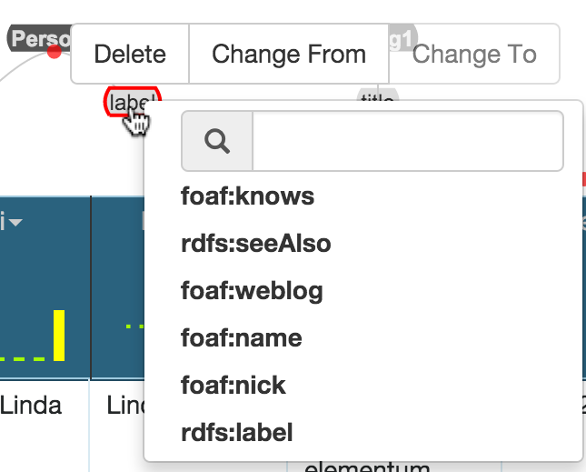 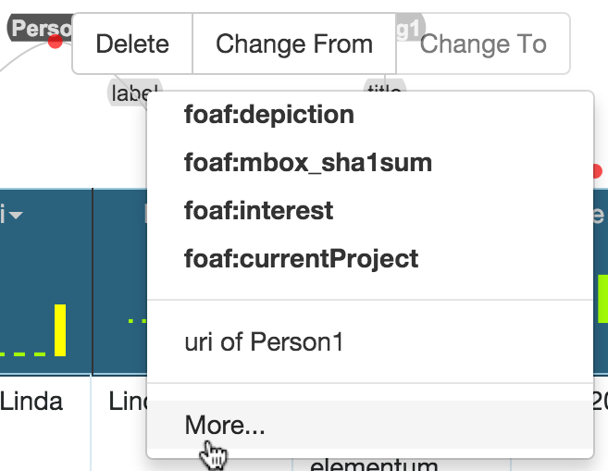

To select a property for a semantic type, click on the property of the semantic type. Subsequently, you have the following three options:

1. Choose a recommended vocabulary term (marked bold)
2. Use the search bar (left picture) to find a vocabulary term that syntactically matches the entered search term
3. Scroll down the recommended vocabulary terms and click on “more” to browse through all available vocabulary terms

To select a Class for a semantic type, simply click on a node representing a Class. The menu looks the same as for the properties, and you have the same three options 1. – 3.

# Connecting two Classes with a property:

## Adding Outgoing Link

To connect two classes via a property, first click on one RDF type in the graph. Click on “Add Outgoing Link” in the menu that is next to the recommended vocabulary terms for the selected Class.

## Specifying the Connection

The menu shows four different areas:

(1) Upper left: The Classes that are already used in the model.

(2) Lower left: All available Classes you can choose

(3) Upper right: Recommended Properties

(4) Lower right: All available properties you can choose

If you select a Class in (1), the recommended properties will adjust to provide better results. However, if no recommendation is found, the result list will be empty.

If you select a Class in (2), the system will create a new node.

## Using the Search Bar

You can also use the search bar for finding an outgoing property and a corresponding Class.

The properties and Classes that match the entered String will appear green.

Choose a Property and a Class and click on save to incorporate the vocabulary terms and their connection into the model