# Link To Survey:

http://bit.ly/recstudy

# Recommendation Method:

# Initial Situation:

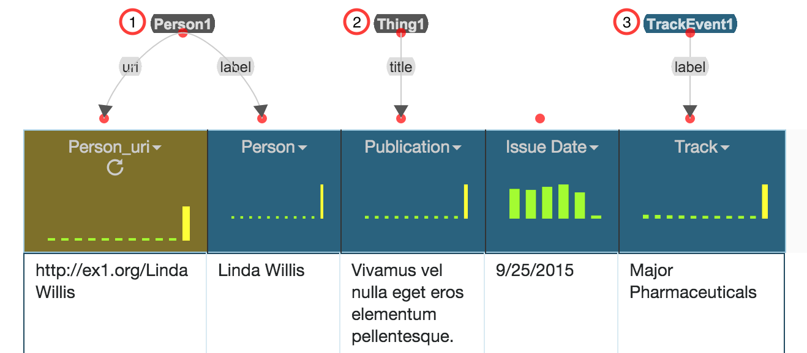

# Assignments:

Before you, you see a dataset containing data on persons and publications. In detail, some person issued some publication on a given data to a given track (e.g. a track in a journal). Your assignment is to replace all nodes that are of type **Thing1** or **label** (used for owl:Thing and rdfs:label) with “better fitting” vocabulary terms, if possible. In addition, you should connect the nodes to specify their relation to each other. The individual steps are listed below:

1. Find a better outgoing property from (1) to the “Person” column to specify that it contains the name of a person
2. Find a better RDF type for (2), specifying that the items in the columns are a bibliographic publication
3. Find a better property from (3) to the “Track” column specifying the name of a track
4. Connect (1) and (2) and specify that a person is the author of a publication
5. Connect (2) and (3) and specify that a publication are part of a track
6. Set the Semantic Type of the column “Issue Date” to (2) specifying that a publication was issued on a specific date

After you complete these tasks, let the principal investigator save the evolved data model, before continuing with the user-study.