# Recommendation Method:

# Initial Situation:

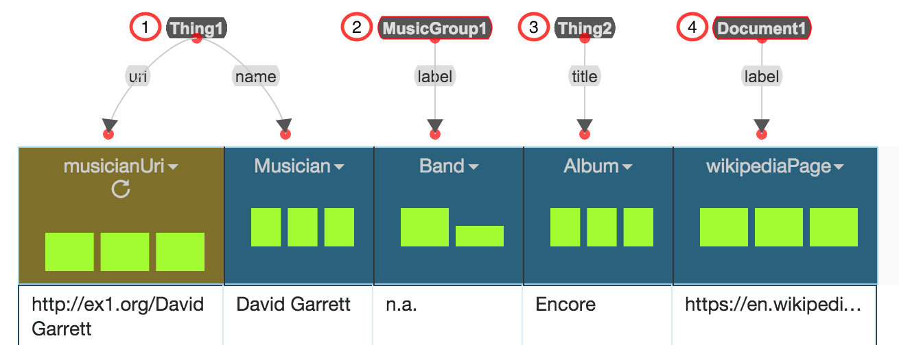

# Assignments:

In front of you, you see a dataset containing data on musicians. In detail, a musician can be part of a band, record an album, and can have Wikipedia page. Your assignment is to replace all nodes that are of type **Thing** (Thing1 and Thing2) or **label** with “better fitting” vocabulary terms, if possible. In addition, you should connect the nodes to specify their relation to each other. The individual steps are listed below:

1. Find a better RDF type for (1) specifying that the entities in the column “Musician” are musicians
2. Find a better property for (2) specifying the name of a music band
3. Find a better RDF type for (3) specifying that the entities in the column “Album” are the musician’s records
4. Find a better property for (4) specifying the URL to a Wikipedia page
5. Connect (1) and (2) to specify that a musician is part of a band
6. Connect (1) and (3) to specify that a musician recorded a album
7. Connect (1) and (4) to specify that a musician has a Wikipedia page

After you complete these tasks, let the principal investigator save the evolved data model, before continuing with the user-study.