# Recommendation Method:

# Initial Situation:

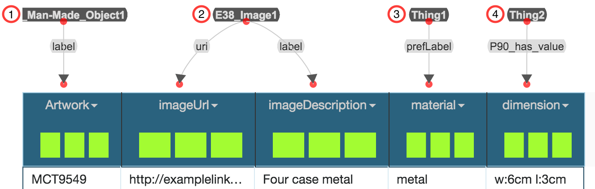

# Assignments:

In front of you, you see a dataset containing data on museum items. In detail, a museum item is an artwork that is some specific size, is made out of some material, and has a corresponding image. Your assignment is to replace all nodes that are of type **Thing** (Thing1 and Thing2) or **label** with “better fitting” vocabulary terms, if possible. In addition, you should connect the nodes to specify their relation to each other. The individual steps are listed below:

1. Find a better property for (1) specifying that an artwork item has a specific name
2. Find a better property for (2) specifying that an image has a specific description
3. Find a better RDF type for (3) specifying that the entities in the column “material” describe some material
4. Find a better RDF type for (4) specifying that the entities in the column “dimension” describe a dimension
5. Connect (1) and (2) to specify that an image represents an artwork
6. Connect (1) and (3) to specify that the artwork is made out of some material
7. Connect (1) and (4) to specify that an artwork has some specific length and width

After you complete these tasks, let the principal investigator save the evolved data model, before continuing with the user-study.