# Recommendation Method:

# Initial Situation:

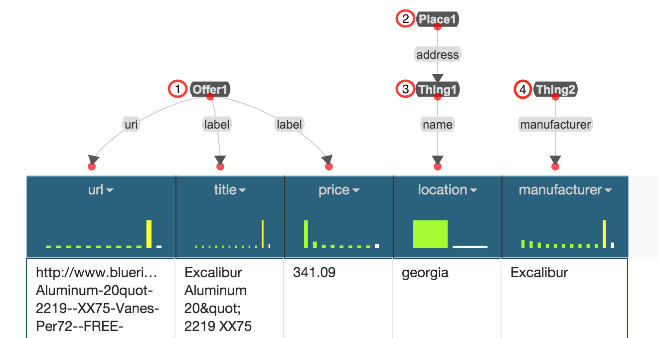

# Assignments:

In front of you, you see a dataset containing data on items that are offered for sale. In detail, an offer has a specific title, a price, and a place where the offer is taking place. The item that is offered is a product that has a manufacturer. Your assignment is to replace all nodes that are of type **Thing** (Thing1 and Thing2) or **label** with “better fitting” vocabulary terms, if possible. In addition, you should connect the nodes to specify their relation to each other. The individual steps are listed below:

1. Find a better property for (1) specifying the title of an offer
2. Find a better property for (1) specifying the price of an offer
3. Find a better RDF type for (3) specifying that the entities in the column “location” describe the address of a place
4. Find a better RDF type for (4) specifying that the entities in the column “manufacturer” are manufacturer of a product
5. Connect (1) and (2) to specify that an offer is available at a location
6. Connect (1) and (4) to specify that it is an offer of a product

After you complete these tasks, let the principal investigator save the evolved data model, before continuing with the user-study.